**Mitt Arv E-Commerce App – A Cross-Platform Shopping Experience Using Flutter**

**Objective:**

To design and develop a cross-platform E-Commerce application that allows users to browse, search, sort, and purchase products using a user-friendly interface. The app is built using Flutter and integrates real-time product data from an external API.

**Tools & Technologies Used:**

| Tool/Tech | Purpose |
| --- | --- |
| Flutter | Frontend development (cross-platform) |
| Dart | Programming language for Flutter |
| Provider | State management |
| Shared Preferences | Local data storage (for login credentials) |
| VS Code / Android Studio | IDEs used |
| Chrome & Android Emulator | Testing platforms |
| fakestoreapi.com | API to fetch product data |

**Features Implemented:**

1. Login & Registration with Validation
2. Home Page with Initial Product Display (10 items)
3. Infinite Scrolling (load more products on scroll)
4. Search Functionality (filter products by title)
5. Sorting (By price, rating, popularity)
6. Add to Cart & Remove from Cart
7. Cart Screen with Total Price Calculation
8. Checkout Screen with Success Message
9. Web + Mobile Compatibility (Flutter Web + Android Emulator)
10. *(Optional)* Dark Mode Toggle *(added earlier during testing)*

**Testing Strategy & Process:**

Test Devices & Platforms:

* Android Emulator (Pixel 5 API 33)
* Chrome Browser (Flutter Web)

Tested Scenarios:

1. Authentication

* Tested login with correct and incorrect credentials.
* Result: Smooth navigation from Auth Screen to Home Page.

2. Home Page Display

* Confirmed that only 10 products load initially.
* As user scrolls down, more products are fetched dynamically.
* Result: Infinite scrolling is responsive and works fine.

3. Search Functionality

* Searched using different keywords.
* The list updated dynamically as the input changed.
* Result: Accurate filtering and quick response.

4. Sorting

* Applied sorting options from dropdown (Price, Rating).
* The list reordered instantly as per selected sort criteria.
* Result: Proper sorting logic is implemented.

5. Cart Operations

* Added multiple products to cart.
* Updated quantities and removed items.
* Result: Total price updated accurately, no glitches observed.

6. Web View (edge)

* Ensured all features looked and worked the same.
* Result: Fully responsive, no UI breakage.

**Screenshots Captured:**

1. Login/Register screen (Emulator & Chrome)

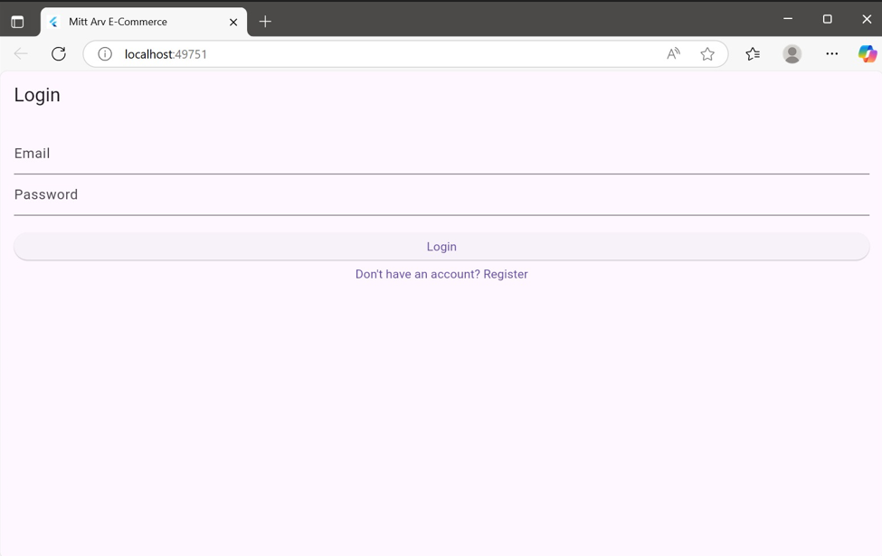

1. Home page with products

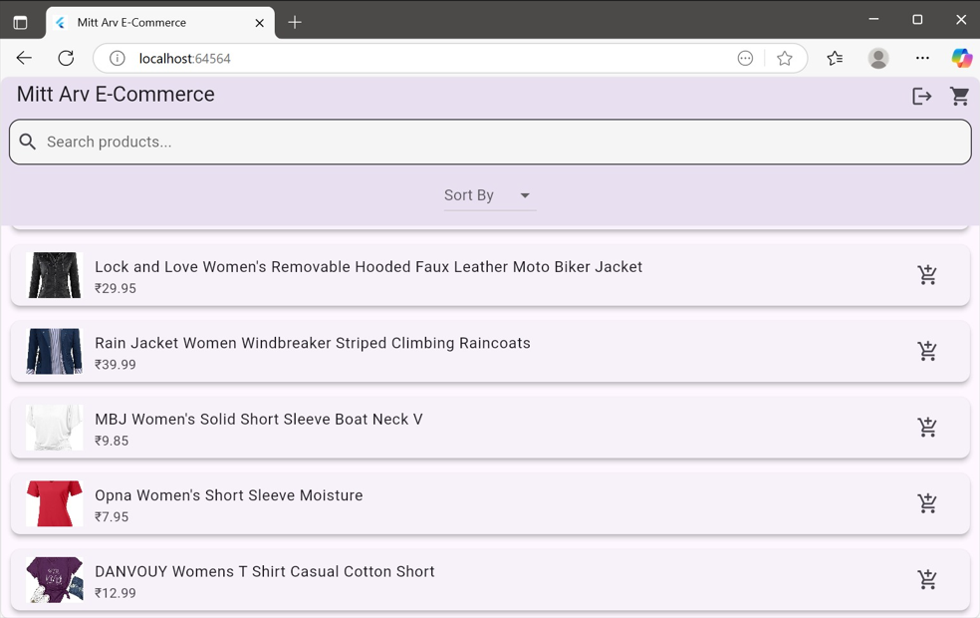

1. Search bar filtering

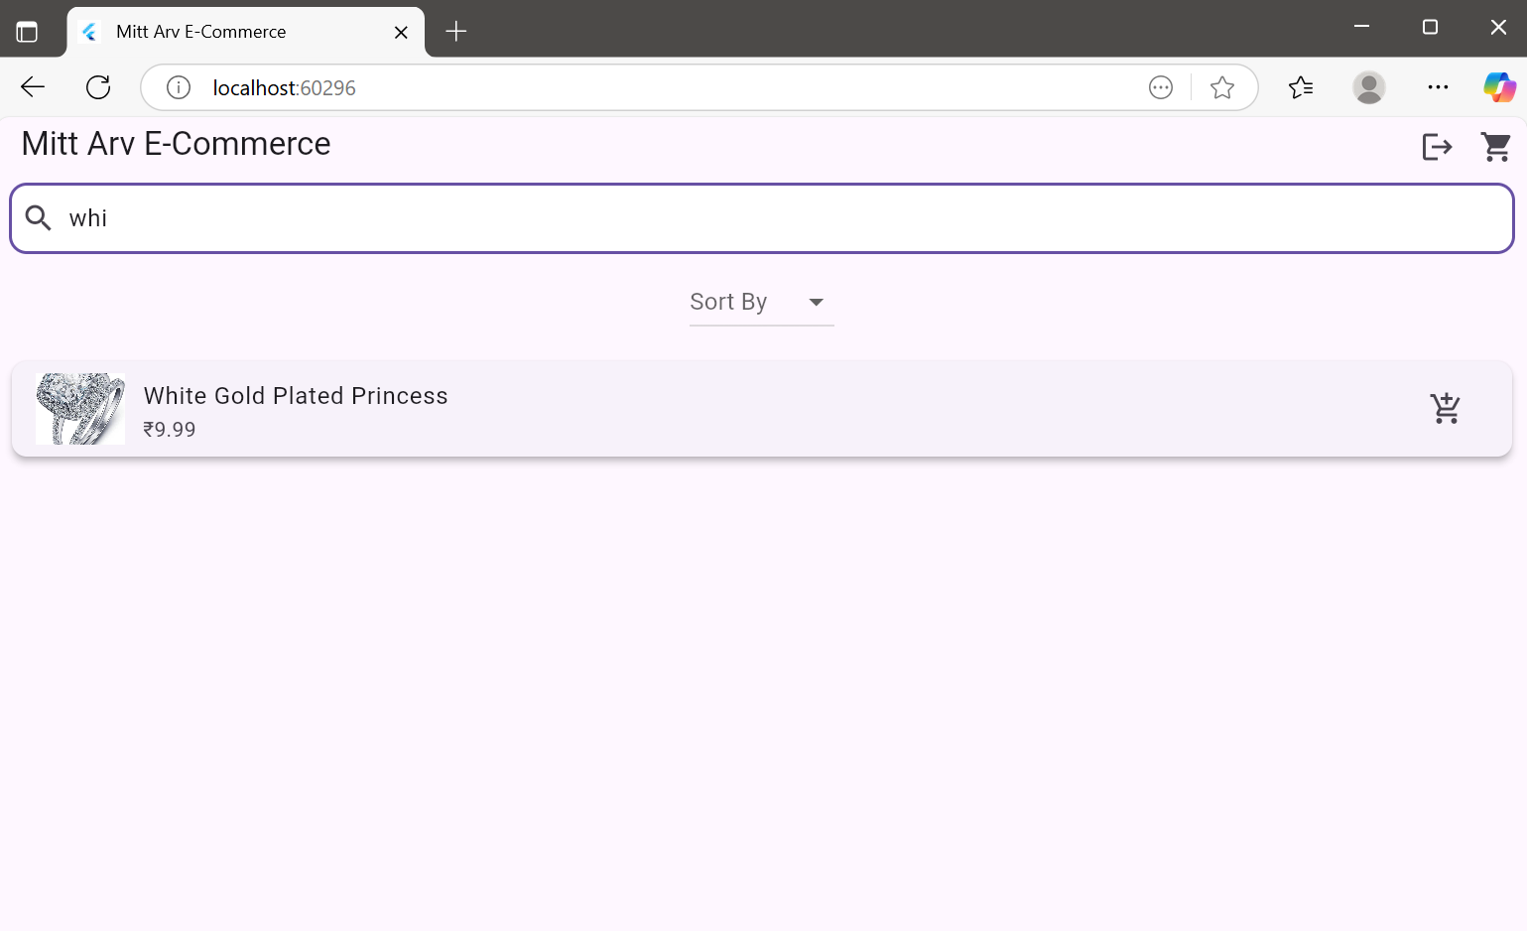

1. Sorting dropdown in action

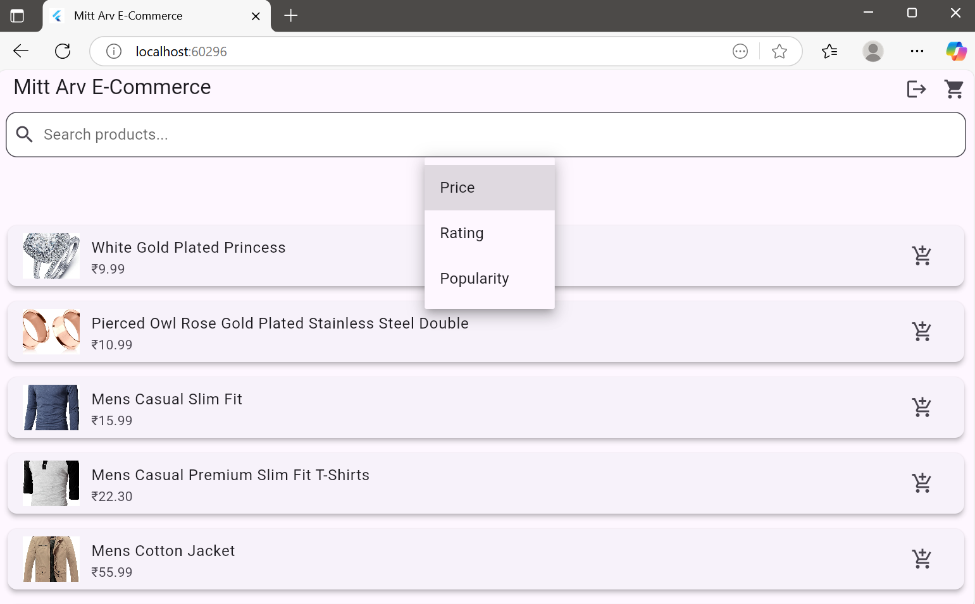

1. Cart screen with items

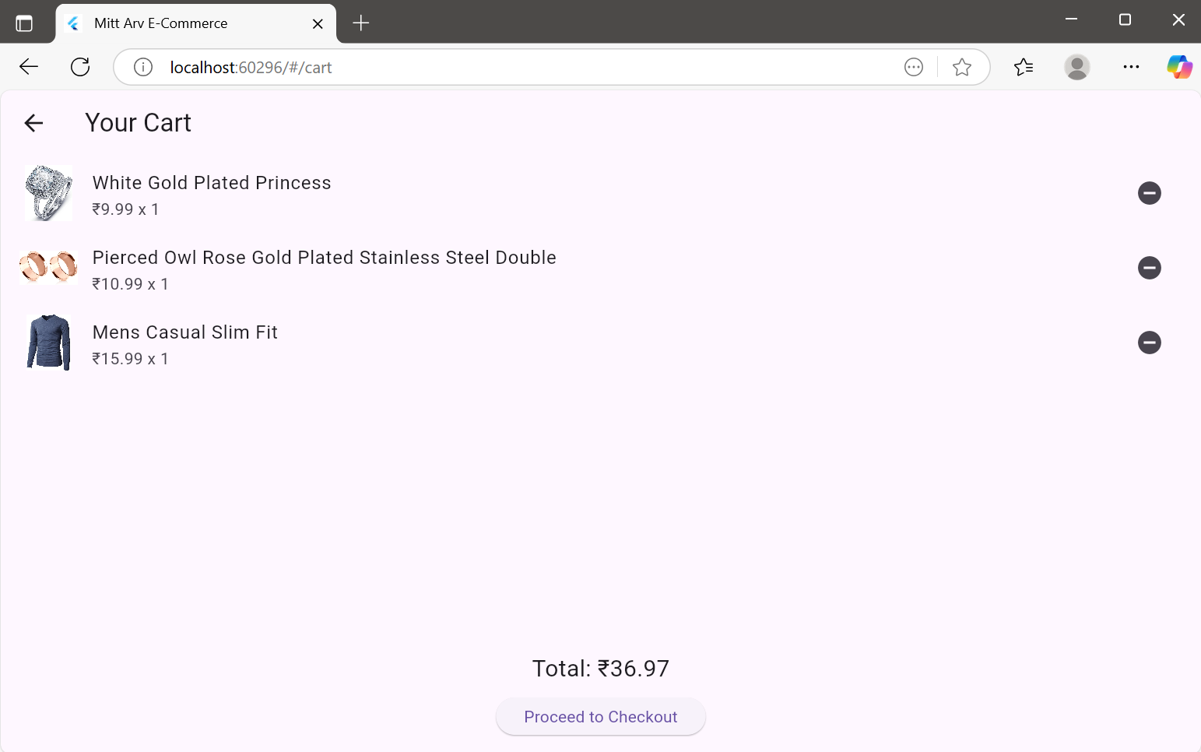

1. Checkout

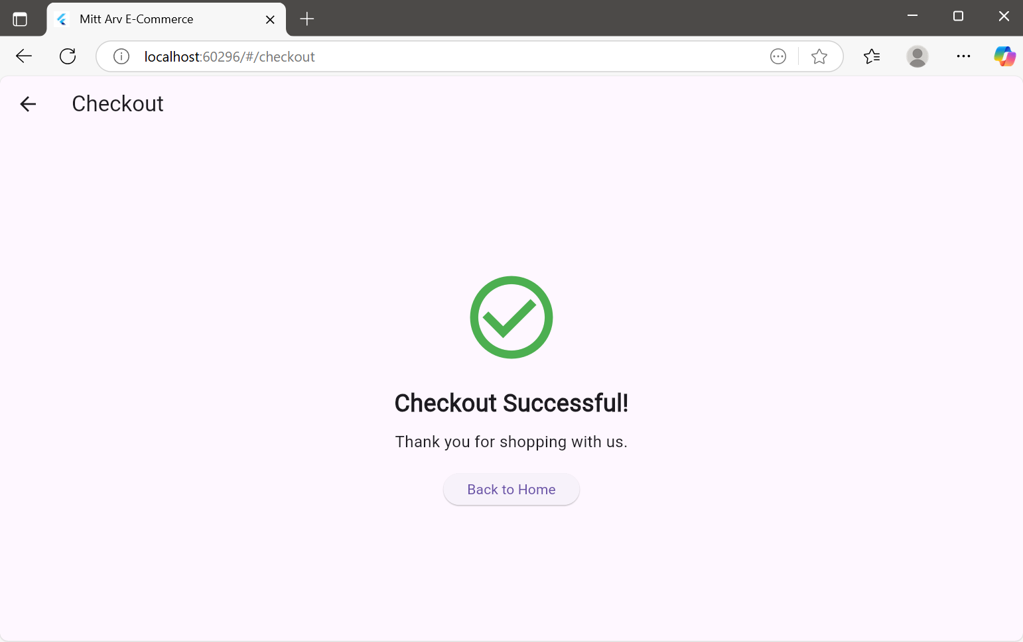

Below are the screenshots captured from the Android Emulator demonstrating key functionalities of the app such as login, product browsing, search, sorting, cart view, and checkout success. These validate the mobile responsiveness and user flow of the application.

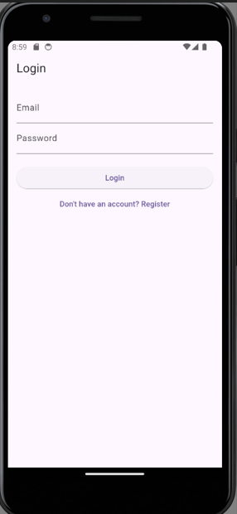

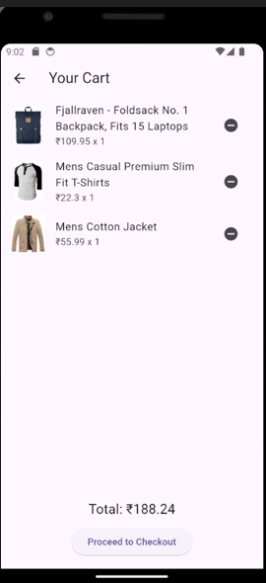

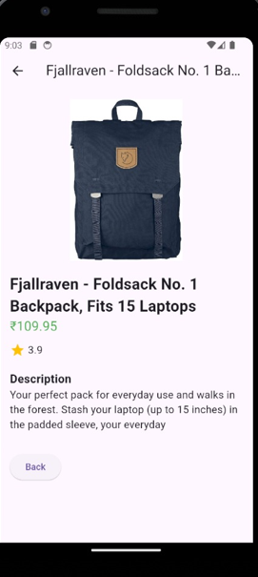

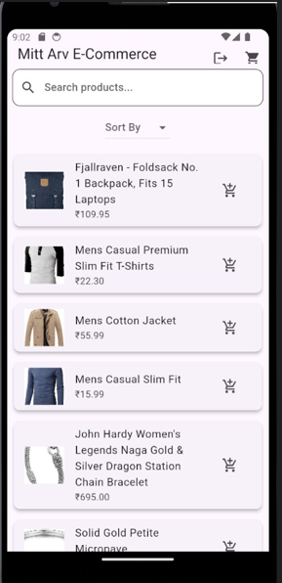

**Results & Observations:**

* The app compiles and runs without any errors or build exceptions.
* Consistent layout and behavior across web and mobile.
* Smooth UI/UX throughout the shopping experience.
* Code follows modular design with separate files for providers, screens, and widgets.
* SharedPreferences ensures session data is stored securely.
* Provider allows efficient state management.
* Readable code structure with helpful variable names and comments.

**Conclusion:**

This e-commerce app successfully demonstrates a complete shopping flow from login to checkout using Flutter. It is lightweight, responsive, and uses best practices for performance and code clarity. The product data is dynamically loaded using a real API (https://fakestoreapi.com), ensuring practical usage and integration.

With multi-platform support (web and Android), user-friendly interfaces, and clean architecture, this project meets all the objectives set out in the beginning.