Major Project Phase I

Project Title:
ReScene: A Hybrid Semantic and Structural Framework for Revisit-Based Video Forgery
Detection

Abstract:
The rise of advanced video editing and AI-based generation tools has made it increasingly difficult to verify the authenticity of digital video. Existing forgery detection methods focus largely on low-level visual artifacts or pixel-level inconsistencies, and therefore often miss semantic changes to the content of a real scene. This work presents ReScene, a hybrid framework for detecting video forgery in revisit scenarios by combining scene-level semantic reasoning with visual structure verification.
ReScene processes the reference and revisit videos through two complementary pathways. In the semantic pathway, YOLOv8 detects objects in representative frames, and each frame is converted into a scene graph in which objects are nodes and spatial relations (left-of, right-of, above, below, near) are edges. A Graph Convolutional Network (MemoryGCN) analyzes these graphs to identify semantic inconsistencies caused by object insertion, deletion, replacement, movement, or altered relationships. In parallel, the structural verification pathway examines the corresponding stable frames without relying on object detection: the Structural Similarity Index (SSIM) localizes regions with structural differences, while ORB feature matching provides additional local-feature evidence of visual change.
The semantic and structural confidence scores are merged through an adaptive confidence fusion mechanism, which produces the final tampering confidence and highlights suspicious scene elements. By unifying object-level semantic reasoning, persistent scene memory, graph-based inconsistency detection, and local structural verification, ReScene offers complementary evidence for assessing the authenticity of revisit-based video scenes and detecting object-level manipulations.
Keywords:
Video Forgery Detection, Scene Graphs, Graph Convolutional Networks, SSIM, ORB Feature Matching, Digital Forensics

Team Members:

S.No | Hall Ticket | Name of the Student | Signature
1 | 23211A6618 | B Manvith Reddy
2 | 24215A6605 | Ravuri Jeetendra

Scope of the Project:
The project, reScene: Dynamic 3D Scene Memory Graphs for Occlusion-Aware Scene Understanding, focuses on developing a system that maintains a persistent representation of a 3D environment using scene graphs. It aims to identify objects, model their spatial relationships, and preserve scene information across multiple observations. The system will use accumulated spatial memory to support reasoning about objects that become partially or completely occluded. It will explore updating object properties, maintaining relationships, and handling changes in object visibility and scene configuration over time. The project will primarily focus on indoor environments and publicly available 3D datasets, with evaluation based on object representation, relationship consistency, memory updates, and occlusion-aware reasoning.

Research Gaps:
- Limited Persistent Scene Memory: Existing 3D scene understanding approaches often focus on the current observation and may not maintain a consistent representation of the environment across multiple observations.
- Occlusion-Aware Reasoning: Objects that become partially or completely occluded may be difficult to identify or reason about when they are not visible in the current observation.
- Temporal Relationship Inconsistency: Spatial relationships between objects may become inconsistent as the scene changes or new observations are processed.
- Object Identity Maintenance: Maintaining consistent object identities across multiple observations remains challenging, particularly when objects disappear and reappear.

Research Objectives:
- To develop a dynamic 3D scene memory graph that maintains object representations and spatial relationships across multiple observations.
- To design a mechanism for occlusion-aware scene understanding that uses previously observed information to reason about objects that are partially or completely hidden.
- To maintain consistent object identities across successive observations, including cases where objects disappear and reappear.
- To develop graph update mechanisms that incorporate new observations while preserving relevant historical scene information.

Brief Overview of the Proposed Method and Implementation:
The proposed reScene framework aims to develop a dynamic 3D scene memory graph for occlusion-aware scene understanding. The system will process sequential observations from publicly available 3D indoor scene datasets, extract object representations and spatial relationships, and organize them into a graph structure. It will maintain persistent object identities and update the graph as new observations arrive. When objects become partially or completely occluded, the framework will use previously stored scene information to reason about their possible presence and relationships. Graph update mechanisms will address duplicate nodes, disconnected components, and inconsistent relationships. The implementation will use Python, PyTorch, and graph-processing libraries, with evaluation based on object identity consistency, spatial relationship accuracy, graph consistency, and occlusion-aware reasoning performance.
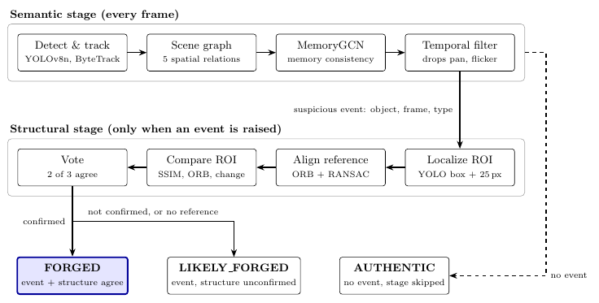

Figure: Overview of the ReScene pipeline. The semantic stage runs on every frame. Only a semantic event starts the structural stage, whose vote decides between FORGED and LIKELY FORGED. With no event the verdict is AUTHENTIC and the structural stage is skipped.

Key Technologies to be Used in the Implementation:
Python 3.11, PyTorch, PyTorch Geometric, Open3D, OpenCV, NumPy, NetworkX, Graph Neural Networks (GNNs), 3D Point Cloud Processing, 3D Scene Graphs, 3D-FRONT Dataset, CUDA, Google Colab, NVIDIA RTX 3060 GPU.
Team Declaration:
- All the Students in Team Have Been Informed About the Guidelines For the Major Project Phase I.
- All the Students Are Also Aware that the Project Carried Out During the IV Year I Semester and II Semester, Shall be Submitted to a Conference or Journal On or Before 31-12-2026.
- Students in the Team Will Adhere to the Timelines of the Major Project Phase I Without Fail.
- Plagiarism/Similarity Index for The Final Documentation Shall Be Less than or Equal to 05% and AI Tools Similarity Shall Also be Less Than or Equal to 05%.

Ms. B Priyanka Dr. B VeeraSekharReddy
Signature of the Co-Supervisor Siganature of the Supervisor

Department Project Review Committee:

Name of Faculty Designation / Role Signature

Dr. G Uday Kiran Program Coordinator CSE(AI & ML) Dr. S Pavan Kumar Reddy Member
Dr. D Dipanwita Member Dr. B Veerasekhar Reddy Member Dr. B Pradeep Kumar Reddy Member Ms. Srilakshmi V Member

External Examiner Program Coordinator CSE(AI & ML)

