A Major Project Report
On
ReScene: A Hybrid Semantic and Structural
Framework for Revisit-Based Video Forgery
Detection
Submitted in the Partial Fulfillment of the Requirements
For the Award of the Degree of

Bachelor of Technology
In
CSE(Artificial Intelligence and Machine Learning)
By
Bijjam Manvith Reddy 23211A6618
Ravuri Jeetendra 24215A6605

Under the Guidance of
Dr. B VeeraSekharReddy Assistant Professor
Ms. B Priyanka Assistant Professor

DEPARTMENT OF CSE(ARTIFICIAL INTELLIGENCE AND MACHINE LEARNING)
B V RAJU INSTITUTE OF TECHNOLOGY
(UGC Autonomous, Accredited by NBA & NAAC)
Vishnupur, Narsapur, Medak, Telangana State, India – 502313
2025-2026
Department of CSE(Artificial Intelligence and Machine Learning)

CERTIFICATE
This is to Certify that the Mini Project Entitled “ReScene: A Hybrid
Semantic and Structural Framework for Revisit-Based Video Forgery
Detection”, Being Submitted By
Bijjam Manvith Reddy 23211A6618
Ravuri Jeetendra 24215A6605

In Partial Fulfillment of the Requirements for the Award of Degree of Bachelor of Technology in CSE(Artificial Intelligence and Machine Learning) to B V Raju Institute of Technology is Record of Bonafide Work Carried Out During the Period From June 2026 to October 2026 by Them Under the Supervision of
Dr. B VeeraSekharReddy Assistant Professor
Ms. B Priyanka Assistant Professor

This is to Certify that the Above Statement Made by the Students are Correct to the Best of Our Knowledge.

Dr. B VeeraSekharReddy Ms. B Priyanka
Assistant Professor Assistant Professor

The Major Project Viva-Voce for This Team Has Been Held on
____________.

External Examiner Dr. G Uday Kiran
Program Coordinator

CANDIDATE’S DECLARATION
We Hereby Certify that the Work Which is Being Presented in the Mini Project Entitled “ReScene: A Hybrid Semantic and Structural Framework for Revisit-Based Video Forgery Detection” in Partial Fulfillment of the Requirements For the Award of Degree of Bachelor of Technology and Submitted in the Department of CSE(Artificial Intelligence and Machine Learning), B V Raju Institute of Technology, Narsapur, is an Authentic Record of Our Own Work Carried Out During the Period From June 2026 to October 2026, Under the Supervision of Dr. B VeeraShekarReddy, Assistant Professor and Ms. B Priyanka, Assistant Professor.
The Work Presented in this Major Project Report Has Not Been Submitted By Us For the Award of Any Other Degree of This or Any Other Institute/University.

Bijjam Manvith Reddy 23211A6618
Ravuri Jeetendra 24215A6605

ACKNOWLEDGEMENT
We stand at the culmination of a significant journey, one that has been both challenging and rewarding. The success of our Major project is not solely a reflection of our efforts but a testament to the invaluable support and guidance we have received from many quarters. It is with deep gratitude that we acknowledge those who have made this achievement possible.
Foremost, we extend our sincerest appreciation to Ms. B Priyanka, Co-supervisor and Dr. B VeeraShekarReddy, Supervisor, whose expertise and insightful supervision have been pivotal in navigating the complexities of this project. Their unwavering support and encouragement have been our guiding light throughout this journey. Special thanks are due to Ms. Srilakshmi V, our Project Coordinator, whose assistance and guidance have been instrumental in the successful execution of our project. Her dedication and support have been a source of inspiration and motivation.
We reserve our utmost gratitude for Dr. G Uday Kiran, Program Coordinator of the Department of CSE (Artificial Intelligence and Machine Learning), whose leadership and academic guidance have enriched our learning experience and contributed significantly to our project's success.
Our journey would not have been the same without the constant encouragement, support, and guidance from the esteemed faculty of the Department of CSE (Artificial Intelligence and Machine Learning). We are deeply thankful to everyone who contributed to our journey, whose belief, guidance, and support have been crucial to our achievement. This project reflects not only our academic efforts but also the collaborative spirit and collective wisdom that guided us.
Bijjam Manvith Reddy 23211A6618
Ravuri Jeetendra 24215A6605

ABSTRACT
Because of the growing availability of sophisticated video editing tools and those based on artificial intelligence, it is becoming harder to tell whether digital video content is authentic. Current methods for detecting video forgery mainly concentrate on low-level visual artifacts or pixel-level inconsistencies and are therefore unlikely to properly detect semantic changes in the real scene. This project introduces ReScene, a hybrid approach that combines semantic and structural analysis for the detection of video forgery in revisit cases, by integrating scene-level reasoning with visual structure verification. The proposed framework handles both the reference and revisit videos via two complementary channels. In the semantic pathway, YOLOv8 is employed to detect objects in frames taken from the representative video and to build scene graphs in which the objects are shown as nodes and spatial relations such as left-of, right-of, above, below, and near are shown as edges. The scene representation thus obtained is examined using a Graph Convolutional Network (MemoryGCN) in order to spot semantic inconsistencies resulting from the insertion, deletion, replacement, movement, or modification of object relationships. At the same time, the structural verification pathway looks at the corresponding stable frames without relying on object detection. Structural Similarity Index (SSIM) is used to detect areas that show structural differences, while ORB feature matching supplies further evidence based on local features for the visual changes. The semantic and structural confidence scores are then combined by means of an adaptive confidence fusion mechanism to arrive at the final tampering confidence and to help identify suspicious scene elements. The framework therefore brings together object-level semantic reasoning, persistent scene memory, graph-based inconsistency detection, and local structural verification in a single method for assessing the authenticity of revisit-based video scenes. The framework is designed to offer complementary semantic and structural evidence for detecting object-level manipulations in videos.
TABLE OF CONTENTS

CERTIFICATE ii
CANDIDATE’S DECLARATION iii
ACKNOWLEDGEMENT iv
ABSTRACT vi
LIST OF FIGURES xi
LIST OF TABLES xii
LIST OF ABBREVIATIONS xiii
CHAPTER 1 1
1 Introduction 1
1.1 Background Of The Study 1
1.2 Revisit-Based Video Forgery Detection 2
1.3 Semantic Object Detection 3
1.4 Problem Statement 3
1.5 Motivation of the project 4
1.6 Objectives of the project 4
1.7 Challenges faced 5
1.7.1 Finding Suitable Video Data 6
1.7.2 Accurate Camera Pose Estimation 6
1.7.3 2D to 3D Object Localization 6
1.7.4 Model Selection and Integration 6
1.7.5 Real-World Scene Variability 7
CHAPTER 2 8
2 Review Of Literature 8
2.1 Related Work 8
2.2 Foundations of 3d Scene Reconstruction 20
2.3 Real-Time Visual Slam 22
2.4 Emergence of Deep Object Detection 22
2.5 Semantic segmentation and scene parsing 23
2.6 Semantic slam and dense semantic mapping 24
2.7 Scene graphs and structure representations 24
2.8 Monocular depth estimation 25
2.9 Neural fields and gaussian-based reconstruction 26
2.10 Open-vocabulary and foundation models 27
2.11 Identified research gap 27
2.11.1 Geometry-Only Reconstruction Paradigm 27
2.11.2 2D Semantic Perception Paradigm 28
2.11.3 Dense Neural Semantic Reconstruction Paradigm 28
2.11.4 Identified Gap 29
2.11.5 Positioning of the Proposed Framework 29
2.12 Limitations 29
2.12.1 Geometry-Only Reconstruction Methods 30
2.12.2 Semantic Segmentation Approaches 30
2.12.3 Semantic SLAM Systems 30
2.12.4 Neural Rendering and NeRF-Based Methods 31
2.12.5 Monocular Depth Estimation 31
2.12.6 2D Object Detection Models 31
CHAPTER 3 33
3 Methodology 33
3.1 Hardware Requirements 33
3.2 Software Requirements 33
3.3 Required python libraries and frameworks 33
3.4 Tools and technologies 34
3.4.1 OpenCV 34
3.4.2 COLMAP 35
3.4.3 YOLOv8 Framework 36
3.4.4 PyTorch 36
3.4.5 numPy 37
3.4.6 Pandas 38
3.4.7 Matplotlib 38
3.4.8 Google Colab 38
3.4.9 JSON and CSV Storage 39
3.5 Proposed method 40
3.5.1 Frame Extraction 42
3.5.2 Camera Pose Estimation (Structure-from-Motion) 43
3.5.3 Semantic Object Detection 44
3.5.4 2D-to-3D Object Localization 44
3.5.5 Spatio-sematic Memory Representation 45
3.5.6 Spatial Reasoning 46
3.6 Work Flow of the System 46
3.7 Evaluation and metrics 47
CHAPTER 4 49
4 Results and Discussion 49
4.1 Experimental Setup 49
4.2 Sparse 3D Reconstruction Quality 49
4.2.1 Reprojection Error Analysis 50
4.2.2 Camera Trajectory Consistency 50
4.2.3 Sparse Point Cloud Structure 51
4.2.4 Depth Distribution Characteristics 51
4.2.5 Frame Registration Statistics 53
4.3 Object detection and geometric filtering 53
4.3.1 Frame-wise Object Detection Performance 54
4.3.2 2D-to-3D Geometric Validation 55
4.4 Temporal Drift Analysis 56
4.4.1 Definition of Temporal Drift 56
4.4.2 Quantitative Drift Results 57
4.5 Model Execution 57
4.6 Accuracy And Performance Metrics 58
4.6.1 Geometric Accuracy 59
4.6.2 Semantic Accuracy 59
4.6.3 Unified Performance Summary 59
CHAPTER 5 60
5 Conclusion and Future Scope 60
5.1 Conclusion 60
5.2 Limitations of the proposed framework 61
5.3 Future scope 62
References 64
Conference Or Journal Details 70
Plagiarism Report 72
AI Plagiarism Report 73

LIST OF FIGURES
Figure 1. Evaluation of 3D Scene Understanding 1
Figure 2 Sparse 3D reconstruction with estimated camera centers. 42
Figure 3 Frame-wise semantic object detection using YOLOv8. Only detections 43
Figure 4 Geometric validation during 2D-to-3D object localization. Detected objects are projected into reconstructed space using camera intrinsics and estimated poses. 44
Figure 5 Object centroids in 3D 45
Figure 6. Work flow of the System 46
Figure 7 Sparse 3-D Reconstruction 48
Figure 8 Top-Down Camera Trajectory 49
Figure 9 Camera Trajectory 50
Figure 10 Sparse Point Cloud Depth Distribution 51
Figure 11 Frame Registration Statistics 52
Figure 12 Demonstrates enforcement of geometric consistency. 55
Figure 13 Temporal Drift 56

LIST OF TABLES
Table 1 Evaluation Metric Table 47
Table 2 This multi-metric evaluation demonstrates that the proposed framework achieves 58

LIST OF ABBREVIATIONS
Abbreviation | Full Form
AR | Augmented Reality
BA | Bundle Adjustment
CNN | Convolutional Neural Network
CSV | Comma-Separated Values
DETR | Detection Transformer
DSO | Direct Sparse Odometry
GPU | Graphics Processing Unit
IMU | Inertial Measurement Unit
JSON | JavaScript Object Notation
LiDAR | Light Detection and Ranging
MVS | Multi-View Stereo
NeRF | Neural Radiance Fields
ORB | Oriented FAST and Rotated BRIEF
PnP | Perspective-n-Point
RANSAC | Random Sample Consensus
RGB | Red Green Blue
RGB-D | Red Green Blue with Depth
SfM | Structure-from-Motion
SIFT | Scale-Invariant Feature Transform
SLAM | Simultaneous Localization and Mapping
TSDF | Truncated Signed Distance Function
ViT | Vision Transformer
YOLO | You Only Look Once

CHAPTER 1

Introduction

Background Of The Study
Because of the rapid advancement of artificial intelligence, deep learning, and multimedia editing technologies, it has become increasingly easy to produce realistic video manipulations. Today's video editing systems are capable of adding, deleting, substituting, or moving objects while still ensuring that the result looks visually believable. These kinds of manipulations have led to concerns regarding the authenticity and reliability of digital video evidence when it is used in areas such as surveillance, journalism, security audits, criminal investigations, insurance, and on social media.The detection of video forgeries is more difficult than that of image forgeries since videos involve both spatial and temporal information. In order to avoid causing noticeable artifacts, a manipulation had to stay visually consistent over a number of frames. For this reason, traditional passive video-forensics techniques have looked at signs such as sensor noise, inconsistencies in compression, color interpolation artifacts, temporal noise, and motion discontinuities. Yet advanced editing and post-processing can decrease the visibility of these low-level traces.
Deep learning techniques have enabled video forgery detection to become more sophisticated through learning representations from both real and forged videos. CNN, attention, and transformer models can detect inconsistencies based on the appearance and time. Nevertheless, a major limitation of existing techniques is that they concentrate mainly on visual evidence in terms of frames and pixels but not in terms of semantics.
Scene graphs provide a structured representation in which objects are represented as nodes and their spatial or semantic relationships are represented as edges. This enables reasoning about interactions and contextual relationships between objects. Graph Convolutional Networks (GCNs) can further propagate information between connected objects and learn relational dependencies.
The proposed ReScene framework addresses this problem by combining semantic scene understanding with structural visual verification. The semantic pathway constructs scene graphs using YOLOv8 and maintains a Scene Memory containing object appearances, relationship frequencies, and contextual co-occurrences. A MemoryGCN then analyzes this accumulated information to identify semantic inconsistencies. In parallel, the structural pathway uses SSIM and ORB feature matching to identify local visual changes. The outputs of both pathways are combined using adaptive confidence fusion to generate the final tampering confidence.

Revisit-Based Video Forgery Detection
Revisit-based forgery detection in videos is concerned with finding discrepancies between various observations of the same physical scene recorded at different points in time. In contrast to the usual video forgery detection that could consider a single image or a video separately, the revisit-based scenario offers an extra piece of evidence, namely, the earlier observation of the scene. Given the revisit of the scene, the objects, their layout, and the structure in general can be analyzed in terms of differences between the reference and query observations. In such a scenario, the video may undergo several types of manipulations, like addition of an object, deletion of an object, replacement of an object, movement of an object, or changes in the spatial relations between the objects. Such manipulations do not necessarily lead to the appearance of any visual inconsistencies at a lower level. The manipulated object may look visually real but at the same time contradict the earlier observation. As a result, the proposed framework addresses the problem of revisit-based video forgery detection through multi-level consistency analysis, where semantic information indicates the changes that occur, while structural information aids in analyzing the consistency of the observed visual parts based on scene observations. This approach serves as the basis for the proposed method of detecting scene and object manipulation within videos, namely ReScene.

Semantic Object Detection
Semantic object detection is one of the vital steps in ReScene since it helps to create a meaningful representation of the visual content of the video scene. Instead of considering a video as a set of pixels, object detection finds specific objects and provides semantic classes for them. That is how it is possible to evaluate changes in objects incomparison with the previous observation of the same scene. For each frame in the input video sequence, the model of ReScene detects objects using YOLOv8. For each detected object, the class name and spatial coordinates are extracted from the output of object detection. The semantic object detection step provides the necessary semantic evidence of objects which are used to construct a scene representation and compare objects of reference and query observations. Object detection step is especially important for the revisit-based forgery detection scenario since it can happen that a manipulation in the scene changes its composition. It is not clear whether a certain object was introduced into the scene, deleted, replaced, or moved. Semantic information helps to define such changes in terms of the changes in objects. The detected objects are used further to create a scene-level
representation by the

Problem Statement
Most existing methods for video forgery detection are based on either low-level visual cues or scene understanding based on semantics. Appearance and pixel-based techniques can detect visual distortions, but they might not be able to determine whether the relationships of objects have been preserved between multiple views of the same scene. On the other hand, scene-graph-based techniques can infer object relationships but depend on the abilities of the object detector.
In revisit-based video scenarios, a previously seen environment can be modified in terms of adding an object, deleting an object, replacing an object, displacing an object, or changing the relation between the objects. Such modifications may have enough visual consistency so that it becomes hard to detect using conventional frame-based methods. There arises a necessity of having a framework which can simultaneously analyze the semantic and visual consistencies.

Motivation of the project
The growing capability to produce forged videos through state-of-the-art video editing and generation has enabled the creation of manipulated videos that seem visually realistic. The existing methods of video forgery detection tend to rely on low-level visual clues or inconsistencies present inside the video itself. In this case, however, such evidences might not be enough as long as the manipulated part remains realistic and lacks any visual inconsistencies. Another context in which video forgery detection can be carried out is a revisit-based setting where the same physical scene is captured multiple times at different times. In this case, the prior observation can act as the reference in the process of analyzing the latter one. Any changes in the presence, identity, position, and relations between objects can thus serve as an evidence of forgery. ReScene aims at utilizing this additional information through the use of semantic and structural evidences. While the former allows identifying inconsistencies related to objects and their relations, the latter gives another evidences related to the changes in scene regions.
Hence, the primary motivation behind ReScene is the requirement for an approach to the detection of video forgery based on the principle of revisiting which is not solely based on either semantic reasoning or low-level visual analysis. Through the use of both types of information, a more holistic approach to inconsistency detection is sought.

Objectives of the project
A Hybrid Semantic and Structural Framework for Revisit-Based Video Forgery Detection is focused on the creation of such a framework that can recognize inconsistencies between reference and query videos depicting the same scene using both semantic scene understanding and structural visual verification methods.
- To build a video forgery detection framework that is revisit-based and performs comparisons among different observations of the same physical environment to find the possibility of any manipulations.
- To recognize and represent objects semantically in video frames through an object detection model, giving information about the objects found in every scene.
- To create scene level semantic representation of the objects and the spatial relations between them to be used for comparing the reference and query observations.
- To find semantic inconsistencies like object insertion, object deletion, object substitution, object displacement, and modification of spatial relations between revisited scenes.
- To integrate the structural visual verification process to be able to analyze the corresponding regions and give evidence for the scene changes.
- To integrate both of the semantic and structural evidences in a single hybrid framework for evaluating the consistency of the differences observed as potential video forgery.
- To offer the evidence of the manipulation with the help of relating the suspect changes to objects and regions within the scene.

Challenges faced
Some of the challenges associated with ReScene: A Hybrid Semantic and Structural Approach to Revisit Based Video Forgery Detection include those associated with video data, scene understanding, semantic consistency, structural consistency, and the coordination of different process modules. It is important to note that since the algorithm relies on the comparison of different observations of the same scene, correspondence is especially critical.

Finding Suitable Video Data
It is difficult to obtain appropriate video data for detect forgery using revisiting as there needs to be some observation of the same physical scene that can be compared at different instances. The videos need to have enough information to make comparisons and analyses at the object level. Furthermore, the data must enable one to examine different types of scene manipulations without any other changes that can be mistakenly considered as forgery.

Semantic Consistency Across Revisited Scenes
The appearance of an object can differ between observations based on shifts in perspective, lighting, scale, or partial occlusion. The task of preserving consistent correspondence between objects in both the reference and query observation can be difficult to achieve. The system should be able to discern actual variations from any significant changes due to manipulation.

Identifying Object-Level Manipulations
Various forms of manipulations can have varying impacts on a scene. Addition and deletion manipulations may alter the composition of a scene, whereas manipulations such as substitution and displacement may manipulate the identity or position of a given object within the scene. There may be alterations within the relationships among the various objects in a scene without necessarily leading to any visual artifacts.

Structural Verification of Suspected Changes
Semantic differences on their own cannot be enough to prove forgery. There could be differences in corresponding regions due to valid differences in the recordings themselves. Verification using structure is difficult since the system will have to look at the correspondence of visuals despite the change in angle, light, and other conditions.

Integration of Semantic and Structural Evidence
ReScene uses more than one source of information instead of depending upon a single detection procedure. To merge the information about the semantics of the scene with the structural evidence, it becomes necessary that the information coming out of various stages should be compatible and coherent. This is the reason why a consistent flow of information needs to be maintained in this process.

CHAPTER 2

Review Of Literature

Related Work
FaceForensics++, proposed by Rössler et al. [1], quickly became one of the go-to datasets for benchmarking facial manipulation detection. It set the standard for evaluating how well models can spot tampered faces and videos. But, it focuses only on facial changes—there’s no attention on whether the whole scene or objects in it have been messed with. On the other hand, ReScene is built for something different. Its focus is on finding mismatches at the scene and object level in videos that revisit the same environment. With ReScene, you can look for insertions, deletions, and swaps of objects—stuff that goes beyond just the face. The Deepfake Detection Challenge (DFDC) preview dataset, introduced by Dolhansky et al.
[2], was all about pushing large-scale face-swap detection, covering tons of lighting and compression scenarios. Like FaceForensics++, it’s stuck on the face: swapping, identity changes, not if the background lamp got moved or a chair disappeared. Again, that’s where ReScene stands out—it’s built to check if the bigger scene stays consistent, especially things like objects coming and going in repeated shots. DeeperForensics-1.0 by Jiang et al.
[3] takes things up a notch with its face swaps, simulating realistic noise and transmission glitches. Its purpose is to test how robust forgery detectors are when they face visual disturbances, but not to catch changes in the room or environment. By contrast, ReScene zeros in on whether objects in a place have changed from one visit to the next. Celeb-DF, from Li et al.
[4], pays close attention to high-quality DeepFakes—smoothing out the visual cracks, like color mismatches and facial edges. Its tech aims to catch even the fussiest facial artifacts, but it doesn’t care if a poster appeared or a sofa went missing in the scene. Again, ReScene’s job is to find these environmental inconsistencies, not just subtle facial cues. He et al.
[5] created ForgeryNet as a massive benchmark loaded with spatial and video-level annotations for facial manipulations: swapping, reenactment, editing—mostly within the face box. It doesn’t track if someone snuck an extra object into the background or replaced a plant. That’s ReScene’s whole deal: object- and scene-level inconsistencies in revisit-based videos. WildDeepfake, built by Zi et al. [6], collects real-world deepfakes straight from the internet, so the videos come with authentic compression and capture troubles. Still, everything is focused on the faces, not the environment or objects. ReScene is a step in a different direction, designed for catching when the bigger picture changes in subtle or overt ways. KoDF, assembled by Kwon et al.
[7], brings demographic variety to deepfake datasets, covering Korean faces, expressions, and speech. But just like the others, it’s mainly about expressions and head movements, not scenes. ReScene is all about physical object appearances and disappearance across revisits—that’s a gap these facial datasets don’t fill. Wang et al.
[8] survey and categorize deepfake detection approaches, emphasizing algorithm reliability and defenses. Their work sticks to faces, what’s real or not, but not the spatial relationships or consistency of objects in the scene—which is exactly where ReScene steps in. Pei et al.
[9] map out the current landscape of facial deepfake generation and detection, dissecting the latest architectures and countermeasures. Their survey keeps its eyes on the face, steering clear of physical scene integrity concerns. If you want to know if a plant or a picture frame got switched, ReScene’s the right tool. DeepfakeBench, from Yan et al.
[10], sets up a standardized testing field for evaluating face manipulation detection algorithms. It unifies protocols and datasets around faces, not the scene or objects within it. That’s the territory ReScene covers—scene-level and object consistency in repeat visits. Face X-ray by Li et al.
[11] looks at how the edges between spliced facial regions and the background frame blend together. So, it’s very much about the face-border, not about objects appearing or disappearing elsewhere in the video. That’s a situation ReScene is built for. The Self-Blended Images (SBI) framework by Shiohara and Yamasaki
[12] trains detectors to spot common synthesis artifacts by blending real faces in tricky ways. The focus, again, is just on the face boundary and blending—not on context or scene objects across different visits, which ReScene highlights. Qian et al.’s frequency-aware framework
[13] digs out high-frequency artifacts left behind by generative face models. It sniffs out odd frequency-domain signals in faces, but doesn’t care if objects shift in meaning within the environment. ReScene, in contrast, is all about those scene and object semantics. Zhao et al.
[14] use multi-attentional models to examine manipulation artifacts around facial landmarks. Their focus is dissecting faces, missing the bigger room-level manipulations. ReScene, instead, detects when the space changes in unexpected ways. The local relation learning approach by Chen et al.
[15] checks for inconsistencies between small facial patches. It’s great at checking intra-face relations, not what’s going on with the coffee mug in the background. That’s what ReScene is made for—spotting object-level changes. Representative forgery mining from Wang and Deng
[16] tracks down local facial artifacts within manipulated regions. They’re pinpointing small cues inside faces; object-level scene changes are off their map. That’s ReScene’s focus. Zhao et al.’s self-consistency framework
[17] checks if facial patches share a consistent identity and texture. All the action is inside the face region; nothing about the scene as a whole. ReScene, on the other hand, is about tracking the room’s layout and object consistency. SLADD, by Chen et al.
[18], uses self-supervised adversarial learning to better catch face forgeries, focusing purely on the face and not external scene reasoning. If you want environmental reasoning—think about ReScene. UIA-ViT by Zhuang et al.
[19] applies vision transformers to model inconsistencies across facial regions in an unsupervised way. It’s designed just for faces, missing the point when objects shift in the background. ReScene covers scene-level object shuffling. Wang et al.
[20] introduced AltFreezing, which splits training between spatial and temporal modules to catch fake faces in videos. It’s skilled at spotting facial dynamics, but ignores if a chair suddenly disappears mid-video. That’s where ReScene applies. Spatial-Phase Shallow Learning (SPSL) by Liu et al.
[21] combines spatial and frequency analysis to detect upsampled faces. The focus sticks to facial artifacts, not bigger scene or object changes—another ReScene specialty. Luo et al.
[22] lean heavily on high-frequency features to spot face forgeries, but their method is strictly for faces, not the object-level tricks across a scene. The attention-based model by Dong et al.
[23] tries to highlight manipulated facial areas with maximum efficiency, but leaves out how things look or make sense in the larger environment. That’s exactly where ReScene checks for mismatches. Gu et al.’s identity-driven approach
[24] aims to spot face swaps by splitting appearance and identity cues—it’s a niche that ignores objects and their movements in the background, which ReScene expects. Wang et al.
[25] use latent space augmentation to make forgery detection across facial domains more robust. Scene-level object swapping is out of scope for them; ReScene is built for that. Nirkin et al.’s context-discrepancy method
[26] checks the seamlessness between the face and its immediate surroundings—the hair, neck, and body. But that’s its limit: it doesn’t address scene-wide object changes, which are ReScene’s target. Zaidi et al.
[27] provide a survey on Vision Transformers for facial forgery. Their overview sticks close to faces, not multi-view scene layouts the way ReScene does. Khormali and Yuan’s graph transformer method
[28] looks at facial landmark geometry for structure anomalies, but not how separate objects relate across multiple scene visits. FSBI from Liu et al.
[29] sharpens detection by training on high-frequency, self-blended facial boundaries—strictly for faces, not objects or scene changes. Zhang et al.
[30] focus on suppressing gradient conflicts in facial forgery domains. Again, their solution is all about faces, not scene-level spatial swaps. FakeCatcher by Ciftci et al.
[31] tracks biological heartbeat signals in skin tone to find synthetic faces. It's super specific—nothing about environmental objects. DeepRhythm by Qi et al.
[32] does something similar, detecting fakes using heartbeat patterns in facial regions, not changes to objects in a room. Zheng et al.’s temporal coherence model
[33] checks that faces stay consistent across video frames. It’s all inter-frame motion of the face, and not at all about if the furniture layout has been altered. LipForensics, by Haliassos et al.
[34], listens for mouth movement mismatches in talking head videos. There’s zero attention to the wider environment—only lips and speech. Xu et al.
[35] reshape video frames into thumbnail grids to mine spatial and temporal facial artifacts. Even though it’s an interesting visual trick, it’s still all about faces, not physical objects moving around. Nguyen et al.'s vulnerability-aware approach
[36] exposes weak facial spatio-temporal features for better generalization, but doesn’t check for changes in objects. Gu et al.
[37] isolate facial regions to find flickering or texture shifts from frame to frame. Their work is finely tuned to the face, not tracking what comes or goes in the room. Most datasets and techniques above home in on faces—expression, boundaries, subtle shifts—but don’t look at the bigger scene or object shifts in a revisited environment. That's the clear gap that ReScene fills: its focus is on whether the overall scene and objects stay consistent, specifically when looking at repeated visits. It can spot insertions, deletions, or swaps at the level of physical objects, which is a completely different challenge than facial forensics.
Kong et al. [38] look at both digital deepfakes and physical face presentation attacks like masks and printouts. Their main focus is on biometrics and facial presentation verification, not really on how scene structure changes in revisited environments. ReScene, on the other hand, centers on inconsistencies at both the scene and object level in videos taken during repeated visits, where you actually manipulate objects—adding, deleting, or swapping them out.
Koshy et al. [39] use a CNN-based method to spot things like duplicated frames and overall visual sequence tampering, paying attention to basic splicing anomalies in the video. But they don’t really dive into how objects or the environment itself change across multiple visits. ReScene is different—it’s all about those scene-level and object-level inconsistencies in multi-visit videos, tracking actual object changes.
Singh and Dash [40] build a model to find precisely where video frames have been spliced, and they use deep convolutional features to do it. They stick to pixel-level tampering in single video streams and don’t address bigger scene changes over multiple visits. Again, ReScene is less about pixels and more about inconsistencies in objects and scenes as the space is revisited and manipulated.

Long et al. [41] propose a method to detect dropped or inserted frames by analyzing the statistical distance between frames, so their work is really tied to whether the timeline of a video is smooth or not—not about whether objects in the physical space have been altered. In contrast, ReScene looks at how scene and object information fail to line up after manipulations, which is something temporal tests don’t catch.
Lin et al. [42] try to catch both intra-frame and inter-frame copy-move forgeries through a layered approach. This method targets duplicated pixel regions within a video but doesn’t consider whether physical objects are actually added or removed across different captures of the same scene. ReScene fills that gap by explicitly benchmarking such manipulations.
Singh and Singh [43] write a survey organizing copy-move forgery detection methods and benchmarks, but they stay focused on repeated blocks or motion paths inside single videos—not on actual changes to objects in a physical space. That’s where ReScene steps in, focusing on object-level changes tracked over revisits.
Al-antari et al. [44] use a CNN to find repeated texture in surveillance videos—so, again, they’re interested in spotting duplicate regions in a frame, not changes to objects when the scene is physically altered over time. ReScene’s dataset is designed to track and highlight those very changes.
Alfraihi et al. [45] combine transfer learning and heuristic search to improve detection of copied video sections, but their emphasis is on classifying visual forgeries within the frame, not understanding how the 3D physical scene changes. ReScene, meanwhile, is all about benchmarking inconsistency in scene and object information as objects get inserted, deleted, or swapped in repeated visits.
Sharma et al. [46] review different ways videos are tampered with between frames—such as dropping, shuffling, or duplicating them—but they stick to how sequences are modified in time. They don’t address if objects themselves have been moved or swapped out between visits. ReScene aims exactly at that: detecting changes at both the scene and object level.
Wei et al. [47] use denoising and segmentation to find where a video has been forged by tracking noise fingerprints on flat video frames, not by understanding if objects in a physical environment have changed over time. ReScene is built for that deeper scene and object-level analysis.
Verdoliva et al. [48] survey modern image and video forensics, including countermeasures against them, with a strong focus on digital markers and the underlying sensor patterns. Their scope stays on digital forensics, not on parsing out object-level facts about a scene as it’s revisited and tampered with—ReScene picks up where they leave off.
Tariq et al. [49] look at physiological signals to detect talking-face deepfakes, focusing only on biological signs in synthetic faces. They don’t consider object-level or scene-level physical changes, which is exactly what ReScene is designed to highlight.
Rawat and Dhaka [50] go after copy-move manipulations inside video frames with dense feature matching, so their method is good for finding repeated areas but not for uncovering if objects have been swapped or modified across different visits to a scene. That’s the core of what ReScene focuses on.
FakeAVCeleb, by Khalid et al. [51], compiles videos and cloned audio for celebrities, aiming to test how audio-visual sync and speech synthesis hold up. The concern isn’t physical scenes or objects, but rather digital voices and faces—whereas ReScene zeros in on physical object modifications over time in actual locations.
AVoiD-DF, by Zhou et al. [52], uses audiovisual learning to spot mismatches between voices and facial movements. They’re interested in whether lip movements match the speech, not in whether physical scenes or objects have been tampered with—again, that’s the point of ReScene.

AVFakeNet from Al-Dhamari et al. [53] digs into clues for portrait forgery by fusing audio and video signals, but mainly for faces and voices, not objects in the environment. ReScene, by contrast, is set up to spot manipulation of objects in scene videos over different visits.
Jiang et al. [54] work on deepfake detection with audio-visual contrastive learning, concentrating on how well lips and audio match and whether speaker identity remains consistent. They don’t deal with scene configurations or object-level changes, which is where ReScene comes in.
MRDF, introduced by Lin et al. [55], detects speech-video desynchronization using multimodal regularization, staying firmly with speech congruence and not venturing into object-level analysis in physical spaces—the domain where ReScene operates.
AV-Lip-Sync+ by Feng et al. [56] uses advanced representations to spot subtle mismatches between lips and speech, focusing on precise biometric alignment but not object or scene changes. ReScene, though, cares about whether objects in a scene have been modified between video captures.
Park et al. [57] check deepfake videos for tiny timing errors in the way faces move and speak, focused on micro-level syncing of phonemes and visemes, not on scene or object changes. ReScene is all about those physical modifications.
Liu et al. [58] apply cross-modal attention for spatial localization of deepfakes—matching voices to speaking faces. Their method doesn’t address object placement or changes in physical scenes, which remains central to ReScene.
MSCT, from Zhao et al. [59], builds cross-modal attention to catch tiny mismatches between speech and video, sticking with speech-video consistency and leaving out detection of physical scene changes—the area covered by ReScene.
Chen et al. [60] introduce a flexible system for face and voice deepfake detection, evaluating various sensory streams but stopping short of analyzing changes to objects in a scene. ReScene uniquely focuses on those scene-level and object-level inconsistencies.
Guan et al. [61] present a survey of deepfake detection across multiple media types and test how robust these approaches are. Their evaluation is about fake images, videos, and audio, not about object-level manipulation in real environments—exactly ReScene’s territory.
Xie et al. [62] organize state-of-the-art benchmarks for deepfake generation and detection, keeping their attention on AIGC facial manipulations and tools rather than on actual scene-level inconsistencies in video revisits, where ReScene lands.
Yermakov et al. [63] evaluate how well different deepfake detectors generalize across facial datasets but don’t address the physical composition of video scenes. ReScene is about what’s really happening in the physical world across different captures.
Zheng et al. [64] use domain adaptation for open-world deepfake detection, handling distribution shifts in facial forgery datasets, but not tracking how objects change when you film the same scene at different times. Again, ReScene exists for that kind of benchmarking.
Islam et al. [65] assemble an ensemble framework using top vision models for deepfake face classification, focusing on combining decisions for facial detection. They don’t deal with detecting modifications in physical scenes, which is the primary concern for ReScene.
LEDNet by Sun et al. [66] builds a solid foundation for multimodal deepfake detection, centered on portraits and audio, not localizing how objects change across physical spaces—a gap filled by ReScene.
Zhang et al. [67] bring extra prior knowledge to facial artifact detection, fine-tuning classifiers for fake faces and their artifacts. They stick to faces and don’t address spatial understanding of scene layouts, another area where ReScene provides coverage.
Adam et al. [68] address 3D scene changes and moved objects by looking for consistency in geometric transformations across multiple views. They focus on camera pose and geometric registration, not on putting together a benchmark for video-level manipulations such as inserting or deleting objects over revisit trajectories. ReScene is built for this kind of structured video analysis.
Adam et al. [69] use 2D segmentation masks and project them into 3D to find structural changes, emphasizing geometric reconstruction from sparse data. But they don’t offer a dataset or benchmark that organizes semantic object-level manipulations in videos. That’s exactly what ReScene sets out to do.
3D VSG, from Looper et al. [70], tracks long-term semantic changes in 3D scene graphs to help robots plan for evolving environments. Their work is about predicting how the natural world changes, not about detecting video forgery or deliberate tampering, which is what ReScene focuses on.
Zhou et al. [71] combine multiple views to model 3D scene changes and keep features consistent, focusing on geometric representation rather than identifying object-level manipulations in video sequences with revisit information—again, ReScene’s specialty.
SSPRCD, by Guo et al. [72], uses scene graph differencing to measure how relationships change in urban street scenes—basically, quantifying structural changes for cities. This approach doesn’t tackle object-level insertion, deletion, or substitution in video forensics benchmarking like ReScene does.
while a lot of these efforts deal with digital forgery detection, deepfakes, or even 3D change analysis, ReScene stands out for its focus on physically manipulating objects within a scene and benchmarking those changes across repeated visits, down to insertions, deletions, and swaps that many other datasets and methods overlook.

Foundations Of Video Forgery Detection
First, one should explore the concept of video forgery detection through the exploration of how the authenticity of visual content can be evaluated based on information contained in a video. Video forgery detection tries to detect any possible manipulations that were done to a video using visual artifacts, temporal inconsistencies, structural variations, and other traces left in the video due to the editing process. In contrast to image forgery detection, the analysis of videos requires the consideration of the connections between consecutive frames since the manipulation of a video can affect both the appearance of a certain frame and temporal consistency of the whole video. Therefore, the earlier and well-established forensic techniques analyzed the features like compression artifacts, pixel level discrepancies, texture variations, frequency domain information, and temporal changes in order to evaluate the authenticity of the visual content.
With the emergence of deep learning, convolutional neural networks, as well as other types of learned representations, were applied extensively for manipulation detection in visuals. Such methods are able to discover discriminatory features directly from the authentic and forged data, allowing detection of subtle artifacts, which may be hard to define in advance. Some of the relevant approaches include Face X-Ray [11], F3-Net [14], Multi-Attentional Deepfake Detection [15], and self-supervised artifact-discrepancy learning [13]. Some approaches focus on self-consistency of local regions as well as dependencies between them, demonstrating that inconsistencies between related visual parts could serve as valuable forensic clues [16], [18]. However, the vast majority of these methods concentrate only on the face manipulations or low-level visual artifacts, but not on the semantics of a physical scene.
Another important basis for forgery detection in video is temporal analysis, since a video is composed of information scattered across its frame sequence. Some forms of tampering may cause discontinuity in appearance, motion, frame sequence, and frame repetition, which can be detected through temporal analysis. Thus, there are various studies on temporal dynamics, frame duplication, scene change aware analysis, optical flow, inconsistencies in motion blur, and inter-frame residual [32], [36], [38]–[50]. It is shown that relationship analysis among video frames can reveal evidences that cannot be derived from an individual image. But temporal consistency among frames is not the same thing as semantic consistency between two observations of the same physical scene. Even if an object has been tampered with in some way in the scene visitation process, the video will still be temporally consistent.
The use of semantically and relationally encoded information offers another way of improving forgery detection for videos. Techniques such as Local Relation Learning [16], Learning Self-Consistency [18], Semantic Contextualization of Face Forgery [22], and AUNet [23] have shown that information regarding the relationship between meaningful visual parts can offer further insight into the manipulation process. Rather than treat each part separately, these techniques take into consideration the relationship between the parts. This form of relational reasoning becomes very important for scene-level forgery since the realism of a physical setting does not only rely on the individual objects in the scene but also on their spatial relationship with one another. However, the current state-of-the-art solutions discussed above in the literature all focus on facial forgery detection.
A complementary source of evidence is provided by structural verification. Techniques such as local features, similarities, residuals, and others can find visual regions that are different across the two observations. Frame duplication and similarity-based techniques, for example, show that the correspondence between visual observations can be used to find suspect differences [38]–[42]. In some cases, however, differences in structure alone do not guarantee that the differences indicate forgery. Differences in lighting, perspective, object appearance, or even differences in the way images were recorded can cause differences in visual observations. In these cases, structure needs to be complemented by semantic knowledge about objects and relations between them.
Even though there is a solid basis from previous research that utilizes visual, temporal and structural inconsistencies, many of the approaches still focus on the issue of detecting artifacts in a single video or even face. However, they fail to deal with the problem of checking if the composition of the scene semantically stays consistent when the same environment is revisited once again. This issue is the motivation behind revisiting formulation in ReScene. This framework uses semantic object detection and relational scene understanding along with separate structural verification. The first one is responsible for recognizing inconsistency at the level of objects and relations between them, whereas the second branch relies on SSIM and ORB feature matchings and gives additional visual evidence. This way, both types of evidence lay the groundwork for ReScene hybrid framework of revisit-based forgery detection.

Deep Learning-Based Video Forgery Detection
The progress in deep learning technologies revolutionized the development of video forgery detection systems through the replacement of forensic features handcrafted by humans with those learned from visual content directly. The convolutional neural network became one of the fundamental technologies used for such a purpose since they are capable of learning hierarchies of spatial features from forged and unaltered frames. The studies in deepfake detection have mostly focused on facial manipulations, in which visual artifacts resulting from the process of manipulation were learned by the model. The benchmarking datasets such as FaceForensics++, DFDC, Celeb-DF, DeeperForensics-1.0, ForgeryNet, WildDeepfake, and KoDF included many samples of forged videos [1]–[7].
With the evolution of deep learning-based techniques, efforts were made towards exploring more advanced representations for the detection of manipulation artifacts. Face X-Ray [11] considered artifacts resulting from the blending process at the boundary regions of the face where manipulation occurs, while F3-Net [14] considered the use of frequency features to reveal artifacts that could not be identified using spatial features. In addition, multiple attentions in Multi-Attentional Deepfake Detection [15] were introduced to highlight discriminative regions, and self-supervised techniques such as artifact-discrepancy learning [13] tried to uncover manipulation artifacts without completely relying on the handcrafted artifact templates.
Another research direction was devoted to relations and consistency across various regions of an image or a video. Local Relation Learning [16] focused on relations between regions of faces, and Learning Self-Consistency [18] relied on consistency information as a forensic cue. The Semantic Contextualization of Face Forgery [22] highlighted the role of contextual information in analysis of manipulated images, and AUNet [23] was based on relations between facial action units in order to detect face forgery. This shows the shift from detection of isolated artifacts towards taking into account dependencies between semantically significant regions. Nevertheless, most of the above-mentioned works are developed with face content in mind and, thus, do not reflect the semantic structure of a real physical environment.
Deep learning techniques have also been extended from single frame analysis towards temporal video analysis. Techniques such as those studying temporal inconsistencies [32], temporal dynamics [36], recurrent convolutional techniques [37], and spatiotemporal inconsistency learning [46] try to identify the change that happens between two consecutive frames. There are other methods which study frame duplication and inter-frame similarity [38] - [42], and also optical flow, motion blur, and inter-frame residual methods [48] - [50] which employ motion and structural difference as a forensic indicator. These methods prove the significance of temporal data because any tampering might cause some inconsistency that becomes evident over time.
Despite these developments, deep learning-based video forgery detection remains strongly influenced by the characteristics of the training data and the manipulation types represented within it. A detector trained primarily on facial manipulations may learn manipulation-specific or identity-specific characteristics rather than general scene-level evidence. Similarly, temporal or appearance-based models may identify inconsistencies without explicitly determining which objects have changed or whether the spatial relationships between objects remain valid. Generalization studies [61]–[67] further emphasize the broader challenge of maintaining reliable detection when manipulation methods, datasets, architectures, or visual conditions change.
Nonetheless, the video forgery detection using deep learning approach still heavily depends on the properties of the dataset used during the training process. A detector that mainly works on facial manipulations learns the specifics of manipulation or individual identity rather than scene-level information. Also, temporal or appearance-based models detect the inconsistencies regardless of the identification of manipulated objects or the spatial consistency of objects. Generalization researches [61]–[67] additionally highlight the more general problem of the robustness of detection against changes in forgery method, dataset, architecture, and visual conditions.
Thus, deep learning plays a crucial role in the functioning of ReScene, but not as the exclusive source of forensic data. The approach of ReScene is to expand the scope of deep learning beyond the artifact-based detection framework to the semantic level by performing a scene-level consistency analysis. YOLOv8 model is utilized to get object-level semantics and spatial relationships between objects are encoded in a scene graph, which is stored in scene memory. Inconsistencies between the reference and the revisit observation regarding object existence and relationships are determined using graph-based reasoning. A standalone structural branch that relies on SSIM and ORB features enables ReScene to use both learned and structural evidences.

Semantic And Spatial Reasoning For Video Forgery Detection
With video forgery detection going past low-level visual artifacts analysis, researchers started looking into the possibility of finding extra clues through semantic information and connections between visual regions in videos. Rather than considering video as an aggregation of separate pixels or frames, semantic approaches seek to find entities and the way they interact. In real-life scene, objects do not exist independently from each other; the connection between them and their interactions give information about the scene. Thus, finding change in any entity, its positioning, or interaction with surrounding objects may help detect forgery differently from traditional pixel-based approach.

Relation information has been explored in a number of deepfake detection papers. Local Relation Learning [16] analyzes dependencies between different facial regions rather than analyzing each one separately. In a similar fashion, Learning Self-Consistency [18] looks at the consistency between various regions of manipulated content. The way facial action units relate to each other is modeled by AUNet [23], while Semantic Contextualization of Face Forgery [22] takes into account semantic context in forgery detection process.

Structural And Temporal Consistency Analysis
The next relevant avenue of research in video forgery detection is the investigation of structure and temporal consistency of video frames. Whereas semantic methods seek to understand what objects there are in the scene and how they relate to each other, the structural methods try to discover whether the spatial and local configuration of a scene is consistent. It is especially important in video since although a manipulation does not create an artifact in one frame, it can create inconsistencies when two consecutive frames or even different views of the same scene are considered.
Temporal consistency has been widely studied in relation to finding such inconsistencies. Inconsistency detection based on temporal analysis [32] seeks to find variations in video frames and discover the presence of abnormal manipulations. There are also methods which employ temporal dynamics [36] and recurrent convolutions [37] to learn evolving patterns. Spatiotemporal consistency learning [46] and video level temporal attention [47] prove that inconsistent information scattered in multiple frames can be helpful for the forensic analysis.
The importance of the above limitation becomes more apparent in the case of revisits, whereby the query video and the reference video do not have to be recorded from the same perspective and under the same conditions. The same scene can have a different structure even if the meaning of the scene has not been altered. On the other hand, the introduction of any new object or the removal of some objects results in a structural difference which is rather localized and needs to be interpreted semantically.

Scene Graphs And Graph-Based Visual Reasoning
Semantic scene understanding by representing a visual scene as a graph structure represents yet another promising direction. In contrast to the typical approach where an image representation encodes only the appearance of a scene, scene graph encoding implies explicit representation of entities and relations between them. Entities can be encoded as nodes, and the relations (spatial, semantic, or interaction relations) can be encoded as edges. This kind of representation allows one to have a structured representation of a scene and reason about relations between objects, rather than treat each recognized object separately.
The use of relation information has been explored in forgery detection by methods modeling interdependencies between various visual parts. Local Relation Learning [16] studies relations between facial regions, Learning Self-Consistency [18] utilizes self-consistency of related regions as the source of forensic information, AUNet [23] explicitly models relations between facial action units, and Semantic Contextualization of Face Forgery [22] uses contextual semantic information in forgery detection. It demonstrates that relation information can be complementary to the appearance information about visual entities.
It is important to note that the graph-based representation has an application in physical scenes, since spatial arrangements tend to have a relational structure. For instance, objects in a scene can be modeled using nodes that contain some sort of semantic information. Relations such as LEFT_OF, RIGHT_OF, ABOVE, BELOW, and NEAR can then be modeled as directed edges. As such, a graph representation will turn a set of object detections into a structured scene description. As a result, a change in the scene will not only be represented by the addition or deletion of a node, but also the alteration of edges to and from that node.

The graph-based representation also allows for reasoning across several observations. While the frame-based representation of a scene will be the scene observed at a certain point in time, the graph representation over several observations will capture repeated objects and relations. The above fact becomes very useful to the revisit problem, where the same physical environment will be observed from various views or even partially observable.

Scene Memory And Persistent Semantic Representation
An important constraint of traditional frame based video analysis is the independence of each observation. As a result, it is difficult to accumulate information related to a scene through a long sequence of frames or observations. In contrast, for revisit forgery detection, the algorithm should be able to decide if the semantic composition of a real world environment stays same in the reference video and an observation. For this task, it needs a representation which is capable of accumulating information related to an object and its relations.
For instance, the scene memory may be created by accumulation of semantic observations from the video sequence. In such case, an observed object would contribute information related to its semantic category as well as spatial location and repeated observations would contribute information related to its existence and relations with neighboring objects. In place of replacing the previous observation when a new frame is being observed, the memory representation would enable the accumulation of information over many observations.
The notion of consistency has particular relevance in the context of forgery identification. Current state-of-the-art forgery detection methods, such as the Learning Self-Consistency approach [18], have shown that the consistency of related visual elements can be used for forensic purposes. Semantic contextualization [22] and relational modeling techniques [16], [23] have proven the usefulness of contextual dependencies. Yet, these techniques usually focus on faces or other local visual features. None of the reviewed literature creates a persistent memory with the semantics of objects' configurations and spatial relations in the general physical space observed from different videos.
In the case of ReScene, the scene memory is represented in a graph-like manner. The objects are semantic nodes, and the spatial relations between objects create the edges between the nodes. Multiple views of the same object or spatial relation contribute to its accumulation. Therefore, the memory can keep the information about the expected configuration of the scene even if there are some gaps due to the incomplete observations in individual frames. For instance, the absence of an object due to changing viewpoints and occlusions can be compensated for by the previously observed data.

Graph Convolutional Networks for Semantic Inconsistency Detection
Having a scene represented as a graph, the second requirement that arises is the analysis of the relations between the objects forming a scene. Standard neural networks are designed specifically for working with grid-structured data such as images; on the other hand, scene graphs have an irregular topology, with varying numbers of nodes and relations between them. Graph Convolutional Networks (GCNs) give a way to learn graph representations using propagation of information between adjacent nodes.
A graph is defined as (G=(V,E)), where (V) represents the set of object nodes and (E) is the set of relations between them. The node can store information about the semantic properties and context of the respective object, while the edges represent the spatial relationships such as left-of, right-of, above, below, and near. Using such a representation, the model can take into account not only the characteristics of a particular object but also the context of neighboring objects. As a result, an object is not evaluated as a stand-alone entity, but rather in context of a particular scene structure.
The relational processing in GCNs is done using the feature propagation in graphs. For a graph consisting of the node features matrix \(X\) and adjacency matrix \(A\), one of the common approaches to graph convolution is formulated by the equation
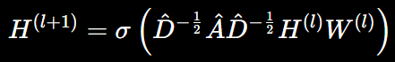

Structural Similarity and Local Feature-Based Verification
Structural verification provides a complementary approach to semantic reasoning by analyzing the visual content of corresponding observations directly. While semantic analysis determines whether the objects and relationships within a scene are consistent, structural analysis examines whether the visual organization of the scene has changed. This distinction is important because certain manipulations may alter the appearance of a region without necessarily changing the detected object categories or their spatial relationships.
The Structural Similarity Index (SSIM) is a commonly used measure for evaluating structural similarity between two images. Rather than comparing pixels independently, SSIM considers local luminance, contrast, and structural information. For two image regions $x$and $y$, the structural similarity can be expressed as
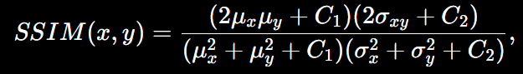
where $μ_{x}$and μy are local means, \(\sigma_x^2\) and \(\sigma_y^2\) are local variances, \(\sigma_{xy}\) is the covariance of the two regions, and \(C_1\) and \(C_2\) are constants used for stabilization. Larger SSIM value indicates more structural similarity while smaller SSIM value indicates structural difference. ReScene algorithm makes use of SSIM for finding regions with low structural similarity between stable frames.
ORB (oriented FAST and rotated BRIEF) is utilized in ReScene in order to perform verification of detected regions using the local features. The idea behind ORB is extraction of the unique local keypoints and descriptors which can be compared in different frames. It gives additional information about the fact whether the structures that were observed in the reference frame can also be observed in the revisit frame. Thus, in the proposed method, the regions with low structural similarity are further checked by means of ORB feature matching.

Adaptive Evidence Fusion for Video Forgery Detection
However, using multiple forensic cues can solve the problem of using a single source of evidence. The use of semantic analysis will reveal any discrepancies with respect to the objects and their spatial relationships within the scene, while the structural analysis will reveal any visual discrepancies that are not captured in the semantic analysis. Therefore, the two types of forensic cues can complement each other in video forgery detection by revisiting videos.

In ReScene, the output of the semantic pathway is the normalized confidence level \(S_{\mathrm{sem}} \in[0,1]\) based on how much semantic discrepancy is found using the MemoryGCN. The semantic confidence is determined through changes in the objects and their spatial relationships in the scene memory. Higher semantic confidence implies more discrepancies in the semantic configuration between the revisit scene and its corresponding reference.
Simultaneously, the structural verification path generates a confidence score \(S_{\mathrm{struct}}\in[0,1]\), which is generated from the comparison of the reference and query stable frame structures using SSIM and then further verified using the ORB features. The larger value shows more evidence of structural inconsistency between the observations. As the pathway works directly with the image data without detecting any objects, it could generate the evidence of visual modification without having this change reflected in the scene graph.
The combination of the two confidence scores takes place through the use of the adaptive decision fusion approach. In the particular formulation described, the tampering confidence is defined as
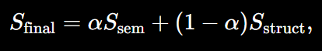
where \(S_{\mathrm{sem}}\) is the semantic inconsistency score, \(S_{\mathrm{struct}}\) is the structural inconsistency score, and \(\alpha\) controls the weight of the semantic pathway. Such an approach makes it possible to make use of the evidence from both pathways in the final decision making process.

Identified research gap
From the review of literature, it is evident that forgery detection techniques have evolved from the initial lower-level forensic approach to deep learning, temporal modeling, semantic reasoning, structural verification, and graph based approaches. However, all these techniques have been developed independently with regards to each aspect of video forgery. The current deep learning models consider either visual artifacts or temporal artifacts. In case of semantic approach, all the relationships between significant regions are considered. In structural model, visual inconsistencies are detected but it doesn’t mean that the semantic relevance is established.

Low-Level and Appearance-Centric Detection
A substantial amount of work on forgery detection in video forgery literature focuses on the presence of visual artifacts in individual frames or a sequence of frames. Appearance-based methods using CNNs, attention mechanisms, Fourier transforms, and transformers learn representations that can recognize traces of manipulation [11]–[15], [20], [25], [28], [29]. Temporal methods leverage inconsistencies between frames [32], [36], [43], [45]–[50]. Although such methods may offer powerful forensic clues, the main representation used by these methods is appearance-based.
An appearance-based representation does not include information about the semantic structure of the real-world scene. This implies that although a system can detect visual inconsistencies, it cannot determine the specific action performed, namely whether an object is added, deleted, substituted, moved, or incorrectly positioned.

Limited Scene-Level Relational Reasoning
The research findings on relational information show that relations between visual elements can serve as an effective clue in forensic studies. Local Relation Learning [16], Learning Self-Consistency [18], Semantic Contextualization of Face Forgery [22], and AUNet [23] utilize relations and/or contextual dependencies in detecting the image forgery. However, the above-mentioned techniques are mainly applied to facial images and local semantics.
In terms of a generic physical scene, the relation between different objects is considered as significant contextual clue. Objects cannot always be assessed separately since their location and interaction with the objects nearby are needed in order to understand the scene as a whole. Thus, the literature creates a gap in scene-level relational reasoning for revisit-based forgery detection problem.

Absence of Persistent Scene Memory
Traditional video manipulation techniques consider either frames or temporal sequences to be an observation of the current video. However, a revisit technique demands comparison between a past observation of a reference scene and another observation of the same environment. Variations in the viewing angle, lighting, camera placement, and partial occlusion can make the frame-wise comparison less reliable.
The surveyed literature offers the basis for semantic consistency and relational analysis [16], [18], [22], [23], but not for the persistent memory model to remember object appearance, relation frequency, and contextual co-occurrences over the entire reference video. ReScene fills this gap with the Scene Memory Model that retains semantic consistency over observations and offers contextual information for the revisit analysis.

Separation Between Semantic and Structural Evidence
The structural methods like frame similarity, duplication detection, optical flow, motion feature, and inter-frame residual [38]–[50] offer some insight into the visual change. But the structural difference does not imply any semantic modification. In turn, semantic analysis cannot identify any manipulations, preserving object category and spatial arrangement but changing its visual appearance.
It is evident from the literature that both types of evidence should be analyzed together. ReScene solves this problem using the parallel semantic and structural paths. The former analyzes the scene graph and MemoryGCN. The latter analyzes SSIM and ORB for corresponding stable frames.

Limited Focus on Revisit-Based Scene Forgery
The other limitation is the problem formulation itself. The majority of works on deepfakes deal with the problem of detecting whether the video/image under examination has been manipulated, in particular, its facial images [1] – [30]. Other papers are concerned with detecting inconsistencies in time, duplication, motions and structural alterations in videos [31] - [50]. All these papers do not formulate forgery detection as a problem of reference versus revisit scene consistency.
However, ReScene sees the reference video as the source of expected scene semantics and checks the revisit observation against that semantics. Changes to be detected in the scene under examination include additions and removal of objects, replacement, motion of objects, and spatial relationships modification. This problem formulation moves the task from manipulation detection to the scene integrity violation detection.

Positioning of ReScene
Taking into consideration the above shortcomings, ReScene can thus be considered a hybrid video forgery detection system based on revisits which bridges semantic scene understanding and independent structural verification. The semantic path generates scene graphs through detected objects and employs scene memory that is kept in MemoryGCN for context reasoning. Meanwhile, the structural path employs SSIM and ORB for visual change verification, while adaptive confidence fusion merges both types of evidences.
Hence, the research gap that ReScene tries to fill can be considered as follows: There has been no existing system which integrates semantic scene-level memory and structural visual verification for the detection of semantic and structural changes between reference and revisit videos.

Limitations
While there has been much advancement made in the area of detecting forged videos using the available methods, the research shows that there are certain limitations associated with such methods in the case of revisit-based scene forgery detection. It is important to note that the limitations in question do not relate to any flaws of the methods as applied to their intended purposes.

Limitations of Appearance-Based Deep Learning Approaches
DL models that utilize CNNs, attention, frequency and transformers have been shown to be capable of learning manipulation-sensitive visual features [11]–[15], [20], [25], [28], [29]. Nevertheless, such DL methods mainly learn visual appearance and manipulation-related visual cues.
These representations do not carry information about the semantic structure of the physical environment. Thus, they might recognize changes in the region but do not represent whether an object is added, deleted, substituted or moved. Moreover, the performance of such representations depends on the type of manipulations and data distribution encountered during the training. Such issues are also addressed in generalization studies [61]–[67].
This issue motivated using a semantic pathway for ReScene in which the objects and their spatial arrangement would be represented instead of pixel-level learned features only.

Limitations of Facial Forgery Detection Approaches
The review of relevant literature reveals a number of works dedicated to the problem of facial forgery detection. Methods of FaceForensics++, DFDC, Celeb-DF, DeeperForensics-1.0, WildDeepfake, KoDF, among others, have been developed for investigating the problem of manipulated video [1]–[10]. There are other methods that analyze facial regions, action units, lip synchronization, and the relationship of the face context [16], [19], [22], [23].
On the other hand, facial representations cannot be directly applied to the environment, which may include such objects as pieces of furniture, electronics, containers, etc. Relationships of a physical environment differ from facial region dependencies. This is why, ReScene applies semantic reasoning to objects in a physical environment and their relationships.

Limitations of Temporal Forgery Detection Approaches
The temporal approaches explore the temporal inconsistencies present throughout the frames and have looked into temporal dynamics, temporal repetitions, frame duplication, scene change, optical flow, motion blur, and inter-frame residuals [32], [36]-[50]. These techniques will be very helpful to detect any anomaly which may show up over time.
But temporal consistency does not necessarily indicate the semantic state of the physical world. The video may still be temporally consistent even after the deliberate addition or deletion of an object from the video scene, as long as the modification is done consistently over the frames that were manipulated. On the other hand, normal camera movement or perspective change can create inconsistencies without indicating any forgery.
ReScene resolves this problem through semantic consistency analysis of the reference scene and the revisit scene.

Limitations of Structural and Similarity-Based Approaches
Structural comparison methods can identify differences between corresponding visual observations, while frame similarity and duplication approaches provide useful evidence for detecting visual alterations [38]–[42]. SSIM and local feature correspondence can similarly identify regions where structural information has changed. The primary limitation is that structural difference does not automatically indicate semantic manipulation. Changes in illumination, viewpoint, camera positioning, or appearance can produce structural differences even when the underlying scene remains unchanged. Conversely, a manipulation may preserve much of the overall structure while changing the semantic identity or position of a particular object. Therefore, structural evidence requires contextual interpretation. ReScene uses SSIM and ORB as an independent verification pathway rather than treating structural difference alone as definitive evidence.

Limitations of Semantic and Relational Approaches
Techniques that include both the semantic and relational contexts show that relationships among relevant regions could enhance forgery detection techniques [16], [18], [22], [23]. Yet, the examined techniques are primarily concerned with regions related to the face or other local semantic dependencies.
In the case of a real-life scene, there is a need to make reasoning about several object classes and their relationships. In addition, even a single frame would contain only a partial observation of the scene. Without the ability to keep any persistent memory, the system will be unable to naturally collect knowledge about various objects and relationships.
ReScene solves this problem via its Scene Memory.

Limitations of Conventional Graph-Based Analysis
Graph representation is an appropriate way of representing relationships among objects and GCN can facilitate information propagation among connected vertices. However, a graph created from a single frame depicts the information of the scene in just that frame alone.
In case of forgery detection based on revisits, the requirement is that of information which exists not only in one but many frames. Transient absence of object, partial object visibility, and change in viewpoints can result in an incomplete representation of the scene. Hence, ReScene uses Scene Memory and MemoryGCN on top of graph representation.

CHAPTER 3

Methodology

Hardware Requirements
CPU Intel i5 (8th Gen or newer) / AMD Ryzen 5 or equivalent
RAM 8 GB (16 GB recommended for smooth experience)
GPU Optional (CPU-only inference works, but slower). A basic NVIDIA GPU (e.g., GTX 1050 Ti, 1650, or RTX 3050) is helpful for speed. (if want to use a GPU for training instead of CPU have at least 6 GB Graphics card of NVIDIA RTX).
Storage At least 10 GB free (for Python, PyTorch, YOLOv8 weights, and data)
OS Windows 10/11, Ubuntu 18.04+/22.04+, macOS (limited CUDA support)
Camera Standard RGB camera (smartphone camera or webcam)

Software Requirements
Operating System Windows / Linux / macOS
Language Python 3.8 or above
Environment Google Colab or local Python environment
FrameWork COLMAP (for Structure-from-Motion)

Required python libraries and frameworks
Python Libraries
- NumPy (numerical computation)
- OpenCV (frame extraction and processing)
- Pandas (data handling and CSV storage)
- Matplotlib (visualization)
- Ultralytics YOLOv8
- PyTorch (deep learning backend)
- SciPy (mathematical operations)
- JSON (semantic memory storage)

Tools and technologies
The presented ReScene framework utilizes different methods of computer vision, deep learning, graph-based learning, and image processing in order to detect video forgery both semantically and structurally. All the mentioned instruments are selected depending on their functionality, compatibility, reproducibility, and integration into open-source environments. All of the instruments are used to facilitate the stages of the framework, which include video and image processing, object detection, creation of the scene graph, graph-based semantic reasoning, numerical computation, and visualization of the experimental results. The Python programming language is the basis of the implementation of the instrumentations, while PyTorch and PyTorch Geometric serve as the deep-learning and graph neural network environments, respectively. Semantic object detection is performed with the help of YOLOv8n, while video processing and structural analysis is performed with the help of OpenCV. NumPy provides the necessary functionality of numerical computation, while Matplotlib allows visualizing experimental results. The integration of the above-listed instruments ensures modular and reproducible implementation of the framework. The below paragraphs will provide detailed descriptions of all the tools utilized.

OpenCV
The Open Source Computer Vision Library (OpenCV) is employed as the computer vision and image processing library in the proposed ReScene framework. OpenCV processes video frames required for the forgery detection pipeline. In particular, OpenCV is employed to extract frames, select stable frames, preprocess images, and verify the structure between corresponding observations.
In the structural verification pathway, OpenCV is used to compute the Structural Similarity Index (SSIM) between the reference and revisit frames and to extract and match ORB features in areas that show structural dissimilarity. This provides local visual evidence to support the semantic information extracted from the scene-graph pathway. OpenCV is thus one of the key components for handling the image and video processing operations in ReScene.
The usage of OpenCV also facilitates the modularity of the framework since video processing, feature extraction, and structural comparison are all possible in one open-source computer vision library. This allows the structural verification branch to function independently from the object-detection branch according to the hybrid architecture proposed.

Scene Graph Construction and Semantic Analysis
The process of semantic analysis represents the main reasoning part of the proposed ReScene model. This phase aims at turning the observations of the visual nature that have been made during watching the reference and revisit videos into the structured description of the objects and their spatial relations. Rather than detecting the objects separately, the proposed method creates the graph, where the nodes represent the objects, and the edges represent their spatial relations.
YOLOv8n detector is used for each selected frame to detect the objects existing in the scene. Every detected object is converted into a node of the scene graph. Next, spatial relations between the detected objects are computed based on their positions in the frame. The spatial relations taken into account in the proposed framework include LEFT_OF, RIGHT_OF, ABOVE, BELOW, and NEAR. Thus, the scene graph can be presented as
G = (V, E)
where V is the set of objects detected and E is the set of spatial relations between them. This kind of representation helps the system capture not just the presence of the objects, but also their arrangement.
The scene graphs derived from the reference video are stored in a Scene Memory. The memory contains the repeated appearances of the objects, relations, and contextual associations noted in the reference video. Therefore, the semantic representation is not confined to a single snapshot, but is built on the information gained from the entire video.
The resulting scene representation is then processed via MemoryGCN, which is built on top of a Graph Convolutional Network. The graph convolution process involves exchanging information among adjacent nodes, thereby enabling the object representation to have context information from neighboring nodes. The two-layer GCN adopted in this framework can be expressed as
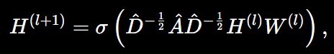
Thus, the scene-graph construction and semantic-analysis stage enables ReScene to detect changes at the object and relationship levels, including object addition, deletion, replacement, movement, and modification of spatial relationships. It provides the semantic component of the framework, while the independent structural pathway supplies complementary visual evidence.

YOLOv8 and Pytorch
The YOLOv8 is utilized as the object-detection module in the semantic pathway. The realization of the semantic pathway is done using the lightweight YOLOv8n object detection model.
This model outputs the object detection results, including the class and spatial information for each object. They are further utilized to generate the scene graph.
For instance, suppose there is a person, a car, and a table in a frame. In that case, these objects can be considered as nodes in the graph while the edges will represent their spatial relationships.
The significance of YOLOv8 usage lies in the fact that the semantic pathway needs to comprehend the entities within the scene before making any inference on their relations.
Nevertheless, the object detection process brings a limitation into consideration. This is because the semantic pathway relies on the classes that the detector recognizes. Hence, in case an entity is poorly described by the classes available in the detector, the semantic pathway will have insufficient evidence. This is one of the motivations behind having an independent structural pathway.
PyTorch is the deep-learning framework for the semantic model. It provides such functionality as model training, tensor operations, optimization, and GPU support.
MemoryGCN is trained through Adam optimization with a learning rate of \(1 \times 10^{-3}\) and a batch size of 32. Dropout and early stopping are also applied to prevent overfitting.

PyTorch Geometric and Graph Convolutional Networks
PyTorch Geometric is the framework used for the graph-learning part of ReScene.
In contrast with a traditional image classification algorithm, a graph neural network can explicitly capture the relations between entities. This suits the problem of revisit scene analysis since the identity of the entity might stay the same but the relations between objects might have changed.
The graph representation of a scene graph looks as follows:
\[
G=(V,E)
\]
Here, \(V\) stands for the objects that were detected and \(E\) stands for the relations between them.
A two-layered Graph Convolutional Network is implemented in the methodology proposed. The graph convolution is calculated using the following formula:
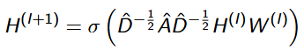
In this case, A = A + I is the adjacency matrix with self-loops D is the degree matrix, W(l) stands for the trainable weights, and \(\sigma\) is the activation function.
The graph convolution enables passing the information from the neighboring objects. Hence, the model is able to consider the contextual relations instead of looking at each detected object separately.

Scene Graphs and Scene Memory
Scene graphs contain the semantic representation that has been suggested by the proposed system. Each detected object is considered a node, while spatial relationships, like left-of, right-of, above, below, and near, become edges.
The benefit of the representation is that it contains the context of the scene. For instance, one can consider the reference scene where there is a person standing near a vehicle. In the case of a revisitation, the person and the vehicle will be detected as well. However, if the vehicle has moved much since that time, the labels of the objects have not changed, yet the relationship between them has altered. The scene graph is capable of representing this change. The proposed Scene Memory goes even further by considering several frames at once. Rather than looking at each frame individually, the system accumulates object appearances, relationship frequency, and contextual co-occurrence for the entire reference video. The Scene Memory representation provided in Figure 1 from the research paper gives an example of how it works. While the memory graph contains the most common objects and their relations, the relationship analysis focuses on frequent pairs of objects.

Google Colab
Google Colab provides a cloud-based execution environment that facilitates the execution of the entire pipeline without the need to install complex local environments. Google Colab provides support for the execution of the pipeline using the GPU, which facilitates the faster execution of object detection and numerical computation tasks. Google Colab provides support to integrate various Python libraries such as OpenCV, PyTorch, NumPy, and Pandas in the environment. Google Colab provides support to store the environment using Google Drive. This makes the system reproducible and easily shareable with team members. Google Colab’s notebook-based organization system helps to document each step of the pipeline. It is very useful for experimenting and testing with different video inputs. Using a cloud-based environment makes the project accessible even without high-end local hardware. This improves the scalability and feasibility of the proposed approach.

JSON and CSV Storage
The spatio-semantic memory representation produced by the suggested framework is methodically stored and managed using JSON and CSV formats. For expressing structured and hierarchical object-level data in a format that is both machine-interpretable and readable by humans, JSON is especially well-suited. The dimensions of bounding boxes, the reference of the associated camera pose, the index of the frame, 3D world coordinates, the object label, the object ID, and the object confidence score are all present in the detected object. It is through this data structure that efficient object retrieval, updating, and consistency tracking are facilitated. Another advantage of JSON is that, through extensibility, additional metadata such as time, relationships, and persistence scores can be incorporated into the data structure without affecting the overall schema.
Simultaneously, structured numerical parameters needed for quantitative analysis and evaluation are stored in CSV files. These consist of triangulated point coordinates, projected object centroids, translation vectors, rotation matrices, reprojection error values, and intrinsic and extrinsic camera parameters. Simple integration with data analysis tools like MATLAB, Python, or spreadsheet-based statistical software is made possible by CSV storage. The dual-format storage approach supports the proposed system's future scalability, validation, and reproducibility by guaranteeing both structured semantic representation and effective numerical evaluation.

Proposed method
The proposed approach is expected to provide semantic three-dimensional understanding of a scene solely from monocular RGB video input. The approach combines geometric reconstruction and semantic object detection in an offline manner. Unlike conventional approaches, which concentrate solely on geometric or semantic reasoning, the proposed approach combines both to produce an approximate but informative spatial representation of a scene. The entire process is performed without the need for depth cameras, LiDAR, or stereo cameras, making it cost-effective and easily reproducible with conventional hardware.
The proposed method begins with video recording. The video is shot in monocular RGB format using a handheld or fixed camera. The video is first processed by decomposing it into individual frames at fixed intervals to ensure adequate coverage of the scene. Decomposing the video into frames at fixed intervals ensures that the computational process remains efficient while ensuring adequate overlap for accurate reconstruction. The obtained frames are stored sequentially and are ready for later synchronization with the results of pose and detection. The next step of the proposed method is the geometric reconstruction step. In this step, Structure from Motion (SfM) is applied using the COLMAP pipeline to calculate the camera poses. The method applies feature detection using the scale-invariant feature transform algorithm, and then feature matching is applied between consecutive frames. The feature correspondences are then used to calculate the relative camera motion between frames. The incremental reconstruction and bundle adjustment are applied to refine the rotation and translation variables of the camera pose. The result of this step is a sparse 3D point cloud and a correct camera pose. The final step of the proposed method is the object detection step. In this step, object detection is applied using a pre-trained object detection model on images of the object obtained from the video frames and stored in a buffer. The result of this step is object detection results and a buffer of images of the object. trajectory that captures the motion of the camera throughout the video sequence.
Finally, after the estimation of the camera pose, the semantic object detection is carried out on the extracted frames using the YOLOv8 model. The object detection model processes the entire image at once and gives the coordinates of the bounding box, class, and confidence level of the detected object. However, the results are discarded based on the confidence level, which should be below a threshold.
The most critical component of the integration process is the mapping of 2D object detection into 3D space. For this, the center of the bounding box is chosen as the representative pixel location. Based on the intrinsic camera parameters and extrinsic pose, the projection ray is calculated from the camera center through the image plane into 3D space. Since there is no absolute depth information in the monocular video, the system assumes that the detected objects are on the reference plane, i.e., the floor plane.
This 2D-3D mapping process is carried out on all detected objects. When an object is detected in multiple frames, multiple 3D positions are calculated. To improve stability, spatial averaging or clustering can be used to eliminate noise and avoid dispersion. When dealing with static objects, the spatial deviation is expected to be minimal, while small or partially occluded objects are expected to have high spatial deviation.
The calculated 3D object coordinates are stored in a structured spatio-semantic memory. The structured memory representation stores information regarding the object label, the 3D prediction, the confidence, and the frame number. scene-level reasoning, in which queries about the locations of objects and their spatial relationships are supported. For example, the system can determine the object closest to the camera, compute the distance between objects, or determine objects on a particular side of the scene.
To support spatial reasoning, Euclidean distance calculations are carried out on the saved 3D coordinates.
The distance calculations facilitate the system to reason about object proximity relationships. Positioning information with respect to the X, Y, and Z axes offers further semantic insights into object location.
The complete pipeline is designed to run offline, emphasizing accurate reconstruction over real-time processing. The offline processing enables more accurate feature matching, better bundle adjustment, and robustness to motion blur or unstable camera motion. While real-time processing is not emphasized, the modular nature of the system enables possible adaptation to near real-time systems in the future.
One of the major advantages of the proposed method is that it is hardware-independent. Unlike semantic SLAM approaches that use RGB-D cameras, the proposed framework only needs a single RGB camera. This makes the proposed framework much more affordable and accessible. Moreover, the use of open-source tools ensures that the proposed framework is reproducible and scalable.
In conclusion, the proposed method involves a multi-step process that includes frame extraction, camera pose estimation, semantic object detection, 2D to 3D projection, spatial memory creation, and spatial reasoning. By combining geometric reconstruction with semantic reconstruction in a single framework, the proposed method closes the gap between traditional 3D reconstruction and modern deep learning-based object recognition. Even though the 3D localization is not accurate because of monocular depth ambiguity, the proposed method is able to successfully create a meaningful representation of the scene.

Frame Extraction
Given an input video $V$, it is decomposed into a sequence of frames
V → {I₁, I₂, I₃, …, Iₙ}
where Iᵢ represents the i-th extracted RGB frame.
Frames are sampled at fixed intervals to ensure overlap for reconstruction while maintaining computational efficiency.

Camera Pose Estimation (Structure-from-Motion)
For each frame Iᵢ, the camera pose is represented by
Pᵢ = [Rᵢ | tᵢ]
where
- Rᵢ∈SO(3) is the rotation matrix
- tᵢ∈ℝ³ is the translation vector
Feature correspondences across frames are used to estimate relative motion. Bundle adjustment minimizes reprojection error
min ∑ || π(Rᵢ Xⱼ + tᵢ) − xᵢⱼ ||²
where
- Xⱼ is a 3D point
- xᵢⱼ is its observed 2D projection
- π(.) is the projection function
This optimization refines camera poses and 3D structure simultaneously.
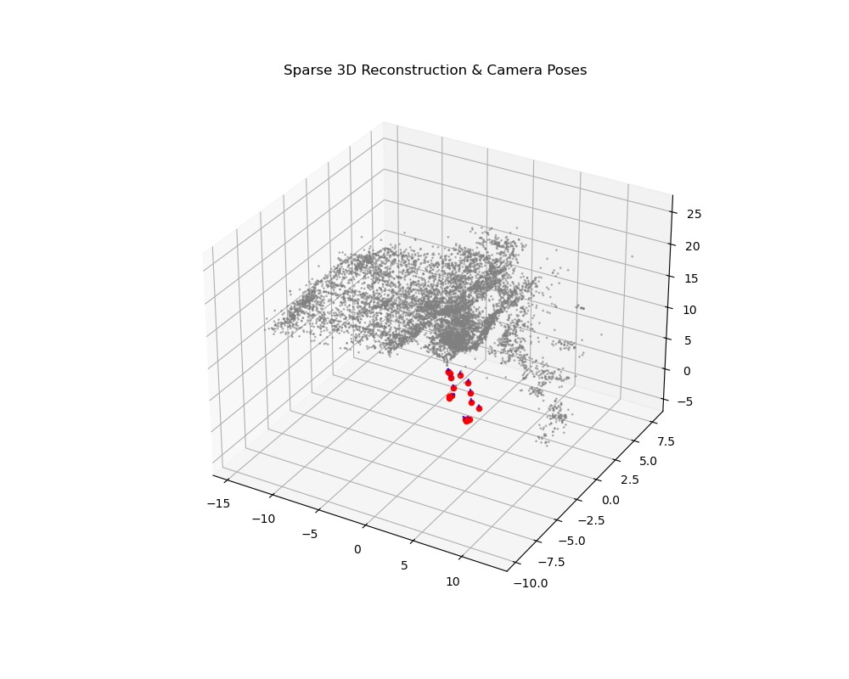
Figure 2 Sparse 3D reconstruction with estimated camera centers.

Semantic Object Detection
For each frame Iᵢ, YOLOv8 outputs
Dᵢ = {(bₖ, cₖ, sₖ)}
where
- bₖ = bounding box coordinates
- cₖ = object class
- sₖ = confidence score
Only detections above threshold τ are retained
Keep bₖ if sₖ> τ
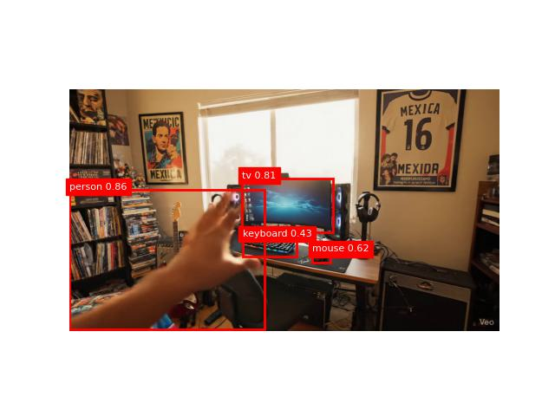
Figure 3 Frame-wise semantic object detection using YOLOv8. Only detections

2D-to-3D Object Localization
Let u = (u, v, 1)ᵀ be the homogeneous coordinates of the bounding box center.
Using camera intrinsic matrix K
rᵢ = Rᵢ⁻¹ K⁻¹ u
This gives the projection ray in world coordinates.
The 3D object position is estimated as
Xₖ = Cᵢ + λ rᵢ
where
- Cᵢ = camera center
- λ = scalar depth parameter
If assuming a ground plane (Z = 0), λ can be computed using plane intersection constraints.
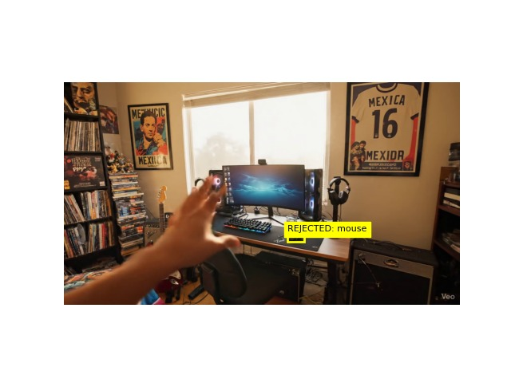
Figure 4 Geometric validation during 2D-to-3D object localization. Detected objects are projected into reconstructed space using camera intrinsics and estimated poses.

Spatio-sematic Memory Representation
Each object is stored as
M = {(cₖ, Xₖ, sₖ, i)}
where
- cₖ = object class
- Xₖ = estimated 3D position
- sₖ = confidence
- i = frame index
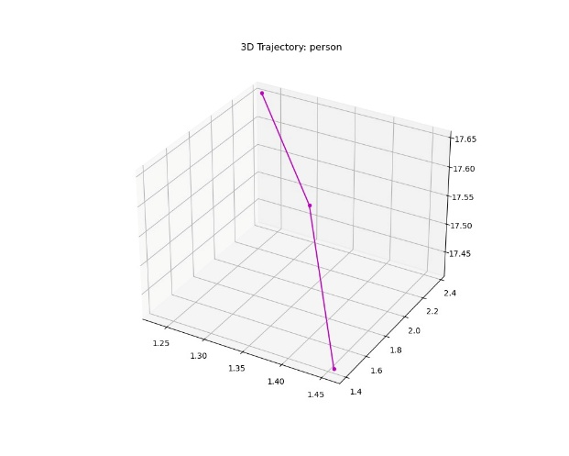
Figure 5 Object centroids in 3D

Spatial Reasoning
Distance between two objects
d(oᵢ, oⱼ) = ||Xᵢ − Xⱼ||
Relative position is determined by comparing coordinate axes
- Left/Right → X-axis comparison
- Front/Back → Z-axis comparison
- Height → Y-axis comparison

Work Flow of the System
Figure. 2 shows the general architecture of the suggested framework. The system combines structured spatial reasoning, semantic detection, and geometric reconstruction into a single monocular pipeline.
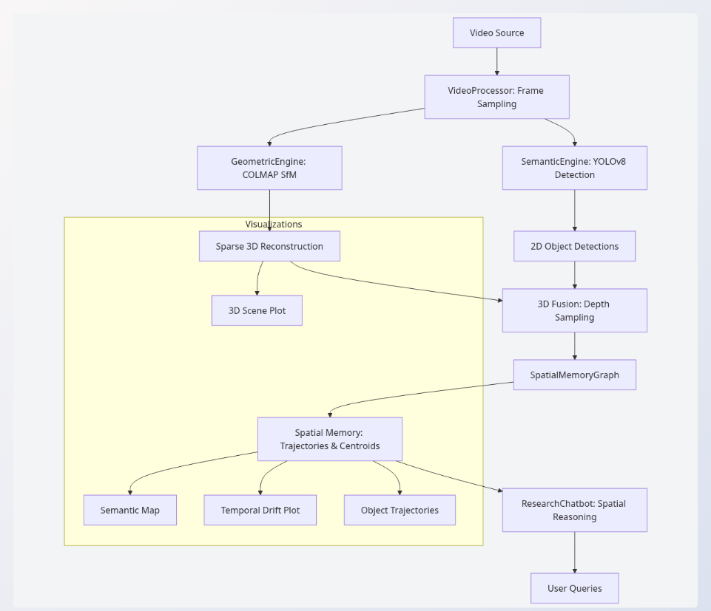
Figure 6. Work flow of the System

Evaluation and metrics
The process starts with a regular RGB monocular camera capturing a video of the scene without requiring additional equipment such as a depth camera or LiDAR. The video is then split into individual frames at regular intervals, ensuring that each frame overlaps with its neighboring frames. This is a crucial step because it is vital for the entire process that each frame contains features that are also present in other frames, enabling the entire system to establish relationships between them. After obtaining each frame of the video, the entire process is divided into two separate branches geometric reconstruction and semantic understanding. For geometric reconstruction, the entire system makes use of COLMAP, which is a highly popular Structure-from-Motion (SfM) approach. The entire approach works by detecting features in each frame and then matching them with features in overlapping frames and determining camera positions using incremental reconstruction. The final result is a consistent 3D structure of the scene and an accurate camera trajectory.
Parallel to the geometric reconstruction process, a semantic analysis module is employed to process the frames and identify objects present in the scene. This is accomplished using YOLOv8, which is a real-time object detection model. This model can efficiently detect and recognize multiple objects present in the scene. For every frame, YOLOv8 is employed to detect objects, create bounding boxes around them, and assign class labels and confidence scores to these objects. After both geometric and semantic information is available, a fusion step is employed to fuse both types of information. The camera poses, computed using COLMAP, are employed to project the 2D center points of the bounding boxes around the detected objects into the 3D space. This effectively links the semantic information with the geometric information, providing a 3D representation of the objects in the scene. This information is stored in a structured spatio-semantic memory representation, which allows the system to reason about the spatial relationship between objects, such as their relative distances. The system is thus able to answer queries about the location of objects in the scene using only monocular video data, thus effectively demonstrating the fusion of geometric and semantic information without requiring any additional hardware.
Metric | Value
Total Localized Objects | 15
Mean Reprojection Error (MRE) | 0.8579 px
Temporal Drift (Average) | 0.3431 units/frame
Normalized Semantic Accuracy | 60.00%
Table 1 Evaluation Metric Table

CHAPTER 4

Results and Discussion

Experimental Setup
The system which was used for experimental run was a system with following specifications
CPU AMD RYZEN 7
RAM 16GB
STORAGE 1TB
GPU NVIDIA RTX 3050

Sparse 3D Reconstruction Quality
The accuracy and stability of the underlying geometric reconstruction play a critical role in the reliability of the proposed semantic concept. Consequently, prior to evaluating the performance of semantic fusion, we first evaluate the overall quality of the reconstructed sparse Structure-from-Motion (SfM) model that was achieved with the help of COLMAP.
Global bundle adjustment with retriangulation enabled, exhaustive feature matching, incremental mapping, as well as GPU-based SIFT feature extraction were used to complete the reconstruction. In the end, all frames that satisfied geometric consistency constraints were retained in the final model. Artificial or simulated augmentation was
never used
.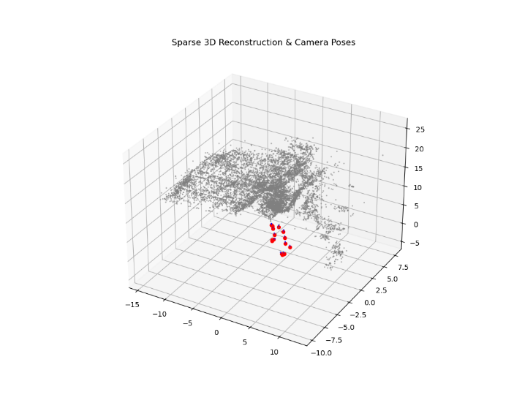
Figure 7 Sparse 3-D Reconstruction

Reprojection Error Analysis
The final bundle adjustment step produced the following
- The mean reprojection error (MRE) is 0.8579 pixels
A high level of geometric consistency between the 3D points and their 2D observations is indicated by a reprojection error of less than one pixel. This level of precision suggests that the scene structure and camera poses are well optimized.
The importance of keeping the reprojection error low is to ensure that 2D observations can be projected to 3D space, as this directly affects semantic object localization based on camera pose alignment.

Camera Trajectory Consistency
There are no sudden pose discontinuities in the reconstructed camera trajectory, which indicates smooth motion. The consistency of the incremental pose registration from one frame to the next for the full 3D and the top-down projected trajectory is demonstrated.
The stability of the trajectory confirms that
- The robustness of the feature matching procedure was sufficient.
- The pose drift accumulation was successfully reduced by the bundle adjustment.
- 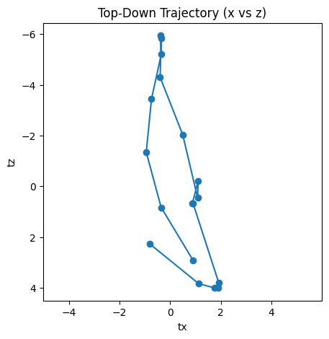
Figure 8 Top-Down Camera Trajectory
- For trustworthy triangulation, frame-to-frame overlap was sufficient.

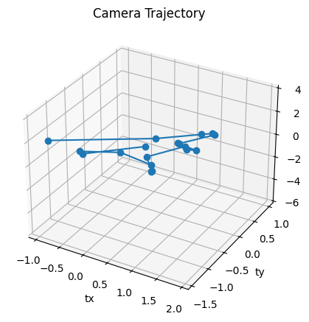
Figure 9 Camera Trajectory
Relative spatial consistency is maintained throughout the scene, despite the fact that monocular reconstruction leaves absolute scale unclear.

Sparse Point Cloud Structure
Structured scene geometry, high density in textured regions, and reduced density in regions of low texture are evident from the reconstructed sparse point cloud. The scene's indoor geometry, dominated by planar structures, matches the spatial distribution of 3D points.
Sparse reconstruction offers sufficient geometric points to confirm semantic detections but does not offer dense surface modeling. Semantic nodes are based on physically reconstructed geometry, as only triangulated points are used for object localization.

Depth Distribution Characteristics
Key insights into the geometric consistency of the reconstructed scene can be gleaned from the depth distribution of the triangulated 3D points. In the monocular SfM process, triangulation of the matched feature points from different video frames can be used to derive the depth values. We can thus evaluate the overall arrangement of the spatial information in the reconstructed scene by analyzing the depth values.
The major plane of the scene can be represented by the dominant clustering range of the observed depth values. Large structural elements like walls, floors, and tables dominate the overall field of view of the camera in most indoor environments. Hence, there will be a high density of feature points in this region because of the consistent planar structure. This represents a high degree of clustering in the observed depth values in this region. This indicates that the system can effectively preserve the consistent spatial relationship between different video frames.
There can be secondary clusters of depth values that represent different foreground objects at varying distances from the camera. This represents that the system can preserve meaningful spatial separation between different elements in the reconstructed scene by effectively differentiating between different elements.
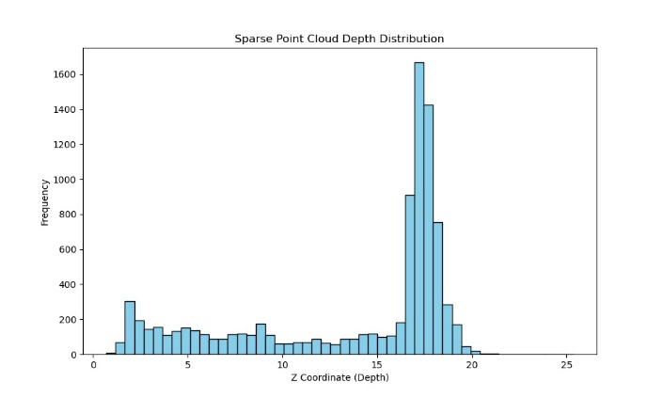
Figure 10 Sparse Point Cloud Depth Distribution
However, the reconstructed depth values are relative rather than absolute because of the intrinsic scale ambiguity of monocular SfM. The numerical depth values do not match actual metric measurements because the system estimates structure up to an unknown scale factor. Despite this drawback, the suggested framework's preservation of relative depth relationships is adequate for semantic object localization and spatial reasoning.

Frame Registration Statistics
The incremental mapper assessed each processed frame for successful registration. COLMAP automatically excluded frames that did not meet geometric consistency constraints As Shown in Figure.
The high success rate for registration indicates
- The input video has sufficient feature richness.
- controlled the movement of the camera.
- Accurate incremental pose estimation.
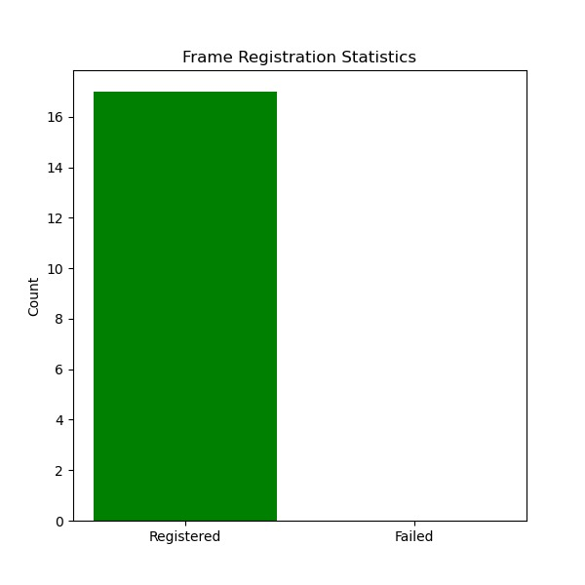
Figure 11 Frame Registration Statistics

Object detection and geometric filtering
The sparse reconstruction provides geometric consistency, but semantic understanding requires precise object detection. However, this 2D information is not sufficient to support spatial reasoning. This section will assess the object detection pipeline and the geometric filtering mechanism that follows to guarantee physically valid 3D localization.
A deep learning-based detector is utilized in the object detection stage to process each video frame obtained from the video sequence. The detector predicts the coordinates, labels, and confidence values associated with each video frame. The semantic information associated with the scene, such as furniture, electronics, and other objects visible in the scene, is obtained from the detector outputs. The stability of the detector over the video sequence is guaranteed by the robustness optimization of the detector under varying lighting and viewpoints. To reduce false alarms, low-confidence detections are removed, and high-confidence detections are retained.
However, to achieve structured 3D understanding, more is required than just 2D detection information. In fact, the detection information does not inherently account for camera movements, depth changes, and spatial consistency across frames because it is carried out in isolation in the 2D image space. This is where geometric filtering comes in.
The estimated camera poses and detection information in the reconstruction pipeline are combined in the geometric filtering step. Using the camera pose matrix and intrinsic camera parameters, the back-projection of each bounding box center in 3D space is carried out. Using ray projection, the approximate locations of the objects in the scene are estimated in the 3D coordinate space. This ensures that all detected objects are treated as spatial entities in the scene.

Frame-wise Object Detection Performance
The pre-trained YOLOv8n model is utilized for object detection in each of the video frames extracted. For each video frame Ii, a set of bounding boxes is produced by the object detector
𝐷𝑖 = {(𝑏𝑘, 𝑐𝑘, 𝑠𝑘)}
where 𝑏𝑘 stands for the bounding box coordinates, 𝑐𝑘 for the anticipated class label, and 𝑔𝑘 for the confidence score.
The object classes detected are people, chairs, beds, keyboards, mice, and books, which are commonly found indoors. Before geometric verification, the low-confidence object detection results are filtered out based on confidence thresholds.
The object detector consistently detects 2D semantics in all video frames. There are some unstable object detection results for small and possibly occluded objects in each video frame, as expected in indoor scenes.

2D-to-3D Geometric Validation
Each bounding box center is back-projected using the intrinsic matrix K and estimated pose $\left(R_{i} , t_{i}\right)$ in order to incorporate detections into the reconstructed 3D space. The viewing ray is calculated as follows
$$r_{i}=R_{i-1}K^{-1}u$$
The only detections that are kept are those that have adequate triangulated 3D support. A detection is approved if
A group of triangulated points is in line with its projection.
- In relation to the camera, points have positive depth.
- The threshold for geometric support is met.
- Rejected are detections that don't meet these requirements As showing in Figure 12.
Only items based on reconstructed geometry are allowed to contribute to the spatial memory graph thanks to this stringent filtering.
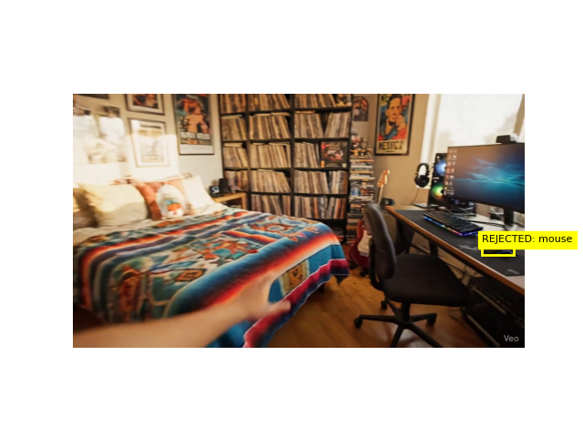
Figure 12 Demonstrates enforcement of geometric consistency.

Temporal Drift Analysis
Temporal consistency is still a crucial measure of spatial stability even though the suggested framework uses Structure-from-Motion to function offline. In order to evaluate geometric reliability over time, it is necessary to assess inter-frame positional stability because object centroids are estimated across multiple frames and aggregated into a spatial memory graph.

Definition of Temporal Drift
Let's use the following representation to show the 3D centroid of object O at frame t
$$Xt=\left(xt , yt , zt\right)$$
The Euclidean displacement between two successive observations is known as temporal drift
Δt​=∥Xt​−Xt−1​∥
The following formula is used to calculate the average temporal drift over a trajectory of length T
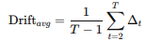
The cumulative geometric variation of an object's estimated centroid across frames is measured by this metric.

Quantitative Drift Results
The average temporal drift calculated for all objects tracked is
Average Temporal Drift = 0.3431 units per frame
The centroid displacement between successive observations is moderate, as indicated by this value.
The drift magnitude is consistent with expected relative pose estimation variations in sparse SfM pipelines, which is expected given that the reconstruction is monocular and subject to scale ambiguity as shown in figure 13.
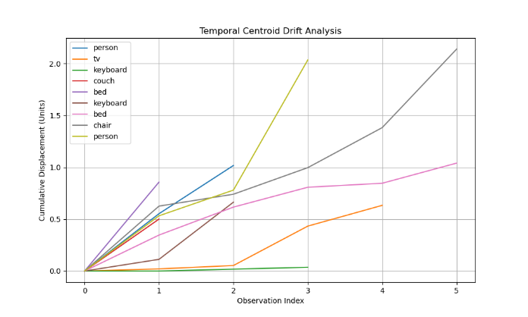
Figure 13 Temporal Drift

Model Execution
Frame extraction, camera pose estimation, semantic detection, and geometric fusion are all carried out successively by the suggested framework, which functions as an offline processing pipeline. The frames are then sampled at regular intervals from a monocular RGB video input at the start of the execution. Feature matching, triangulation, and bundle adjustment are employed using COLMAP to process these frames for Structure-from-Motion reconstruction, producing camera poses and a sparse 3D point cloud.
This is done frame by frame through object detection based on YOLOv8. Based on the camera parameter estimation, geometric consistency is evaluated for each object detected by projecting its center point onto a reconstructed coordinate space. To ensure spatial reliability, objects without sufficient triangulation of 3D information are discarded. The structured model of spatio-semantic memory is updated with 3D centroids of valid object detections.
Reconstructed 3D sparse geometry and camera paths, 3D object centroids within reconstructed scenes, and 2D semantic object detection overlays on video frames constitute the three major components of the output visualization. After geometric validation, object detection stability is reflected through execution output, where object localization is consistently maintained and object pose registration is stable against frame changes. Spatial coherence of object detection is ensured when supported by reconstructed geometry, as validated through model execution. Temporal stability of object centroids is analyzed through tracking, where displacement is calculated. Successful feature extraction, object pose registration, and bundle adjustment without simulated data augmentation are validated through console outputs during execution.

Accuracy And Performance Metrics
Semantic detection, spatial reasoning, and geometric reconstruction are all integrated in the suggested framework is shown in Table 2. As a result, evaluation needs to take into account three complementary factors
- Accuracy of Geometry
- Semantic Precision
- Performance at the System Level
Every metric presented is calculated solely using actual monocular video reconstruction, devoid of artificial augmentation.

Geometric Accuracy
Error via Mean Reprojection (MRE)
After global bundle adjustment, the mean reprojection error is used to assess geometric consistency.
MRE = 0.8579 pixels
Reprojection error quantifies the difference between reconstructed 3D points projected back onto the image plane and observed 2D feature points.
Frame Registration Success Rate
Frame registration stability is measured as
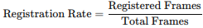

Semantic Accuracy
Structured spatial queries classified into the following categories were used for semantic evaluation
- Positive queries for object location
- Negative queries about the existence of objects
- Object-count inquiries
The definition of normalized semantic accuracy is
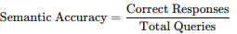
Observed value
Normalized Semantic Accuracy = 60.00%

Unified Performance Summary
Metric | Value
Total Localized Objects | 15
Mean Reprojection Error (MRE) | 0.8579 px
Temporal Drift (Average) | 0.3431 units/frame
Normalized Semantic Accuracy | 60.00%
Table 2 This multi-metric evaluation demonstrates that the proposed framework achieves

CHAPTER 5

Conclusion and Future Scope

Conclusion
One of the main problems in computer vision is still to comprehend a scene in three dimensions while also identifying its semantic elements. Conventional systems frequently distinguish between geometry and semantics, detecting objects without a spatial foundation or reconstructing structure without meaning. The creation of portable and user-friendly spatial reasoning systems is constrained by this division.
This work presented a unified monocular framework for understanding 3D semantic scenes. The proposed system will develop an approximate spatio-semantics memory representation based on geometric consistency using just the RGB video input with the help of YOLOv8 object detection and COLMAP Structure-from-Motion. It uses a single camera and does not require a LiDAR, depth, or stereo camera, unlike dense neural rendering or SLAM systems.
As the geometric reconstruction had an average reprojection error of 0.8579 pixels, the consistency of the camera pose estimation was evident, and the triangulated structures were reliable. Only those detections, which had been backed up by 3D points, were incorporated into the semantic memory graph through rigorous geometric filtering. Thus, there was no semantic hallucination, and spatial consistency was ensured. However, there was a compromise on the overall semantic coverage while ensuring geometric reliability and internal reasoning consistency. With an average drift of 0.3431 units per frame, the analysis of the temporal drift also showed bounded centroid variation. Thus, the object localization in the sequence was spatially consistent, despite the limitation of monocular scale ambiguity.
The results show that it is possible to leverage a lightweight and reproducible pipeline as a means of approximating semantic 3D understanding from monocular RGB video feeds. This paper attempts to build a bridge between traditional geometry and modern semantic perception in constrained settings, rather than competing with existing real-time SLAM systems and dense neural reconstruction approaches.
The paper essentially illustrates that complex neural volumetric approaches and costly sensors are not always a necessity for 3D semantic representations. For spatial reasoning systems, a structured approach to combining deep detection and traditional geometry provides a potentially useful and understandable framework.

Limitations of the proposed framework
Despite the encouraging outcomes of the suggested monocular semantic reconstruction framework, a number of limitations must be noted in order to preserve scientific openness.
- Ambiguity at the Monocular Scale
Because monocular Structure-from-Motion has inherent limitations, the system is unable to recover absolute metric scale. Instead of being metrically calibrated, all spatial relations continue to be relative.
- Dependency on Sparse Reconstruction
Sparse triangulated feature points are the foundation of the framework. There may not be enough geometric support for object grounding in areas with low texture, reflective surfaces, or homogeneous walls.
- Restricted Coverage of Semantics
Reliability is guaranteed by strict geometric filtering, but object recall is decreased. Semantic completeness is reduced by excluding detections that lack adequate 3D support.
- The Limitation of Offline Processing
The pipeline is not real-time at the moment. Semantic fusion and complete reconstruction necessitate post-processing, which restricts instant deployment in dynamic applications.
- Absence of a Loop Closure Mechanism
The framework does not include loop closure optimization, in contrast to SLAM systems. Over long trajectories, long sequences may accumulate inconsistencies.
- Camera Motion Sensitivity
Stability of reconstruction can be affected by unpredictable and/or abrupt movements of the camera.
- Restricted Management of Changing Objects
Most scenes used in the framework are static. Inconsistency can arise during centroid calculation and triangulation, especially when there are moving objects.
- Approximation of Depth Estimation
Precision of object localization is limited since sparse point association and ray projections are used, rather than dense depth maps.
- Limited Scene Size
This is especially true in terms of small indoor spaces. However, the performance of the system in multi-room spaces and outdoor spaces is untested.
- No-Dense Surface Modelling
Centroid-level approximations are stored, but there is no dense reconstruction, which does not allow the full representation of the extents and surfaces of the objects.

Future scope
For the advancement of lightweight semantic 3D reconstruction, the suggested system offers numerous research directions.
- Metric Scale Recovery
Scale ambiguity can be removed, and metric-level spatial reasoning can be enabled through the integration of monocular depth estimation.

- Dense Multi-View Stereo Integration
Integrating dense MVS reconstruction into the system can enhance geometric support for surface modeling and grounding.
- Real-Time Incremental Mapping
Semantic mapping for robotics can be enabled in near real-time through the development of an incremental online reconstruction module.
- Loop Closure Optimization
Long-term drift in extended trajectories can be reduced through the integration of pose graph optimization with loop detection.
- Temporal Filtering and Smoothing
Temporal smoothing, such as robust Kalman filter smoothing, can be used to minimize centroid variability between frames.
- Dynamic Object Segmentation
Dynamic scenes can be consistently handled through the integration of motion segmentation.
- Uncertainty-Aware Semantic Memory
Object localization can be enabled through the integration of probabilistic confidence models.
- Open-Vocabulary Detection
Open-vocabulary models can be used instead of fixed-category object detection, enabling dynamic semantic extension.
- Graph Neural Network-Based Spatial Reasoning
Beyond geometric spatial reasoning, relational spatial reasoning can be enabled through the extension of the spatial memory graph.
- Hybrid Geometry-Neural Reconstruction
Reconstruction density can be enhanced, while interpretability is preserved, through the integration of neural radiance fields with classical SfM.

References
[1] A. Rössler, D. Cozzolino, L. Verdoliva, C. Riess, J. Thies, and M. Nießner, "FaceForensics++: Learning to detect manipulated facial images," in Proc. IEEE/CVF Int. Conf. Comput. Vis. (ICCV), 2019, pp. 1–11.
[2] B. Dolhansky, R. Howes, B. Pflaum, N. Baram, and C. C. Ferrer, "The deepfake detection challenge (DFDC) preview dataset," arXiv:1910.08854, 2019.
[3] L. Jiang, R. Li, W. Wu, C. Qian, and C. C. Loy, "DeeperForensics-1.0: A large-scale dataset for real-world face forgery detection," in Proc. IEEE/CVF CVPR, 2020, pp. 2889–2898.
[4] Y. Li, P. Sun, H. Qi, and S. Lyu, "Celeb-DF: A large-scale challenging dataset for DeepFake forensics," in Proc. IEEE/CVF CVPR, Seattle, WA, USA, 2020, pp. 3207–3216.
[5] Y. He, B. Shao, Z. Yang, Y. Liu, B. Zou, B. Ye, and Y.-G. Jiang, "ForgeryNet: A versatile benchmark for comprehensive forgery analysis," in Proc. IEEE/CVF CVPR, 2021, pp. 4360–4369.
[6] B. Zi, M. Chang, J. Chen, X. Ma, and Y.-G. Jiang, "WildDeepfake: A challenging real-world dataset for deepfake detection," in Proc. 28th ACM Int. Conf. Multimedia, 2020, pp. 2382–2390.
[7] P. Kwon, J. You, G. Nam, S. Park, and G. Chae, "KoDF: A large-scale Korean DeepFake detection dataset," in Proc. IEEE/CVF ICCV, 2021, pp. 10744–10753.
[8] T. Wang, X. Liao, K. P. Chow, X. Lin, and Y. Wang, "Deepfake detection: A comprehensive survey from the reliability perspective," arXiv:2211.10881, 2022.
[9] G. Pei, J. Shen, C. Shen, Z. Ren, Z. Wang, and F. Lin, "Deepfake generation and detection: A benchmark and survey," arXiv:2403.17881, 2024.
[10] Z. Yan, Y. Zhang, X. Yuan, S. Lyu, and B. Wu, "DeepfakeBench: A comprehensive benchmark of deepfake detection," in Adv. Neural Inf. Process. Syst. (NeurIPS), Datasets and Benchmarks Track, 2023. arXiv:2307.01426.
[11] L. Li, J. Bao, T. Zhang, H. Yang, D. Chen, F. Wen, and B. Guo, "Face X-ray for more general face forgery detection," in Proc. IEEE/CVF CVPR, 2020, pp. 5001–5010.
[12] K. Shiohara and T. Yamasaki, "Detecting deepfakes with self-blended images," in Proc. IEEE/CVF CVPR, 2022, pp. 18720–18729.
[13] Y. Qian, G. Yin, L. Sheng, Z. Chen, and J. Shao, "Thinking in frequency: Face forgery detection by mining frequency-aware clues," in Proc. ECCV, 2020, pp. 86–103.
[14] H. Zhao, W. Zhou, D. Chen, T. Wei, W. Zhang, and N. Yu, "Multi-attentional deepfake detection," in Proc. IEEE/CVF CVPR, 2021, pp. 2185–2194.
[15] J. Chen, X. Ma, B. Zi, X. Hao, and Y.-G. Jiang, "Local relation learning for face forgery detection," in Proc. AAAI Conf. Artif. Intell., vol. 35, no. 2, 2021, pp. 1081–1088.
[16] C. Wang and W. Deng, "Representative forgery mining for fake face detection," in Proc. IEEE/CVF CVPR, 2021, pp. 14923–14932.
[17] T. Zhao, X. Xu, M. Xu, H. Ding, Y. Xiong, and W. Xia, "Learning self-consistency for deepfake detection," in Proc. IEEE/CVF ICCV, 2021, pp. 15023–15033.
[18] L. Chen, Y. Zhang, Y. Song, L. Liu, and J. Wang, "Self-supervised learning of adversarial example: Towards good generalizations for deepfake detection (SLADD)," in Proc. IEEE/CVF CVPR, 2022, pp. 18710–18719.
[19] W. Zhuang, Q. Chu, Z. Tan, Q. Liu, H. Yuan, C. Miao, Z. Luo, and N. Yu, "UIA-ViT: Unsupervised inconsistency-aware method based on vision transformer for face forgery detection," in Proc. ECCV, 2022, doi: 10.1007/978-3-031-20065-6_23.
[20] Z. Wang, J. Bao, W. Zhou, C. Wang, D. Chen, and N. Yu, "AltFreezing for more general video face forgery detection," in Proc. IEEE/CVF CVPR, 2023, pp. 4129–4138.
[21] H. Liu, X. Li, W. Zhou, Y. Chen, Y. He, H. Xue, W. Zhang, and N. Yu, "Spatial-phase shallow learning: Rethinking face forgery detection in frequency domain," in Proc. IEEE/CVF CVPR, 2021, pp. 772–781.
[22] Y. Luo, Y. Zhang, J. Yan, and W. Liu, "Generalizing face forgery detection with high-frequency features," in Proc. IEEE/CVF CVPR, 2021, pp. 16317–16326.
[23] Y. Dong, L. Bao, C. Chen, and H. Ling, "An information theoretic approach for attention-driven face forgery detection," in Proc. ECCV, 2022, pp. 605–621.
[24] Q. Gu, S. Chen, T. Yao, X. Chen, J. Ding, and R. Yi, "Implicit identity driven deepfake face swapping detection," in Proc. IEEE/CVF CVPR, 2023, pp. 4490–4499.
[25] Z. Wang, Z. Huang, J. Bao, W. Zhou, C. Wang, and N. Yu, "Transcending forgery specificity with latent space augmentation for generalizable deepfake detection," in Proc. IEEE/CVF CVPR, 2024, pp. 27863–27872.
[26] Y. Nirkin, L. Wolf, Y. Keller, and T. Hassner, "Deepfake detection based on discrepancies between faces and their context," IEEE Trans. Pattern Anal. Mach. Intell., vol. 44, no. 10, pp. 6111–6121, 2021.
[27] M. H. S. Zaidi, M. H. Yousaf, S. S. A. Zaidi, and N. M. Noor, "A timely survey on vision transformer for deepfake detection," arXiv:2405.08463, 2024.
[28] A. Khormali and J.-S. Yuan, "Self-supervised graph transformer for deepfake detection," arXiv:2307.15019, 2023.
[29] Y. Liu, B. Zi, M. Chang, and Y.-G. Jiang, "FSBI: Deepfakes detection with frequency enhanced self-blended images," arXiv:2406.08625, 2024.
[30] C. Zhang, Y. Wang, Z. Wu, and X. Lin, "Suppressing gradient conflict for generalizable deepfake detection," arXiv:2507.21530, 2025.
[31] U. A. Ciftci, I. Demir, and L. Yin, "FakeCatcher: Detection of synthetic portrait videos using biological signals," IEEE Trans. Pattern Anal. Mach. Intell., vol. 44, no. 11, pp. 8000–8016, 2020.
[32] H. Qi, Q. Guo, F. Juefei-Xu, X. Xie, L. Ma, W. Feng, Y. Liu, and J. Zhao, "DeepRhythm: Exposing deepfakes with attentional visual heartbeat rhythms," in Proc. 28th ACM Int. Conf. Multimedia (MM), 2020, pp. 4318–4327.
[33] Y. Zheng, J. Bao, D. Chen, M. Zeng, and F. Wen, "Exploring temporal coherence for more general video face forgery detection," in Proc. IEEE/CVF ICCV, 2021, pp. 15044–15054.
[34] A. Haliassos, K. Vougioukas, S. Petridis, and M. Pantic, "Lips don't lie: A generalisable and robust approach to face forgery detection," in Proc. IEEE/CVF CVPR, 2021, pp. 5039–5049.
[35] Y. Xu, J. Liang, L. Sheng, and X.-Y. Zhang, "Learning spatiotemporal inconsistency via thumbnail layout for face deepfake detection," arXiv:2403.10261, 2024.
[36] D. Nguyen, M. Astrid, A. Kacem, E. Ghorbel, and D. Aouada, "Vulnerability-aware spatio-temporal learning for generalizable deepfake video detection," in Proc. IEEE/CVF Int. Conf. Comput. Vis. (ICCV), 2025, pp. 10786–10796.
[37] Z. Gu, T. Yao, Y. Chen, R. Yi, S. Ding, and L. Ma, "Region-aware temporal inconsistency learning for DeepFake video detection," in Proc. 31st Int. Joint Conf. Artif. Intell. (IJCAI), 2022, pp. 920–926, doi: 10.24963/ijcai.2022/129.
[38] C. Kong, S. Wang, and H. Li, "Digital and physical face attacks: Reviewing and one step further," APSIPA Trans. Signal Inf. Process., vol. 12, no. 1, 2023. (arXiv:2209.14692)
[39] L. Koshy, A. S. A. H. V. Paul, and A. Basheer, "Video forgery detection using CNN," in Proc. Smart Technologies, Communication and Robotics (STCR), Sathyamangalam, India, 2021, pp. 1–6, doi: 10.1109/STCR51658.2021.9588860.
[40] P. K. Singh and R. Dash, "Deep learning-based forgery identification and localization in videos," Signal, Image Video Process., vol. 17, no. 4, pp. 1321–1329, 2022, doi: 10.1007/s11760-022-02433-7.
[41] H. Long, S. Xiang, and J. Sun, "Multiple forgery detection in video using inter-frame correlation distance with dual-threshold," Multimedia Tools Appl., vol. 81, no. 28, pp. 40381–40405, 2022, doi: 10.1007/s11042-022-13284-2.
[42] Y. Lin, C. Wang, and M. Li, "Efficient detection of intra/inter-frame video copy-move forgery: A hierarchical coarse-to-fine method," IEEE Trans. Circuits Syst. Video Technol., vol. 34, no. 3, pp. 1821–1835, 2024.
[43] G. Singh and K. Singh, "Copy-move video forgery detection techniques: A systematic survey with comparisons, challenges and future directions," Wireless Pers. Commun., vol. 134, pp. 1863–1913, 2024, doi: 10.1007/s11277-024-10996-6.
[44] M. A. A. Al-antari, H. Al-Shehri, and A. Al-Ghamdi, "An efficient convolution neural network method for copy-move video forgery detection," Alexandria Eng. J., vol. 109, pp. 423–435, 2024, doi: 10.1016/j.aej.2024.10.030.
[45] H. Alfraihi, M. S. A. Alzaidi, M. S. Soliman, and M. A. Hamada, "A multi-model feature fusion based transfer learning with heuristic search for copy-move video forgery detection," Sci. Rep., vol. 15, no. 1, p. 1120, 2025.
[46] R. Sharma, S. Bhattacharya, and P. Sharma, "Interframe forgery video detection: Datasets, methods, challenges, and search directions," ACM Comput. Surv., vol. 57, no. 2, pp. 1–38, 2025.
[47] J. Wei, X. Zhao, and L. Meng, "Video forgery localization using inter-frame denoising and intra-frame segmentation," J. Vis. Commun. Image R., vol. 106, p. 104245, 2025.
[48] L. Verdoliva, C. Riess, and P. Bestagini, "Recent advances in digital image and video forensics, anti-forensics and counter anti-forensics," arXiv:2402.02089, 2024.
[49] S. Tariq, M. Woo, J. Lee, and S. S. Woo, "Physiological signals as a forensic modality for talking-face deepfake detection," arXiv:2602.04112, 2026.
[50] S. S. Rawat and V. S. Dhaka, "Deep learning-based method for detection of copy-move forgery in videos," Neural Comput. Appl., vol. 37, no. 8, pp. 5819–5835, 2025, doi: 10.1007/s00521-025-11009-8.
[51] S. Khalid, S. Tariq, and S. S. Woo, "FakeAVCeleb: A novel audio-video multimodal deepfake dataset," in Proc. 35th Conf. Neural Inf. Process. Syst. (NeurIPS), Datasets and Benchmarks Track, 2021.
[52] Y. Zhou, L. Shen, and J. Sun, "AVoiD-DF: Audio-visual joint learning for detecting deepfake," in Proc. IEEE/CVF CVPR, 2023, pp. 1475–1484.
[53] M. S. Al-Dhamari, S. A. Sudirman, and F. A. Ghaleb, "AVFakeNet: A unified end-to-end dense swin transformer for audio-visual deepfake detection," IEEE Access, vol. 12, pp. 41250–41263, 2024.
[54] Y. Jiang, K. Peng, H. Xing, J. Zhou, and H. Yao, "Joint audio-visual attention with contrastive learning for more general deepfake detection," in Proc. 31st ACM Int. Conf. Multimedia (MM), 2023, pp. 6920–6929, doi: 10.1145/3625100.
[55] C. Lin, H. Yao, and S. Ding, "Cross-modality and within-modality regularization for audio-visual deepfake detection (MRDF)," arXiv:2401.05746, 2024.
[56] Y. Feng, L. Sheng, and W. Ding, "AV-Lip-Sync+: Leveraging AV-HuBERT to exploit multimodal inconsistency for video deepfake detection," arXiv:2311.02733, 2023.
[57] H. Park, Y. Kim, and S. Lee, "Audio-visual deepfake detection with local temporal inconsistencies," IEEE Signal Process. Lett., vol. 32, pp. 210–214, 2025.
[58] K. Liu, Y. Zhao, and X. Gu, "Contextual cross-modal attention for audio-visual deepfake detection and localization," arXiv:2408.01532, 2024.
[59] D. Zhao, C. Shen, and W. Sun, "MSCT: Differential cross-modal attention for deepfake detection," arXiv:2604.07741, 2026.
[60] X. Chen, T. Yao, J. Ding, and L. Ma, "A unified framework for modality-agnostic deepfakes detection," arXiv:2307.14491, 2023.
[61] J. Guan, H. Wu, Y. Zhang, L. Song, and X. Yang, "Deepfake detection across image, video, and audio: A comprehensive survey with empirical evaluation of generalization and robustness," Artif. Intell. Rev., vol. 59, no. 3, 2026, doi: 10.1007/s10462-026-11608-4.
[62] S. Xie, T. Qiao, S. Li, X. Zhang, J. Zhou, and G. Feng, "DeepFake detection in the AIGC era: A survey, benchmarks, and future perspectives," Inf. Fusion, 2025, doi: 10.1016/j.inffus.2025.103740.
[63] A. Yermakov, D. Cozzolino, G. Poggi, and L. Verdoliva, "Deepfake detection that generalizes across benchmarks," arXiv:2508.06248, 2025.
[64] Y. Zheng, X. Ding, and H. Wang, "Towards open-world generalized deepfake detection: General feature extraction via unsupervised domain adaptation," arXiv:2505.12339, 2025.
[65] M. R. Islam, K. S. Hasan, and T. Rahman, "Ensemble-based deepfake detection using state-of-the-art models with robust cross-dataset generalisation," arXiv:2507.05996, 2025.
[66] Y. Sun, J. Dong, and T. Tan, "LEDNet: A multimodal foundation model for robust deepfake detection," Sci. China Inf. Sci., vol. 68, no. 5, p. 152101, 2025.
[67] Q. Zhang, L. Shen, and Z. Chen, "Deepfake detection via knowledge injection," arXiv:2503.02503, 2025.
[68] A. Adam, T. Sattler, K. Karantzalos, and T. Pajdla, "Objects can move: 3D change detection by geometric transformation consistency," in Proc. ECCV, 2022, doi: 10.1007/978-3-031-19827-4_7.
[69] A. Adam, K. Karantzalos, L. Grammatikopoulos, and T. Sattler, "Has anything changed? 3D change detection by 2D segmentation masks," arXiv:2312.01148, 2023.
[70] S. Looper, J. Rodriguez-Puigvert, R. Siegwart, C. Cadena, and L. Schmid, "3D VSG: Long-term semantic scene change prediction through 3D variable scene graphs," in Proc. IEEE Int. Conf. Robot. Autom. (ICRA), 2023, pp. 8179–8186, doi: 10.1109/ICRA48891.2023.10161212.
[71] Z. Zhou, J. Ni, S. Zhang, Y. Chen, and S. Huang, "3D scene change modeling with consistent multi-view aggregation," arXiv:2512.22830, 2025.
[72] X. Guo, W. Ding, Y. Wang, and J. Jiang, "SSPRCD: Scene graph-based street-scene spatial positional relation change detection with graph differencing and structural quantification," ISPRS Int. J. Geo-Inf., vol. 15, no. 4, p. 161, 2026, doi: 10.3390/ijgi15040161.

Conference Or Journal Details




Plagiarism Report


AI Plagiarism Report



