Rockbox Gateway
2nd Generation

Product Development Proposal

Version 1.0

Revision History

Version | Description of change (s) | Date
1.0 | Initial release for Rockbox 2nd generation development | 2024.04.02
A03 | - Antenna requirement changed from MIMO to SISO  - Remove USB PD requirement | 2024.04.21

Table of Contents
1.Company Vision & Business Strategy 4
2.Project Overall 4
3.Project Objectives 4
4.System Architecture 5
5.ID/Mechanical Requirements 5
6.Electrical Requirements 6
7.Software Requirements 6
8.Role & Responsibility 7
9.Assumption & Constraints 8
10.Project Management 8
11.Project High-level Schedule (due date, TBC) 8
12.AcuSense & Vendor Team Roster 9

1.Company Vision & Business Strategy

Acusense BioMedical Technology Co. Ltd is providing a safer medical environment for patients and healthcare professionals worldwide, developing wearable device, IoT product and AI algorithms integrated into RPM and Telehealth businesses.

2.Project Overall

The goal of the project is to develop Rockbox 2nd generation that enhances wireless connectivity functionalities, edge computing performance, mechanical reliability and battery life based on concept of Rockbox 1st generation.

Rockbox 1st generation had achieved PoC development and qualified in hospital IT system, it could support WiFi/BLE connecting cross fields of medical sensing devices and transmitting secured data to Cloud/database.

High-level Engineering service requested ME, EE, ANT/RF, ECAD, SW/FW designs and verifications, SMT/Assembly sample build based on the quantity of 50 sets.

3.Project Objectives

OBJECTIVE 1 | Product design maturity achieved as DVT stage to Pre-MP
OBJECTIVE 2 | Full integration of product functionalities into form factor (ID design might refer to power bank)
OBJECTIVE 3 | One-button setup hardware and software configuration
OBJECTIVE 4 | Completed board-level verifications
OBJECTIVE 5 | Communication validation in field test connecting to Taiwan telecom suppliers
OBJECTIVE 6 | Long-term partnership with key component suppliers
OBJECTIVE 7 | Finish-good BOM cost USD 42 USD excluded tooling fee, PCBA BOM cost USD 35

4.System Architecture

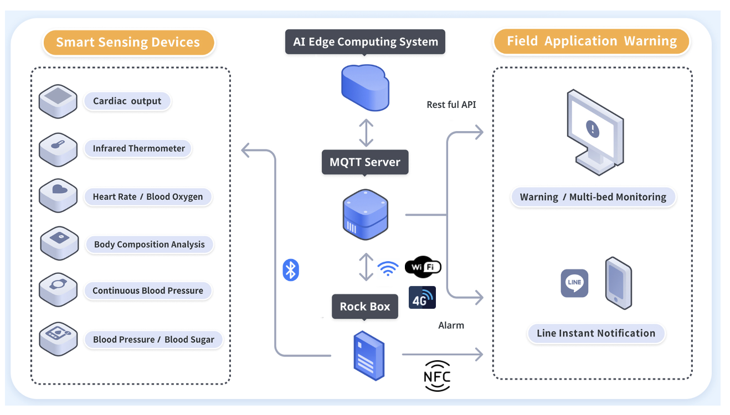

5.ID/Mechanical Requirements

Plastic Housing PC/ABS
Structure design based on soft tooling
Dimension (L x W x H): 90 × 64 × 24 mm (might change by ID final design)
Complies with drop test 1M height
Waterproof IPx4
Additional accessory attached to hospital bed
USB Type C 1 port

6.Electrical Requirements

Application processor at least Arm Cortex-M33 with FPU and DSP instructions
System storage flash 16 MB
4G LTE Cat M1/NB1 VPN Gateway for IoT applications
WiFi Complies with 802.11a/b/g/n/ac/ax, SISO
Support BLE 5.x protocol and 6 medical sensing devices in simultaneous Bluetooth connections
Antennas for 2.4 and 5 GHz, 1T1R
NFC coil for patient pairing
Display OLED 1.5” (might change by ID final design)
Power management and charging 15W w/ OCP/OVP/OTP
1× SIM connector, may consider eSIM solution if telecom support
Operational temperature ranges from -20 °C to +80 °C
ESD protection +/- 4KV(air) & +/- 8KV(contact)
Battery with protection circuit board

7.Software Requirements

3GPP standard 4G LTE Cat M1/NB1
MQTT and eSIM initialization development
WiFi standard 802.11a/b/g/n/ac/ax
Wireless security WEP, WPA-PSK, WPA-Enterprise (WPA/WPA2/WPA3)
BLE 5.x standard protocol
BLE Audio (optional)
Support guest traffic isolation
User RTOS image
Diagnostic Firmware using for product verification/validation
OTA firmware upgrade
Power saving mode when battery only

8.Role & Responsibility

Service Requirement | AcuSense | Vendor
System architecture | ◉
ID Design | ◉(Approver) | ◉(Owner)
Electrical Design |  | ◉
Mechanical Design |  | ◉
Antenna Design |  | ◉
RF Design |  | ◉
Software/Firmware | ◉(Support) | ◉(Owner)
Design Verification |  | ◉
Product validation | ◉(Owner) | ◉(Support)
PCBA Fabrication | ◉(Support) | ◉(Owner)
Tooling Fabrication | ◉(Support) | ◉(Owner)
Final Assembly | ◉(Owner) | ◉(Support)
BOM cost /VAVE | ◉(Approver) | ◉(Owner)

9.Assumption & Constraints

- Ownership of Rockbox 2nd generation gateway design to AcuSense
- ID CMF proposed by vendor that should consider medical user scenario.
- Excluded regulatory and compliance implementation but should consider key testing criterion into design development.
- Implement basic reliability test due to cost-reduction.
- Tooling requirement should consider low-cost material as possible.
- Nordic cellular, WiFi, BLE, NFC solutions as preferred
- Discrete or module solution acceptable to design development.
- Passive component dimension 0402 and 0201 as possible
- 18650 battery with protection board as preferred
- Leverage Taiwan telecom supplier’s eSIM in design development as preferred.
- Software development environment/firmware compiler proposed by vendor or leverage main chip SDK.
- Cost of testing equipment should be considered if needed.

10.Project Management

- Regular meeting weekly
- Data management in Google Drive or MS OneDrive
- Complied with confidentiality.
- Project schedule change should approve by AcuSense.
- Engineering change should approve by AcuSense.
- Review of manpower and material budget bi-weekly
- Review of critical issue and gating items weekly

11.Project High-level Schedule (due date, TBC)

- AcuSense product development proposal release
- 2nd April 2024
- Received vendor’s proposal including NRE quotation.
- 16th April
- Review vendor’s proposal and negotiate entire cost.
- 17th April to 18th April
- Project Awarded to vendor formally.
- 19th April
- Product hardware design development
- 22th April to 10th May
- ME/EE/ANT/RF design review
- 13th May
- Software/Firmware design review
- 31th May
- 3D file and Gerber release
- 15th May
- Component arrangement
- PCB fabrication included DFM(TQ/EQ) : 16th May to 29th May.
- EE: 8th May to 5th June
- ME: 15th May to 10th June
- Software/Firmware file release
- 6th June
- SMT process
- 6th June to 7th June
- Assembly process
- 10th June -14th June
- HW/SW Design verification
- 10th June to 28th June
- Product validation
- 1st July to 31th July

12.AcuSense & Vendor Team Roster

Title | AcuSense CTO
AUTHOR | Kenji Hsueh
PHONE | +886-922-580797
EMAIL | kenji.cchsueh@acusense.com.tw
Functional Role | Project lead, technical approver, escalated management

Title
AUTHOR
PHONE
EMAIL
Functional Role

Title
AUTHOR
PHONE
EMAIL
Functional Role

