**Array Questions**

**Instructions DATE: 23_JUNE_2023**

1.Pair sum without extra space and nested loop

2.Rotate array by one in clockwise

3. Rotate array by one in anticlockwise

4.Rotate array by k : Leetcode - 189

**Source Code_01:**

package Backtracking;

import java.util.*;

class Ques_07

{

public static void findPairs(int[] arr, int targetSum)

{

Arrays.sort(arr);

int left = 0;

int right = arr.length - 1;

while (left < right)

{

int currentSum = arr[left] + arr[right];

if (currentSum == targetSum)

{

System.out.println("Pair found: " + arr[left] + ", " + arr[right]);

left++;

right--;

}

else if (currentSum < targetSum)

{

left++;

}

else

{

right--;

}

}

}

public static void main(String[] args)

{

int[] arr = {2, 4, 6, 8, 10};

int targetSum = 12;

findPairs(arr, targetSum);

}

}

**Output_01:**

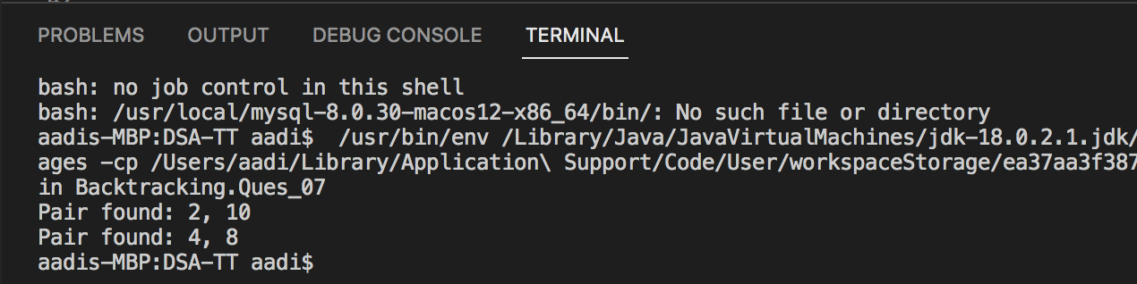

**Source Code_02:**

class Ques_08

{

public static void rotateClockwise(int[] arr)

{

int lastElement = arr[arr.length - 1];

for (int i = arr.length - 1; i > 0; i--)

{

arr[i] = arr[i - 1];

}

arr[0] = lastElement;

}

public static void main(String[] args)

{

int[] arr = {1, 2, 3, 4, 5};

rotateClockwise(arr);

System.out.println(Arrays.toString(arr));

}

}

**Output_02:**

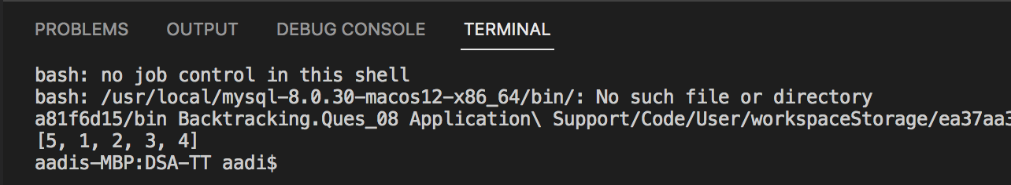

**Source Code_03:**

class Ques_09

{

public static void rotateAnticlockwise(int[] arr)

{

int firstElement = arr[0];

for (int i = 0; i < arr.length - 1; i++)

{

arr[i] = arr[i + 1];

}

arr[arr.length - 1] = firstElement;

}

public static void main(String[] args)

{

int[] arr = {1, 2, 3, 4, 5};

rotateAnticlockwise(arr);

System.out.println(Arrays.toString(arr));

}

}

**Output_03:**

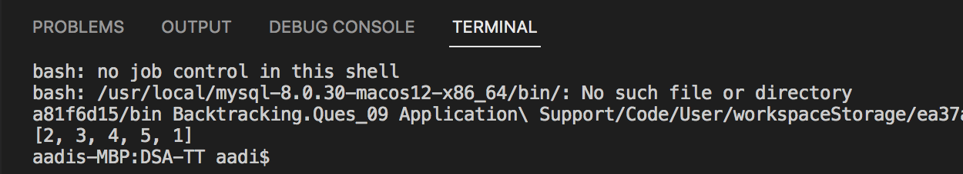

**Source Code_04:**

class Ques_10

{

public static void rotate(int[] arr, int k)

{

int n = arr.length;

k = k % n;

reverse(arr, 0, n - 1);

reverse(arr, 0, k - 1);

reverse(arr, k, n - 1);

}

private static void reverse(int[] arr, int start, int end)

{

while (start < end)

{

int temp = arr[start];

arr[start] = arr[end];

arr[end] = temp;

start++;

end--;

}

}

public static void main(String[] args)

{

int[] arr = {1, 2, 3, 4, 5};

int k = 2;

rotate(arr, k);

System.out.println(Arrays.toString(arr));

}

}

**Output_04:**

