Members:

* Abul Gylymkhan
* Raleigh Matthews
* Jeffrey Huynh
* Zhongjie Ruan
* Rohan Baishya

Title: JARRZ

Vision:

Our LightTemp device is for the someone that wants to monitor the temperature, humidity and light dependency of a particular environment in real time remotely. Our device is currently set up to display data every hour (to save hard drive space) but can be adjusted. We imagine our product would work well for the diligent chemist or the overzealous pet owner; essentially anyone that wants to track readings constantly from a distance.

Software testing:

Our project was heavily focused on the building and functionality of the Arduino device and the code to actually get the data we want from the device. We were initially testing our code with the Arduino device connected to the machine running the code. However, as our project developed and we needed to spend more time coding individually, testing the code was a challenge because we had to have the Arduino device in order to be able to test our code. Our initial solution was to use an Arduino emulator software which replicates the sensors of an Arduino breadboard. This did not go as well as we planned because we could not get the emulator to properly replicate the actual Arduino. We used a software called UnoArduSim: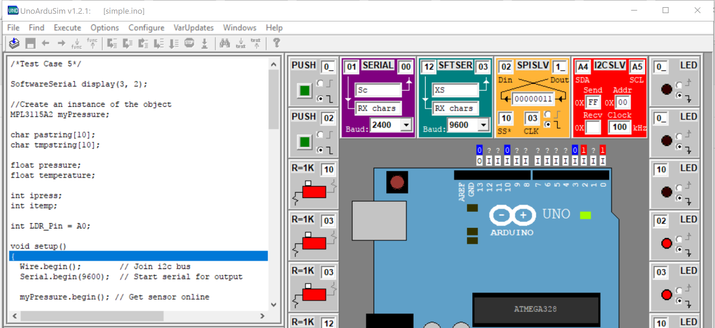

Since this failed, we had to do functionality tests individually by breaking apart the Arduino code and doing basic input/output tests to individual functions. Everything else in our product did not require unit testing.