How the GyroGlove Works

The glove utilizes advanced gyroscopic stabilization technology to reduce hand tremors, offering users a steady hand and the ability to carry out daily tasks with ease. GyroGlove is comprised of three primary components: the fabric glove, the gyroscopic stabilization module, and a battery system. It is worn similarly to a regular glove, although it is slightly bulkier. The glove features a custom-designed twist-and-lock mechanism that creates a strong mechanical coupling, ensuring a secure fit.

Made from lightweight, breathable, and stretchable fabric, the glove is comfortable for daily use. It feels soft and spongy on the hand while maintaining durability with proper care.

The battery pack is equipped with an oversized charging point for easy and hassle-free charging. It can power the device continuously for up to four hours on a single charge, and up to 10 hours if used intermittently. The battery pack also includes global adapters, ensuring the device can be charged anywhere.

Once activated, the glove's battery-powered gyroscope begins rotating, immediately counteracting the user’s hand movements to restore stability. This proportional resistance mitigates tremors, allowing for precise control. The gyroscope can be dynamically adjusted to meet individual needs, distinguishing it from robotic rehabilitation systems.

The current price of GyroGlove is $4,899 with a discount, while the regular price is $5,899. With an expected three-year lifespan, it is possible that multiple purchases may be needed over time. However, as a drug-free solution, there is the potential for health insurance companies to eventually cover the cost, offering an alternative to ongoing medication expenses.

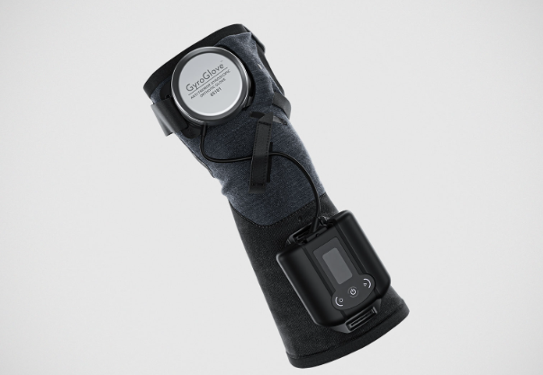

Innovative TechnologyGyroGlove leverages the principle of gyroscopic stabilization to reduce hand tremors, providing increased control and stability for individuals with Parkinson’s disease and other neurological conditions.

At the heart of GyroGlove's technology is a high-performance mechanical gyroscope, about the size of a hockey puck, which delivers gyroscopic stabilization to counteract tremors. This advanced technology, packaged in a comfortable wearable form, is inspired by innovations from aerospace and Formula 1 racing.

When tremor movements are detected, the glove’s built-in gyroscope automatically produces counteracting forces to stabilize the hand. By applying equal and opposite torques to the tremor-induced motions, the glove effectively cancels out the involuntary shaking, allowing users to regain normal hand functionality.

The gyroscope within GyroGlove is engineered to rotate at extremely high speeds, reportedly four times faster than a jet turbine blade. Over its estimated three-year lifespan, the gyroscope is expected to complete approximately 11 billion rotations.

Article

The following information was obtained from a research paper listed in the sources below.

The article referenced below primarily focuses on tremors that result in hand rotation about a central oscillator parallel to the forearm.

Engineers harnessed the physical properties of a spinning gyroscope to function as a stabilization mechanism, reducing the effects of tremors experienced by the individual.

The final prototype developed utilizes a small electric motor to spin a gyroscope on a swinging cradle. This setup allows for natural precession of the gyroscope when subjected to an input torque, producing a counter-torque along the axis of the hand's rotation. To monitor the device's performance, an RPM sensor, along with an Arduino, was integrated to receive sensory information about the gyroscope.

Power System

The power system's role is to supply energy to the motor that spins the gyroscope, which is essential in generating the rotation needed to counteract the torque produced by hand tremors. The three main components of the power system are the power supply, the speed controller, and the motor.

Several factors affect motor performance, including motor type, size, and revolutions per minute per volt (kV).

A brushless motor was selected instead of a brushed motor due to its higher efficiency, longer lifespan, and minimal maintenance needs. After careful consideration, the Brother Hobby R3 2207 2400kV brushless motor was chosen. This motor has a battery rating of 3-5S, defining the voltage range the motor can receive from the battery, which, in this case, is 11.1-21V. With a kV rating of 2,400, the theoretical maximum RPM reaches 44,400 RPM. The motor dimensions are 24 mm in diameter and 20 mm in height.

To drive and control the brushless motor, an electronic speed controller (ESC) was required. The ESC receives a pulse width modulation (PWM) signal, which controls the ESC’s output and subsequently the motor’s speed.

When selecting the speed controller, two essential factors were considered to ensure compatibility with the motor: maximum continuous current and input voltage. For safety, an ESC rated for a higher continuous current than the stall current of the motor was chosen to prevent failure. The YEP 60A (2~6S) SBEC Brushless Speed Controller was selected for this task.

For power supply, a rechargeable battery was selected for portability. A lithium polymer (LiPo) battery was chosen for its high energy density compared to other available options. Based on system requirements, the Turnigy 5000mAh 5S 30C LiPo battery was selected, offering a large 5000mAh capacity with five cells arranged in series, each with a nominal voltage of 3.7 volts.

Control System

The control system manages the ESC of the power system. If the system detects severe or high-amplitude hand tremors, it increases the motor's RPM; when tremors are minimal or less severe, the RPM is decreased.

A PWM signal is required to control the motor’s RPM, which is achieved using an HJ digital servo tester that generates a variable PWM signal. The pulse length ranges from 800 to 2200 microseconds, with a frequency of 50 Hz. A digital monitor displays the signal pulse, which is controlled by an integrated potentiometer.

Sensor System

An adaptive control system requires sensors to provide input data. As mentioned, an Arduino microcontroller was employed to interface with the sensors.

Three types of tachometers—mechanical, optical, and stroboscopic—were considered to measure the RPM of a spinning object. The optical tachometer, using an infrared (IR) emitter and receiver wired to an integrated chip, was chosen for this project. To detect speed, a reflective tape or surface is applied to a portion of the rotating surface. The IR emitter generates a signal that is reflected by the tape and read by the receiver, with each reading representing one revolution.

Hand tremors involve rotational motion around the center of the hand. To effectively measure this motion, an inertial measurement unit (IMU) was selected. The IMU includes a microelectromechanical system (MEMS) accelerometer and gyroscope transducer to measure translational and rotational motion. Key factors in selecting the transducer include axis, range, and resolution. Tremors typically occur at frequencies of 3Hz or greater, and resolution determines the level of detail captured. The six-axis MPU 6050 was chosen, with a range of +/- 16g on the accelerometer and +/- 2000 deg./sec on the gyroscope.

Additionally, since motor speed depends on the power source's input voltage, a voltage sensor was connected to the battery. This sensor measures the battery voltage and provides real-time information on battery capacity.

Data Processing

The data processing system's purpose is to log sensor data and provide input to enable adaptive responses. Based on sensor input, analyses can be conducted to determine the characteristics of the tremor and the damping effect provided by the gyroscope.

In this setup, the Arduino microcontroller interfaces with and controls the gyroscope's speed. After comparing microcontrollers and microprocessors, it was concluded that combining both would offer the benefits of both systems. The controller sends sensor data to the computer, where it can be logged, transformed, and used to determine how to respond to hand tremors. A Raspberry Pi 3 was selected as the microprocessor.

Data from the accelerometer and gyroscope is filtered using a Fast Fourier Transform (FFT). According to Fourier's theorem, any continuous sinusoidal signal can be represented by a sum of sine and cosine waves. Tremor motion, being roughly sinusoidal, can be decomposed mathematically. The resulting amplitude-frequency spectrum allows for calculating the tremor's frequency and amplitude, which the system can use to automatically adjust the damping mechanism.

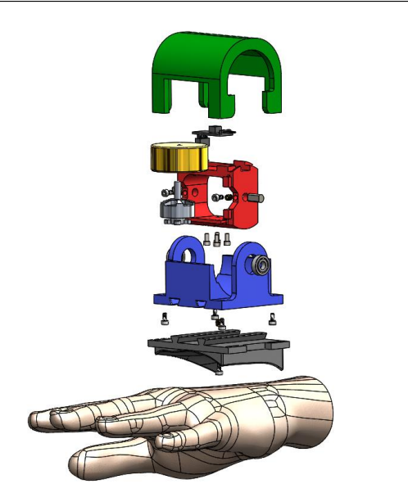

Sources

"GyroGlove: An Ingenious Solution to Hand Tremors." *Accessibility.com*, <https://www.accessibility.com/blog/gyroglove-an-ingenious-solution-to-hand-tremors>.

Ergül, Erhan. "How GyroGlove Could Change Lives for Tremor Patients." *TechAcute*, 2022, <https://techacute.com/how-gyroglove-could-change-lives-tremor-patients/>.

"Gyroscopic Stabilization of Hand Tremors." *PDF Document*. Retrieved from file:///C:/Users/erawa/Downloads/Gyroscopic_Stabilization_of_Hand_Tremors.pdf.