This lab session covers Django Forms (Part 2 – Django form field and file handling). By the end of this session, students should have a very good understanding of how to use Django form field

**Pre-lab Preparation:**

1. The table student and address as in Lab (8).
2. The fake data from mockaroo.com website or any other methods.

**Lab Activities:**

**Task 1:** Create a URL to list, add, update, or delete students and specify addresses (one address for each student) by applying the Django form field with any necessary HTML files and view functions.

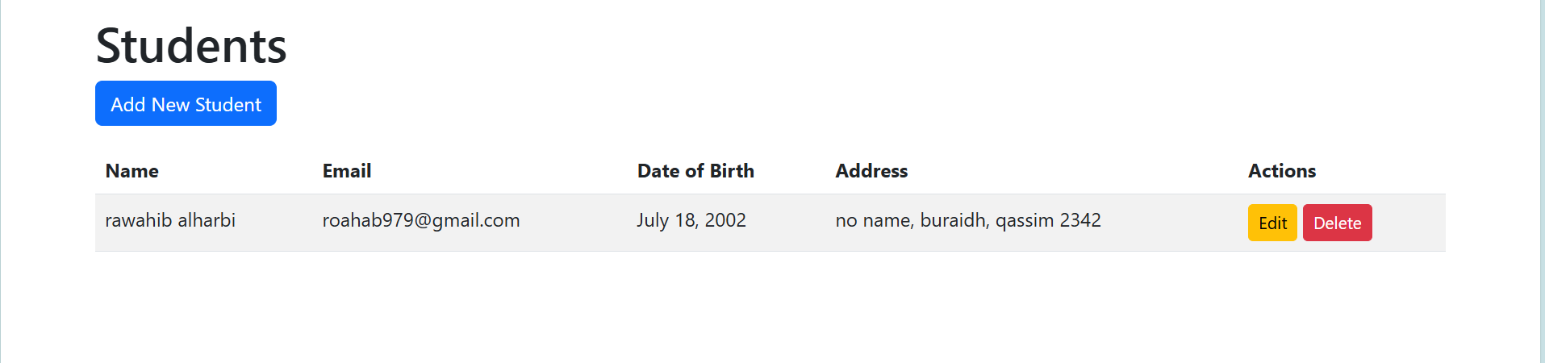

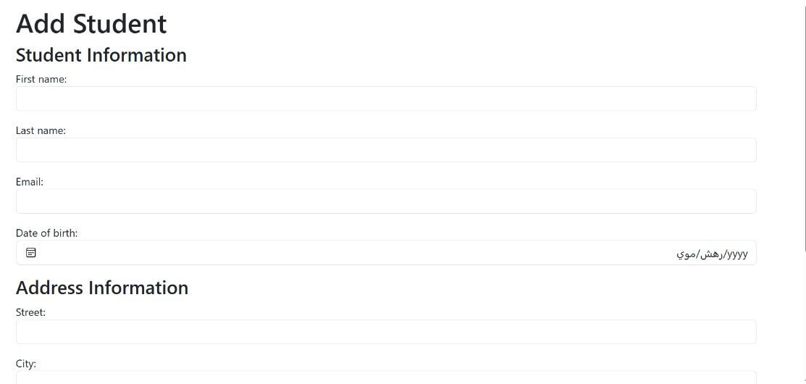

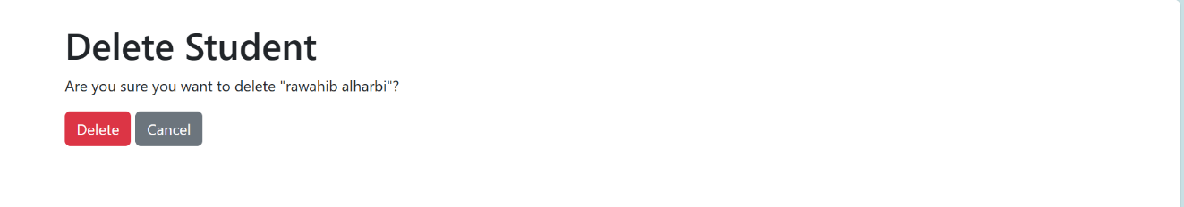

**Task 2:** Suppose the relation between students and addresses is many-to-many, in which a student can have multiple addresses, and also, one address can be associated with many students. In this task, the code in the previous task should be copied and modified to implement many-to-many relationships.

**Note:** If needed, student or address models should be copied and renamed to, for example, student2 and address2.

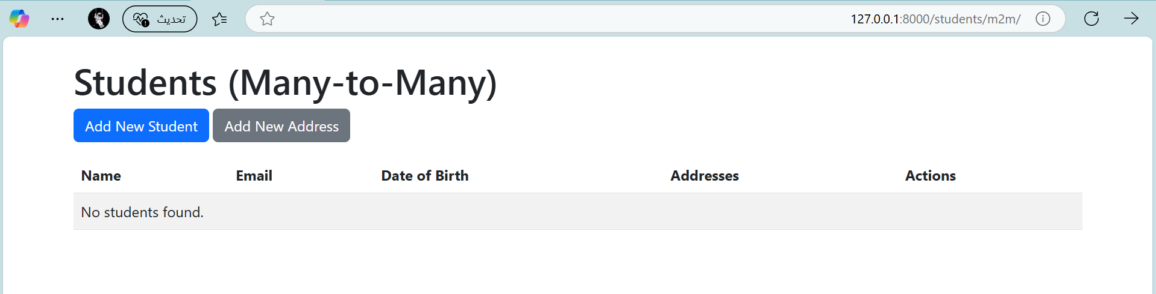

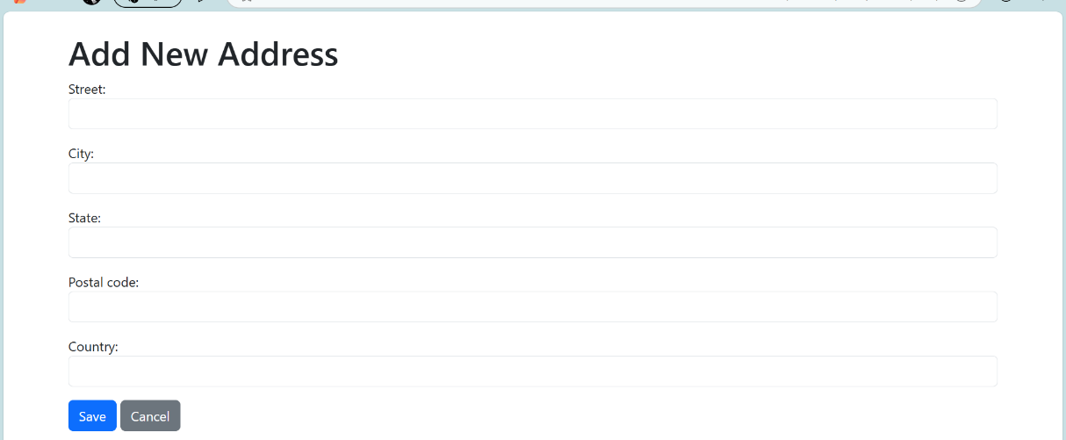

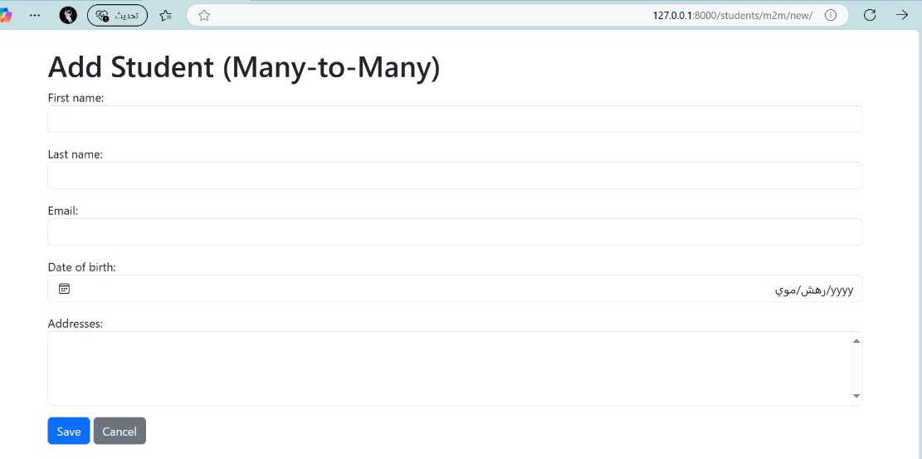

**Task 3:** Create an additional table (of your own choice) that includes images, and you should build forms to handle data with images through Django.

**Note:** A few configurations are needed for file handling.

