This lab session covers additional HTML and CSS Fundamentals (part2). By the end of this session, students should have a very good understanding of how to integrate links, text formatting, lists, and tables into arbitrary webpages with static files in Django framework.

**Pre-lab Preparation:**

1. Having bookmodule and usermodule in apps directory, each containing separate URL configurations.
2. Template directory located in ‘apps’ with necessary settings.

**Lab Activities:**

**Task 1:** (Links and layout customization) Create a page with the URL ‘/books/html5/links’ to display the following. You should use external CSS (main.css) with class and id for styling purposes (having padding, text center, text color, background color, and display as a block). Also, you should add different styles to each state, which a link can have, such as visited, hover, and action.

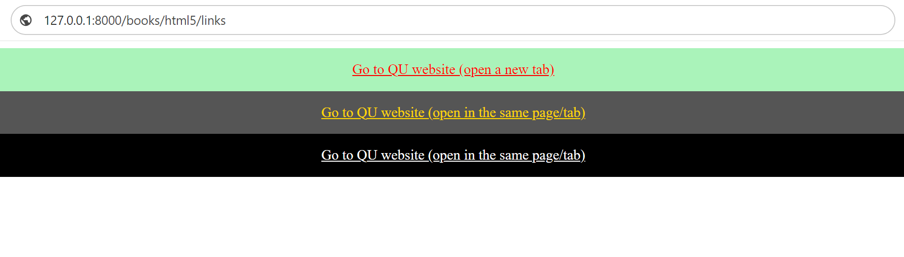

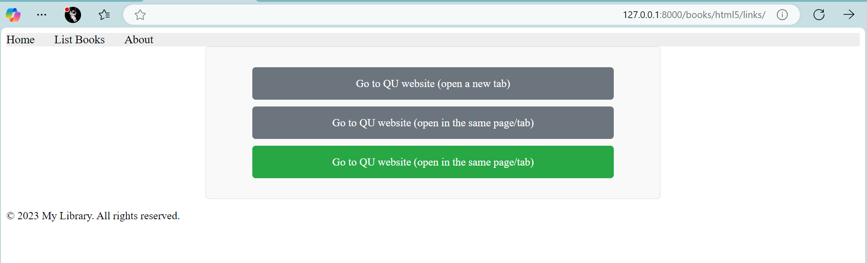

**Task 2:** (Text formatters (nested formatters)) Create another page with the URL ‘/books/html5/text/formatting’ to display the following. You may use the external CSS file ‘main.css’ to add style for the h1 tag that contains ‘Example of Formatting tags’

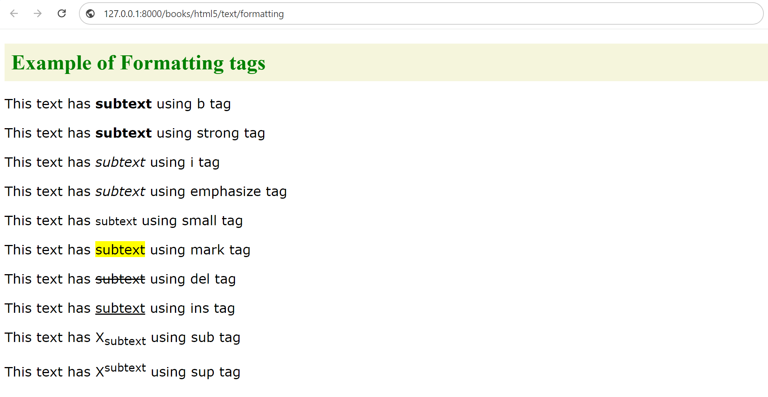

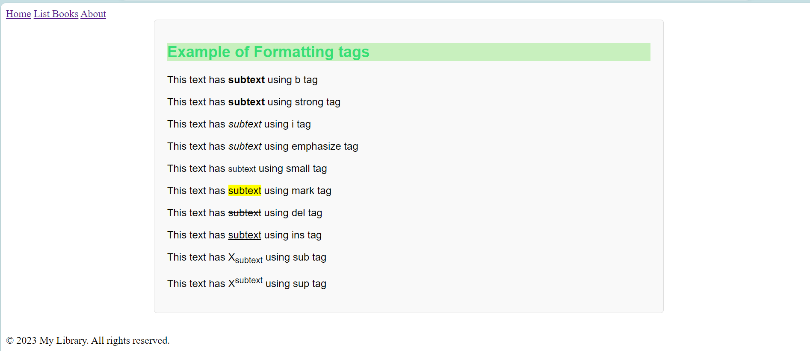

**Task 3: (**Listing (nested)) Create a third page with the URL ‘/books/html5/listing’ to display the following. You may also add style to the external CSS file ‘main.css’

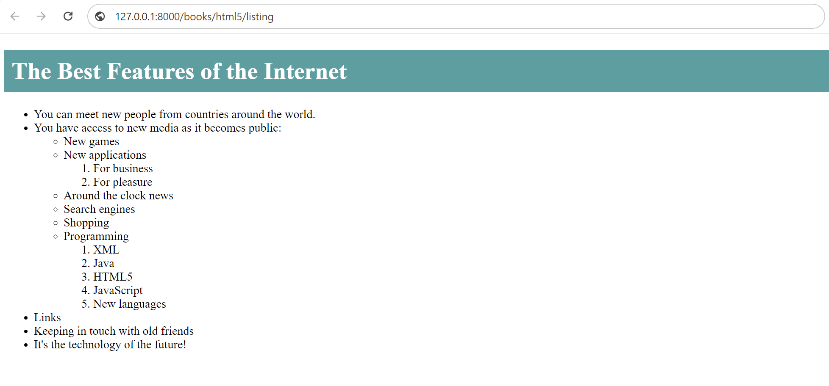

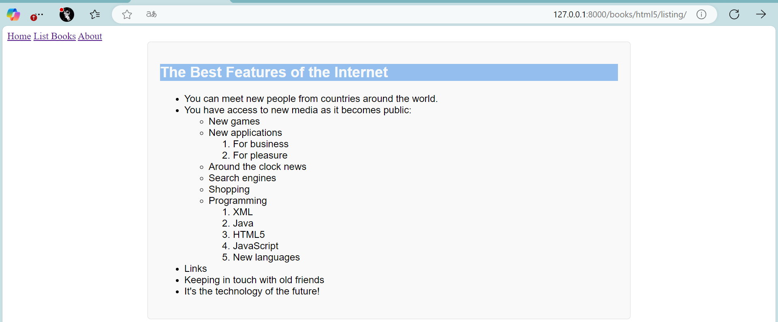

**Task 4:** (Tables and layout customization) Create a fourth page with the URL ‘/books/html5/tables’ to display the following. You may also add any necessary style to the external CSS file ‘main.css’.

