The Impact of Oil Price Shocks on GDP and Inflation: Case of Saudi Arabia
Rawan Al Gharib
Master of Arts in Applied Economics
March 2023

Abstract
This paper aims to explore the impact of oil price shocks on gross domestic product and inflation in Saudi Arabia using quarterly data spanning the period from 2005Q1 till 2022Q3. A unit root test was conducted, in which the data were shown to be non-stationary in the level, and they became stationary in the log difference. A structural VAR model is employed along with 15 lags. One main finding is that an increase in oil prices has a direct positive impact on the country's national income and inflation in the short run according to the impulse function. It can be said that a one-time oil price shock boosts aggregate demand in Saudi Arabia. Furthermore, the results reveal that an oil price shock contributes substantially to the forecast error variance for the real economic growth rate and inflation rate.

Keywords: oil shock, GDP, inflation, aggregate demand shock, Saudi Arabia, SVAR model
JEL Classification: C32; E30; F41

- Introduction and Literature Review:
Economists have analyzed how oil price shocks can greatly impact macroeconomic factors. The global economy has witnessed both positive and negative fluctuations in oil prices. These price fluctuations have been a primary source of disruption for oil-exporting economies, for the oil sector being the keystone for output and exports. Due to the uncertainty in the world's oil markets, the oil sector of oil-exporting countries is vulnerable to volatility, which can have a notable impact on the macroeconomy.
Oil is the cornerstone of Saudi Arabia’s economy, representing approximately 17% of the world’s discovered petroleum reserves. Saudi Arabia's petroleum sector makes up 45% of the country’s total GDP and its share of oil exports in total exports is around 80%. These critical statistics make Saudi Arabia very vulnerable to oil price shocks. In fact, the authorities have initiated extensive economic reforms aimed at reducing the Kingdom’s reliance on oil. Following the 2014 oil price crash and excessive government spending have significantly impacted Saudi Arabia's budget. With oil accounting for over 80% of government revenues and low oil prices persisting, fiscal deficits were projected to reach $118 billion in 2016 and $97 billion in 2017, equivalent to 16% of GDP. To address these challenges, Saudi Arabia has borrowed extensively, with plans to raise an additional $15 billion through bond issuance, resulting in a debt-to-GDP ratio of 26% in 2017. To address these challenges, the government implemented austerity measures, including spending cuts and subsidy reductions. In the long run, Saudi Arabia has implemented a major economic reform program, Saudi Vision 2030, aimed at lifting the country out of its oil-dependency, in addition to, diversifying its economy. Thus, given the huge impact of oil price shocks, this study will investigate the impact of oil price shocks on economic growth and inflation in Saudi Arabia during the period 2005: Q1 to 2022: Q3. But first, it is significant to present some theoretical and empirical literature that have addressed this topic.
Theoretically, oil price increases can be beneficial to oil exporting countries, as Saudi Arabia, the aim of this study. Kilian (2010) elaborated on the benefits of higher oil prices, in the sense that they are translated into more money to spend. When oil prices rise, the revenue earned by oil exporting countries from oil exports also increases. This additional revenue can be used to fund infrastructure development, education, healthcare, and other initiatives that can help spur economic growth. However, inefficiency in the allocation of this marginal revenue may induce recessions, the case of Venezuela (Lopez, 2006). Ghalayini (2011) finds that a price increase directly increases real national income through higher export earnings, however, part of this gain would be later offset by losses from lower demand for exports generally due to the economic recession suffered by trading partners. Furthermore, high oil prices may also incentivize industrialized nations to develop and use alternative oil substitutes, potentially reducing their demand for oil (Ferderer,1996).
Another macro-variable that oil price fluctuations can affect is inflation. As oil prices rise or decline, inflation moves in the same direction (Anandan et al., 2013). This relationship can be captured through different mechanisms. The first is the cost channel. A rise in oil prices induces an increase in production costs, even when energy prices are subsidized by the government in oil-exporting countries. This is because the cost of imported goods used in production can also increase, thus, affecting consumer price index (Tang et al., 2010). Another channel is the effect on fiscal expenditure. Despite being an oil exporter, a country may experience high level of inflation if it exceeds its capacity of purchase during positive price shocks (Farzanegan, 2011).
However, the effect of oil price shocks on an economy cannot be only determined by oil prices. Cunado et al. (2015) reveals that such shocks are determined by the response of monetary policy measures. To mitigate the effect on inflation, the central bank may implement policy changes to achieve a low and stable inflation rate. Moreover, Al-Mutairi (1993) reveals that government’s fiscal stimuli are the main drivers of domestic price variance. When the government increases its spending, it injects more money into the economy, which in turn, increases the purchasing power of consumers. This can lead to higher demand for goods and services, which can push up prices.
Since Hamilton's (1983) influential research suggesting a strong relationship between US recessions and oil price spikes, there has been an increasing amount of literature exploring the correlation between oil prices and the macroeconomy. The majority of this literature concentrates on oil-importing economies (Maghyereh et al., 2019). However, there are a small but growing number of studies that investigate this relationship in the context of oil-exporting economies. My study is closely related to and contributes to this field of literature. Thus, I will provide a brief review of the literature that focuses on oil-exporting economies.
Mehara and Oskoui (2007) employed a structural VAR model to investigate the key drivers of macroeconomic fluctuations in 4 exporting countries. Their results suggest that oil price shocks serve a significant role in driving business cycles in Iran and Saudi Arabia. Berument et al. (2010) examined the impacts of oil shocks on economic growth in some Middle East and North African (MENA) countries. Their result suggested that the impact in most exporting countries is positive and significant. Moreover, many studies in the literature of oil-exporting countries focus on one individual country. Zulfigarov and Neuenkirch (2020) studied the relationship between fluctuations in oil prices and economic activities in Azerbaijan by utilizing a VAR model for the period 2002–2018. Their findings revealed that an innovation in oil prices induces higher inflation. In his study on Kuwait, Al-Mutairi (1993) found that the reliance of the fiscal policy on oil price significantly affects output fluctuations and that government’s fiscal stimuli are the key drivers of domestic price fluctuations. Alkhathlan and Javid (2018) employed a vector error correction model (VECM) to examine the effect of oil price shocks on Saudi Arabia. The study found that oil price shocks had a positive effect on the country's economic growth, but the impact was short-lived. However, Olomola (2006) conducted a study using VAR approach to investigate the effect of oil shocks in Nigeria. The analysis suggests that oil price shocks had no significant effect on inflation and output. In this study, it was the money supply that majorly impacted the output growth.
However, it is surprising that, inspite of being an important oil-exporter in the global market and having one of the world's top 20 economies in terms of size, Saudi Arabia is not adequately signified in the literature on the impacts of oil shocks on the macroeconomy. Thus, the aim of this paper is to investigate the effect of oil price shocks on real GDP growth and inflation in Saudi Arabia. Our contribution to the literature is multifold. First, the current study takes the case of Saudi Arabia, the second largest oil producer in the world, which makes it highly dependent on oil revenues and thus highly affected by oil price fluctuations. Second, the study employs data from 2007 to 2022, a critical period which involves many global price shocks. Furthermore, the current study can have important policy implications for the government and policymakers. It can inform decisions related to economic diversification, energy policies, fiscal management, and investment strategies, thus, supporting Saudi’s 2030 Vision.
The remainder of this paper will be as follows. Section 2 describes the data employed, variables used, and the tests implemented in this study. Section 3 examines the empirical methodology. Section 4 includes the empirical findings as well as an analysis. Lastly, section 5 provides some concluding remarks.

2. Data
This paper relies on time series data from Federal Reserve Economic Data (FRED), which has been supplying researchers with reliable conformations since 1991. To investigate the impact of oil price shocks on Saudi Arabia’s macroeconomy, three variables are employed: gross domestic product, Brent oil price, and consumer price index. The data spans the period from 2005: Q1 to 2022: Q4. This critical period involves notable oil shocks that the country has witnessed, including the 2008 Financial crisis, 2011 Arab Spring, 2014-2016 Oil Price Collapse, 2019 Abqaiq-Khurais attack and eventually the 2020 COVID-19 Pandemic. For the dependent variable, the Gross domestic product by expenditure (GDP) is a proxy for total output, measured by categorizing the spending pattern of the economy (Saudi Riyal). To obtain it in real terms, GDP is deflated by inflation. The other variable is the Brent oil price, a benchmark for global oil prices used to price two-thirds of the world's internationally traded crude oil supplies (USD/Barrel). This variable is determined by global supply and demand factors, geopolitical tensions, and economic factors such as inflation, interest rates, and currency exchange rates.
Besides oil price, this study employs consumer price index (CPI), a measure of the average change over time in the prices paid by consumers for a fixed basket of goods and services (base year 2010). This variable tracks inflation in an economy and is commonly employed in the literature.
2.1. Descriptive statistics:
Table 1 provides an overview of the summary statistics for the macroeconomic variables. The study is conducted with a sample size of 71. Real GDP has an average value of 6.68 Billion Saudi Riyal. Figure 1 displays the data for real gross domestic product (GDP), oil price, and CPI. The plot of real GDP is somehow volatile, but following an upward trend. The plot of oil price shows more volatility during the period of study. However, the plot of CPI shows a clear upward trend with no sharp fluctuations.
2.2. Preliminary Analysis:
Before conducting advanced statistical analyses, it is important to examine visual data to identify patterns, trends and relationships. Figure 2 shows the plots of real GDP and oil price simultaneously. It is evident how the two variables follow a similar pattern. It clearly reveals how the hike of oil prices around the beginning of the Great recession in 2007 followed by a sharp drop in oil prices during the 2008 financial crisis is accompanied with similar changes in GDP. This pattern remains obvious during the whole period 2005-2022 which witnessed many other oil shocks with the recent COVID-19 pandemic. Thus, this paper attempts to address this hypothesis.
Figure 3 shows the plots of real GDP and CPI simultaneously. It is clear that the upward-trend in real GDP is accompanied with an upward-trend in CPI in the long run. One may predict that the effect of oil price shock is expansionary and inflationary in Saudi Arabia. With increased oil revenue, the Saudi government often increases spending on infrastructure projects, public services, and subsidies. The increased government spending creates job opportunities, income growth, and business expansion, which contributes to economic expansion. Higher oil prices also enhance business and investor confidence in Saudi Arabia's economy. Increased revenues for the government and businesses translate into greater economic stability and growth prospects. Moreover, higher oil prices lead to increased wealth for oil producers and the government. This wealth effect translates into higher consumer spending as individuals and businesses have more disposable income. Increased consumer spending drives up aggregate demand and boosts economic growth. However, the oil price shock can be also inflationary. Rising oil prices increase the costs of production, especially for industries heavily reliant on oil, such as transportation, manufacturing, and energy. Higher production costs can be passed on to consumers in the form of higher prices for goods and services, leading to cost-push inflation. With increased economic activity and expansionary fiscal policies, the demand for labor tends to rise. This increased demand for workers can lead to wage pressures as businesses compete for limited labor supply. Higher wages can further contribute to inflationary pressures within the economy.
2.3. Unit Root Tests:
Prior to decide on the model to be employed and given the time series data, we should use the unit root test to figure out whether the variables real GDP, oil price, and CPI are stationary or not. However, it is important before to test for serial correlation. To account for the latter, the Breusch-Godfrey Lagrange Multiplier (LM) test is employed to determine the number of lags to include in the Augmented Dickey-Fuller (ADF) test. To decide what type of equation to be used, the variables are plotted in figure 1. For the real GDP, the LM test reveals that adding 1 lag of the variable is enough to get rid of serial correlation (table 2). For the oil price variable and CPI, 1 and 0 lags are needed to remove serial correlation, respectively (tables 3 and 4).
Applying the ADF test based on the graphing plots, tau observed is greater than tau critical at a 5% significance level for each variable (table 8-column 1). This fails to reject the null of non-stationary, implying that each of the variables: real GDP, oil price and inflation is non-stationary.
Hence, the log difference of each variable, which is commonly used in the literature, is computed. To test for stationarity, the LM test and ADF test are employed again. Tables 5,6 and 7 display the results of the LM test for real GDP growth rate, oil price growth rate and inflation rate, after adding the needed lags respectively. Table 8 (column 2) then displays the results of the ADF test. Since the tau observed for each of the variables is less than the tau critical at a 5% significant level, we reject the null hypothesis of non-stationarity. Consequently, real GDP growth rate, oil price growth rate and inflation rate are stationary. This is evident in the plots of the variables in figure 4.
3. Empirical model:
To decide on the appropriate model following our finding that all the variables are stationary after taking the log difference, the Engle-Granger test is employed to test whether co-integration exists or not. The test reveals that the tau observed (-2.287) is greater than the tau critical (-2.76) at 5% significance level. Consequently, the VECM model is not appropriate.
Following this, a structural Vector Autoregressive (SVAR) model is employed in this empirical study to investigate the effect of an oil price shock on each of the following macro variables: real GDP and inflation in Saudi Arabia.
The SVAR model is chosen because it can be used to analyze the contemporaneous effects of oil price shocks on the Saudi Arabian economy, as well as the dynamic effects over time. This feature makes this model special and different from the conventional VAR model that solely captures the effect of a lag of an endogenous variable on another endogenous variable. Moreover, the adoption of this model allows us to apply restrictions based on theoretical acquaintance. Kilian (2011) asserts that since the studies grounded on SVARs are identification driven, this characteristic allows to visualize likely patterns of the impulse responses for policy implications, as well as, forecast error variance decomposition (FEVD) for analyzing the underlying origins of fluctuations in the variables of interest. (Kilian and Lütkepohl, 2017).
For the model identification, the optimal lag length is determined by Akaike information criterion. The findings show that AIC is minimized at 15 lags. Another test is needed to make sure that there is no serial correlation. The test reveals that at lag 15, there is no evidence of serial correlation. Consequently, an SVAR (15) is employed in this study. The structural VAR is represented as follows:
$B_{0}x_{t}=Γ_{0}+\sum_{i=1}^{i=15}{Γ_{i}x_{t-i}} + ε_{t}$ (1)
Where $x_{t}$ is a $3×1$ matrix of the three variables (real GDP growth rate, oil price growth rate and inflation rate) at time t. $B_{0}$ is a $3×3$ matrix of structural parameters that that shows the instantaneous effect between these variables, $Γ_{i}(i=0, 1, 2, …, 15)$ is a $3×3$ matrix of structural parameters, and $ε_{t}$ is a $3×1$ matrix corresponding to structural shocks.
To obtain the reduced-form parameters, both sides of (1) are multiplied by $B_{0}^{-1}$. The reduced system will be as follows:
$x_{t}=A_{0} + \sum_{i=1}^{i=15}{A_{i}x_{t-i}}+e_{t}$ (2)
Where $A_{i}=B_{0}^{-1}Γ_{i}$ denotes a $3×3$ matrix of reduced-form parameters, and $e_{t}=B_{0}^{-1}ε_{t}$ denotes a $3×1$ vector of reduced-form shocks.
To recover the parameters from the structural model, we will employ an identification process proposed by Sims (1986). This recursive based-procedure is used to restrict the structural model. The identification affirms that for n SVAR equations, $\frac{n^{2}-n}{2}$ restrictions are to be imposed. Following this, the 3-SVAR equation model requires 3 restrictions. These restrictions are imposed using a method called Cholesky decomposition which decomposes the residuals in a lower triangular matrix as follows:
$B_{0}=\left[\begin{aligned} 1 0 0 \\ b_{21} 1 0 \\ b_{31} b_{32} 1\end{aligned}\right] ,x_{t}=\left[\begin{aligned} \\ Oil price growth rate \\ GDP growth rate \\ Inflation rate\end{aligned}\right]$& $e_{t}=\left[\begin{aligned}e_{Oilpricegrowthrate} \\ e_{GDPgrowthrate} \\ e_{Inflationrate} \end{aligned}\right]$
Where the nonzero elements $b_{ij}$ (i=1,2,3; j=1,2,3) are the coefficients representing the instantaneous effect of (i)’s response to the shock (j), and the element $0$ indicates that there are no cotemporaneous responses from specific shocks.
The relationship between the reduced-form errors and the structural errors is represented by:
$$\left[\begin{aligned} 1 0 0 \\ b_{21} 1 0 \\ b_{31} b_{32} 1\end{aligned}\right]\left[\begin{aligned}e_{Oilpricegrowthrate} \\ e_{GDPgrowthrate} \\ e_{Inflationrate} \end{aligned}\right]=\left[\begin{aligned} 1 0 0 \\ 0 1 0 \\ 0 0 1\end{aligned}\right]\left[\begin{aligned}ɛ_{ Oilpricegrowthrate} \\ {ɛ }_{GDPgrowthrate} \\ {ɛ }_{Inflationrate} \end{aligned}\right]$$
This scheme adheres to a sequence that progresses from exogeneous to endogenous (Lee and Ni, 2002). This ordering relates to the respective responses of variables to temporary disturbances (Amaiquema and Amaiquema, 2017). The underlying three restrictions in this SVAR model are based on economic theory. Oil price is placed first since previous resource support the idea that it does not respond to shocks of the other macroeconomic variables in the period t (Lee and Ni, 2002; Kilian 2011). Oil price has a contemporaneous effect on real GDP growth rate because oil is an essential input for production and economic activity. Thus, any change in the oil prices would immediately affect production, and thus, real GDP growth rate. Although Saudi Arabia is a large oil exporter in the world, the literature shows that its supply shocks have a negligible effect on the global crude oil market equilibrium (De Santis, 2003). The economic growth of Saudi Arabia, proxied by real GDP growth rate is assumed to only be impacted by itself and by oil price (Taghizadeh-Hesary et. al., 2013). Oil prices can have an immediate impact on inflation because they affect the cost of production and transportation for many goods and services. Similarly, real GDP growth can have an instantaneous effect on inflation because it reflects the overall level of economic activity in a country. The more prosperous the economic activity, the higher the demand for goods and services, which can lead to higher overall prices in the economy.
4. Empirical Results:
This section is divided into 2 parts. The first part displays the impulse response functions to provide a clear understanding of how the variables interact with each other. The second part demonstrates the contribution of oil price shocks to the forecast error variation of GDP and inflation.
4.1. Impulse Response Function
Since the coefficients in the estimated SVAR model are often difficult to interpret, it is convenient to estimate the orthogonalized impulse response functions. These functions are derived from the SVAR model and capture the effect of a one-time shock in oil price on real GDP growth rate and inflation. Figure 5 depicts the impact of oil price shock on real GDP growth and inflation with a period of 12 quarters. The shaded part in figure 5 reports the 95 percent confidence interval. The effect is significant whenever the upper and lower bounds of this interval have the same sign.
The first graph of figure 5 reveals that a one positive standard deviation shock in oil price’s growth causes a statistically significant and positive increase in Saudi Arabia’ s GDP growth rate in the first period. This effect remains significant and reaches its peak in period 2. However, the increase slows down during periods 3 and 4. After period 7, the effect becomes negative but insignificant. For a better overall effect of the shock on the real GDP growth rate, the first graph of figure 6 depicts the corresponding cumulative impulse response. The latter reveals a clear upward trend in real GDP growth rate. Moreover, as displayed in Table 7, the 1-year cumulative change in real GDP growth rate is 2.43 due to a one standard deviation shock in oil price growth rate. Thus, a positive oil price shock triggers a significant increase in Saudi Arabia’s real GDP growth rate in the short run.
Our result is consistent with the findings of Ghalayini (2011), that suggests that in oil-exporting countries, an increase in oil prices will have a direct impact on the country's actual national income by boosting export earnings. However, there is typically a trade-off between this gain and the losses incurred from reduced export demand resulting from economic stagnation among trading partners. The danger is that if prices go too high, and stay high, GDP growth in the consuming nations might decline, reducing the demand and price of oil. This may explain the immediate increase in the real GDP growth rate, followed by a slow-down afterwards. Also, the findings come in line with the results of Mendoza and Vera (2010) that showed a significant positive impact of oil price shocks on economic growth in the case of Venezuela. Moreover, the study of Nazir and Hameed (2015) also emphasize that oil prices impact real GDP.
To examine the effect of a one-time shock in oil prices on inflation rate in Saudi Arabia, the second graph in figure 5 shows the corresponding impulse response function. An innovation in oil price causes a statistically significant and positive increase in Saudi Arabia’ s inflation rate immediately in the first period. Moreover, the top-right graph in Figure 4, reflects that the cumulative effect of a one standard deviation innovation in oil price is significantly positive on inflation rate in almost all the periods. Furthermore, as displayed in Table 8, the 1-year cumulative change in inflation rate is 0.188 due to a one standard deviation shock in oil price growth rate. Thus, a positive oil price shock triggers a significant increase in Saudi Arabia’s inflation rate in the short run.
Our result is consistent with the finding of Tang et al., (2010) that a rise in oil prices induces an increase in production costs, that are translated to higher consumer price index. Moreover, our finding is in line with that of Zulfigarov and Neuenkirch (2020) that an increase in oil prices induces higher inflation rates in the short run. Furthermore, Brini et al. (2016) shows that the reaction of Saudi Arabia inflation to the shock in oil price is positive at the first period, thus, supporting our result.
In all, the results of the impulse response function of oil price (impulse) on real GDP growth rate and inflation rate (responses) suggest that, for Saudi Arabia, a positive oil shock is a positive aggregate demand shock. While positive oil shocks tend to have a positive impact on real GDP growth, it can lead to inflationary pressures, as the increased demand for goods and services in the economy can outstrip supply, leading to higher prices.
4.2. Economic significance:
To test whether the real GDP growth rate and inflation rate are economically significant, the average of each variable is compared to the cumulative impulse response function. Table 2 reveals that the mean of real GDP growth rate is 1.069 and that of inflation rate is 0.749. Comparing these values to the tables 11 and 12 reveals that real GDP growth rate is economically significant (the coirf is greater than its mean value), while inflation rate is not economically significant (the coirf is less than its mean value).
4.3. Forecast Error Variance Decomposition
The variation decompositions of real GDP growth rate in Saudi Arabia to oil price shock and inflation shock are reported in table 8. The results show that for the 2-step ahead forecast, 16% of the forecast error variance in real GDP growth rate is explained by an oil price shock while 34.6% is explained by an inflation shock. Moving to the subsequent periods, the contribution of oil shock to economic growth increases. After 1 year, an oil shock explains 35% of the forecast error variance in real GDP growth rate. The contribution of inflation to the forecast error variance in real GDP growth rate is substantially larger in the early 2-step ahead period with 34.67%. the percentage contribution remains substantial but lower in the subsequent periods with 27.7% after 1 year. Therefore, the results reveal that oil shocks contribute substantially to the variation in real economic growth. In fact, this result is expected for the case of Saudi Arabia, a heavily dependent economy on the oil sector, that accounts for a significant portion of the country's GDP and government revenue. Moreover, it is evident that inflation is contributes substantially to the variation in real economic growth. Furthermore, it is noteworthy here to examine the percentage contribution of forecast error variance in inflation to oil shocks. Table 9 displays the results. It shows that oil price shocks substantially explain fluctuations in inflation rate. For the 2-step ahead and 1-year forecasts, 19% and 28% of the fluctuations in inflation are explained by oil price shocks, respectively. This result may be explained by the expansionary fiscal policy in Saudi Arabia during oil price shocks. To mitigate the impact of higher prices on its citizens, the Saudi Arabian government often increases its subsidization programs during an increase in oil price increase. this is in line with economic theory which suggests that government spending can increase inflation through many channels, including demand-pull inflation and cost-push inflation.

5. Conclusion:
Saudi Arabia is the second largest oil-exporter in the world with around 17% of the world’s discovered petroleum reserves. Most of the literature on the impact of oil price shocks address oil-importing countries, but there is no sufficient empirical evidence in the context of oil-exporting countries, mainly Saudi Arabia which is a critical economy. In the current study, the aim is to examine the impact of oil price shocks on Saudi Arabia’s economic growth and inflation. To achieve this purpose, quarterly data spanning the period 2005: Q1 to 2022: Q3 is employed. Three variables are used: Real GDP, Brent crude oil price and CPI (proxy for inflation). These variables are transformed to growth rates to capture the percentage difference due to a price innovation. A structural VAR model is used using 15 quarterly lags. The findings from impulse response analysis suggest that an increase in oil prices has a direct positive impact on both the country's national income and inflation in the short run. It is revealed that an oil price increase boosts aggregate demand in Saudi Arabia. Furthermore, the results show that oil price shocks contribute substantially to the forecast error variance for the real economic growth and inflation in Saudi Arabia.
The results of the current study can have significant policy implications for the government and policymakers. Given the heavy reliance on the oil sector and the high contribution of oil price shocks to fluctuations in real GDP and inflation, policymakers must prioritize efforts lessen oil-dependency. One policy implication could be focusing on economic diversification. This would involve promoting the growth of non-oil sectors, such as manufacturing, services, and tourism, to reduce the economy's dependence on oil. Another implication could be efficiently using government’s fiscal policy in allocations during oil price hikes. When oil prices are high, the government can increase spending on infrastructure, education, and social programs. Investment in human capital can equip citizens with the skills needed to work in non-oil sectors. Moreover, investment in renewable energies can promote efficiency and sustainability. These policy implications help lessen the Kingdom’s reliance on the oil sector, thus, making it more resilient to oil price shocks.
This paper does not consider the asymmetries in output and inflation responses to negative vs. positive oil price shocks as it considers that impulse responses are symmetric. Future research could study the asymmetric effects of oil price shocks, for positive and negative oil price shocks may affect the macroeconomy differently. Furthermore, while our main focus in this study is on oil price shocks, future research may include other macroeconomic variables that may impact economic growth in Saudi Arabia (fiscal policy, monetary policy, real exchange rate…). It is interesting for future research to evaluate the effectiveness of diversification efforts and the success or failure of “Saudi Vision 2030” by comparing the effect of oil price shocks before and after these efforts.

References
Al-Mutairi, N. (1993). Exports and Pakistan's economic development. Pakistan Economic and Social Review, 134-146.
Amaiquema, J. R. P., & Amaiquema, A. R. P. (2017). Consequences of oil and food price shocks on the Ecuadorian economy. International Journal of Energy Economics and Policy, 7(3), 146-151.
Anandan, M., Ramaswamy, S., & Sridhar, S. (2013). Crude oil price behavior and its impact on macroeconomic variable: A case of inflation. Language in India, 13(6), 147-160.
Berument, M. H., Ceylan, N. B., & Dogan, N. (2010). The impact of oil price shocks on the economic growth of selected MENA1 countries. The Energy Journal, 31(1).
Brini, R., & Jemmali, H. (2016). Macroeconomic impacts of oil price shocks on inflation and real exchange rate: Evidence from selected MENA countries. Topics in Middle Eastern and North African Economies, 18(2).
Cunado, J., Jo, S., & de Gracia, F. P. (2015). Macroeconomic impacts of oil price shocks in Asian economies. Energy Policy, 86, 867-879.
De Santis, R. A. (2003). Crude oil price fluctuations and Saudi Arabia's behaviour. Energy economics, 25(2), 155-173.
Farzanegan, M. R. (2011). Oil revenue shocks and government spending behavior in Iran. Energy Economics, 33(6), 1055-1069.
Ferderer, J. P. (1996). Oil price volatility and the macroeconomy. Journal of macroeconomics, 18(1), 1-26.
Ghalayini, L. (2011). The interaction between oil price and economic growth. Middle Eastern Finance and Economics, 13(21), 127-141.
Hamilton, J. D. (1983). Oil and the macroeconomy since World War II. Journal of political economy, 91(2), 228-248.
Hesary, F. T., Yoshino, N., Abdoli, G., & Farzinvash, A. (2013). An estimation of the impact of oil shocks on crude oil exporting economies and their trade partners. Frontiers of Economics in China, 8(4), 571-591.
Javid, M., Sharif, F., & Alkhathlan, K. (2018). Oil price volatility and interdependency of GCC economies and North East Asian economies. Energy Strategy Reviews, 21, 172-179.
Kilian, L. (2010). Oil price volatility: Origins and effects (No. ERSD-2010-02). WTO Staff Working Paper.
Kilian, L. (2011). Structural Vector Autoregressions (No. 8515). CEPR Discussion Papers.
Kilian, L., & Lütkepohl, H. (2017). Structural vector autoregressive analysis. Cambridge University Press.
López, R. (2006). Structural adjustment and sustainable development. Economic development and environmental sustainability: new policy options, 154-77.
Maghyereh, A. I., Awartani, B., & Sweidan, O. D. (2019). Oil price uncertainty and real output growth: New evidence from selected oil-importing countries in the Middle East. Empirical Economics, 56, 1601-1621.
Mendoza, O., & Vera, D. (2010). The asymmetric effects of oil shocks on an oil-exporting economy. Cuadernos de Economía, 47(135), 3-13.
Nazir, S., & Hameed, T. (2015). Impact of Oil Price and Shocks on Economic Growth of Pakistan: Multivariate Analysis (Sectoral Oil Consumption). Business and Economics Journal, 6(4), 1-11.
Olomola, P. A., & Adejumo, A. V. (2006). Oil price shock and macroeconomic activities in Nigeria. International Research Journal of Finance and Economics, 3(1), 28-34.
Ordóñez, J., Monfort, M., & Cuestas, J. C. (2019). Oil prices, unemployment and the financial crisis in oil-importing countries: The case of Spain. Energy, 181, 625-634.
Sims, C. A. (1986). Are forecasting models usable for policy analysis? Quarterly Review, 10(Win), 2-16.
Tang, W., Wu, L., & Zhang, Z. (2010). Oil price shocks and their short-and long-term effects on the Chinese economy. Energy Economics, 32, S3-S14.
Zulfigarov, F., & Neuenkirch, M. (2020). The impact of oil price changes on selected macroeconomic indicators in Azerbaijan. Economic Systems, 44(4), 100814.

Appendix:
Table 1: Descriptive Statistics of at level variables:
Variable | Obs | Mean | Std. Dev. | Min | Max
Real GDP | 71 | 6.687e+09 | 1.131e+09 | 4.400e+09 | 9.390e+09
Oil price | 71 | 75.679 | 24.63 | 33.377 | 122.219
CPI | 71 | 88.733 | 13.315 | 63.54 | 107.57
Table 2: Descriptive Statistics of at difference variables:
Variable | Obs | Mean | Std. Dev. | Min | Max
Real GDP growth rate | 70 | 1.069156 | 7.825728 | -42.38148 | 11.30123
Oil price | 70 | 1.025963 | 17.08557 | -73.97546 | 29.86755
Inflation rate | 70 | .7497059 | 1.093282 | -1.55015 | 5.524492

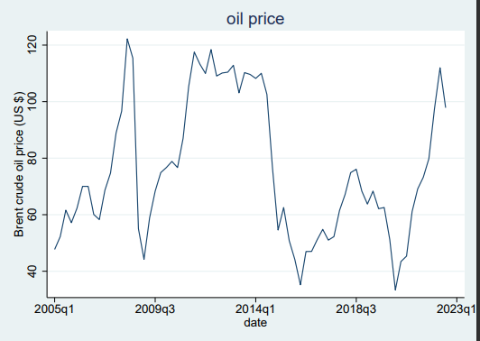
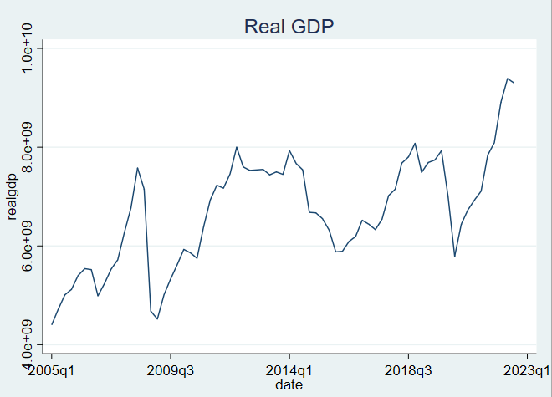
Figure 1: Real GDP, oil price and CPI from 2005Q1 till 2022Q4

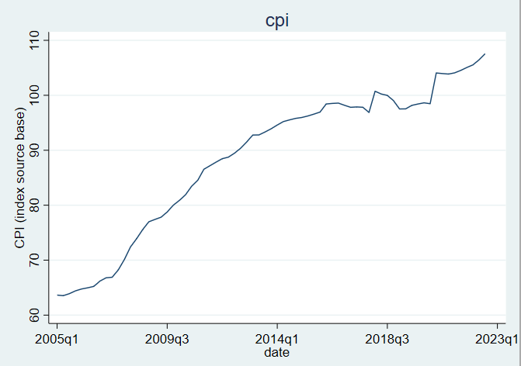

Figure 2: Oil price and Real GDP, 2005Q1 – 2022Q4
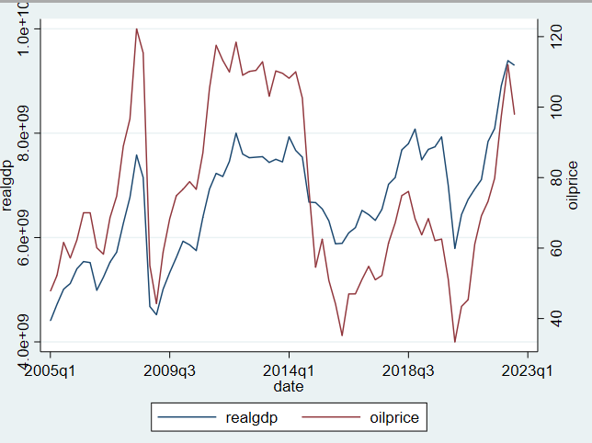

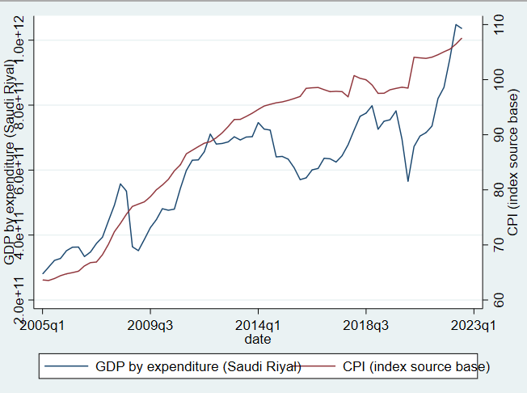
Figure 3: Real GDP and CPI, 2005Q1 – 2022Q4

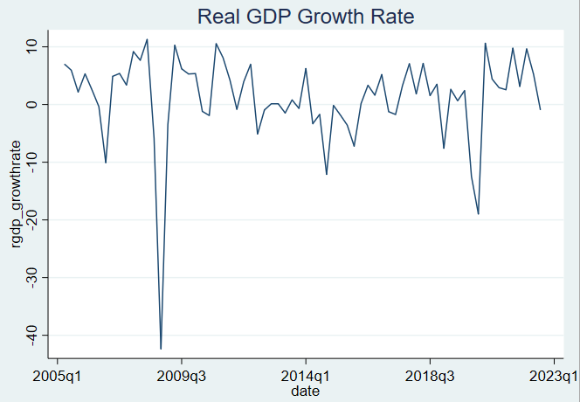
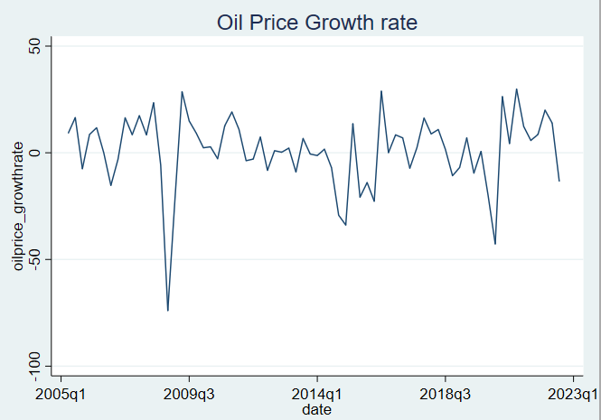
Figure 4: Growth Rates of the Variables from 2005Q1 till 2022Q4

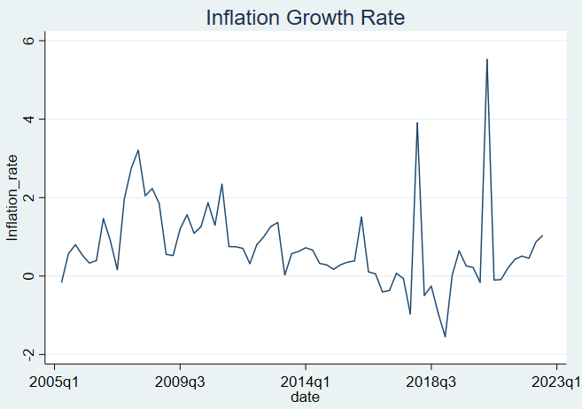

Table 3: Breusch-Godfrey LM test for autocorrelation for real GDP (after adding 1 lag)
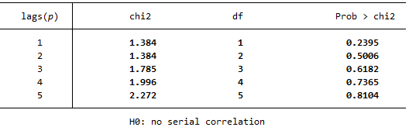
Table 4: Breusch-Godfrey LM test for autocorrelation for oil price (after adding 1 lag)
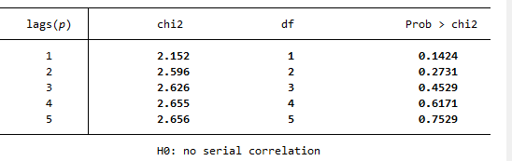
Table 5: Breusch-Godfrey LM test for autocorrelation for CPI (zero lags)
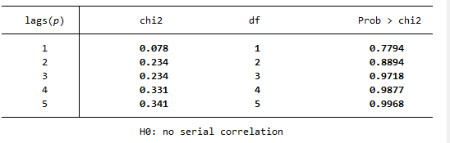

Table 6: Breusch-Godfrey LM test for autocorrelation for real GDP growth rate (after adding 1 lag)
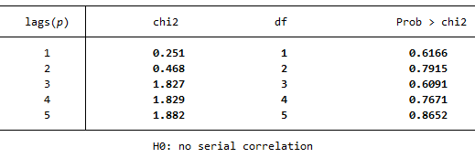
Table 7: Breusch-Godfrey LM test for autocorrelation for oil price growth rate (zero lags)
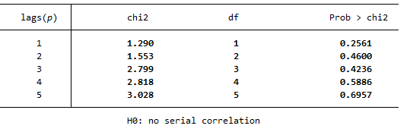
Table 8: Breusch-Godfrey LM test for autocorrelation for GDP growth rate (zero lags)
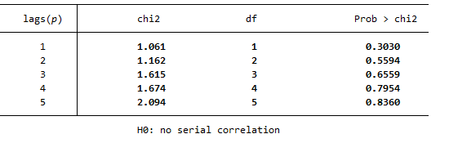

Table 9: Augmented Dickey-Fuller (ADF) Test for both at level and at first difference.
 | ADF (t-statistic)
 | Data (at level) | Data (first difference)
Variables
Real GDP | -3.356 (trend) | -6.495 (no constant)
Oil price | -0.550 (no constant) | -6.686 (no constant)
CPI | -1.117 (trend) | -7.36 (trend)

Table 10: Granger causality test for SVAR
Dependent Variable | Real GDP growth rate | Oil price growth rate | Inflation rate
Real GDP growth rate | … | 0.000 | 0.000
Oil price growth rate | 0.000 | … | 0.000
Inflation rate | 0.000 | 0.000 | …

Figure 5: Orthogonalized Impulse Response Functions
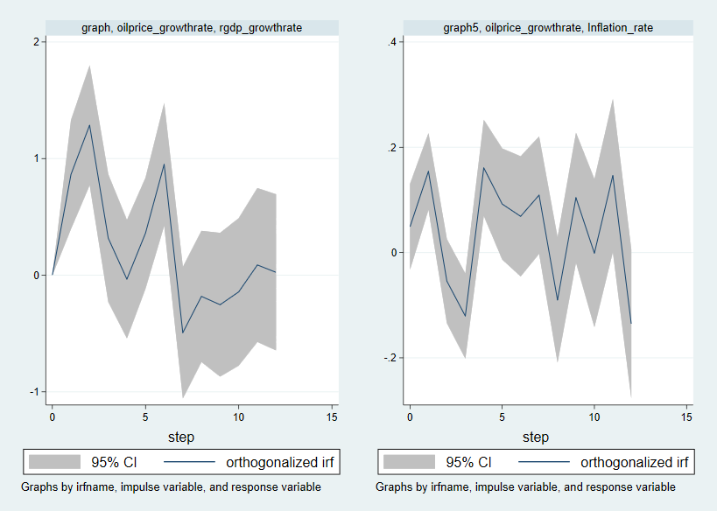

Figure 6: Cumulative Impulse Response Functions
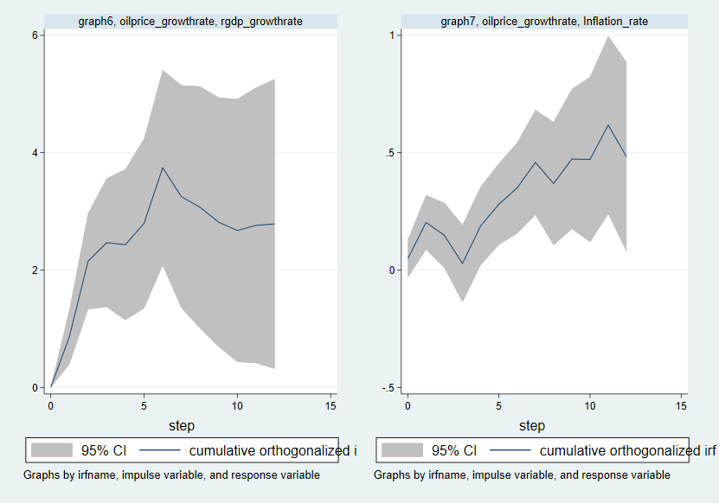
Table 11: The cumulative 1-year effect on real GDP growth rate
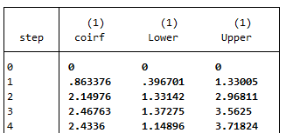
Table 12: The cumulative 1-year effect on inflation rate
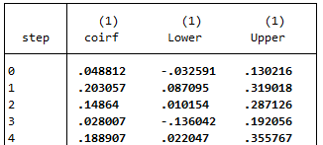
Table 13: Forecast Error Variance Decomposition for GDP growth rate due to oil price shock
Horizon (Quarter) | Oil price shock | Inflation shock
2 | 0.167975 | 0.346762
4 | 0.353508 | 0.277193
8 | 0.385735 | 0.282867
Ꝏ | 0.410685 | 0.30406

Table 14: Forecast Error Variance Decomposition for inflation rate due to oil price shock

Horizon (Quarter) | Oil price shocks
2 | 0.191009
4 | 0.265304
8 | 0.315302
Ꝏ | 0.441633

Table 15: Granger Causality Wald Tests
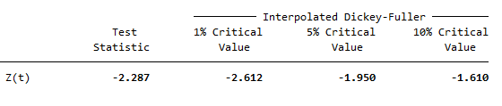

https://www.opec.org
https://www.arabnews.com
https://www.worldbank.org/en/country/gcc/publication/economic-brief-july-saudi-arabia-2016
https://www.vision2030.gov.sa/
https://www.investopedia.com/insights/worlds-top-economies/
$\frac{3^{2}-3}{2}=\frac{9-3 }{2}$= 3

