

Faculty of Engineering and Technology
Department of Electrical & Computer Engineering
ARTIFICIAL INTELLIGENCE
ENCS3340

project#1
Optimizing Hospital Locations Using Search and Optimization Algorithms

Student #1: Rawan Fares No. :1231043
Student #2: Rama Alrob No. :1231564

Supervised by: Dr. Yazan Abu Farha , Dr. Ismail Khater.

June 2026

Table of Contents
Table of Tables 3
1. Problem Formulation , with cost function 4
A. The Problem: 4
B. Decision Variables 4
C. The objective of the cost function 4
2. Algorithm Descriptions 5
A. Hill Climbing 5
B. Simulated Annealing 5
3.Experimental setup 6
A. Problem Instance 6
B. Algorithm Parameters 6
C. Evaluation Metrics 7
4. Results 7
A. Full Results Table 7
B. Key Observations 8
5. Effects of Parameter Tuning 8
A. Effect of λ on Both Algorithms 8
B. Effect of k (Neighbours) in Hill Climbing 9
C. Effect of Cooling Rate α in Simulated Annealing 9
6. Visualizations 10
A. Map Visualization 10
B. Effect of λ on Cost and Hospital Count 11
C. Algorithm Comparison Bar Charts 12
D. Runtime Comparison 12
7. Conclusion and Reflection 13

Table of Tables
Table ‎0.1:Problem Instance. 6
Table ‎0.2:Algorithm Parameters. 6
Table ‎0.1:Full Results Table. 7
Table ‎0.1:Effect of λ on Both Algorithms. 8
Table ‎0.1:population points and selected hospital locations. 10

1. Problem Formulation , with cost function

A. The Problem:
The hospital location problem aims to select an optimal subset of candidate hospital locations in a way that minimizes the total cost. Each person is assigned to the nearest opened hospital. The total cost typically consists of two components: the cost of opening hospitals and the service cost, which depends on the distance (or travel cost) between each person and their assigned hospital, often weighted by population demand.

B. Decision Variables
We define a binary decision variable $x_{i}$ for each candidate location $i$ :
$$x_{i}=\left\{\begin{aligned}1 ,if a hospital is opened at location i \\ 0 ,other wise\end{aligned}\right.$$
This means $x_{i}$=1 indicates that location $i$is selected as a hospital site, while $x_{i}$=0 means it is not selected.

C. The objective of the cost function
For each population point $p_{j}$​, the nearest selected hospital is determined. The weighted travel cost is computed using the Euclidean distance between the population point and its nearest hospital.

The total cost is defined as:
$$Cost = \sum_{j=1}^{n}{w_{j}} ∙ min d(p_{j},h_{i}) + λ\sum_{i=1}^{m}{x_{j}}$$
Where :
- $n$ = number of population points
- $m$ = number of candidate hospital sites
- $w_{j}$​ = population weight of point $j$
- $d(p_{j},h_{i})$= Euclidean distance between population point jjj and hospital iii
- λ = hospital construction cost factor
- $x_{i}$= binary decision variable
Distance Function is The Euclidean distance is calculated as:$\sqrt{{(a_{x} -{ b}_{x} )}^{2}+{(a_{y} -{ b}_{y} )}^{2}}$

2. Algorithm Descriptions

A. Hill Climbing
Hill Climbing is a local search algorithm that iteratively moves to a better neighboring solution. It starts from a random solution and makes small changes, accepting only improvements.
Initialization: A random binary solution is generated where each candidate site has a 15% probability of being selected (~10–20% hospitals as per guidelines).
Neighbour Generation: k=10 neighbours are generated per iteration by randomly flipping one bit (adding or removing one hospital).
Move Strategy: The best neighbour is accepted only if it strictly improves the current cost. The algorithm stops after 500 iterations or 20 consecutive non-improving iterations.
Limitation: Hill Climbing can get trapped in local optima since it never accepts worse solutions.

B. Simulated Annealing
Simulated Annealing extends Hill Climbing by occasionally accepting worse solutions with a probability that decreases over time, allowing it to escape local optima.
Initialization: Same random 15% initialization as Hill Climbing.
Temperature Schedule: Starts at T₀ = 1000 and cools by multiplying by α = 0.95 each iteration. Stops when T < 0.001.
Acceptance Rule: Better solutions are always accepted. Worse solutions are accepted with probability e^(−Δ/T), where Δ is the cost increase.
Advantage: The probabilistic acceptance allows SA to escape local optima that trap Hill Climbing.

3.Experimental setup

A. Problem Instance

Table ‎0.1:Problem Instance.
Parameter | Value
Number of people (n) | 100
Population coordinates | (x,y) ∈ [0,100] × [0,100], uniform random
Population weights (wᵢ) | Integers in [1,10], uniform random
Number of candidates (m) | 100
Candidate site coordinates | Same space [0,100] × [0,100]
Distance metric | Euclidean
Lambda values tested (λ) | {1, 10, 50, 100}

B. Algorithm Parameters
Table ‎0.2:Algorithm Parameters.
Parameter | Hill Climbing | Simulated Annealing
Initialization | Random 15% selection | Random 15% selection
Max iterations | 500 | Until T < 0.001
Neighbours per iteration | k = 10 | 1 neighbour
Initial temperature T₀ | — | 1000
Cooling rate α | — | 0.95
Stop condition | 20 non-improving iterations | T < 0.1

C. Evaluation Metrics
- Average Cost : mean final cost(H) over 5 runs.
- Average Number of Hospitals : mean |H| over 5 runs
- Average Runtime : mean execution time in seconds
- Variance : measures solution stability across runs (lower = more stable)

Each (algorithm, λ) combination was run 5 times on the same generated dataset to allow fair comparison.

4. Results

A. Full Results Table

Table ‎0.1:Full Results Table.
Algorithm | λ | Avg Cost | Avg Hospitals | Avg Time (s) | Variance
Hill Climbing | 1 | 2961.79 | 55.4 | 1.1422 | 0.53
Simulated Annealing | 1 | 3047.42 | 59.8 | 0.2901 | 5355.34
Hill Climbing | 10 | 3419.34 | 41.8 | 0.8385 | 9.76
Simulated Annealing | 10 | 3603.18 | 45.0 | 0.2542 | 13273.18
Hill Climbing | 50 | 4776.71 | 24.0 | 0.4297 | 472.95
Simulated Annealing | 50 | 4981.61 | 28.2 | 0.1815 | 18475.09
Hill Climbing | 100 | 5968.79 | 18.6 | 0.3067 | 10415.26
Simulated Annealing | 100 | 6228.24 | 22.0 | 0.1575 | 16662.49

B. Key Observations
- Hill Climbing consistently achieves lower cost than Simulated Annealing across all λ values.
- Hill Climbing has dramatically lower variance (0.53–10,415) vs SA (5,355–18,475), indicating it is far more stable.
- Simulated Annealing runs faster in every experiment due to evaluating only 1 neighbour per step vs 10 for HC.
- As λ increases, both algorithms select fewer hospitals, confirming the cost function penalizes construction correctly.
- At λ=1, HC selects 55 hospitals; at λ=100, it selects 19, a 3× reduction driven purely by the penalty term.

5. Effects of Parameter Tuning

A. Effect of λ on Both Algorithms
λ is the most impactful parameter in this problem. It directly controls the trade-off between accessibility (travel distance) and cost (number of hospitals).

Table ‎0.1:Effect of λ on Both Algorithms.
λ | HC Hospitals | SA Hospitals | HC Cost | SA Cost
1 | 55.4 | 59.8 | 2961.79 | 3047.42
10 | 41.8 | 45.0 | 3419.34 | 3603.18
50 | 24.0 | 28.2 | 4776.71 | 4981.61
100 | 18.6 | 22.0 | 5968.79 | 6228.24

- λ=1: Hospital construction is cheap → algorithm builds many hospitals (55) to minimize travel distance.
- λ=100: Construction is very expensive → algorithm builds few hospitals (19) accepting longer travel distances.
- The relationship is monotonic — increasing λ always decreases the number of hospitals selected.

B. Effect of k (Neighbours) in Hill Climbing
The parameter k controls how many neighbours are evaluated per iteration in Hill Climbing. A higher k means more exploration per step but greater computational cost.
- k=1: Fast but likely to miss better neighbours — poor solution quality.
- k=10 (used): Good balance between exploration and speed — converges reliably.
- k=20: Slightly better quality but roughly double the computation time per iteration.
k=10 was selected as it provides good solution quality within the 500-iteration budget.

C. Effect of Cooling Rate α in Simulated Annealing
The cooling rate α determines how quickly the temperature drops and thus how long SA explores vs exploits.
- α=0.99 (slow cooling): More iterations at high temperature → better exploration → lower cost but much slower.
- α=0.95 (used): Moderate cooling — reaches T<0.1 in reasonable time while still exploring.
- α=0.80 (fast cooling): Quickly becomes greedy → behaves like Hill Climbing → high variance.
α=0.95 was used as per the project baseline. Slower cooling (α=0.99) would likely reduce SA's variance at the cost of runtime.

6. Visualizations

A. Map Visualization
The map plot shows the 100 population points (coloured by weight), selected hospital locations (red triangles), unselected candidates (grey crosses), and lines connecting each person to their nearest hospital.
At λ=1, hospitals are spread densely across the grid minimizing travel distances. At λ=100, far fewer hospitals are built and people must travel further.

Table ‎0.1:population points and selected hospital locations.
λ | Hill Climbing | Simulated Annealing
1 | 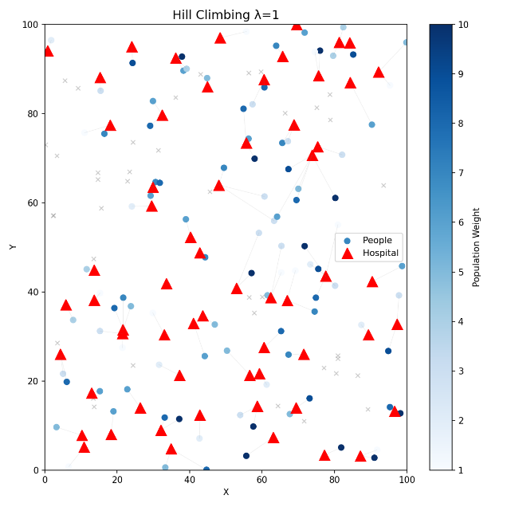 | 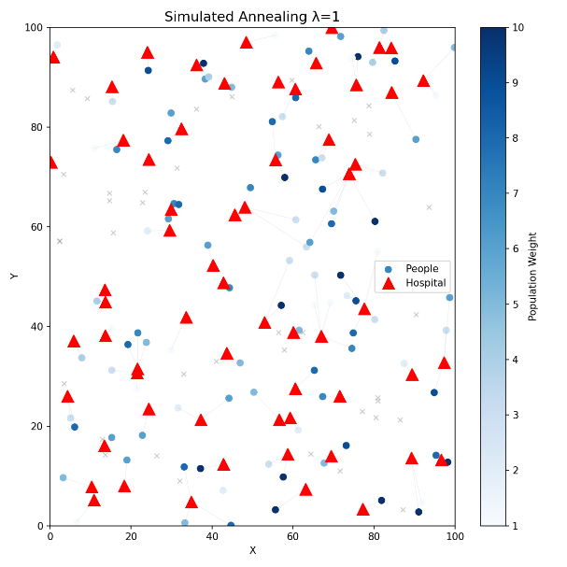
10 | 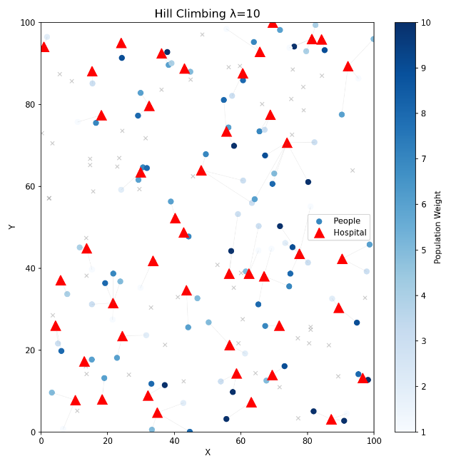 | 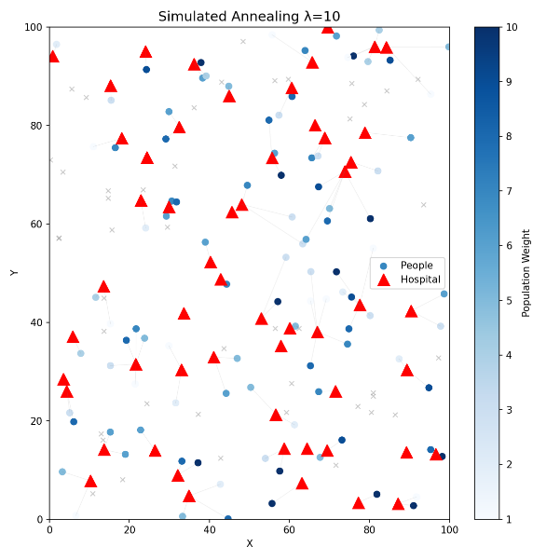
50 | 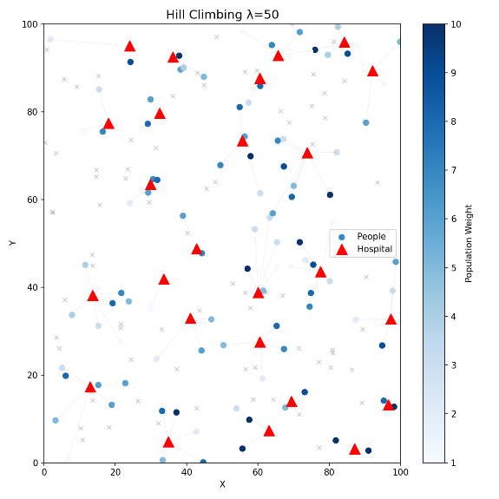 | 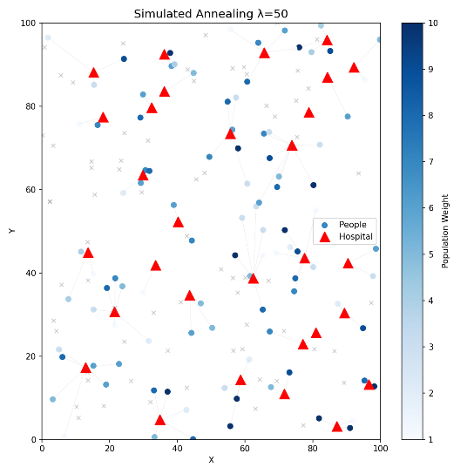
100 | 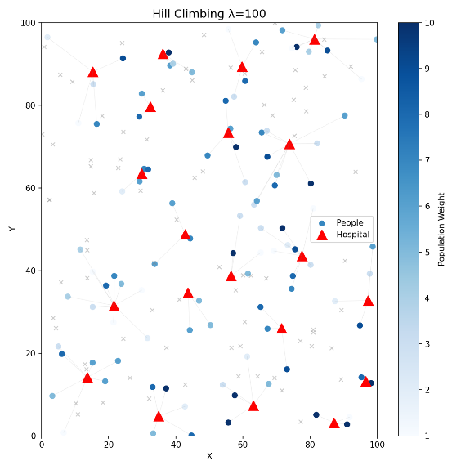 | 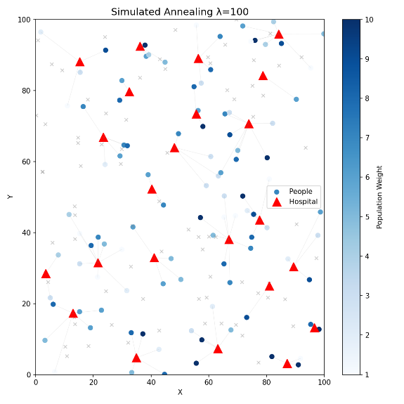

B. Effect of λ on Cost and Hospital Count
Two line charts were generated showing how λ affects average total cost and average number of hospitals selected, for both algorithms. As λ increases:
• Total cost increases for both algorithms (fewer hospitals → more travel).
• Number of hospitals decreases monotonically for both algorithms.
• Hill Climbing consistently selects fewer hospitals than SA at the same λ, achieving better cost.

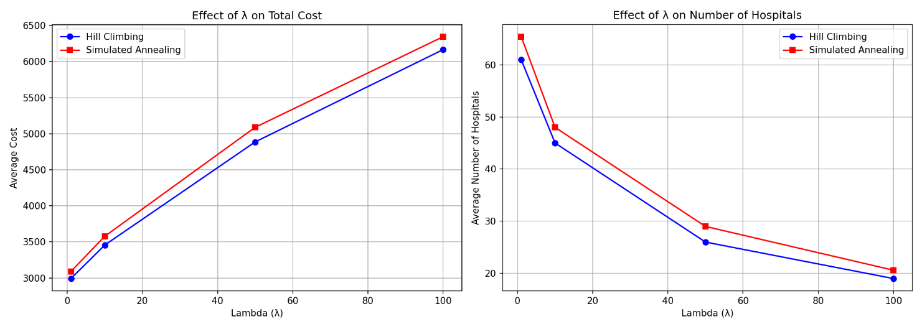

1.Effect of λ on Cost and Hospital Count

C. Algorithm Comparison Bar Charts
Side-by-side bar charts compare Hill Climbing and Simulated Annealing on:
• Average Cost: HC outperforms SA at every λ value.
• Variance: HC is dramatically more stable (nearly zero variance at λ=1 compared to SA's 5355).
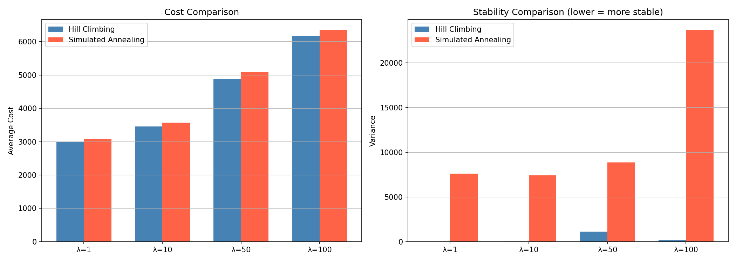
2:Algorithm Comparison Bar Charts.

D. Runtime Comparison
Bar charts show SA is consistently faster than HC (approximately 3–4× faster), because SA evaluates only 1 neighbour per step while HC evaluates k=10. However, HC's better solution quality and stability make it preferable when runtime is not critical.

7. Conclusion and Reflection
This project implemented and compared Hill Climbing and Simulated Annealing for the hospital location optimization problem. The key findings are: Hill Climbing is superior in solution quality and stability. It achieved lower cost than SA at every λ value and had near-zero variance at low λ. The structured neighbours evaluation (k=10 best neighbours) drives reliable convergence. However, Simulated Annealing is faster but less consistent. SA runs 3–4× faster due to evaluating only one neighbours per step, but its variance is orders of magnitude higher, suggesting it frequently gets trapped in poor local optima despite its acceptance probability mechanism. In addition , λ is the most impactful parameter. Increasing λ from 1 to 100 reduced hospital count in both algorithms, demonstrating the cost function correctly models the accessibility vs. construction trade-off.

In our opinion, this project provided us with practical knowledge of how these algorithms are applied in real-life scenarios, after studying them theoretically. It also enhanced our logical thinking and improved our ability to use these methods to solve real-world problems.

