Rock , Paper, Scissors

Rawan Eldeep 900223269

Zeina Zida 90022

Fundamentals of Simulation

Dr. Ali Hadi

The American University in Cairo



**Introduction** Rock, paper, scissors is a hand game which consists of players saying “rock, paper, scissors, shoot,” and the sequence goes as follows: rock beats scissors, scissors beats paper, paper beats rock. This game is believed to have originated in China during the Han dynasty before spreading to Japan, where it became popular as Jan-Ken, and eventually it spread all over the world, becoming a globally recognized decision-making and competitive game. The game offers surprising depth and findings when played repetitively, especially when strategies are used in the play.

**Objective** Our main objective for this project was to set the question of: how to win this game.  
 While the game can be treated as a game of chance, we were curious whether a specific strategy could outperform randomness. This question seemed to be specifically interesting as it ties into broader ideas about human behavior, predictability, and how simple adaptive systems can beat fixed patterns. This simulation allowed us to explore whether a strategy could be more beneficial for winning.

**Strategies** Two strategies were tested in our simulation over 10,000 rounds.

**Strategy 1: The Fixed Move** This strategy represents a player who always chooses the same move in every round of the game. For example, the player may always play "Rock" no matter what the opponent does. This kind of behavior is simple but predictable. It simulates a naive or stubborn opponent who doesn’t adapt or change their move based on the game’s progress. The purpose of using this strategy in the simulation is to test whether a smart opponent can detect and exploit this predictable behavior over time.

**Strategy 2: The Counter Player** In this strategy, we assumed that the player looks at the opponent’s move in the previous round and plays a move that would beat it. For example, if the opponent played Rock last round, the player would play Paper. This strategy mimics basic learning and adaptation.

**Design of the Experiment** For our simulation, we simulated 10,000 rounds of rock-paper-scissors using the two strategies mentioned above. We started out by defining the winning situations and losing situations

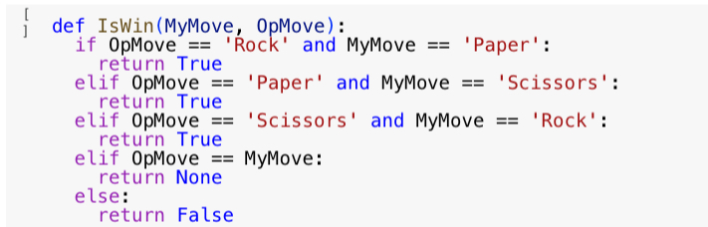

We then tested Strategy 1, where the player chose the same move every round

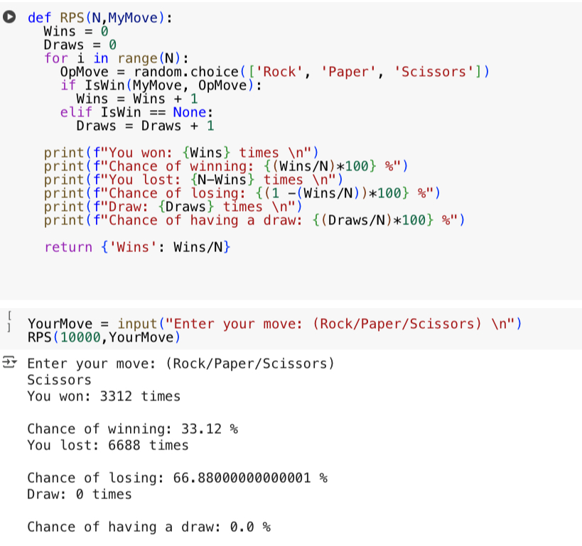

Following that we tested Strategy 2. The player uses a simple learning algorithm: it remembers the opponent’s last move and plays the move that beats it. The first round is played randomly. Results were also obtained.

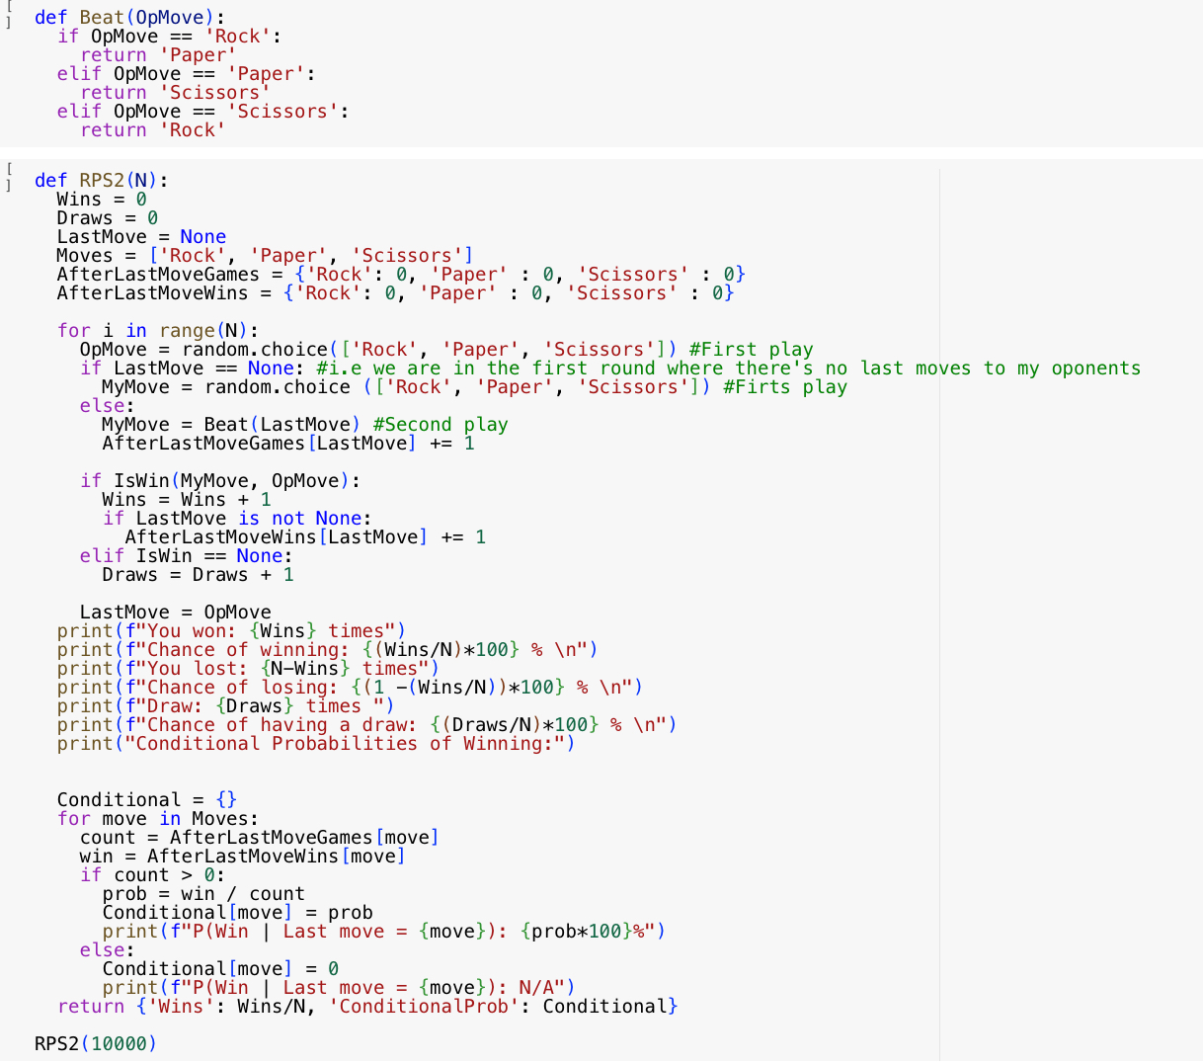

After each round for each strategy, the outcome was recorded whether win, loss, or draw and then we calculated overall win rates. In addition, for Strategy 2, we calculated conditional rates which represent how well the strategy performs based on the opponent’s last move.

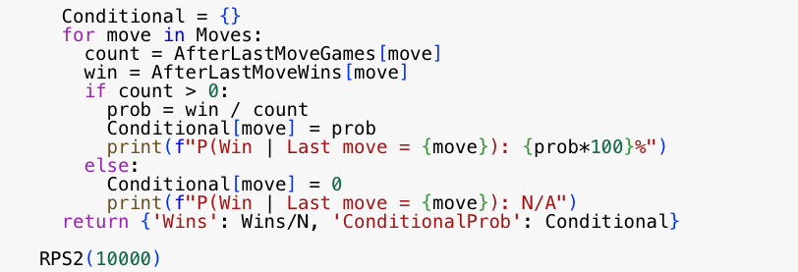

We finally visualized percentages for both strategies across all move types using a bar chart.

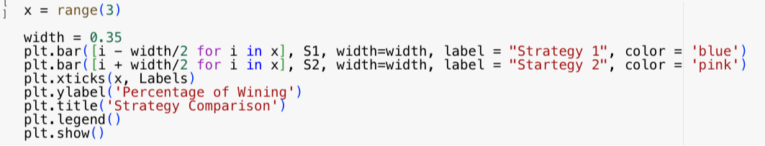

**Outputs and Interpretations** Strategy 1: The win rates ranged from 32.37% to 33.48% depending on the chosen fixed move, as seen below.

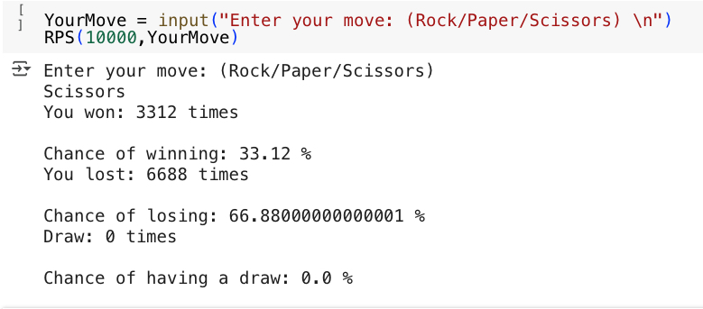  
 Strategy 2: An overall win rate of 32.69% was achieved.

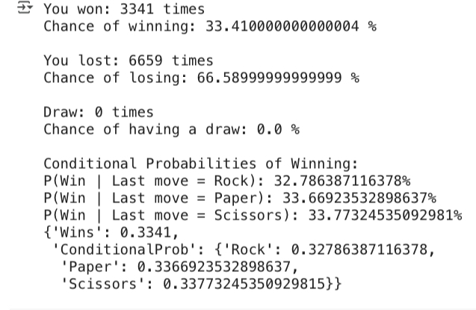 The conditional probabilities were as follows:

* 32.7% when the opponent last played Rock
* 32.1% when the opponent last played Paper
* 33.3% when the opponent last played Scissors

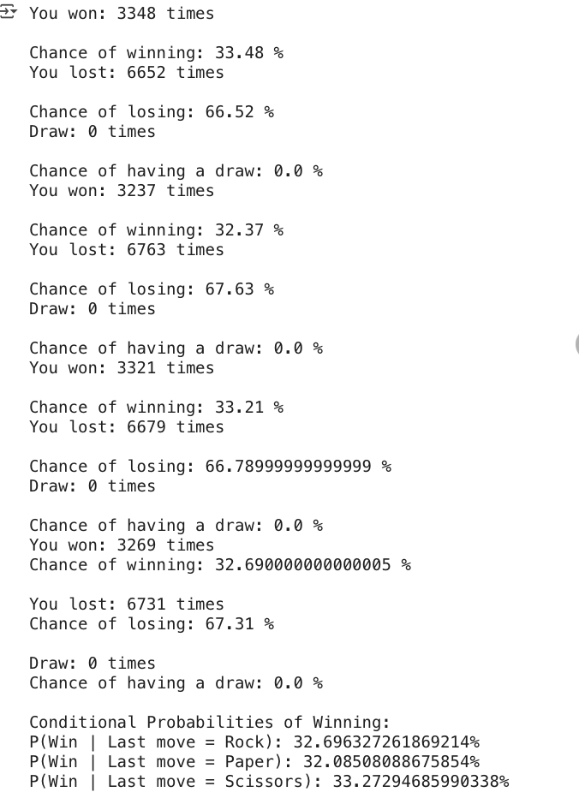

Despite being adaptive, Strategy 2 didn’t significantly outperform Strategy 1. This is likely because the opponent’s moves were randomly generated, meaning there were no real patterns to exploit.

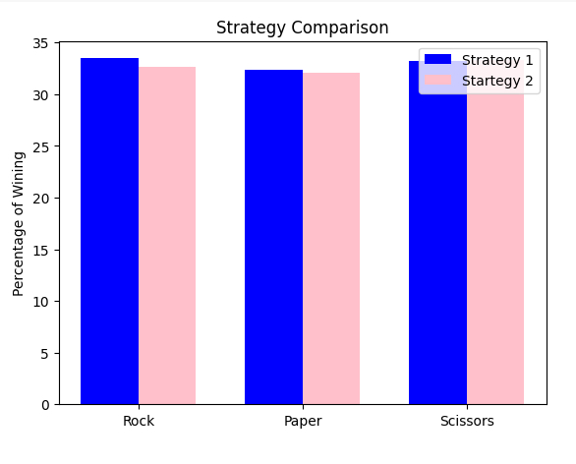

**Conclusion** In conclusion, we can realize from this experiment that adaptiveness alone isn’t enough when facing pure randomness. While Strategy 2 was designed to learn from the opponent, it couldn’t really learn because there wasn’t an existing pattern.  
 Overall, the best-performing strategy resulted in a winning rate of around 33%, which shows that in a perfectly random environment, no strategy can decisively dominate. However, this setup in the future might allow us to test more complex adaptive algorithms, especially when facing human opponents who may unintentionally follow patterns.