**Friendships**

(1) Query: **Display the relationships** created as given image

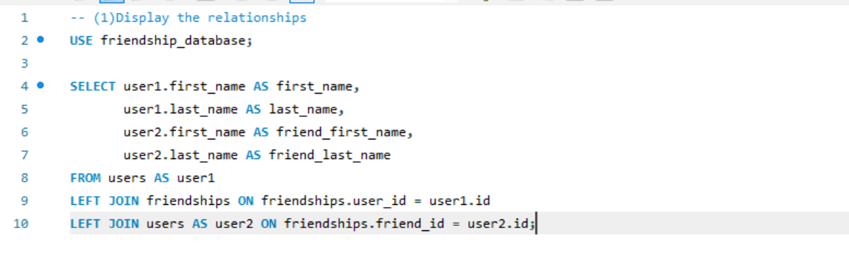

(2) NINJA Query: Return **all users who are friends with the first user**, **and make sure their names are displayed in the results**.

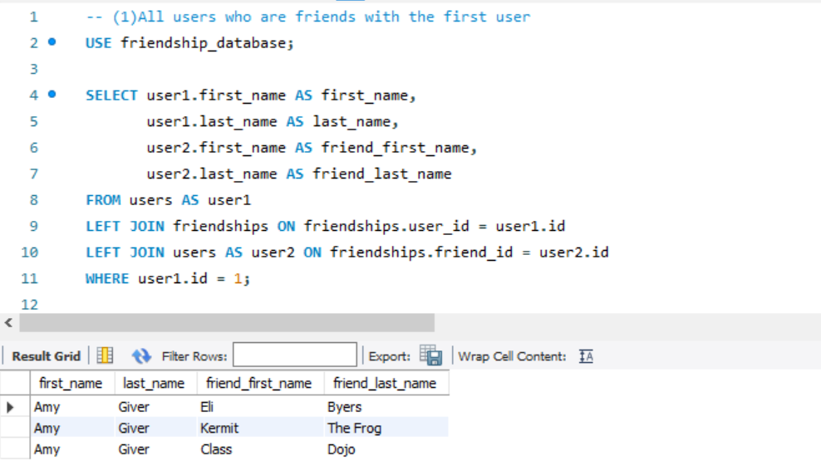

(3) NINJA Query: **Return the count of all friendships**

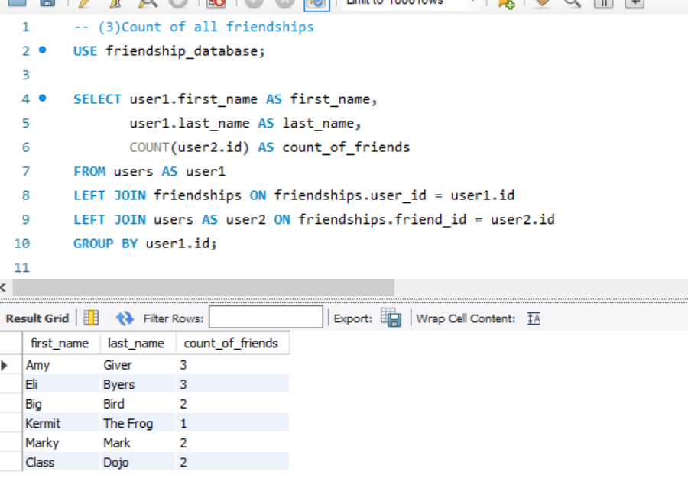

(4) NINJA Query: Find out who has **the most friends** and return the **count of their friends**.

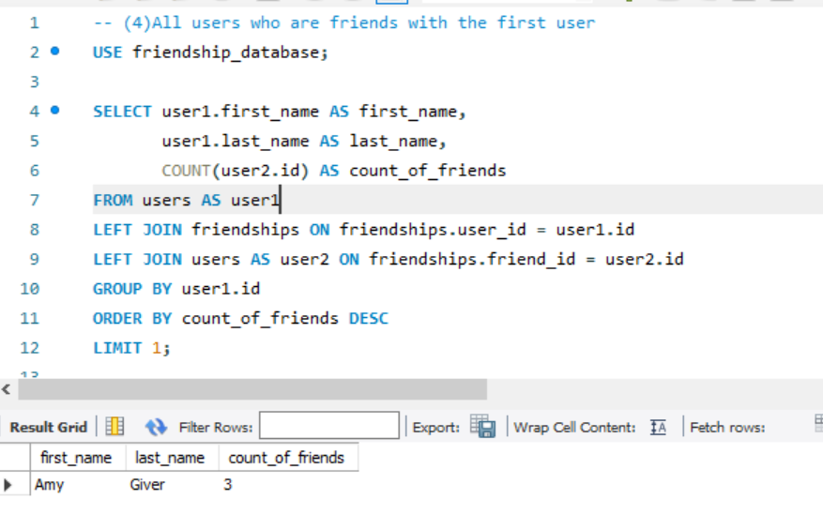

(5) NINJA Query: Return the friends of the third user in alphabetical order

