**MySQL Countries**

**(1)** Whatquery would you run to get all **the countries that speak Slovene**? Your query should return the **name of the country, language, and language percentage**. Your query should arrange the result by **language percentage in descending order**.

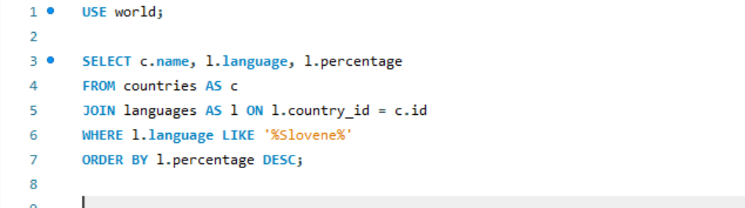

**(2)** What query would you run to display each **country's total number of cities**? Your query should return the **name of the country and the total number of cities**. Your query should arrange the result by the **number of cities in descending order**.

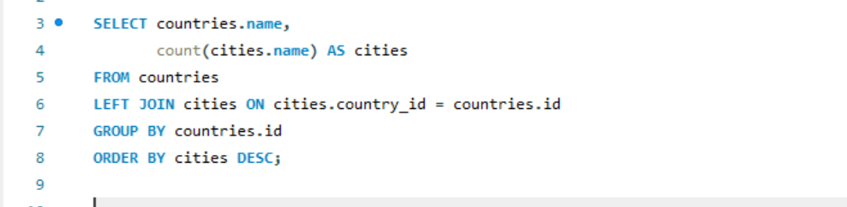

**(3)** What query would you run to **get all the cities in Mexico with a population greater than 500,000**? Your query should **arrange the results by population in descending order**.

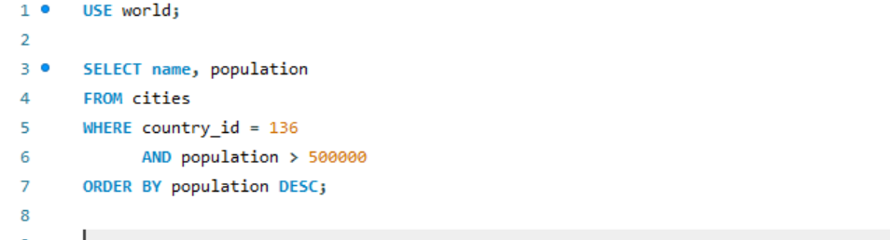

**(4)** What query would you run to get **all languages in each country with a percentage greater than 89%**? Your query should arrange the **result by percentage in descending order**.

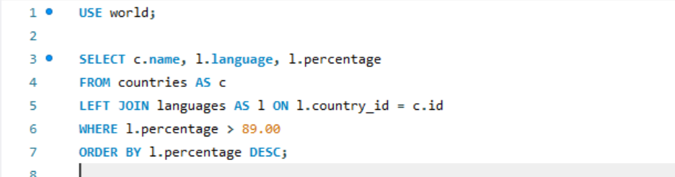

**(5)** What query would you run to **get all the countries with a Surface Area below 501** **and a** **Population greater than 100,000**?

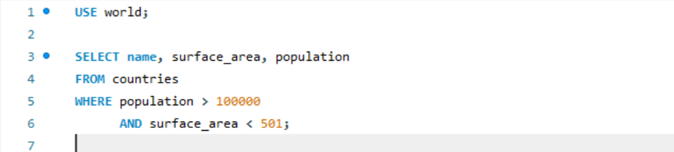

**(6)** What query would you run to get countries **with only a Constitutional Monarchy** with a **capital greater than 200** and a **life expectancy greater than 75 years**?

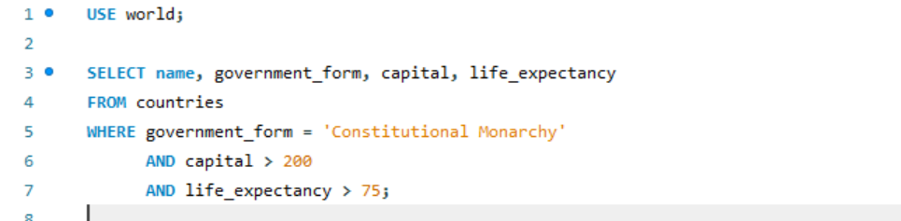

**(7)** What query would you run to get **all the cities of Argentina inside the Buenos Aires** **district** and **have a population greater than 500,000**? The query should return the **Country Name, City Name, District, and Population**.

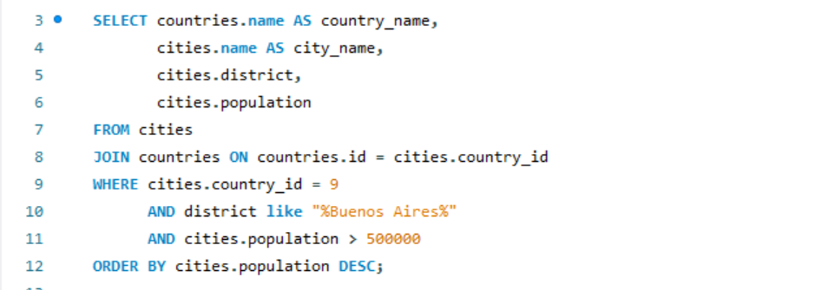

**(8)** What query would you run to **summarize the number of countries in each region**? The query should display the **region's name and the number of countries**. Also, the query should arrange the result by the **number of countries in descending order**

