**Sakila**

**(1)** What query would you run to get **all the customers inside city_id = 312**? Your query should return the **customer's** **first name, last name, email, and address**.

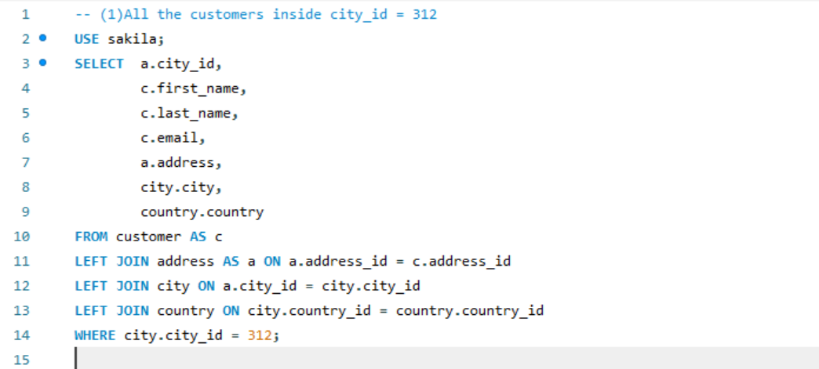

(2) What query would you run to get all **comedy films**? Your query should return the **film title, description, release year, rating, special features, and genre (category).**

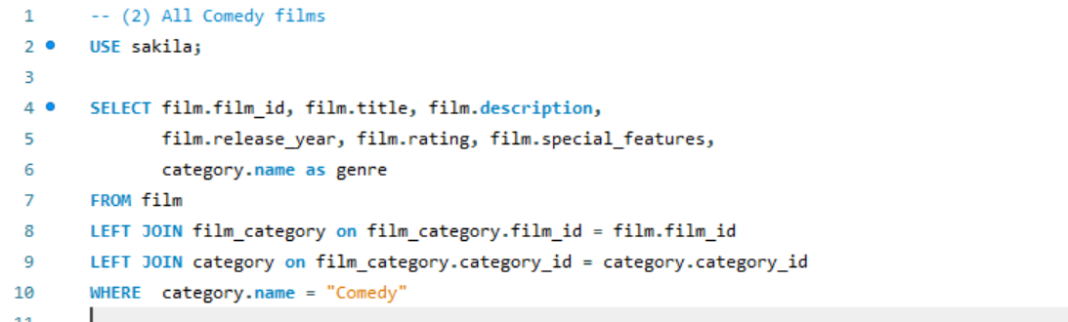

(3) What query would you run to get **all the films joined by actor_id=5**? Your query should return the **actor ID, name, film title, description, and release year**.

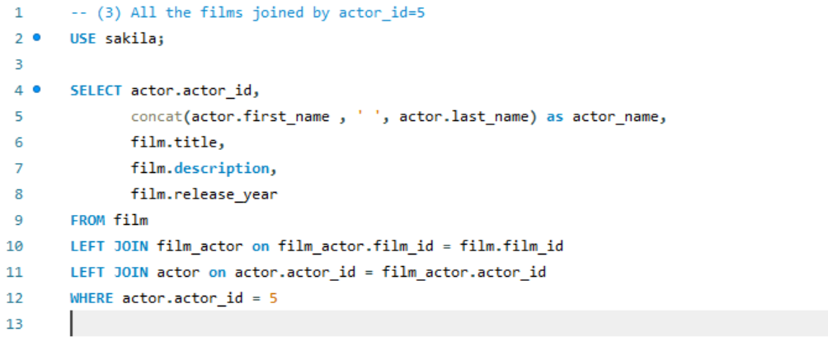

(4) What query would you run to get **all the customers in store_id = 1** and **inside these cities (1, 42, 312, and 459)?** Your query should return the customer's **first name, last name, email, and address**.

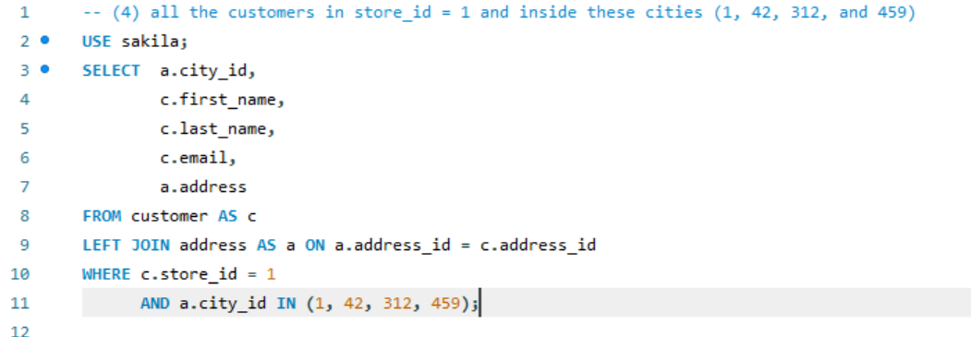

(5) What query would you run to **get all the films with a "rating = G" and "special feature = behind the scenes",** **joined by actor_id = 15**? Your query should return the **film title, description, release year, rating, and special feature**. Hint: You may use the **LIKE function to get the 'behind the scenes'** part.

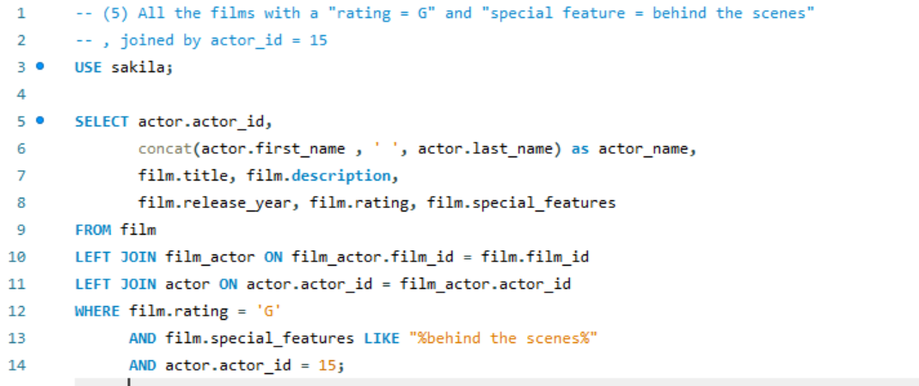

(6) What query would you run to get **all the actors joining the film_id = 369**? Your query should return the **film_id, title, actor_id, and actor_name**.

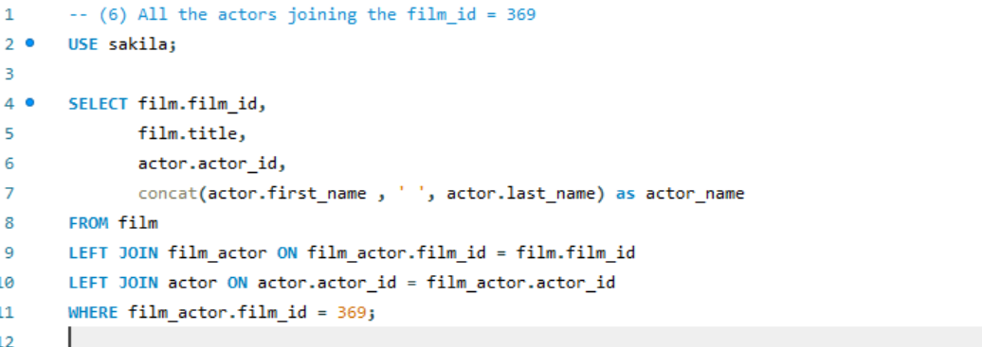

(7) What query would you run **to get all drama films** **with a rental rate of 2.99**? Your query should return the **film title, description, release year, rating, special features, and genre (category)**.

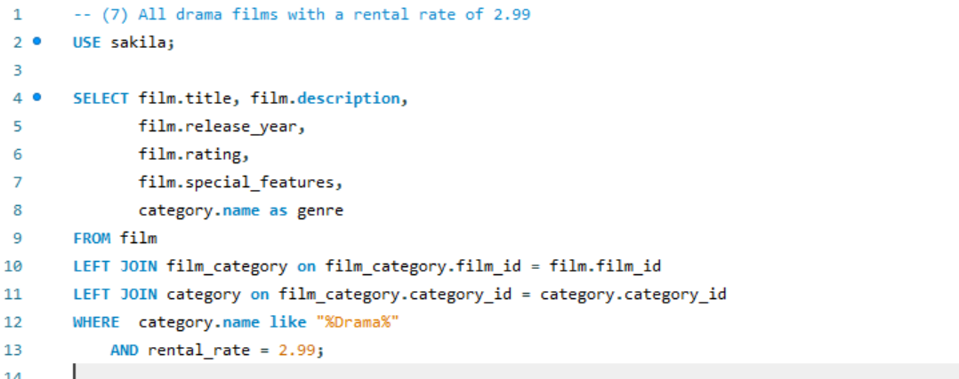

8. What query would you run to get **all the action films joined by SANDRA KILMER**? Your query should return the **film title, description, release year, rating, special features, genre (category), and actor's first and last name.**

