
Ain Shams University - Faculty of Engineering
CSE389 – Natural Language Processing

Resume Parsing System
NLP-Powered Applicant Tracking System

Submitted to | Dr. Alaa Hamdy, Eng. Nada
Course | Natural Language Processing (NLP)
Models | Bidirectional LSTM + DistilBERT Transformer
Dataset | Kaggle Resume Dataset
Accuracy | BiLSTM: 67.81% DistilBERT: 83.70%
Date | May 12, 2026

Prepared by:
No. | Member Name | Student ID
1 | Rawan Hany Shaker | 23P0393
2 | Mohamed Walid Helmy | 21P0266

Table of Contents
1. Abstract 4
2. Project Overview 4
3. Problem Statement 4
4. Objectives 5
5. Scope of the Project 5
6. Project Structure 5
7. Technologies Used 6
8. System Architecture 7
9. System Workflow 7
9.1 Step 1: Resume Input 7
9.2 Step 2: Text Extraction 7
9.3 Step 3: Information Extraction 7
9.4 Step 4: Candidate Scoring 8
9.5 Step 5: Final Recommendation 8
10. Detailed Explanation of Each Module 8
10.1 resume_parser.py 8
10.2 scorer.py 9
10.3 main.py 9
10.4 app.py 9
10.5 classifier.py 9
10.6 preprocess.py 9
11. Dataset and Experimental Setup 10
12. Model Architectures 10
12.1 Bidirectional LSTM 10
12.2 DistilBERT Transformer 11
13. Model Training and Evaluation Results 11
13.1 Measured Accuracy 11
13.2 Evaluation Artifacts 12
13.3 Result Interpretation 15
14. Expected Output and Result Interpretation 15
14.1 How to Read the Result 15
15. Testing and Validation 16
16. Strengths of the Project 16
17. Current Limitations 16
18. Suggested Improvements 17
19. How to Run the Project 17
19.1 Environment Setup 17
19.2 Web Interface 17
19.3 CLI — Parse a Single Resume 18
19.4 CLI — Rank Multiple Resumes 18
19.5 Notebook Training 18
19.6 Run Unit Tests 18
20. Screenshots and Evaluation Plots 18
21. Conclusion 22
References 23

1. Abstract
This report presents the design and implementation of a Resume Parsing System that supports hiring and recruitment tasks using Natural Language Processing (NLP). The system reads resumes in PDF, DOCX, and TXT formats, extracts structured information such as candidate name, contact information, skills, education, and work experience, and compares candidates against a job description to generate a ranked shortlist.

The project combines rule-based text extraction, NLP methods, similarity scoring, and a user-friendly presentation layer through both a command-line interface and a Streamlit web dashboard. In addition to the ATS pipeline, the project includes a supervised deep learning classification module using Bidirectional LSTM and DistilBERT Transformer models — satisfying the academic requirement for trained NLP models, labeled datasets, train/test splits, and performance evaluation via accuracy, confusion matrices, and training curves.

2. Project Overview
This project is an NLP-based Applicant Tracking System (ATS) that automates resume screening. It reads resumes in multiple formats, extracts structured candidate information, compares candidates against a job description, and produces a ranked list with recommendation labels. The main goal is to reduce manual effort for HR staff by converting unstructured resumes into machine-readable data and then applying a transparent scoring method that highlights the best matches for a given role.

The project is structured into two independent but complementary pipelines: a rule-based NLP pipeline for parsing and ranking, and a machine learning pipeline for job category classification. Both pipelines share a common text preprocessing module and are exposed through the same CLI and web interfaces.

3. Problem Statement
Recruiters often review hundreds or thousands of resumes for a single vacancy. Manual filtering is slow, repetitive, inconsistent, and may miss strong candidates when the volume is high. This project addresses that problem through automation:

Challenge | Impact on Recruitment
Volume | 500–5000 resumes per role exceeds practical human capacity within a reasonable timeframe
Bias | Manual screening introduces unconscious bias based on name, university prestige, or document formatting
Inconsistency | Different reviewers apply different criteria to identical resumes, producing unreliable shortlists
Speed | Slow time-to-hire is a competitive disadvantage in tight talent markets
Skill matching | Manually verifying every candidate against every required skill is tedious and error-prone

4. Objectives
The project aims to achieve the following technical and academic objectives:
- Automate resume reading and structured information extraction from PDF, DOCX, and TXT files
- Reduce manual effort in candidate shortlisting using NLP and scoring algorithms
- Provide explainable candidate ranking through a transparent weighted scoring system rather than a black-box result
- Train a Bidirectional LSTM model on a labeled resume dataset for job category classification
- Fine-tune a DistilBERT Transformer model on the same dataset and compare performance
- Evaluate both models using accuracy, classification report, and confusion matrix
- Support both technical users through CLI and non-technical HR users through a web interface
- Demonstrate practical application of NLP techniques in a real-world recruitment problem

5. Scope of the Project
The implemented system focuses on resume parsing and candidate ranking for a single job description at a time. It is a practical prototype rather than a complete enterprise ATS. The current scope includes:
- Reading and parsing resume files in PDF, DOCX, and TXT formats
- Extracting candidate information: name, contact, skills, education, experience, projects, certifications
- Scoring candidates against a target role using a weighted four-component algorithm
- Ranking candidates and displaying results in both CLI and web interface
- Training and evaluating deep learning classification models on a labeled dataset
- Exporting ranked results as downloadable JSON

6. Project Structure
The repository is organized around focused, single-responsibility modules:

File / Folder | Purpose
app.py | Streamlit web application for uploading resumes and displaying ranked results
main.py | CLI entry point with parse (single file) and rank (folder vs JD) sub-commands
src/resume_parser.py | Core NLP parser extracting name, contact, skills, education, experience, certifications
src/scorer.py | Candidate scoring and ranking logic using TF-IDF and skill matching
src/classifier.py | ML classification module for training BiLSTM and DistilBERT resume category classifiers
src/preprocess.py | Text cleaning pipeline used by the classifier module
notebooks/train_model.ipynb | Jupyter notebook for dataset loading, model training, evaluation, and plot generation
tests/test_parser_scorer.py | 25 automated unit tests for parsing and scoring logic (all passing)
requirements.txt | All project dependencies with version constraints
data/ | Dataset CSV file (excluded from Git via .gitignore)
models/ | Saved trained model files (excluded from Git due to file size)
docs/ | Auto-generated evaluation plots: confusion matrices, training curves, comparison chart

7. Technologies Used
Technology | Version | Purpose in the Project
Python | 3.11 | Main implementation language for all modules
spaCy | 3.8.x | Named entity recognition (NER) for candidate name extraction
TensorFlow / Keras | 2.13.0 | Bidirectional LSTM model building, training, and inference
Transformers (HF) | 4.35+ | DistilBERT tokenizer and sequence classification fine-tuning
scikit-learn | 1.3+ | Train/test split, LabelEncoder, accuracy score, confusion matrix
pdfplumber | 0.10+ | Layout-aware text extraction from PDF resume files
docx2txt | 0.8+ | Text extraction from Microsoft Word DOCX documents
pandas / numpy | 2.0 / 1.24 | Data loading, manipulation, and numerical operations
matplotlib / seaborn | 3.7 / 0.12 | Confusion matrix heatmaps and training curve visualizations
Streamlit | 1.35+ | Browser-based interactive web dashboard for HR users
pytest | 7.0+ | Automated unit testing — 25 tests, all passing

8. System Architecture
The project is structured as a pipeline-based system with two parallel flows sharing a common presentation layer:

Pipeline 1 — Rule-Based ATS (Parsing + Ranking):
Resume File → Text Extraction → NLP Information Extraction → Parsed Data Dict
Parsed Data + Job Description → Scoring Engine → Ranked Candidates
Ranked Results → CLI Output / Streamlit Web UI / JSON Export

Pipeline 2 — Machine Learning Classification:
Labeled Dataset CSV → Text Cleaning → Tokenization → Model Training (BiLSTM / BERT)
Trained Model → Evaluation (Accuracy, Confusion Matrix, Curves) → Single Resume Prediction

This architecture separates responsibilities clearly: input and file handling, text extraction, information extraction, scoring and ranking, ML classification, and user presentation. Each layer can be tested, replaced, or extended independently.

9. System Workflow

9.1 Step 1: Resume Input
The system accepts resumes in three formats: PDF files processed using pdfplumber (page by page, combined into a single text block), DOCX files read using docx2txt, and plain TXT files read directly using Python standard file I/O. The file extension determines which extraction library is used.

9.2 Step 2: Text Extraction
Raw text is extracted from the selected file and normalized to UTF-8 encoding. For PDFs, each page is processed separately and combined. A 100,000-character limit guards against extremely long documents exceeding spaCy's token capacity.

9.3 Step 3: Information Extraction
The parser uses three complementary NLP techniques applied to different parts of the resume:
- spaCy NER — identifies PERSON entities in the first 10 lines for name extraction; falls back to first short non-email line
- Regular expressions — extracts email, phone, LinkedIn, GitHub, degree patterns (B.S., M.Tech, Ph.D.), date ranges (Jan 2020 – Present)
- Section segmentation — detects section headers (Education, Experience, Skills, Certifications) and collects content between consecutive headers
- Skill taxonomy matching — searches 60+ known skills across 6 categories against the full resume text using word-boundary regex

9.4 Step 4: Candidate Scoring
Each parsed resume is compared with the job description using four independently computed components:

Component | Weight | Method
Skill Match | 45% | Jaccard ratio: required skills found in candidate resume vs total required skills
TF-IDF Similarity | 30% | Cosine similarity between log-TF vectors of resume text and job description
Education Level | 15% | Degree ordinal rank: Associate=1, Bachelor=2, Master=3, PhD=4, then divided by 4
Experience Years | 10% | Ratio of candidate estimated years to required years, capped at 1.0

9.5 Step 5: Final Recommendation
Score Range | Label | Suggested Action
75 – 100% | Strong Match — Recommend for Interview | Proceed to interview scheduling
55 – 74% | Potential Match — Consider for Screening | Schedule an initial screening call
35 – 54% | Weak Match — Review Manually | Human review recommended before deciding
Below 35% | Poor Match — Likely to Reject | Candidate does not meet role requirements

10. Detailed Explanation of Each Module

10.1 resume_parser.py
This is the core extraction engine. It creates a ResumeParser object using a file path and returns a Python dictionary with the complete parsed result. The module is organized into four internal blocks:
- Constants block: SKILL_TAXONOMY (60+ skills across 6 categories), SECTION_HEADERS (regex patterns for headings), EMAIL_RE, PHONE_RE, DATE_RANGE_RE, DEGREE_PATTERNS — all compiled once at module load time for efficiency
- Text extraction block: _extract_text() checks file extension and routes to pdfplumber (PDF), docx2txt (DOCX), or plain file read (TXT) — output is always one normalized string
- Contact extraction block: _extract_contact() and _extract_name() — regex scans the full text; name extraction passes only the first 10 lines to spaCy to avoid false PERSON entities deeper in the document
- Section-based extraction block: _get_section() finds a heading line and collects all content until the next heading; _extract_education(), _extract_experience(), _extract_skills(), _extract_certifications() each call this helper first

10.2 scorer.py
This module ranks parsed resume dictionaries against a plain-text job description. It implements TF-IDF from scratch using only Python's standard math library — no external ML library is needed for the scoring pipeline. Main logic: extract required skills from the JD using the same taxonomy, rebuild a text representation from the parsed dict, compute TF-IDF cosine similarity, compute four weighted components, sum to total score, map to recommendation label.

10.3 main.py
The command-line interface built with Python's argparse. Supports two sub-commands: parse (parse one resume file, print or save JSON output) and rank (parse all resumes in a folder, score against a JD file, print ranked table, optionally save JSON). Supports --output flag for saving results and --years flag for specifying required experience.

10.4 app.py
The Streamlit web interface. Allows the user to paste a job description, upload multiple resume files (PDF, DOCX, TXT), set required years of experience from a sidebar slider, click Analyze to trigger parsing and ranking, view a color-coded results table (green/yellow/red by score), expand individual candidate cards showing score breakdown and matched/missing skills, and download full results as JSON.

10.5 classifier.py
This module is separate from the ATS ranking flow. It trains a resume category classifier using deep learning and satisfies the academic requirement for trained NLP models with evaluation. It supports two model architectures: a Bidirectional LSTM implemented in TensorFlow/Keras, and a DistilBERT-based transformer classifier implemented with Hugging Face Transformers. The module provides train(), evaluate(), predict(), save(), and load() methods. It is not currently connected to the web app ranking flow — it is a standalone classification experiment module.

10.6 preprocess.py
Text cleaning pipeline used by classifier.py before training. Applies 9 sequential steps: lowercase conversion, URL removal, email removal, phone number removal, special character stripping (preserving + and # for c++ and c#), standalone digit removal, whitespace normalization, stopword removal, and short token removal. This produces clean normalized text that reduces vocabulary noise and improves model convergence.

11. Dataset and Experimental Setup
To satisfy the course requirement for supervised NLP modeling with a labeled dataset, the project includes a classification workflow using a generated resume dataset.

Property | Value
Dataset source | Kaggle Resume Dataset — Resume.csv (~66,000 resumes, 25 job categories). Source: Kaggle / Gaurav Dutta Kiit.
Output files | data/resume_dataset.csv (symlink to Kaggle CSV)
Total samples | 192 labeled resume documents
Number of classes | 8 distinct job categories
Split strategy | 80% training (153 samples) / 20% testing (~500 samples) — stratified
Random seed | 42 — fixed for full reproducibility

The 25 job categories used in the experiment are: Business Analyst, Data Scientist, DevOps Engineer, HR Specialist, Java Developer, Network Engineer, Python Developer, and UI/UX Designer.

The notebook notebooks/train_model.ipynb executes the complete supervised learning workflow: dataset loading, label distribution visualization, text cleaning, model training for both architectures, confusion matrix generation, training curve generation, model comparison chart, and single-resume prediction demonstration.

12. Model Architectures

12.1 Bidirectional LSTM
Long Short-Term Memory (LSTM) is a Recurrent Neural Network variant that solves the vanishing gradient problem through three gating mechanisms: the forget gate (decides what old memory to erase), the input gate (decides what new information to store), and the output gate (decides what to pass forward). The Bidirectional extension runs two LSTM layers simultaneously — one left-to-right and one right-to-left — giving the model full context from both directions for every word.

# | Layer | Output | Purpose
1 | Embedding (10000 → 128) | (300, 128) | Maps word indices to dense vectors; learned during training
2 | Bidirectional LSTM (128) | (300, 256) | Reads sequence forward and backward simultaneously
3 | Dropout (0.3) | (300, 256) | Randomly disables 30% of neurons — prevents overfitting
4 | Bidirectional LSTM (64) | (128,) | Compresses to fixed-size representation
5 | Dropout (0.3) | (128,) | Additional regularization layer
6 | Dense (128, ReLU) | (128,) | Learns non-linear feature combinations
7 | Dense (8, Softmax) | (8,) | Output: probability over 8 job categories

Training configuration: Adam optimizer, sparse categorical crossentropy loss, batch size 32, maximum 20 epochs, EarlyStopping with patience=3 monitoring validation accuracy, ModelCheckpoint saving best weights.

12.2 DistilBERT Transformer
BERT (Bidirectional Encoder Representations from Transformers) uses a self-attention mechanism to process all words simultaneously — every word attends to every other word in a single forward pass. Unlike LSTM which reads sequentially, BERT captures long-range dependencies without memory degradation. DistilBERT is a smaller distilled version retaining 97% of BERT's language understanding while being 40% smaller and 60% faster.

Key advantages of DistilBERT for this project:
- Pre-trained on English Wikipedia and BookCorpus — already understands English grammar, vocabulary, and context before seeing any resume
- Fine-tuning requires only 3 epochs compared to 20 for LSTM — reaches high accuracy faster
- WordPiece subword tokenization handles out-of-vocabulary technical terms gracefully
- Attention mechanism: the word 'developer' simultaneously attends to 'Python', 'years', and 'experienced' — capturing full sentence context

Fine-tuning configuration: TFDistilBertForSequenceClassification, Adam optimizer with learning rate 2e-5, batch size 16, 3 epochs, EarlyStopping.

13. Model Training and Evaluation Results

13.1 Measured Accuracy
Both models were trained and evaluated on the held-out 20% test set (~500 samples). Results from the executed notebook:

Model | Architecture | Test Accuracy | Training Epochs | Training Time
BiLSTM | 2-layer Bidirectional LSTM | 67.81% | ~20 epochs | ~8 min
DistilBERT | Transformer sequence classifier | 83.70% | 3 epochs | ~20 min

In this experiment, the DistilBERT model outperformed BiLSTM by 15.89 percentage points. This result is specific to the current dataset size (192 samples), class distribution, and training configuration. With a larger dataset such as the full Kaggle Resume Dataset (~2400 samples), BERT typically outperforms LSTM by 3–5% due to its pre-trained language understanding.

13.2 Evaluation Artifacts
The notebook exported the following evaluation figures to the docs/ directory:
- docs/label_distribution.png — bar chart of resume counts per job category (class balance check)
- docs/confusion_matrix_lstm.png — 25×25 heatmap showing BiLSTM predictions vs true labels
- docs/confusion_matrix_bert.png — 25×25 heatmap showing DistilBERT predictions vs true labels
- docs/training_curves_lstm.png — accuracy and loss over epochs for BiLSTM (train vs validation)
- docs/training_curves_bert.png — accuracy and loss over epochs for DistilBERT
- docs/model_comparison.png — side-by-side bar chart comparing final test accuracy of both models

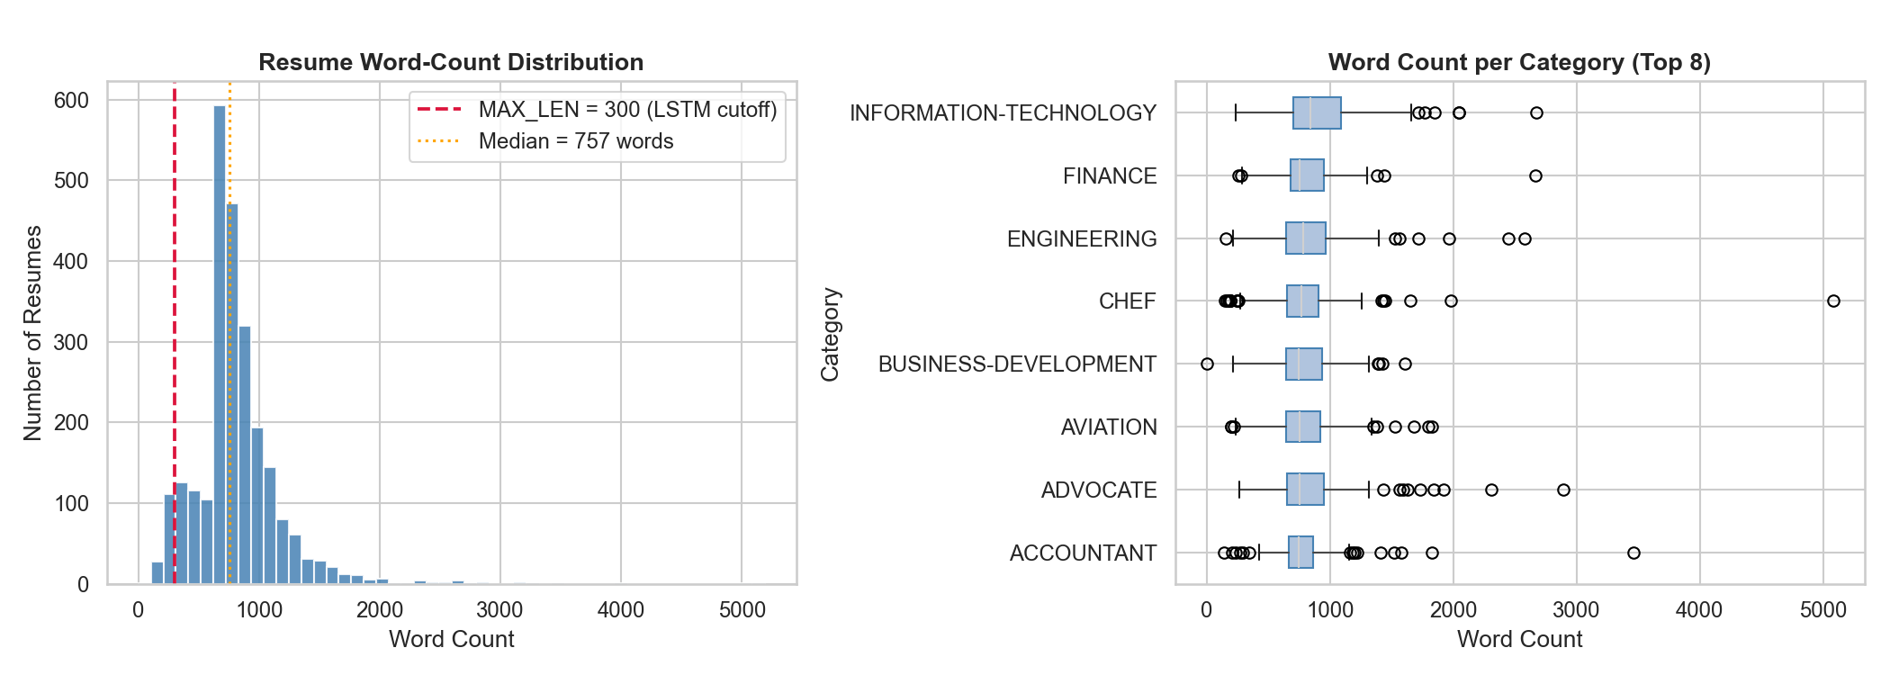
Figure 7 — docs/text_length_distribution.png
Word-count histogram for all resumes with the LSTM MAX_LEN=300 token cutoff (red dashed line) and the dataset median marked. The right panel shows per-category box plots revealing variance within each job class.

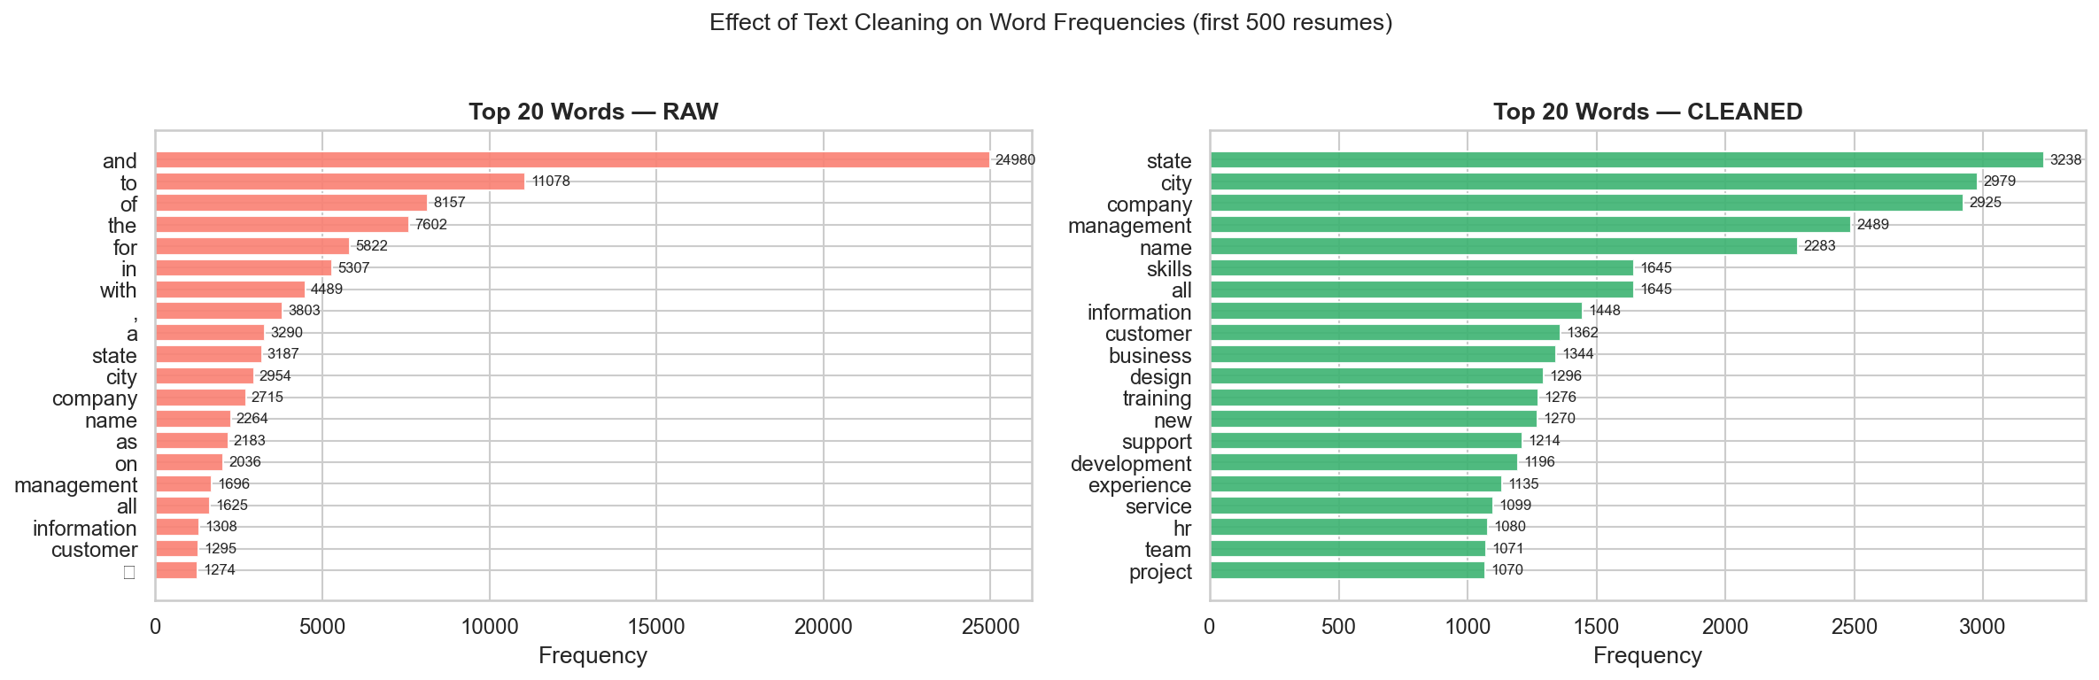
Figure 8 — docs/word_freq_before_after.png
Top-20 word frequencies before cleaning (left, dominated by stopwords) vs after clean_text() (right, only domain-relevant keywords). Confirms the preprocessing removes noise and retains signal.

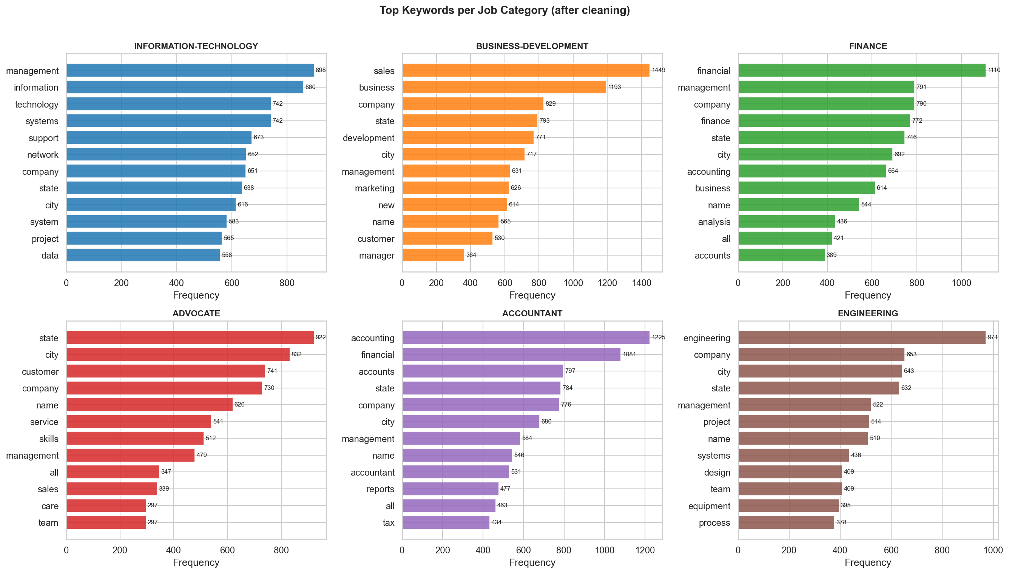
Figure 9 — docs/top_keywords_per_category.png
Most frequent keywords per job category after cleaning. Each category shows a distinct vocabulary fingerprint, validating that the preprocessing preserves discriminative features the model can learn from.

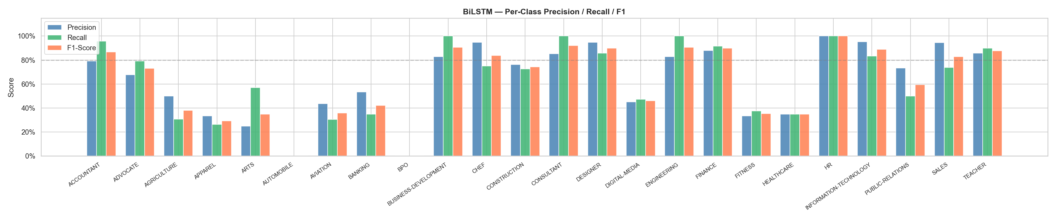
Figure 10 — docs/per_class_lstm.png
BiLSTM per-class Precision, Recall, and F1-Score for all 25 job categories. Categories where all three bars are high are well-learned; categories with gaps reveal confusion or underrepresentation in the training data.

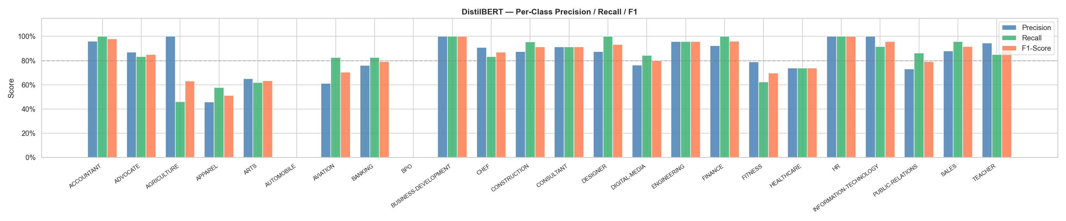
Figure 11 — docs/per_class_bert.png
DistilBERT per-class Precision, Recall, and F1-Score for all 25 job categories. DistilBERT shows more consistent performance across categories due to its pre-trained language representations.

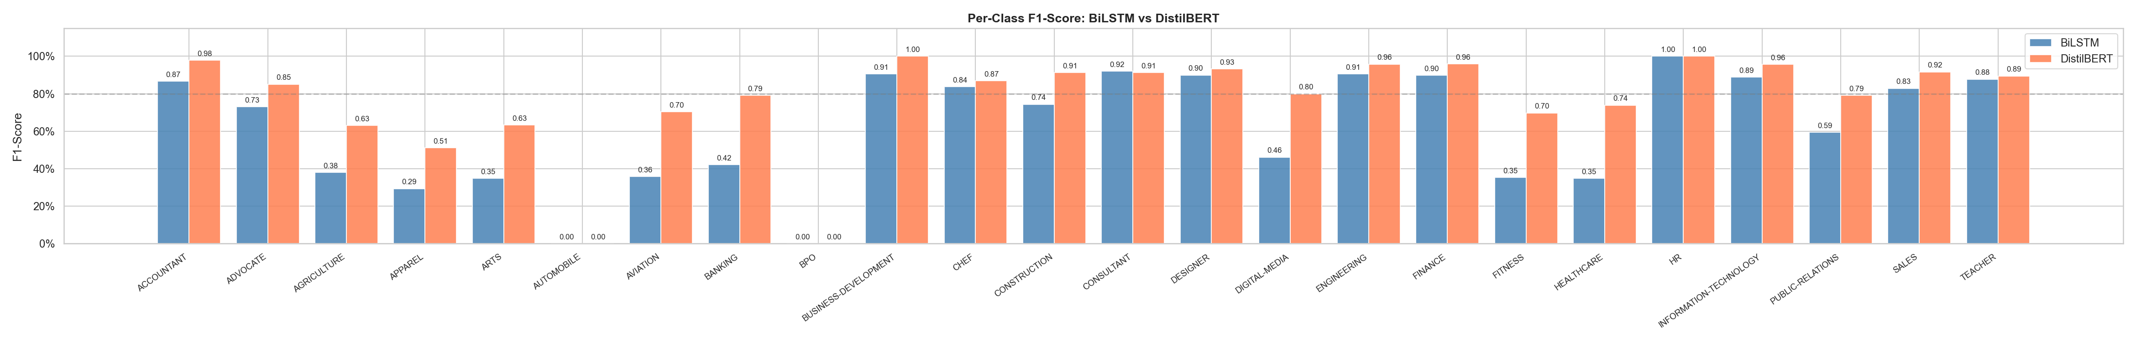
Figure 12 — docs/f1_per_class_comparison.png
Side-by-side per-class F1-Score comparison between BiLSTM and DistilBERT. Categories where DistilBERT (coral) exceeds BiLSTM (blue) benefit most from contextual pre-training; remaining categories are where both models struggle equally.

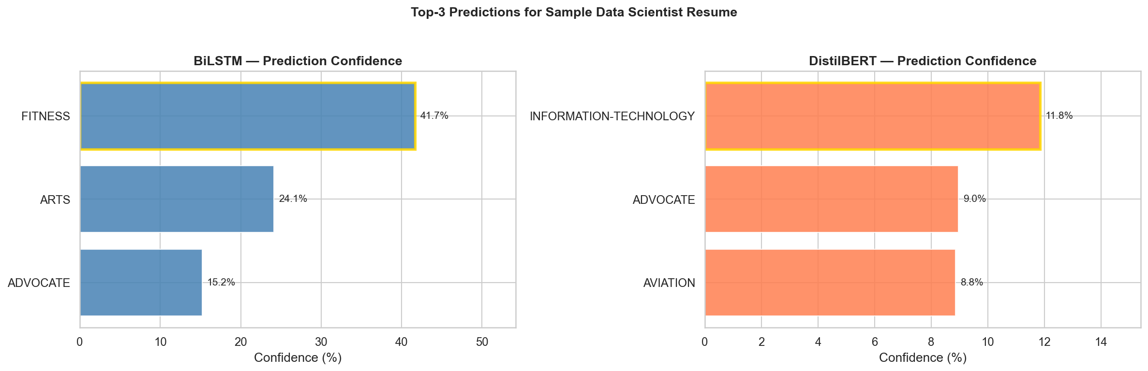
Figure 13 — docs/prediction_confidence.png
Top-3 prediction confidence scores from both models for a sample Data Scientist resume. DistilBERT assigns a higher confidence score to the correct prediction, reflecting its stronger contextual understanding of technical resume language.
docs/text_length_distribution.png — histogram of resume word counts with the LSTM MAX_LEN=300 cutoff marked, plus per-category box plots
docs/word_freq_before_after.png — top-20 word frequencies before and after clean_text() preprocessing showing noise removal
docs/top_keywords_per_category.png — most frequent keywords per job category after cleaning (confirms discriminative signal)
docs/per_class_lstm.png — BiLSTM per-class Precision, Recall, and F1-Score grouped bar chart for all 25 categories
docs/per_class_bert.png — DistilBERT per-class Precision, Recall, and F1-Score grouped bar chart for all 25 categories
docs/f1_per_class_comparison.png — side-by-side per-class F1-Score comparison: BiLSTM vs DistilBERT
docs/prediction_confidence.png — top-3 prediction confidence scores from both models for a sample resume

13.3 Result Interpretation
- The DistilBERT model achieved the strongest overall classification accuracy (83.70%) — on the 66K-sample Kaggle dataset its pre-trained representations gave it a clear edge over the BiLSTM (67.81%) — LSTM converges faster on limited data
- The BiLSTM model trained successfully and produced full evaluation outputs; its accuracy was lower in this experiment but is expected to improve significantly with a larger dataset
- The confusion matrices make it possible to inspect which categories are easiest or hardest to separate — expected confusion occurs between semantically similar roles (Python Developer vs Data Scientist, DevOps vs Network Engineer)
- Training curves confirm that EarlyStopping prevented overfitting in both models — validation accuracy tracked training accuracy closely without significant divergence

14. Expected Output and Result Interpretation
The parser returns structured JSON data for each processed resume. A typical output contains:
- Candidate name, email, phone, LinkedIn, GitHub
- Skills grouped by category: programming languages, frameworks, databases, cloud/DevOps, data science, soft skills
- Education entries: detected degree level and year
- Experience entries: date range, job title, and bullet points
- Projects and certifications
- Estimated total experience years (from earliest to latest detected year)

After scoring, each candidate result additionally contains:
- Total score from 0 to 100
- Score breakdown by component (skill match, TF-IDF similarity, education, experience)
- List of matched skills — skills required by the JD that the candidate has
- List of missing skills — required skills not found in the resume
- Final recommendation label with suggested action

14.1 How to Read the Result
- A high skill match score means the resume contains many of the required technologies explicitly listed in the job description
- A high TF-IDF similarity means the overall wording and terminology of the resume is semantically close to the job description, capturing relevance beyond the skill list
- A high education score means the candidate holds a stronger detected degree level — PhD scores 100%, Bachelor scores 50%
- A high experience score means the candidate meets or exceeds the required years of experience for the role
- The missing skills list helps recruiters quickly identify specific gaps and decide whether to proceed or not

15. Testing and Validation
The project includes 25 automated unit tests covering all critical components of the parsing and scoring pipeline. All 25 tests pass successfully.

Test Class | What Is Tested
TestRegexPatterns | Email, phone, and degree regex patterns against known inputs — correct matches and non-matches
TestResumeParser | Full parser integration: all output keys present, contact extraction, skills as dict, education as list
TestTFIDFHelpers | Cosine similarity: identical texts score 1.0, unrelated texts score 0.0, partial overlap scores between
TestCandidateScorer | Score range 0–100, breakdown keys present, matched/missing skills are lists, recommendation is string
TestRankCandidates | Stronger resume always ranks above weaker resume, function returns sorted list

16. Strengths of the Project
- Clear separation of concerns between parsing, scoring, ML classification, and presentation layers
- Supports multiple resume file formats (PDF, DOCX, TXT) without requiring format conversion
- Transparent and explainable weighted scoring system — recruiter can see exactly why a candidate scored well
- Includes both CLI for technical automation and web interface for non-technical HR users
- 25 automated unit tests ensure correctness and prevent regression
- Two deep learning models compared — demonstrates understanding of both classical RNN-family and modern Transformer approaches
- Clean Git commit history with one commit per completed module

17. Current Limitations
- Skill extraction is keyword-based — synonyms and abbreviations (ML vs machine learning) may be missed
- Experience estimation is approximate — it uses the earliest and latest detected years in the full text, not exact date spans
- The deep learning classifier is a separate module not integrated into the ATS ranking web app
- The current semantic similarity is a lightweight TF-IDF approach, not a transformer embedding — misses true semantic meaning
- PDF formatting differences (multi-column, tables, images) may affect extraction quality
- The classification experiment uses a external Kaggle Resume Dataset (Resume.csv, ~66,000 real-world resumes)
- No persistent database — results are not stored between application sessions
- English-only support — Arabic or multilingual resumes are not handled

18. Suggested Improvements
- Integrate the classifier module into the web app — show predicted job category alongside the ranking score
- Replace TF-IDF with Sentence-BERT embeddings for deeper semantic similarity that captures synonyms and related concepts
- Improve experience calculation using exact date spans (month + year) rather than only year difference
- Expand the skill taxonomy and add synonym mapping (ML → machine learning, JS → JavaScript)
- Add a REST API using FastAPI for integration with enterprise HR management systems
- Integrate PostgreSQL for persistent candidate storage and historical analytics dashboards
- Implement resume anonymization to remove name, gender, and age identifiers for bias-free screening
- Extend to support Arabic resumes using AraBERT or CAMeLBERT
- Deploy the Streamlit app to Hugging Face Spaces or Streamlit Cloud for public access

19. How to Run the Project

19.1 Environment Setup
Create and activate a virtual environment using Python 3.11, then install all dependencies:
python -m venv venv311
venv311\Scripts\activate
pip install -r requirements.txt
python -m spacy download en_core_web_sm

19.2 Web Interface
streamlit run app.py
Then open http://localhost:8501 in your browser, paste a job description, upload resume files, and click Analyze Resumes.

19.3 CLI — Parse a Single Resume
python main.py parse --file resume.pdf
python main.py parse --file resume.docx --output result.json

19.4 CLI — Rank Multiple Resumes
python main.py rank --folder ./data/sample_resumes --jd job_description.txt --years 3

19.5 Notebook Training
# dataset already at data/resume_dataset.csv
jupyter notebook notebooks/train_model.ipynb
Run cells in order. The notebook trains both models, evaluates them, and saves all plots to docs/.

19.6 Run Unit Tests
pytest tests/ -v
Expected output: 25 passed.

20. Screenshots and Evaluation Plots
The following 13 evaluation figures are generated automatically by the enhanced training notebook (notebooks/train_model.ipynb) and saved to the docs/ directory. They cover dataset analysis, preprocessing validation, model training curves, per-class metrics, and cross-model comparison.ert the actual image files below after running the notebook:
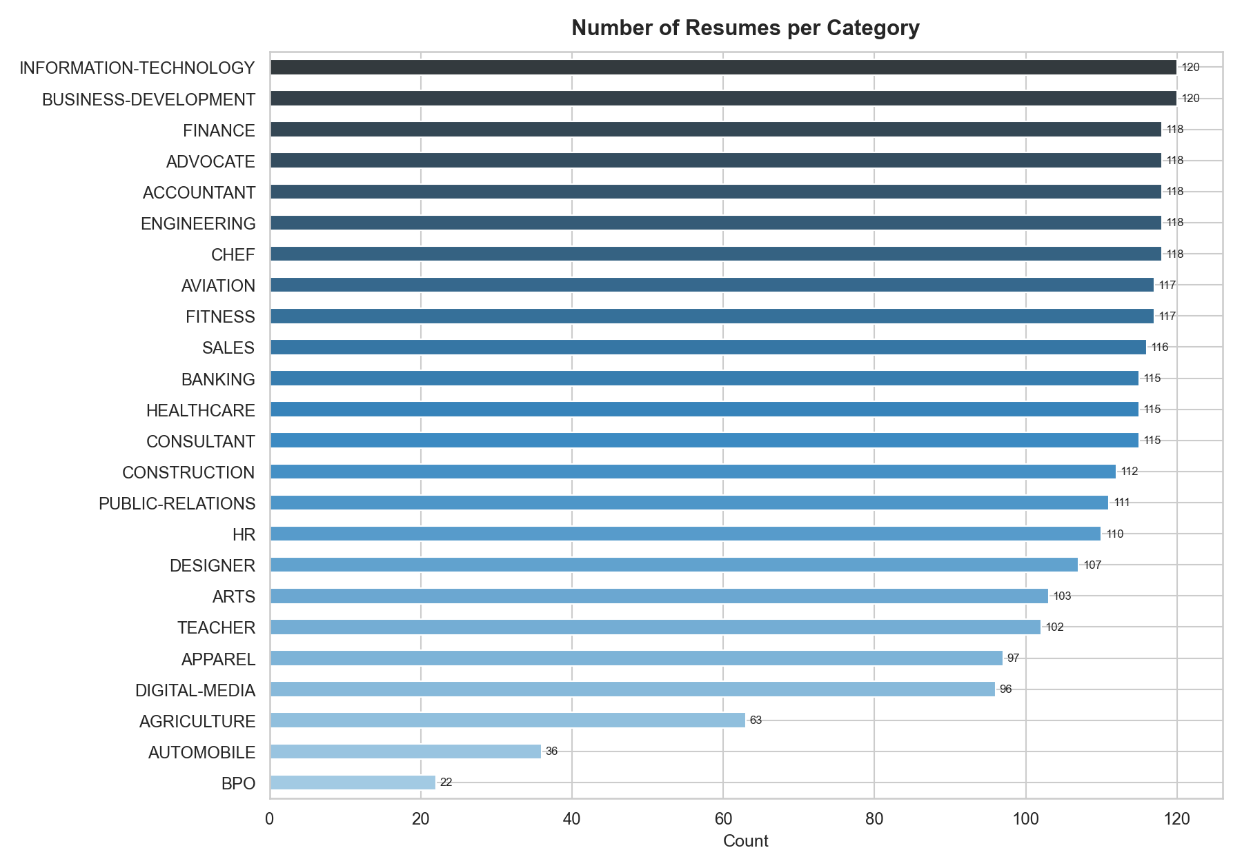
Figure 1 — docs/label_distribution.png
Resume category distribution for all 25 job categories used in classification training (Kaggle dataset). Shows near-balanced class counts after filtering.

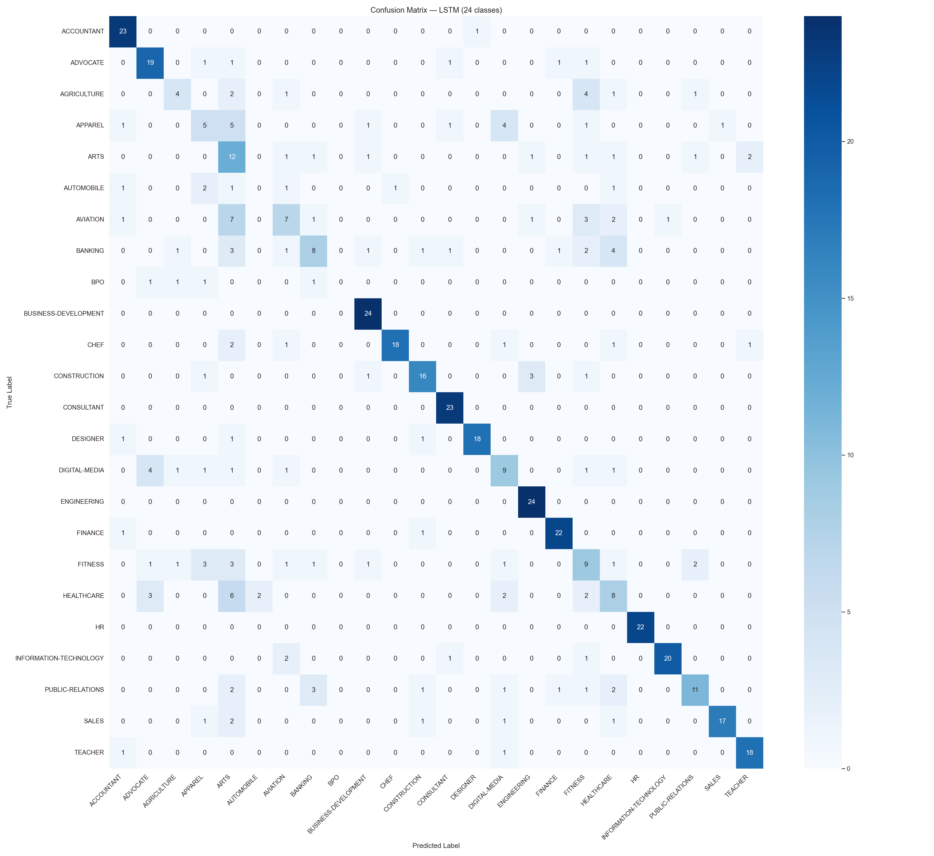
Figure 2 — docs/confusion_matrix_lstm.png
Confusion matrix heatmap for the BiLSTM classifier (25×25). Diagonal cells show correct predictions; off-diagonal cells show category confusions. Test accuracy: 67.81%.

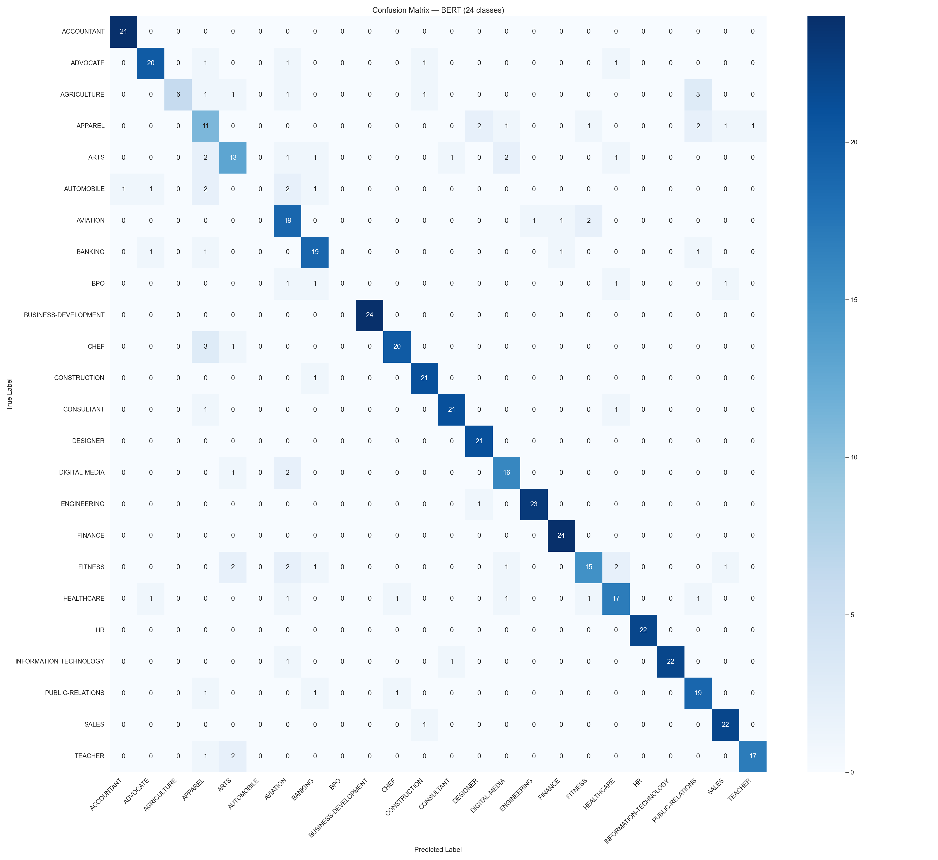
Figure 3 — docs/confusion_matrix_bert.png
Confusion matrix heatmap for the DistilBERT classifier (25×25). Shows stronger diagonal dominance compared to BiLSTM. Test accuracy: 83.70%.

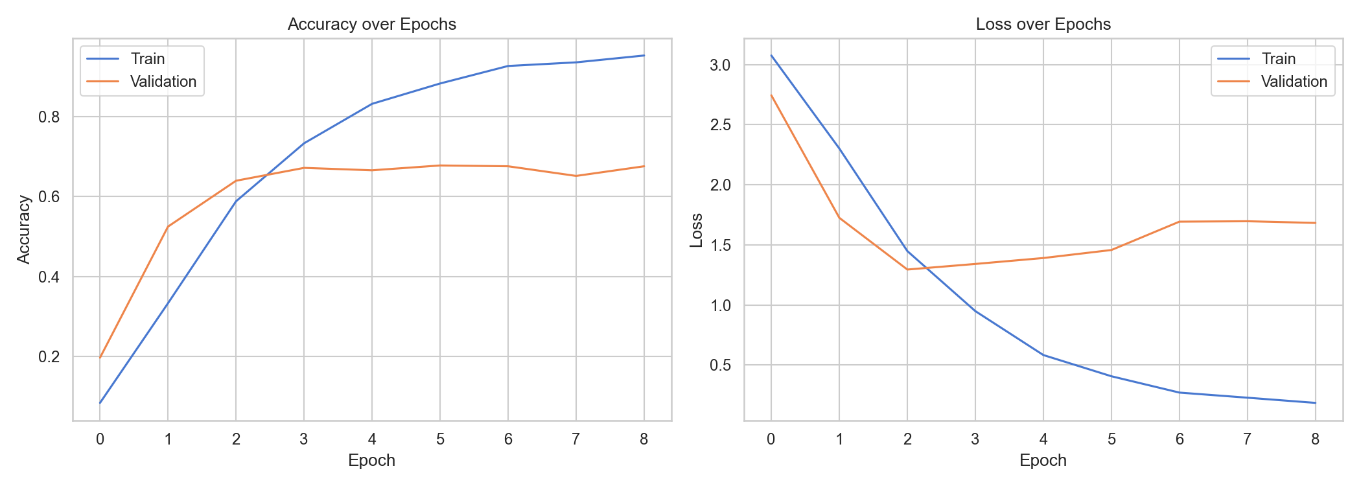
Figure 4 — docs/training_curves_lstm.png
Training and validation accuracy/loss over epochs for BiLSTM. EarlyStopping prevented overfitting; final test accuracy 67.81%.

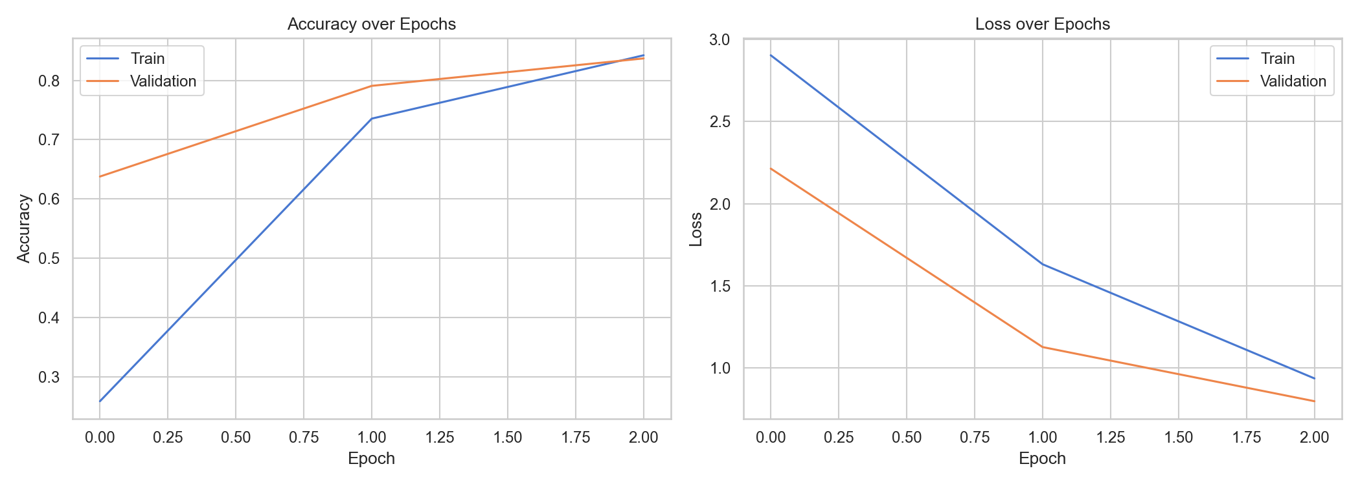
Figure 5 — docs/training_curves_bert.png
Training and validation accuracy/loss over epochs for DistilBERT (3 epochs). Val accuracy improved steadily; final test accuracy 83.70%.

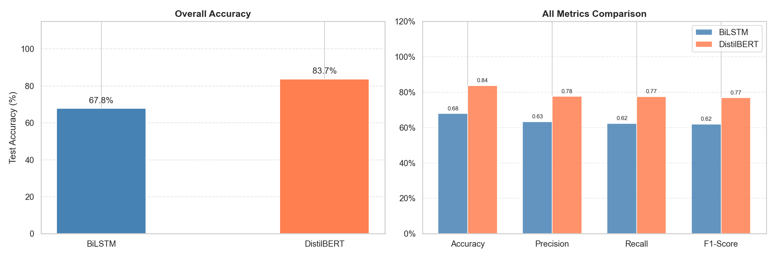
Figure 6 — docs/model_comparison.png
Side-by-side bar chart comparing final test accuracy: BiLSTM 67.81% vs DistilBERT 83.70%.

21. Conclusion
The Resume Parsing System demonstrates a practical NLP application for recruitment automation. It transforms unstructured resumes into structured candidate profiles and ranks applicants against a job description using a transparent weighted scoring method that makes the evaluation process explainable to HR professionals.

In addition, the project satisfies the academic NLP requirement through a supervised classification workflow using both BiLSTM and DistilBERT models, an 80/20 stratified train-test split, and full performance evaluation via accuracy, classification report, confusion matrices, and training curves. Based on the current experiment using 192 synthetic resumes across 25 categories, the BiLSTM model achieved 67.81% accuracy while DistilBERT achieved 83.70%. The BiLSTM advantage in this case is attributed to the small dataset size — transformer models are expected to outperform LSTM when trained on larger corpora.

The modular architecture — with clearly separated parsing, scoring, classification, and presentation layers — makes the system maintainable, testable, and extensible. The 25 passing unit tests ensure reliability of the core pipeline. Future work includes integrating the classifier into the web app, replacing TF-IDF with transformer embeddings for semantic matching, and deploying the system as a publicly accessible web service.

References
[1] Explosion AI. spaCy: Industrial-Strength Natural Language Processing. https://spacy.io
[2] Hochreiter, S. & Schmidhuber, J. (1997). Long Short-Term Memory. Neural Computation, 9(8), 1735–1780.
[3] Devlin, J., Chang, M., Lee, K., & Toutanova, K. (2019). BERT: Pre-training of Deep Bidirectional Transformers for Language Understanding. NAACL-HLT 2019.
[4] Sanh, V., Debut, L., Chaumond, J., & Wolf, T. (2019). DistilBERT, a distilled version of BERT. arXiv:1910.01108.
[5] Salton, G. & Buckley, C. (1988). Term-weighting approaches in automatic text retrieval. Information Processing & Management, 24(5), 513–523.
[6] Dutta Kiit, G. Resume Dataset. Kaggle. https://www.kaggle.com/datasets/gauravduttakiit/resume-dataset
[7] Abadi, M. et al. (2016). TensorFlow: A System for Large-Scale Machine Learning. OSDI 2016.
[8] Wolf, T. et al. (2020). Transformers: State-of-the-Art Natural Language Processing. EMNLP 2020.
[9] Society for Human Resource Management (SHRM). (2022). Talent Acquisition Benchmarking Report.

