#I2C Master Controller (Verilog):
This project implements a hardware-synthesizable I2C (Inter-Integrated Circuit) Master Controller in Verilog HDL. Designed following the standard Philips/NXP I2C protocol specification, the controller enables seamless, reliable half-duplex serial communication between a master integrated circuit and external target slave peripherals (such as sensors, EEPROMs, or display drivers) over a shared two-wire bus.
#Files:
File | Description
Master.v | I2C Master module (DUT)
Master_tb.v | Self-checking testbench with pass/fail messages per case
SDC1.sdc | Synopsys Design Constraint file for Quartus

#Features:
Standard 2-Wire Protocol Support: Drives serial clock (SCL) and manages bidirectional data transfer via an open drain tri-state Serial Data (SDA) line.
7-Bit Slave Addressing: Transmits 7-bit peripheral addresses alongside dynamic Read/Write direction routing.
Robust FSM Control: Built upon an efficient 7-state Finite State Machine (FSM) ensuring accurate Start, Stop, Bit shifting, and Acknowledge (ACK/NACK) sampling dynamics.
Status Flags & Error Handling: Provides hardware status feedback including busy, error, and D_ready for valid data reception.
Clock Domain Management: Integrates an internal clock divider (SCL_clk) to serialize data synchronous with system clock requirements.

#Pins:
Signal Name | Direction | Bit Width | Description
clk | Input | 1 bit | Main system clock.
rst | Input | 1 bit | Active-low asynchronous  system reset.
start | Input | 1 bit | Trigger pulse to initiate an  I2C transaction.
stop | Input | 1 bit | Flag to issue a stop  condition at sequence  completion.
write | Input | 1 bit | Operation selector: 1= Write operation,  0 = Read operation.
addr | Input | 7 bits | Target 7-bit slave  peripheral device address.
data | Input | 8 bits | 8-bit data byte to be  written to the slave.
SDA | Inout | 1 bit | Bidirectional open-drain Serial Data Line.
SCL | Output | 1 bit | Generated Serial Clock output line.
busy/error | Output | 1 bit | busy: Transaction active flag | error: Asserts on NACK.
ack/D_ready | Ouput | 1 bit | ack: Slave ACK received |  D_ready: Valid data_out  byte flag.

#System Architecture:
The core of the system is driven by a 7-state Finite State Machine (FSM):
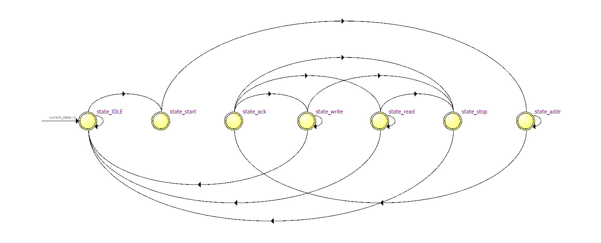
Encoding:
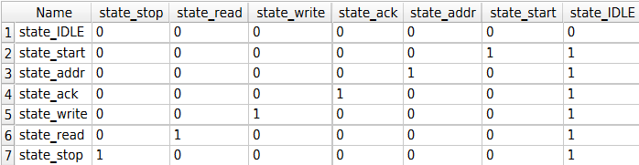
Transitions:
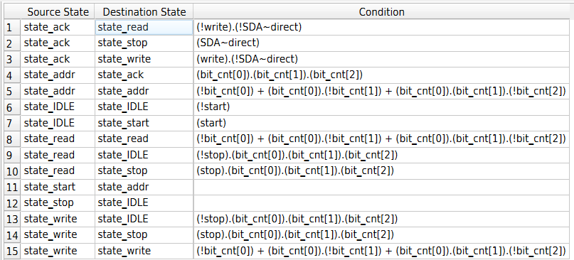
#RTL viewer:
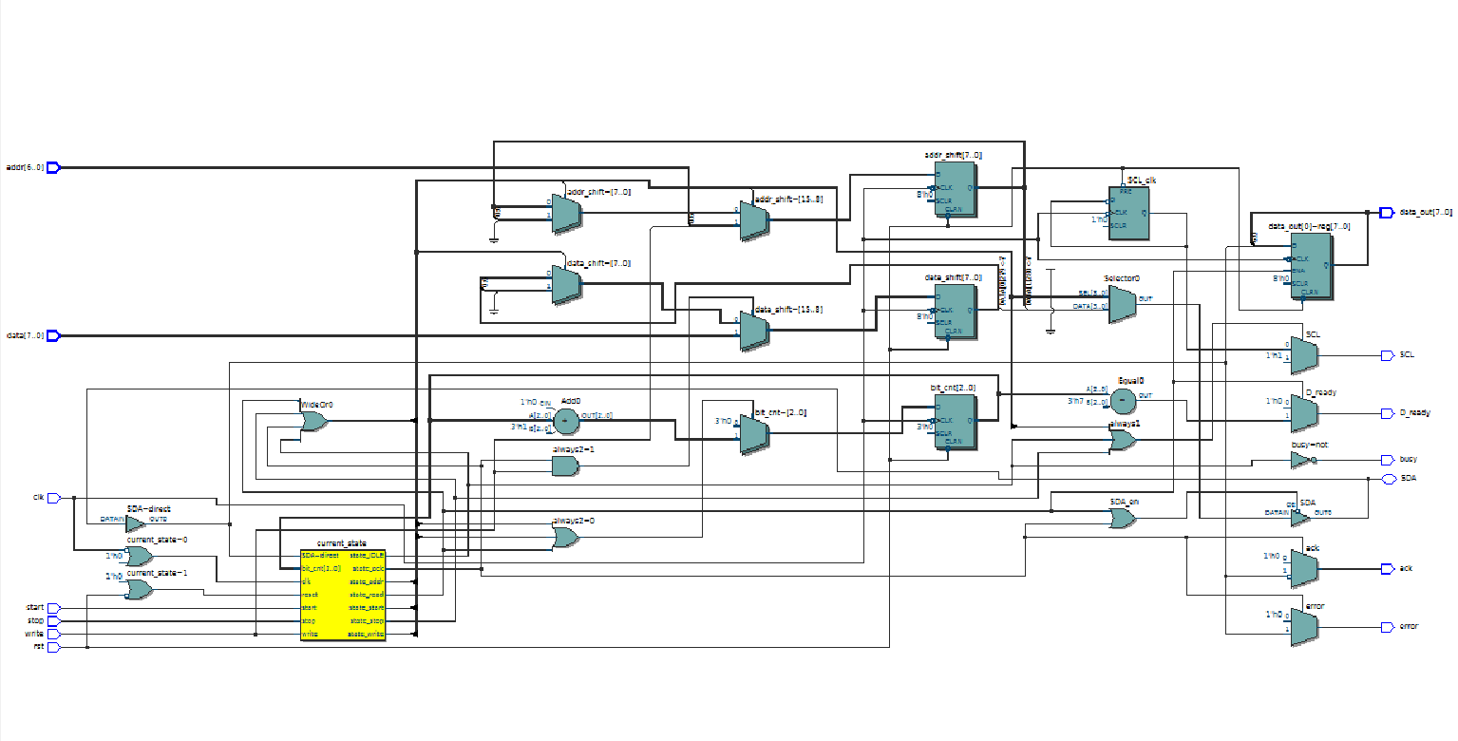

#Simulation:
- Add Master.v and Master_tb.v to any Verilog simulator, e.g. ModelSim/Questa/Quartus.
- Set Master_tb as the simulation top-level module.
- Run the simulation and check the console output for pass/fail per test case.

#Testbench:
Master_tb.v emulates a slave on the shared SDA line (via SDA_en/SDA_out) and drives the Master through a sequence of self-checking cases, each printing PASS/FAIL to the console:
- Reset and IDLE hold behavior
- Start condition generation
- Full write transaction with slave Ack
- NACK handling (no slave response) and error flag
- Full read transaction and data_out verification
- SCL idle-high behavior during IDLE/start
- Mid-transaction reset recovery
- Edge-value address/data patterns (all-zeros, all-ones)
- busy signal correctness across every state
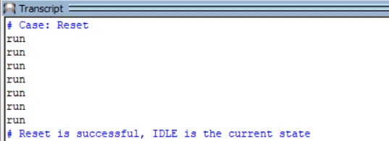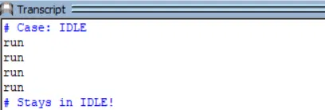

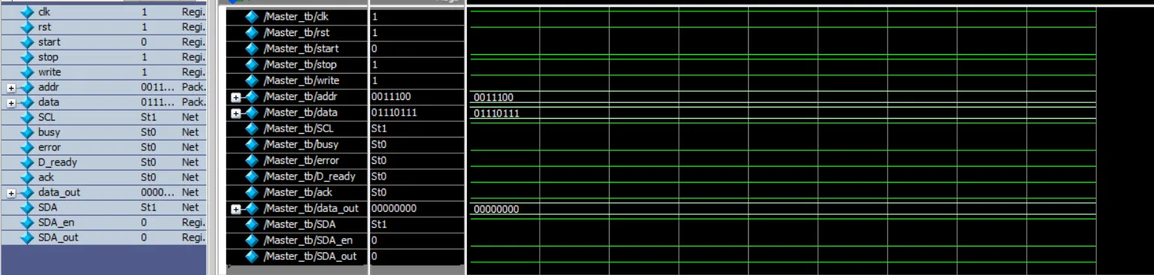

#Quartus prime synthesis:
To run static timing analysis (STA) in Intel Quartus Prime and evaluate the maximum operating clock frequency (Fmax), the Synopsys Design Constraints (.sdc) file attached must be supplied to the Timing Analyzer (TimeQuest).
