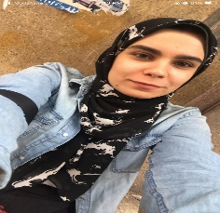

J

Omneya Mohamed El bakry







Omneyaa1999@gmail.com

01067471492

El menofia

Seeking on good opportunity where my skills can be applied and exploited to their fullest capacity.

2021

Bachelor of veterinary medicine

Very good

Excellent communication skills

Strongly analytical and detail-focused

Very Good Presentation skills

Time managment

Well Organized

Problems Solver

Volunteer at Resala charity organization (2017)

Arabic (native language )

English (very good)

Germany

Establishing and managing lab at Al shifaa lab 2020.

Pet animal online courses

Al shifaa pharmacy

Omaima pharmacy

Nashy pharmacy

Zahran pharmacy

Traza awny pharmacy

Dr silvia pet animal clinic

Dr osama pet animal clinic

Dr ahmed amer large animal clinic

Al shifaa lab