**Handbook**

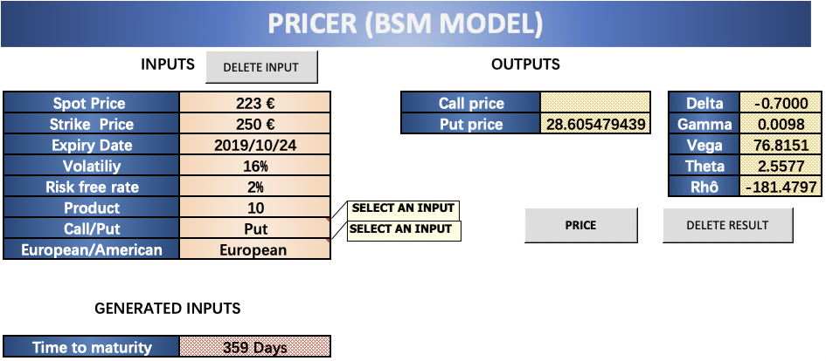

**Step1:** Press ‘DELETE RESULT’ and input the data, which are ‘Spot Price’, Strike Price’, ‘Expiry Date’, ‘Volatility’, ‘Risk-free Rate’, ‘Call/Put’, ‘European/American’.  
**Step 2:** Press ‘PRICE’ and get the generated input ‘Time to maturity’ which computes days from today to expiry date.

**Step 3:** Then the pricer will compute the option price as well as the related Greek letters delta, gamma, vega, theta, rho, which reflect the change of option price when spot price changes, the change of delta when spot price changes, the change of option price when volatility changes, the change of option price when time to maturity changes, the change of option price when risk-free rate changes separately.

**CRR Model**

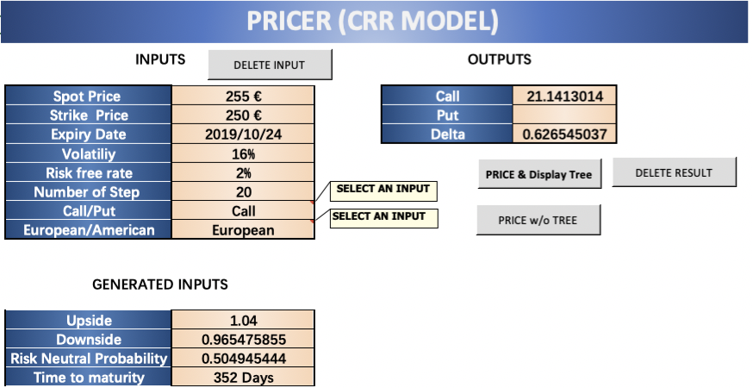

**Step 1:** Press ‘DELETE RESULT’ and then input the model parameters, which has one more data ‘Number of Step’.  
**Step 2:** You can quickly get the price by pressing “PRICE w/o TREE” or pressing “PRICE & DISPLAY TREE” to have a look at the binomial tree. Generated inputs are extent of price changes when it goes up or down, probability distribution and time to maturity. And the risk- neutral probability is the probability that the price will go up in one period.  
**Step 3**: When the screen shows “Done! Let’s have a look at the TREE”, you can look through the CRR tree in another work sheet.

**Convergence**

**Step 1**: Press “Refresh output” and then input the original data just like CRR model parameters. Step 2: You can change every number in column “STEPS” and then press “RUN convergence” to have a look the convergence of targeted steps. As the above picture “Convergence CRR- BSM” stated, the results of CRR and BSM will become quite closer from 80 steps, namely, you can get a very precise price through CRR pricer with 80 steps.

There is a small problem that you cannot use convergence tool here to simulate American option since BSM pricer is not suitable here. For options written on a non-paying dividend stock it is never optimal to exercise an American option so its price is equal to European options price.