Problem Statement 1: Write a C program to fork a process
Theory:
- A process is an executing instance of a program.
- The fork() system call in Unix/Linux creates a new child process by duplicating the calling (parent) process.
- After fork() executes, two processes run concurrently:
  - Parent process → receives child’s PID (positive value)
  - Child process → receives 0
- If fork() fails, it returns -1.
- Both processes start executing from the next statement after fork().
Algorithm:
Step 1: Start
Step 2: Call the fork() system call for three times.
Step 3: Stop
Code:
#include<stdio.h>
#include<unistd.h>
int main(){
fork();
fork();
fork();
printf(“Linux\n”);
return 0;
}
Output:
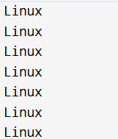
Problem Statement 2: Write a C program to demonstrate process creation using fork() and synchronization using wait().
Theory:
- The fork() system call creates a child process, which is a duplicate of the parent.
- After fork() executes:
  - Child process receives return value 0.
  - Parent process receives child’s PID (positive value).
- The wait() system call is used by the parent to pause execution until the child finishes.
- This ensures synchronization: the parent does not proceed until the child completes.
- Without wait(), parent and child may run concurrently in unpredictable order.
Algorithm:
Step 1: Start
Step 2: Call fork() to create a child process
Step 3: If return value < 0, handle fork failure
Step 4: If return value == 0, execute child process tasks
Step 5: If return value > 0, call wait() to synchronize and wait for child to finish
Step 6: After child completes, parent executes its remaining tasks
Step 7: Stop
Code:
#include <stdio.h>
#include <unistd.h>
#include <sys/wait.h>

int main() {
pid_t pid = fork();

if (pid < 0) {
printf("Fork failed!\n");
return 1;
}
else if (pid == 0) {
// Child process
printf("Child process executing. PID = %d\n", getpid());
printf("Child process parent's PID = %d\n",getppid());
}
else {
// Parent process
wait(NULL); // Synchronization point
printf("Parent process resumed after child finished. PID = %d\n", getpid());
}
return 0;
}
Output:
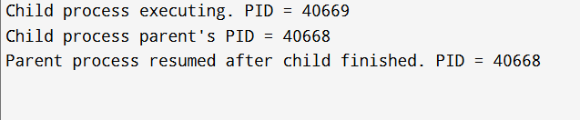
Problem Statement 3: Write a C program that demonstrates how a parent process can create multiple child process.
Theory:
- The fork() system call is used to create a new child process, which is a duplicate of the calling parent process.
- The parent process receives the child's PID (a positive value), while the child process receives a return value of 0.
- To create multiple children, the parent process can repeatedly call fork().
- It is crucial to use conditional logic (if-else if-else) on the return value of fork() to ensure the children are created by the original parent and not by the children themselves, which would lead to a process tree⁴.
Algorithm:
Step 1: Start
Step 2: Define the number of child processes.
Step 3: Use a loop that iterates N times.
Step 4: Inside the loop, call fork() to attempt creating a new child process.
Step 5: If fork() returns 0, the current process is a child; execute the child's specific task and then exit the child process.
Step 6: If fork() returns a positive value, the current process is the parent; continue to the next iteration of the loop to create the next child.
Step 7: After the loop, the parent process can call wait() multiple times (once for each child) to ensure all children complete before the parent exits.
Step 8: Stop
Code:
#include <stdio.h>
#include <stdlib.h>
#include <unistd.h>
#include <sys/wait.h>

#define NUM_CHILDREN 3

int main() {
int i;
pid_t pid;

for (i = 0; i < NUM_CHILDREN; i++) {
pid = fork();

if (pid < 0) {
// Error handling
perror("Fork failed");
exit(1);
} else if (pid == 0) {
// Child process
printf("Child %d created. PID: %d, Parent PID: %d\n", i + 1, getpid(), getppid());
// Simulate work
sleep(1);
exit(0); // Child must exit after its task
}
// Parent process continues loop to create next child
}

// Parent waits for all children
for (i = 0; i < NUM_CHILDREN; i++) {
wait(NULL);
printf("Parent: Waited for a child to finish.\n");
}

printf("Parent process finished. PID: %d\n", getpid());
return 0;
}
Output:
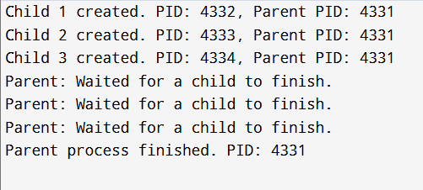
Problem Statement 4: Write a C program in which parent process computes sum of even numbers and child process computes sum of odd numbers using fork().
Theory:
- The fork() system call is used to create a child process.
- The primary mechanism for distinguishing between the parent and child is the return value of fork(): 0 for the child, and the child's PID (positive value) for the parent.
- An if/else structure based on the fork() return value allows each process (parent and child) to execute a distinct block of code (the even sum calculation for one, the odd sum calculation for the other).
- The parent should use wait() to synchronize and ensure the child completes its calculation before the parent potentially continues or exits⁷.
Algorithm:
Step 1: Start
Step 2: Define a range [A, B] for summation.
Step 3: Call fork() to create a child process.
Step 4: If fork() returns 0 (Child process): * Initialize odd sum to 0. * Iterate from A to B. * If the current number is odd, add it to the odd sum. * Print the calculated odd sum.
Step 5: If fork() returns a positive value (Parent process): * Call wait(NULL) to pause until the child process finishes. * Initialize even sum to 0. * Iterate from A to B. * If the current number is even, add it to the even sum. * Print the calculated even sum.
Step 6: Stop
Code:
#include <stdio.h>
#include <unistd.h>
#include <sys/wait.h>

#define START 1
#define END 10

int main() {
pid_t pid = fork();

if (pid < 0) {
// Fork failed
perror("Fork failed");
return 1;
} else if (pid == 0) {
// Child process: computes odd sum
long long odd_sum = 0;
for (int i = START; i <= END; i++) {
if (i % 2 != 0) {
odd_sum += i;
}
}
printf("Child Process (PID: %d): Sum of odd numbers [%d-%d] = %lld\n", getpid(), START, END, odd_sum);
} else {
// Parent process: computes even sum
// Wait for the child to finish
wait(NULL);

long long even_sum = 0;
for (int i = START; i <= END; i++) {
if (i % 2 == 0) {
even_sum += i;
}
}
printf("Parent Process (PID: %d): Sum of even numbers [%d-%d] = %lld\n", getpid(), START, END, even_sum);
}

return 0;
}
Output:
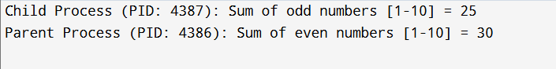
Problem Statement 5: Write a C program for simple wait() system call in single fork().
Theory:
- The fork() system call creates a new child process.
- The wait() system call is specifically used by the parent process to pause its own execution until one of its child processes terminates.
- This mechanism is essential for process synchronization, ensuring a predictable order of execution, where the parent waits for the child's completion.
- The wait(NULL) call is the simplest form, waiting for any child process to change state (i.e., terminate).
Algorithm:
Step 1: Start
Step 2: Call fork() to create a single child process.
Step 3: If fork() returns 0 (Child process): * Execute the child's task (e.g., print a message). * Exit the child process.
Step 4: If fork() returns a positive value (Parent process): * Call wait(NULL) to pause execution until the child terminates. * After wait() returns, execute the parent's remaining task (e.g., print a completion message).
Step 5: Stop
Code:
#include <stdio.h>
#include <unistd.h>
#include <sys/wait.h>

int main() {
pid_t pid = fork();

if (pid < 0) {
// Fork failed
perror("Fork failed");
return 1;
} else if (pid == 0) {
// Child process
printf("Child (PID: %d) is running.\n", getpid());
sleep(2); // Simulate child work
printf("Child (PID: %d) finished its task and is exiting.\n", getpid());
} else {
// Parent process
printf("Parent (PID: %d) is waiting for child (PID: %d).\n", getpid(), pid);
wait(NULL); // Wait for the child process to finish
printf("Parent (PID: %d) resumed after child termination.\n", getpid());
}

return 0;
}
Output:
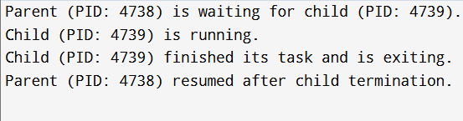
Problem Statement 6: Write a C program for wait() system call in multiple forks.
Theory:
- When a parent process creates multiple child processes using repeated fork() calls, it can use the wait() or waitpid() system calls to synchronize with them.
- The simple wait(NULL) call waits for any one child process to terminate¹².
- If a parent creates $N$ children, it must call wait() $N$ times to wait for all of them to terminate.
- Alternatively, waitpid(pid, &status, 0) allows the parent to wait for a specific child identified by its PID, which is useful for ordered waiting or specific handling.
Algorithm:
Step 1: Start
Step 2: Define N, the number of children to create.
Step 3: Use a loop to call fork() N times to create N child processes, ensuring the children immediately exit after their task (to prevent them from creating more processes).
Step 4: After the creation loop, the parent enters a second loop that iterates N times.
Step 5: Inside the second loop, the parent calls wait(NULL) to wait for the termination of one of its children.
Step 6: Print a message each time a child is collected.
Step 7: Stop
Code:
#include <stdio.h>
#include <stdlib.h>
#include <unistd.h>
#include <sys/wait.h>

#define NUM_CHILDREN 3

int main() {
int i;
pid_t pids[NUM_CHILDREN];

// 1. Create children
for (i = 0; i < NUM_CHILDREN; i++) {
pids[i] = fork();

if (pids[i] == 0) {
// Child process
printf("Child %d (PID: %d) running.\n", i + 1, getpid());
sleep(NUM_CHILDREN - i); // Simulate different work times
printf("Child %d (PID: %d) exiting.\n", i + 1, getpid());
exit(i + 1); // Child exits
} else if (pids[i] < 0) {
perror("Fork failed");
exit(1);
}
}

// 2. Parent waits for all children
printf("Parent (PID: %d) waiting for all %d children.\n", getpid(), NUM_CHILDREN);

// We call wait() NUM_CHILDREN times
for (i = 0; i < NUM_CHILDREN; i++) {
pid_t terminated_pid = wait(NULL);
if (terminated_pid > 0) {
printf("Parent collected terminated child with PID: %d.\n", terminated_pid);
}
}

printf("Parent finished all waiting.\n");
return 0;
}
Output:
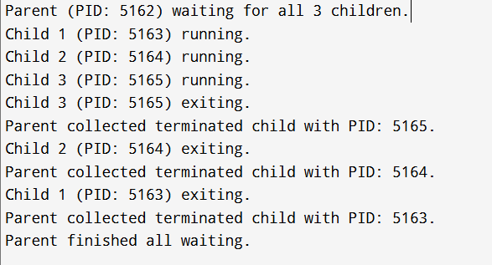
Problem Statement 7: Write a C program to create process using fork().
Theory
- A process is an executing instance of a program¹³.
- The fork() system call is the standard way in Unix/Linux to create a new process (the child) by duplicating the calling process (the parent)¹⁴¹⁴¹⁴¹⁴.
- Crucially, after fork(), both parent and child processes execute the same code from the statement after the fork() call¹⁵.
- The return value of fork() differentiates the processes: parent gets the child's PID (positive value), and the child gets $0$¹⁶.
.
Algorithm:
Step 1: Start
Step 2: Call the fork() system call.
Step 3: If the return value is 0, execute the code block specific to the Child process (e.g., print child PID).
Step 4: If the return value is greater than 0, execute the code block specific to the Parent process (e.g., print parent PID and child PID).
Step 5: Stop
Code:
#include <stdio.h>
#include <unistd.h>
#include <sys/types.h>
int main() {
pid_t pid;

printf("Before fork, only one process exists (PID: %d).\n", getpid());

pid = fork();

if (pid < 0) {
// Error handling
perror("Fork failed");
return 1;
} else if (pid == 0) {
// Child process
printf("I am the CHILD process.\n");
printf("Child PID: %d, My Parent PID: %d\n", getpid(), getppid());
} else {
// Parent process
printf("I am the PARENT process.\n");
printf("Parent PID: %d, My Child PID: %d\n", getpid(), pid);
}

printf("This line is executed by both processes. PID: %d\n", getpid());

return 0;
}
Output:
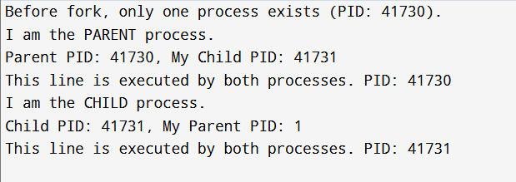
Problem Statement 8: Write a C program to create 2 processes using fork().
Theory:
- To create exactly N child processes where the original parent remains the sole parent, fork() must be called N times, and the children must exit immediately after their task to prevent them from creating further processes (which would lead to 2^N - 1 processes if all processes continued calling fork() in a loop).
- For creating just two processes (one child, one parent), only one call to fork() is necessary. The initial program (the parent) and the newly created process (the child) make up the two processes.
Algorithm:
Step 1: Start
Step 2: Call fork().
Step 3: If fork() returns 0 (Child process): * Execute the child's task.
Step 4: If fork() returns a positive value (Parent process): * Execute the parent's task. * Call wait(NULL) to wait for the child to finish.
Step 5: Stop
Code:
#include <stdio.h>
#include <unistd.h>
#include <sys/wait.h>

int main() {
pid_t pid;

printf("Initial process (Parent-to-be) PID: %d\n", getpid());

pid = fork();

if (pid < 0) {
perror("Fork failed");
return 1;
} else if (pid == 0) {
// Process 2: Child
printf("Process 2 (Child) created. PID: %d, Parent PID: %d\n", getpid(), getppid());
sleep(1); // Simulate work
} else {
// Process 1: Parent
wait(NULL); // Ensure the child finishes first
printf("Process 1 (Parent). PID: %d, Child PID: %d\n", getpid(), pid);
}

printf("Two processes executed successfully. (Process PID: %d)\n", getpid());
return 0;
}
Output:
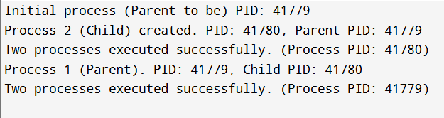

Problem Statement 9: Write a C program to implement zombie process.
Theory:
- A Zombie process (or defunct process) is a process that has completed its execution (i.e., called exit()) but still has an entry in the process table.
- This entry is kept so that its parent can read its exit status using the wait() or waitpid() system call.
- If the parent process terminates without calling wait() for the child, and the child process exits first, the child process becomes a zombie.
- The zombie state is maintained until the parent process calls wait() (collecting the status) or until the parent itself terminates (at which point the init process adopts the zombie and collects its status).
2) Algorithm
Step 1: Start
Step 2: Call fork() to create a child process.
Step 3: If fork() returns 0 (Child process): * Print a message and immediately call exit(0). This causes the child to terminate, but its status remains uncollected.
Step 4: If fork() returns a positive value (Parent process): * Print a message indicating the child's PID. * Use sleep() for a few seconds. The parent must not call wait(). * During this sleep(), the terminated child will be visible in the system process list (ps -aux) as a Zombie process (<defunct>).
Step 5: Stop
Code:
Algorithm:
#include <stdio.h>
#include <stdlib.h>
#include <unistd.h>
#include <sys/wait.h>
int main() {
pid_t pid;
pid = fork();
if (pid < 0) {
perror("Fork failed");
return 1;
} else if (pid == 0) {
// Child process
printf("Child (PID: %d) is running.\n", getpid());
// Child exits immediately, becoming a zombie because parent won't wait
printf("Child (PID: %d) exiting now.\n", getpid());
exit(0);
} else {
// Parent process
printf("Parent (PID: %d) created child (PID: %d).\n", getpid(), pid);
printf("The child is now likely a ZOMBIE. Check 'ps -aux | grep %d'\n", pid);
// Parent sleeps for 10 seconds without calling wait()
sleep(10);
printf("Parent (PID: %d) waking up and exiting. The zombie will now be reaped by init.\n", getpid());
}
return 0;
}
Output:
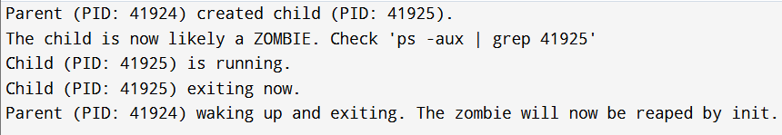

Problem Statement 10: Write a C program that demonstrates communication between a parent and child process using a pipe. The child process should send a message to the parent through a pipe and read and display on the console.
Theory:
- Pipes provide a unidirectional (one-way) communication channel between related processes (e.g., parent and child).
- The pipe() system call creates a pipe, returning two file descriptors: fd[0] for the read end and fd[1] for the write end.
- To ensure unidirectional communication, after the fork() call, one process must close the unused read end, and the other must close the unused write end.
- In this case, the Child (sender) closes fd[0] and writes to fd[1]. The Parent (receiver) closes fd[1] and reads from fd[0]
Algorithm:
Step 1: Start
Step 2: Declare an array of two integers for file descriptors: fd[2].
Step 3: Call pipe(fd) to create the pipe. Handle error if pipe creation fails.
Step 4: Call fork() to create a child process. Handle error if fork fails.
Step 5: If fork() returns 0 (Child process - Sender): * Close the read end of the pipe: close(fd[0]). * Write the message string to the write end: write(fd[1], ...) * Close the write end: close(fd[1]). * Exit.
Step 6: If fork() returns a positive value (Parent process - Receiver): * Close the write end of the pipe: close(fd[1]). * Call read(fd[0], ...) to read the message from the read end. * Print the received message. * Close the read end: close(fd[0]). * Call wait(NULL) to wait for the child.
Step 7: Stop
Code:
#include <stdio.h>
#include <stdlib.h>
#include <unistd.h>
#include <sys/wait.h>
#include <string.h>

#define MAX_BUF 100

int main() {
int pipe_fd[2]; // pipe_fd[0] is read, pipe_fd[1] is write
pid_t pid;
char write_msg[MAX_BUF] = "Hello from the Child process via pipe!";
char read_msg[MAX_BUF];

// Create pipe
if (pipe(pipe_fd) == -1) {
perror("Pipe failed");
return 1;
}

pid = fork();

if (pid < 0) {
perror("Fork failed");
return 1;
} else if (pid == 0) {
// Child Process (Sender)
close(pipe_fd[0]); // Close unused read end
printf("Child (PID: %d) is sending message: \"%s\"\n", getpid(), write_msg);
write(pipe_fd[1], write_msg, strlen(write_msg) + 1); // +1 for null terminator
close(pipe_fd[1]); // Close write end
exit(0);
} else {
// Parent Process (Receiver)
close(pipe_fd[1]); // Close unused write end

// Wait for child before reading (optional but good practice)
wait(NULL);

read(pipe_fd[0], read_msg, MAX_BUF);
printf("Parent (PID: %d) received message: \"%s\"\n", getpid(), read_msg);
close(pipe_fd[0]); // Close read end
}

return 0;
}
Output:

Problem Statement 11: Write a C program to demonstrate IPC using a pipe between a parent and child process. The child process should prompt the user to input a string and send it to the parent process via the pipe. The parent process should read string from the pipe.
Theory:
- This problem extends the previous one by incorporating user input into the IPC process.
- The fundamental principles of pipe IPC remain the same: pipe() creates the channel, fork() creates the processes, and file descriptor manipulation (close()) ensures unidirectional flow.
- The child process will use fgets() or scanf() to read the user's string from the standard input (stdin) and then use write() to send it through the pipe.
- The parent process will use read() to retrieve the data from the pipe and then process it.
Algorithm:
Step 1: Start
Step 2: Create a pipe using pipe(fd).
Step 3: Call fork() to create a child process.
Step 4: If fork() returns 0 (Child process - Sender): * Close the read end: close(fd[0]). * Prompt the user to enter a string. * Read the string using fgets(). * Write the user-input string to the write end: write(fd[1], ...) * Close the write end and exit.
Step 5: If fork() returns a positive value (Parent process - Receiver): * Close the write end: close(fd[1]). * Call wait(NULL) to synchronize. * Read the string from the read end: read(fd[0], ...) * Print the received string. * Close the read end.
Step 6: Stop
Code:
#include <stdio.h>
#include <stdlib.h>
#include <unistd.h>
#include <sys/wait.h>
#include <string.h>

#define MAX_BUF 256

int main() {
int pipe_fd[2];
pid_t pid;
char buffer[MAX_BUF];

if (pipe(pipe_fd) == -1) {
perror("Pipe failed");
return 1;
}

pid = fork();

if (pid < 0) {
perror("Fork failed");
return 1;
} else if (pid == 0) {
// Child Process (Sender)
close(pipe_fd[0]); // Close read end

printf("Child (PID: %d): Enter a string to send to Parent: \n", getpid());
// Read string from user input
if (fgets(buffer, MAX_BUF, stdin) == NULL) {
perror("Error reading input");
exit(1);
}

// Write string to pipe
write(pipe_fd[1], buffer, strlen(buffer) + 1); // +1 for null terminator
printf("Child sent message and exiting.\n");
close(pipe_fd[1]); // Close write end
exit(0);

} else {
// Parent Process (Receiver)
close(pipe_fd[1]); // Close write end

// Wait for child to finish sending
wait(NULL);
ssize_t bytes_read = read(pipe_fd[0], buffer, MAX_BUF);

if (bytes_read > 0) {
printf("Parent (PID: %d) received message: \"%s\"\n", getpid(), buffer);
} else {
printf("Parent received no data.\n");
}
close(pipe_fd[0]); // Close read end
}

return 0;
}
Output:
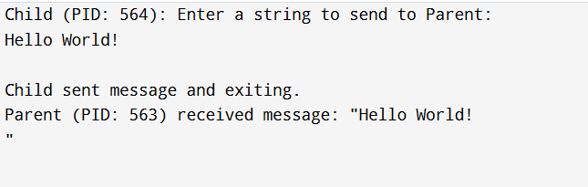

Problem Statement 12: Write a C program to demonstrate unidirectional IPC using a pipe. The parent process should send a fixed message to the child process reads and display received message.
Theory:
Theory
- This is the reverse of Problem 10: the Parent is the sender, and the Child is the receiver.
- The unidirectional nature of the pipe is key: data flows from the write file descriptor (fd[1]) to the read file descriptor (fd[0]).
- The Parent (Sender) must close fd[0] (read end) and write to fd[1] (write end).
- The Child (Receiver) must close fd[1] (write end) and read from fd[0] (read end).
- The parent does not need to use wait() to ensure the child receives the message, as the child's read() will block until data is available. However, wait() is still needed for proper process management (preventing a zombie).
Algorithm:
Step 1: Start
Step 2: Create a pipe using pipe(fd).
Step 3: Call fork() to create a child process.
Step 4: If fork() returns 0 (Child process - Receiver): * Close the write end: close(fd[1]). * Read the message from the read end: read(fd[0], ...) * Print the received message. * Close the read end and exit.
Step 5: If fork() returns a positive value (Parent process - Sender): * Close the read end: close(fd[0]). * Define a fixed message string. * Write the message string to the write end: write(fd[1], ...) * Close the write end. * Call wait(NULL) to wait for the child to finish. Step 6: Stop
Code:
#include <stdio.h>
#include <stdlib.h>
#include <unistd.h>
#include <sys/wait.h>
#include <string.h>

#define MAX_BUF 100

int main() {
int pipe_fd[2];
pid_t pid;
const char *write_msg = "Fixed message sent from Parent to Child.";
char read_msg[MAX_BUF];

if (pipe(pipe_fd) == -1) {
perror("Pipe failed");
return 1;
}

pid = fork();

if (pid < 0) {
perror("Fork failed");
return 1;
} else if (pid == 0) {
// Child Process (Receiver)
close(pipe_fd[1]); // Close unused write end

ssize_t bytes_read = read(pipe_fd[0], read_msg, MAX_BUF);

if (bytes_read > 0) {
read_msg[bytes_read] = '\0'; // Ensure null termination
printf("Child (PID: %d) received message: \"%s\"\n", getpid(), read_msg);
} else {
printf("Child received no data.\n");
}

close(pipe_fd[0]); // Close read end
exit(0);
} else {
// Parent Process (Sender)
close(pipe_fd[0]); // Close unused read end

printf("Parent (PID: %d) is sending message: \"%s\"\n", getpid(), write_msg);
write(pipe_fd[1], write_msg, strlen(write_msg));

close(pipe_fd[1]); // Close write end, signaling end of transmission
wait(NULL); // Wait for the child process to finish
printf("Parent finished.\n");
}

return 0;
}
Output:
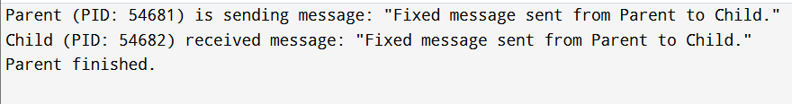
Problem Statement 13: Write a program to implement FIFO.
Theory:
- FIFO (First-In, First-Out) can refer to two concepts in Operating Systemsx`:
  - Pipes (Named Pipes/FIFOs): A special type of file (a named pipe) that allows inter-process communication (IPC) between unrelated processes. Unlike standard unnamed pipes, a FIFO exists as a file system entry, allowing processes to open it by name for reading and writing. Data is read in the same order it was written.
  - Page Replacement/Scheduling Algorithm: A simple scheduling or page replacement algorithm where the oldest element (process or page) is always removed first.
- Assuming the context of IPC due to the preceding pipe problems, we will focus on Named Pipes (FIFOs).
- The mkfifo() system call creates a new named pipe file.
- Processes open the FIFO using standard open(), one for writing and one for reading.
Algorithm:
Step 1: Start
Step 2: Define the FIFO file name (e.g., /tmp/my_fifo).
Step 3: Call mkfifo() to create the named pipe in the file system. Handle error.
Step 4: Process 1 (Writer): * Open the FIFO in write-only mode (O_WRONLY). * Write the message to the FIFO file descriptor using write(). * Close the FIFO descriptor.
Step 5: Process 2 (Reader): * Open the FIFO in read-only mode (O_RDONLY). This call will block until a writer opens the other end. * Read the message from the FIFO file descriptor using read(). * Print the received message. * Close the FIFO descriptor.
Step 6: Use unlink() to remove the FIFO file from the file system.
Step 7: Stop
Code:
// Note: This requires two separate programs (writer and reader) or a fork,
// but for demonstration, we'll use fork to keep it in a single file like previous problems.

#include <stdio.h>
#include <stdlib.h>
#include <unistd.h>
#include <sys/types.h>
#include <sys/stat.h>
#include <fcntl.h>
#include <string.h>
#include <sys/wait.h>

#define FIFO_NAME "/tmp/my_fifo"
#define MAX_BUF 100

int main() {
// 1. Create the FIFO
if (mkfifo(FIFO_NAME, 0666) == -1) {
perror("mkfifo failed or FIFO already exists");
// Don't exit on EEXIST, proceed if it's already there
}

pid_t pid = fork();

if (pid < 0) {
perror("Fork failed");
return 1;
} else if (pid == 0) {
// Child Process (Reader)
char read_msg[MAX_BUF];
int fd;

printf("Child (Reader): Waiting for writer to open FIFO...\n");
fd = open(FIFO_NAME, O_RDONLY);
if (fd == -1) {
perror("Child open failed");
exit(1);
}

read(fd, read_msg, MAX_BUF);
printf("Child (Reader) received: %s\n", read_msg);
close(fd);
exit(0);

} else {
// Parent Process (Writer)
const char *write_msg = "Message sent via Named Pipe (FIFO).";
int fd;

printf("Parent (Writer): Opening FIFO...\n");
// O_WRONLY will block until a reader opens it, ensuring sync
fd = open(FIFO_NAME, O_WRONLY);
if (fd == -1) {
perror("Parent open failed");
wait(NULL);
unlink(FIFO_NAME);
return 1;
}

write(fd, write_msg, strlen(write_msg) + 1);
printf("Parent (Writer): Sent message and closing.\n");
close(fd);

wait(NULL); // Wait for child to finish
unlink(FIFO_NAME); // Remove the FIFO file
}

return 0;
}
Output:
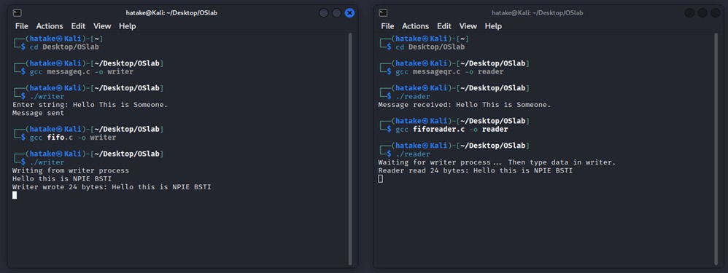
Problem Statement 14: Write a C program to implement the First Come First Serve algorithm.
Theory:
- The First Come First Serve (FCFS) CPU scheduling algorithm is the simplest scheduling algorithm.
- Processes are executed in the order they arrive in the ready queue.
- FCFS is a non-preemptive algorithm, meaning once a process starts executing, it runs to completion (or until it yields the CPU) without interruption.
- Key performance metrics calculated are:
  - Turnaround Time (TAT): The total time a process spends in the system (Completion Time - Arrival Time).
  - Waiting Time (WT): The total time a process spends waiting in the ready queue (Turnaround Time - Burst Time).
- FCFS can suffer from the Convoy Effect, where a short process waits for a single long process to finish, leading to high average waiting time.
Algorithm:
Step 1: Start
Step 2: Read the number of processes (n), and for each process, read its Arrival Time (AT) and Burst Time (BT).
Step 3: Sort the processes based on their AT in ascending order. (FCFS processes the earliest arrival first.)
Step 4: Initialize Completion Time (CT) of the first process as AT_1 + BT_1.
Step 5: For subsequent processes i = 2 to n: * Calculate the Start Time (ST) of process i: ST_i = \max(CT_{i-1}, AT_i). * Calculate CT_i: CT_i = ST_i + BT_i.
Step 6: Calculate Turnaround Time (TAT) for each process: $TAT_i = CT_i - AT_i.
Step 7: Calculate Waiting Time (WT) for each process: WT_i = TAT_i - BT_i.
Step 8: Calculate the Average Turnaround Time and Average Waiting Time across all processes.
Step 9: Display the results (e.g., AT, BT, CT, TAT, WT).
Step 10: Stop
Code:
#include <stdio.h>
#include <stdlib.h>

int main() {
int n;
printf("Enter number of processes: ");
scanf("%d", &n);

int pid[n], at[n], bt[n], ct[n], tat[n], wt[n];
int gp[100], gs[100], ge[100], gc = 0;

for (int i = 0; i < n; i++) {
pid[i] = i + 1;
printf("Enter AT and BT for P%d: ", i+1);
scanf("%d %d", &at[i], &bt[i]);
}

// Sort by arrival time
for (int i = 0; i < n - 1; i++) {
for (int j = 0; j < n - i - 1; j++) {
if (at[j] > at[j+1]) {
int t;

t = at[j]; at[j] = at[j+1]; at[j+1] = t;
t = bt[j]; bt[j] = bt[j+1]; bt[j+1] = t;
t = pid[j]; pid[j] = pid[j+1]; pid[j+1] = t;
}
}
}

int time = 0;
float totalTAT = 0, totalWT = 0;

printf("\nP\tAT\tBT\tCT\tTAT\tWT\n");

for (int i = 0; i < n; i++) {
int start = (time > at[i]) ? time : at[i];

gp[gc] = pid[i];
gs[gc] = start;
ge[gc] = start + bt[i];
gc++;

ct[i] = ge[gc-1];
tat[i] = ct[i] - at[i];
wt[i] = tat[i] - bt[i];

totalTAT += tat[i];
totalWT += wt[i];

time = ct[i];

printf("P%d\t%d\t%d\t%d\t%d\t%d\n",
pid[i], at[i], bt[i], ct[i], tat[i], wt[i]);
}

printf("\nAverage Turnaround Time: %.2f", totalTAT / n);
printf("\nAverage Waiting Time : %.2f\n", totalWT / n);

printf("\nGantt Chart:\n");

for (int i = 0; i < gc; i++) printf("--------");
printf("-\n");

for (int i = 0; i < gc; i++) printf("| P%d ", gp[i]);
printf("|\n");

for (int i = 0; i < gc; i++) printf("--------");
printf("-\n");

printf("%d", gs[0]);
for (int i = 0; i < gc; i++) printf(" %d", ge[i]);
printf("\n");
return 0;
}

Output:
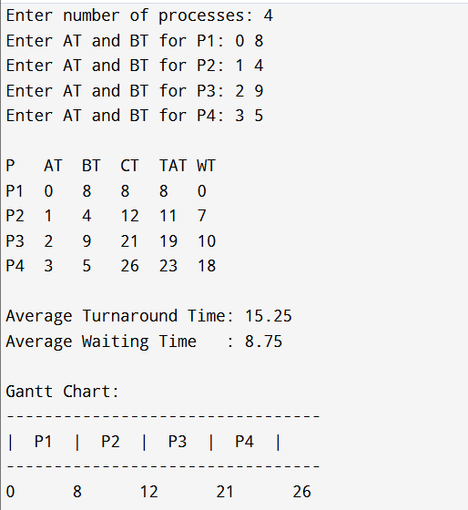

Problem Statement 15: Write a C program to implement Non-preemptive Shortest Job First algorithm.
Theory:
- Non-preemptive SJF (Shortest Job First) is a CPU scheduling algorithm where the process with the smallest burst time is selected next.
- It is non-preemptive, meaning once a process starts executing, it runs until completion.
- Key metrics:
  - Waiting Time (WT) = Time process waits before execution starts
  - Turnaround Time (TAT) = Completion Time − Arrival Time
- When all processes arrive at time 0, SJF simply sorts by burst time.
- When arrival times differ, at each selection moment you choose the shortest job among all arrived processes.
Algorithm:
Step 1: Start
Step 2: Input number of processes and their arrival and burst times
Step 3: Sort processes by arrival time
Step 4: From the set of arrived processes, select the one with the shortest burst time
Step 5: Schedule the selected process and compute its completion, waiting, and turnaround times
Step 6: Mark the process as completed
Step 7: Repeat Steps 4–6 until all processes are completed
Step 8: Display the scheduling results
Step 9: Stop
Code:
#include <stdio.h>

int main() {
int n;
printf("Enter number of processes: ");
scanf("%d", &n);

int at[n], bt[n], ct[n], tat[n], wt[n], completed[n];
int ganttPid[100], ganttStart[100], ganttEnd[100], gc = 0;
int i, time = 0, completedCount = 0;

for (i = 0; i < n; i++) {
printf("Enter Arrival Time and Burst Time for P%d: ", i+1);
scanf("%d %d", &at[i], &bt[i]);
completed[i] = 0;
}

while (completedCount < n) {
int idx = -1, minBT = 9999;

for (i = 0; i < n; i++) {
if (!completed[i] && at[i] <= time && bt[i] < minBT) {
minBT = bt[i];
idx = i;
}
}

if (idx == -1) {
time++;
} else {
ganttPid[gc] = idx + 1;
ganttStart[gc] = time;

time += bt[idx];

ganttEnd[gc] = time;
gc++;

ct[idx] = time;
tat[idx] = ct[idx] - at[idx];
wt[idx] = tat[idx] - bt[idx];
completed[idx] = 1;
completedCount++;
}
}

printf("\nP\tAT\tBT\tCT\tTAT\tWT\n");

float totalWT = 0, totalTAT = 0;
for (i = 0; i < n; i++) {
printf("P%d\t%d\t%d\t%d\t%d\t%d\n",
i+1, at[i], bt[i], ct[i], tat[i], wt[i]);
totalWT += wt[i];
totalTAT += tat[i];
}

printf("\nAverage Waiting Time: %.2f", totalWT / n);
printf("\nAverage Turnaround Time: %.2f\n", totalTAT / n);

// Gantt Chart
printf("\nGantt Chart:\n");
for (i = 0; i < gc; i++) printf("--------");
printf("-\n");
for (i = 0; i < gc; i++) printf("| P%d ", ganttPid[i]);
printf("|\n");
for (i = 0; i < gc; i++) printf("--------");
printf("-\n");
printf("%d", ganttStart[0]);
for (i = 0; i < gc; i++) printf(" %d", ganttEnd[i]);
printf("\n");
return 0;
}
Output:
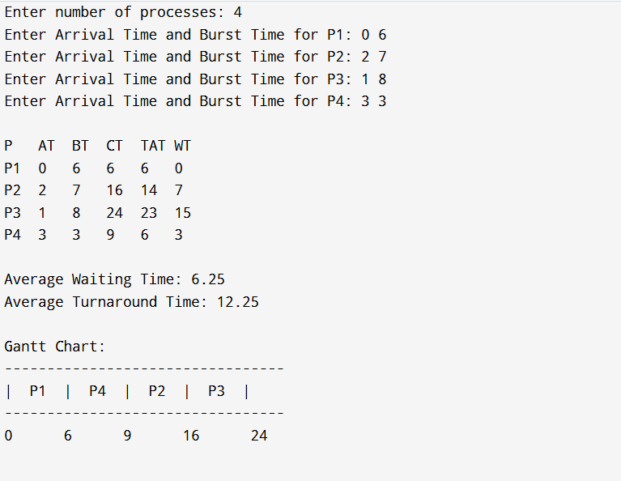
Problem Statement 16: Write a C program to implement Preemptive Shortest Job First algorithm.
Theory:
Preemptive Shortest Job First is also known as Shortest Remaining Time First (SRTF).
- At every moment, the scheduler selects the process with the smallest remaining burst time among all arrived processes.
- If a new process arrives with a burst time smaller than the remaining time of the currently running process, before occurs.
- This results in minimal average waiting time but requires continuous comparison of remaining times.
Key formula
- With: Yes
- Pour = CT − Arrival Time
- IN = TAT − Burst Time
Algorithm:
Step 1: Start
Step 2: Read n, AT[i] and BT[i] for each process i
Step 3: For each i, set RT[i] = BT[i], CT[i] = 0, completed[i] = 0
Step 4: Set time = 0, completedCount = 0
Step 5: While completedCount < n do:
Step 5.1: Find index idx of process with AT[idx] <= time,RT[idx] > 0 and minimum RT[idx]
Step 5.2: If no such idx exists then time = time + 1and accounts
Step 5.3: Execute process idx for 1 time unit: RT[idx] = RT[idx] - 1
Step 5.4: time = time + 1
Step 5.5: If RT[idx] == 0 then CT[idx] = time, completed[idx] = 1, completedCount = completedCount + 1
Step 6:i, withTAT[i] = CT[i] - AT[i] and WT[i] = TAT[i] - BT[i]
Step 7: Optionally compute average TAT and WT
Step 8: Display PID, AT, BT, CT, TAT, WT (and averages if computed)
Step 9: Stop
Code:
#include <stdio.h>
int main() {
int n;
printf("Enter number of processes: ");
scanf("%d", &n);

int at[n], bt[n], rt[n], ct[n], tat[n], wt[n];
int i, time = 0, completed = 0, smallest;

int ganttPid[1000], ganttStart[1000], ganttEnd[1000], gc = 0;
int last = -2;

for (i = 0; i < n; i++) {
printf("Enter AT and BT for P%d: ", i+1);
scanf("%d %d", &at[i], &bt[i]);
rt[i] = bt[i];
}

while (completed != n) {
smallest = -1;
int min = 9999;

for (i = 0; i < n; i++) {
if (at[i] <= time && rt[i] > 0 && rt[i] < min) {
min = rt[i];
smallest = i;
}
}

if (smallest == -1) {
if (last != -1) {
if (last != -2) ganttEnd[gc-1] = time;
ganttPid[gc] = 0;
ganttStart[gc] = time;
gc++;
last = -1;
}
time++;
continue;
}

if (last != smallest) {
if (last != -2) ganttEnd[gc-1] = time;
ganttPid[gc] = smallest + 1;
ganttStart[gc] = time;
gc++;
last = smallest;
}

rt[smallest]--;

if (rt[smallest] == 0) {
completed++;
ct[smallest] = time + 1;
}
time++;
}

ganttEnd[gc-1] = time;

float totalTAT = 0, totalWT = 0;

for (i = 0; i < n; i++) {
tat[i] = ct[i] - at[i];
wt[i] = tat[i] - bt[i];
totalTAT += tat[i];
totalWT += wt[i];
}
printf("\nP\tAT\tBT\tCT\tTAT\tWT\n");
for (i = 0; i < n; i++) {
printf("P%d\t%d\t%d\t%d\t%d\t%d\n",
i+1, at[i], bt[i], ct[i], tat[i], wt[i]);
}
printf("\nAverage Turnaround Time: %.2f", totalTAT / n);
printf("\nAverage Waiting Time : %.2f\n", totalWT / n);

printf("\nGantt Chart:\n");
for (i = 0; i < gc; i++) printf("--------");
printf("-\n");
for (i = 0; i < gc; i++) {
if (ganttPid[i] == 0) printf("| Idle ");
else printf("| P%d ", ganttPid[i]);
}
printf("|\n");
for (i = 0; i < gc; i++) printf("--------");
printf("-\n");
printf("%d", ganttStart[0]);
for (i = 0; i < gc; i++) printf(" %d", ganttEnd[i]);
printf("\n");
return 0;
}
Output:
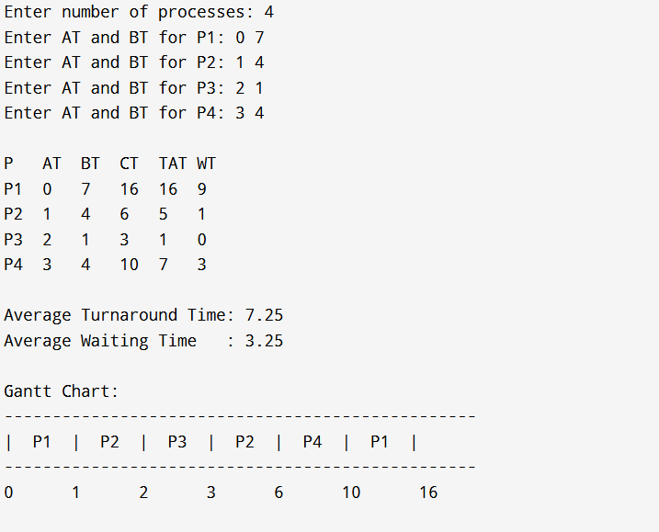
Problem Statement 17: Write a C program to implement Non-preemptive priority algorithm.
Theory:
- Non-preemptive SJF (Shortest Job First) is a CPU scheduling algorithm where the process with the smallest burst time is selected next.
- It is non-preemptive, meaning once a process starts executing, it runs until completion.
- Key metrics:
  - Waiting Time (WT) = Time process waits before execution starts
  - Turnaround Time (TAT) = Completion Time − Arrival Time
- When all processes arrive at time 0, SJF simply sorts by burst time.
- When arrival times differ, at each selection moment you choose the shortest job among all arrived processes.
Algorithm:
Step 1: Start
Step 2: Input number of processes and their arrival, burst, and priority values
Step 3: Set all processes as not completed
Step 4: Set time = 0 and completedCount = 0
Step 5: While completedCount < n:
a) From all arrived and non-completed processes, select the one with the highest priority
b) Execute the selected process fully (non-preemptive)
c)
d) Mark it as completed and increment completedCount
e) Update time
Step 6: Compute turnaround time and waiting time for all processes
Step 7: Display the results.
Step 8: Stop
Code:
#include <stdio.h>
int main() {
int n;
printf("Enter number of processes: ");
scanf("%d", &n);
int at[n], bt[n], pr[n], ct[n], tat[n], wt[n], completed[n];
int time = 0, completedCount = 0;
for (int i = 0; i < n; i++) {
printf("Enter Arrival Time, Burst Time and Priority for P%d: ", i + 1);
scanf("%d %d %d", &at[i], &bt[i], &pr[i]);
completed[i] = 0;
}
while (completedCount < n) {
int idx = -1;
int highestPriority = 9999;
for (int i = 0; i < n; i++) {
if (!completed[i] && at[i] <= time) {
if (pr[i] < highestPriority) { // lower number = higher priority
highestPriority = pr[i];
idx = i;
}
}
}

if (idx == -1) {
time++;
}
else {
time += bt[idx];
ct[idx] = time;
completed[idx] = 1;
completedCount++;
}
}

for (int i = 0; i < n; i++) {
tat[i] = ct[i] - at[i];
wt[i] = tat[i] - bt[i];
}

printf("\nP\tAT\tBT\tPR\tCT\tTAT\tWT\n");
for (int i = 0; i < n; i++) {
printf("P%d\t%d\t%d\t%d\t%d\t%d\t%d\n",
i + 1, at[i], bt[i], pr[i], ct[i], tat[i], wt[i]);
}
return 0;
}
Output: 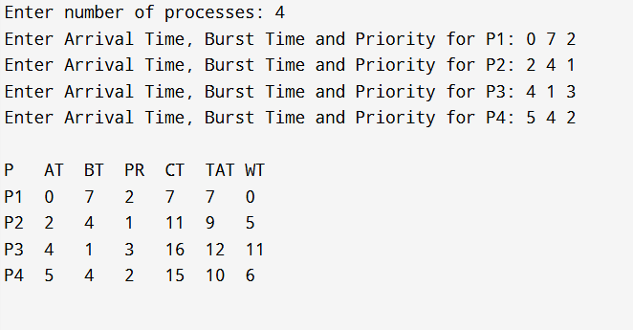
Problem Statement 18: Write a C program to implement Preemptive priority algorithm.
Theory:
Preemptive Priority Scheduling selects the process with the highest priority among all arrived processes at every time unit.
- Lower priority value = higher priority (common convention).
- If a new process arrives with a higher priority than the running one, it preempts the CPU.
- When a process finishes, we compute:
  - CT = completion time
  - TAT = CT − AT
  - WT = TAT − BT
Algorithm:
Step 1: Start
Step 2: Input number of processes and their arrival, burst, and priority values
Step 3: Initialize re
Step 4: Set time = 0 and completedCount = 0
Step 5: While completed
a) From all arrived processes, select the one with the high and RT > 0
b) Execute it for 1 time unit (RT = RT − 1)
c) Increment time
d) If RT becomes 0, record completion time and increase completedCount
Step 6: Compute turnaround and waiting times
Step 7: Display results
Step 8: Stop
Code:
#include <stdio.h>
int main() {
int n;
printf("Enter number of processes: ");
scanf("%d", &n);

int at[n], bt[n], pr[n], ct[n], tat[n], wt[n], completed[n];
int time = 0, completedCount = 0;

int gp[100], gs[100], ge[100], gc = 0;

for (int i = 0; i < n; i++) {
printf("Enter AT, BT, Priority for P%d: ", i+1);
scanf("%d %d %d", &at[i], &bt[i], &pr[i]);
completed[i] = 0;
}

while (completedCount < n) {
int idx = -1, best = 9999;

for (int i = 0; i < n; i++) {
if (!completed[i] && at[i] <= time && pr[i] < best) {
best = pr[i];
idx = i;
}
}

if (idx == -1) {
time++;
}
else {
gs[gc] = time;
gp[gc] = idx + 1;

time += bt[idx];
ge[gc] = time;
gc++;

ct[idx] = time;
completed[idx] = 1;
completedCount++;
}
}

float totalTAT = 0, totalWT = 0;
for (int i = 0; i < n; i++) {
tat[i] = ct[i] - at[i];
wt[i] = tat[i] - bt[i];
totalTAT += tat[i];
totalWT += wt[i];
}

printf("\nP\tAT\tBT\tPR\tCT\tTAT\tWT\n");
for (int i = 0; i < n; i++) {
printf("P%d\t%d\t%d\t%d\t%d\t%d\t%d\n",
i+1, at[i], bt[i], pr[i], ct[i], tat[i], wt[i]);
}

printf("\nAverage Turnaround Time: %.2f", totalTAT / n);
printf("\nAverage Waiting Time : %.2f\n", totalWT / n);
printf("\nGantt Chart:\n");
for (int i = 0; i < gc; i++) printf("--------");
printf("-\n");
for (int i = 0; i < gc; i++) printf("| P%d ", gp[i]);
printf("|\n");
for (int i = 0; i < gc; i++) printf("--------");
printf("-\n");
printf("%d", gs[0]);
for (int i = 0; i < gc; i++) printf(" %d", ge[i]);
printf("\n");
return 0;
}
Output:
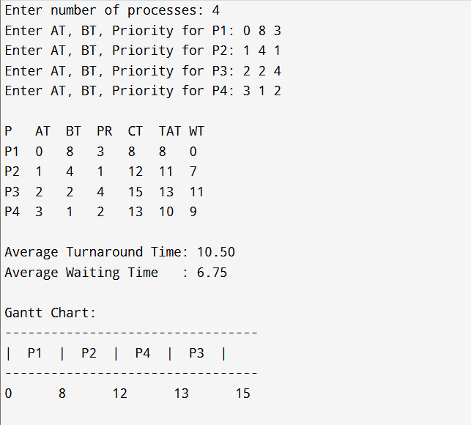
Problem Statement 19: Write a C program to implement Round-Robin algorithm.
Theory:
Round Robin (RR) is a preemptive CPU scheduling algorithm.
Each process gets a fixed time quantum.
If a process doesn’t finish within that quantum, it is preempted and moved to the end of the ready queue.
This ensures fairness and prevents starvation.
Key with
- CT (Completion Time)
- FACING
- WT = TAT − BT
Algorithm:
Code:
#include <stdio.h>

struct process {
int pid, at, bt, ct, tat, wt;
int remaining_bt;
};

struct gantt {
int pid;
int start;
int end;
};

int main() {
int n, tq;
printf("Enter number of processes: ");
scanf("%d", &n);

struct process p[n];
struct gantt chart[1000];
int gc = 0;

for (int i = 0; i < n; i++) {
printf("Enter Arrival Time and Burst Time for P%d: ", i+1);
scanf("%d %d", &p[i].at, &p[i].bt);
p[i].pid = i + 1;
p[i].remaining_bt = p[i].bt;
}

printf("Enter Time Quantum: ");
scanf("%d", &tq);

int currentTime = 0, completed = 0;
int queue[1000], front = 0, rear = 0;
int visited[n];

for (int i = 0; i < n; i++) visited[i] = 0;

int earliest = 1e9, idx = -1;
for (int i = 0; i < n; i++) {
if (p[i].at < earliest) {
earliest = p[i].at;
idx = i;
}
}

currentTime = p[idx].at;
queue[rear++] = idx;
visited[idx] = 1;

while (completed < n) {

if (front == rear) {
int nextArrival = 1e9, nextIdx = -1;
for (int i = 0; i < n; i++) {
if (p[i].remaining_bt > 0 && p[i].at < nextArrival) {
nextArrival = p[i].at;
nextIdx = i;
}
}
currentTime = p[nextIdx].at;
queue[rear++] = nextIdx;
visited[nextIdx] = 1;
continue;
}

int i = queue[front++];

chart[gc].pid = p[i].pid;
chart[gc].start = currentTime;

int execTime = (p[i].remaining_bt > tq) ? tq : p[i].remaining_bt;
p[i].remaining_bt -= execTime;
currentTime += execTime;

chart[gc].end = currentTime;
gc++;

for (int k = 0; k < n; k++) {
if (!visited[k] && p[k].at <= currentTime && p[k].remaining_bt > 0) {
queue[rear++] = k;
visited[k] = 1;
}
}

if (p[i].remaining_bt == 0) {
p[i].ct = currentTime;
p[i].tat = p[i].ct - p[i].at;
p[i].wt = p[i].tat - p[i].bt;
completed++;
} else {
queue[rear++] = i;
}
}

printf("\nP\tAT\tBT\tCT\tTAT\tWT\n");

float totalTAT = 0, totalWT = 0;
for (int i = 0; i < n; i++) {
printf("P%d\t%d\t%d\t%d\t%d\t%d\n",
p[i].pid, p[i].at, p[i].bt, p[i].ct, p[i].tat, p[i].wt);
totalTAT += p[i].tat;
totalWT += p[i].wt;
}

printf("\nAverage Turnaround Time: %.2f", totalTAT / n);
printf("\nAverage Waiting Time : %.2f\n", totalWT / n);

printf("\nGantt Chart:\n");

for (int i = 0; i < gc; i++) printf("--------");
printf("-\n");

for (int i = 0; i < gc; i++) printf("| P%d ", chart[i].pid);
printf("|\n");

for (int i = 0; i < gc; i++) printf("--------");
printf("-\n");

printf("%d", chart[0].start);
for (int i = 0; i < gc; i++) printf(" %d", chart[i].end);
printf("\n");

return 0;
}

Output:
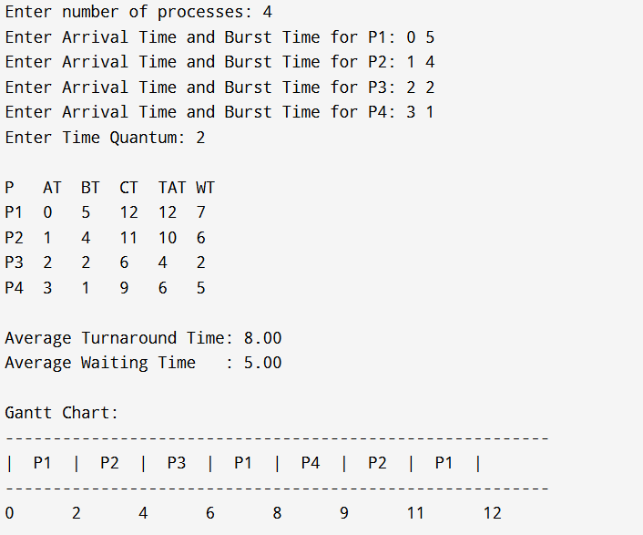

Problem Statement 20: Write a C program to implement Message Queue.
Theory:
A Message Queue in UNIX System V IPC allows processes to communicate by sending and receiving messages through a shared queue located in the kernel.
Important functions:
- ftok() → Generates a unique key.
- msgget() → Creates/opens a message queue.
- msgsnd() → Sends messages to the queue.
- msgrcv() → Receives messages from the queue.
- msgctl() → Performs control operations like deleting the queue.
Message queues support asynchronous communication — sender and receiver do not need to run at the same time.
Algorithm:
Writer Process Algorithm
Step 1: Start
Step 2: Generate key using ftok()
Step 3: Create/get message queue using msgget()
Step 4: Fill message structure with type and text
Step 5: Send message using msgsnd()
Step 6: Stop
Reader Process Algorithm
Step 1: Start
Step 2:ftok()
Step 3:msgget()
Step 4: Receive message using msgrcv()
Step 5: Display received message
Step 6: Delete the message queue using msgctl()
Step 7: Stop

Code:
Writer’s process:
// C program for message queue (Writer Process)
#include <stdio.h>
#include <stdlib.h>
#include <sys/ipc.h>
#include <sys/msg.h>
#include <string.h>

#define MAX_TEXT 100
struct message {
long msg_type;
char msg_text[MAX_TEXT];
};

int main() {
struct message msg;
int msgid;
key_t key;
key = ftok("msgqueuefile", 65);
msgid = msgget(key, 0666 | IPC_CREAT);
if (msgid == -1) {
perror("msgget");
exit(EXIT_FAILURE);
}
msg.msg_type = 1;
printf("Enter string: ");
fgets(msg.msg_text, MAX_TEXT, stdin);
msg.msg_text[strcspn(msg.msg_text, "\n")] = '\0';
if (msgsnd(msgid, &msg, sizeof(msg.msg_text), 0) == -1) {
perror("msgsnd");
exit(EXIT_FAILURE);
}
printf("Message sent \n");
return 0;
}

Reader’s process:
// C program for message queue (Reader Process)
#include <stdio.h>
#include <stdlib.h>
#include <sys/ipc.h>
#include <sys/msg.h>
#include <string.h>
#define MAX_TEXT 100
struct message {
long msg_type;
char msg_text[MAX_TEXT];
};
int main() {
struct message msg;
int msgid;
key_t key;
key = ftok("msgqueuefile", 65);
msgid = msgget(key, 0666 | IPC_CREAT);
if (msgid == -1) {
perror("msgget");
exit(EXIT_FAILURE);
}
if (msgrcv(msgid, &msg, sizeof(msg.msg_text), 0, 0) == -1) {
perror("msgrcv");
exit(EXIT_FAILURE);
}
printf("Message received: %s\n", msg.msg_text);
msgctl(msgid, IPC_RMID, NULL);
return 0;
}
Output:
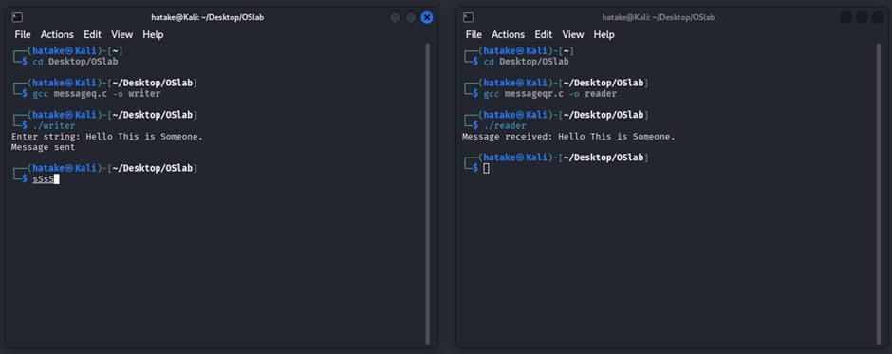

Problem Statement 21: Write a C program to implement First In First Out page replacement algorithm.
Theory:
FIFO (First-In First-Out) page replacement algorithm replaces the page that has been in memory the longest
Key points:
- Pages are loaded in order.
- When a page fault occurs and all frames are full, the oldest page is removed.
- FIFO uses a circular queue to track which page entered first.
Terms:
- Page Faul → When the referenced page is not found in any frame.
- Frames → Fixed number of slots available in main memory.
- Reference String → Sequence of page requests.
Algorithm:
Step 1: Start
Step 2: Read number of pages and the reference string
Step 3: Read number of frames
Step 4: Initialize all frames to empty (−1)
Step 5: Set index = 0 and pageFaults = 0
Step 6: For each page in the reference string:
a) Check if the page is already in a frame
b) If found → no page fault
c) If not found → replace the page at frames[index]
d) Update index = (index + 1) % frames (circular queue)
e) Increment pageFaults
f) Display current frame contents
Step 7: Print total page faults
Step 8: Stop
Code:
#include<stdio.h>
int main(){
int frames[10], pages[30];
int n, j, i, f, k, pageFaults = 0, index = 0, flag;
printf("Enter number of pages: ");
scanf("%d", &n);

printf("Enter the reference string: ");
for(i = 0; i < n; i++)
scanf("%d", &pages[i]);
printf("Enter number of frames: ");
scanf("%d", &f);
for(i = 0; i < f; i++)
frames[i] = -1;
printf("\nPage Replacement Process:\n");
for(i = 0; i < n; i++){
flag = 0;
for(j = 0; j < f; j++){
if(frames[j] == pages[i]) {
flag = 1;
break;
}
}
if(flag == 0){
frames[index] = pages[i];
index = (index + 1) % f;
pageFaults++;
printf("For page %d: ", pages[i]);
for(k = 0; k < f; k++){
if(frames[k] != -1)
printf("%d ", frames[k]);
else
printf("- ");
}
printf(" <--- page fault\n");
}
else{
printf("For page %d: No page fault\n", pages[i]);
}
}
printf("\nTotal Page Faults = %d\n", pageFaults);
}
Output:
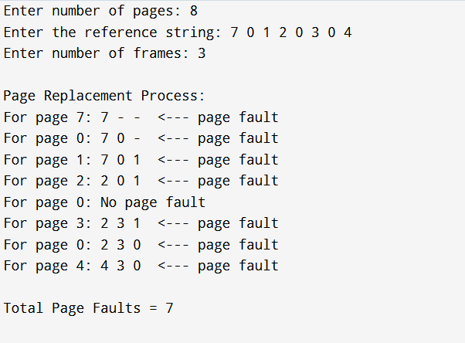

Problem Statement 22: Write a C program to implement Least Recently Used replacement algorithm.
Theory:
LRU (Least Recently Used) page replacement algorithm replaces the page that was used the longest time ago.
It keeps track of when each page was last accessed.
When a page fault occurs:
- If a frame is empty → simply insert the page
- If no frame is empty → replace the page with the smallest last-used value (oldest access)
Terms:
- lastUsed[i] → timestamp of when frame iwhat read
- Page Fault → page not found in any frame
LRU approximates optimal replacement well because it assumes past behavior predicts future use.
Algorithm:
Step 1: Start
Step 2: Input number of p
Step 3: Input number of f
Step 4: Initialize all frames to −1 and lastUsed[] to −1
Step 5: Set time = 0 and pageFaults = 0
Step
a) Increment time
b) Check if the page is already in frames
c) If present → update its lastUsed time (no page fault)
d) If not present → find the frame with the smallest lastUsed value
e) Replace
f) Update lastUsed for that frame and increment pageFaults
g) Display the frame contents
Step 7: Print total page faults
Step 8: Stop
Code:
#include<stdio.h>

int main() {
int frames[10], pages[30], lastUsed[10];
int n, j, i, f, k, pageFaults = 0, time = 0, flag;

printf("Enter number of pages: ");
scanf("%d", &n);
printf("Enter the reference string: ");
for (i = 0; i < n; i++)
scanf("%d", &pages[i]);
printf("Enter number of frames: ");
scanf("%d", &f);
for (i = 0; i < f; i++) {
frames[i] = -1;
lastUsed[i] = -1;
}
printf("\nPage Replacement Process: \n");
for (i = 0; i < n; i++) {
flag = 0;
time++;
for (j = 0; j < f; j++) {
if (frames[j] == pages[i]) {
flag = 1;
lastUsed[j] = time;
break;
}
}
if (flag == 0) {
int minIndex = 0;
for (j = 1; j < f; j++) {
if (lastUsed[j] < lastUsed[minIndex])
minIndex = j;
}
frames[minIndex] = pages[i];
lastUsed[minIndex] = time;
pageFaults++;
printf("For page %d: ", pages[i]);
for (k = 0; k < f; k++) {
if (frames[k] != -1)
printf("%d ", frames[k]);
else
printf("- ");
}
printf("<--- page fault\n");
}
else {
printf("For page %d: No page fault\n", pages[i]);
}
}
printf("\nTotal page faults = %d\n", pageFaults);
return 0;
}
Output:
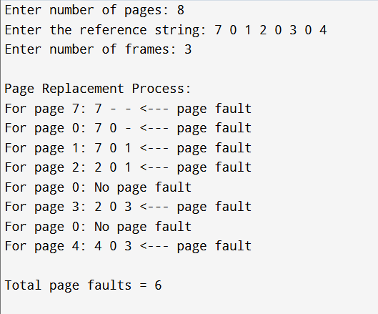

Problem Statement 23: Write a C program to use execl() system call to tell date and list files in the directory with the help of fork().
Theory:
The fork() system call creates a child process.
After forking:
- Child process executes the first execl() → runs /bin/date
- Parent process waits for the child using wait()
- After the child finishes, the parent process executes the second execl() → runs /bin/ls -l
execl() replaces the current process image with a new program.
So after execl() runs, the original process code does not continue.
Algorithm:
Step 1: Start
Step 2: Call fork() to create a child
Step 3: If fork() fails, exit
Step 4: If child process:
a) When
b) Execute /bin/date using execl()
Step 5: If parent process:
a) Wait for child to finish
b) Print message
c) Execute /bin/ls -l using execl()
Step 6: Stop
Code:
#include<stdio.h>
#include<stdlib.h>
#include<sys/wait.h>
#include<sys/types.h>
#include<unistd.h>

int main() {
pid_t pid;
int status;

pid = fork();

if(pid < 0) {
exit(0);
}
else if(pid == 0) {
printf("\nChild is executing date command:\n");
execl("/bin/date", "date", NULL);
}
else {
wait(&status);
printf("\nParent executing ls -l command:\n");
execl("/bin/ls", "ls", "-l", NULL);
}

return 0;
}

Output:
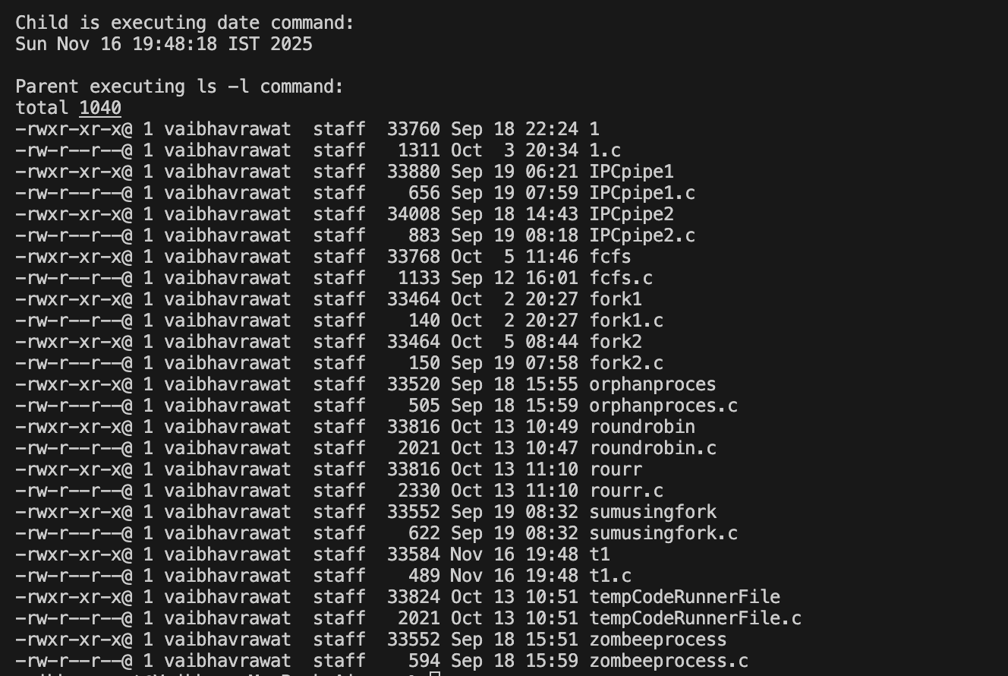
Problem Statement 24: Write a C program to use execl() system call to run wc command with the help of fork().
Theory:
This program demonstrates how to combine fork(), pipe(), and execl() to achieve a UNIX-style pipeline:
ls | wc
Key system calls:
- pipe(fd) → creates a communication channel
- fork() → creates two processes
- dup() / dup2() → redirects input/output
- execl() → replaces the current process with a specified command
Flow:
- Parent process runs ls and writes output into the pipe
- Child process reads from the pipe and runs wc
- The pipe connects them exactly like ls | wc
Algorithm:
Step 1: Start
Step 2: Create a pipe using pipe(fd)
Step 3: Fork the process
Step
a) Repeat
b) Close unused pipe ends
c) Executionls using execl()
Step
a) Redirect standard input to pipe read end
b) Close unused pipe ends
c) Execute wc using execl()
Step 6: Stop
Code:
#include<stdlib.h>
#include<unistd.h>
int main() {
pid_t pid;
int fd[2];
pipe(fd);
pid = fork();

if(pid != 0) {
close(1); // Redirect stdout
dup(fd[1]); // Write end of pipe
close(fd[0]); // Close unused read end
execl("/bin/ls", "ls", NULL);
}
else {
close(0); // Redirect stdin
dup(fd[0]); // Read end of pipe
close(fd[1]); // Close unused write end
execl("/usr/bin/wc", "wc", NULL);
exit(0);
}
return 0;
}
Output:

