**Ansible Case Study**

Creating role for Apache:



Creating role for Nginx:



**Apache Role:**

Task:

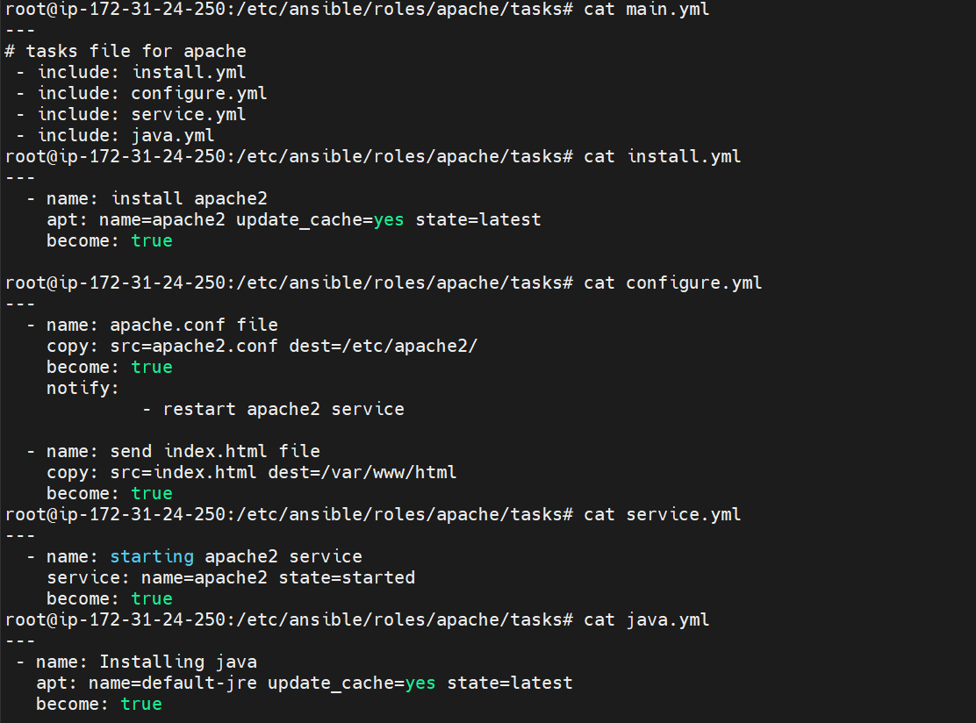

Files:

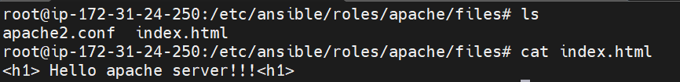

Handlers:

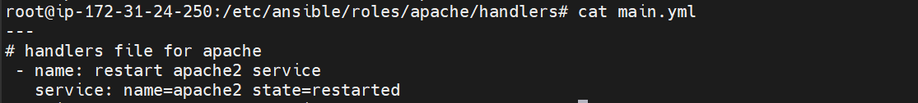

**Nginx Role:**

Tasks:

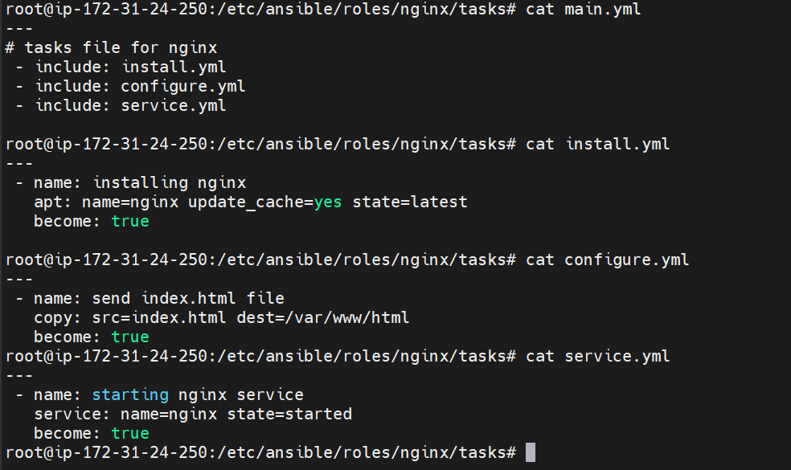

Files:

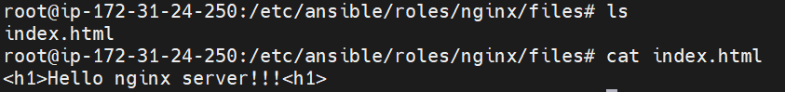

build.yml file

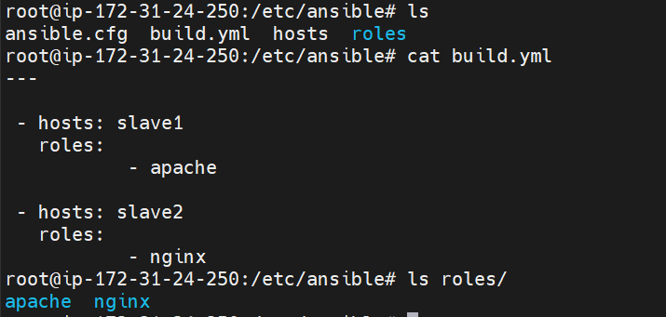

Checking ping connection:

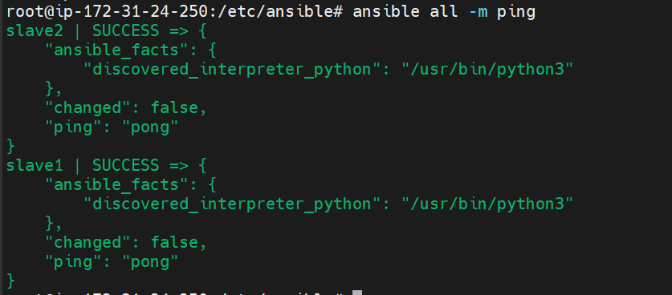

Checking syntax-error:



Running playbook:

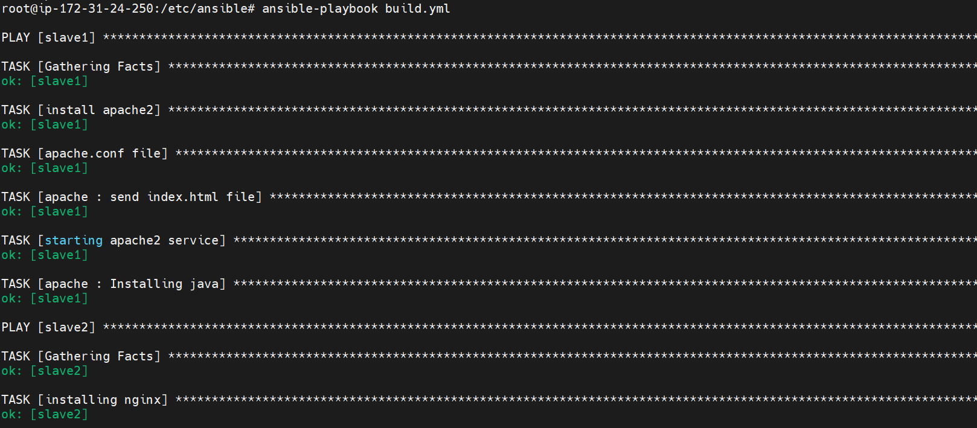

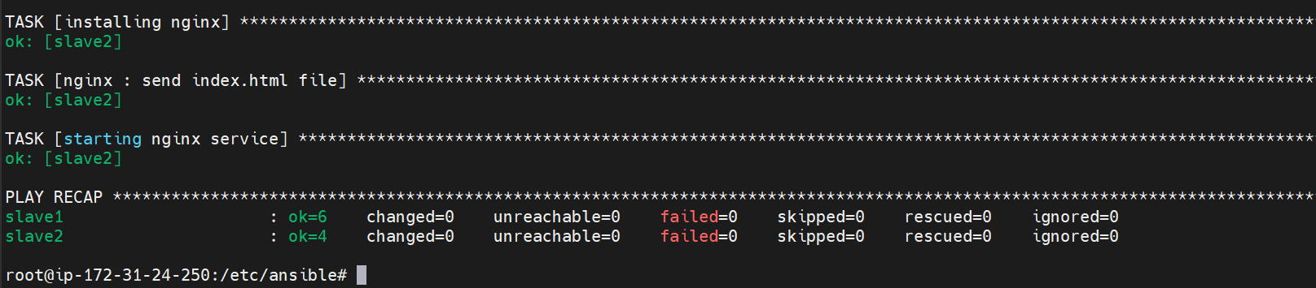

Output:





