**Capstone Projects 1**

1. Installing necessary software on the using ansible playbook.

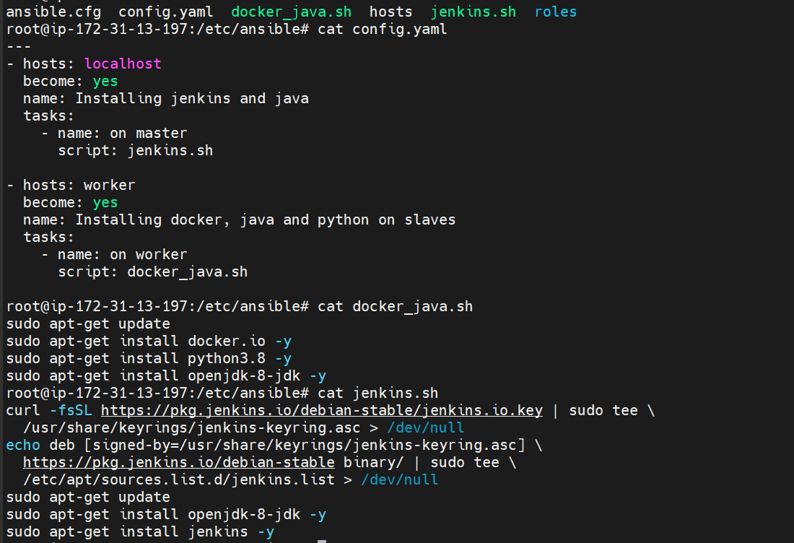

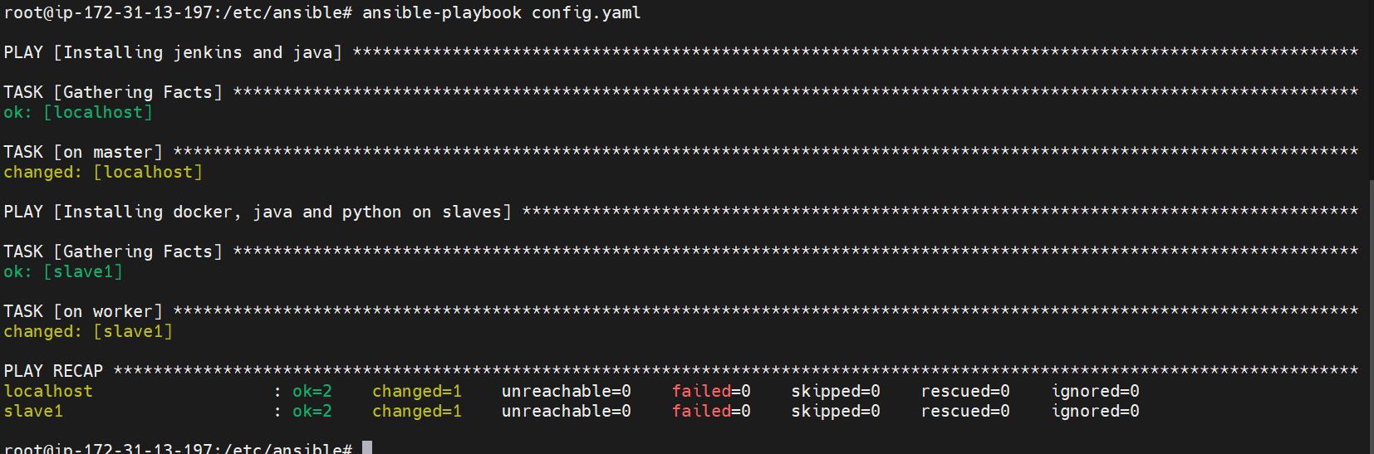

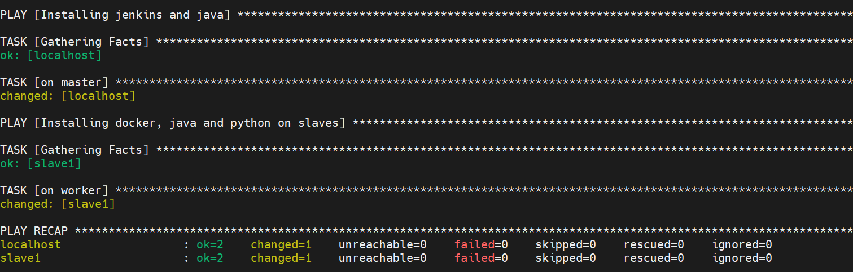

On Master: -

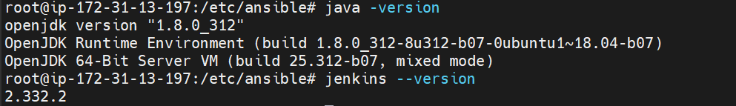

On Worker: -

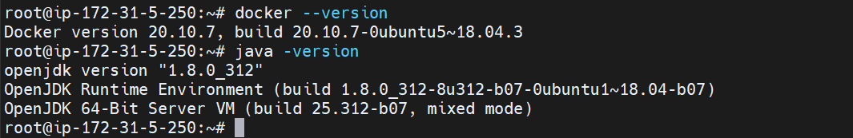

1. Git repo used in this project: -

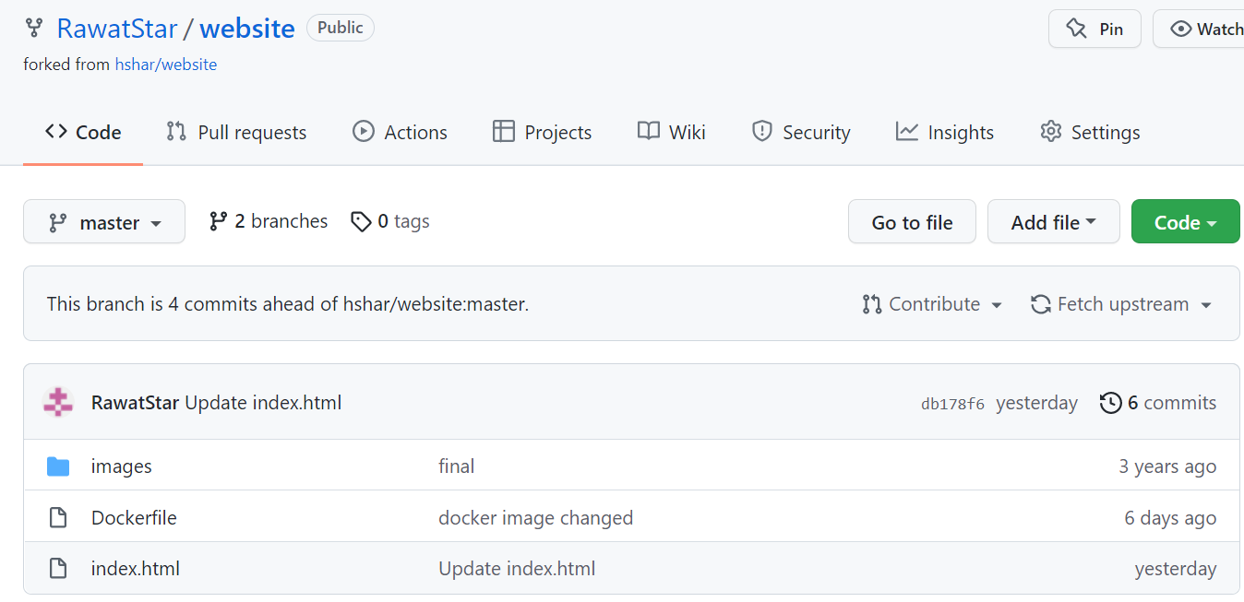

Git webhook added for jenkins to auto trigger the job/build.

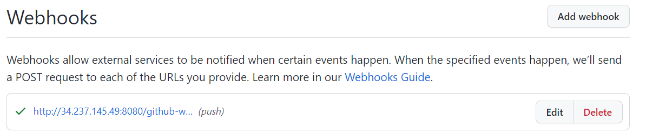

1. Jenkins jobs pipeline used for auto build once the commit is done on master or devloper branch.

Pipeline: -

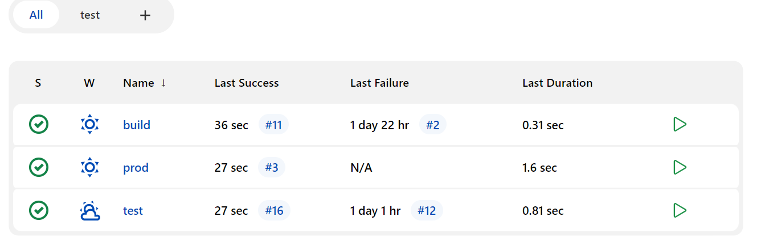

Jobs used: -

Build job for git trigger other job, parameter is used to trigger it on 2 slaves: -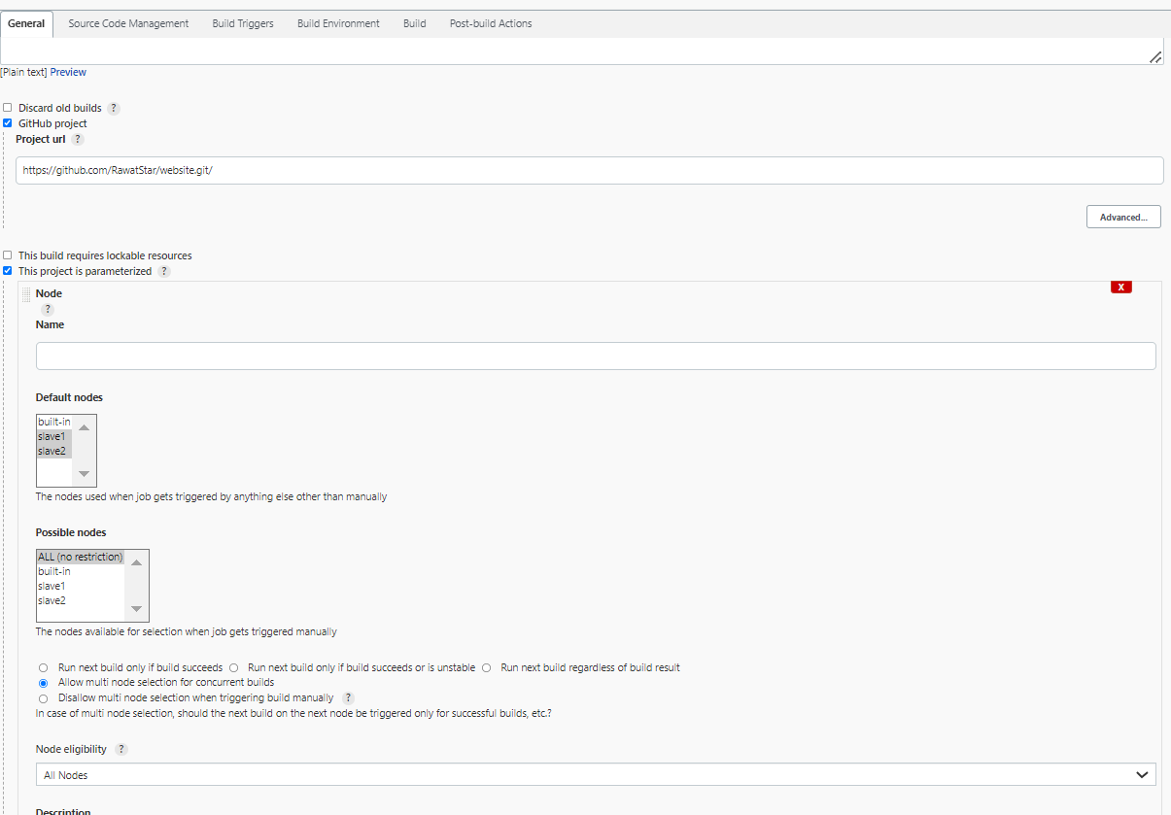

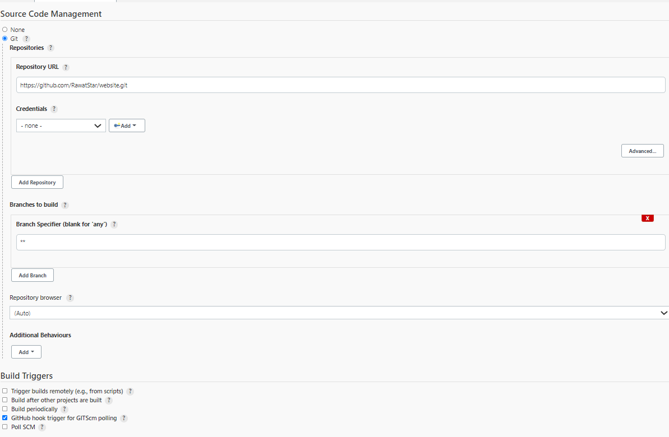

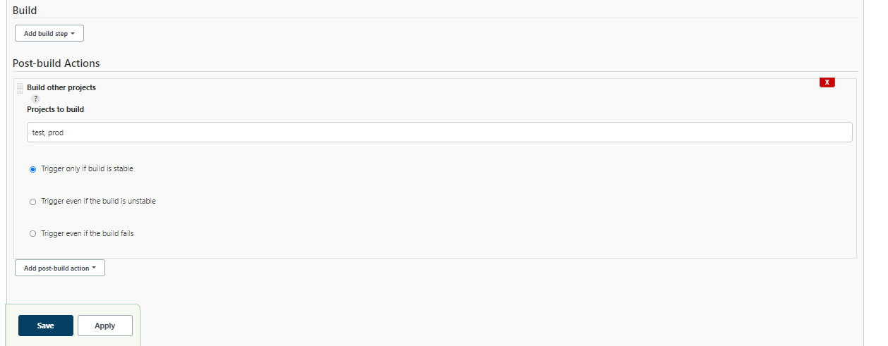

Prod Job for production server: 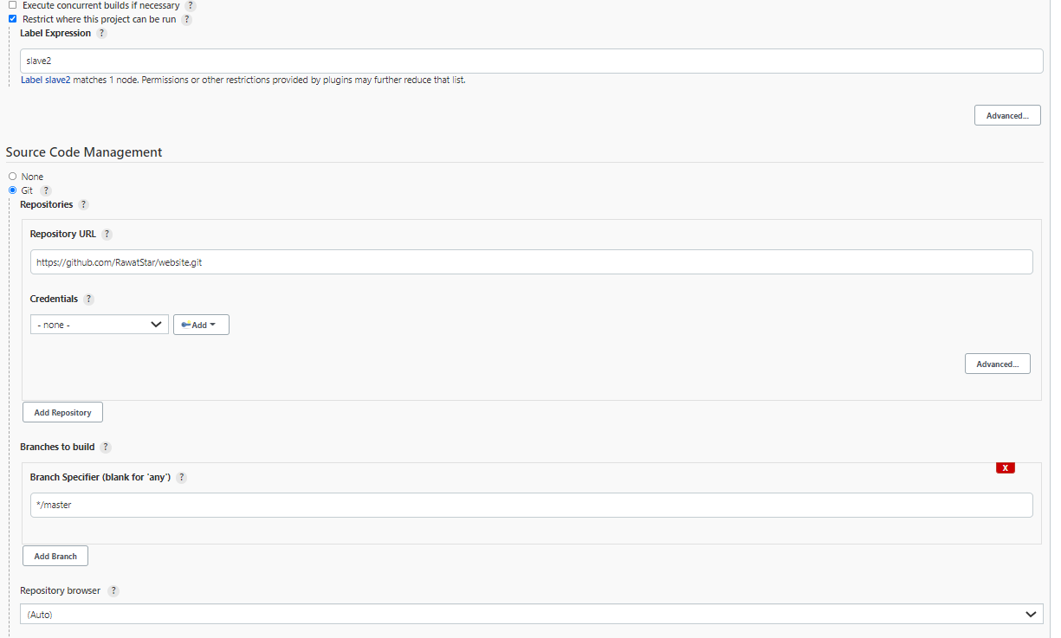

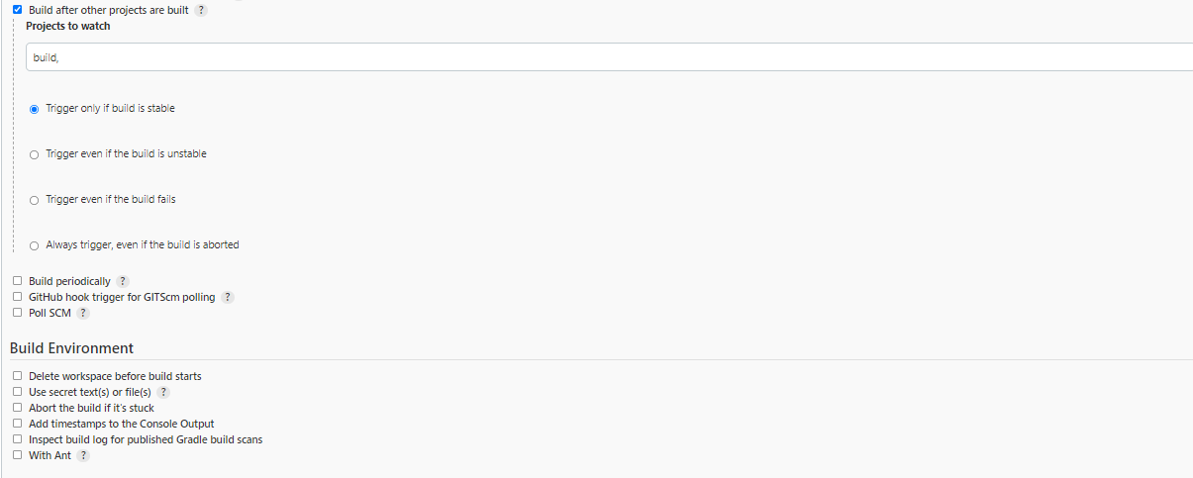

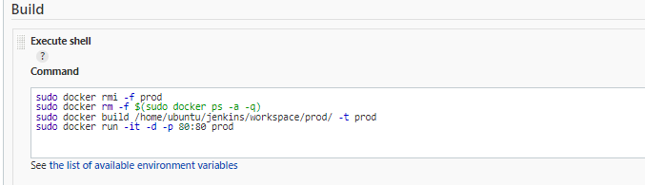

Test job for developer branch only image is created not deployed: -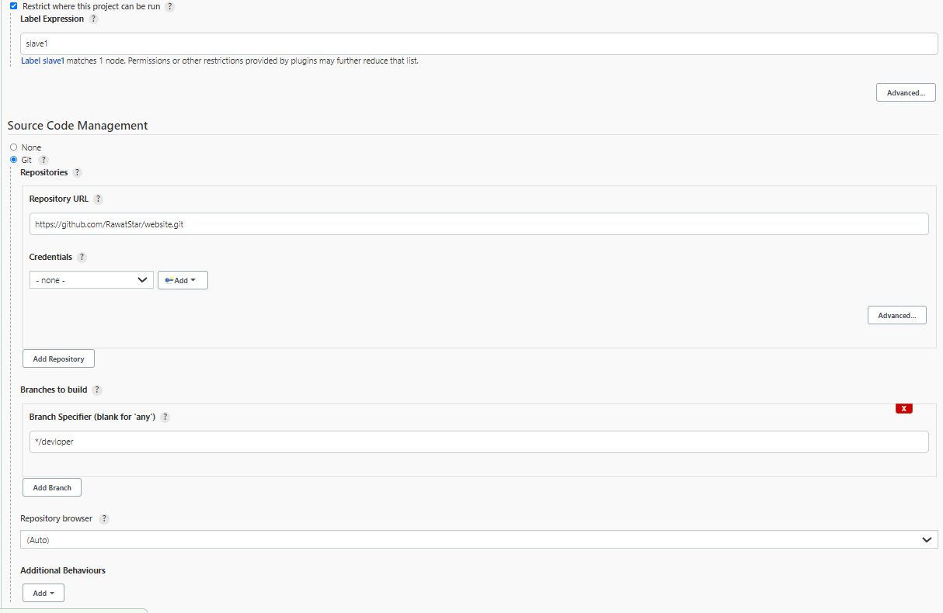

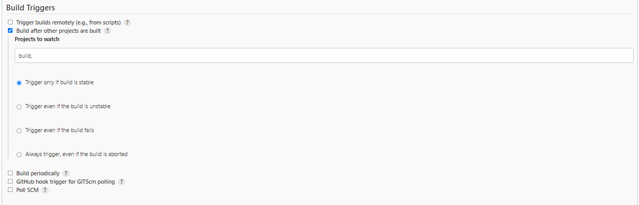

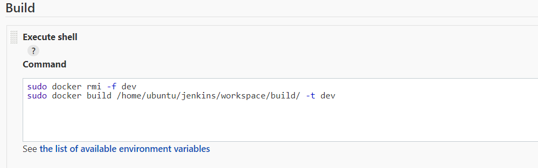

Results: -

Prod server outcome: -

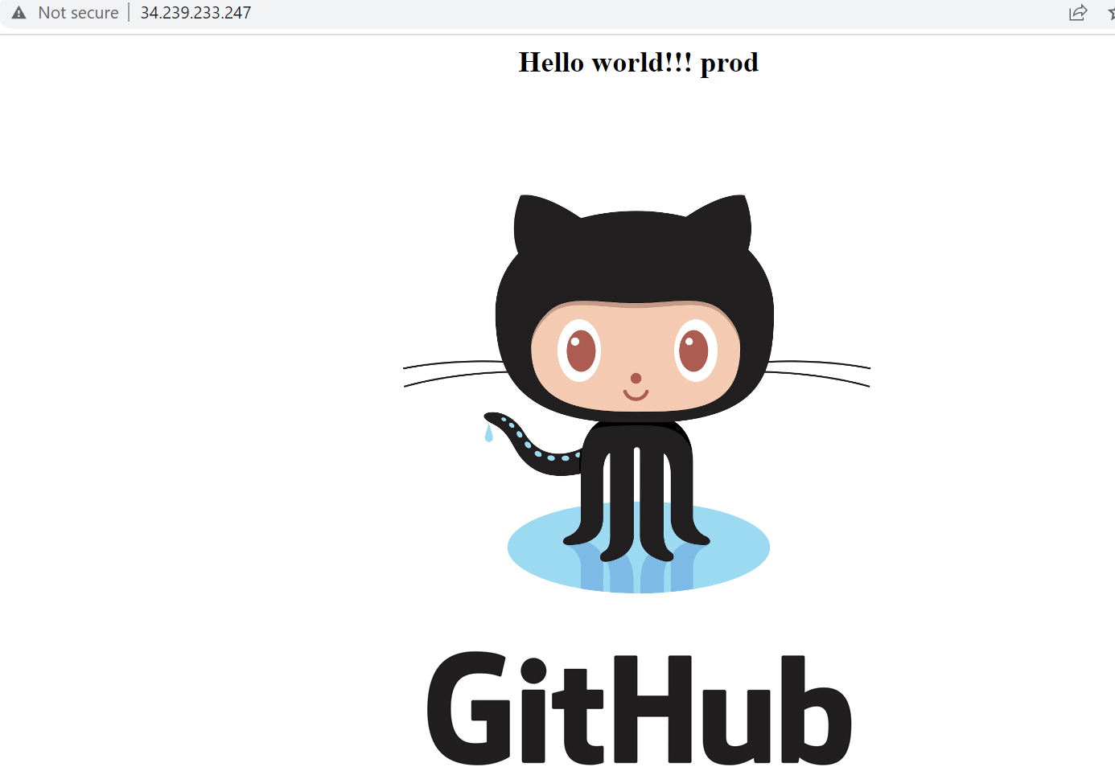

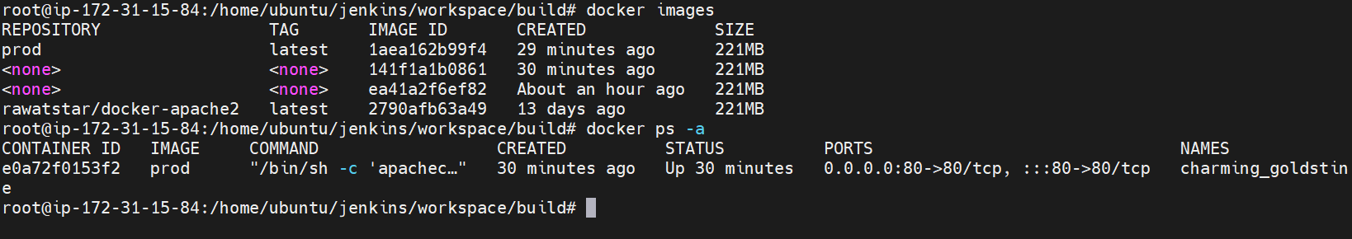

Test server outcome: -

