Kubernetes Assignment

1. Installing K8s

3 AWS instance created

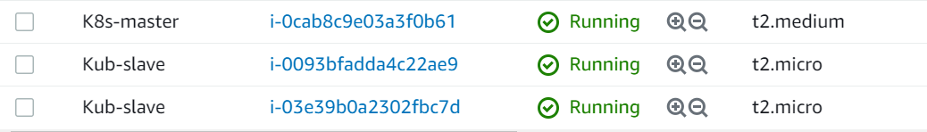

* To install following command used: -
* On Master & worker node

sudo su

apt-get update

apt-get install docker.io -y

service docker restart

curl -s https://packages.cloud.google.com/apt/doc/apt-key.gpg | apt-key add -

echo "deb http://apt.kubernetes.io/ kubernetes-xenial main" >/etc/apt/sources.list.d/kubernetes.list

apt-get update

apt install kubeadm=1.20.0-00 kubectl=1.20.0-00 kubelet=1.20.0-00 -y

* **On Master**

**kubeadm init --pod-network-cidr=192.168.0.0/16**





* **On worker Node: - Joining to cluster.**
* **Worker1**

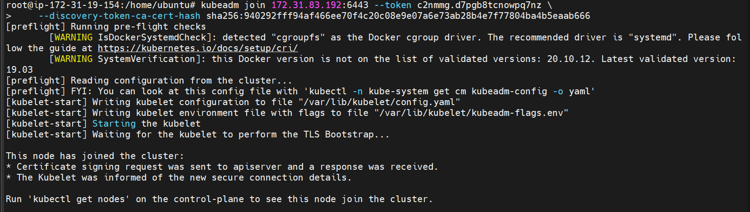

* **Worker2**

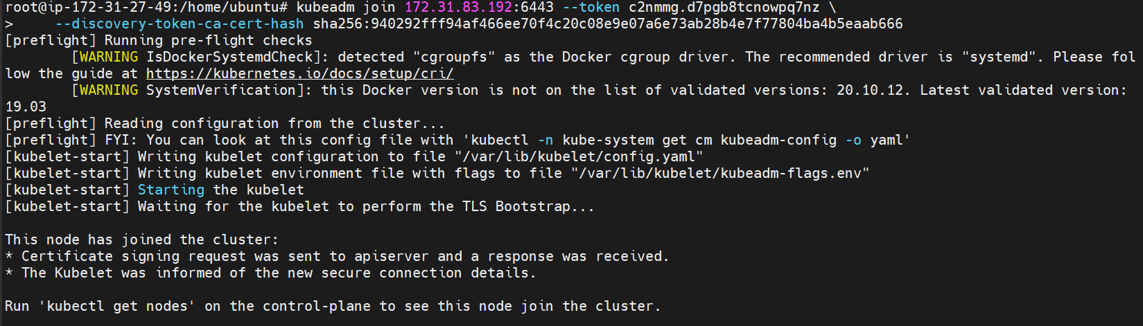

* **On Master**

As normal user

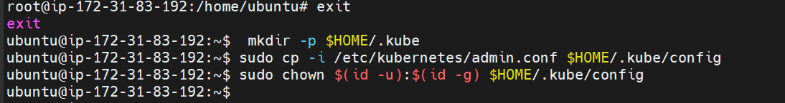

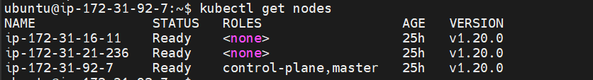

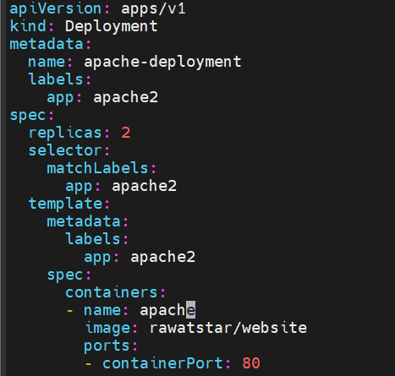







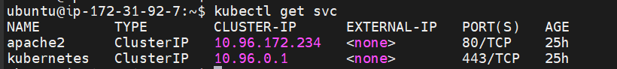



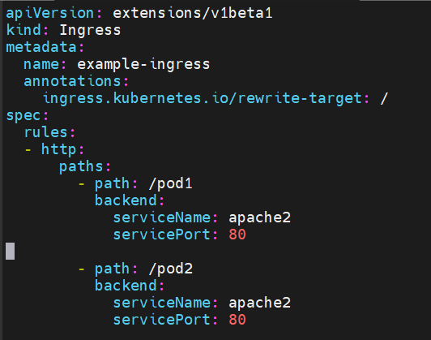





**Output: -**

Master IP: -

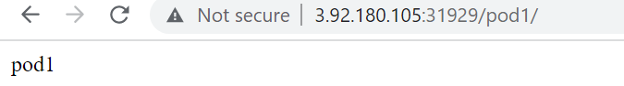

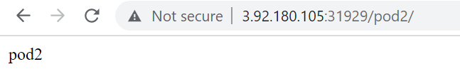

Worker IP: -

