Docker-1 Assignment-1

1. Installing ubuntu image. 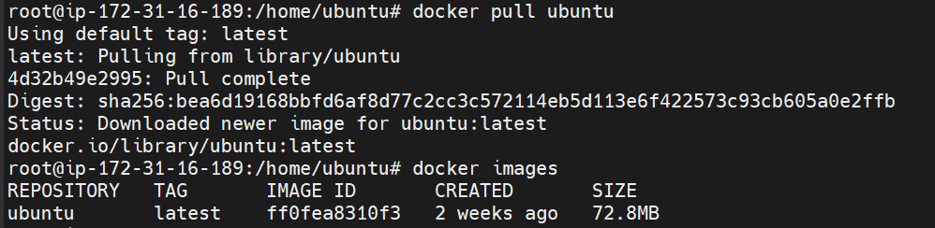
2. Running ubuntu image with port 80 mapped on local
3. docker exec -it 0b9c7ed438a5 /bin/bash running docker container. 
4. apt-get install apache2 (installing apache2 in container and ctrl+p+q for save and exit).
5. Running apache in local machine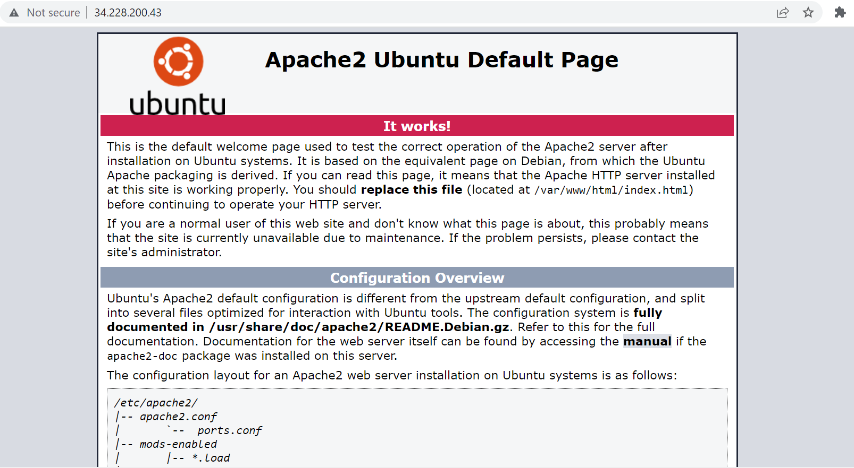

Docker-1 Assignment-2

1. Saving image as Docker image. 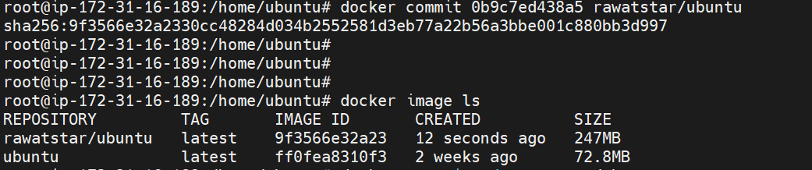
2. Launching container from new image with port 81 mapped on it. 
3. Running apache services inside container. 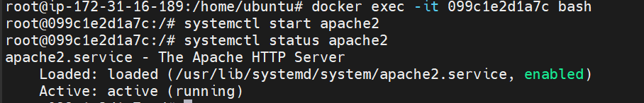
4. Apache successfully running on local machine. 