**CASE STUDY - CONTAINERIZATION USING DOCKER**

1. Creating Dockerfile and pushing to docker hub.

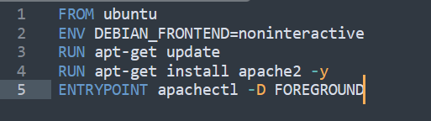

Command to build image and push to docker hub account.

#docker build . -t rawatstar/docker-apache2

#docker push docker-apache2

Image on Docker hub



1. Creating docker file to pull custom image and copy file from developer.





1. Testing custom image.

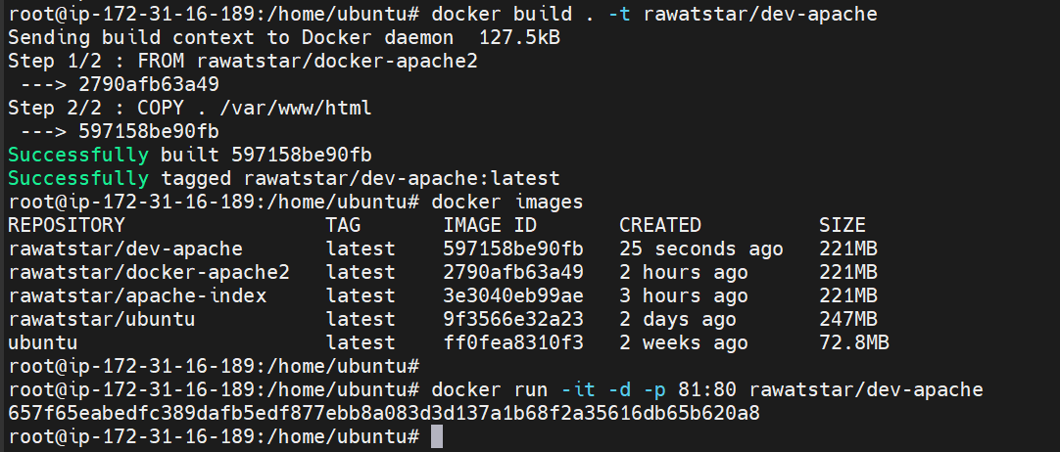

Output:

