Module 3: Docker Assignment

1. Creating a web container(apache) using Dockerfile and deploying index.html to container.

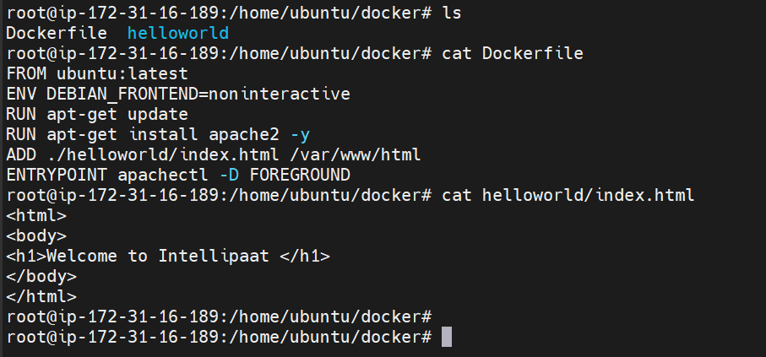

1. Running container and checking output.

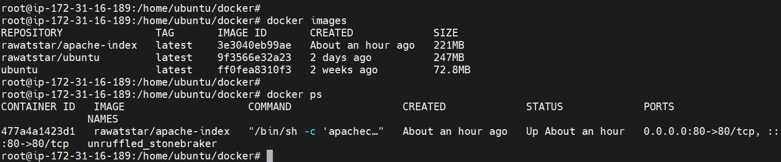

Output:

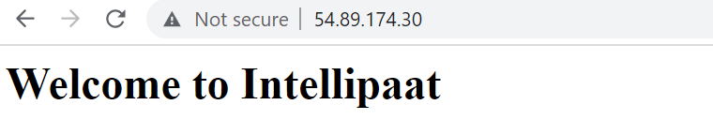

1. Saving changes in container and pushing to Docker hub.

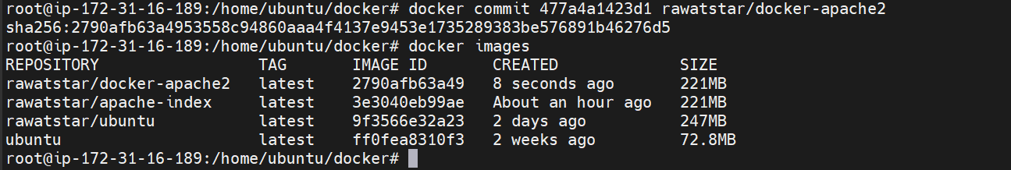

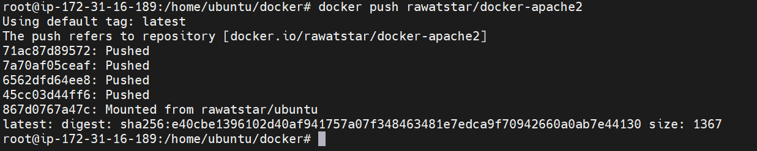

1. Image successfully pushed on Dockerhub.

