

Docker-1 Assignment

DevOps



April 6, 2022

Manish Singh Rawat

8295308644

Assignment-1

1. Installing ubuntu image. 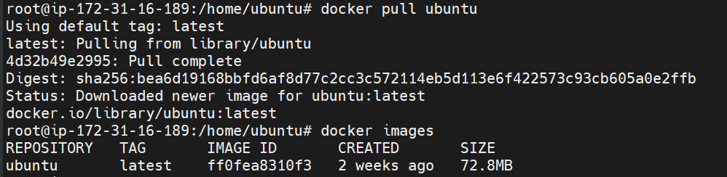
2. Running ubuntu image with port 80 mapped on local
3. docker exec -it 0b9c7ed438a5 /bin/bash running docker container. 
4. apt-get install apache2 (installing apache2 in container and ctrl+p+q for save and exit).
5. Running apache in local machine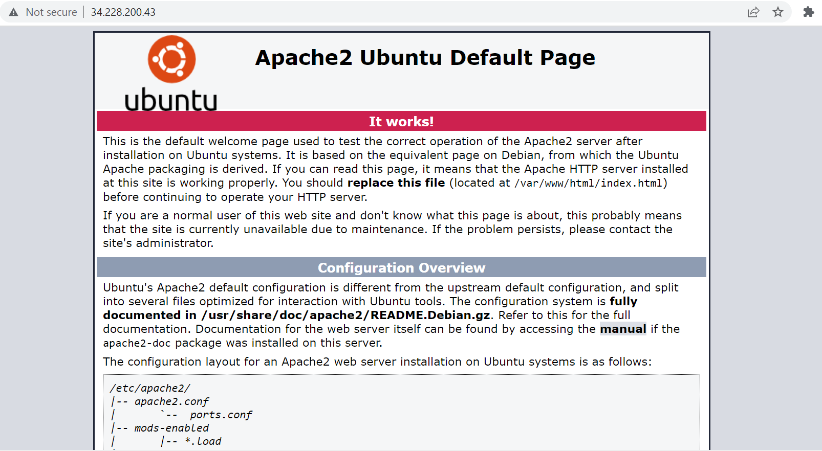

Assignment-2

1. Saving image as Docker image. 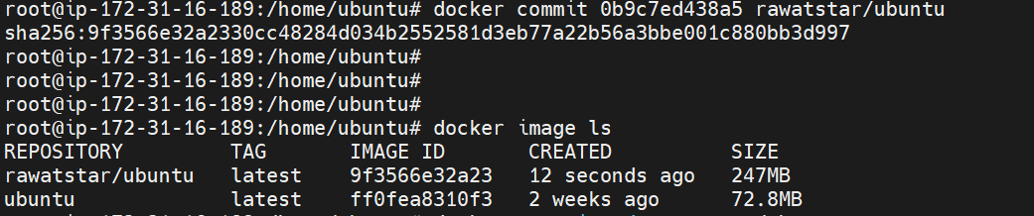
2. Launching container from new image with port 81 mapped on it. 
3. Running apache services inside container. 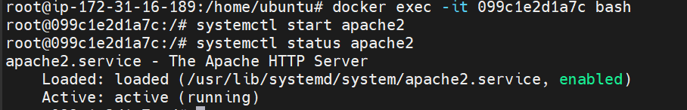
4. Apache successfully running on local machine. 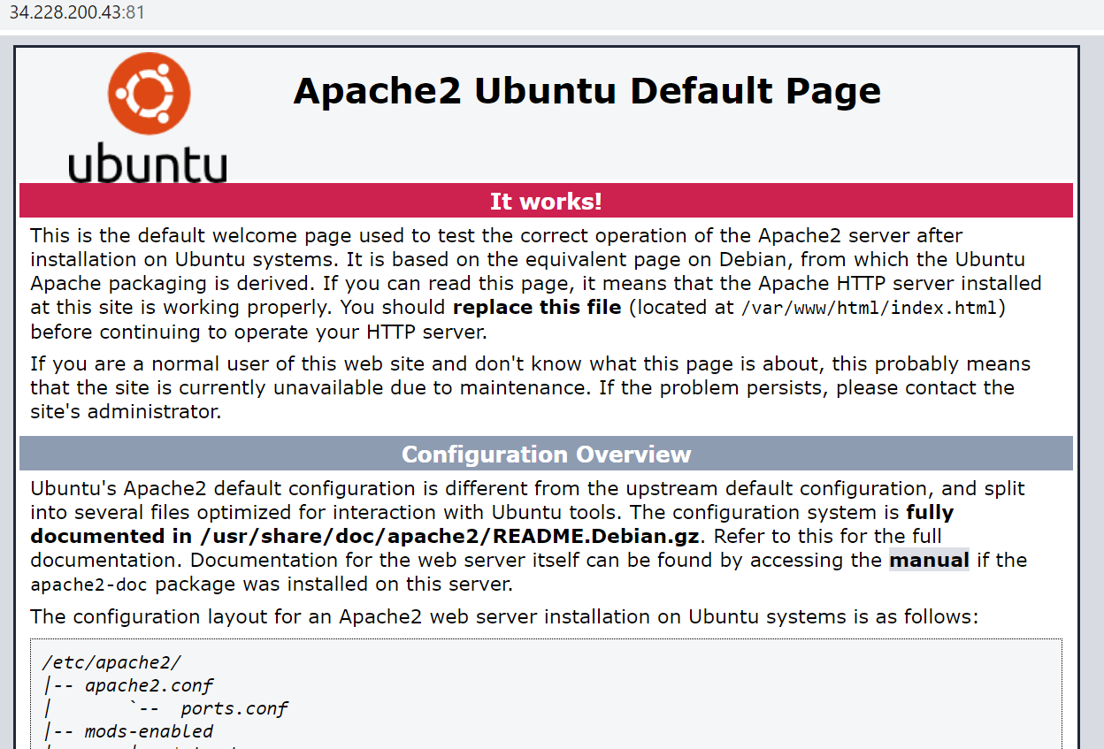

**Assignment-3**

1. Uploading the save image in DockerHub. 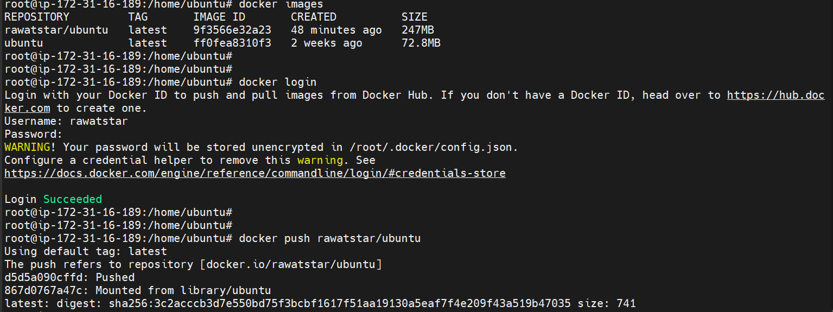
2. Pulling same image from dockerhub and running on port 80. 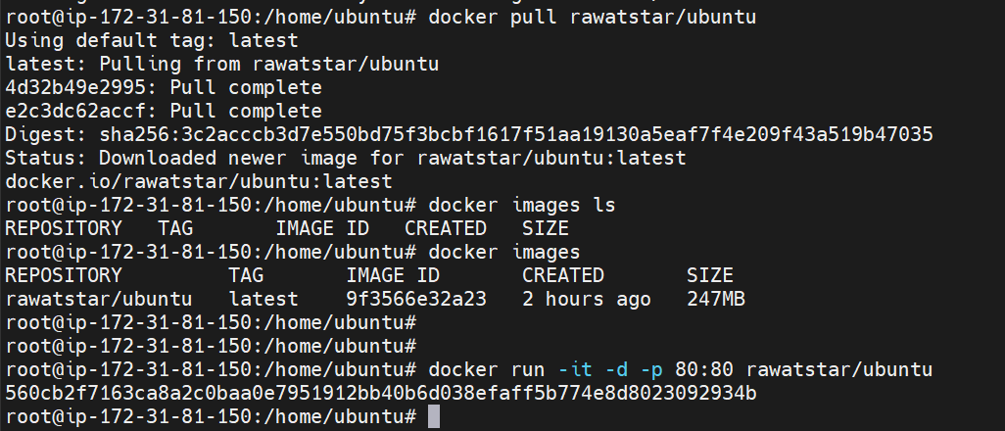
3. Running apache on this image. 
4. Apache services is running. 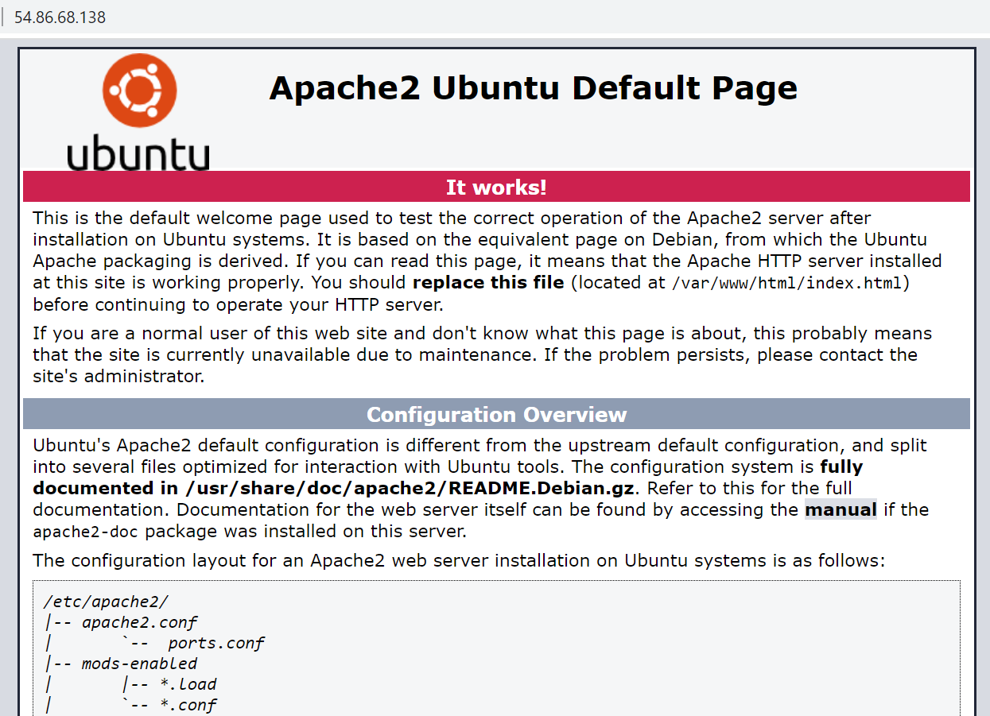

**Assignment-4**

1. Creating Dockerfile with ubuntu in it and apache running.

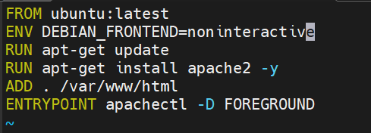

1. Creating an index.html file on same directory location, message hello world!!!!! in it.
2. Running the following Dockerfile.



1. Output.

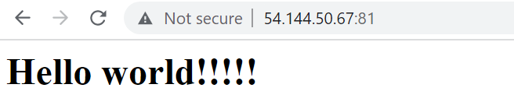

**Assignment-5**

1. Creating sample html file and adding it in same Dockerfile is done in assignment

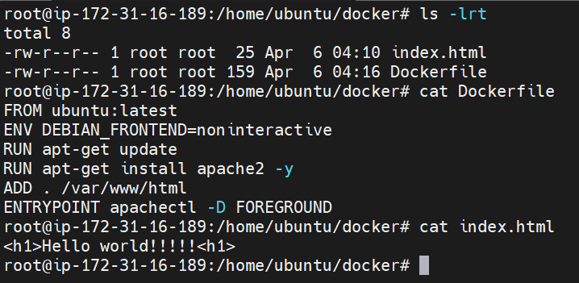

1. Output of following file are:

