**Git Project**

1. Creating file and committing as ”First commit” in master branch.



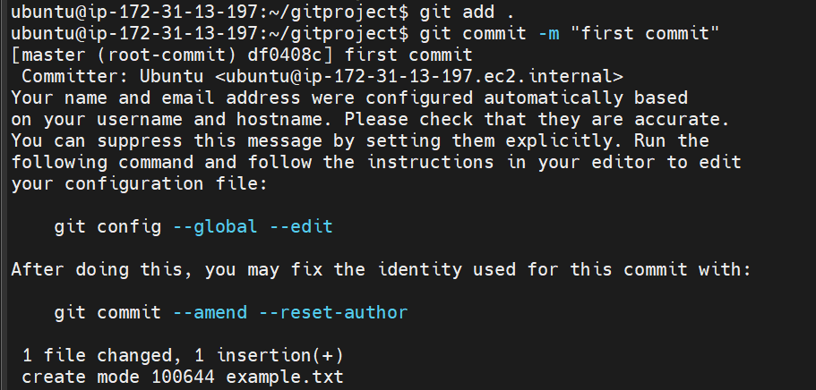

1. Creating Feature1 branch from master branch and committing .

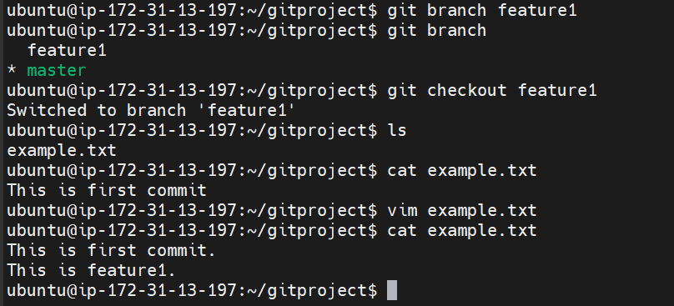

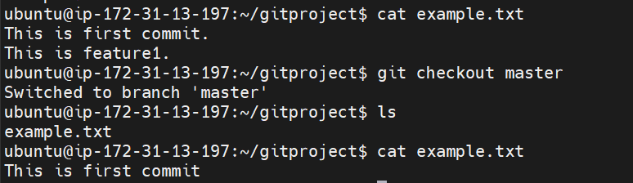

1. Creating Feature2 branch from master branch and committing in feature2 branch.

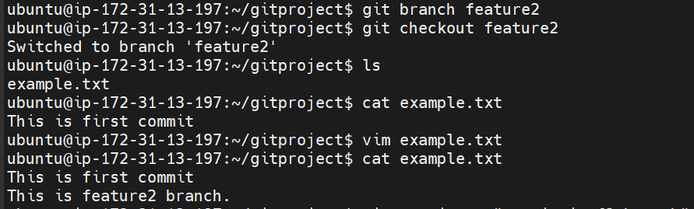

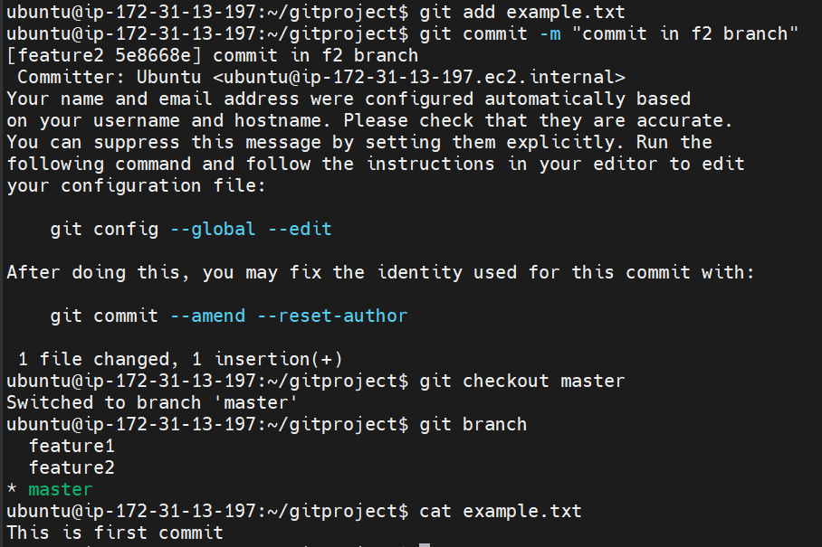

1. Merging branches to master branch

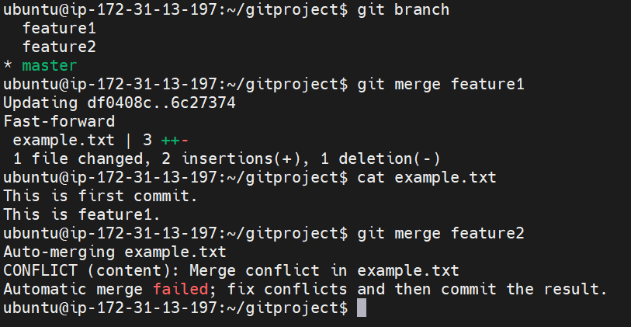

1. Feature2 branch through error for merge.
2. Git mergetool is used for manually resolve the conflict I used two time first time I forget to take snapshot.

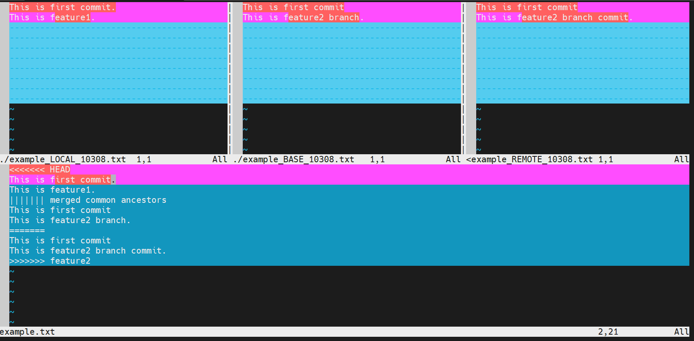

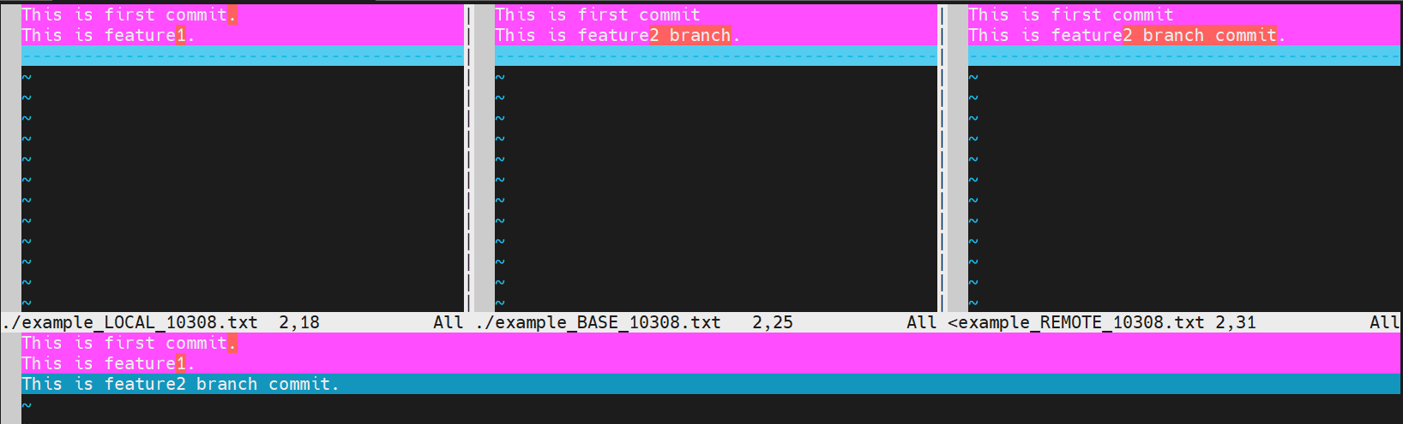

1. Merge conflict resolve using mergetool.

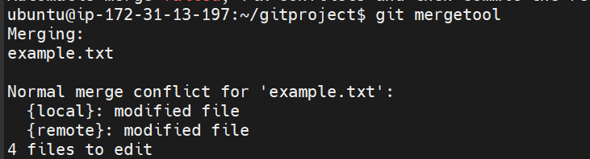

1. Merge successful and repo push to the github.

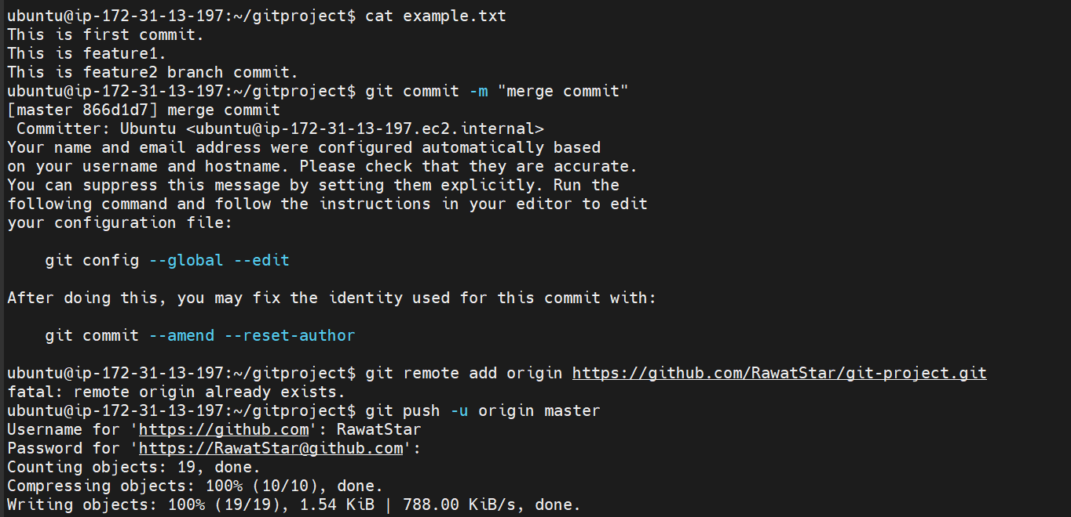

Result: - Git repo on git hub.

