Integration of Devops tools with Jenkins

1. Git Workflow has to be implemented: - For this first I fork the mentioned git hub repo to <https://github.com/RawatStar/website.git> below are the screenshots.

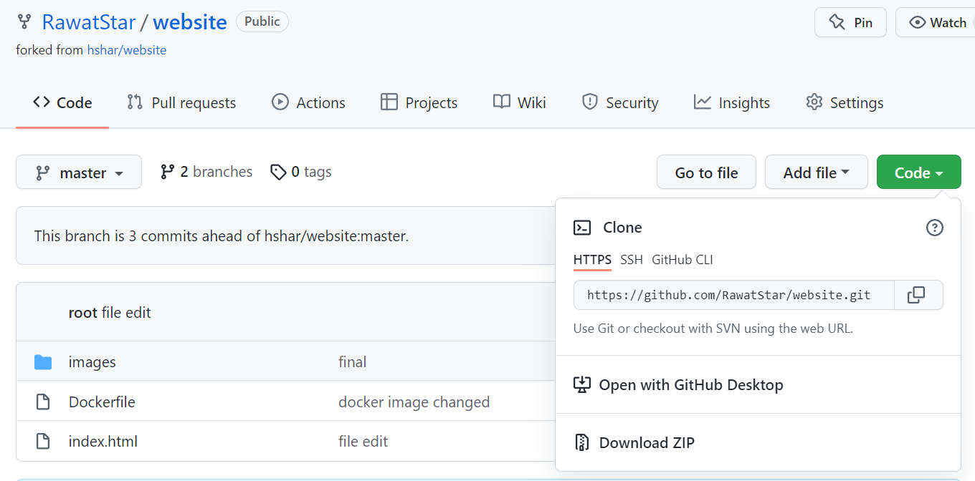

1. I clone it to my local machine to push any change.
2. Then I create a Dockerfile for deployment and push it to Github.

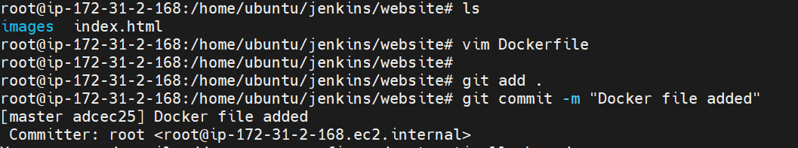

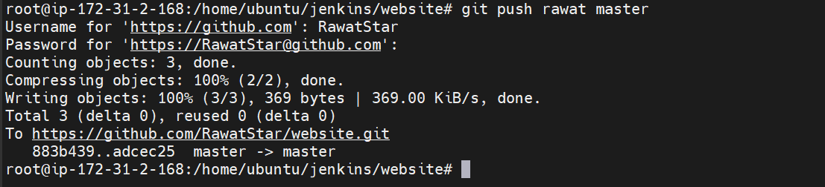

1. Then I created devloper branch as required and push it.

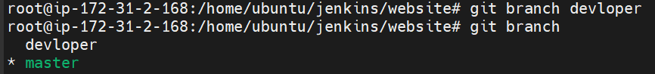

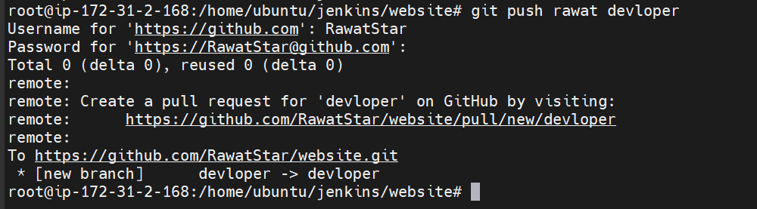

1. Then I create two AWS instance one for Jenkins master and other for Jenkins slave.



1. In Jenkins master I created one slave node for deployment and install docker and java manually in slave node and name it as slave1.

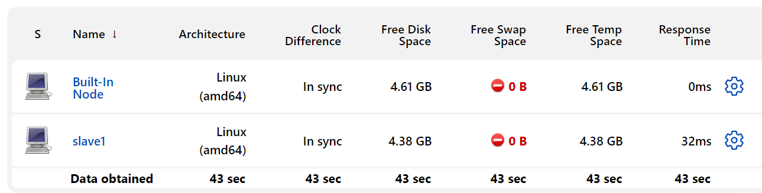

1. Then I created two different pipeline jobs as required in assignment one for master branch and other for developer branch and set build trigger: GitHub hook trigger for GITScm polling.

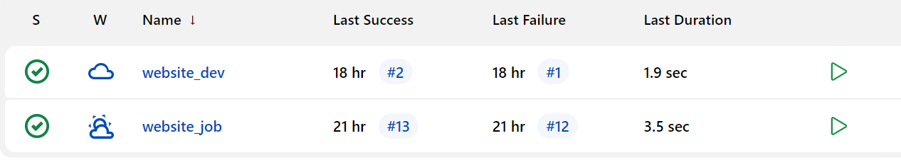

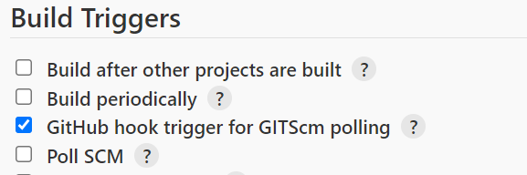

1. Pipeline code for master branch:

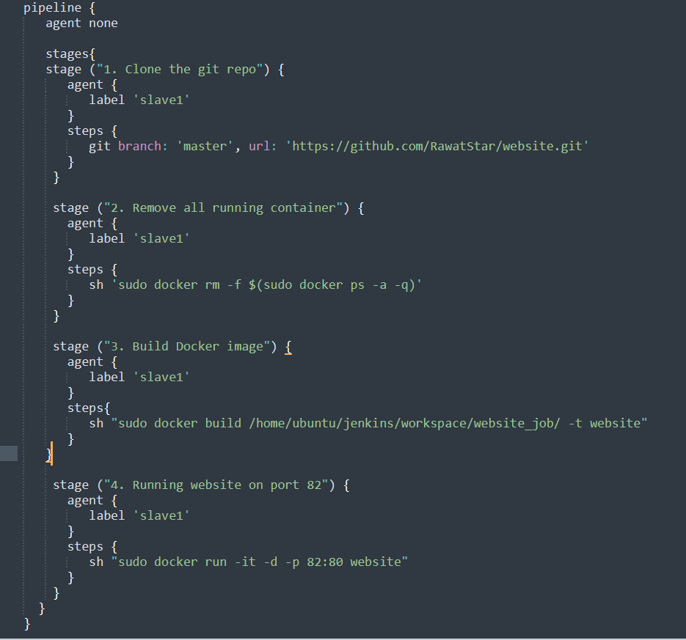

Pipeline code for developer branch:

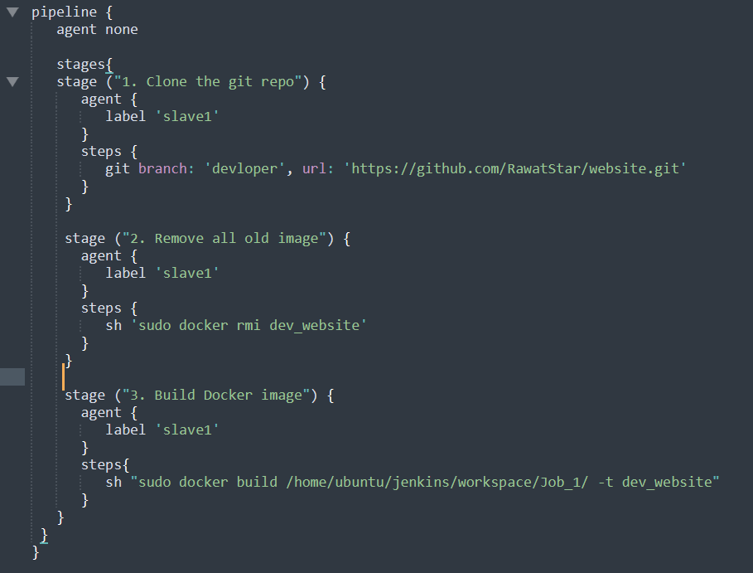

1. After running the jobs here, the results as required running on port 82.

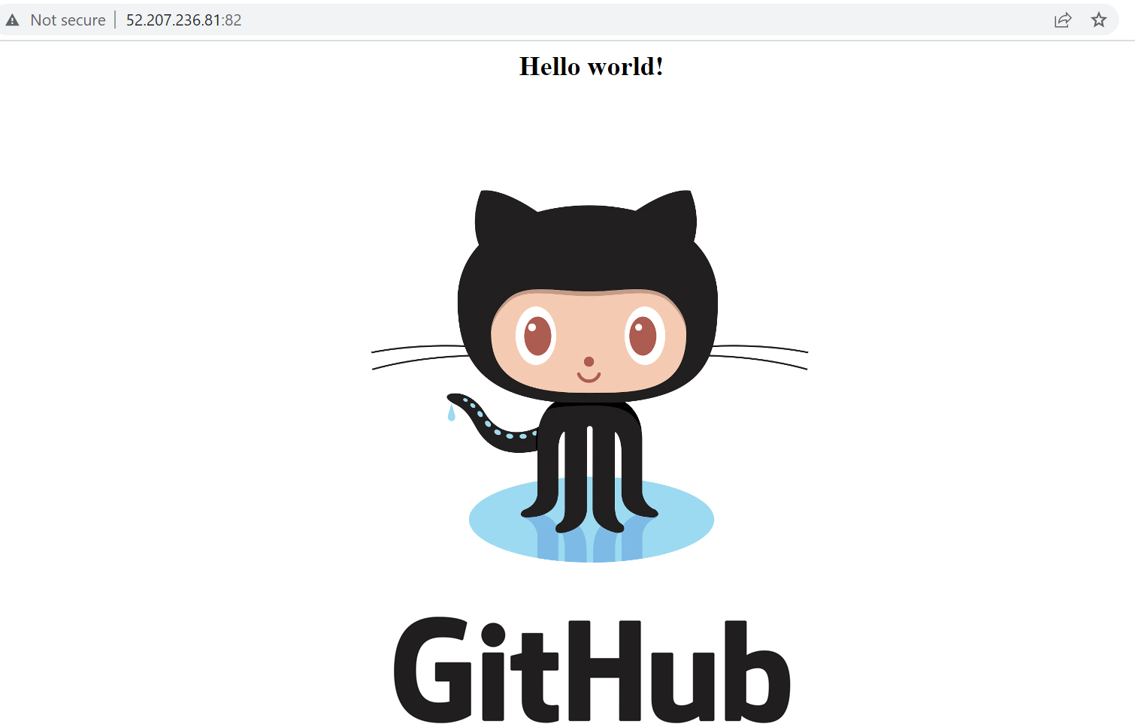

Testing change in index.html file and pushing it to master branch.

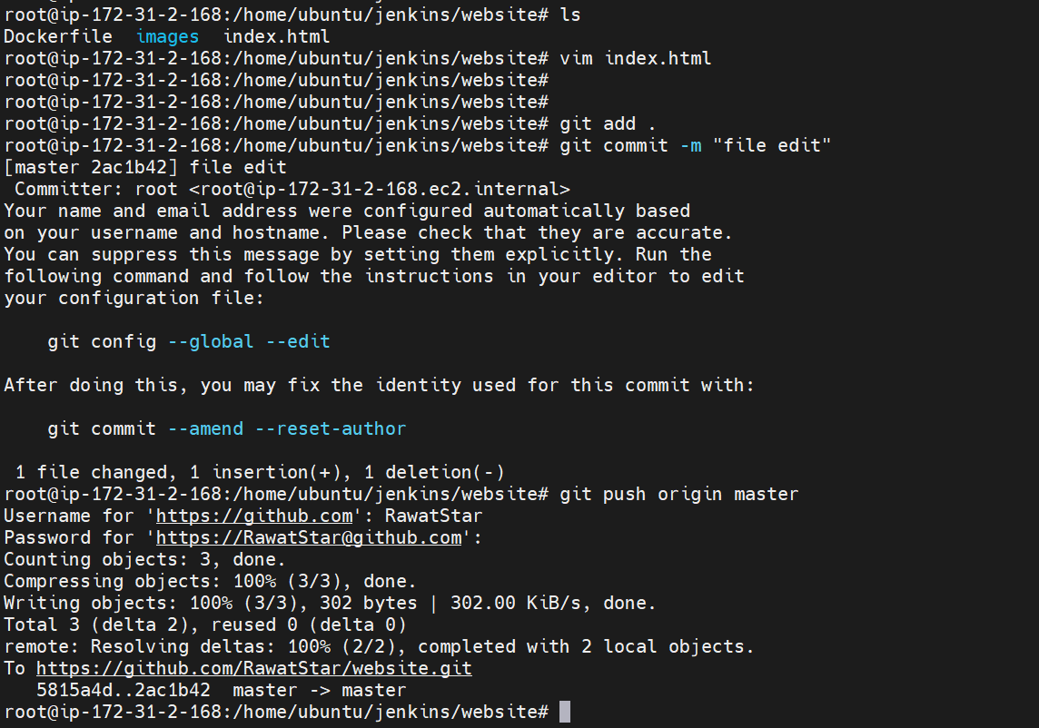

On slave1 node: -

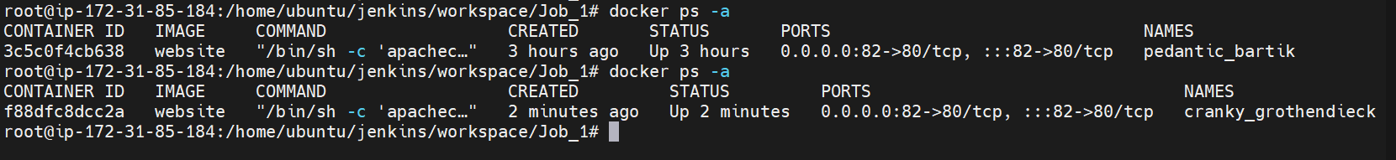

Changes trigger automatically successfully: -

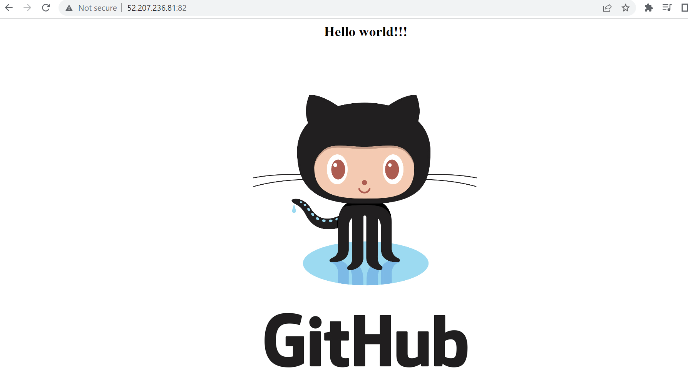

On developer branch:

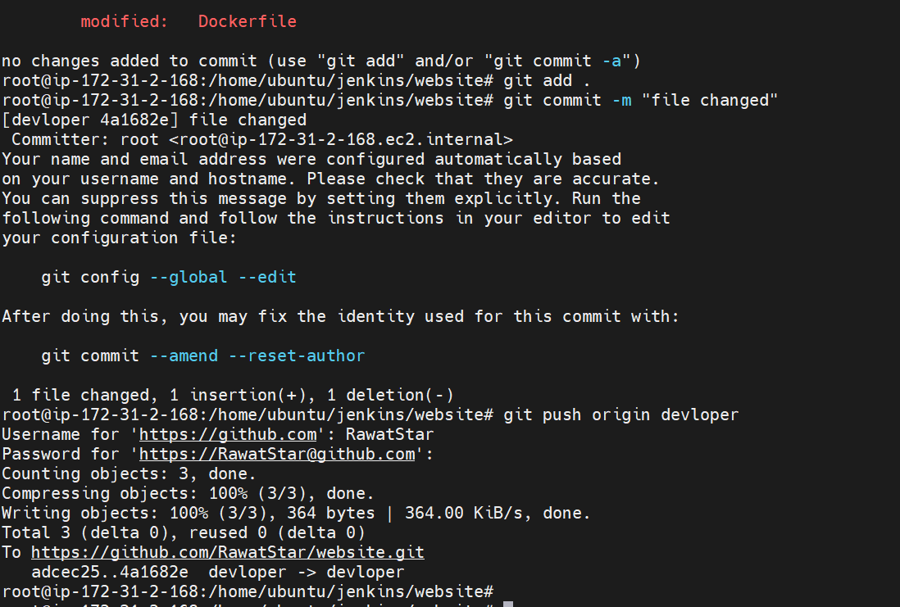

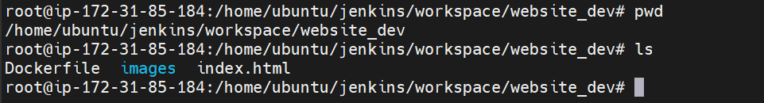

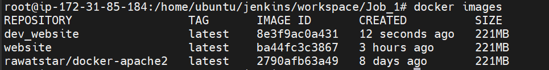

Build jobs result successful on Jenkins:

