**Objective Q&A**

1. **The data consists of some inconsistent and missing values so ensure that the data used for further analysis is cleaned.**

***Steps For Solution****:* **Data Cleaning & Missing Value**

***Conditional Formatting -*** The data provided have missing values, so I selected Raw data table and went to the home tab then applied conditional formatting, selected highlights cells rule, selected more rules, formatted only cells with, selected Blanks and custom with color, then found missing values in column name Cuisines.

***Find & Replace data -***  The provided data have missing values so, I have applied a filter in the Raw data table selected the column name Cuisines, and selected blank after that to fill the blank cells, I used the average of values then I replaced blank cells with “North Indian”.

**Formatting of Date Column -** Datekey_opening - This column of the date is not set in the appropriate date format.

**Formula Used =DATEVALUE(SUBSTITUTE(V2,”_”,”-”,))**

date format changed from  (2019_9_21   to  21-9-2019).

After this, I extracted 3 more columns from the date key opening column. The 3 new columns are DAY, MONTH, YEAR.

**For DAY formula used =TEXT(V2,”DD”)**

**For MONTH formula used =TEXT(V2,”MM”)**

**For YEAR formula used =LEFT(U2,4)**

1. **Using the LookUp functions, fill up the countries in the original data using the country code.**

**Steps For Solution**:

The VLOOKUP function extracts the country from the country code:

Formula: = **VLOOKUP(C2,'country description'!$A$2:$B$16,2,0)**

Explanation:

* **C2:** Country code selected for searching.
* **'country description'!$A$2:$B$16**: Range where the code will be searched.
* **2**: Column number where the country will be searched.
* **0**: Denotes the match type, with zero indicating an exact match.

1. **Create a table to represent the number of restaurants opened in each country.**

**Steps For Solution**:

The function used to count the restaurants opened in each country is a Pivot Table:

**Process:**

* Create a Pivot Table.
* Place "Country" in Rows.
* Place "Restaurant ID" in Values.
* Set the Values to count (by default, it counts the occurrences of each Restaurant ID).
* Sort the table by Count.

This setup efficiently displays the number of restaurants opened in each country.

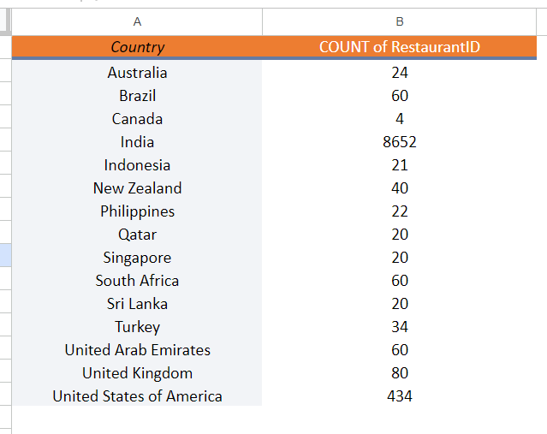

Please refer to this link for a better understanding: [objective_3_answer](https://docs.google.com/spreadsheets/d/1J8MYet6yXPLEP-ocOJKUC67Il0xZUNhO/edit#gid=2087135293)

1. **Also, the management wants to look at the number of restaurants opened yearly, so provide them with something here.**

**Steps For Solution**:

Counting Restaurants Opened in Each Year:

Function: Pivot Table

Process:

* Create a Pivot Table.
* Place "Year" in Rows.
* Place "Restaurant Name" in Values.
* Set the Values to count (automatically count the occurrences of each restaurant).
* Sort the table by Count.

This method efficiently displays the number of restaurants opened each year.

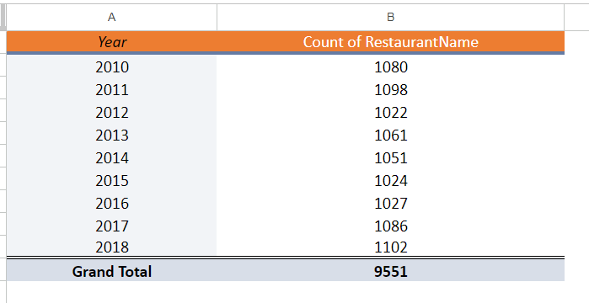

Please refer to this link for a better understanding: [objective_4_answer](https://docs.google.com/spreadsheets/d/1J8MYet6yXPLEP-ocOJKUC67Il0xZUNhO/edit#gid=842930510)

1. **What is the total number of restaurants in India in the price range of 4?**

**Steps For Solution**:

Counting Total Restaurants in India in Price Range 4:

Function: Pivot Table

Process:

* Create a Pivot Table.
* Place "Country" and "Price Range" in the Filters.
* Select "India" in the Country filter and "4" in the Price Range filter.
* Place "Restaurant Name" in Values.
* Set the Values to count (automatically count the occurrences of each restaurant).
* Sort the table by Count.

This approach effectively shows the total number of restaurants in India within the price range of 4.

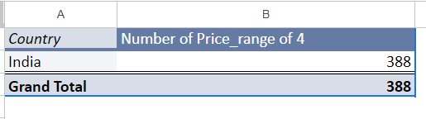

Please refer this for a better understanding :[objective_5_answer](https://docs.google.com/spreadsheets/d/1J8MYet6yXPLEP-ocOJKUC67Il0xZUNhO/edit#gid=758736076)

1. **According to the data, what is the average number of voters for the restaurants in each country?**

**Steps For Solution**:

Averaging Number of Voters for Restaurants in Each Country:

Function: Pivot Table

**Process:**

* Create a Pivot Table.
* Place "Country" in Rows.
* Place "Votes" in Values.
* Set the Values to average (calculates the average number of voters for each country).
* Sort the table by Average.

By using this Pivot Table setup, you can efficiently calculate and display the average number of voters for restaurants in each country.

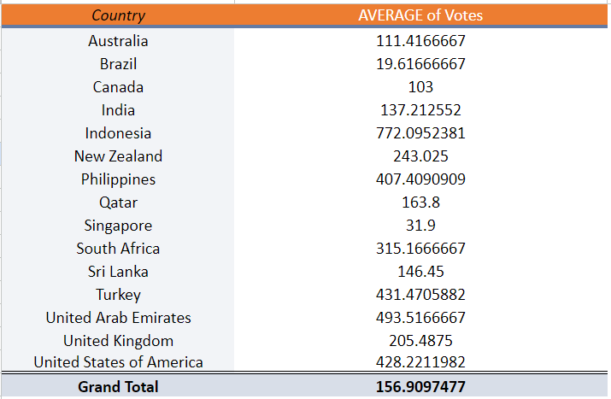

Please refer to this link for a better understanding: [objective_6_answer](https://docs.google.com/spreadsheets/d/1J8MYet6yXPLEP-ocOJKUC67Il0xZUNhO/edit#gid=998875500)

**Subjective Q&A**

1. **Suggest a few countries where the team can open newer restaurants with lesser competition. Which visualization/technique will you use here to justify the suggestions?**

**Solution**: Method Used:

* Pivot Table with Country in Rows, Restaurant Name in Values (sorted by count), and Rating in Values (sorted by average).
* Selection of countries with fewer restaurants to identify less competitive markets.

**Analysis:**

* Identified countries with less competition and average ratings.
* Suggested focusing on countries with lower satisfaction ratings to understand market needs better.

Countries Suggested for Opening New Restaurants:

* Canada
* Australia
* Singapore
* Sri Lanka

**Refer to this link to view the solution** [subjective_1_Answer](https://docs.google.com/spreadsheets/d/1J8MYet6yXPLEP-ocOJKUC67Il0xZUNhO/edit#gid=570573993)

1. **Come up with the names of States and cities in the suggested countries suitable for opening restaurants.**

**Solution**: Method Used:

* Utilized Pivot Table with City in Rows, Country in Filter, Restaurant Name in Values (sorted by count), and Rating in Values (sorted by average).

Country - City Selected:

* **Add filter as these 4 countries to get cities (please use this )**
* Canada – (Yorkton, Chatham-kent, consort, Vineland station)
* Australia – (Armidale, Flaxton, Macedo,)
* Singapore - Singapore
* Sri Lanka - Colombo

Please refer to this link for a complete solution: [Subjective_2_answer](https://docs.google.com/spreadsheets/d/1J8MYet6yXPLEP-ocOJKUC67Il0xZUNhO/edit#gid=41987179)

**9**. **According to the countries you suggested, what is the current quality regarding ratings for restaurants that are opened there?**

**Solution: Method Used**

* Utilized Pivot Table with Country in Rows and Rating in Values (sorted by average).

**Country with Average Rating:**

* **Canada – 3.6**
* **Australia – 3.7**
* **Singapore – 3.6**
* **Sri Lanka – 3.9**

**Please refer to this link for a complete solution:** [**Subjective_3_answer**](https://docs.google.com/spreadsheets/d/1J8MYet6yXPLEP-ocOJKUC67Il0xZUNhO/edit#gid=708890167)

**10. Also, what is the current expenditure on food in the suggested countries, so that we can keep our financial expenditure in control?**

**Solution: Method used   
Current Expenditure on Food:**

I have used the Pivot table, in which I take the country in a row, the average cost for two in value, and sort by average.

* **Canada: 36.25**
* **Australia: 24.08**
* **Singapore: 155.75**
* **Sri Lanka: 2375.00**

**Please refer to this link for a complete solution:** [**subjective_4_answer**](https://docs.google.com/spreadsheets/d/1J8MYet6yXPLEP-ocOJKUC67Il0xZUNhO/edit#gid=526225248)

**11. Come up with the names of restaurants from the recommended states that are our biggest competitors and also those that are rated in the lower brackets, i.e. 1-2 or 2-3?**

**Solution Method used: Uitilized pivot table method (lesser Competitor)**

* **Take row in restaurant name**
* **Value in rating**
* **Filter by country (Australia, Sri-lanka, Singapore, Canada)**
* **Filter by rating < 2.4**

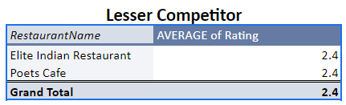

**Solution Method used: Uitilized pivot table method (Biggest Competitor)**

* **Take row in restaurant name**
* **Value in rating**
* **Filter by country (Australia, Sri-lanka, Singapore, Canada)**
* **Filter by rating > 4**

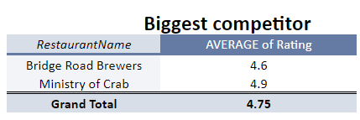

**Please refer to this link for a complete solution:**[**subjective_5_answer**](https://docs.google.com/spreadsheets/d/1J8MYet6yXPLEP-ocOJKUC67Il0xZUNhO/edit#gid=793283798)

**12. Which cuisines should we focus on in the newer restaurants to get better feedback? Does the choice of cuisines affect the restaurant ratings?**

**Solution Method used: Uitilized pivot table method**

* **Take row in cuisine**
* **Value in rating**
* **Filter by country (Australia, Sri-lanka,Singapore, Canada)**
* **Filter by rating > 4**

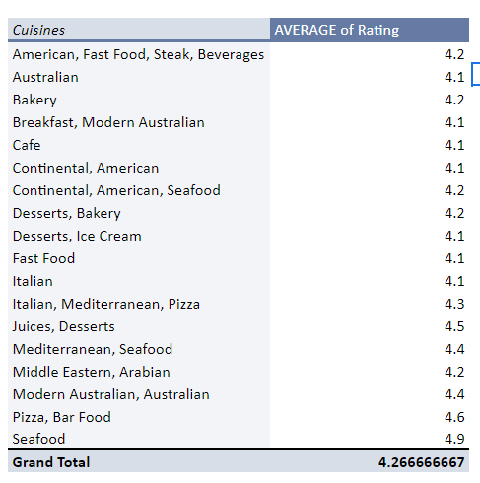

**Please refer to this link for a complete solution:**[**subjective_6_answer**](https://docs.google.com/spreadsheets/d/1J8MYet6yXPLEP-ocOJKUC67Il0xZUNhO/edit#gid=1601721266)

**13.  According to our current data, should we go for online delivery and table booking? Does that affect the customer’s rating?**

**Solution Method Used:** Employed two pivot tables**.**

* **Table Booking Analysis**: Rows categorized by "Has Table Booking," with ratings as values, sorted by average.

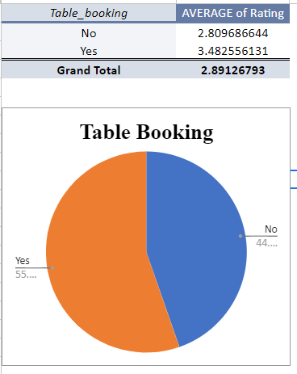

* **Online Delivery Analysis:** Rows categorized by "Has Online Delivery," with ratings as values, sorted by average.

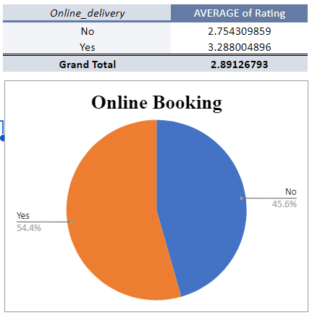

**Please refer to this link for a complete solution::**[**subjective_7_answer**](https://docs.google.com/spreadsheets/d/1J8MYet6yXPLEP-ocOJKUC67Il0xZUNhO/edit#gid=220823980)

**14. Should the team keep the rate of cuisines higher? Will that affect the feedback? According to our data are the rates of cuisines and ratings, correlated?**

**Solution Method used**: I have used the CORREL Function to find the correlation between the rate of cuisines and ratings**.**

**Formula Used** :**=CORREL(B13:B9563,C13:C9563)**

* **Decision**: We can keep the rate of cuisines higher, as the correlation is very negligible between rating and rate of cuisines.

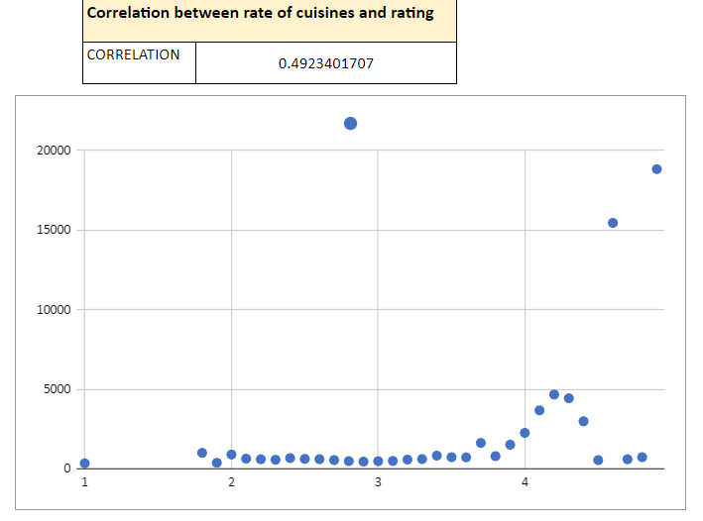

**Please refer to this link for a complete solution:**[**subjective_8_answer**](https://docs.google.com/spreadsheets/d/1J8MYet6yXPLEP-ocOJKUC67Il0xZUNhO/edit#gid=1634212300)

**15. What is the distribution of a number of restaurants of different price ranges in all the countries?**

**Solution Method used**: I have used a Pivot table, in which I take price range in row, a country in the filter, Restaurant name in value, and sort by count.

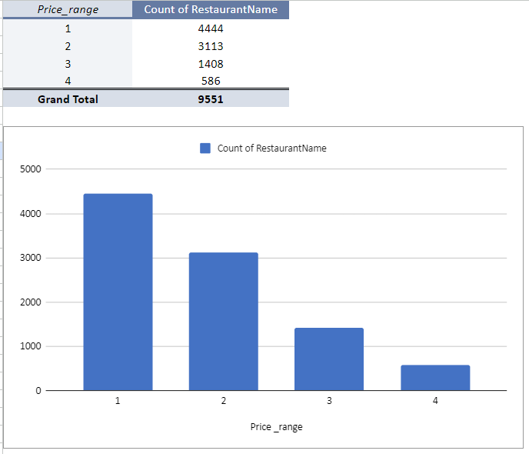

**Please refer to this link for a complete solution:**[**subjective_9_answer**](https://docs.google.com/spreadsheets/d/1J8MYet6yXPLEP-ocOJKUC67Il0xZUNhO/edit#gid=705700648)