Assignment 2 (simulation)

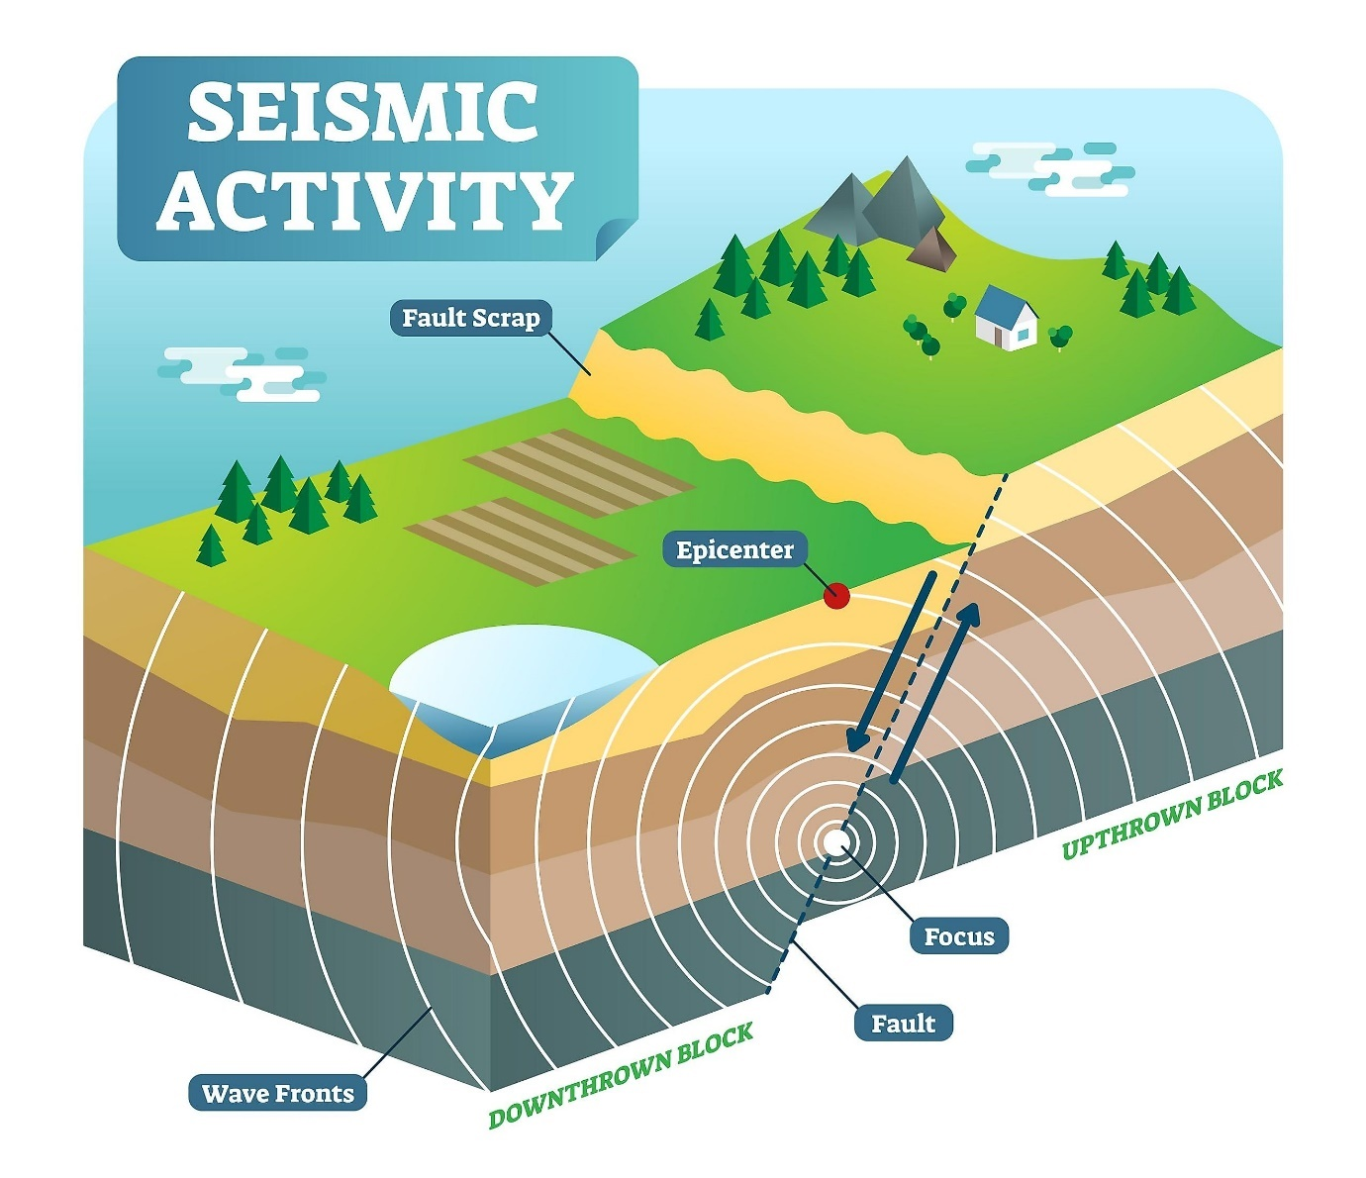

Lars Bogman (2011891)

Robin Chung ()

20-10-2024

2DF20 Stochastics and Simulation for Finance

Table of Contents

Introduction 3

# Introduction

In this research, data of past earthquakes will be investigated, with the main goal of predicting the number of earthquakes for the next 365 days (1 year). In order to fulfill this goal, some boundaries have to be made. First of all, one specific area will be investigated, which will be whole Australia. Therefore, some data on past earthquakes in Australia is gathered, along with some important specifications. The data that will be investigated will be over the time period 2014-09-23 till 2024-09-23. Besides that, also the range of the magnitude is important to specify. The magnitude of an earthquake is a measure of the size of the earthquake, so how heavy it is. In the data that will be used, the magnitude is ranging from 2.7 to 6.6.

As mentioned, the goal of this research will be to predict the number of earthquakes in Australia during the next year. From this, the main research questions follow:

* What is the prediction of the number of earthquakes next year in Australia?

In order to answer this question, some additional sub-research questions will be used to make the research more clear and easier to understand. First, it is useful to find out what kind of distribution is followed by the times between earthquakes in Australia. This will help a lot in order to predict the numbers for upcoming times. Additionally, to make it a bit easier to understand, the main research question will first be split up into two categories. Namely, predicting the number of earthquakes the next year with a magnitude greater or equal to 5, those will be called “type 1” earthquakes, and with a magnitude smaller than 5, those will be called “type 2” earthquakes. Therefore, three sub-research questions will be used in this study:

* What is the distribution that fits the time between earthquakes resulting from the data of the last 10 years?
* What is the prediction of the number of earthquakes the next year in Australia with a magnitude greater or equal to 5?
* What is the prediction of the number of earthquakes the next year in Australia with a magnitude smaller than 5?

Multiple chapters are written about the findings of the research. The first chapter will focus on the data analysis, where three sub-chapters are created. The first sub-chapter will provide some overall insights into the data to create an overview of what can be concluded from the past data. Additionally, the second sub- chapter will be about finding a suitable distribution for the times between earthquakes in the data set, which will answer the first sub-research question. Finally, in the third sub-chapter the data set will be split into “type 1” and “type 2” earthquakes, and again, there will be searched for a suitable distribution of the times between earthquakes in order to answer sub-research questions two and three easier. Also, the probability of an arbitrary earthquake having a magnitude less than 5 will be investigated.

In chapter two, the second and third sub-research questions will be answered. This will be done using two different methods, and for each method, a sub-chapter is written. In sub-chapter one, method one will be used, whereby the two datasets, “type 1” and “type 2” earthquakes, will be sampled separately using the distribution found in chapter 1.3. In sub-chapter two, there will be sampled over the complete data set using the distribution found in chapter 1.2, and after that, the probability found in chapter 1.3 will be used to answer sub-research questions two and three.

Finally, in chapter 3, both methods of chapter two will be combined, and an overall conclusion will be made. Figures and tables will be used to show the conclusion and to answer the main research question properly.