
Department of CSE

B.Tech. CSE Trimester -5

Roll Number: 2520030124
Name: Nihal Metuku

Cloud Infrastructure and Services
25CS2206E

LAB RECORD
2026
Experiment -1
a) Amazon Free Tier Account Creation
AIM: To create an AWS free tier account to provision the resources.
Description:
Amazon Web Services (AWS) provides cloud computing resources that can be managed using the AWS Management Console. In this experiment, a student creates an AWS account under the Free plan, completes the applicable email, contact, billing and identity-verification steps, and signs in to the console. The AWS Free plan selected in the supplied procedure is described as a six-month option.
Prerequisites: Valid email ID; mobile number for OTP; full name and address; internet access; an accepted payment method (debit/credit card or UPI where supported); and Aadhaar, PAN, or another accepted identity document if requested.
Steps:
1. Open Chrome or Microsoft Edge and visit https://aws.amazon.com/free.
2. On the AWS Free Tier page, select “Sign in to console.”
3. Select “Create a new AWS account” to begin registration.
4. Enter an email address, choose a password, and provide an AWS account name (for example, StudentAWSAccount).
5. Verify the email address by entering the one-time password (OTP) received by email.
6. Select the Free account plan shown in the experiment instructions (six months), then click “Choose Free plan.”
7. Provide contact information: full name, phone number and address. Accept the agreement and continue.
8. Enter billing information using a supported UPI or debit/credit card method. The supplied instructions mention a ₹15,000 UPI AutoPay authorization limit and a possible refundable ₹2 card-verification charge for some AWS India registrations.
9. Complete identity confirmation. The supplied procedure specifies “Academic” as the primary purpose and “Individual” as ownership type. Use Aadhaar through DigiLocker or another accepted document (such as voter ID or driving licence), as requested.
10. Enter the mobile number, request the SMS verification code, enter the code and continue.
11. Complete AWS account setup and wait for the registration process to finish (the experiment sheet estimates approximately 1–2 minutes).
12. Open the AWS Management Console dashboard. For subsequent access, visit https://console.aws.amazon.com and sign in with the registered account credentials.
Output:
AWS Management Console – Successful Sign-in
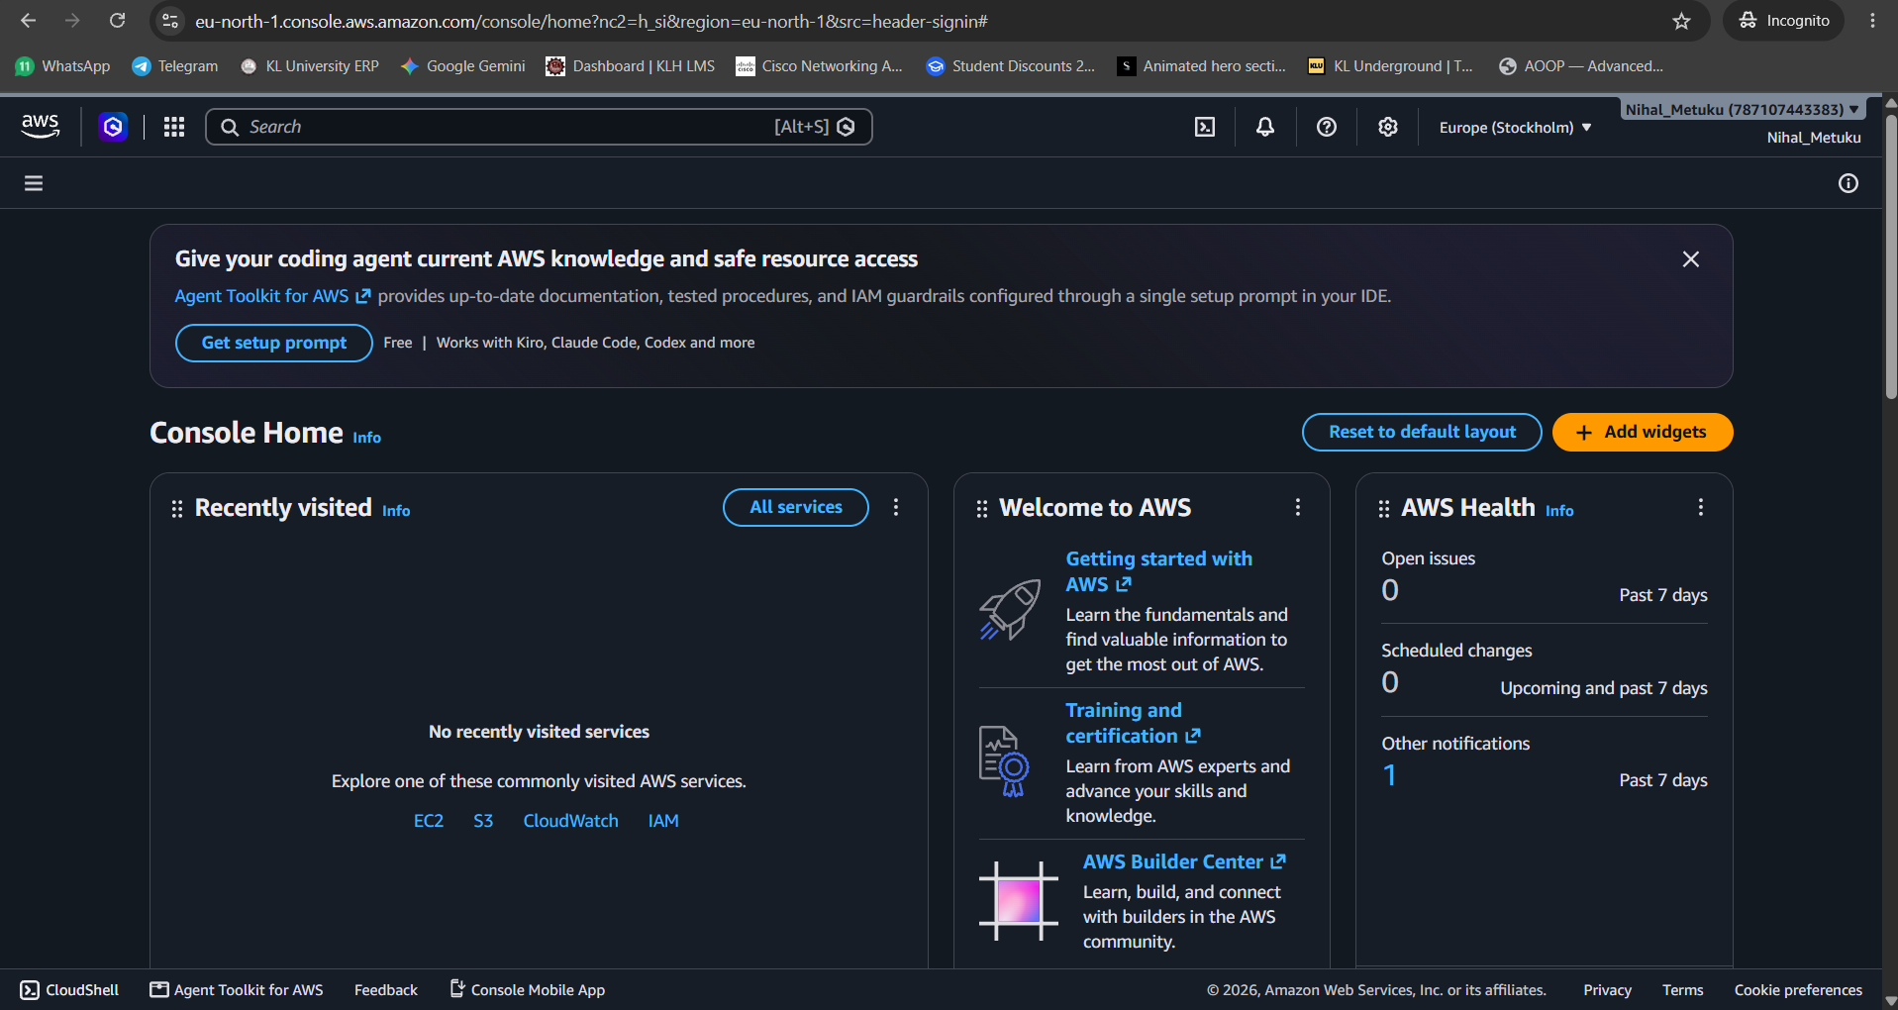
Figure 1: AWS Management Console Home displayed after signing in to the AWS account.
Verification:
• The AWS Management Console Home dashboard is visible in the supplied screenshot.
• The account menu at the upper-right shows the account name “Nihal_Metuku.”
• The selected AWS region is Europe (Stockholm), and service links such as EC2, S3, CloudWatch and IAM are visible.
Result / Expected Outcome:
AWS account access was successfully demonstrated by opening the AWS Management Console. The screenshot confirms the signed-in console dashboard; Free plan and billing status can be checked separately under the account settings as described in the experiment instructions.

