Experiment – 1(b)
AIM: To create an IAM user in AWS and enable Multi-Factor Authentication (MFA) using a passkey or security key to provide an additional layer of security.
Description:
AWS Identity and Access Management (IAM) is used to manage users and their access to AWS resources. In this experiment, an IAM user named Student1 was created with console access. AWS was allowed to generate the initial password automatically. After signing in as the IAM user, MFA was configured using the Passkeys and security keys option. The registered passkey/security key provides an additional verification method during sign-in.
Steps:
Part A: Creating an IAM User
1. Open the AWS Management Console and sign in using the root account credentials.
2. Search for IAM and open Identity and Access Management (IAM).
3. From the navigation pane, select Users and click Create user.
4. Enter the username as Student1 and enable access to the AWS Management Console.
5. Select the option to use an autogenerated password. The password was generated by AWS.
6. Under Set permissions, choose Attach policies directly and select the AdministratorAccess policy, as specified in the experiment procedure.
7. Review the user details and permissions, then click Create user.
8. Save the generated sign-in details securely. Return to the IAM users list and verify that Student1 has been created.
9. Sign out of the root account.
Part B: Signing in as the IAM User
1. Open the IAM user sign-in page using the AWS console sign-in URL.
2. Enter the AWS account ID or account alias, the username Student1, and the autogenerated password.
3. Complete any password update prompt if it is displayed, then sign in to the AWS Management Console.
Part C: Enabling MFA with Passkeys and Security Keys
1. In the AWS console, search for IAM and open the IAM dashboard.
2. Select Users, open the Student1 user, and go to the Security credentials tab.
3. In the Multi-factor authentication (MFA) section, click Assign MFA device.
4. Enter a device name if prompted, then select Passkeys and security keys as the MFA device type.
5. Click Next and follow the browser instructions to create and register the passkey.
6. If prompted, choose an available password manager or device option to save the passkey.
7. Complete verification using the available device authentication method, such as biometric authentication or the device PIN.
8. Finish the registration and verify that the passkey/security key appears under the user's assigned MFA devices.
Part D: Testing MFA Authentication
1. Sign out of the AWS Management Console.
2. Sign in again as the IAM user Student1 using the account details.
3. When prompted for MFA, choose the registered passkey/security key.
4. Complete verification using the registered device, biometric authentication, or device PIN.
5. Verify that access to the AWS Management Console is granted after successful verification.

Output:
The IAM user Student1 was created successfully. The Security credentials page shows that one MFA device of type “Passkeys and security keys” is assigned to the user. The screenshot below is the output captured from the AWS IAM console.
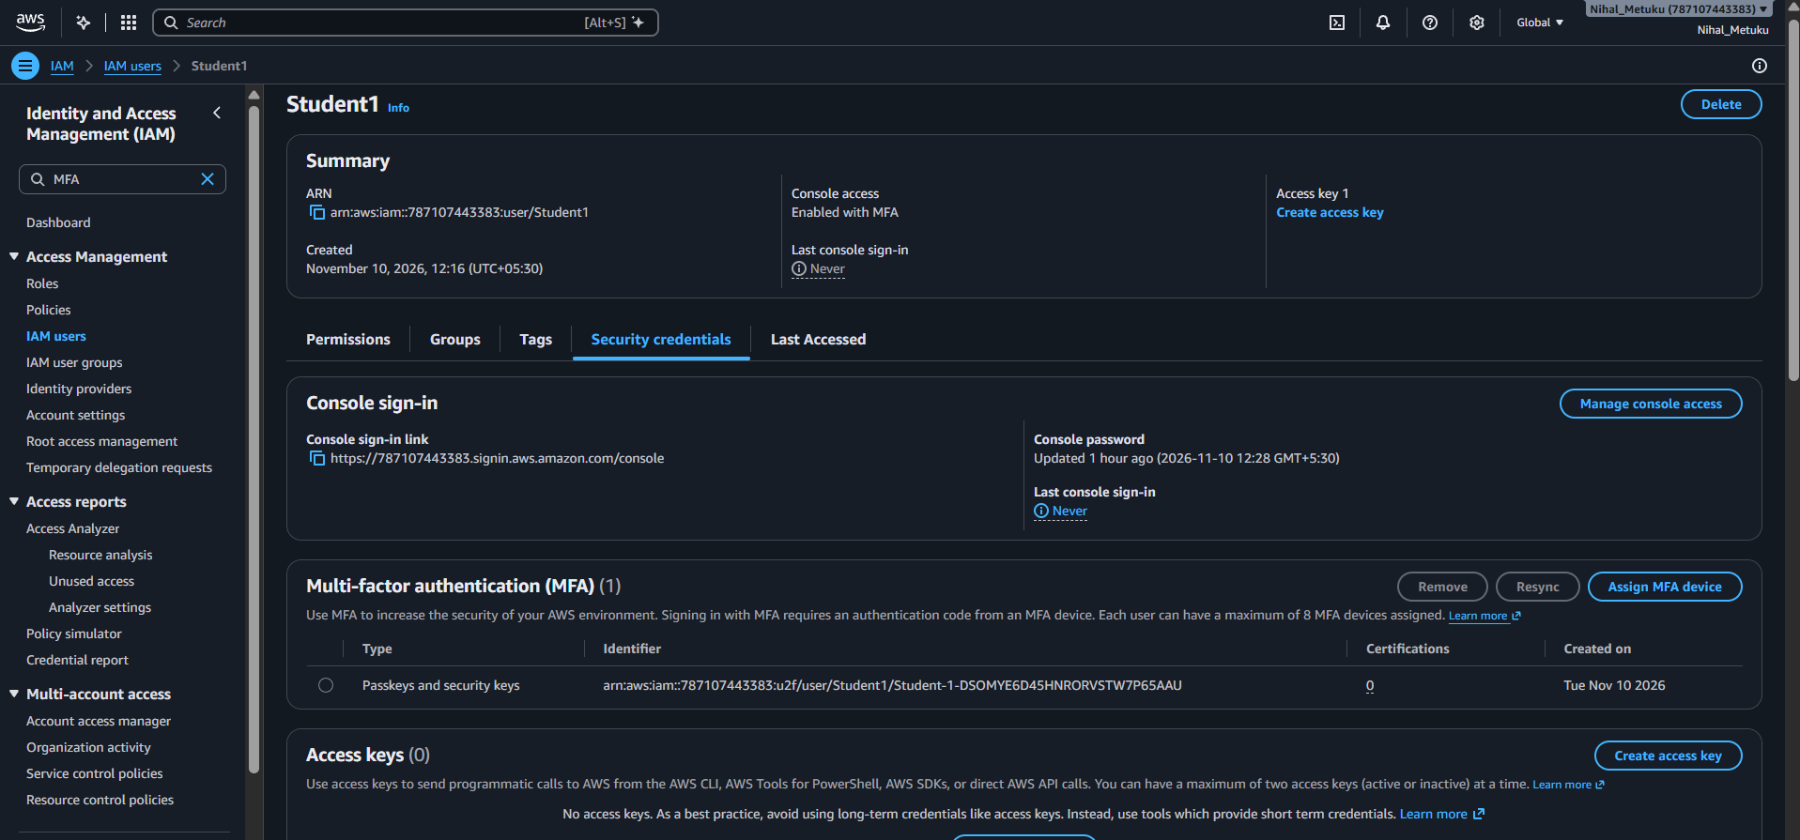
Figure 1: AWS IAM Security credentials page showing the assigned Passkeys and security keys MFA device for Student1.
Result:
An IAM user named Student1 was created with an AWS-generated password, and Multi-Factor Authentication was configured using Passkeys and security keys. The assigned MFA device is visible in the AWS IAM Security credentials page.

