OSSP (Operating Systems And Systems Programming) - 25CS2104E

PRACTICAL – 1 M. Nihal - 2520030124

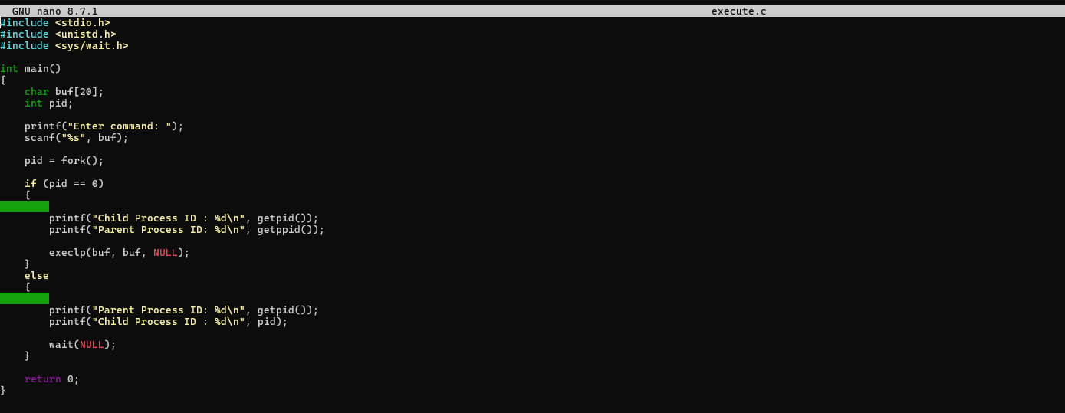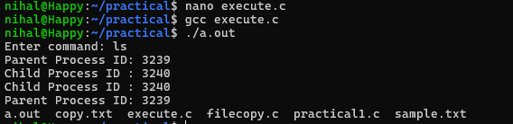

Hardware Resources and Operating System Services
Commands Used

uname
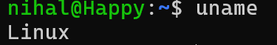

Lscpu
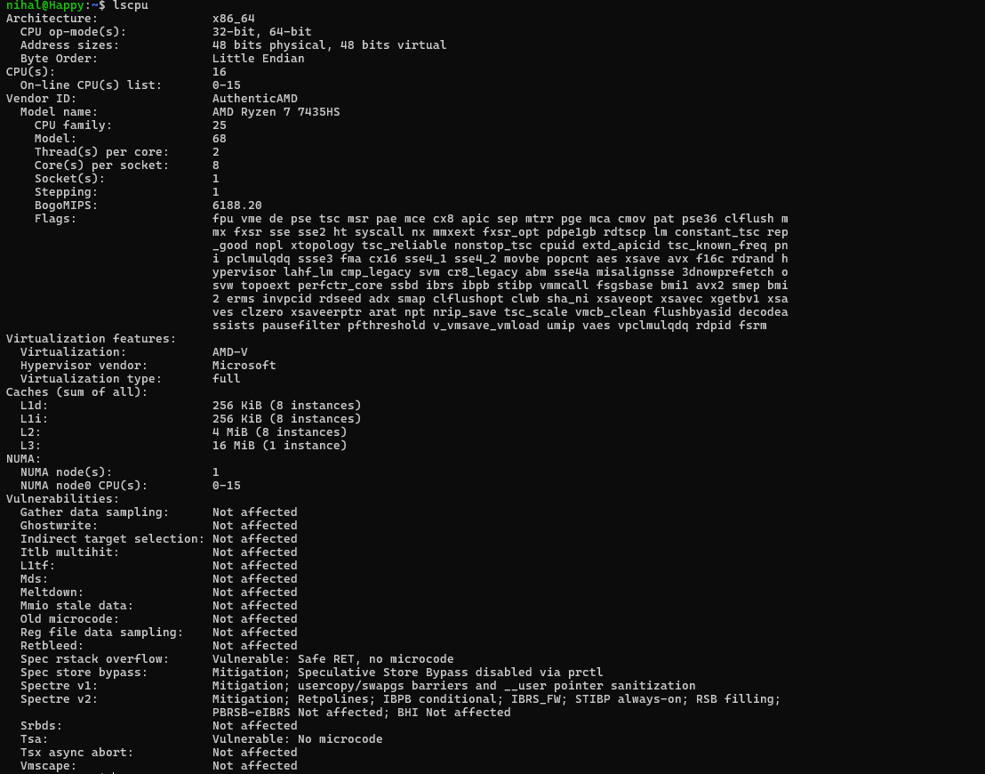

Lsblk
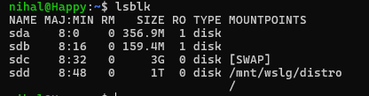

ps
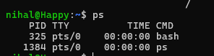

top