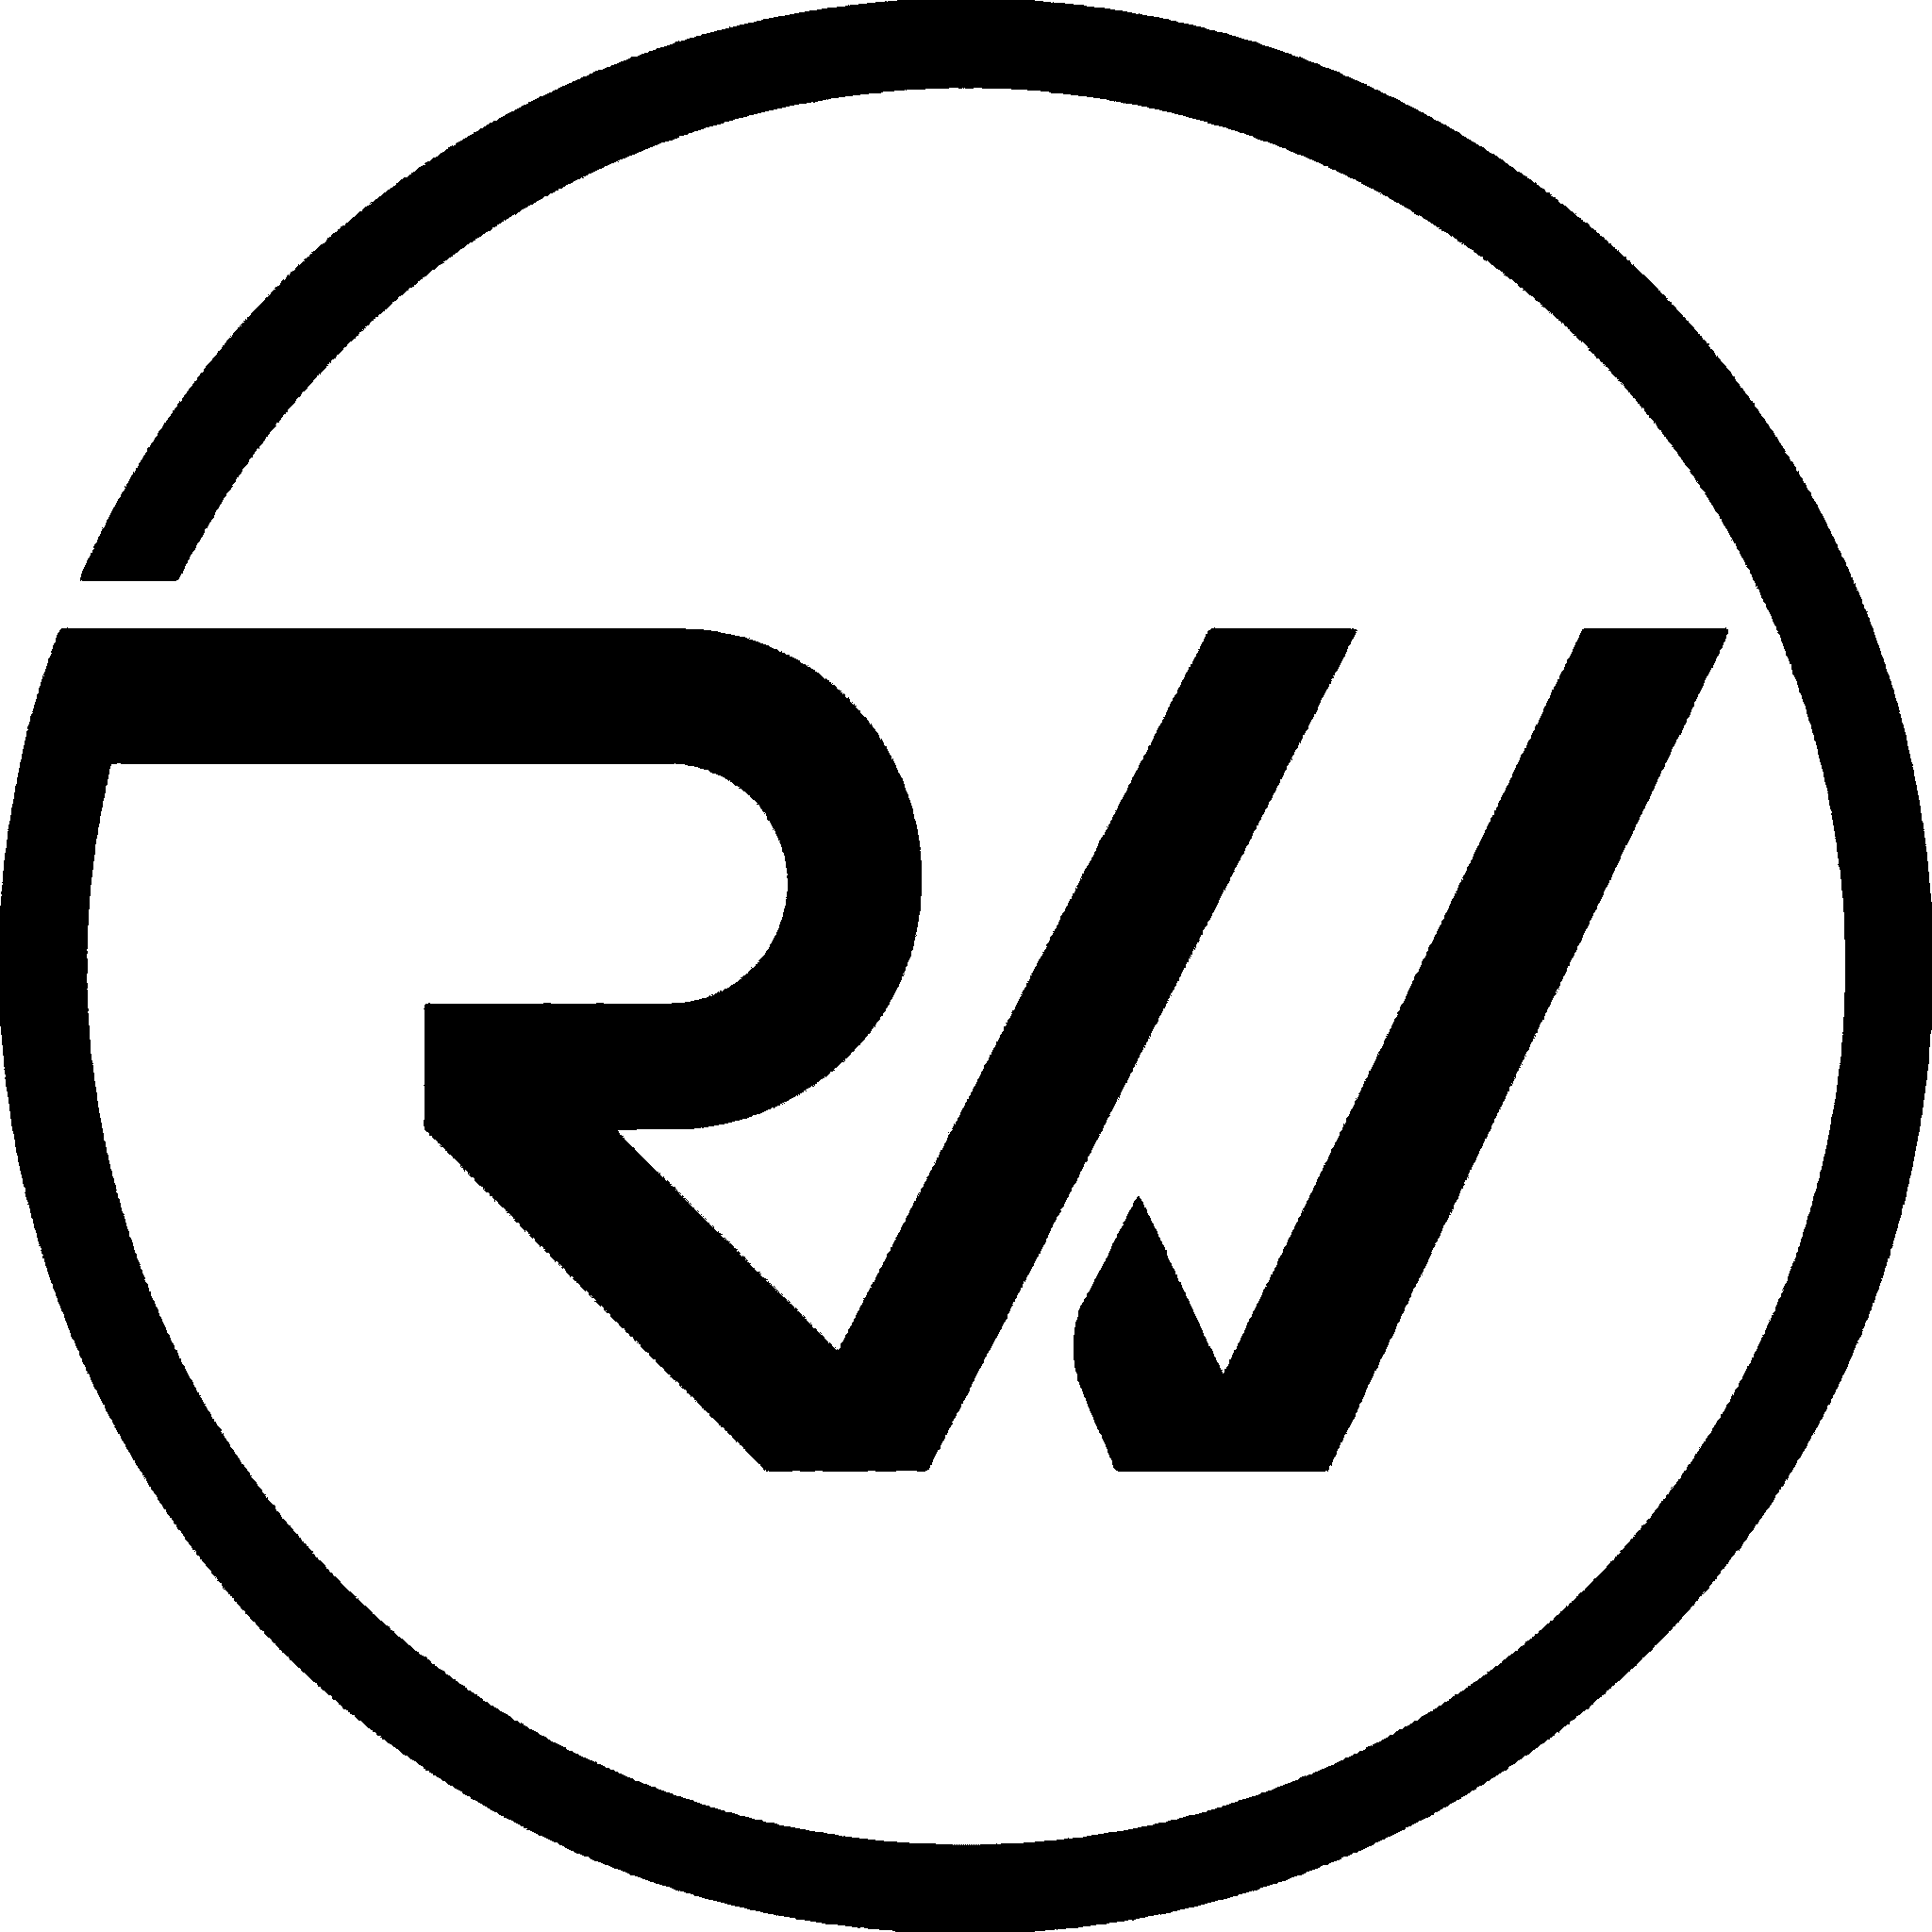
Uniform Spec Sheet
Polo & Crew-Neck Tee · v1.0
Rawinnipa Co., Ltd. · April 2026

This document defines the production specifications for Rawinnipa's corporate uniforms across four design concepts, two garment types, and four approved shirt colors. All measurements are production-ready; all placements are millimeter-accurate.
Refer to the Rawinnipa Brand Guidelines v1.0 for master brand rules. Any deviation from this spec — particularly color, logo size, or placement — must be approved in writing by the brand owner.

1. Program summary

Garment types
- Polo shirt — knit collar, 3-button placket, short sleeve. Unisex cut, adult sizes XS–3XL.
- Crew-neck tee — rib-knit collar, short sleeve. Unisex cut, adult sizes XS–3XL.

Shirt colors (approved)
- Deep Black #0A0A0A — primary uniform color.
- Charcoal #1A1A1A — alternate uniform color.
- Off White #F7F7F7 — summer / event use.
- Rawin Green #3EDC81 — brand-moment color, use sparingly.

Design concepts
- 01 · Classic — chest-left logo, URL on sleeve, tagline heat-transfer at inner neck. Low-key everyday uniform.
- 02 · Bold Back — small chest logo + large embroidered logo centered on the back, tagline beneath. High visibility, best for events and trade shows.
- 03 · Gradient — signature 3-color gradient stripe across the left shoulder + hem tagline. The most visually distinctive option.
- 04 · Typography — large 'RAWINNIPA' wordmark across the chest with a green accent dot, and a stacked 'BUILD / WHAT / MOVES.' slogan across the back. Bold statement piece.

Quantity matrix
4 concepts × 2 garments × 4 colors = 32 approved SKUs. Front + back views documented individually; mockup library contains 64 PNGs plus 8 concept grids.

2. Color standards

Shirt dye colors shall be lab-dipped and matched against the Pantone references below. Substitutions require written brand approval.

Shirt fabric colors
Deep Black  #0A0A0A  Pantone Black 6 C | Charcoal  #1A1A1A  Pantone Black 7 C | Off White  #F7F7F7  Pantone 11-0601 TCX | Rawin Green  #3EDC81  Pantone 2256 C

Logo & print colors
Deep Teal  #23B591  Pantone 339 C | Rawin Green  #3EDC81  Pantone 2256 C | Lime Accent  #9DC351  Pantone 2285 C
Pantone values are approximate cross-references — final matches to be confirmed via lab dip at the supplier.

Ink matrix by shirt color
Shirt color | Logo variant | Text / URL ink | Accent ink
Deep Black | logo_white.png | White #FFFFFF | Rawin Green #3EDC81
Charcoal | logo_white.png | White #FFFFFF | Rawin Green #3EDC81
Off White | logo_black.png | Deep Black #0A0A0A | Rawin Green #3EDC81
Rawin Green | logo_white.png | White #FFFFFF | White #FFFFFF (no green-on-green)

3. Fabric & construction

Polo shirt
Fabric | Cotton 65% / Polyester 35% piqué knit, 200–220 GSM
Collar | Self-fabric rib knit, flat-bed, 2×2 rib, color-matched to body
Placket | 3-button, self-fabric reinforced, 18 cm length
Buttons | Polyester, color-matched to shirt (deep tone) or body-matched, 11 mm dia.
Stitching | Single-needle on hems; 3-needle coverstitch on sleeve & bottom hems
Sleeve | Short, self-fabric banded hem, 3.5 cm band
Side seam | Open side seam, 1.0 cm SA, overlocked
Shrinkage | Max 3% warp, 3% weft after one wash
Weight (size L) | 210 g ±10 g finished

Crew-neck tee
Fabric | Combed cotton 100%, single jersey, 180–200 GSM
Neck | 1×1 rib knit, 2.0 cm band, self-fabric color-matched
Neck tape | Tonal cotton twill tape across back neck
Stitching | Single-needle on neck binding; double-needle coverstitch on sleeve & bottom hems
Sleeve | Short, 3.0 cm double-needle hem
Side seam | Set-in tubular body OR side-seamed depending on manufacturer; confirm with vendor
Shrinkage | Max 4% warp, 4% weft after one wash
Weight (size L) | 180 g ±10 g finished

Finishing
- Pre-washed to control shrinkage before cut.
- All raw edges overlocked; no frayed edges in finished goods.
- Remove all thread tails; no knots visible on face side.
- Care label in Thai + English heat-transferred at left hip side seam.

4. Tech pack — Polo

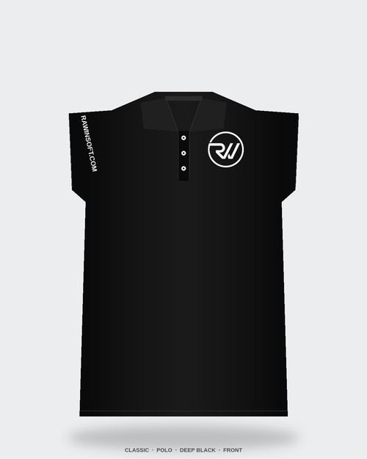  Front · Classic concept (reference) | 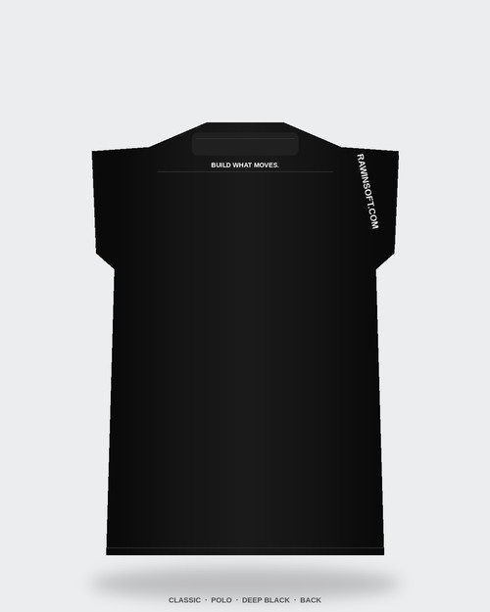  Back · Classic concept (reference)

Branding placement — Polo
Element | Method | Size (W×H) | Placement anchor | Notes
Chest-left logo | Embroidery | 70 × 70 mm | Center 90 mm below HPS¹, 100 mm from center-front placket | Logo variant per ink matrix. 9000-stitch max.
Big back logo | Embroidery | 170 × 170 mm | Center, 180 mm below HPS centerline | Concepts 02 + 04 only. Confirm density for dark shirts.
Sleeve URL | Screen print or embroidery | Text height 8 mm, length ~90 mm | Viewer-left sleeve, centered on sleeve hem band, 15° tilt toward cuff | All caps. Font: Inter Bold.
Inner-neck tagline | Heat-transfer label | 60 × 8 mm | Centered below collar band, 20 mm below neckline | Thin stretch film, color per ink matrix.
Hem tagline | Screen print | Text height 6 mm, length ~48 mm | Center-front, 45 mm above hem stitch | Concept 03 only.
Gradient stripe | Sublimation or screen | Length 280 mm, thickness 16 mm | Angled 22° across left shoulder, starting 10 mm from shoulder seam | Concept 03 only. Gradient teal→green→lime. On green shirts: solid white.
Chest wordmark | Screen print | Text height 26 mm, length ~220 mm | Center chest, 200 mm below HPS | Concept 04 only. Green dot at end (8 mm dia.).
Back stacked slogan | Screen print | Each line 55 mm high | Centered, starting 220 mm below HPS, 20 mm line gap | Concept 04 only. Keep period after 'MOVES.'
¹ HPS = High Point of Shoulder. All measurements are finished-garment dimensions on a size L.

5. Tech pack — Crew-neck tee

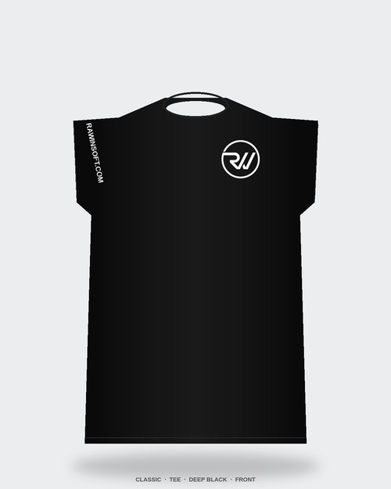  Front · Classic concept (reference) | 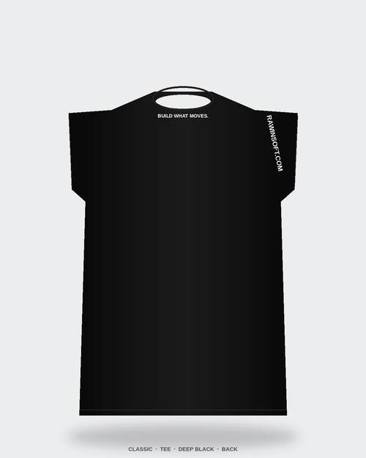  Back · Classic concept (reference)

Branding placement — Tee
Identical to polo placements except: chest-left logo sits 85 mm below HPS (the crew neck is higher than a polo's open collar). Hem tagline for concept 03 sits 35 mm above hem stitch. All other anchors match the polo table in section 4.

6. Size chart

All measurements in centimeters, tolerance ±1.5 cm. Chest measured 2.5 cm below armpit, laid flat and doubled for full circumference.

Polo — finished measurements
Size | Chest (cm) | Body length (cm) | Shoulder (cm) | Sleeve length (cm) | Neck opening (cm)
XS | 96 | 66 | 41 | 20 | 38
S | 100 | 68 | 43 | 21 | 39
M | 104 | 70 | 45 | 22 | 40
L | 110 | 72 | 47 | 23 | 41
XL | 116 | 74 | 49 | 24 | 42
2XL | 122 | 76 | 51 | 25 | 43
3XL | 128 | 78 | 53 | 26 | 44

Crew tee — finished measurements
Size | Chest (cm) | Body length (cm) | Shoulder (cm) | Sleeve length (cm) | Neck opening (cm)
XS | 94 | 66 | 40 | 19 | 36
S | 98 | 68 | 42 | 20 | 37
M | 102 | 70 | 44 | 21 | 38
L | 108 | 72 | 46 | 22 | 39
XL | 114 | 74 | 48 | 23 | 40
2XL | 120 | 76 | 50 | 24 | 41
3XL | 126 | 78 | 52 | 25 | 42

7. Decoration methods

Embroidery (preferred for logos)
- Chest-left and big back logo variants. Thread: polyester; stitch density 4.0–4.4 pt.
- Stabilizer: medium-weight cut-away on knit fabric.
- Max stitch count: 9,000 (chest), 22,000 (back).
- Use approved DST file from brand owner — do not redigitize without approval.

Screen print
- Preferred for text-heavy elements (wordmark, back slogan, hem tagline).
- Plastisol ink on knits; soft-hand additive for comfort.
- Mesh count: 305 for fine type; 156 for solid blocks.
- Cure temp 160°C for 90 s; snap-cure not accepted on production runs.

Sublimation (gradient only)
- Concept 03 gradient stripe on polyester-blend (polo) only. 100% cotton tees cannot sublimate — use screen print with two-color simulated gradient instead.
- Color calibration must be confirmed against Pantone references (§2) before production.

Heat-transfer label
- Inner-neck tagline only. 45 µm stretch film, matte finish.
- Apply at 160°C / 15 s / medium pressure. Peel hot.

8. Design concept gallery

Reference mockups for each concept. Black colorway shown; other colors rendered per ink matrix (§2). Full 64-file mockup library is in 05-uniforms/mockups/.

01 · Classic
Chest-left logo + sleeve URL + inner-neck tagline. The everyday uniform.
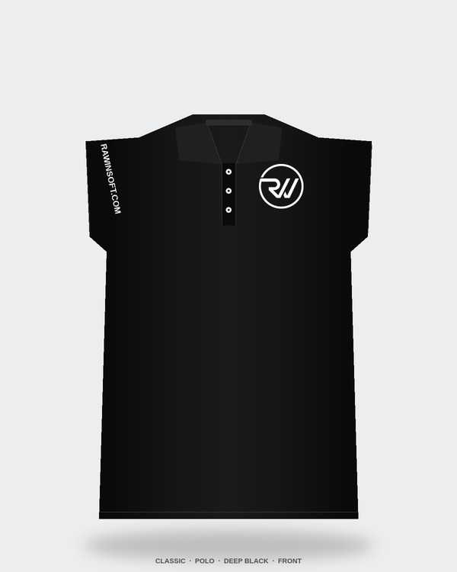  Polo · Deep Black | 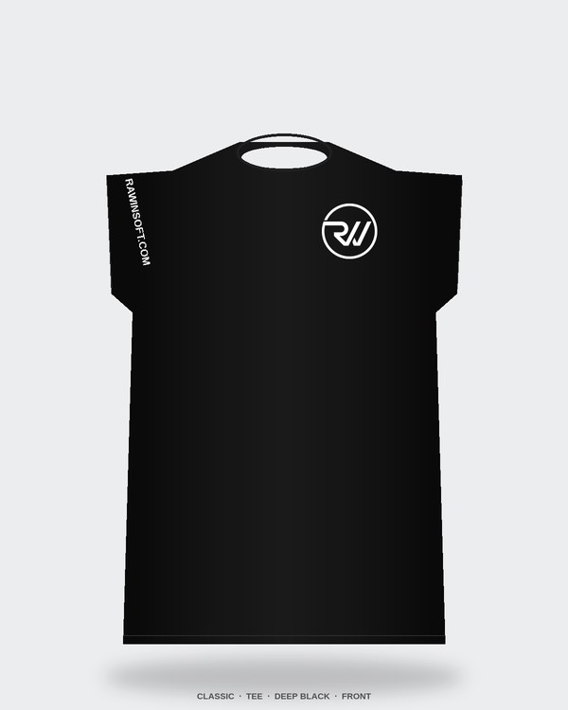  Tee · Deep Black

02 · Bold Back
Small chest logo + large embroidered back logo + tagline. High-visibility option.
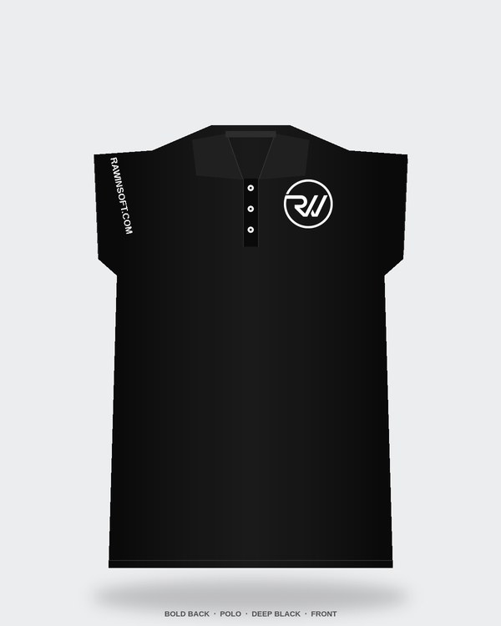  Polo · Deep Black | 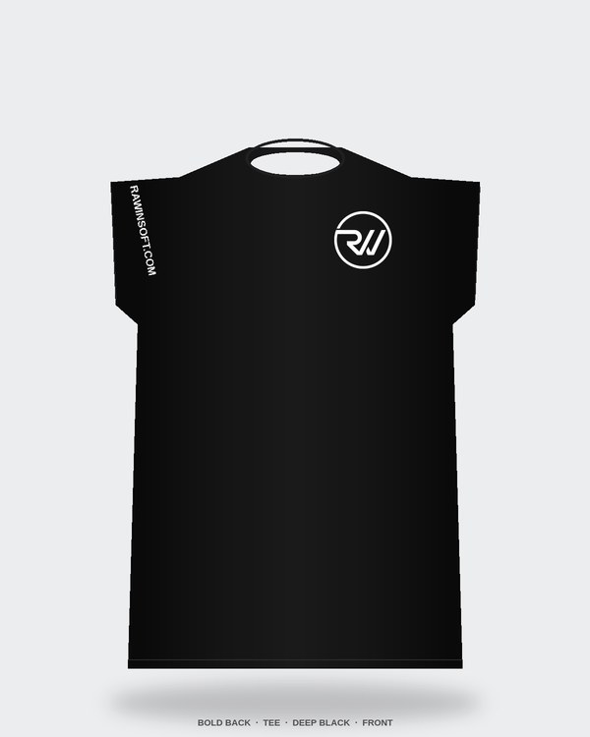  Tee · Deep Black

03 · Gradient
Signature 3-color gradient stripe on left shoulder + hem tagline. Brand signature.
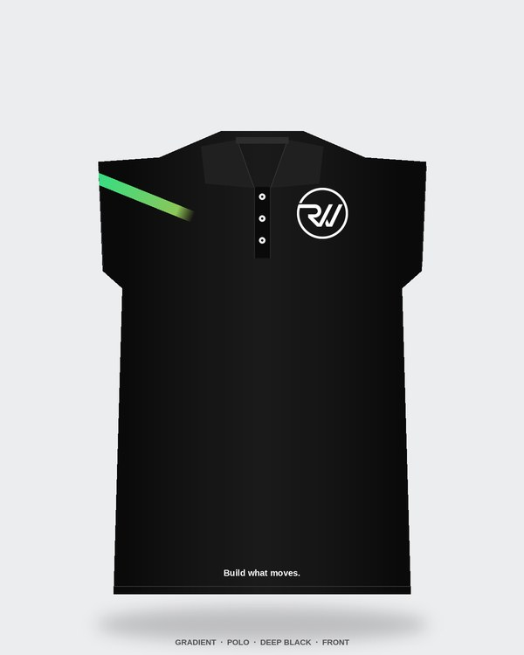  Polo · Deep Black | 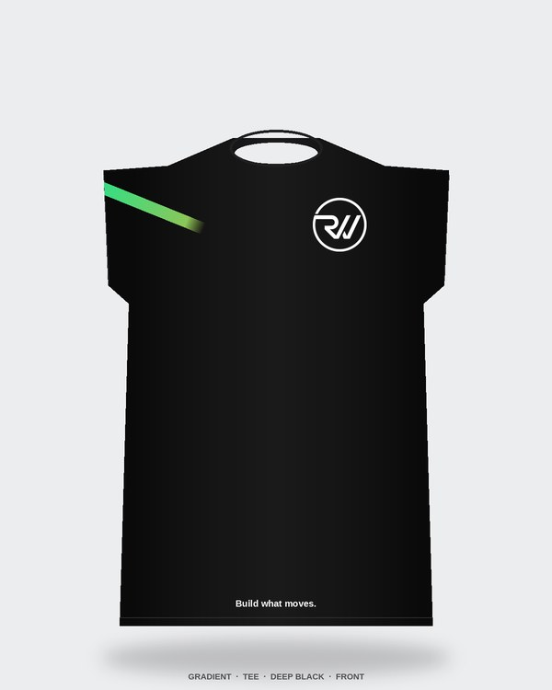  Tee · Deep Black

04 · Typography
Big 'RAWINNIPA' wordmark on chest + stacked 'BUILD / WHAT / MOVES.' on back.
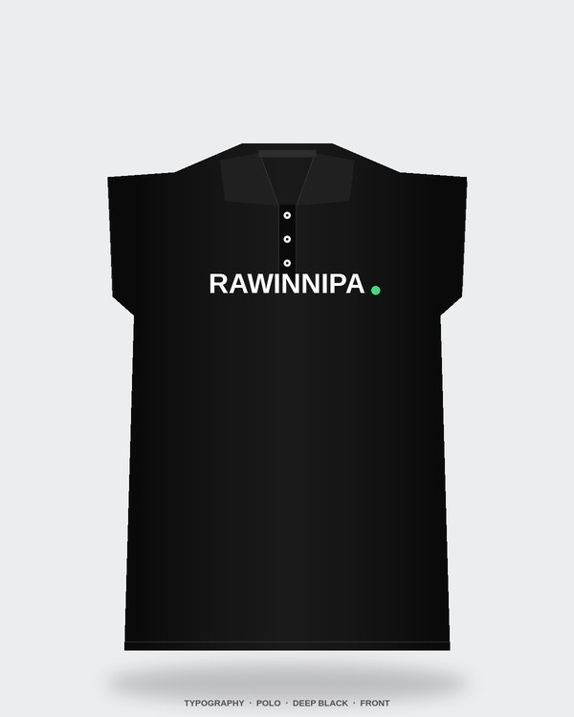  Polo · Deep Black | 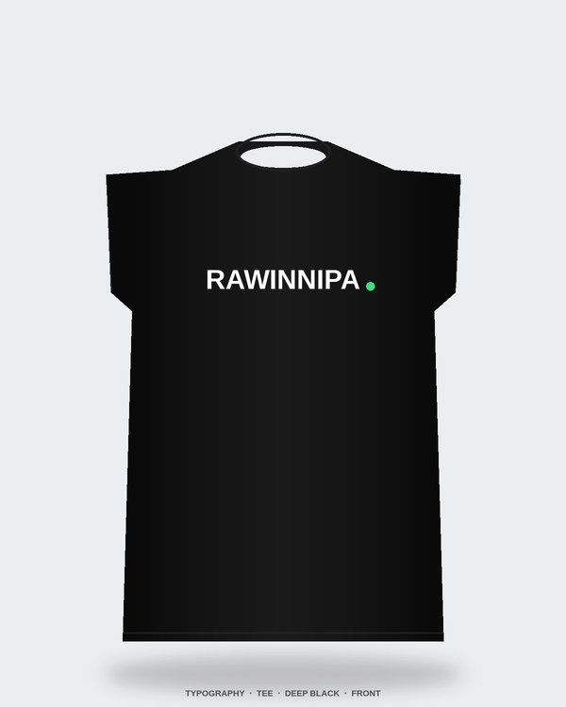  Tee · Deep Black

9. Care & packaging

Care instructions (label)
- Machine wash cold, inside out.
- Non-chlorine bleach only if needed.
- Tumble dry low; remove promptly.
- Do not iron directly on prints or embroidery.
- Do not dry clean.

Packaging
- Individual flat-fold with collar support board (polo) or tissue paper (tee).
- Poly-bag: 40 µm LDPE, 300 × 380 mm, resealable.
- Hang tag: kraft card 250 gsm, 50 × 90 mm, black string loop, logo foil-stamped.
- Cartons: 50 pieces per master carton, single size per carton, label with SKU + size + color + quantity.

Labeling
- Size label: woven, black with white text, at center-back neck.
- Care label: printed on satin, below size label.
- Country of origin label: joint side seam at left hip.

10. QA & approval

Pre-production samples
- Submit 1 sample per garment × per concept × per color = 32 samples for brand approval before bulk production.
- Each sample must include all four decoration types relevant to its concept.
- Turnaround target: 14 working days after PO confirmation.

Inspection points
- Color match vs. Pantone reference (§2) — confirmed in natural daylight.
- Logo placement — measured from HPS per §4/§5 tables, ±5 mm tolerance.
- Logo size — measured W×H, ±2 mm tolerance.
- Embroidery quality — no puckering, no loose threads, registration within 0.5 mm.
- Stitch density — count per 10 mm² must match digitized file ±10%.
- Shrinkage — max per §3 after one standard wash cycle.

Acceptance criteria
- AQL 2.5 for major defects, AQL 4.0 for minor, per ISO 2859-1.
- Any unit with logo misregistration >2 mm, wrong color thread, or print ghosting is rejected.

Approval sign-off
Role | Name | Date / signature
Brand owner
Production manager
QA lead

Contact
All questions about this spec sheet: sayhi@rawinsoft.com

