MyToDoo Mobile UAT QA Report — latest-ma full merge
Updated: 2026-09-09 12:25:38.833647
UAT API: https://api.mytodoo.com/api — PASS 32/32
Live October pack: NOT deployed (test on UAT only)
APK: 1.3.4 / versionCode 45 — branding + bug-fix markers YES
iOS Simulator runtime: INSTALLED (iOS 26.3.1); app run started separately

Verdict
PARTIAL PASS — API + APK content OK; interactive UI incomplete; iOS device QA pending build.

Screenshots
01-launch.png
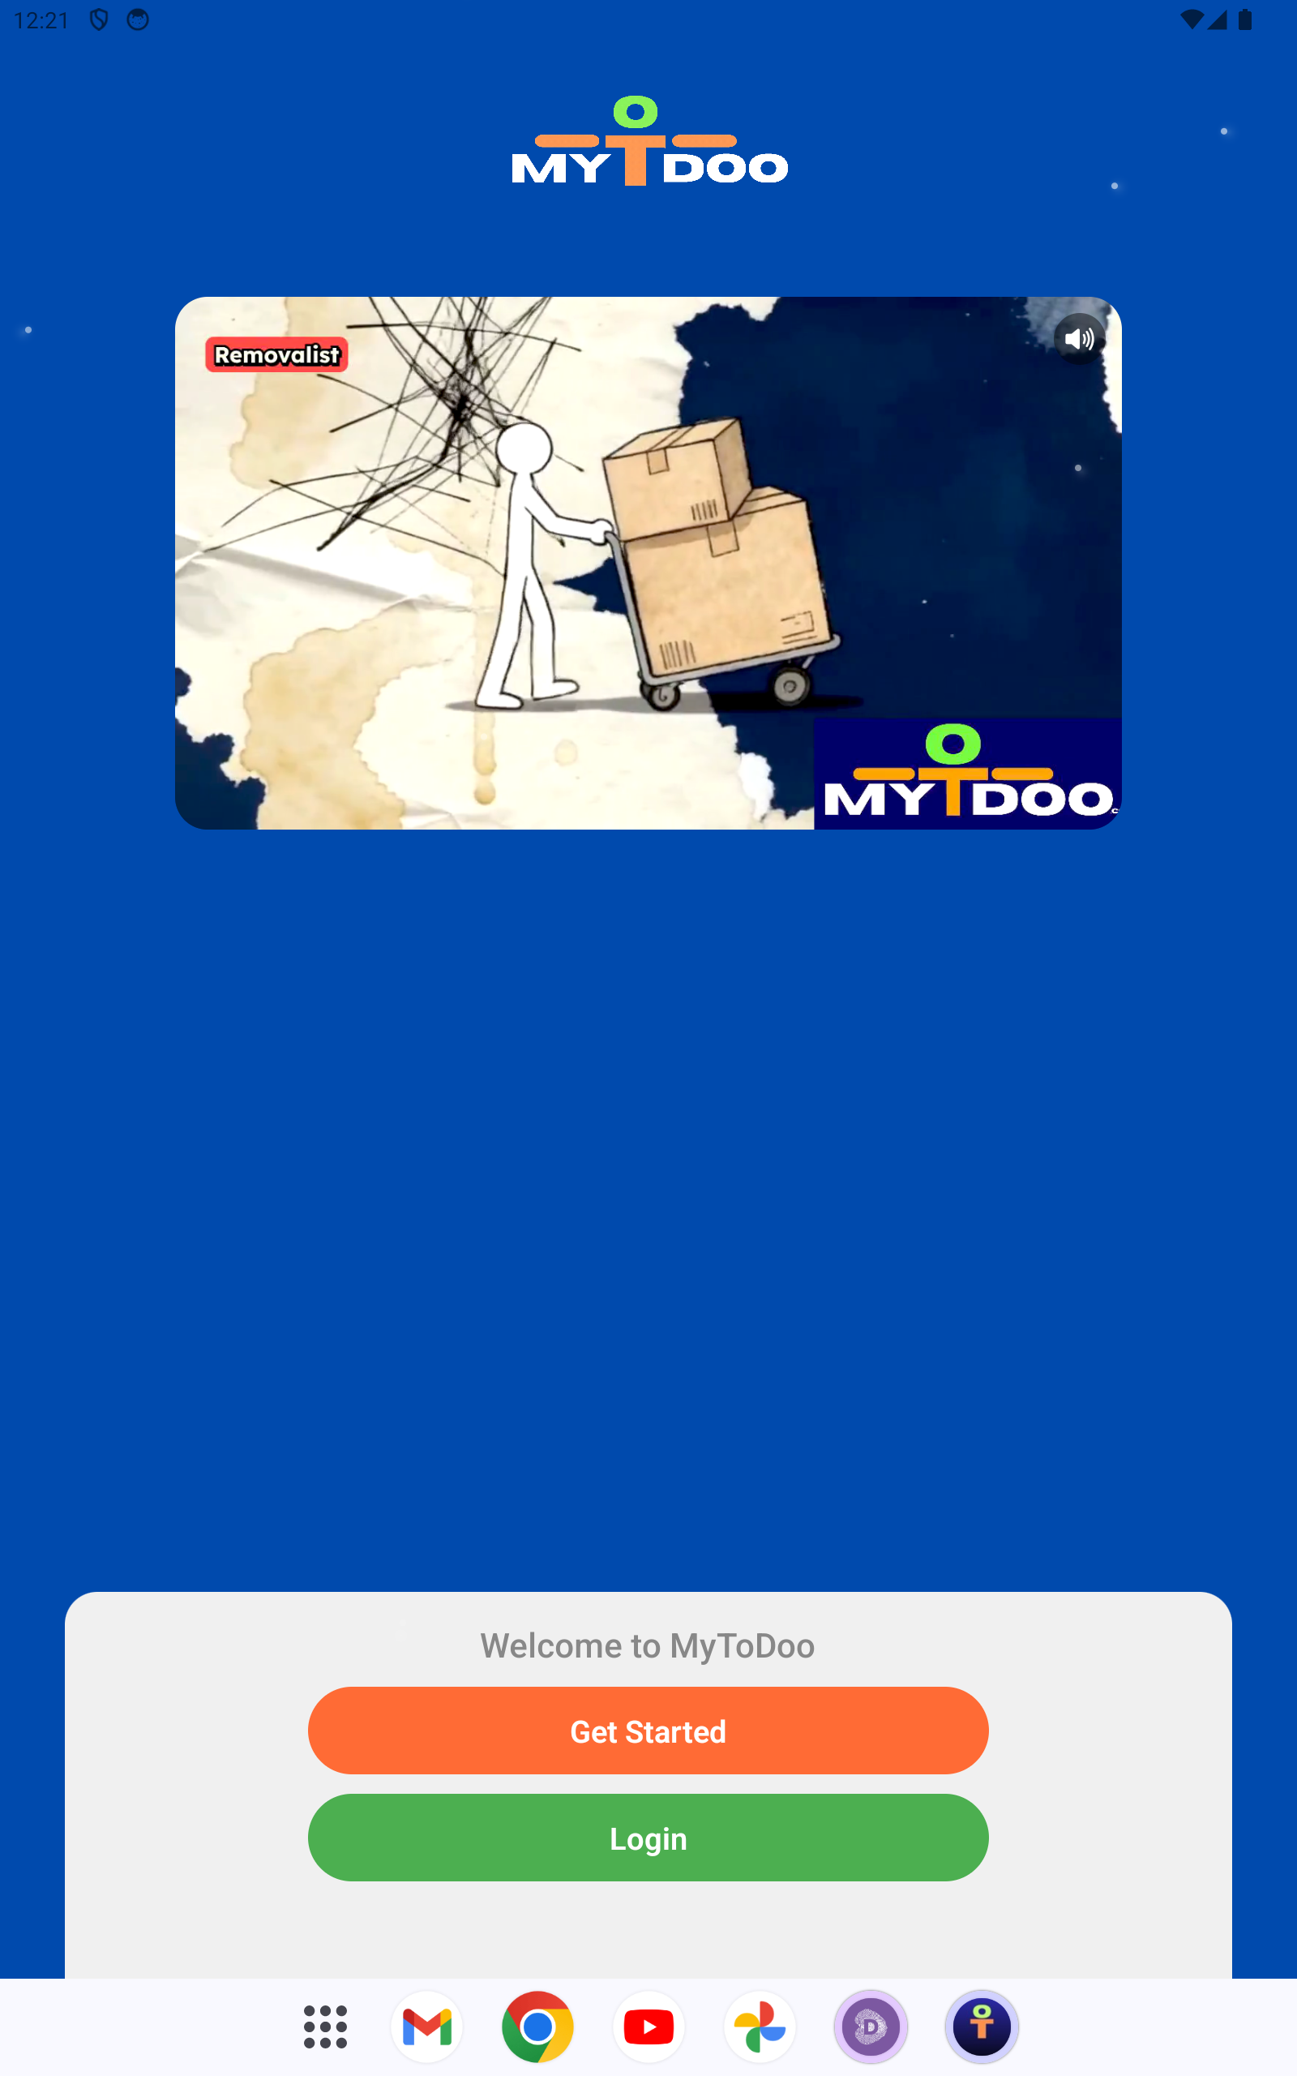
02-auth.png
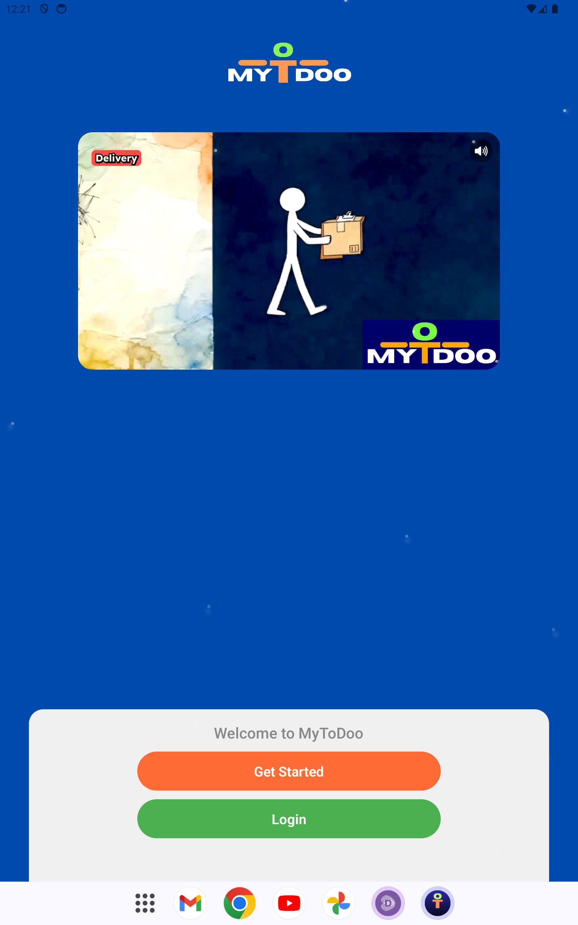
02b-login-screen.png
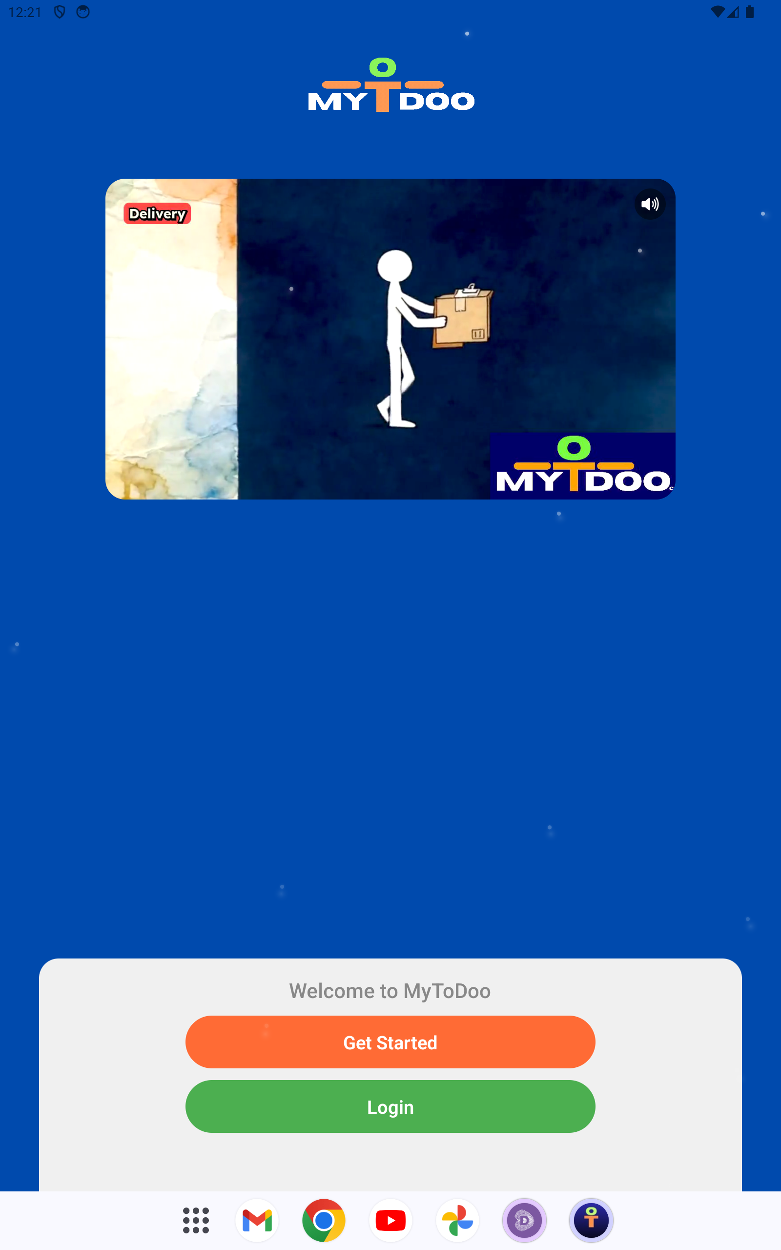
99-final.png
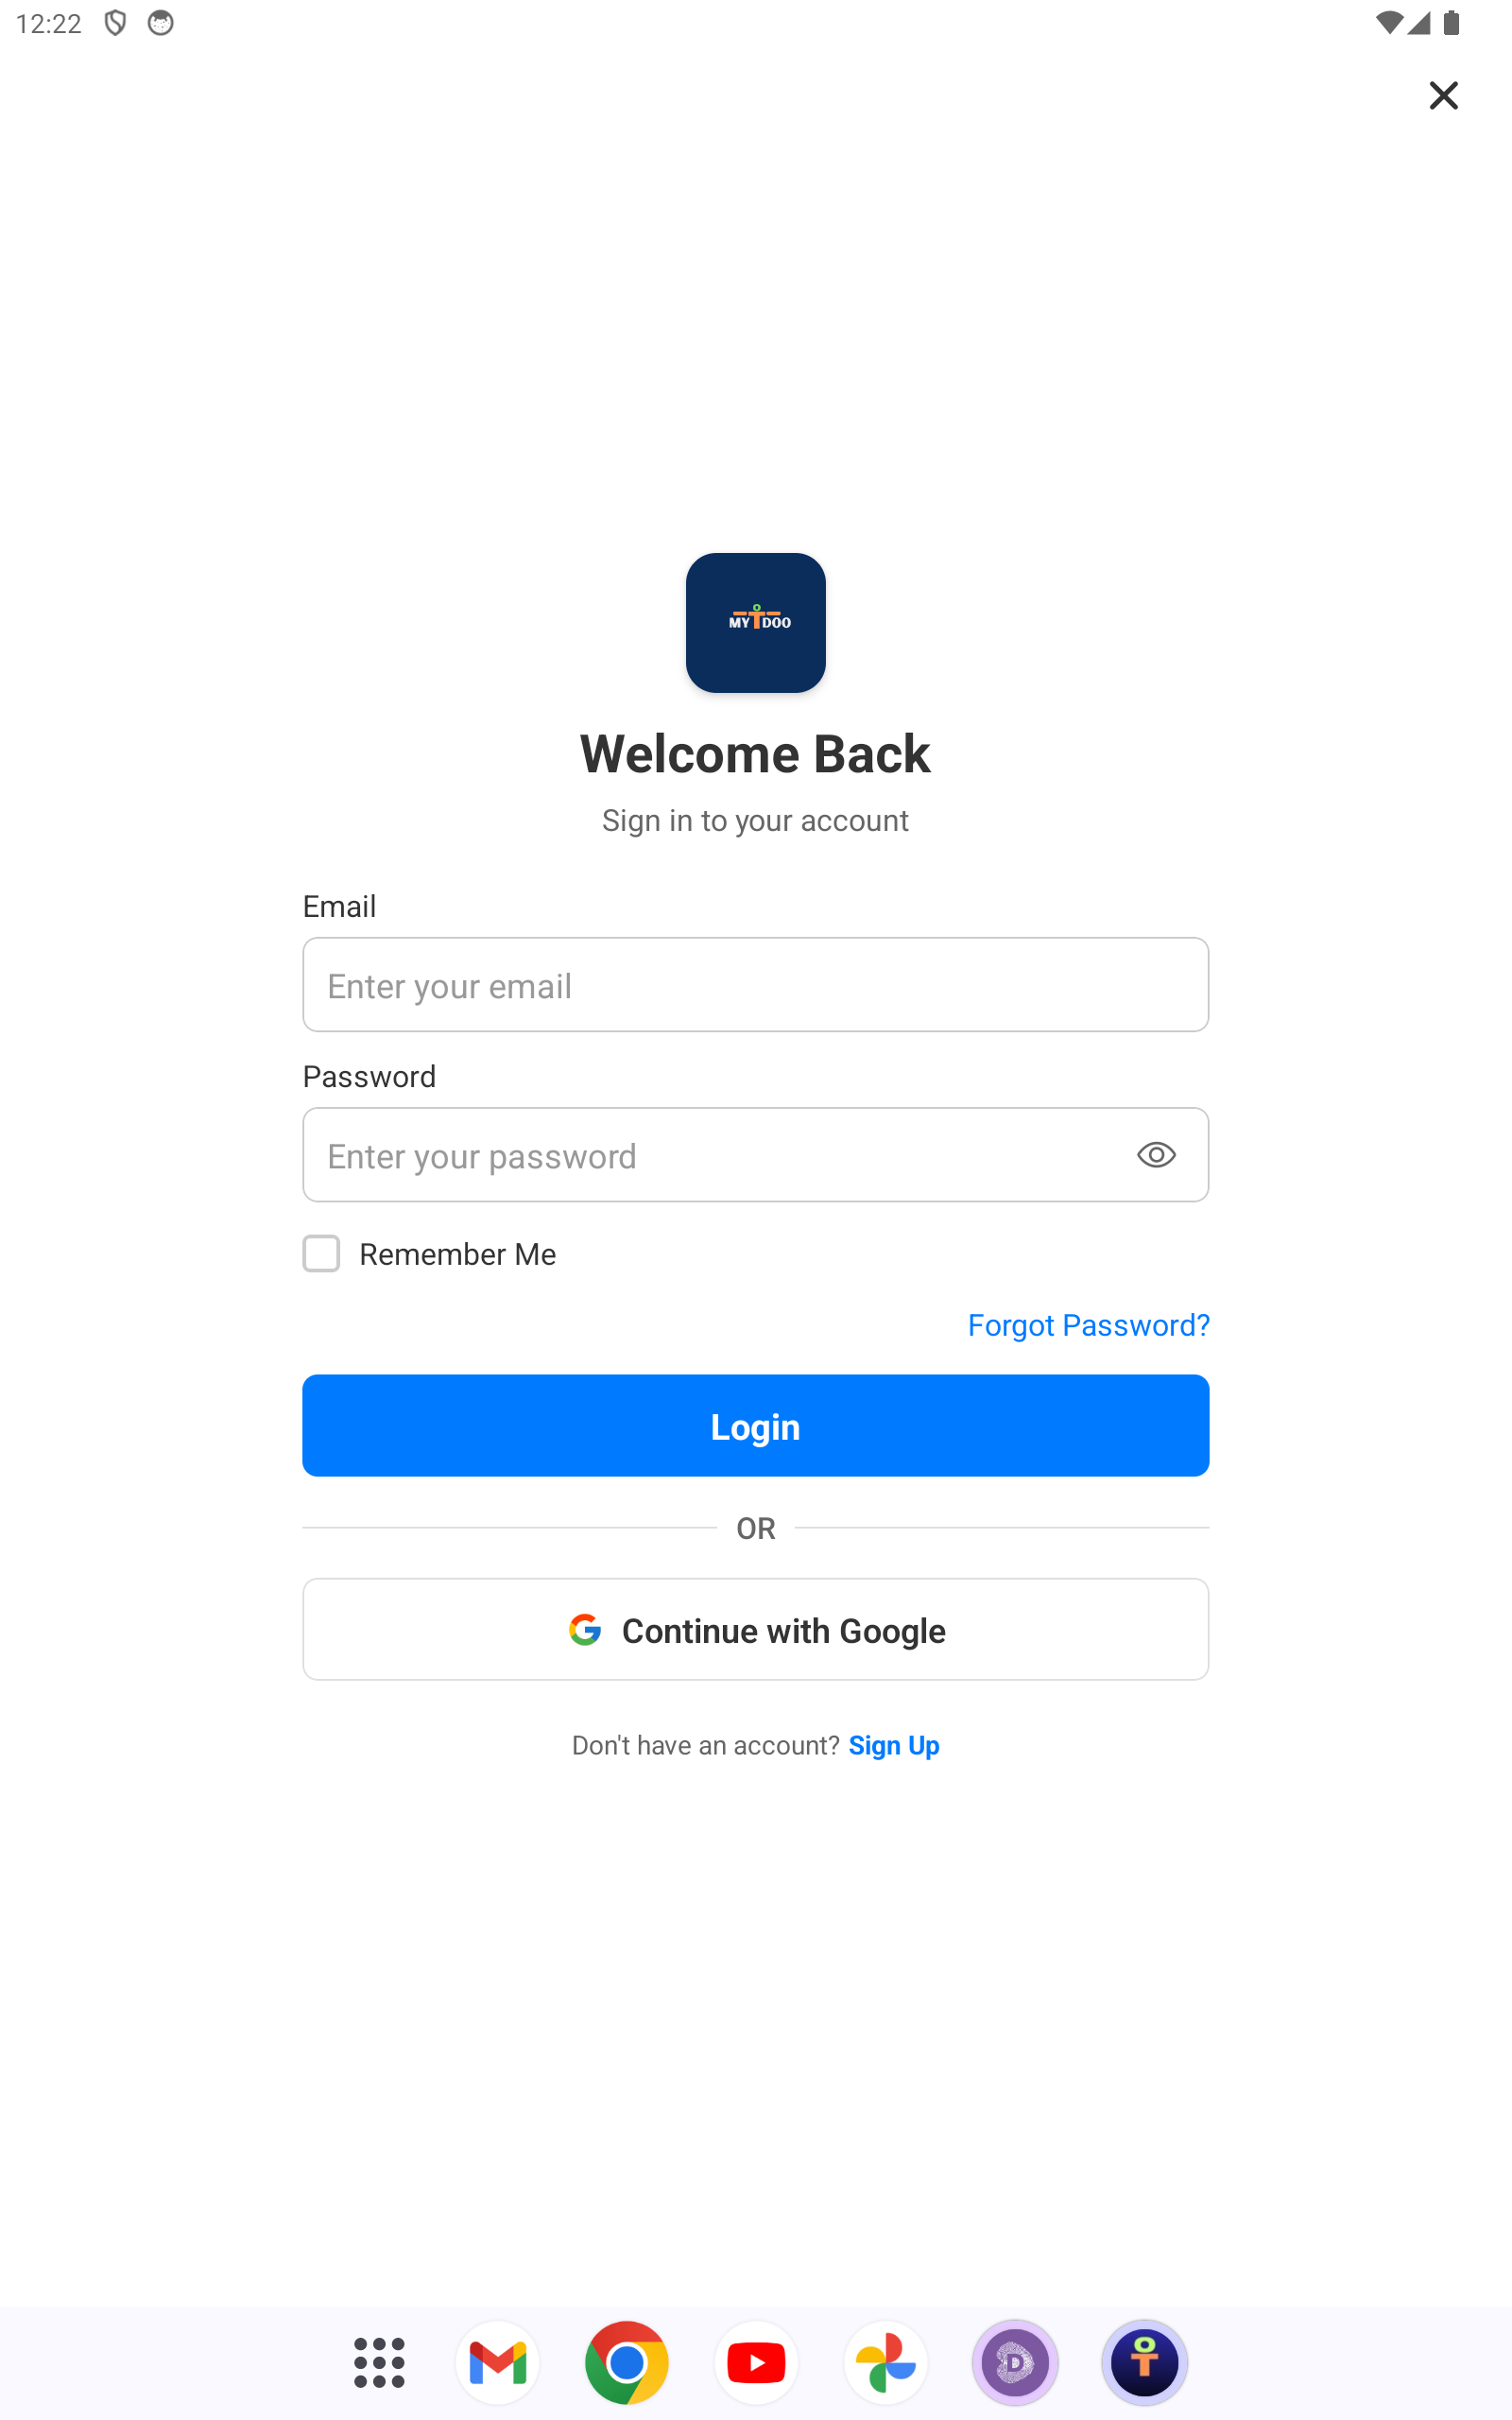
A-login.png
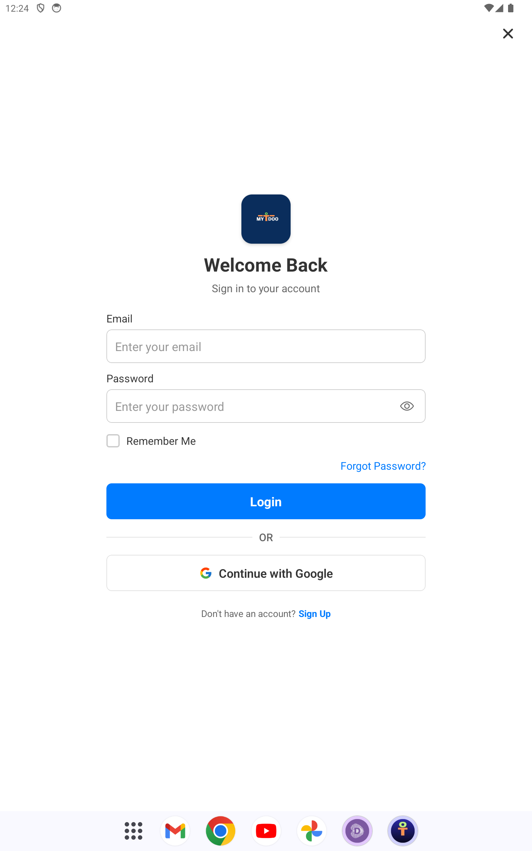
B-create-account.png
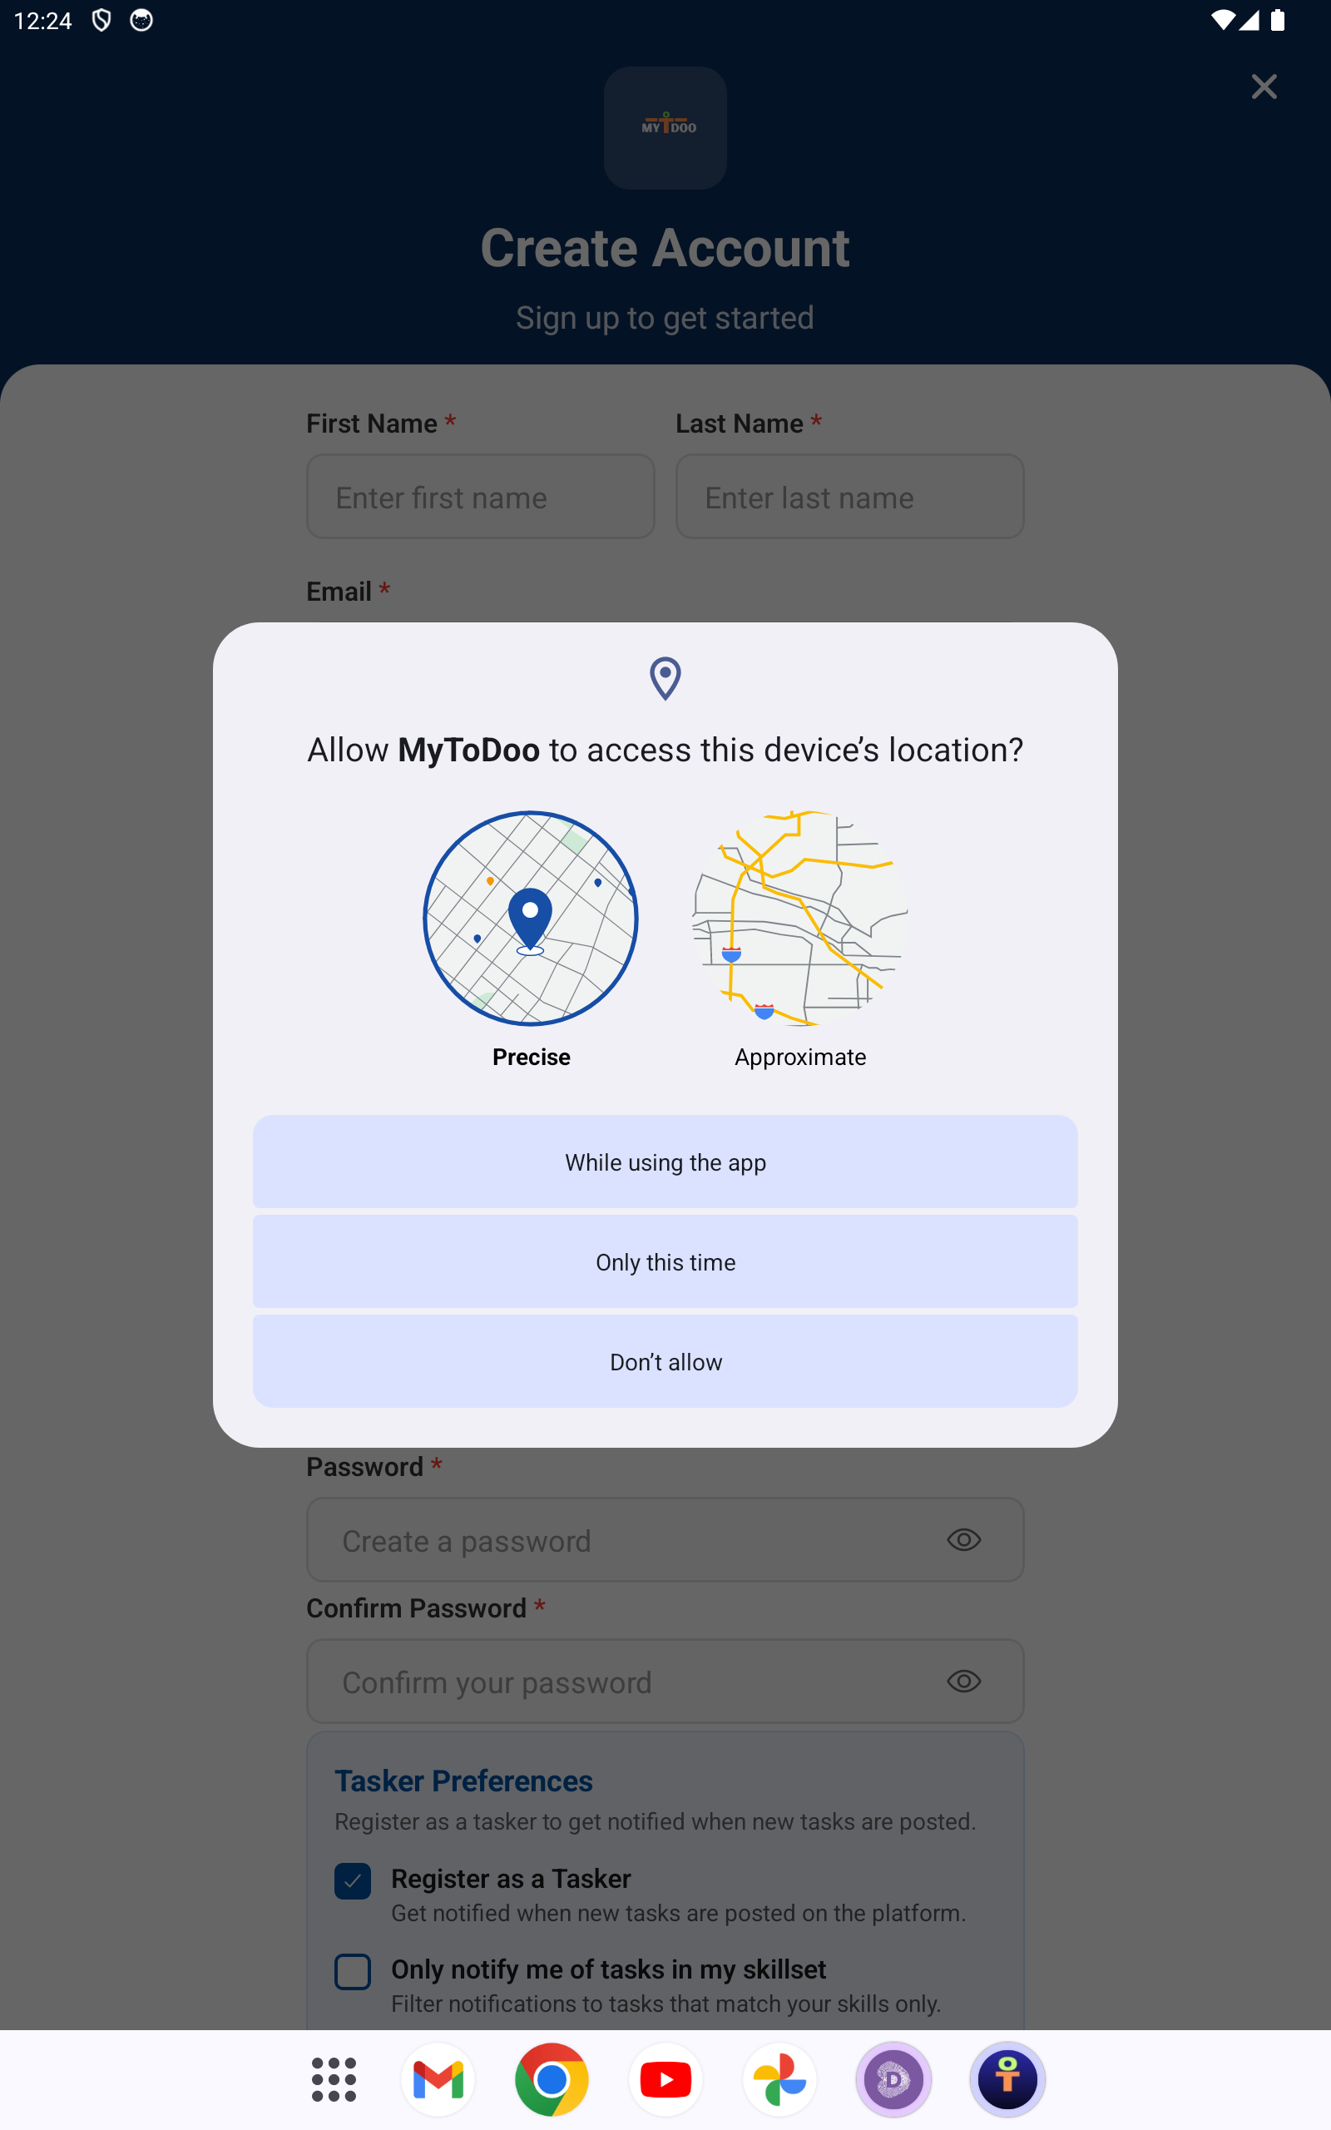
C-login.png

