Global Football Through Data: An Interactive Analysis of 1872–2025 Matches
Prepared by: Group C5

Introduction
This report presents an analysis of more than a century of international football matches, spanning the period from 1872 to 2025. The objective is to uncover historical trends, patterns, and performance dynamics across different teams, eras, and locations.
The analysis was carried out using Python for data cleaning and merging, followed by Power BI for transforming the raw match data into an interactive dashboard. This dashboard enables users to explore match results, goals, home advantage, and tournament histories. It also allows filtering and visualization by year, country, and competition type, making it a valuable tool for both football analysts and enthusiasts.
By examining over one hundred years of match outcomes, the study provides a data-driven perspective on the evolution of international football and the key factors that have shaped its development over time.
Dataset preparation
The dataset used for this analysis combines over a century of international football match records, ranging from 1872 to 2025. It includes four main files:
- results.csv: match-level data (date, teams, scores, location, neutral venue).
- shootouts.csv: goal-level data (scorer, minute, own goal, penalty).
- goalscorers.csv: penalty shootout results (winner, first shooter).
- former_names.csv: mapping of historical to modern team names (e.g., Burma changed to Myanmar).
All four CSV files were imported and merged into Python using the Pandas library. Basic checks were carried out to understand their structure, shape, data types, and missing values. Duplicates were removed across all datasets to prevent inflated counts during aggregation.
Cleaning and Formatting
Each dataset required specific cleaning steps:
- The date column was standardized using pandas.to_datetime() to handle mixed date formats (YYYY-MM-DD, MM/DD/YYYY).
- Team and country names were trimmed for extra spaces, capitalized uniformly, and corrected using the former_names.csv mapping file.
- Missing or invalid entries in key columns such as date, team names, and scores were dropped.
Feature Engineering
- A unique match_key was generated by combining date, home_team, and away_team to link shootouts to results.
- A result_label was created to classify each match outcome as Home Win, Away Win, or Draw.
- The goal_diff and total_goals were calculated to track the match’s goal difference and total goals scored.
- The venue_type feature identified whether the match was played at a neutral venue or at a home venue.
Data Model and Measures
- Matches = COUNTROWS(Matches)
- Home Goals = SUM(Matches[home_score])
- Away Goals = SUM(Matches[away_score])
- Total Goals = [Home Goals] + [Away Goals]
- Home Wins = CALCULATE(COUNTROWS(Matches), Matches[result] = "Home Win")
- Away Wins = CALCULATE(COUNTROWS(Matches), Matches[result] = "Away Win")
- Draws = CALCULATE(COUNTROWS(Matches), Matches[result] = "Draw")
- Home Win % = DIVIDE([Home Wins], [Matches])
- Away Win % = DIVIDE([Away Wins], [Matches])
- Draw % = DIVIDE([Draws], [Matches])
- Avg Goals per Match = DIVIDE([Total Goals], [Matches])
- Big Upsets = COUNTROWS(FILTER(Matches, Matches[is_big_upset] = TRUE()))

Dashboard Design and Visualization Trends
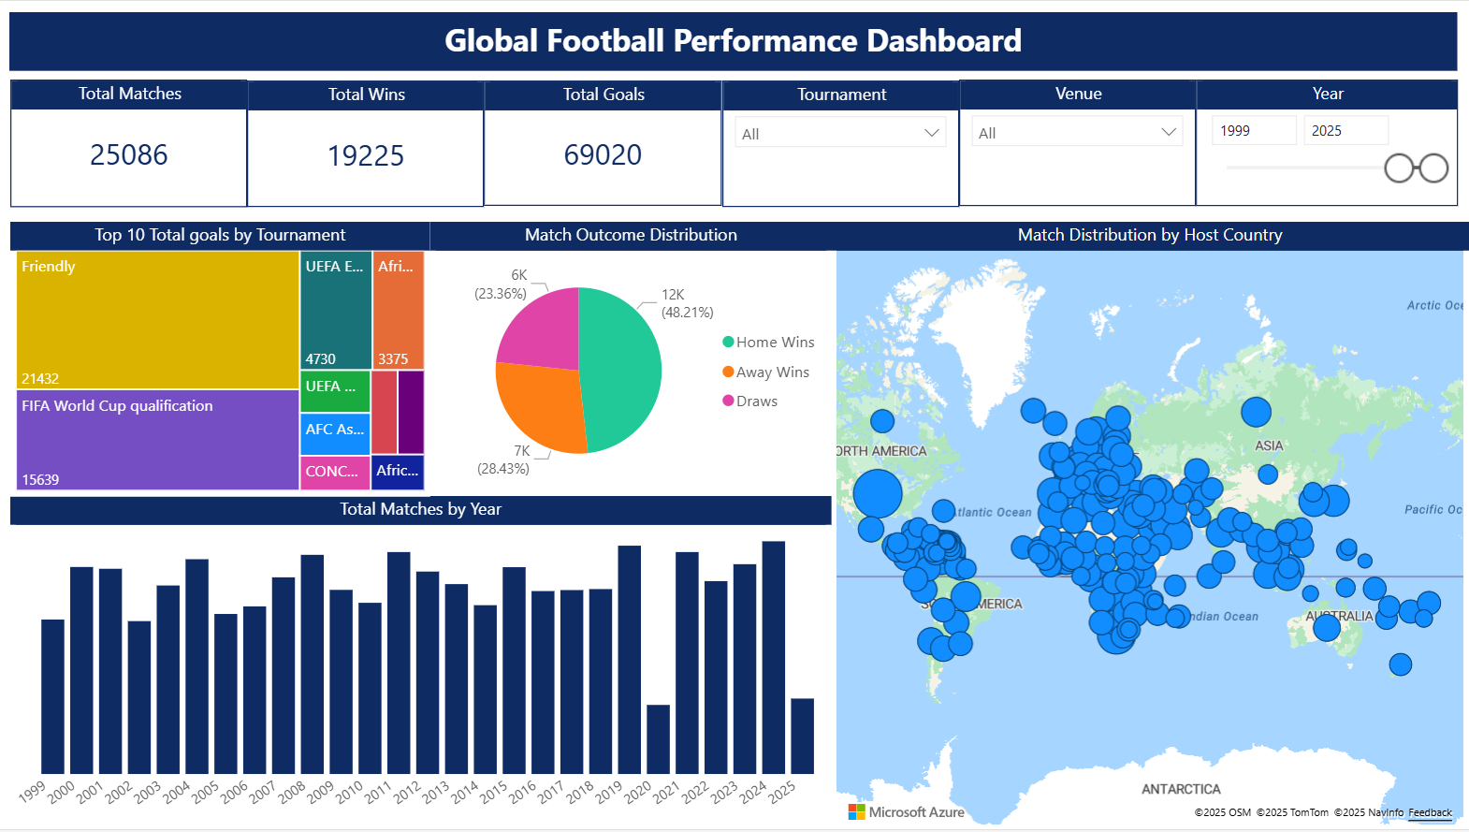
Fig 1: First page of Dashboard.
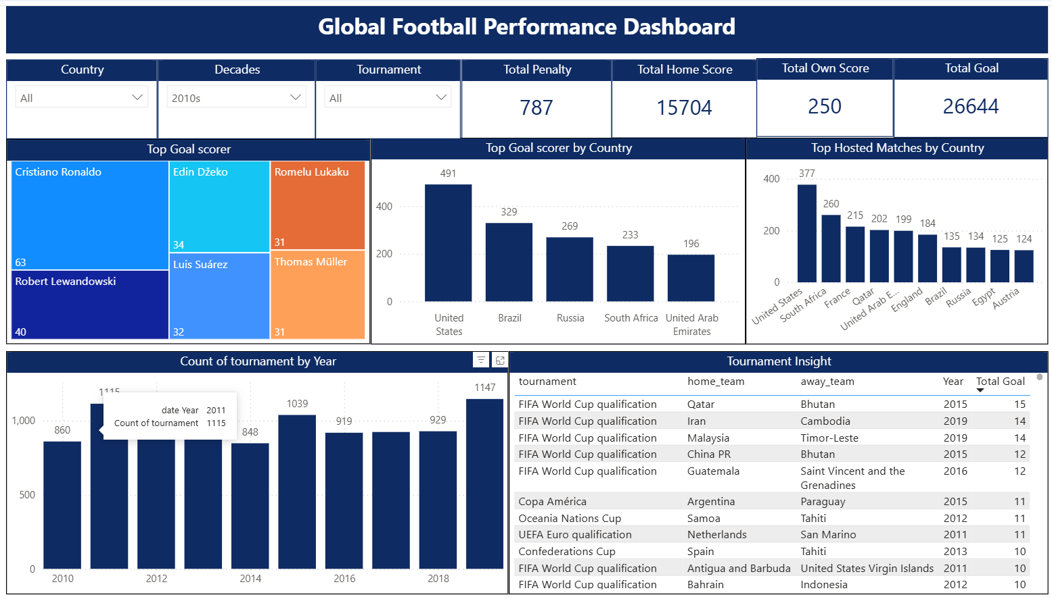
Fig 2: Second page of Dashboard (Decade from 2010s).
Key Insights
Exact percentages in these statements are visible in the dashboard KPIs and trend visuals when filtered by era or tournament.
KPI include the following:
Total Penalty: 2,975
Total Home Score: 8,5050
Total Own Score: 823
Total Goal: 142,168
- Home advantage has gradually declined: early decades show a higher Home Win %, with a noticeable narrowing between Home and Away win rates in the modern era (especially post 1990s).
- Average goals per match trace a classic 'U-shaped pattern' over time, high before the 1950s, troughing around the 1960s–70s, followed by a modest rebound from the 1990s onward.
- Neutral venues (tournaments) are fertile ground for upsets: underdogs draw or win more often on neutral ground compared with true away fixtures.
- Tougher competitions mean tighter games. Big tournaments such as the World Cup or continental championships usually have fewer goals overall, but the matches are closer, often decided by just one goal.
- Long-distance travel affects performance. Teams that travel long distances for matches tend to perform worse, especially those not used to play internationally.
- Different eras had different champions. Each time period had its own dominant teams. The Tournament Insight page highlights how global power shifted over time, showing when certain countries were at their best.

Recommendation
- For FIFA and Organizers: Plan tournaments with travel and rest periods in mind to make competition fairer for all teams.
- For National Teams: Prepare well for long-distance or neutral matches with proper recovery and travel strategies.
- For Coaches and Analysts: Use insights from scoring and performance trends to shape tactics to be more defensive in qualifiers and flexible or experimental in friendlies.
- For Federations: Study how dominance has shifted across eras to understand what factors make teams consistently successful.
Limitations
- Some older matches (especially before the 1950s) might not have complete or consistent records.
- The dataset doesn’t include in-depth details like player performance, referee decisions, or weather conditions that might have influenced results.
- Certain tournament-heavy years could slightly skew averages since some countries played more often during those periods.
Conclusion
This analysis captures how international football has evolved over more than a century. It shows how the game has grown fairer, faster, and more global, with home advantage shrinking and scoring styles changing over time.
From shifting team dominance to the effects of travel and tournament type, the data tells a story of how football keeps adapting with each generation. These insights not only reflect football’s history but also help teams, analysts, and organizers make better decisions for the future of the game.

