SEO and Keywords Analysis for Consumer Bank in Nigeria

The Dashboard link
Introduction
Search Engine Optimization (SEO) and keyword analytics measure how visible a brand is when users search on the web, its rank positions, and the audience reach through search volume. In consumer banking, SEO shows how often banks are discovered for customer-driven queries. High visibility of popular keywords can increase organic traffic, discovery support from customers which eventually increase revenue.
Objectives:
This analysis evaluates SEO visibility for 17 selected Nigerian banks by:
- measuring how many consumer-banking keywords each bank ranks.
- scoring average rank positions.
- comparing keyword visibility with reported bank revenue to test correlation.
Methodology
Data collection and tools (how this dataset was built)
- Keyword_filtered.csv: are gotten from Wordstream.com with the following main words: loans, online banking, savings account, interest rates. Total keywords gotten initially is 665. Search volume and competition each keyword was included were also gotten with it. Then keywords were filtered to those that appeared in bank_rank_results to analyze the keywords available for the bank only.
- Bank_rank_results.csv: Search engine results collected using SerpApi (Google results via API) to determine which banks appear for each keyword and their rank positions. The banks are Access bank, Gt bank, Zenith bank, First bank, UBA, Polaris bank, FCMB, Union bank, Sterling bank, Fidelity bank, Stanbic IBTC, Providus bank, Keystone bank, Jaiz bank, Taj bank, Wema, Glo bank.
- Bank_revenues.csv: are estimated revenue values from the bank’s yearly financial statements and the source of each one is included in the csv.
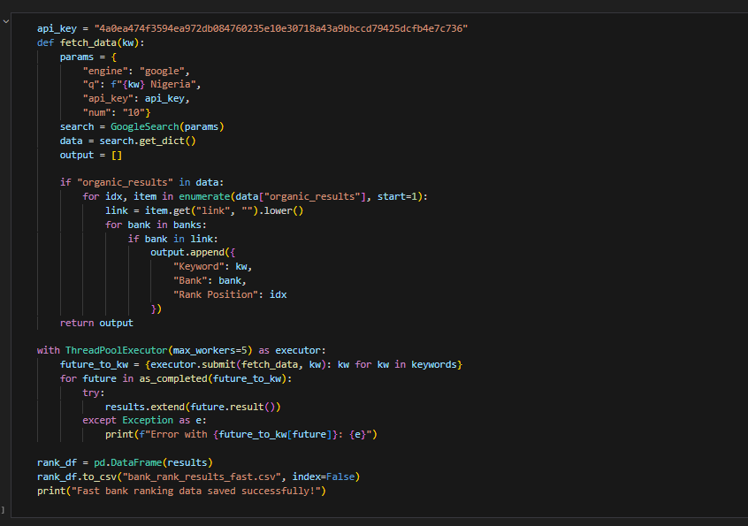
- After cleaning the csv file in excel. It was imported into PowerBI for modeling and visualization.
- Created relationship between the three csv : bank_rank_results[Keyword] → keywords_filtered[Keyword]; bank_rank_results[Bank Name] → bank_revenues[Bank Name].
- Created measures in Power BI (examples used in visuals):
  - Keywords per Bank = DISTINCTCOUNT(bank_rank_results[Keyword]).
  - Avg Rank Position = AVERAGE(bank_rank_results[Rank Position]).
  - SEO Visibility Share (%) (occurrence-weighted share) = Keywords per Bank / Total keyword-occurrences across all banks.
Dashboard & Insights
The key KPIs include:
- Total keywords: 165.
- Total banks covered: 17.
- Average rank position for banks/keywords: 5.10.
- Max revenue: ₦4.8Trillion.
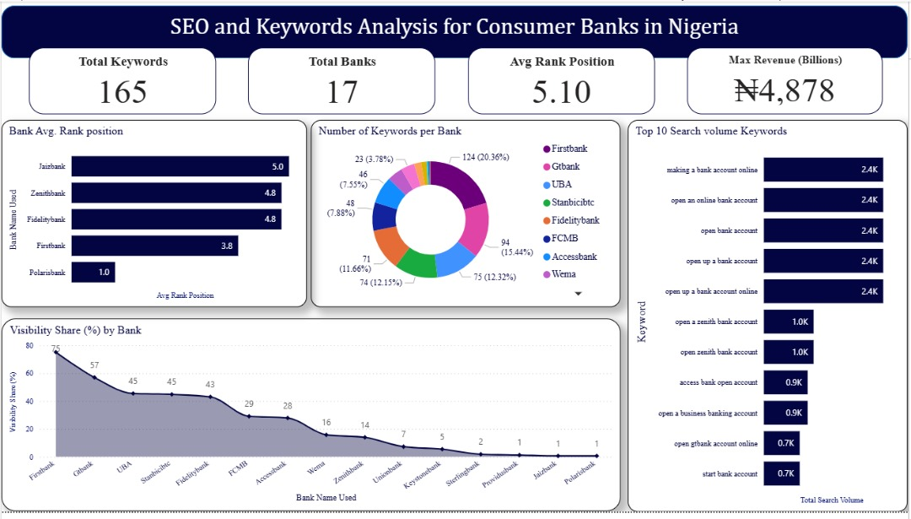
Fig 1:First page dashboard.
Charts
- Top 10 keywords by search volume (Bar chart):
It is dominated by account-opening and online banking queries. These keywords have the highest search volumes (x-axis shows volume in the ~0–2K range in the screenshot).
- Average rank position per bank (Column chart)
First bank, fidelity bank, zenith bank and Polaris bank show a low average rank less than 5. Which suggests these banks often appear in the top 3 positions for the keywords it ranks for.
Banks like GTBank, UBA, FCMB have average ranks around 5 to 6, indicating medium visibility and opportunity for improvement.
- SEO visibility vs revenue (correlation plot)
Pearson correlation occurrence-based visibility share vs revenue is 0.39 which is positive. The moderate positive relationship between how many keyword occurrences a bank has in the visibility share and its revenue. This means that banks with larger visibility shares tend to have higher revenues, but it’s not a strict rule.
Conclusion
First bank is the best-performing bank on the SEO metrics shown:
- Highest number of keyword occurrences (124) in the dataset giving it the largest portion of the visibility donut (20.5%).
- Best average rank (3.83) among leading banks. First bank tends to appear in the top positions.
- It also ranks highly across high search volume queries, evidenced by its strong presence on Top 10 keywords in the dashboard.
First bank has the strongest SEO strategy in the dataset: high coverage (many keywords) and strong average ranking (ranking in top positions).
The computed correlation between occurrence-based visibility share and reported revenue is moderately positive. This suggests banks with stronger visibility tend to have higher revenues, but correlation is not deterministic.
Some banks show high revenue but lower SEO visibility opportunities to invest in SEO while others have good visibility but lower revenue SEO advantage they could monetize.
Average rank position alone correlates weakly with revenue near zero in the sample, indicating that the breadth of presence has more relationship with revenue in this dataset than average rank alone.

