STRUCTURAL NETWORK ANALYSIS REPORT: ORKUT DATASET AND IMPLICATIONS FOR DEEN AI
Prepared by Rofiat Muhammad

Introduction

Background
Online communities often grow the same way people gather around shared needs in real life. Orkut was one of the strongest examples of this, with users joining communities that reflected their interests, routines, struggles, and identity. The Orkut dataset gives a clear window into how people naturally form circles, how they stay connected inside them, and how they drift across different groups.
This study builds on the ideas from Yang et al, (2012), who explained what a strong community looks like when measured by real network structure. By following these ideas, this analysis examines the internal bonds, boundaries, and patterns inside Orkut’s top communities. The goal is simple: to understand what makes a healthy group and translate those lessons into product ideas for Deen AI, where Muslims also gather around shared goals and spiritual needs.

Purpose and Objective of the Analysis
This analysis explores the structural and behavioral patterns of user-declared communities in the Orkut social network. The purpose is to examine the quality of strong communities, using the criteria highlighted in Yang et al (2012) journal on ground-truth communities.
The focus is to understand how people gather around shared interests, what makes a community healthy, and how users move inside those groups. These insights help us translate proven patterns of connected, focused, and supportive community behavior into product principles for Deen AI, especially for features that aim to build trust, belonging, and spiritual growth.
Research Questions
1. How dense are real Orkut communities compared to random node sets?
2. Are ground-truth communities well-separated from the rest of the network?
3. Do Orkut groups exhibit strong triadic closure (i.e., friends of friends are also friends)?
4. How cohesive are these communities, are they connected with subgraphs?
5. What is the size distribution of high-quality communities (those with strong internal structure)?
6. How many ground-truth communities do a typical user belong to, and how does this relate to their social connectivity (degree)?

Dataset Description
The analysis uses two Orkut publicly available datasets from the Stanford Network Analysis Project (SNAP): Community un-graph Orkut: It contains over 3milions nodes and 100millions edges which represents undirected relationship between two numeric user IDs. I sampled the 2million edges to manage computational constraints while preserving structural integrity.
Top 5000 Orkut community: contains a list of 5,000 ground truth communities and 731,514 users, where each line a group of users who explicitly belonged to a specific community. The communities contain 731,514 users. To ensure all community members were represented in the graph even if they had no edges in the sampled data. I added isolated nodes for any missing users. The final graph contains 1,065,059 nodes and 2,000,000 edges.
This dataset was chosen because Orkut users show how people naturally form groups based on shared interests, routines, or struggles, which aligns with Deen AI's interest in how Muslims gather into different clusters with similar needs and studies how habits and information spread inside each community.

Analytical Methods
All analysis was performed using Python with the following libraries:
NetworkX: For graph construction and structural metrics.
Pandas and NumPy: For data manipulation and statistical computation.
Matplotlib: For visualization.
SciPy: For correlation analysis.
Key Methodological Choices:
- Metric Definitions:
- Density: Ratio of actual internal edges to all possible edges.
- Separability: Ratio of internal to external edges.
- Triadic Closure: Fraction of users in at least one triangle (friend-of-friend bond).
- Cohesiveness: Whether the induced subgraph is connected.
- Baseline Comparison: For Question 1 and 3, I generated random node sets matched in size to real communities to establish statistical baselines.
- High-Quality Communities: Defined as those in the top 25% for both density and clustering representing the most internally cohesive and relationally rich groups.
- Membership Analysis: Counted how many communities each user joined and correlated this with their degree in the friendship graph to infer behavioral roles.
This analysis compares ground-truth communities with size-matched random node sets to establish a baseline for non-random structural patterns, specifically for density and triadic closure, following an evaluation approach aligned with established network community assessment practices. No random baselines were used for the remaining questions as they focus on descriptive characteristics of real user behavior rather than statistical deviation from randomness.

Table 1: Showing the metrics computed for the 5000 communities.
Statistics Summary | Density | Separability | Clustering
Count | 5000 | 5000 | 5000
Mean | 0.006684 | 93600.049628 | 0.056056
Std | 0.035861 | 291300.535376 | 0.166761
Min | 0.000000 | 0.000000 | 0.000000
25% | 0.000000 | 0.000000 | 0.000000
50% | 0.000000 | 0.000000 | 0.000000
75% | 0.001514 | 0.123915 | 0.000000
Max | 0.794872 | 1000000 | 1

Key Findings and Visualizations
A small subgraph of 100 nodes was plotted to illustrate the scale-free nature of social networks and isolated nodes as shown in Fig. 1, reinforcing the need for Deen AI to act as a central, calming presence. To support interpretation, the following visualizations were created:
Boxplot: To compare density of ground-truth and random communities, confirmed significant internal connectivity and showed strong relational clustering.
Histogram: to reveal pervasive overlaps between groups using log scale, identify the median of high-quality communities and demonstrate focused and intentional engagement.
Bar chart to highlight fragmentation
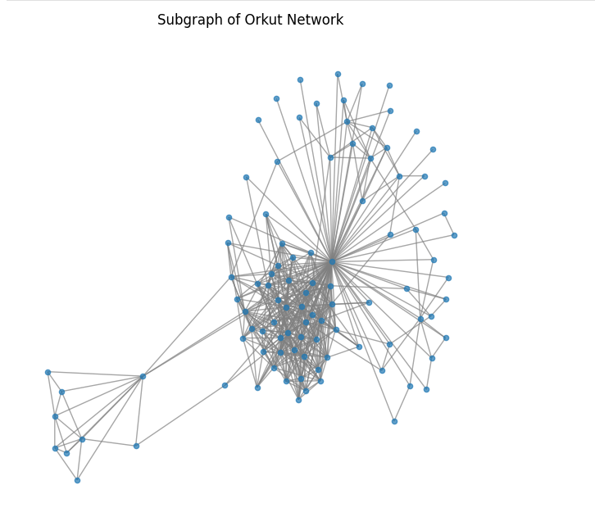
Fig 1: Subgraph of Orkut Network
Research Questions and Key findings
The analysis focuses on six questions that uncover the structure and quality of communities:

Research Question 1
How dense are real Orkut communities compared to random node sets?
To analyze community density, I calculated the density (ratio of actual internal edges to all possible internal edges) for each of the 5,000 ground-truth communities, then generated 100 random node sets matching the size of each real community, computed their average density, and compared it to the density of the real communities to assess whether their internal connectivity was meaningfully higher than chance.
Key Findings and Implication for choosing case study (Deen AI)
The ground truth communities are 1,953 times denser than random with an average density of 0.00668394 compared to random node sets that have an average density of 0.00000342. This confirms that users don’t join communities by chance, instead they form intentional clusters with shared needs, interests, and goals, even in sparse networks. For Deen AI, this means users are actively seeking connection, not just passive content consumers. The product should reflect this intentionality by offering deep, structured interactions like guided reflections or personalized Qur’anic insights rather than generic or surface-level features.

Research Question 2
Are ground-truth communities well-separated from the rest of the network?
I analyzed community separability by calculating the ratio of internal to external edges for each of the 5,000 ground-truth communities, then examined the overall pattern using histogram and summary statistics like median and percentiles.
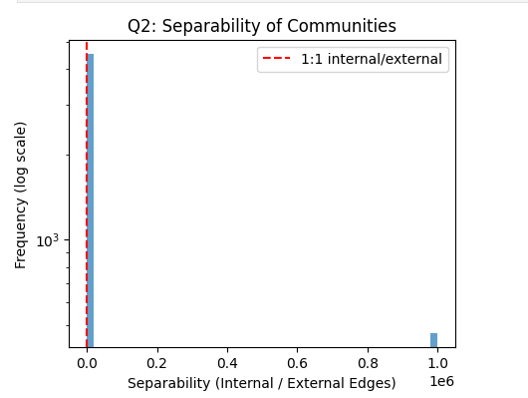
Fig 2: Separability chart of communities
Key Findings and Implication for choosing case study (Deen AI)
Median separability is 0.000 which is extremely low. 90.6% of communities have more external than internal edges, indicating that most Orkut communities are not well-separated. This shows that people inside a community connect more with outsiders than with members of their own community. For Deen AI, this means users will belong to different fixed audience types and also follow multiple topics at the same time. Deen AI can work with this by building flexible user profiles, recommending content across overlapping interests, and designing features that adapt to users who move between several communities rather than staying inside a single closed group.

Research Question 3
Do Orkut groups exhibit strong triadic closure (friends of friends are friends)?
To assess triadic closure (friends of friends to be friends), I measured the fraction of users in each Orkut community who belong to at least one triangle (a group of three mutually connected users). Then compared this to a baseline of randomly selected node sets of the same size to determine whether real communities show significantly stronger clustering than chance would predict.
Key Findings and Implication for choosing case study (Deen AI)
Real communities have a clustering score of 0.0561 while the random sets score near 0. This shows that ground truth communities are 4,001 times stronger in triadic closure. sDeen AI can emulate this by helping users form small interest-based groups, connecting people with similar faith habits, and recommending peers who share goals which allows the app to naturally build tight, connected circles the same way strong communities grow.

Research Question 4
How cohesive are these communities are they subgraph connected?
I checked whether each ground-truth community formed a fully connected subgraph meaning every member could reach every other member through friendship links in the Orkut network. Then reported the percentage of communities that met this connectivity requirement.
Key Findings and Implication for choosing case study (Deen AI)
Only 0.6% of communities are fully connected. The vast majority are fragmented: members have no direct or indirect social links within the group. Most communities look united, but they are scattered. For Deen AI, this shows that real users may join the same faith-focused space but remain disconnected in practice. Deen AI can use this insight to build features that bridge these gaps such as personalized reminders, shared learning rooms, Quran circles, and topic-based micro-communities that pull isolated users into active clusters. This helps the product turn a scattered audience into a truly connected one.

Research Question 5
What is the size distribution of high-quality communities?
I defined “high-quality” communities as those falling in the top 25% for both density and clustering (Triad Participation Ratio), then analyzed their size distribution and reported the median size.
Key Findings and Implication for choosing case study (Deen AI)
Median size of high-quality communities is 223 users. These groups are medium scale: large enough for diversity, small enough to maintain focus. This implies that the communities are big enough to bring people with different backgrounds together, yet still small enough for members to stay connected and focused on the same goal. For Deen AI, this is useful because it shows the ideal community size where people stay active and benefit the most. Deen AI can use this insight to build learning circles, support groups, and habit-building cohorts that stay within this healthy size range, so users feel connected, supported, and engaged.

Research Question 6
How many ground-truth communities do a typical user belong to, and how does this relate to their connectivity?
I examined user participation across communities by counting how many of the top 5,000 ground-truth communities each user belongs to. Then calculated the average and median number of community memberships per user and explored whether users with more friends (higher degree) tend to belong to more communities by correlating membership count with user degree.

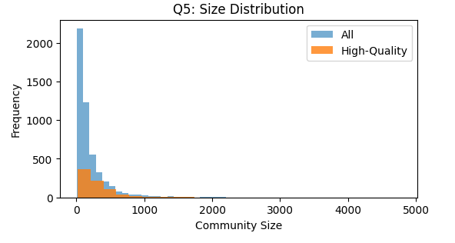
Fig 3: Size distribution of the communities
Key Findings and Implication for choosing case study (Deen AI)
Average membership per user: 1.5, Median: 1. Most users belong to only one group, suggesting focused intent. This confirms that a user picks the community that speaks to their needs and stays there. Users often begin their spiritual journey with one clear need. Deen AI should meet their exact needs but not overwhelming choices. Over time, as trust builds, the app can gently invite deeper exploration like: You’ve been reflecting on patience, would you like to explore verses about hope next? This mirrors how real growth happens: focused at first, expanding with time.

Limitations
Even though the analysis defined the structure of the community, there are still few limitations in the analysis, which are the following:
- Only 2 million edges were sampled from Orkut’s 117 million, leading to sparsity.
- Due to the small sample data, biased correlation toward only highly connected users and underestimating isolated users among community.
- The top 5,000 communities may not reflect all spiritual or emotional group types.
- The analysis captures how users connect, not why they connect.
- Degree was computed on a partial graph, potentially underestimating true connectivity.

Conclusion
This analysis shows that real communities are intentional, not accidental. People join groups where they find meaning, and even in large networks, they form tight circles through trust, shared habits, and stable patterns of connection. At the same time, most communities are scattered, which means many people may be part of a community without really being part of it.
For Deen AI, these insights guide how to build safe, focused, and supportive digital spaces. The product can help users grow in small circles, bridge silent or isolated members, and guide them gently from one need to the next as their spiritual journey widens.

