**Name : Chirag patil**

**Class :** TYBSc - CS, Div 1

**Roll no. :** CS-4080

**Batch B**

**PRACTICAL NO: 09**

**Title: Email Forensic**

* Mail Service Providers
* Email protocols
* Recovering Emails
* Analyzing email Headers

**Steps:**

1. Download Forensic Tool:

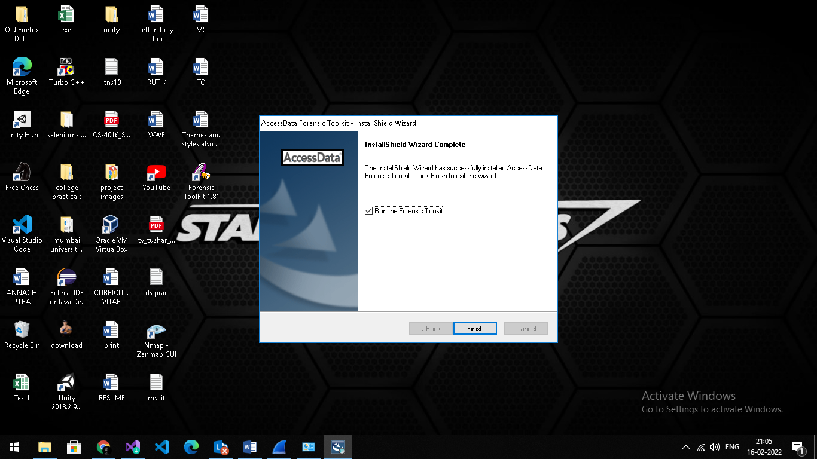

1. Select a new case and fill the details & click on next:

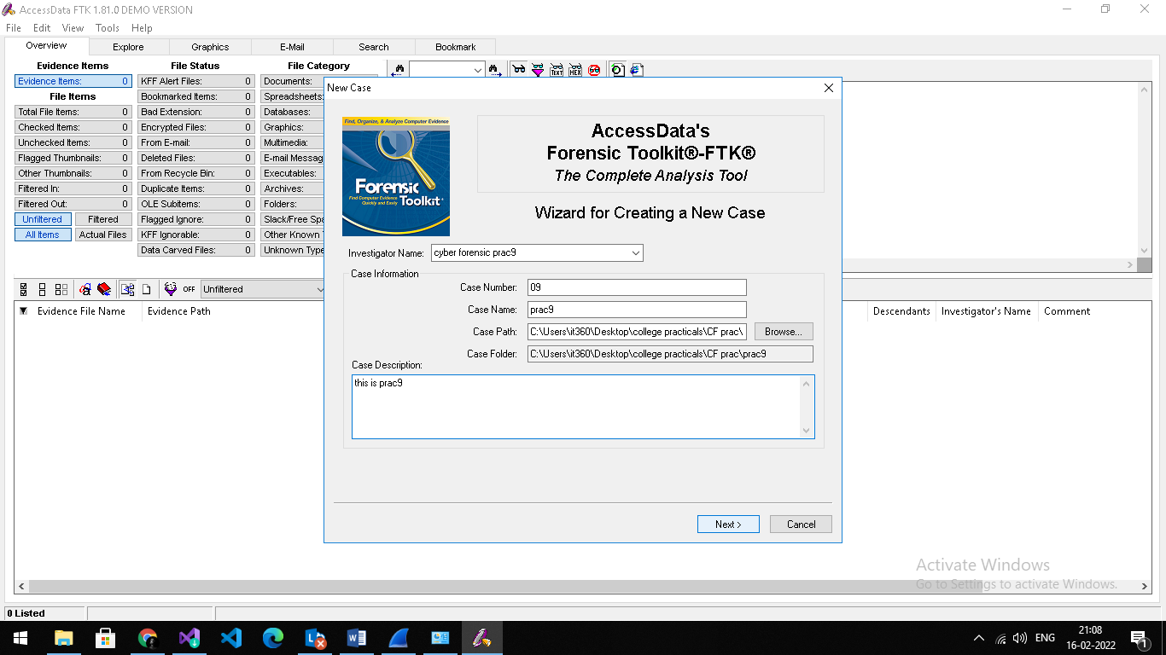

1. Skip this page click on next:

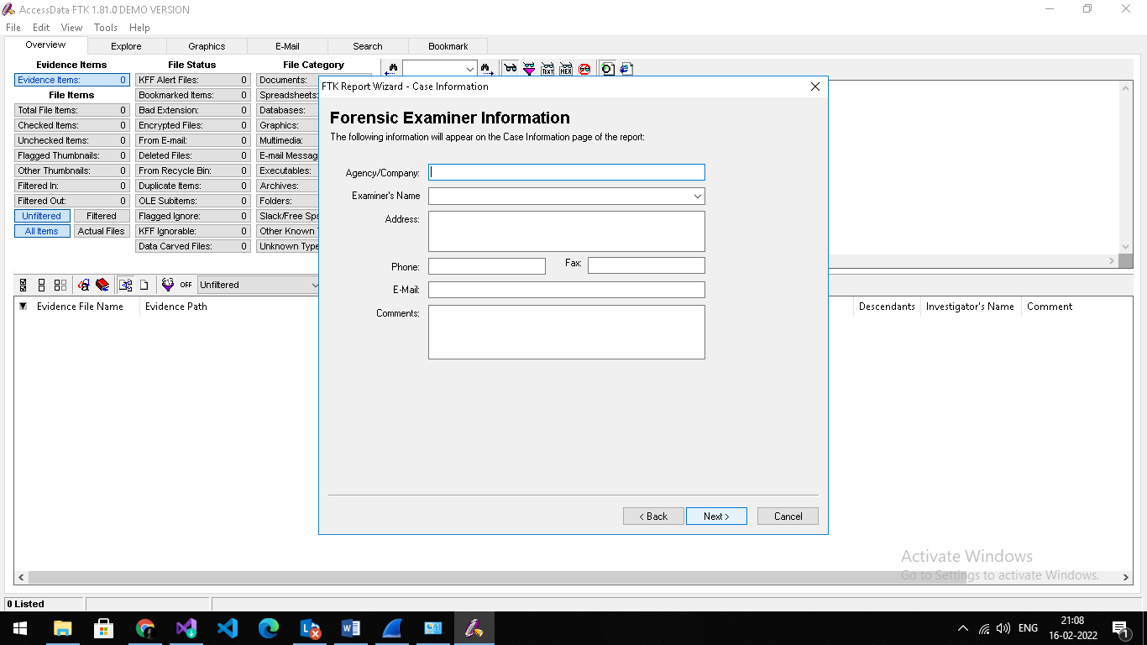

1. Skip this page click on next:

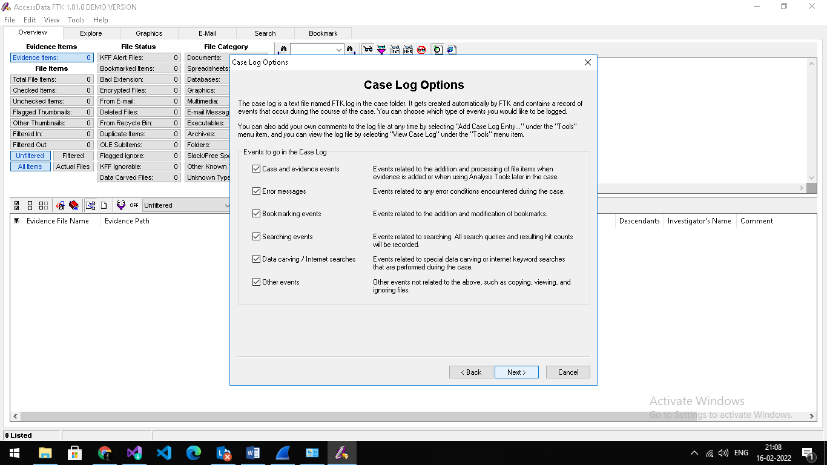

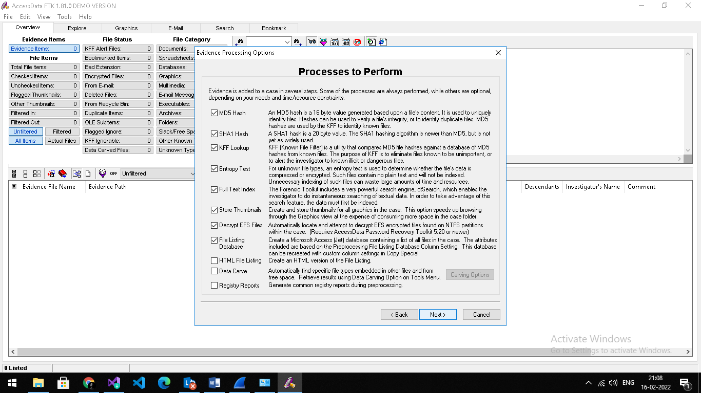

1. Select Individual all & click on next:

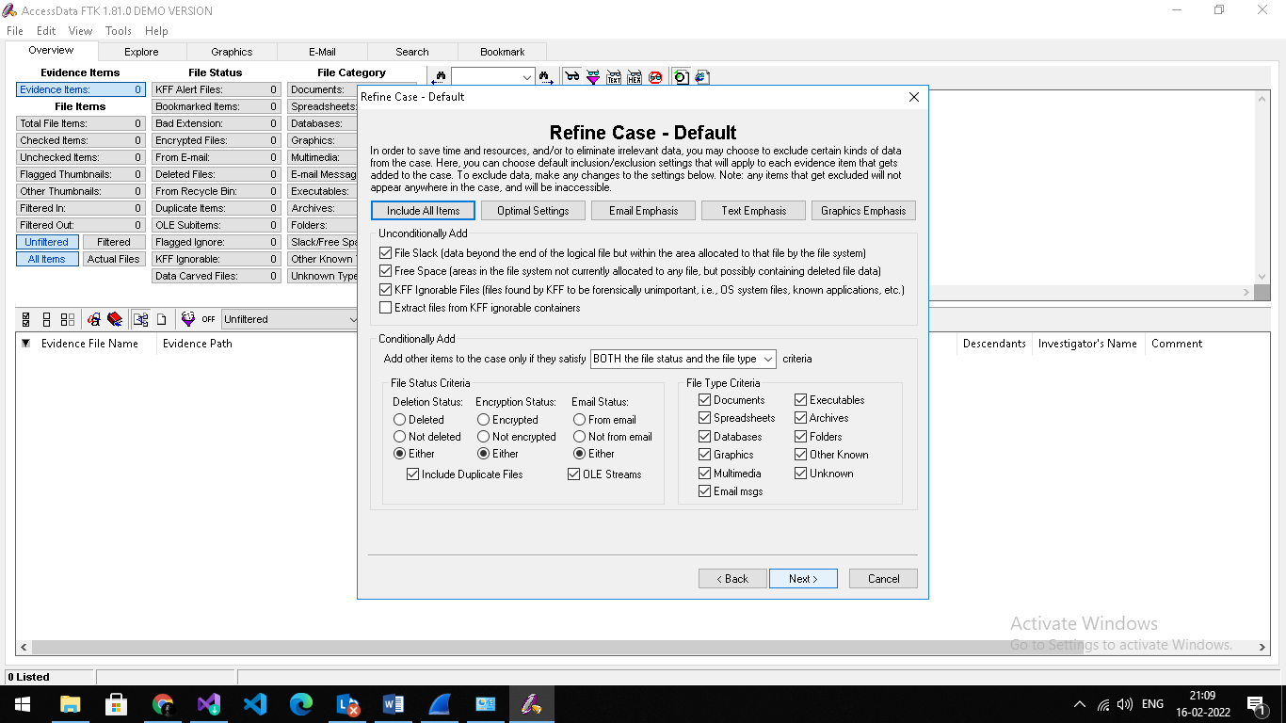

1. Skip this page click on next:

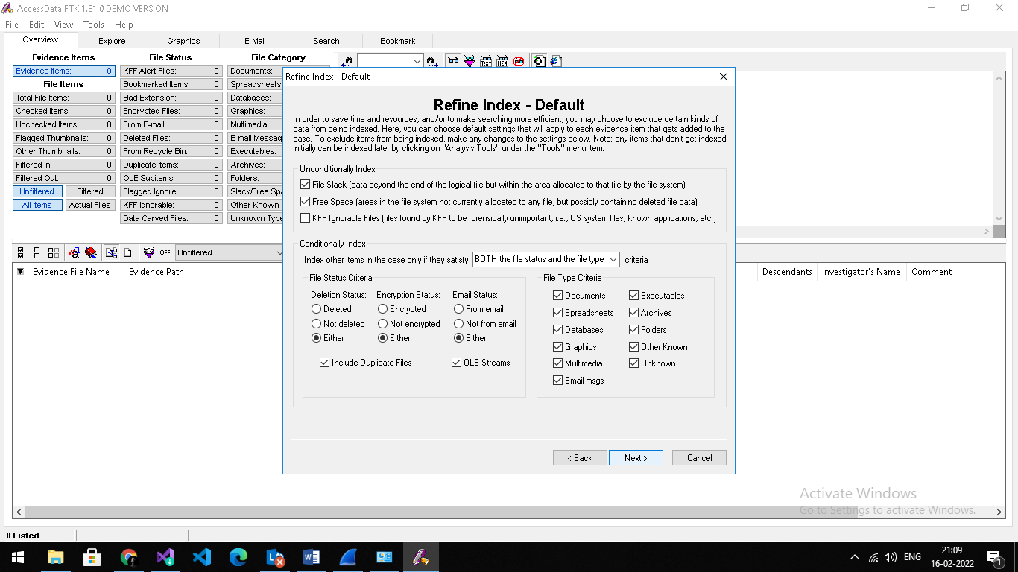

1. Select Add evidence ->select individual file-> click on continue:

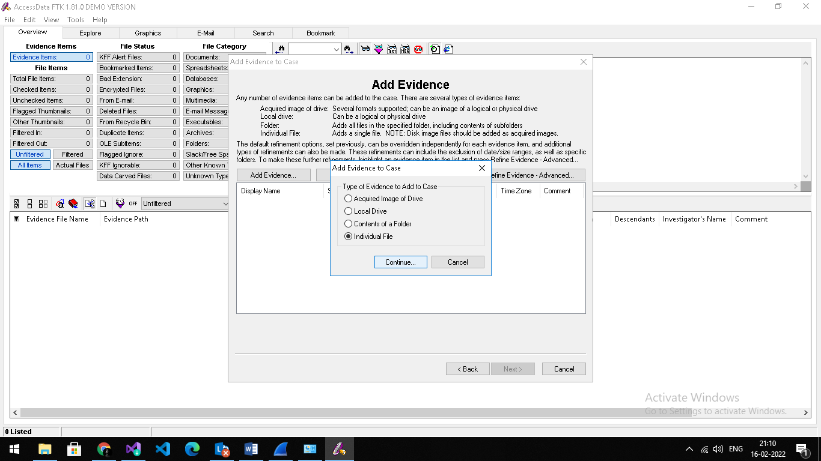

1. Brows & Select “Sample.pst” file :

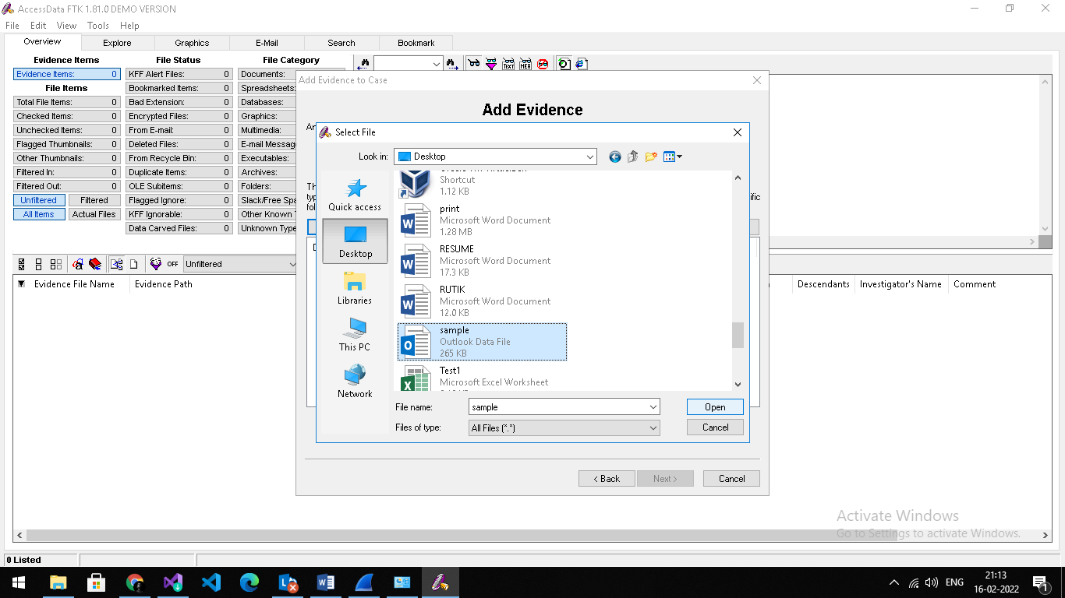

1. Fill the Details & click on ok:

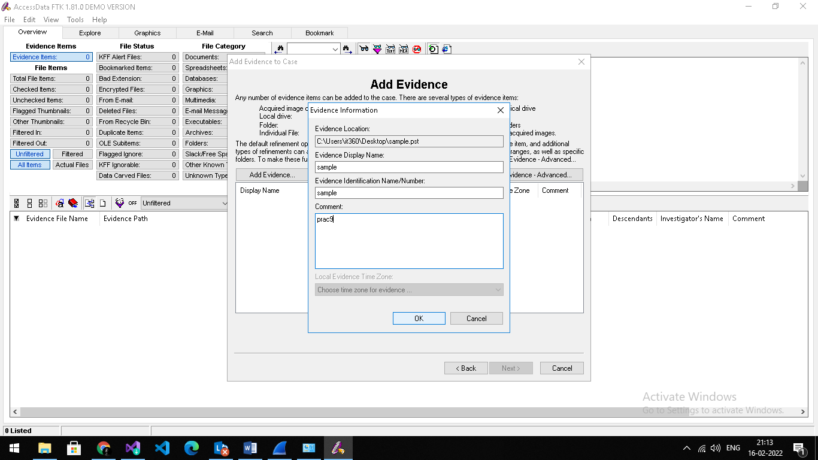

1. Sample file will add & click on next:

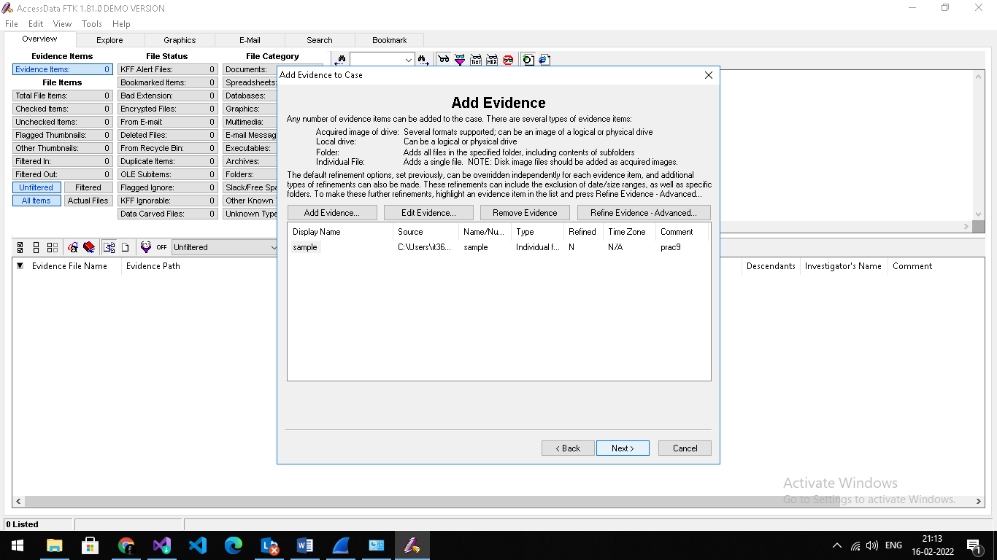

1. Select path & click on finish:

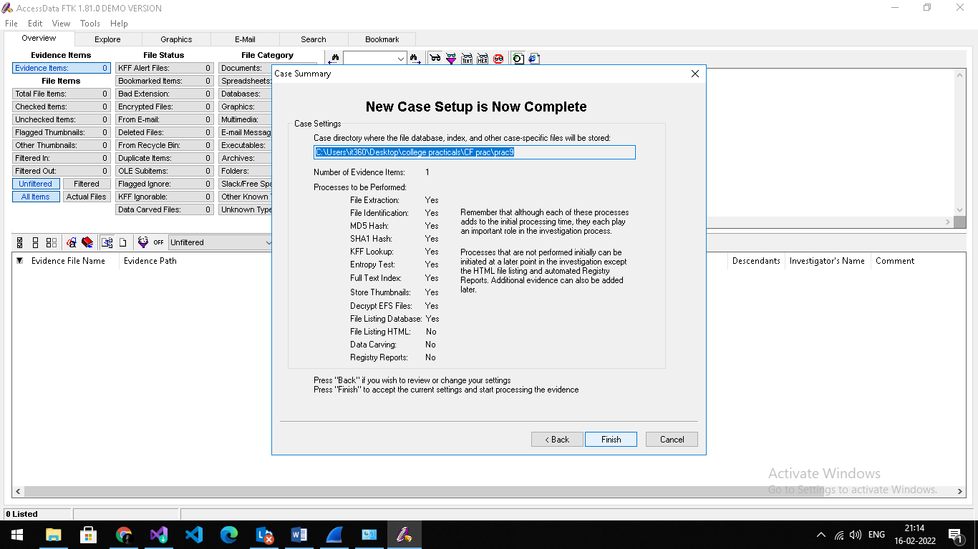

1. Select sample.pst file, click on email messages:

