Arnold Sam Rume
Born 8th September 2006
Software Engineering Student at Kirinyaga University
Github profile: https://raxine091.github.io/

Notable Projects:

1. Basic website
Created a basic 1 page website (Raxine Dishes), a restaurant menu website that lists dishes in a table.
https://raxine091.github.io/Web-Technologies/

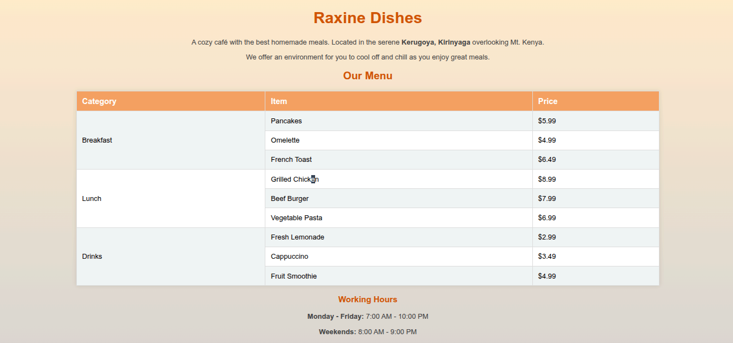
2. Basic interactive website with multiple landing pages
The website created was for a theoretic e-commerce company – Smartedge Technologies.
https://smartedge-store.onrender.com
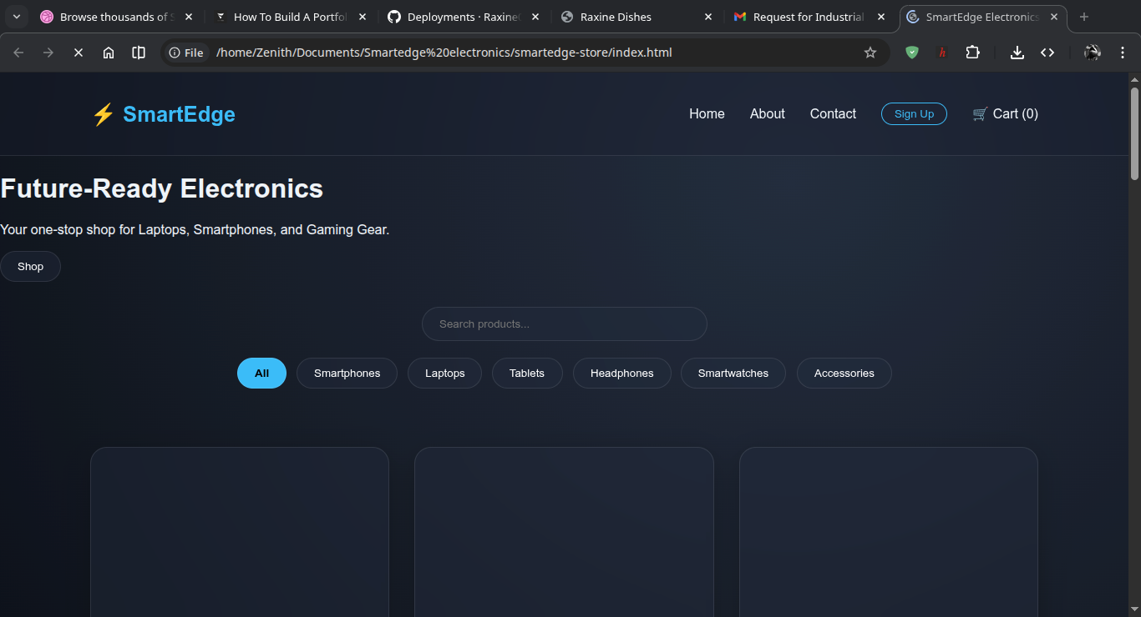
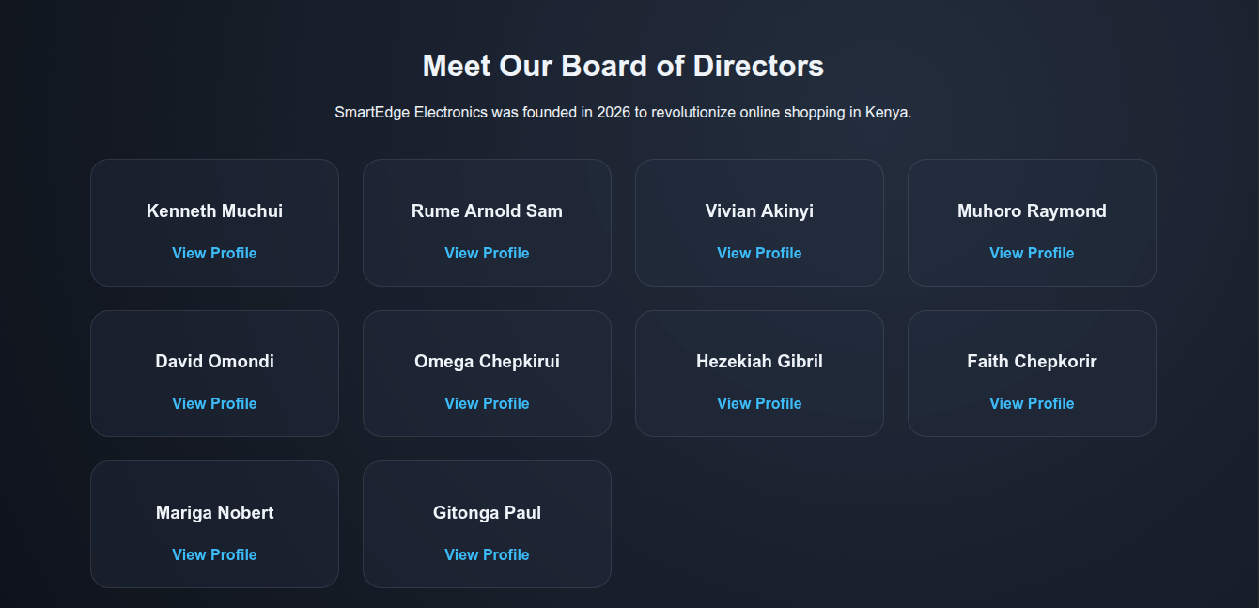
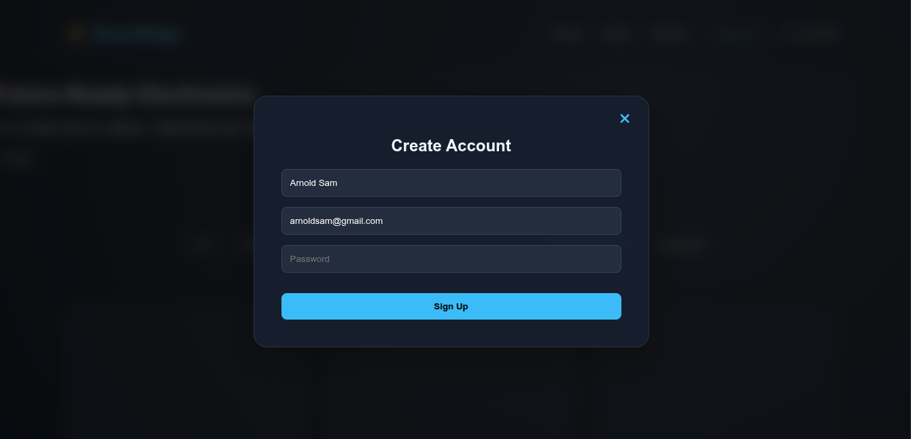
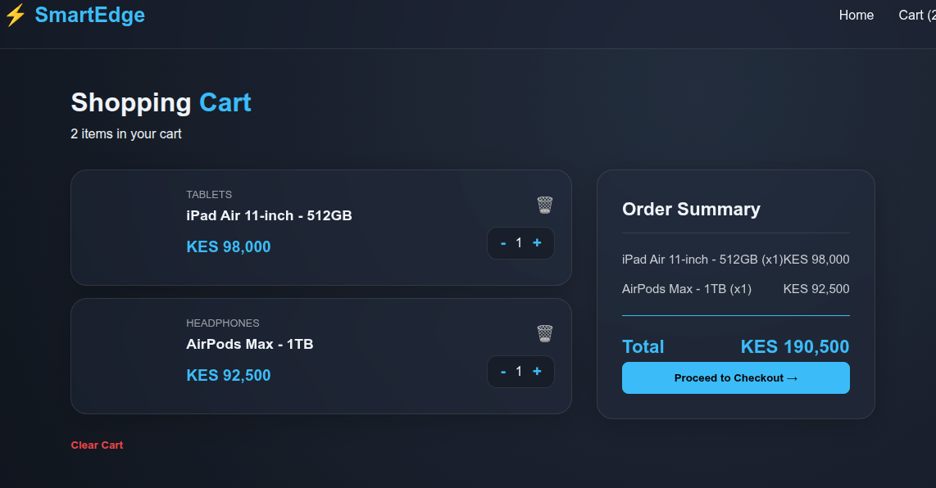

3. Database Management (MySQL, PHPMyAdmin, Apache)
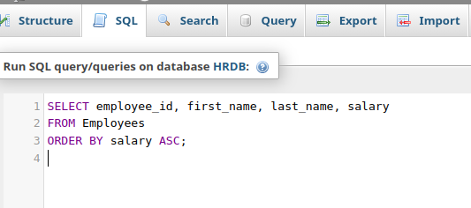
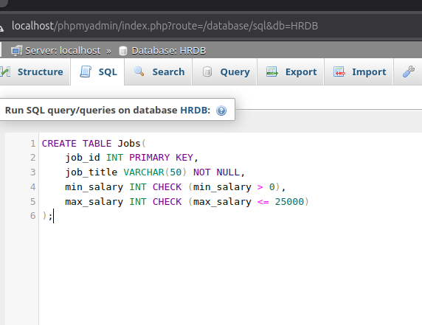
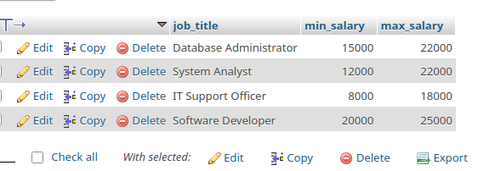
A database was created (HRDB) locally and tables created successfully. XAMMP was used to start the local servers
Database management techniques applied successfully : Creation, Insertion, Updating, Deletion.
Queries made returned valid results.

4. Bookstore Billing System (Visual Basic)
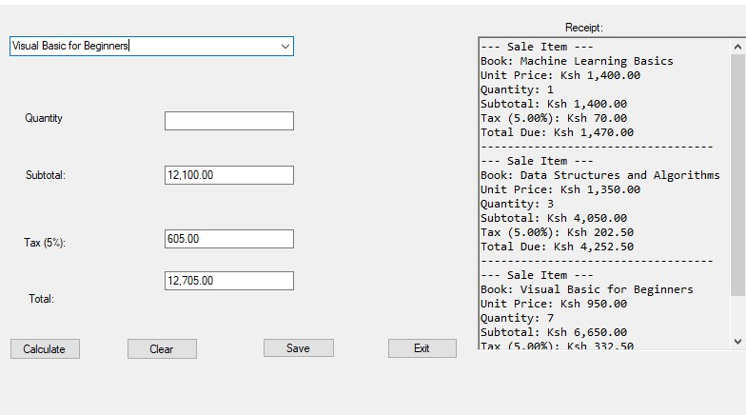
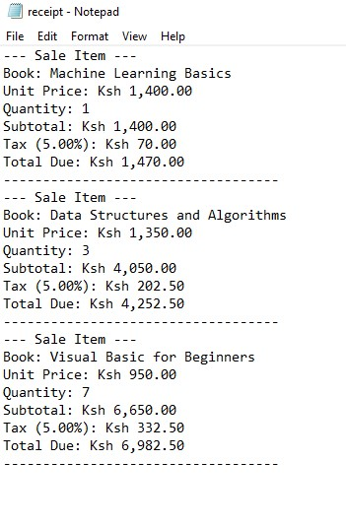
This project was done when learning the basic concepts of GUI.
Visual Basic in visual studio community was used in it’s development. The final product is a windows executable file that calculates total price of goods bought from the bookstore imposing a 5% tax and then produces a receipt. The app is not fully integrated with a working database.

5. Number system converter
A web-page that uses digital logic to convert numbers in the various number systems to a desired system. https://raxine091.github.io/Number-System-Converter./
The web-page uses the front-end languages (HTML, CSS, JS)
It also shows the conversion steps – the logic.
