Model Architecture
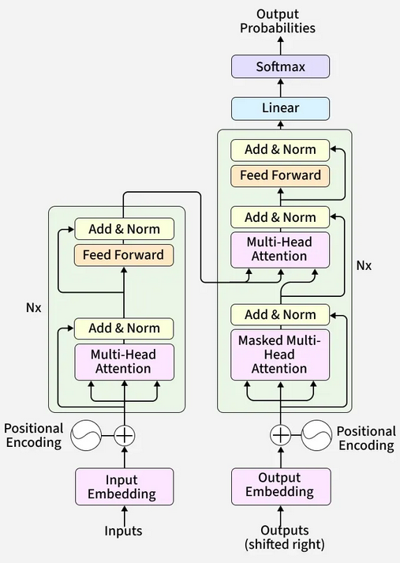
Figure 1, classical transformer architecture with our implementation roughly outlined in red
For the task of training a language model to do next-token prediction, there is no need for both an encoder and decoder stack as in the classical transformer architecture depicted above. In this project, we landed on a simple implementation is effectively a decoder stack minus the multi-head attention block on the encoder’s output. We currently have it implemented for two layers of masked multi-head self attention, but it would be trivial to add more. In the code, we used the pytorch nn.TransformerEncoderLayer module to build the decoder, since it includes self-attention, feed forward, and normalization, which are all the key processes needed for training. The nn.TransformerDecoderLayer module is designed to take input from and apply cross-attention on encoder output, so it was simpler to use the encoder for this task.
The biggest challenge to getting this to work was that, since the encoder module we used does not include masked self-attention by default, only attention over the whole sequence, the mask had to be passed in manually. This is done using a pytorch method to generate an upper triangular matrix where all the ‘upper’ values take on the value of negative infinity, which effectively masks those tokens from the transformer. The effect of this is that future tokens in the sequence do not receive attention during training.

Training and Loss
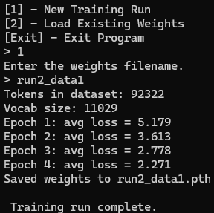
Figure 2, loss tracking of the first successful run
To train the model, after tokenization, all tokens are sequenced in parallel as an input sequence and a target sequence, so that the target sequence at every position contains the next token for the input sequence. The input sequence is passed into the model, which learns to predict the next token. To save on memory, the tokens are passed in batches to the model for training, the size of which can be changed in the code. During each training batch, the loss is calculated between the inputs and targets, and the optimizer is called to step the weights. The total loss per epoch is calculated as a running total during the batching and is reported at the end of each epoch.
One important note here is that the loss tracked by this process is training loss. It is not being calculated on tokens the model has not seen, which would give more insight into how much overfitting the model is doing. This would be a top contender for next feature to implement. However, the current measured training loss is enough to demonstrate that the model is in fact learning to predict next token better than random guessing. We observe that the measured loss continues to decrease, albeit with diminishing returns, with more training time. Additionally, the output from the model, currently set to be trained on just shy of 100 thousand tokens of The History of the Peloponnesian War by Thucydides, is somewhat coherent and sometimes produces complete clauses. It is not useful for any task, but it does work. This, combined with our measured training loss, indicates that the model is, in fact, learning.
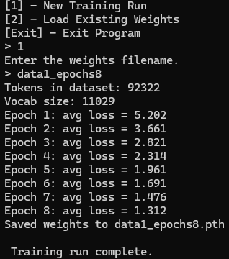
Figure 3, a training run using 8 epochs
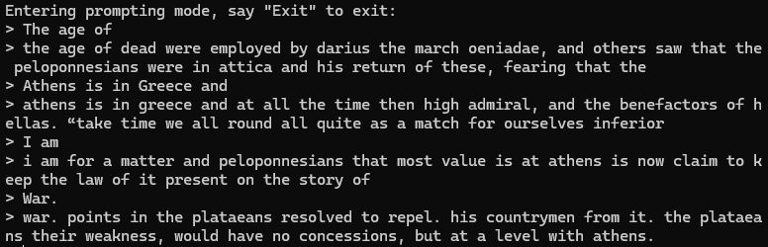
Figure 4, some generated responses using the weights from an 8-epoch run on the Peloponnesian War corpus

Tokenizer
The tokenizer is incredibly simple. It takes in the text of the corpus, converts it all to lowercase, splits each word by spaces, and collapses Unicode characters, such as control characters, to reduce the vocabulary size. Each unique token becomes part of the vocabulary set which is used to built two dictionaries that allow tokens to be converted from string to integer and vice versa. The tokenizer contains methods for encoding and decoding tokens, which are used extensively throughout the rest of the code. Further techniques to reduce the vocabulary size were considered, such as stemming and lemmatization, but since this project’s ultimate goal was to produce coherent text, the full words were used as tokens.

Comparisons

Reflection

