Linux Commands Practical Report

Name: Raksh

Date: 5/7/2025

Environment: Ubuntu on WSL

# 1. Creating and Renaming Files

Commands

mkdir test_dir

cd test_dir

touch example.txt

mv example.txt renamed_example.txt

Explanation:Creates a directory, then an empty file, and finally renames it.

Screenshot:

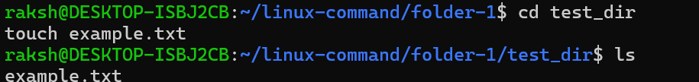

# 2. Viewing File Contents

Commands:

cat /etc/passwd

head -n 5 /etc/passwd

tail -n 5 /etc/passwd

Explanation: Displays full content, first 5 lines, and last 5 lines of /etc/passwd.

Screenshot  
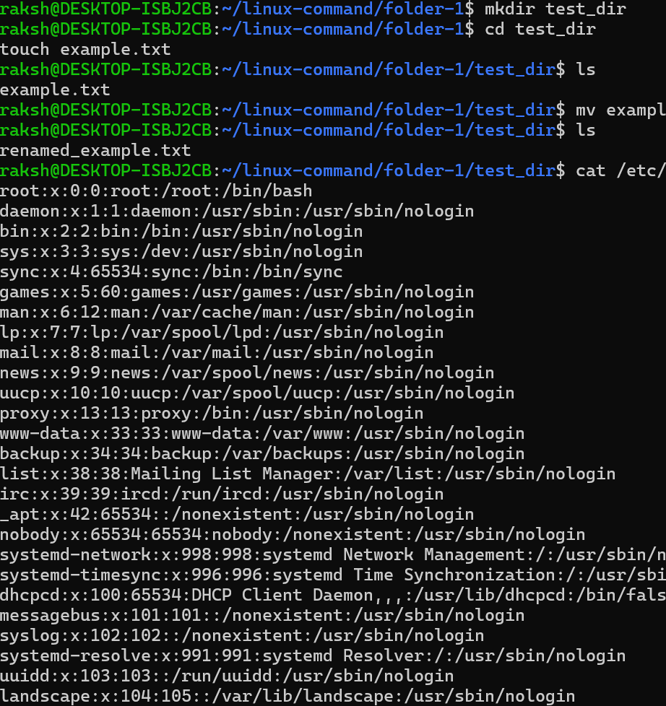

# 3. Searching for Patterns

Commands:

grep "root" /etc/passwd

Explanation:Searches for lines containing the word 'root'.

Screenshot

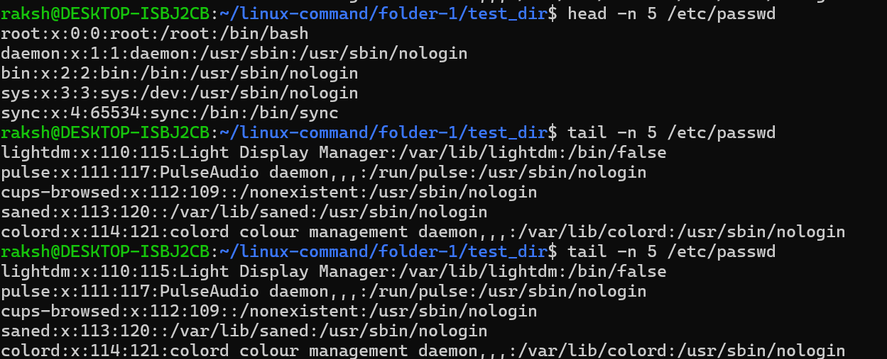

# 4. Zipping and Unzipping

Commands:

cd ..

zip -r test_dir.zip test_dir

unzip test_dir.zip -d unzipped_dir

Explanation:Compresses and extracts the test_dir folder.

Screenshot

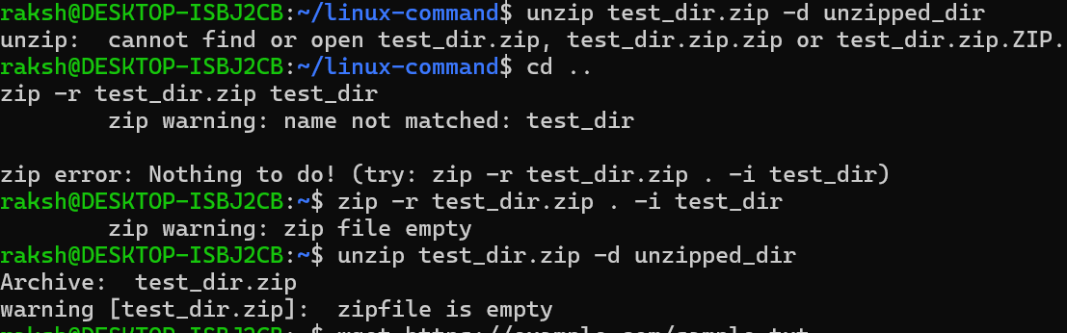

# 5. Downloading Files

Commands:

wget https://example.com/sample.txt

Explanation:Downloads a file from a given URL.

Screenshot:

# 6. Changing Permissions

Commands:

touch secure.txt

chmod 444 secure.txt

Explanation:Creates a file and makes it read-only for all users.

Screenshot



# 7. Working with Environment Variables

Commands:

export MY_VAR="Hello, Linux!"

echo $MY_VAR

Explanation:Sets and displays a new environment variable.

Screenshot

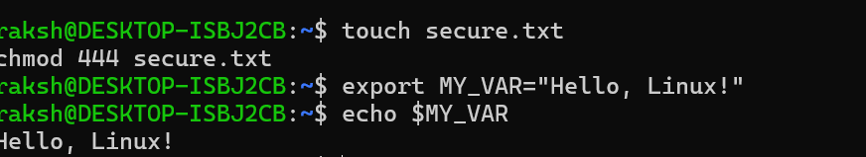

# GitHub Repository

[Insert your GitHub repo link here]