As we are all aware, we are experiencing a pandemic crisis caused by Covid-19 virus.

For the last two weeks I have been trying to make a computer simulation for this virus to investigate how it spreads.

In this project I have been trying to achieve two main goals:

* Creating a simulation for a better and realistic understanding of how the virus spreads
* Experimenting with the model in order to find the most effective ways to reduce the spreading of the virus.

**How does the simulation work?**

(Be sure to check my video for better understanding

<https://www.youtube.com/watch?v=eO_7Zq0WUH4> )

First step is identifying the most important variables effective on the spreading of the virus.

Here is a list of the most important variables.

* Population
* Number of initially people infected
* Number of people in the gatherings
* Chance of people getting the virus in interactions with infected people
* Mortality rate
* The duration of disease
* Days until the patient realises, he or she has got the virus

At first a number of people get infected randomly.

Every day people will be randomly selected in groups of people with the specified number of people in each gathering.

Then interactions between people happen within each gathering.

I will be explaining the maths behind the interactions but first, there is one more important factor we have to pay attention.

Researchers have reported that about 50 percent of people who tested positive for COVID-19 were without symptoms.[1]

This is an important point because of not being aware that they are infected and they may able to transmit the virus to others.

The reason is some people are more immune than others. However, studies have shown if the infected people but without any health issues make contact with other infected people, it may cause them to show symptoms and they may increase their chance of mortality.

People in each gathering will interact in pairs. If one of them is infected and the other is healthy, there is a chance that the other person will get infected as well (by using the chance mentioned above). However, when they are infected there is a 50% chance that they will not be showing any symptoms. In other words, their disease is not very serious but they will be able to infect others.

On the other hand, when two infected people interact but one of them is not in a critical condition (not showing any symptoms) there is a chance that the health condition of the healthier person can also become critical.

Using these values below I ran the first simulation.

Population = 1000

Initially infected = 5

Number in gatherings = 4

Chance of infection = 0.1

Mortality rate = 0.2

Chance of becoming worse = 0.01 (chance of a healthy infected person getting a bad condition in each interaction)

Duration of disease = 12 days

Days until patient gets notified = 3 days (they will only be notified if they are in critical condition)

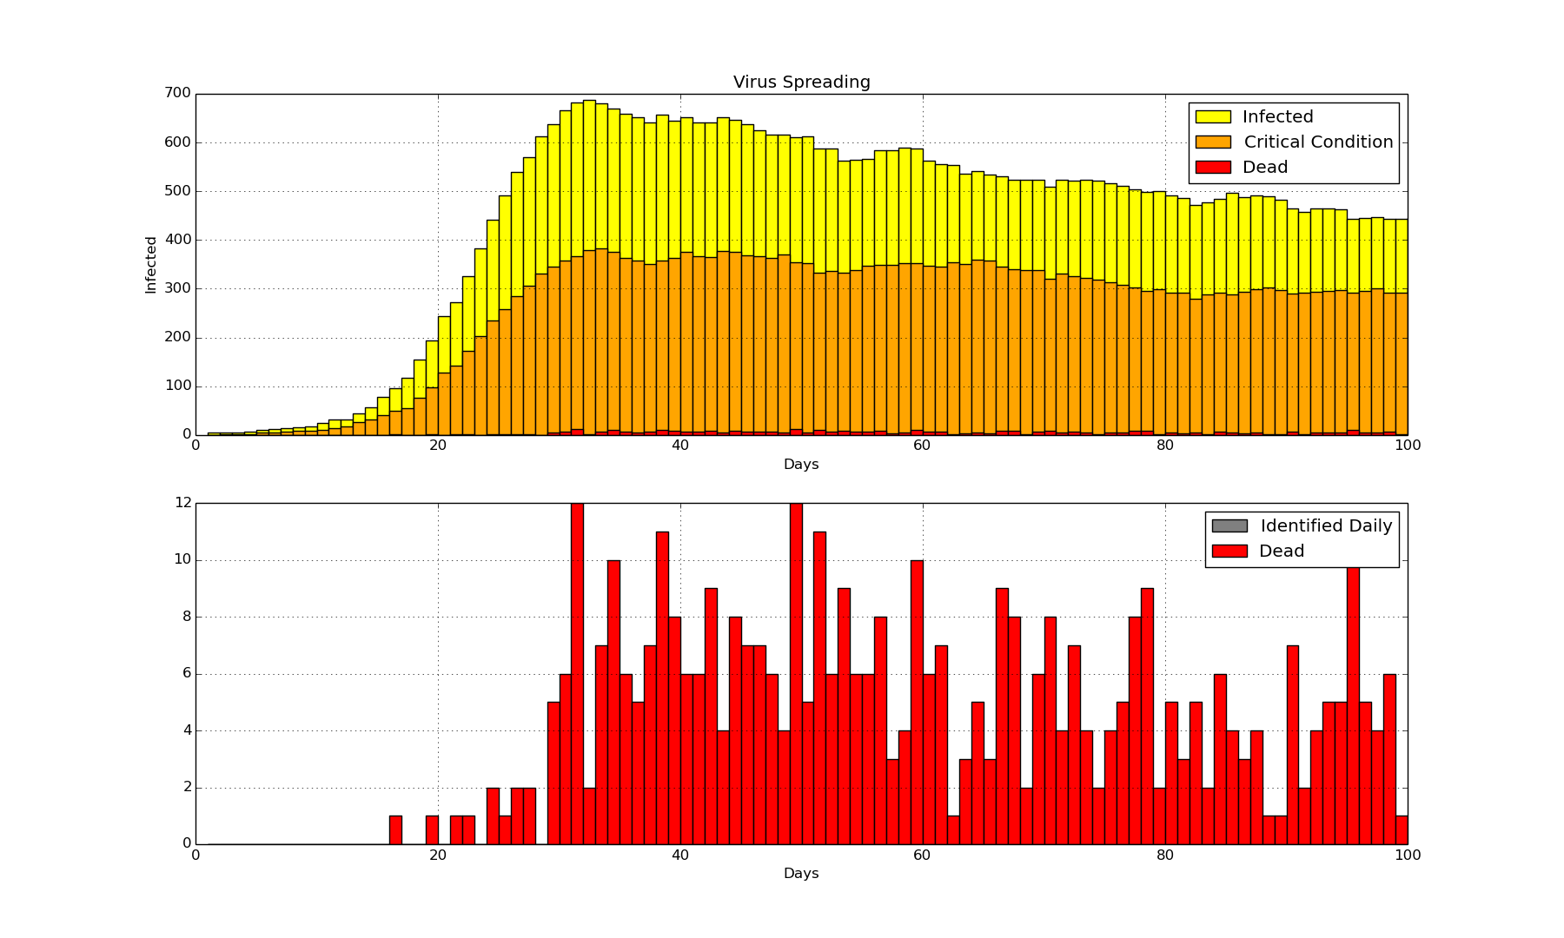

Deaths = 414

In this simulation, if they get cured, they will again be infected and this will go on until the whole population is dead. Because we are not accounting for people who are getting cured,

The results will not to be very dependable.

For the people who get cured, there will be a small chance (less than 10 %) that they may get the virus otherwise they will be immune to it. [2]

So, I decided to add the cure function to the same simulation and here are the results:

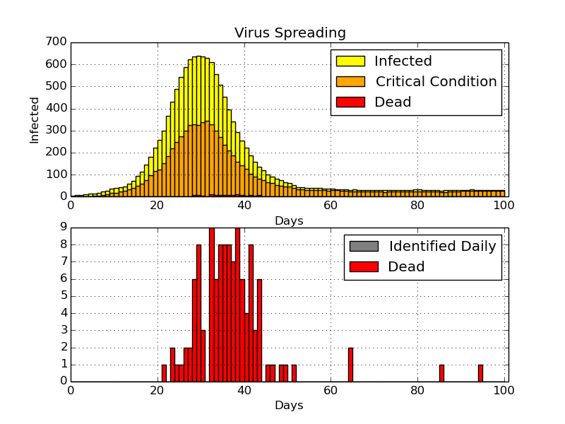

Deaths: 117 (11.7%)

Never Infected: 28 (2.8%)

Variance: 354

Maximum: 345

As observed the results changed significantly and they are looking more realistic.

For experimenting with results, I decided to compare the variance and maximum number of critically conditioned people per day for each simulation.

Comparing the variance can be helpful as variance shows how spread the data is.

The more spread the data is, the better hospitals would be able to take care of their patients.

So, I had to write an algorithm to calculate the variance.

In order to find the variance, I used the variance formula to have a better understanding how spread the values are.

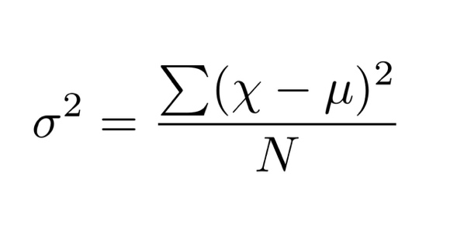

**Number of People in Gatherings**

One factor which has a significant effect on the model is the number of people in gatherings.

Let’s change the number from 4 to 3 and see what happens

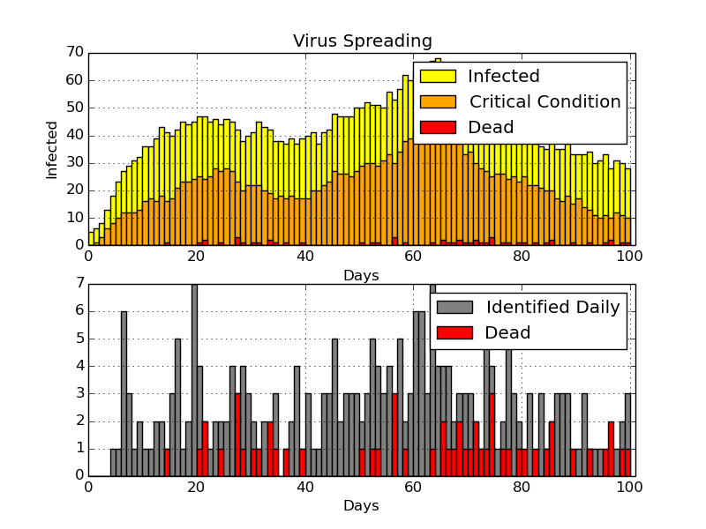

Deaths: 54 (5.4%)

Never Infected: 623 (62.3%)

Variance: 583

Maximum: 44

We can see that It has been very helpful and less than 40% of the population got infected. So, we are just going to continue the simulation with 4 people in the gathering s instead of 3 in order to have better experiments with the simulation.

**Self-Isolating**

Now that we have a dependable simulation, let’s try some strategies in order to control the disease and see how effective they are.

First, I decided to add self-isolating to the model. When people are in critical health after a specific number of days, they will know that they have the virus and by using this self-isolating function, they will be removed from the population until they are either cured or dead.

In this simulation 90% of the identified people self-isolate.

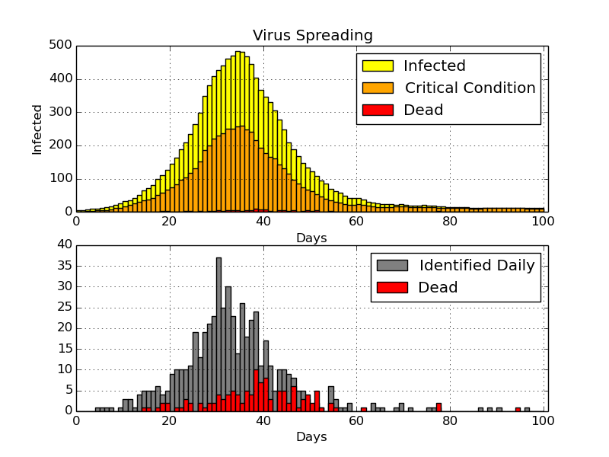

Deaths: 100 (10.0%)

Never Infected: 86 (8.6%)

Variance: 149

Maximum: 252

As you can see, the results are quite different. There is only a small decrease in the number of deaths which is not very significant. However, the other results have changed significantly, the percentage of people never getting infected is almost tripled which is a great improvement. When we look at the variance, it may seem that it has got worse as more spread the data, the better for the population. But we have to pay attention to the maximum number of people infected as well. The maximum number of infections has plummeted from about 345 to 252 which is a 27% decrease. This also tells us the decrease in the variance is not bad, in fact it shows the disease has been controlled quicker by using self-isolation (The mean number of people infected has decreased significantly)

**Daily Testing**

Let’s improve the model even more by adding daily testing to the simulation.

The simulation will randomly choose a group of people and they will be all tested. These are the people who do not know that are infected. They may not be in critical condition or it may be the beginning of their disease.

Identifying the infected people would be very helpful as it will reduce the rate of the spreading virus. But let’s see how effective will it be with testing 10 people daily (1% of the population) and with a test accuracy of 90%

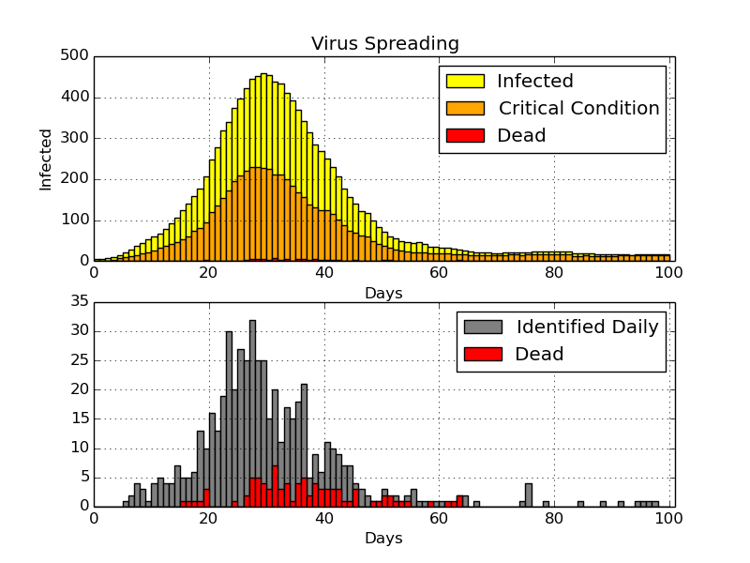

Deaths: 88 (8.8%)

Never Infected: 73 (7.3%)

Variance: 317

Maximum: 230

We can see a slight decrease in the number of deaths and the maximum number of daily infected people. Also, there has been an increase in the variance which shows the data is more spread.

Now let’s double the number of the daily test.

Daily Tests: 20 people

Test Accuracy: 90%

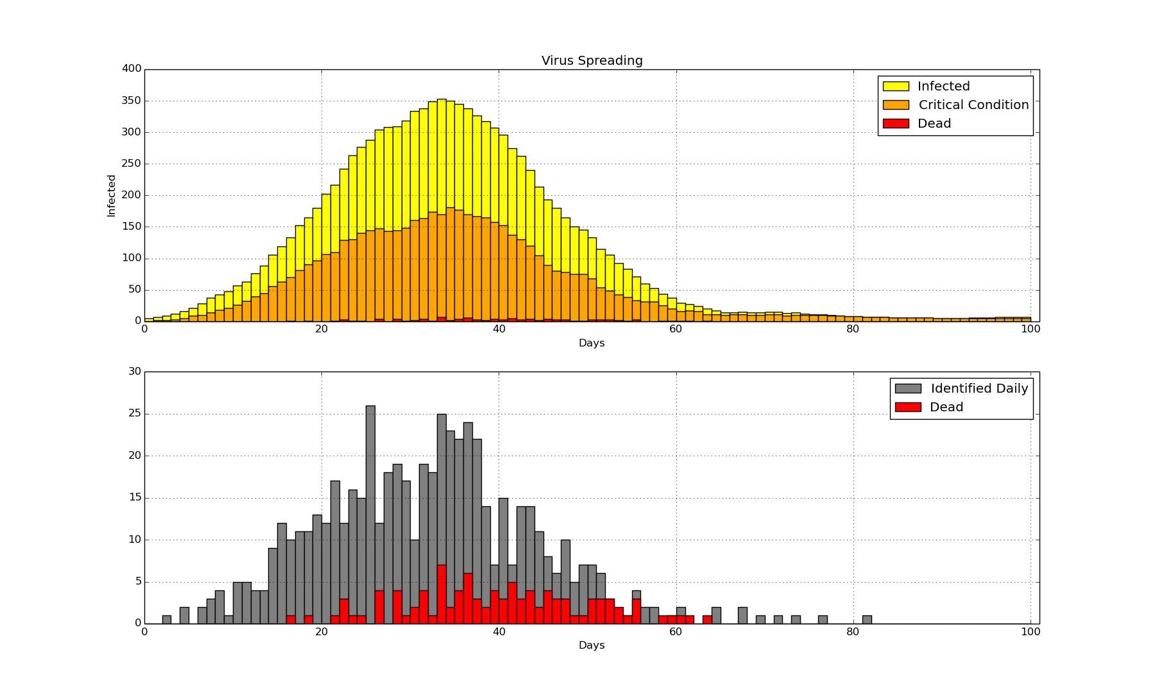

Deaths: 101 (10.1%)

Never Infected: 125 (12.5%)

Variance: 232

Maximum: 181

Although the number of deaths has increased, there is a significant decrease in the overall number of infected people per day with a maximum of 181.

**Variable Chance of Infection**

In this simulation one of the important factors, in fact the most important one is the chance of infection. When we look at the beginning of the corona virus pandemic, the chance of getting infected was really high because people did not know about this virus.

In the other hand, the opposite can also be true. For instance, the numbers for corona virus for my country were really low two weeks ago so people stopped wearing their masks and they paid less attention to social distancing rules. As a result, the numbers reached all time high this week and the only reason behind it was people had been increasing their chance of infection when they heard the numbers were going down.

So, I decided to apply this changing chance of infection to the simulation and here are the results.

Population: 5000

Primary chance of infection: 20%

Min Chance of infection: 5%

Maximum Chance of infection: 10%

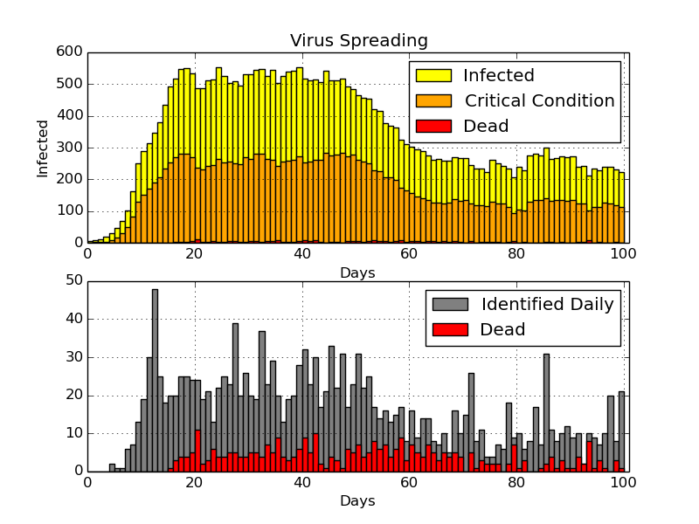

Deaths: 335 (6.7%)

Never Infected: 1984 (39.68%)

Variance: 599

Maximum: 283

As you can see the numbers for infected people increase exponentially at first but as people start to pay more attention to the disease, the rate of spreading slows down. However, as the numbers starts to decrease, people would care less and it will cause the chance of infection to increase again.

Overall, I was able to create a realistic simulation for disease and I tried using any details to make this simulation as close to reality as possible. However, there is anther important factor which I couldn’t add to the simulation because of lack of time and that is families.

I believe families have a significant in spreading diseases as people do not use protections in their household and you are in contact with the members of your family every day.

References:

[1]<https://www.healthline.com/health-news/50-percent-of-people-with-covid19-not-aware-have-virus>

[2] <https://theconversation.com/can-you-get-the-covid-19-coronavirus-twice-137309>