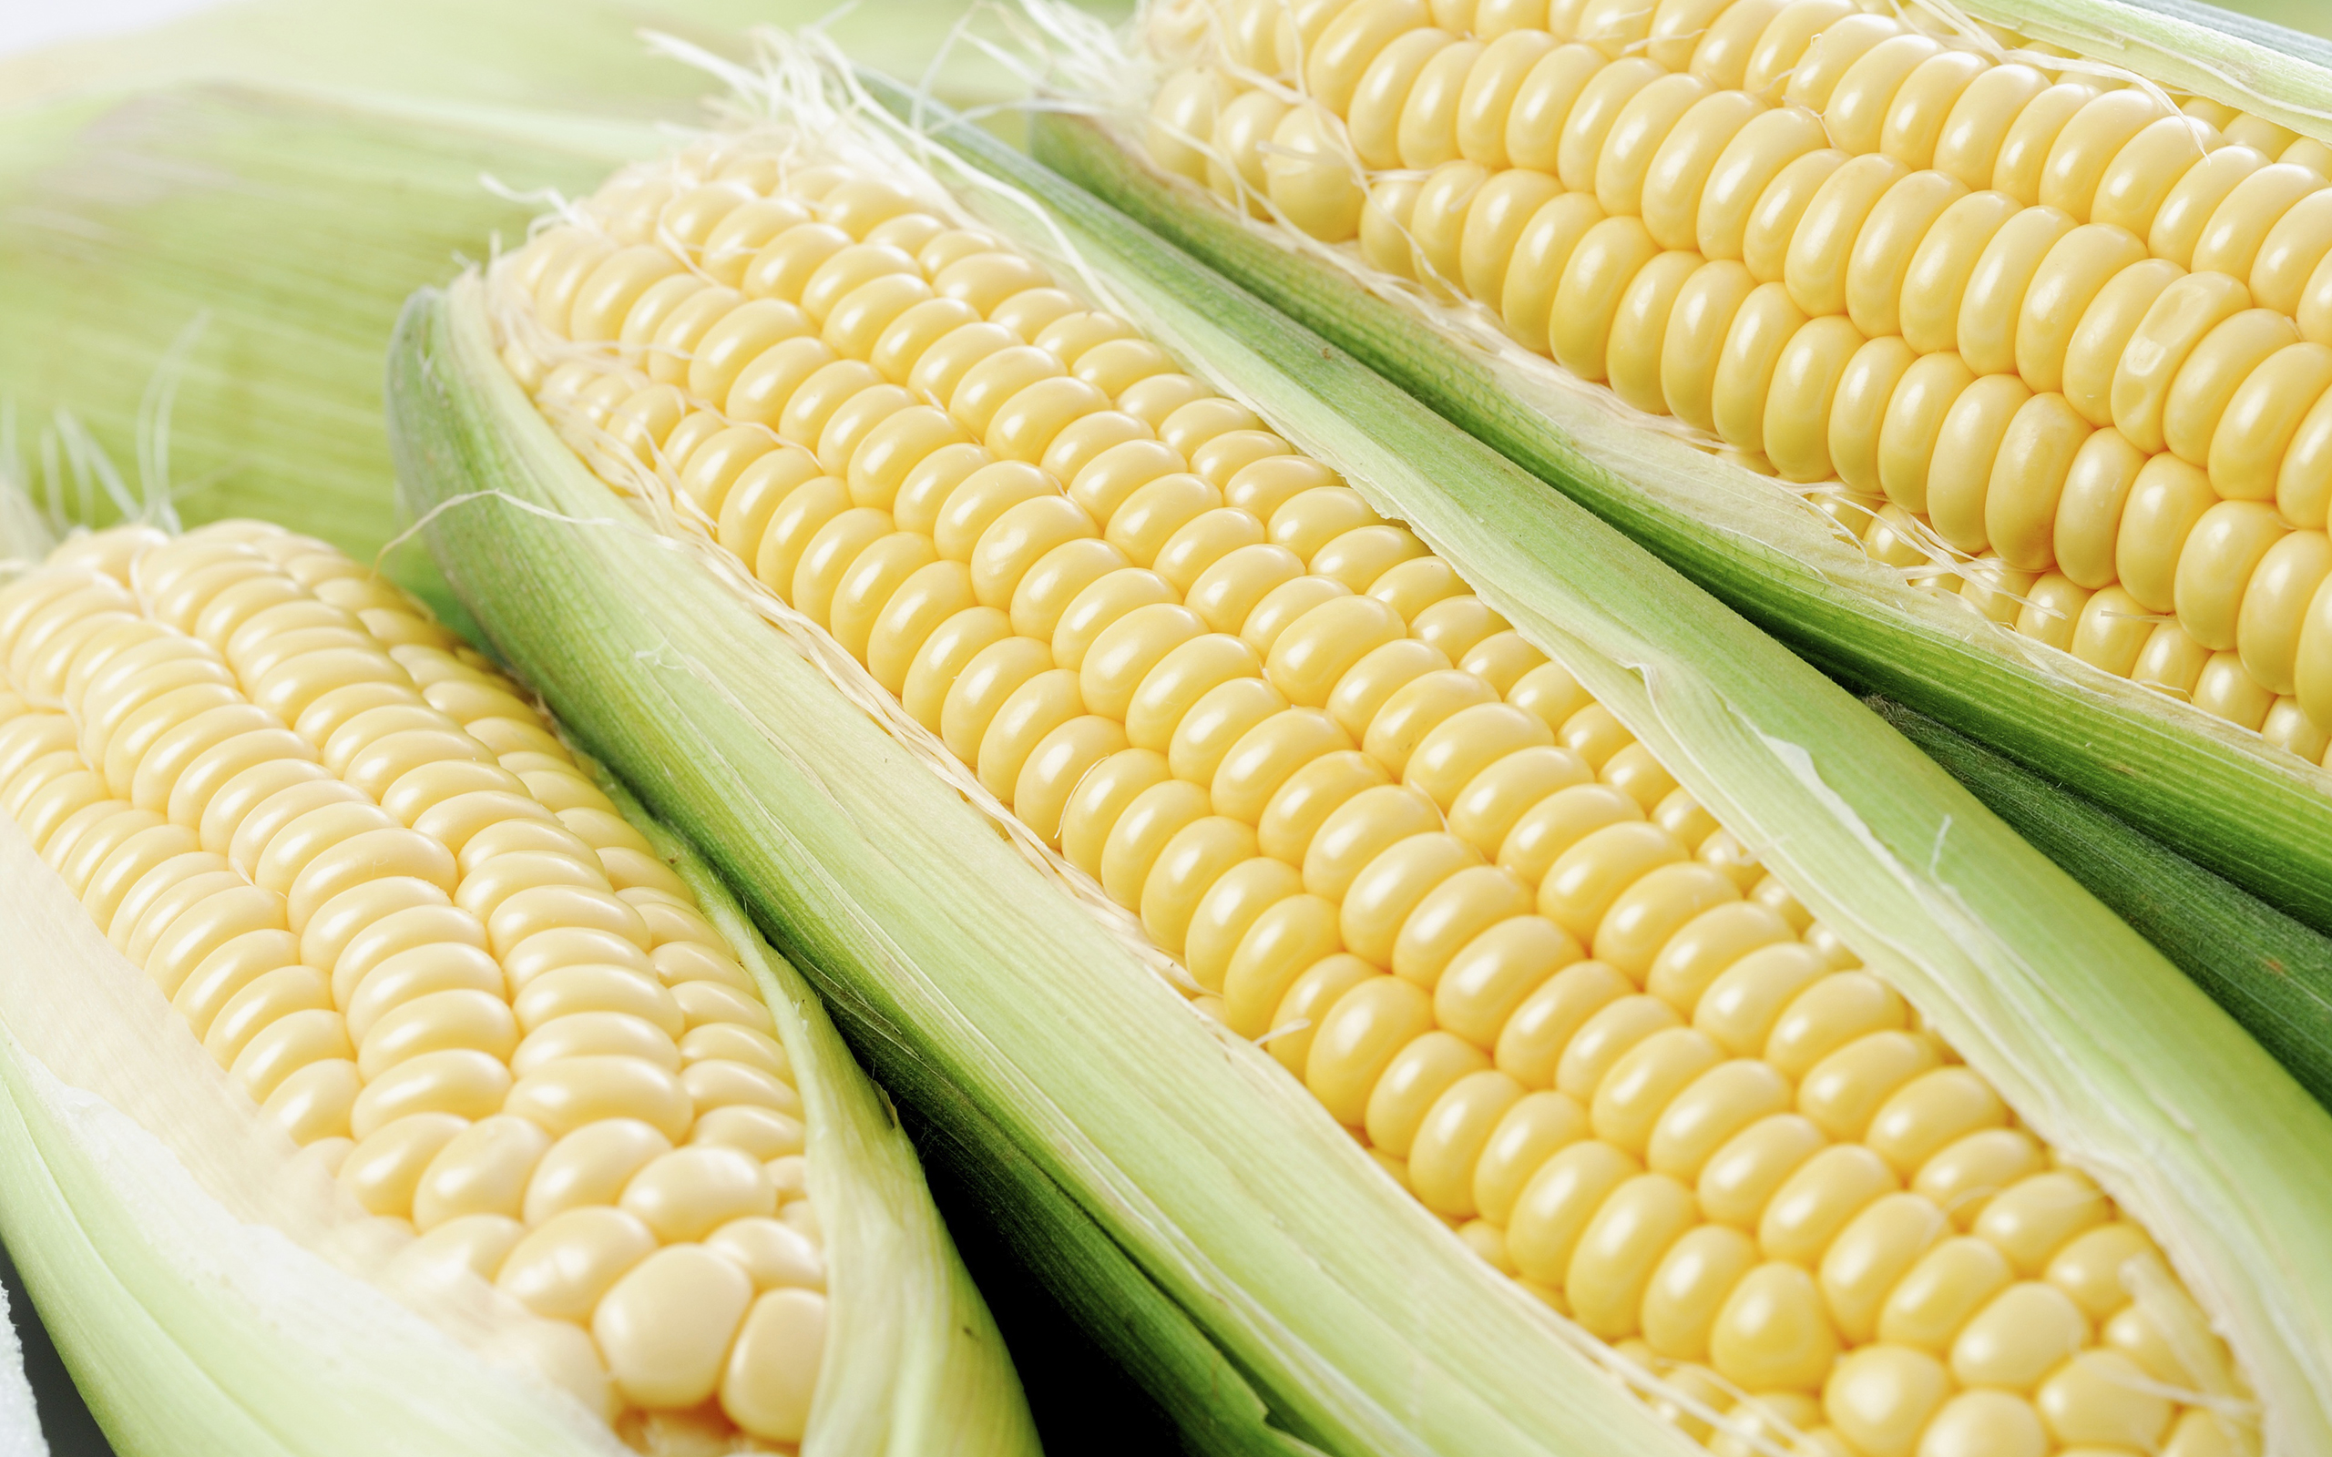

Smart Farming

Internet of Things

Okay, I’ve seen enough. Where’s the thing? Any proof of concept?

See the *thing* below.

Samuel I. Gunadi

https://github.com/multiprecision/smart_farm_arduino

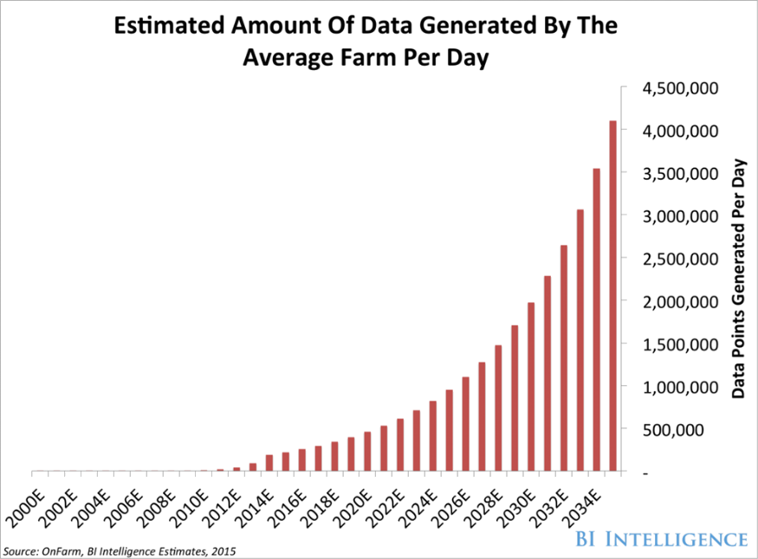

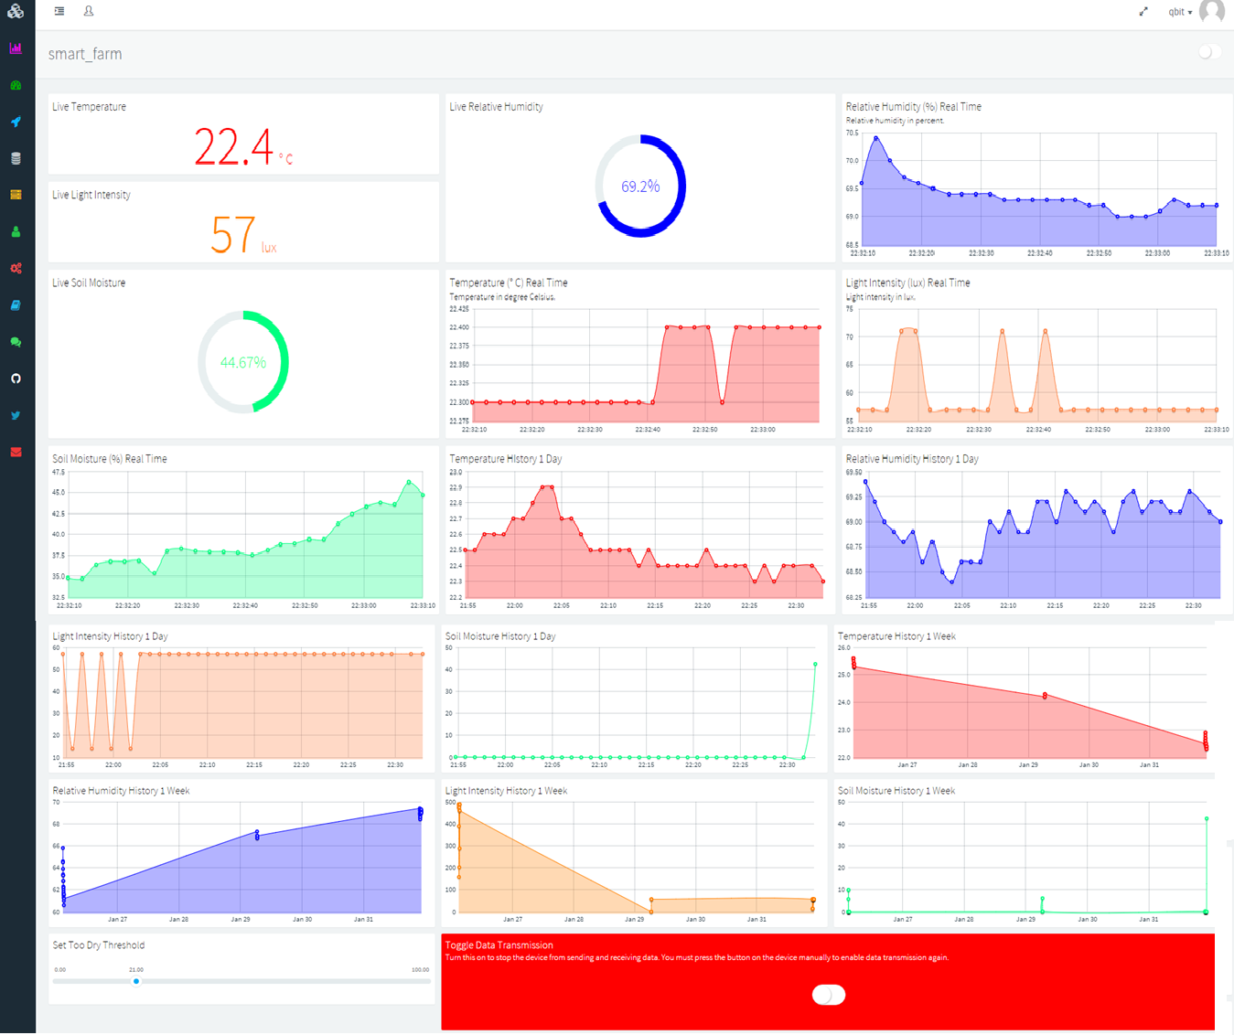

What does it do?

*Monitor your farm anytime, anywhere.*

My smart farming system allows real-time monitoring of air temperature, air humidity, light intensity, and soil moisture on their farm. Users can monitor their farm from the web and mobile application via thinger.io IoT platform. The system gives users notification via LCD screen and web application if the soil is too dry.

How does it work?

Prototyping board Arduino Yun is used. Arduino Yun has onboard Wi-Fi and Ethernet so it can directly connect to the Internet and send data to server.

There are 3 sensors used:

1. Temperature and humidity sensor. Model: DHT22. Output: Digital.
2. Luminosity Sensor. Model: TSL2561. Output: Digital (I2C).
3. Soil moisture sensor. Model: RobotDyn. Output: Analog.

Meh. That seems generic. How is it any different from others?

There’s a 20×4 characters LCD screen with an I2C backpack to display data from the sensors and a button to toggle data transmission. Push this button to toggle data transmission, e.g., when you need to save bandwidth or when online monitoring isn’t needed, i.e., monitoring from the LCD is enough.

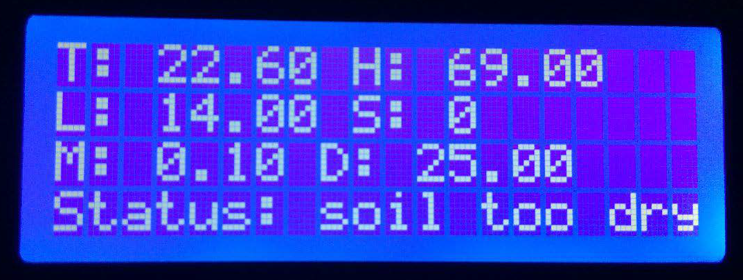

The IoT platform thinger.io is used to store data and display data via web application and mobile application. The devices send data in binary JSON format (thinger.io’s own protocol called protoson, like Google’s protobuf) to thinger.io servers. Data from the sensors is pulled every 2 seconds, i.e., the polling interval is 2 seconds, and then the data is sent to thinger.io server.

The IoT platform thinger.io dashboard can be accessed from any device with a web browser, so desktops, laptops, and smartphones can access the dashboard. Users interact through the dashboard and can monitor their farms from here or set the threshold for when the soil is too dry. The local rule for the soil moisture too dry threshold is 25%. Users can modify this threshold via the dashboard (cloud rule).

What is smart farming?

The future of farming is in collecting and analyzing big data in agriculture in order to maximize efficiency.

Farmers have already begun employing some high-tech farming techniques and technologies in order to improve the efficiency of their day-to-day work. For example, sensors placed in fields allow farmers to obtain detailed maps of both the topography and resources in the area, as well as variables such as acidity and temperature of the soil. They can also access climate forecasts to predict weather patterns in the coming days and weeks.

Farmers can use their smartphones to remotely monitor their equipment, crops, and livestock, as well as obtain stats on their livestock feeding and produce. They can even use this technology to run statistical predictions for their crops and livestock. Also, drones have become an invaluable tool for farmers to survey their lands and generate crop data.

As a concrete example, John Deere (one of the biggest names in farming equipment) has begun connecting its tractors to the Internet and has created a method to display data about farmers' crop yields. Similar to smart cars, the company is pioneering self-driving tractors, which would free up farmers to perform other tasks and further increase efficiency.

All of these techniques help make up precision farming or precision agriculture, the process of using satellite imagery and other technology (such as sensors) to observe and record data with the goal of improving production output while minimizing cost and preserving resources.

Source: Business Insider



Push me!

