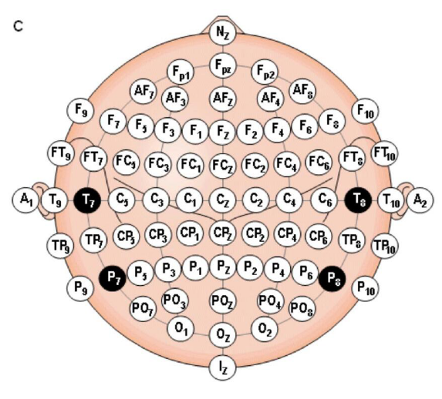

|  |  |  |  |  |  |  |  |  |  |  |
| --- | --- | --- | --- | --- | --- | --- | --- | --- | --- | --- |
| 1 | 2 | 3 | 4 | 5 | 6 | 7 | 8 | 9 | 10 | 11 |
| POz | PO3 | PO4 | PO5 | PO6 | PO7 | PO8 | Oz | O1 | O2 | 标签 |