**Hometrack API Challenge**

**Contains :**

1. Agenda
2. Use case
3. API Endpoints
4. Stack used
5. Important points
6. Improvement scope
7. Note
8. How to Run

**Agenda :**

* Build a base API test automation framework.
* Test the “Profanity Filter” API endpoints by [PurgoMalum — Free Profanity Filter Web Service](http://www.purgomalum.com/)
* Discusses the approach and future updates

**Use case :**

* Profanity Filter contains several combinations of GET requests, accepting query parameters.
* Based on the input it will indicate if an input had a curse word.

**API endpoint :**

* **Base URI** :[**https://www.purgomalum.com/service/**](https://www.purgomalum.com/service/)
* **Methods :**

| **Methods** | **Return Type** | **Tests** |
| --- | --- | --- |
| **xml** | **xml** | 1. **Test XML method type with/without slang** 2. **Assert asterix while slang or otherwise** |
| **JSON** | **jason** | 1. **Test JSON method type with/without slang** 2. **Assert asterix when slang or otherwise** |
| **plane** | **txt** | 1. **Test txt method type with/without slang** 2. **Assert asterix when slang or otherwise** |
| **containsprofanity** | **txt** | 1. **Test response** 2. **Assert asterix when slang or otherwise** |

* **Parameters :**

| **Params** | **Required** | **Tests** |
| --- | --- | --- |
| **text** | **Yes** | 1. **This is mandatory params & got tested in all cases** |
| **add** | **optional** | 1. **Tested this with word replacement method** |
| **fill_text** | **optional** | 1. **Tested this with word replacement method** |
| **fill_char** | **txt** | 1. **NOT TESTED** |

**Stack used :**

* + **C#**
  + **RestSharp**
  + **SpecFlow**
  + **NUnit**
  + **Extent Report**

**Important Points :**

* + A BDD approach is taken with dynamic input value
  + Hooks are used for setup, teardown or any manipulation of test patterns.
  + 2 feature file & corresponding Step Def is created to segregate between method test and parameter tests.
  + Reporting is added using Extent report
  + Context injection used to decouple/share common objects

**Improvement scope given time :**

* + Isolate in a Page object manner if more endpoints to test eg: separate class for method types etc
  + Adding custom Logger, screenshot method upon failure, excel /sql driven
  + Implementing CI/CD if dev code sits together & provision executors on cloud.
  + Cover more negative test criteria, extreme cases & proper documentation

**Note :**

* + Kept one failed test case to test reporting
  + For running,simply build & run

**How to run :**

1. Create an empty folder, open gitbash (prereq- git CLI) and clone the repo :   
   *git clone* [*https://github.com/zoopla/Raihan-Kabir.git*](https://github.com/zoopla/Raihan-Kabir.git)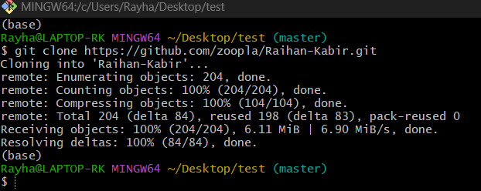

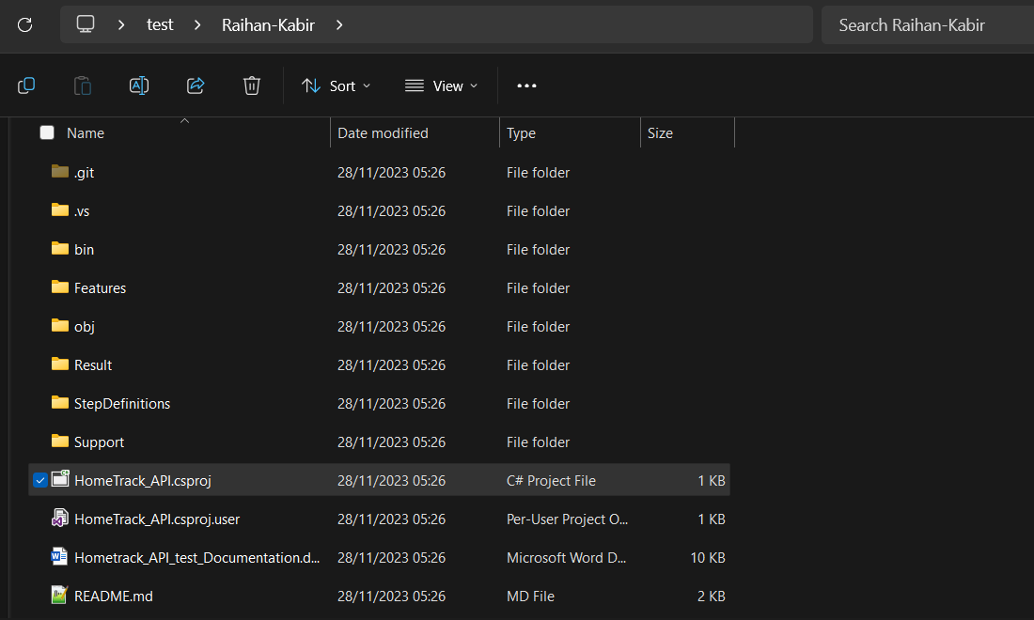

1. Open latest Visual Studio for best results

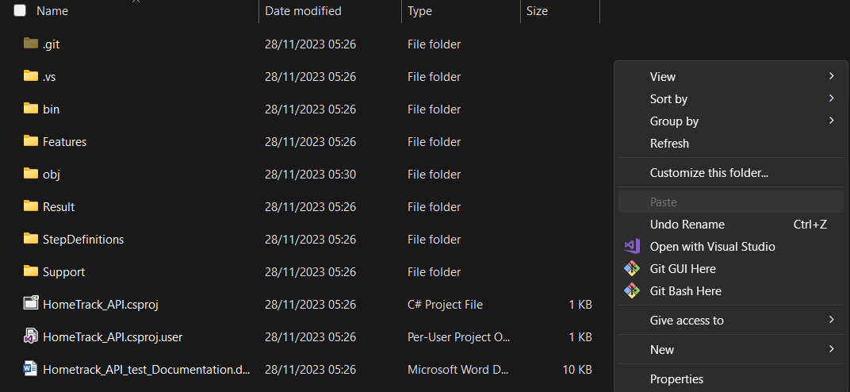

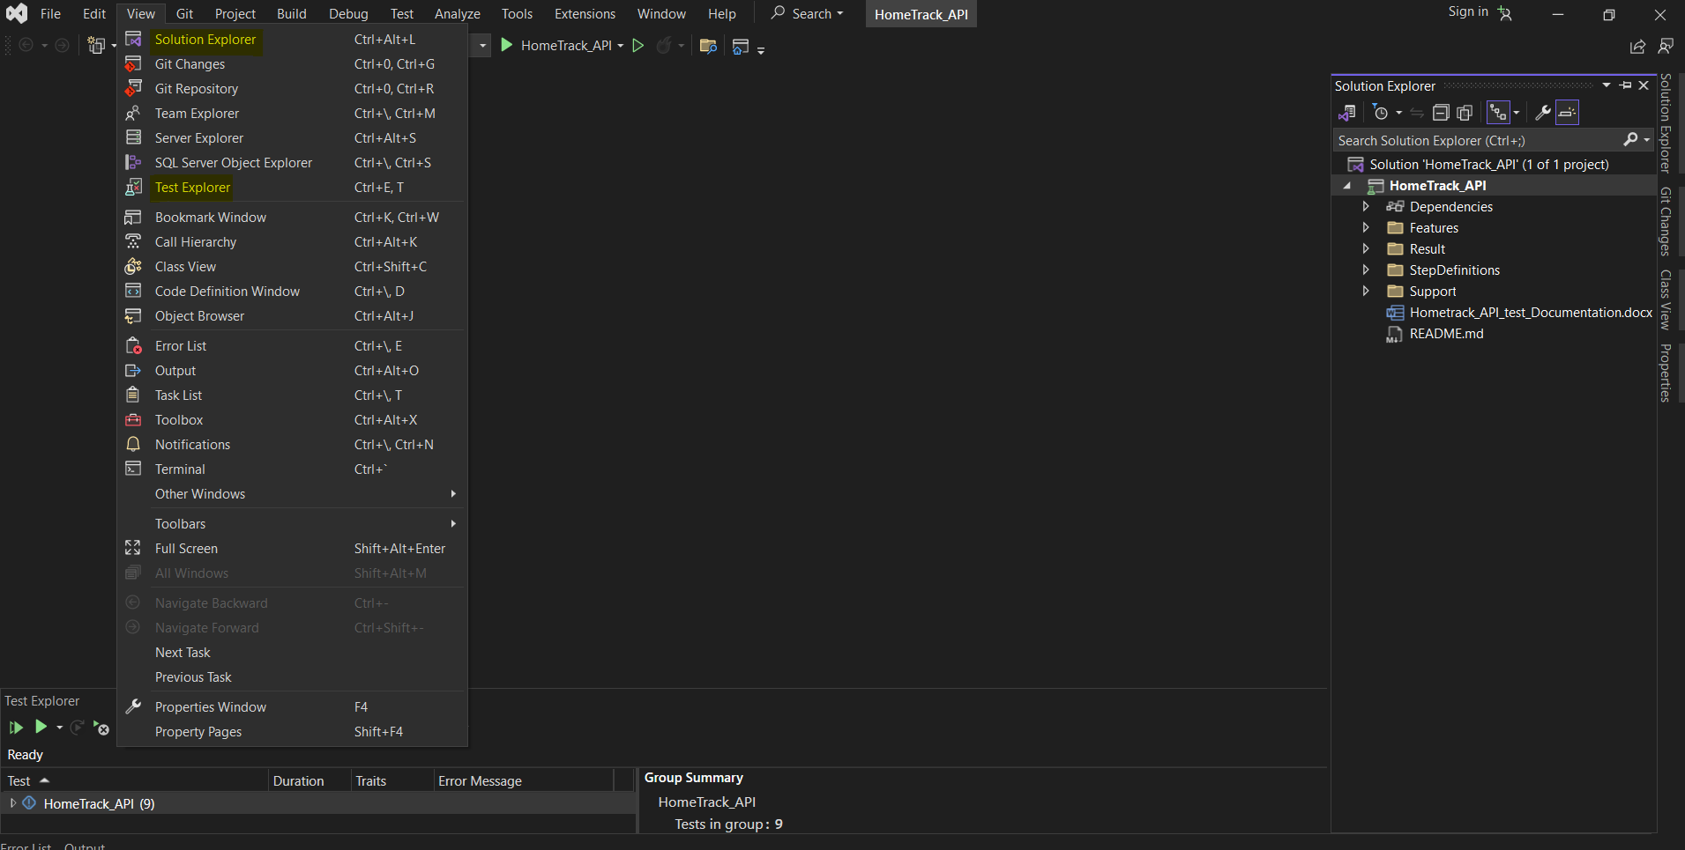

1. The current project runs 4 external libraries:
   1. Nunit & Nunit-test-adapter
   2. Specflow, specflow.Nunit.TestRunner
   3. Extent Report
   4. RestSharp

These libraries should be initialized with the cloned code as .gitignore is kept empty, if not then best way to install is Nuget Package Manager within VS.  
  
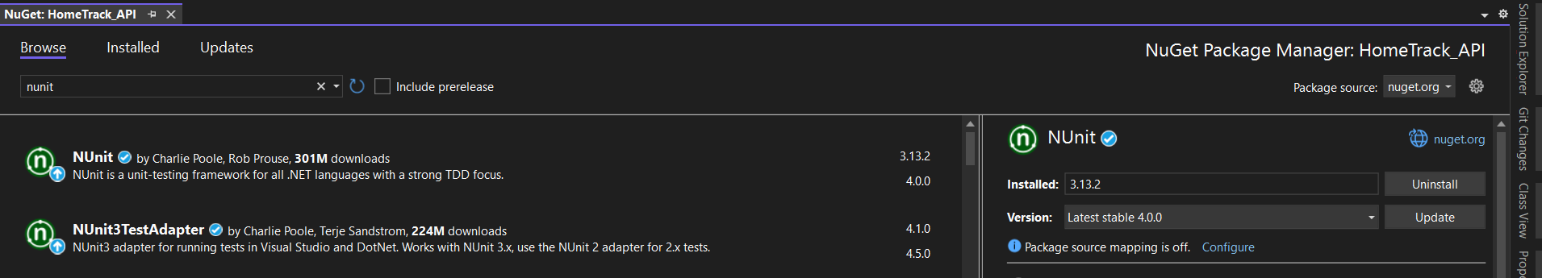  
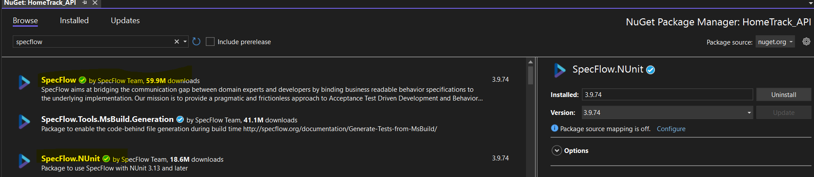

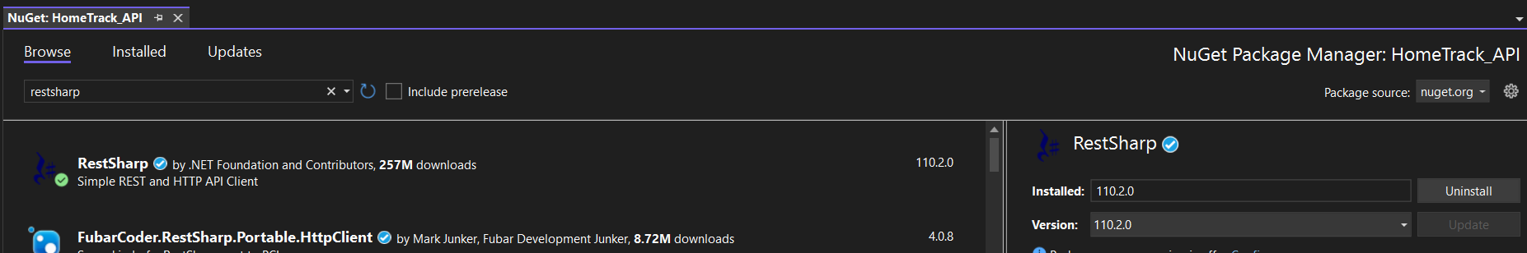



1. After installations open the *Test Explorer Perspective* where it automatically tracks the test cases

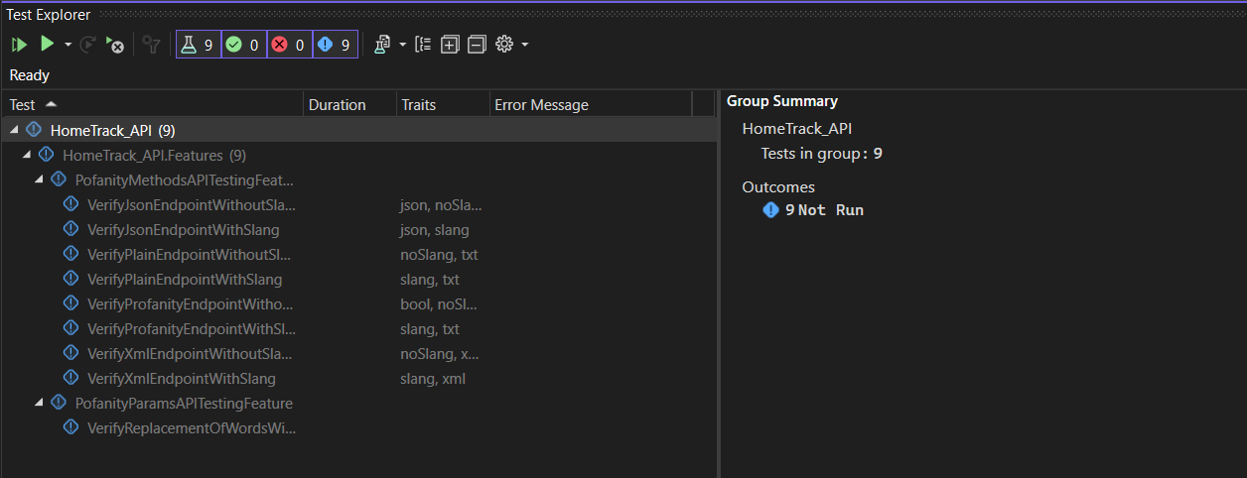

1. Now either *build the project* and *run the test cases* or click the *run all button* to automatically Build & Run

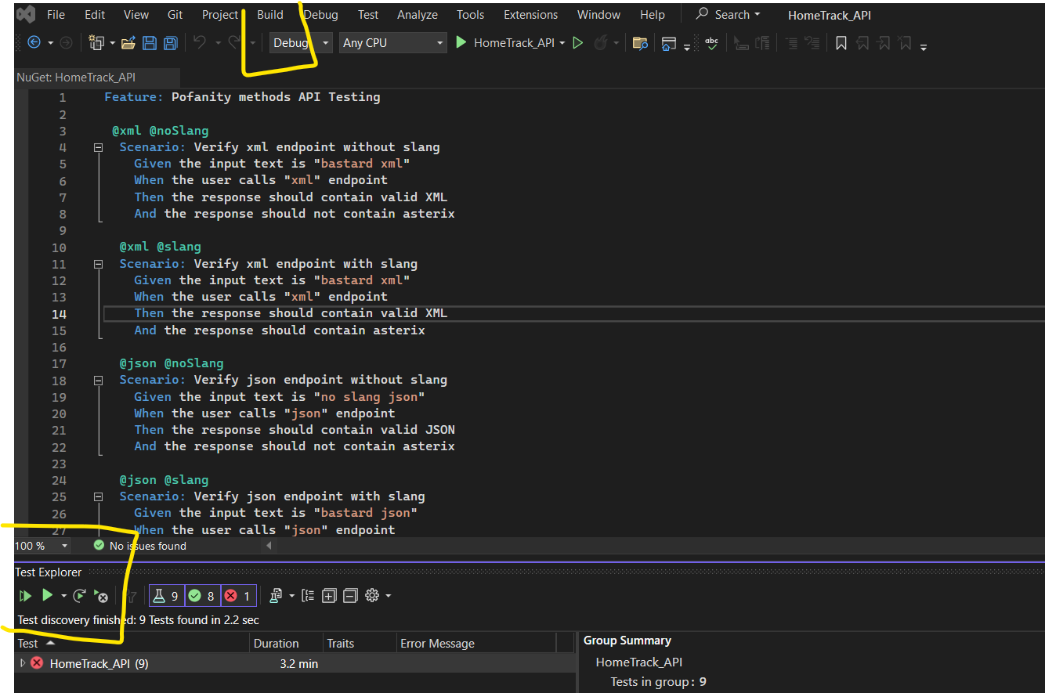

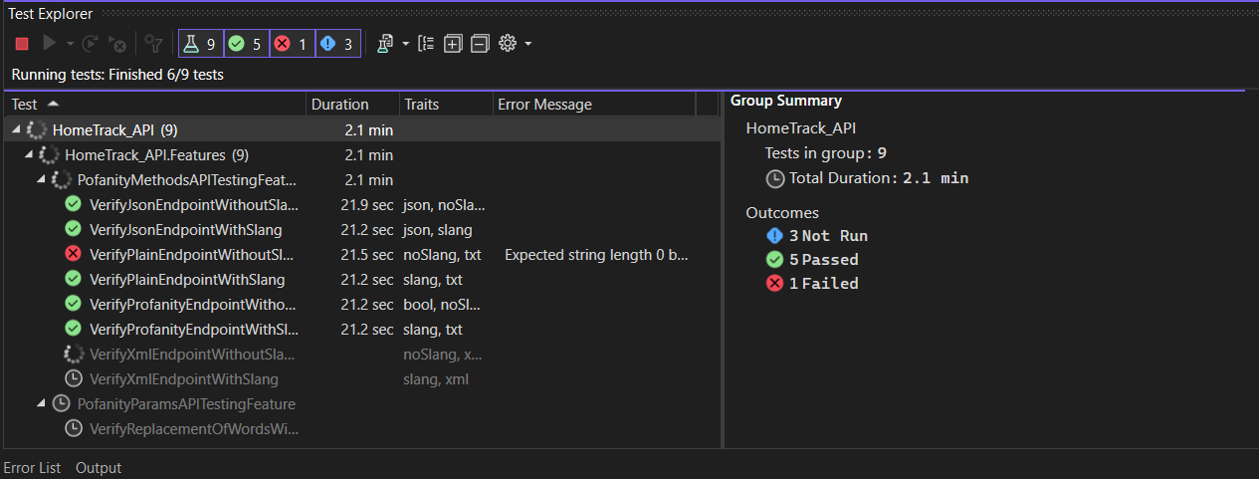

1. Check the report in the Result folder :

