Walmart Retail Demand Forecasting
& Category Performance Analysis
Business Report | Portfolio Project
Prepared by Haiyang Huang

Executive Summary
This project analyzed Walmart food-category sales, price, calendar, and event data to evaluate demand patterns, forecast accuracy, forecast bias, and replenishment risk. The analysis focused on the FOODS category and the top 100 recent high-volume items over a 365-day period. A 28-day holdout period was used to compare moving-average baselines with regression and tree-based forecasting methods.
- HistGradientBoosting delivered the strongest overall accuracy, reducing MAE by 9.1% versus the 28-day moving-average baseline and 5.7% versus the 7-day moving-average baseline.
- Despite better MAE and RMSE, the best model still showed negative forecast bias (-6.9%), meaning actual demand remained higher than forecasted demand overall.
- The top 20 model under-forecast exceptions had 99,932 actual units versus 80,652 forecasted units, creating a total under-forecast error of -19,280 units and weighted bias of -19.3%.
- The top 20 model over-forecast exceptions had 48,984 actual units versus 55,315 forecasted units, creating a total over-forecast error of 6,331 units and weighted bias of 12.9%.
- FOODS_3 accounted for most under-forecast and over-forecast exceptions, indicating higher demand volatility and a need for recurring item-level review.

Forecast Method Comparison
Forecast Method | MAE | RMSE | Forecast Bias | sMAPE
HistGradientBoosting | 4.39 | 7.40 | -6.9% | 68.8%
Ridge Regression | 4.60 | 7.70 | -7.1% | 65.6%
7-Day Moving Average | 4.66 | 7.82 | -7.4% | 59.1%
28-Day Moving Average | 4.83 | 7.98 | -3.1% | 70.4%
Interpretation: error is defined as forecast minus actual. A negative forecast bias means the forecast under-predicted actual demand. In replenishment planning, this can create stockout risk even when MAE or RMSE improves.
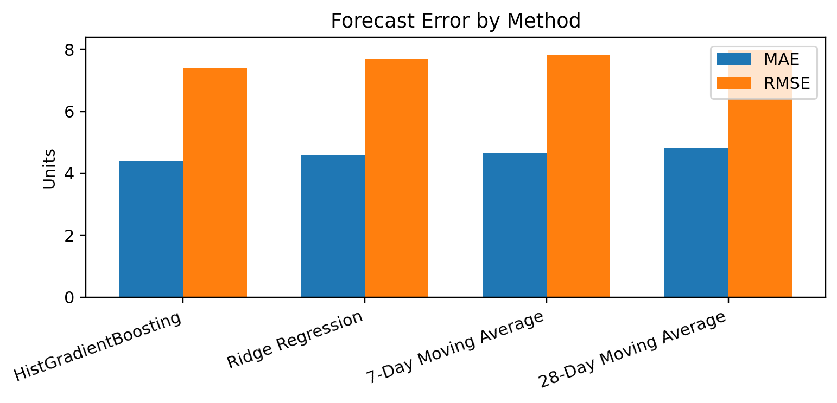

Scope and Methodology
- Data source: Kaggle M5 Forecasting Accuracy dataset, using Walmart historical daily unit sales, calendar, and sell price files.
- Scope: FOODS category only; top 100 items selected by recent 365-day unit sales to keep the analysis focused on high-volume products.
- Forecast level: item-store combination, using the final 28 days as a holdout period to simulate short-term operational demand planning.
- Baseline methods: last 7-day average and last 28-day average, selected because they are transparent and easy to interpret.
- Model upgrade: Ridge regression and HistGradientBoosting using item, department, store, calendar, price, event, SNAP, lag, and rolling-demand features.
- Evaluation focus: MAE, RMSE, sMAPE, forecast bias, under-forecast risk, over-forecast risk, and department-level exception concentration.

Key Findings

1. The tree-based model improved accuracy, but did not eliminate under-forecast bias.
HistGradientBoosting had the lowest MAE (4.39) and RMSE (7.40) across tested methods. Compared with the 28-day moving-average baseline, it reduced MAE by 9.1% and RMSE by 7.4%. However, its forecast bias remained negative (-6.9%), which means the model still under-forecasted actual demand overall. This highlights a planning trade-off: the most accurate model by error metrics may still require bias monitoring and exception alerts.
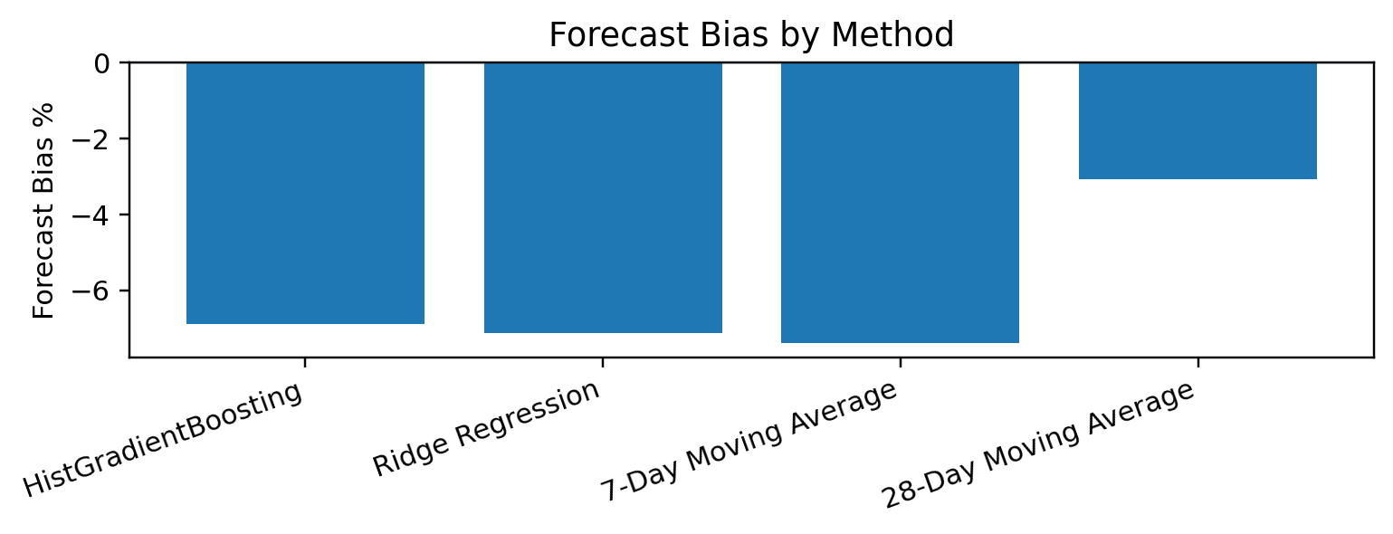

2. Severe model under-forecasting indicates potential stockout risk.
The top 20 model under-forecast items had 99,932 actual units versus 80,652 forecasted units, resulting in a total forecast error of -19,280 units and weighted bias of -19.3%. The most severe cases included FOODS_1_043 and FOODS_1_004, where forecast volume remained near zero despite strong actual demand. These cases suggest potential item lifecycle, demand restart, active-item flag, or recent-availability issues not fully captured by the current model.
Item | Dept | Actual Units | Forecast Units | Forecast Error | Bias %
FOODS_1_043 | FOODS_1 | 3,287 | 84 | -3,203 | -97.5%
FOODS_1_004 | FOODS_1 | 2,770 | 84 | -2,686 | -97.0%
FOODS_3_090 | FOODS_3 | 15,387 | 13,838 | -1,549 | -10.1%
FOODS_3_586 | FOODS_3 | 11,994 | 10,601 | -1,393 | -11.6%
FOODS_3_702 | FOODS_3 | 3,919 | 2,560 | -1,359 | -34.7%
FOODS_3_252 | FOODS_3 | 8,424 | 7,498 | -926 | -11.0%
FOODS_3_714 | FOODS_3 | 5,939 | 5,078 | -861 | -14.5%
FOODS_2_360 | FOODS_2 | 4,759 | 3,911 | -848 | -17.8%

3. Model over-forecasting still creates excess inventory risk.
The top 20 model over-forecast items had 48,984 actual units versus 55,315 forecasted units, resulting in a total forecast error of +6,331 units and weighted bias of +12.9%. FOODS_3_362 was the largest over-forecast exception, with 1,649 actual units compared with 3,509 forecasted units. For low-volume items, percentage bias should be interpreted carefully because small actual sales can create exaggerated bias percentages.
Item | Dept | Actual Units | Forecast Units | Forecast Error | Bias %
FOODS_3_362 | FOODS_3 | 1,649 | 3,509 | 1,860 | 112.8%
FOODS_3_739 | FOODS_3 | 2,719 | 3,333 | 614 | 22.6%
FOODS_3_785 | FOODS_3 | 3,617 | 4,206 | 589 | 16.3%
FOODS_3_760 | FOODS_3 | 1,507 | 1,973 | 466 | 30.9%
FOODS_3_288 | FOODS_3 | 3,896 | 4,230 | 334 | 8.6%
FOODS_3_282 | FOODS_3 | 4,335 | 4,663 | 328 | 7.6%
FOODS_3_587 | FOODS_3 | 6,040 | 6,350 | 310 | 5.1%
FOODS_1_161 | FOODS_1 | 513 | 816 | 303 | 59.1%

Department-Level Exception Concentration
FOODS_3 represented the largest concentration of forecast exceptions on both sides of risk. This suggests that the department may have higher demand volatility and may require more frequent item-level forecast review, parameter tuning, or planner exception workflow.

Model Under-Forecast Risk by Department
Dept | Risk Items | Actual Units | Forecast Units | Total Error
FOODS_3 | 14 | 80,091 | 69,132 | -10,959
FOODS_1 | 3 | 9,196 | 2,697 | -6,499
FOODS_2 | 3 | 10,645 | 8,822 | -1,823

Model Over-Forecast Risk by Department
Dept | Risk Items | Actual Units | Forecast Units | Total Error
FOODS_3 | 17 | 45,462 | 51,222 | 5,760
FOODS_1 | 2 | 2,024 | 2,470 | 446
FOODS_2 | 1 | 1,498 | 1,623 | 125

Business Recommendations
- Use HistGradientBoosting as the primary forecast accuracy benchmark, but pair it with forecast bias monitoring and under-forecast exception alerts.
- Prioritize under-forecast exceptions for high-volume items, especially cases where forecast demand is near zero while actual demand is strong. These items may require item lifecycle, active-item, or demand restart flags.
- Monitor FOODS_3 more closely because it contributed the majority of both under-forecast and over-forecast exceptions, indicating higher demand volatility.
- Use both absolute forecast error and forecast bias percentage when ranking exceptions; low-volume items can show extreme percentage bias without large business impact.
- Build dashboard views for actual vs. forecast, department-level risk, under-forecast exceptions, and over-forecast exceptions to support recurring planner review.

Suggested Next Steps
Phase | Action | Business Value
1. Dashboard | Create Power BI / Tableau views for actual vs forecast, item exceptions, and department risk. | Improves recurring forecast review and stakeholder communication.
2. Feature Expansion | Add price-change, event, SNAP, availability, and item lifecycle signals to forecast exception analysis. | Reduces missed demand spikes and near-zero forecast cases.
3. Bias Calibration | Test bias adjustment or forecast calibration for high-volume items with recurring under-forecasting. | Improves planning reliability beyond raw MAE/RMSE gains.
4. Exception Workflow | Set thresholds for under-forecast and over-forecast alerts by item volume, absolute error, and bias percentage. | Helps planners prioritize actions by business impact and replenishment risk.

Resume-Ready Project Description
Walmart Retail Demand Forecasting & Category Performance Analysis | Python / pandas / scikit-learn / Tableau-ready outputs
- Analyzed Walmart food-category sales, price, calendar, and event data to evaluate demand patterns, seasonality, and sales volatility.
- Compared moving-average baselines with Ridge regression and tree-based forecasting models, improving MAE by 9.1% versus the 28-day baseline while evaluating forecast bias and item-level exception risk.
- Developed business recommendations to support category performance tracking, replenishment planning, and inventory risk identification.

