Honours Project Mid Report
Pranoy J, 2019115004

The initial question decided upon for the entirety of the project was to identify and explore primary sources of information to see how right wing political parties have used the Babri Masjid iowever, the scope of this question was too large to be finished as an honours project in a single semester and as such, the question was alternated to find the contexts implied in the usage of this topic in primary sources i.e. what was implied when the Babri Masjid or the Ayodhya Ram temple was brought up in a right wing poitician’s speech or a party publication.

Initial Methodology

For the initial part of this project, pamphlets published and circulated directly by right wing parties were considered to be the database. For this purpose, 1486 images were scraped, all published by the Akhila Bharatha Vidyarthi Parishat, the student wing of BJP from JNU over the years from 1999 and 2014 and initial analyses were run. However, on running Optical Character Recognition softwares on the scraped images of the pamphlets (Tesseract was used in this case) the occurence of the required keywords (eg: Babri Masjid, Ayodhya Ram Temple, Hindu Rashtra) were too low to condsider this a valid database and no inferences could be drawn. Another issue faced during the implementation of this methodology was the unkempt archiving of pamphlets in most political parties. The pamphlets belonging to ABVP were obtained because they were stored in OCR recognizable forms by ‘The PaRCha project’, a movement local to JNU that attempts to add all pamphlets distributed within the university to a common database.

Speeches

As the earlier database under consideration did not serve the requirements, attention was redirected to speeches made by the following BJP leaders:

- Narendra Modi
- Amit Shah
- Rajnath SIngh
- L K Advani
- Ravi Shankar Prasad
- Prakash Javadekar
- Atal Bihari Vajpayee
- Murali Manohar Joshi
- Yogi Aadityanath

These leaders were chosen due to one of two reasons, either they were major forces within the BJP during the time period when the demolition of the Babri Masjid occured or are influential power figures within the party at present. Various archives were looked into to find documented speeches of these persons, examples being:

- https://www.narendramodi.in/category/text-speeches
- https://www.bjp.org/speeches

However, most of the sites looked into were poorly managed, with very inconsistent updates and a lack of usefulness in its archives. Very few contained non-negligible amounts of relevant information such as the second link mentioned above but did not allow for scraping.

Work being done now

As a starting point to the analysis on speeches, it was suggested by Prof. Radhika Krishnan to analyse ‘Mann ki baat’, the monthly program on All India Radio where the prime minister, Narendra Modi speaks on various topics concerning the Indian nation’s welfare. The speeches were succesfully scraped and as part of the initial analysis, a wordcloud of all the speeches combined was formed:

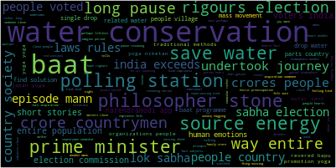
Wordclouds for individual speeches have also been completed and further tools such as topic modelling with the topics being evaluated yearly are in progress.

