ONLINE EVALUATION SYSTEM FOR NON-ACADEMIC SCHOLARS OF ASIAN COLLEGE OF TECHNOLOGY

A System Study Presented to the

Faculty of the College of Computer Studies

Asian College of Technology International Educational Foundation

Cebu, Philippines

In Partial Fulfillment

of the Requirement for the Degree

BACHELOR OF SCIENCE IN INFORMATION TECHNOLOGY

by

RAYMUNDO R. ALFECHE JR.

OCTOBER 2018

APPROVAL SHEET

This system study entitled, “ONLINE EVALUATION SYSTEM FOR NON-ACADEMIC SCHOLARS OF ASIAN COLLEGE OF TECHNOLOGY”, prepared and submitted by RAYMUNDO R. ALFECHE JR in partial fulfillment of the requirement for the degree of BACHELOR OF SCIENCE IN INFORMATION TECHNOLOGY has been examined and is recommended for acceptance and approval for ORAL DEFENSE.

ADVISORY OF COMMITTEE

ARTEMIO CABRILLOS JR, MIT ANGELBERT MAGHANOY,MIT

Adviser Instructor

Approved by the committee on Oral Examination with the grade of PASSED.

PANEL OF EXAMINERS

Chairman

Member Member

Accepted and approved in partial fulfillment of requirement for the degree of

BACHELOR OF SCIENCEIN INFORMATION TECHNOLOGY.

LEIF JAY DE SAGUN, PhD.

Dean, College of Computer Studies

Date: OCTOBER 2018

# ACKNOWLEDGEMENT

The researchers would like to express their sincerest and deepest gratitude to the following for the unyielding help and support they have received all throughout the research period:

To Almighty God, for giving them the wisdom, strength, patience and

determination as they faced all problems that challenged them to complete this study.

To Mr. Artemio Cabrillos Jr., their thesis adviser, for guiding and giving his informative advises as they make the study.

To Mr. Angelbert Maghanoy, their subject instructor for supervising the deliverables needed in the documentation and brilliant insights.

To Asian College of Techonology administration, for giving the researchers a chance to conduct a study and for supplying the things that the researchers need to know with the regards to the current system of the restaurant.

Lastly, to their compassionate families, for both financial and moral support, love, motivation and guidance they have given to them.

THE RESEARCHERS

ABSTRACT OF THE STUDY

Title of the Study: ONLINE EVALUATION SYSTEM FOR NON-ACADEMIC SCHOLARS OF ASIAN COLLEGE OF TECHNOLOGY

Synopsis of the Study: The Online Evaluation System for Non-Academic Scholars of Asian College of Technology aims to design and implement online evaluation. Which Department heads can evaluate their scholar online. The administrator can also manage evaluation and the scholar’s information, dtr , working dates and grade. This system intends to increase the speed of evaluation scholars and generating reports needed. Implementing this system gives a time-efficient opportunity to give the department head(evaluator) to evaluate their scholars without waiting for the evaluation form to be handed over as well as calculating allowance based on the daily time record from the biometric will more time-efficient. We have chosen to target the Web platform, because it is widely used and most accessible online. We developed this system using the Metro UI Framework for front end, Code Igniter for Server-side scripting and MySQL for the database.

Authors: Degree Conferred:

Raymundo R. Alfeche Jr. BSIT

School : ASIAN COLLEGE OF TECHNOLOGY

Address : Corner Leon Kilat and P. del Rosario St., Cebu City

Date Completed : October 2018

Chapter 1

RESEARCH DESIGN

Rationale of the Study

The advancement of technology today has immersed itself towards education. The presence of technology has reached its maximum of providing sustainable technology towards quality education through delivery and effective learning. Asian College of Technology International Education Foundation is one of the highly growing private schools that embrace information and communication technology now. As they immersed themselves with technology through their institution and other forms brought about by information technology.

The staff and management of Asian College of Technology have problems in releasing scholar’s monthly allowance on-time due to the difficulty in calculating based in DTR generated from the biometric machine. NAS are always late on enrolment because of waiting the results of the evaluation from different departments. Calculating the evaluation results seemed to be a lot of work since there are almost a lot of NAS in the institution. Lastly, renewal remarks are always delayed resulting to late enrollment of scholars.

The researcher have proposed a system that will solve these problems; the researcher build an online evaluation system that will allow the evaluator evaluate their scholars online without waiting for an evaluation form and automate the calculation of evaluation results. Since automation and mobility are high on demand, the system built is a web application. With this system, the administrator and the evaluator will not have any issues in the inaccuracy of evaluation results, monthly allowance, and renewal remarks. Next, the system is also equipped in updating the information of scholars and in an organized manner. Finally, the researcher built a simple UI for easy navigation to lessen the odds and difficulty of the users.

Related Systems

According to Ylanan et al (2004) inraising teaching performance is perhaps the policy directionmost likely to lead the substantial gains in student learning. In turn, the effective monitoring and evaluation of teaching is central to the continuous improvement of the effectiveness of teaching in a school. It is essential to know the strength of teachers and those aspects of their practice which could be further developed. From this perspective, the institution of teacher evaluation is a vital step in the drive to improve the effectiveness of teaching and learning and raise educational standards.

Andales, Bacarisas, Coronel and Gonzaga (2010) state that Teacher’s Evaluation System is a software which aims to evaluate the teacher’s performance based on the different categories that is being provided. This can greatly affect how the teacher’s performance is to be improve and appreciated. Specifically, this study lets the students and the school heads to evaluate the teachers’ skills, behavior, and their school year’s objectives which is based on the RPMS (Result-Based Performance Management System).

Lim et al., (2014) concluded that it is necessary to automate manual evaluation system to improve the way of processing evaluation and retrieving the data among the users and administrators. The purpose of the study is to speed up the pace of their system so that both the users and administrators can conserve time. The main concern of this study is the security system. For the safety of the information and data if the system, it should be insured that there are no third party programs such as malware; even hackers are prevented.

Institutions structure and locate their evaluation systems differently on their campuses. In general, institutions either organize evaluations through a central office on campus or within individual departments. With regard to the formative purposes of evaluation, the organizational location of evaluation systems can potentially influence the effectiveness of those systems. In particular, certain researchers advocate a departmental approach to evaluation. Advantages with this approach are: instruction and its improvement are often discipline specific and faculty most closely identify with their department and are more likely to seek guidance and information within their department. (Hativa, 1995).

Research on the validity and reliability of these different forms of evaluation is scarce and especially in comparison to the amount of research available on the usefulness of student rating forms. However, studies do recognize that these other forms of evaluation can provide more qualitative and comprehensive information but may nonetheless be biased. In addition, these approaches require significant amounts of time and commitment on the part of the institution and faculty members. Institutions are continuing to incorporate more of these methods, and research has begun examining the effectiveness and utility of these approaches as well. (Johnson & Ryan, 2000; Hoyt & Pallett, 1999; Hativa, 1995).

Stufflebeam et al... (1971) provided a new definition of evaluation which states that "evaluation is the process of delineating, gathering and providing useful information for decision making alternatives" (p. 40). This definition, which has already been cited, holds a lot of features. The Context, Input, Process and Product (CIPP) model, one of the widely known evaluation models developed by Stufflebeam is based on this definition. The most common among these definitions centers on the concept of gathering information for decision-making. In this regard, therefore it is appropriate to conclude that the evaluation is an instrument which brings about change through decision making thereby leading to change (improvement) in the educational program and/or process. To do this, only positive change is useful or desirable. Improvement indicates alterations and comes only as a result of actions or methods different from those currently in use. Therefore, to improve the activity program, a decision maker must know the various alternatives available to him/her and choose the ones which make positive impacts on his/her activity program. To make this choice implies an element of understanding the various alternatives in making decisions.

Evaluation-based decisions off student rating systems, which critics claim are too subjective. Some of the subjectivity in the evaluation process results from students rating areas of effectiveness that they are unable to access, which they identify as, 1) the goals, content, and organization of questions; 2) methods and materials used in delivery; and 3) evaluation of student work, including grading practices (Cohen, 1980; Cashin, 1989; McKeachie, 1997; 2006; Bain, 2004).

Manual system is retrieving, maintaining, security and filling of records consume lot of time and effort. There are some cases wherein misplaced of records are taking place because of the years gone by. Furthermore, these files were only kept in envelope, folder or wooden racks. There are also instances when the right information is given to the wrong person, which may affect quality of service. (M. Cantonas, 2008).

According to Aquino (2011), Importance of computer application is increasing day by day. In the latest decades of the millennium winning organization are those which are willing to integrate business strategy and computer information technology in plying their respective trades. The use of computer information technology results for them to be able to develop products fast and make decisions fast, ability to have fluid organization structures, able to cope with the demanding work force and external environment by the rapid development of innovative approaches and lastly using information system confirms the company’s mission vision.

Chapter 2

THE PROBLEM

Statement of the Problem

This research aims to develop an Online Activities Evaluation System using a Web-based technology in Asian College of Technology (ACT).

Specifically, it answers the following problems:

1. Takes a lot of time to complete the evaluation.
2. It requires a hard copy of every questionnaire.
3. Hassle in computing the results of the evaluation.

Objective of the system

This research aims to develop an Online Activities Evaluation System using a Web-based technology in Asian College of Technology (ACT).

Specifically, it aims to:

1. Time efficient in evaluating NAS.
2. Much easier, faster and accurate computing of results based on the Criteria.
3. Evaluation will be more accessible and paperless.

Scope of the system

The researchers aim to develop a system that focuses on Online Evaluation System for Non-Academic Scholars of Asian College of Technology, which is capable of:

1. Maintaining the following
   1. User accounts
   2. NAS
   3. Evaluation Question
   4. Attendance
   5. Grade
2. Process the following
   1. User authentication
   2. Registration of user accounts
   3. Importing of the following
      1. NAS
      2. Attendance
      3. Grade
      4. Evaluation Question
   4. Evaluation
   5. Compute the following
      1. Attendance
         1. Total number of Lates
         2. Total number of Absences
      2. Grades
         1. Total Average
      3. Evaluation
         1. Total Mean
         2. Mean Interpretation
3. Monitors the following
   1. Attendance
   2. Evaluation
4. Generates the following
   1. Evaluation results
      1. Total Mean
      2. Mean Interpretation
   2. Reports
      1. List of NAS with renewal remarks
      2. List of NAS with number of units to be taken

However, the following limitations are;

1. The system is not accessible offline.
2. The system can’t process DTR for attendance.
3. The system can’t process accomplishment reports.

Significance of the study

The findings of this study will redound to the benefit of the school and to the in-charge person. The project’s goal is designed to help the in-charge person for the evaluation of the institution, as well as to improve the efficiency, effectiveness, time and data gathering of the required output. The study will be valuable to the following

Administrator. With the help of the online evaluation system, the administrator will now have lesser time in having results for the evaluation.

NAS. Late enrolment will be lessen because generating the evaluation results is generated automatically and the monthly allowance delay will be lessen because of the automation of the calculation based on the DTR.

School. Evaluation of the Non-academic scholars is part of gathering the information needed for the school to improve their future Non-Academic Scholars, in which is the main purpose of this evaluation system.

Future researchers. This study serves as the future basis in creating and, or enhancing the future system related to this study.

RESEARCH METHODOLOGY

Research Environment

The study was conducted at Asian College of Technology in College of Computer Studies located in Corner Leon Kilat Street and P. Del Rosario Street, Cebu City. The researchers conducted an interview to Director of Student Welfare and Services Dr. Andres S. Gotera. The school was established in the year of 1988.Mr. Rodrigo Bebot Abellanosa, the school founder, and Mrs. Viannie C. Loquero, as her co-founder. The school has three sessions morning, afternoon and evening session. It has four departments namely; College of Computer Studies, College of Business and Management, College of Arts and Sciences Pedagogy and Senior High School Department.



Figure 1 Outside of Asian College of Technology

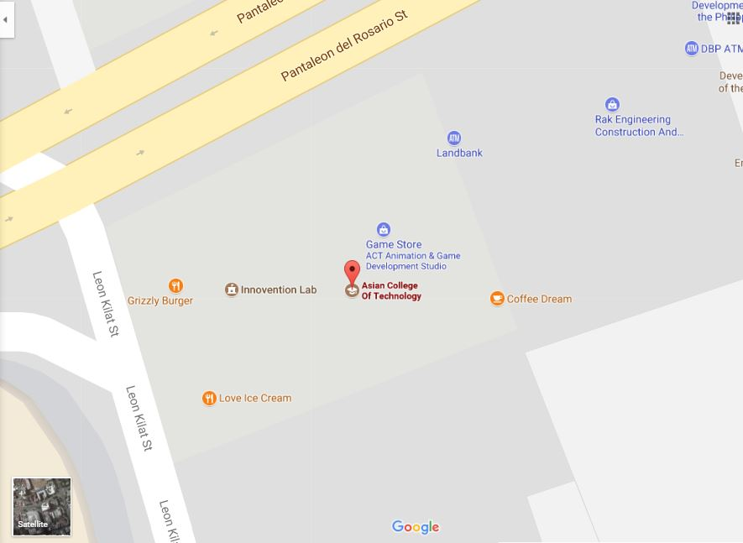Research Map

Figure 2: Asian College of Technology Location Map

Sources of Data

A system could not be possible without any data that can be used in creating it and it is one of the most important aspects that will give knowledge to the researchers on how to solve the problems they are working in conducting the study

Interview. The researchers conducted an interviewing Asian College of Technology with the help of the Standard Accreditation and Research Director in gathering the information that will be used by the researchers in making their system.

Questionnaire. During the interview list of guide questions was used by the researchers in gathering the needed information that will be answered by the Standard Accreditation and Research Director.

Research. To gains more data the researchers gather the information in the unpublished thesis from the library of Asian College of Technology, document review and electronic sources.

Methods and Techniques

The following methods and techniques were used in the development of the proposed system:

Structured Analysis and Design Technique. The researchers used this technique to describe systems as a hierarchy of functions, a structured analysis modeling language, which uses two types of diagrams: activity models and data models.

Project Management Technique. The researchers used this technique to monitor the progress of the capstone project by using Gantt chart.

User-Interviewing Technique.The researchers used this technique to create a valuable method for exploratory user research.

Relational Database Technique. The researchers used this technique to maintain relational databases and also to be relatively easy to create and access.

Models

The following models were used by the researchers that serve as the graphical representation to analyze the different aspects and the flow of the proposed system:

Use Case Diagram. This model was used by the researchers to show the interaction between the user and the system it is also used in identifying the different types of user in the system and its role and its functionalities and the relationship between the user and the different use cases in which the user is involved.

Class Diagram. This model that was used by the researchers to show a static structure of a system and its relationships between classes, objects, attributes, and operations.

Component Model. It illustrates the software components that will be used to build the system.

Object Diagram. This model describes the static structure of a system at a particular time; it can be used to test class diagrams for accuracy.

Deployment Model. It is used by the researchers to describe a web site; and it would show what hardware components exist what software components run on each node and how the different pieces are connected.

Data Model. It is used by the researchers to gather, organize data and relate properties of the object in real world.

Gantt chart. This was used to show the different phases of the systems development with the corresponding number of days spent to perform a single task.

Tools

The following tools were used by the researchers in developing of the proposed system:

Adobe Photoshop. It is used by the researchers to manipulate and modify the image needed in the system.

Google Chrome. It is used by the researchers to test the code in developing the system.

XAMPP. It is used by the researchers for hosting the local server.

Microsoft Office 2010.It is used by the researchers to create the documentation of the system.

PHP. Used by the researchers in manipulating the MySQL queries.

Development Process

The table 1 below shows the Gantt chart of the study. It shows the different phases of the systems development with the corresponding number of days spent to perform a single task of Online Activities Evaluation System of Asian College of Technology.

|  |  |  |  |  |  |  |  |  |  |  |  |  |  |  |  |  |  |
| --- | --- | --- | --- | --- | --- | --- | --- | --- | --- | --- | --- | --- | --- | --- | --- | --- | --- |
| First Phase | Dec ‘17 | | | Jan ‘17 | | | | Feb ‘17 | | | | Mar ‘17 | | | | Apr ‘17 | |
| 2 | 3 | 4 | 1 | 2 | 3 | 4 | 1 | 2 | 3 | 4 | 1 | 2 | 3 | 4 | 1 | 2 |
| Systems Planning |  |  |  |  |  |  |  |  |  |  |  |  |  |  |  |  |  |
| Company Selection |  |  |  |  |  |  |  |  |  |  |  |  |  |  |  |  |  |
| Gathering of Data |  |  |  |  |  |  |  |  |  |  |  |  |  |  |  |  |  |
| Problem Recognition |  |  |  |  |  |  |  |  |  |  |  |  |  |  |  |  |  |
| Scope Planning |  |  |  |  |  |  |  |  |  |  |  |  |  |  |  |  |  |
|  |  |  |  |  |  |  |  |  |  |  |  |  |  |  |  |  |  |
| Systems Analysis |  |  |  |  |  |  |  |  |  |  |  |  |  |  |  |  |  |
| Interview |  |  |  |  |  |  |  |  |  |  |  |  |  |  |  |  |  |
| Ocular Observation |  |  |  |  |  |  |  |  |  |  |  |  |  |  |  |  |  |
| System Requirements |  |  |  |  |  |  |  |  |  |  |  |  |  |  |  |  |  |
| Hardware  Identification |  |  |  |  |  |  |  |  |  |  |  |  |  |  |  |  |  |
| Software Identification |  |  |  |  |  |  |  |  |  |  |  |  |  |  |  |  |  |
|  |  |  |  |  |  |  |  |  |  |  |  |  |  |  |  |  |  |
| Second Phase | Jun ‘17 | | | July ‘17 | | | | Aug ‘18 | | | | Sep ‘18 | | | | Oct ‘18 | |
| 2 | 3 | 4 | 1 | 2 | 3 | 4 | 1 | 2 | 3 | 4 | 1 | 2 | 3 | 4 | 1 | 2 |
| Systems Designs |  |  |  |  |  |  |  |  |  |  |  |  |  |  |  |  |  |
| Data Model Creation |  |  |  |  |  |  |  |  |  |  |  |  |  |  |  |  |  |
| Metadata Creation |  |  |  |  |  |  |  |  |  |  |  |  |  |  |  |  |  |
| Prototyping |  |  |  |  |  |  |  |  |  |  |  |  |  |  |  |  |  |
| Program Coding |  |  |  |  |  |  |  |  |  |  |  |  |  |  |  |  |  |
|  |  |  |  |  |  |  |  |  |  |  |  |  |  |  |  |  |  |
| Systems Implementation |  |  |  |  |  |  |  |  |  |  |  |  |  |  |  |  |  |
| Unit Test |  |  |  |  |  |  |  |  |  |  |  |  |  |  |  |  |  |
| System Test |  |  |  |  |  |  |  |  |  |  |  |  |  |  |  |  |  |
|  |  |  |  |  |  |  |  |  |  |  |  |  |  |  |  |  |  |
| Systems Operations and Supports |  |  |  |  |  |  |  |  |  |  |  |  |  |  |  |  |  |
| Testing/Debugging |  |  |  |  |  |  |  |  |  |  |  |  |  |  |  |  |  |
|  |  |  |  |  |  |  |  |  |  |  |  |  |  |  |  |  |  |
| Systems Development Guidelines |  |  |  |  |  |  |  |  |  |  |  |  |  |  |  |  |  |
| Training Materials |  |  |  |  |  |  |  |  |  |  |  |  |  |  |  |  |  |

DEFINITION OF TERMS

NAS. These are the Non-Academic Scholars of ACT.

Evaluation Result. It refers to the outcome of the evaluation.

Evaluation System. A web-based automated system where the evaluator evaluates the performances of the scholar.

Evaluators. The person in charge of evaluating a particular activity.

Online. A state of being connected to a network or to the internet.

Researchers. It is the persons who conduct the study.

User. It refers to the students and administrator of the system.

DTR. It refers to the Daily Time Record from the Biometric Machine.

Renewal Remarks. It refers to the report needed at the end of the semester based from the evaluation results.

Chapter 3

REQUIREMENTS ANALYSIS

Functional requirements

Functional requirements may be calculations, technical details, data manipulation and processing and other specific functionality that define what a system is supposed to accomplish. In other words, a functional requirement will describe a particular behavior of function of the system when certain conditions are met.

Input:

The system is capable of accepting the following data:

* + User accounts
  + NAS
  + Evaluation Question
  + Attendance
  + Grade

Process:

The system is capable of performing the following processes:

* User authentication
* Registration of user accounts
* Importing of the information
* Compute the results

Output:

The system is capable of displaying the following outputs:

* Evaluation results
* Reports

Non-Functional requirements

A non-functional requirement is a requirement that specifies criteria that can be used to judge the operation of a system, rather than specific behaviors. They are contrasted with functional requirements that define specific behavior or functions.

1. Accessibility

* Only the registered accounts can access the system.
* The system can only be access online.

1. Access security

* The evaluator must change his password after the first login.
* The admin cannot view the evaluator’s password.

1. Availability

* The system will be available for the department heads or department evaluator only.

Usability requirements:

Usability is the ease of use and learnability of a human-made object such as a tool or device. The degree to which a software can be used by specified consumers to achieve quantified objectives with effectiveness, efficiency, and satisfaction in a quantified context of use.

1. The student must be registered in the system.
2. The evaluator must be employed in Asian College of Technology.
3. The user should know how the evaluation system works.
4. The user should be computer literate.

Use Case Diagram

The following diagrams are the system Use Case Model showing the internal actor and internal cases on which it is intended as a way to communicate between the system analysts and system developer.

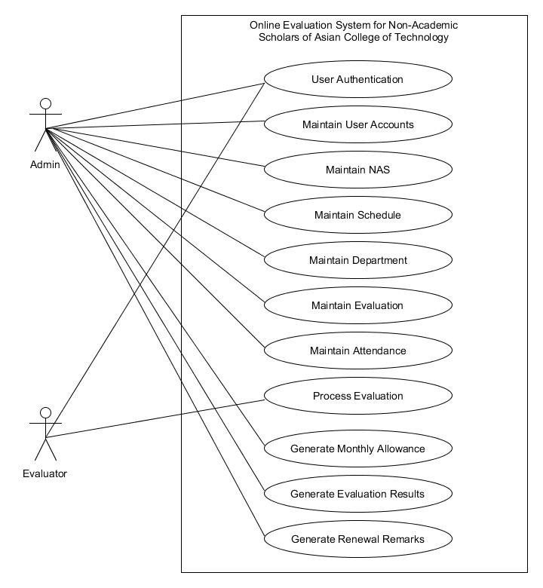

Figure 3: Business Use Case Model of OESNAS

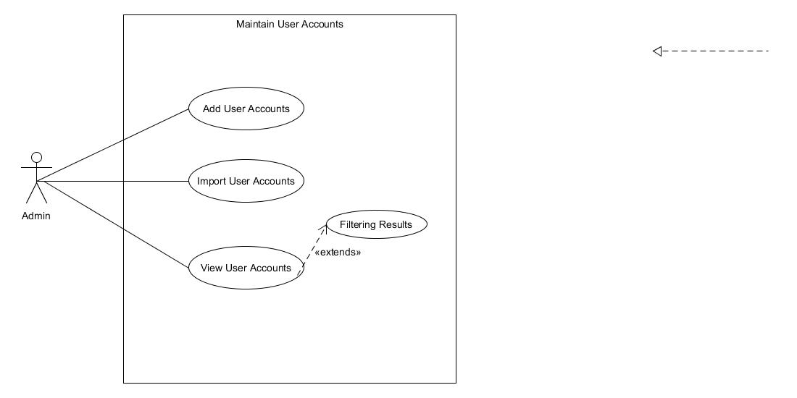

Figure 4: System User Case Of Maintain User Account in Admin

Figure 5: System Use Case of Maintain User Account in Admin

Use Case Description

Use Case name : Add User Account

Triggering Actor : Admin

Benefiting Actor : User

Purpose : To Add User Account

Pre-condition : The user clicks the add button

Post-condition : Successfully Added!

Steps

|  |  |
| --- | --- |
| Admin | System |
| 2. Input fields required | 1. Load Adding User Accounts page |
| 3. Click Add button | 4. Displays success message |

Use Case Description

Use Case name : Import User Accounts

Triggering Actor : Admin

Benefiting Actor : User

Purpose : To import user accounts

Pre-condition : The admin clicks the import button

Post-condition : Displays the number row inserted and failed.

Steps

|  |  |
| --- | --- |
| Admin | System |
| 2. Input fields needed | 1. Load Importing User Accounts page |
| 3. Click Import button | 4. Display rows inserted and rows failed |

Use Case Description

Use Case name : View User Accounts

Triggering Actor : Admin

Benefiting Actor : Admin

Purpose : View user accounts.

Pre-condition : The admin wants to view user accounts.

Post-condition : Display User accounts on a table.

Steps

|  |  |
| --- | --- |
| Admin | System |
| 1. Clicks the user account side navigation. | 2. Load user accounts result page. |

Use Case Description

Use Case name : Filtering Results

Triggering Actor : Admin

Benefiting Actor : Admin

Purpose : Filtering the results of viewing User Accounts.

Pre-condition : The admin wants to filter in viewing user accounts.

Post-condition : Display Filtered User accounts.

Steps

|  |  |
| --- | --- |
| Admin | System |
| 2. Select role or department. | 1. Load User Accounts page |
| 3. Click Import button | 4. Load User Accounts page with filtered results. |

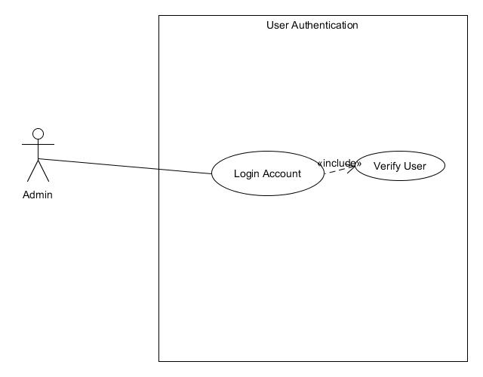

Figure 6: System User Case of User Authentication of Admin

Use Case Description

Use Case name : User Authentication

Triggering Actor : Admin/Evaluator

Benefiting Actor : Admin/Evaluator

Purpose : To login admin account

Pre-condition : The admin wants to login

Post-condition : Verify User

Steps

|  |  |
| --- | --- |
| Admin/Evaluator | System |
| 2. Input Username and Password | 1. Load Login UI |
| 3. Click Login button | 4. Verify credentials |

Use Case Description

Use Case name : Verify User

Triggering Actor : Admin/Evaluator

Benefiting Actor : Admin/Evaluator

Purpose : To verify admin account

Pre-condition : The admin clicks the login button

Post-condition : The admin successfully login

Steps

|  |  |
| --- | --- |
| Admin /Evaluator | System |
|  | 1. If admin’s credential are registered.  1.1 If user is verified  1.1.1 If user is admin  1.1.1.1 Load Admin Start UI  Else  1.1.1.2 Load Evaluator Home Page  Else  1.2 Show verification dialog.  Else  Show infobox “It looks like the credentials you've entered was not registered.” |

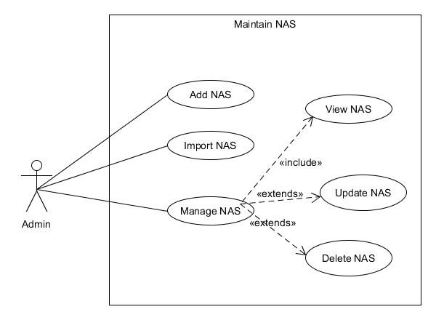

Figure 7: System User Case of Maintain NAS of Admin

Use Case Description

Use Case name : Add NAS

Triggering Actor : Admin

Benefiting Actor : Admin

Purpose : To add new NAS.

Pre-condition : The admin wants to add NAS.

Post-condition : Adding successful.

Steps

|  |  |
| --- | --- |
| Admin | System |
| 2. Input fields required | 1. Load Adding NAS page |
| 3. Click Add button | 4. Displays a success message |

Use Case Description

Use Case name : Import NAS

Triggering Actor : Admin

Benefiting Actor : Admin

Purpose : To add new NAS.

Pre-condition : The admin wants to add nas.

Post-condition : Adding successful.

Steps

|  |  |
| --- | --- |
| Admin | System |
| 2. Input fields required | 1. Load Adding NAS page |
| 3. Click Add button | 4. Display a success message |

Use Case Description

Use Case name : Manage NAS

Triggering Actor : Admin

Benefiting Actor : Admin

Purpose : To manage NAS.

Pre-condition : The admin wants to manage nas.

Post-condition : Adding successful.

Steps

|  |  |
| --- | --- |
| Admin | System |
| 2. Click manage button | 1. Loads all NAS page |
|  | 3. Load NAS Profile, Schedule, Attendance and Grade |

Use Case Description

Use Case name : View NAS

Triggering Actor : Admin

Benefiting Actor : Admin

Purpose : To view NAS.

Pre-condition : The admin wants to view NAS info.

Post-condition : The admin successfully viewed NAS info.

Steps

|  |  |
| --- | --- |
| Admin | System |
| 1. Clicks manage button |  |
|  | 2. Loads View NAS page |

Use Case Description

Use Case name : Update NAS

Triggering Actor : Admin

Benefiting Actor : Admin

Purpose : To update NAS.

Pre-condition : The admin wants to update NAS info.

Post-condition : The admin successfully updated NAS info.

Steps

|  |  |
| --- | --- |
| Admin | System |
|  | 1. Load update page for NAS |
| 2. Fill out fields to be updated |  |
| 3. Click Update button |  |
|  | 3. Display success message. |

Use Case Description

Use Case name : Delete NAS

Triggering Actor : Admin

Benefiting Actor : Admin

Purpose : To delete NAS.

Pre-condition : The admin wants to delete NAS info.

Post-condition : The admin successfully deleted NAS info.

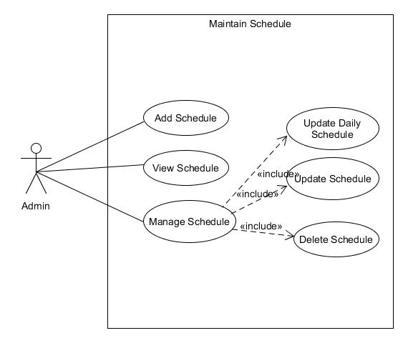Steps

Figure 8: System Use Case of Maintain Schedule of Admin

|  |  |
| --- | --- |
| Admin | System |
|  | 1. Load All NAS page |
| 2. Click delete button. |  |
|  | 3. Display success message |

Use Case Description

Use Case name : Add Schedule

Triggering Actor : Admin

Benefiting Actor : Admin

Purpose : To add schedule.

Pre-condition : The admin wants to add schedule.

Post-condition : The admin successfully added schedule.

Steps

|  |  |
| --- | --- |
| Admin | System |
|  | 1. Load Add Schedule page |
| 2. Fill out fields to be updated |  |
| 3. Click Add button |  |
|  | 3. Display success message |

Use Case Description

Use Case name : View Schedule

Triggering Actor : Admin

Benefiting Actor : Admin

Purpose : To view schedule.

Pre-condition : The admin wants to view schedule.

Post-condition : The admin successfully viewed schedule.

Steps

|  |  |
| --- | --- |
| Admin | System |
| 1. Clicks the manage schedule side navigation button |  |
|  | 2. Load View Schedule page |

Use Case Description

Use Case name : Manage Schedule

Triggering Actor : Admin

Benefiting Actor : Admin

Purpose : To manage schedule.

Pre-condition : The admin wants to manage schedule.

Post-condition : The admin successfully update, delete schedule.

Steps

|  |  |
| --- | --- |
| Admin | System |
| 1. Clicks the manage schedule side navigation button |  |
|  | 2. Load View Schedule page |
| 3. Clicks the Update button |  |
|  | 3. Load the Manage Schedule page |

Use Case Description

Use Case name : Update Daily Schedule

Triggering Actor : Admin

Benefiting Actor : Admin

Purpose : To update daily schedule.

Pre-condition : The admin wants to update daily schedule.

Post-condition : The admin successfully update daily schedule.

Steps

|  |  |
| --- | --- |
| Admin | System |
| 1. Clicks the daily schedule tab |  |
|  | 2. Load Daily Schedule page |
| 3. Clicks update button on the table |  |
|  | 3. Show update dialog. |
| 4. Input value and click update button. |  |
|  | 5. Display success message. |

Use Case Description

Use Case name : Update Schedule

Triggering Actor : Admin

Benefiting Actor : Admin

Purpose : To update schedule info.

Pre-condition : The admin wants to update schedule info.

Post-condition : The admin successfully updated schedule info.

Steps

|  |  |
| --- | --- |
| Admin | System |
| 1. Clicks the info tab |  |
|  | 2. Load Schedule Info page |
| 3. Clicks edit info button. |  |
|  | 3. Show edit schedule details dialog. |
| 4. Input value and click update button. |  |
|  | 5. Displays success message |

Use Case Description

Use Case name : Delete Schedule

Triggering Actor : Admin

Benefiting Actor : Admin

Purpose : To delete schedule info.

Pre-condition : The admin wants to delete schedule info.

Post-condition : The admin successfully deleted schedule info.

Steps

|  |  |
| --- | --- |
| Admin | System |
|  | 1. Load Manage Schedule page |
|  | 2. Load Schedule Info page |
| 3. Clicks edit info button. |  |
|  | 3. Show edit schedule details dialog. |
| 4. Input value and click update button. |  |
|  | 5. Displays a success message. |

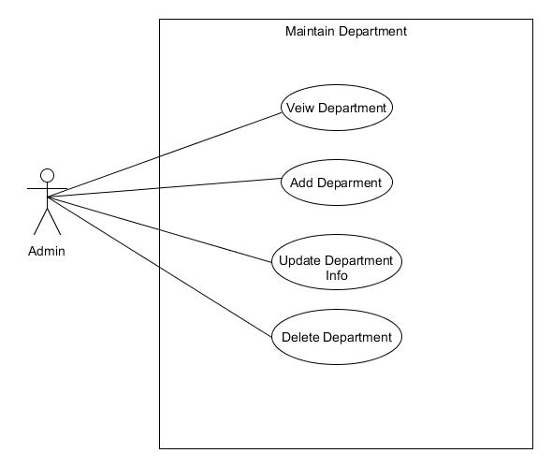

Figure 9: System Use Case of Maintain Department

Use Case Description

Use Case name : View Department

Triggering Actor : Admin

Benefiting Actor : Admin

Purpose : To view department.

Pre-condition : The admin wants to view department.

Post-condition : The admin viewed department.

Steps

|  |  |
| --- | --- |
| Admin | System |
| 1. Clicks the department side navigation button |  |
|  | 2. Load Department View page |

Use Case Description

Use Case name : Add Department

Triggering Actor : Admin

Benefiting Actor : Admin

Purpose : To add department.

Pre-condition : The admin wants to add department.

Post-condition : The admin added department successfully.

Steps

|  |  |
| --- | --- |
| Admin | System |
|  | 1. Load Department View page |
| 2. Clicks add new department button |  |
|  | 3. Show add department dialog |
| 4. Fill out all fields required and click add button. |  |
|  | 5. Display success message. |

Use Case Description

Use Case name : Update Department Info

Triggering Actor : Admin

Benefiting Actor : Admin

Purpose : To update department info.

Pre-condition : The admin wants update department info.

Post-condition : The admin updated department info successfully.

Steps

|  |  |
| --- | --- |
| Admin | System |
|  | 1. Load Department View page |
| 2. Clicks update button in the table |  |
|  | 3. Loads the manage department page |
| 4. Clicks the edit info button . |  |
|  | 5. Show Edit Info Dialog. |
| 6. Input fields to be updated and click update button |  |
|  | 7. Display success message. |

Use Case Description

Use Case name : Delete department

Triggering Actor : Admin

Benefiting Actor : Admin

Purpose : To delete department.

Pre-condition : The admin wants to delete department.

Post-condition : The admin deleted department.

Steps

|  |  |
| --- | --- |
| Admin | System |
|  | 1. Load Department View page |
| 2. Clicks delete button in the table |  |
|  | 3. Display success message. |

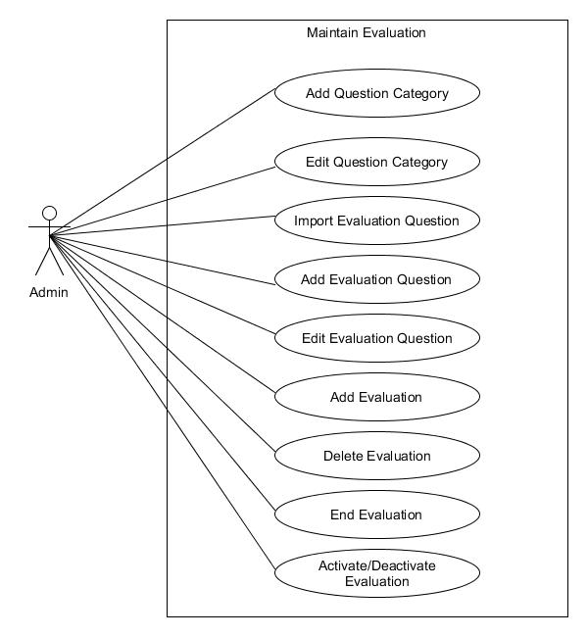

Figure 10: System Use Case of Maintain Evaluation

Use Case Description

Use Case name : Add Question Category

Triggering Actor : Admin

Benefiting Actor : Admin

Purpose : To add question category.

Pre-condition : The admin wants to add question category.

Post-condition : The admin successfully added question category.

Steps

|  |  |
| --- | --- |
| Admin | System |
|  | 1. Loads the question category view page |
| 2. Clicks the add button |  |
|  | 3. Show the add question category dialog |
| 4. Input fields required and click add button |  |
|  | 5. Display success message |

Use Case Description

Use Case name : Edit Question Category

Triggering Actor : Admin

Benefiting Actor : Admin

Purpose : To edit question category.

Pre-condition : The admin wants to edit question category.

Post-condition : The admin successfully edit question category.

Steps

|  |  |
| --- | --- |
| Admin | System |
|  | 1. Loads the question category view page |
| 2. Clicks the edit button in the table |  |
|  | 3. Show the edit question category dialog |
| 4. Input fields and click update button |  |
|  | 5. Display success message |

Use Case Description

Use Case name : Import Evaluation Question

Triggering Actor : Admin

Benefiting Actor : Admin

Purpose : To import evaluation question.

Pre-condition : The admin wants to import evaluation questions.

Post-condition : The admin successfully imported evaluation questions.

Steps

|  |  |
| --- | --- |
| Admin | System |
|  | 1. Loads the evaluation question view page |
| 2. Clicks the import button |  |
|  | 3. Loads the import evaluation page |
| 4. Choose excel file from the file browser button |  |
|  | 5. Display excel content into the table |
| 6. Click import button |  |
|  | 6. Display success message |

Use Case Description

Use Case name : Add Evaluation Question

Triggering Actor : Admin

Benefiting Actor : Admin

Purpose : To add evaluation question.

Pre-condition : The admin wants to add evaluation questions.

Post-condition : The admin successfully added evaluation questions.

Steps

|  |  |
| --- | --- |
| Admin | System |
|  | 1. Loads the evaluation question view page |
| 2. Clicks the add button |  |
|  | 3. Shows add evaluation question dialog |
| 4. Input fields required and click the add button |  |
|  | 5. Display success message |

Use Case Description

Use Case name : Edit Evaluation Question

Triggering Actor : Admin

Benefiting Actor : Admin

Purpose : To edit evaluation question.

Pre-condition : The admin wants to edit evaluation questions.

Post-condition : The admin successfully edited evaluation questions.

Steps

|  |  |
| --- | --- |
| Admin | System |
|  | 1. Loads the evaluation question view page |
| 2. Clicks the edit button in the table |  |
|  | 3. Show edit evaluation question dialog |
| 4. Input values and click update button |  |
|  | 5. Display success message |

Use Case Description

Use Case name : Add Evaluation

Triggering Actor : Admin

Benefiting Actor : Admin

Purpose : To add evaluation question.

Pre-condition : The admin wants to add evaluation.

Post-condition : The admin successfully added evaluation.

Steps

|  |  |
| --- | --- |
| Admin | System |
|  | 1. Loads the evaluation view page |
| 2. Clicks the add new button |  |
|  | 3. Shows add new evaluation dialog |
| 4. Input fields required and click add button |  |
|  | 5. Display success message |

Use Case Description

Use Case name : Delete Evaluation

Triggering Actor : Admin

Benefiting Actor : Admin

Purpose : To delete evaluation question.

Pre-condition : The admin wants to delete evaluation.

Post-condition : The admin successfully deleted evaluation.

Steps

|  |  |
| --- | --- |
| Admin | System |
|  | 1. Loads the evaluation view page |
| 2. Clicks the delete button on the table |  |
|  | 3. Shows delete confirmation dialog |
| 4. Clicks delete |  |
|  | 5. Display success message |

Use Case Description

Use Case name : End evaluation

Triggering Actor : Admin

Benefiting Actor : Admin

Purpose : To end evaluation.

Pre-condition : The admin wants to end evaluation.

Post-condition : The admin successfully ended evaluation.

Steps

|  |  |
| --- | --- |
| Admin | System |
|  | 1. Loads the evaluation view page |
| 2. Clicks the monitor button on the table |  |
|  | 3. Loads Monitor Evaluation page |
| 4. Clicks end evaluation button |  |
|  | 5. Refresh page |

Use Case Description

Use Case name : Activate/Deactivate evaluation

Triggering Actor : Admin

Benefiting Actor : Admin

Purpose : To activate/deactivate evaluation.

Pre-condition : The admin wants to end evaluation.

Post-condition : The admin successfully ended evaluation.

Steps

|  |  |
| --- | --- |
| Admin | System |
|  | 1. Loads the evaluation view page |
| 2. Clicks the monitor button on the table |  |
|  | 3. Loads Monitor Evaluation page |
| 4. Clicks activate/deactivate swicth button |  |
|  | 5. Refresh page |

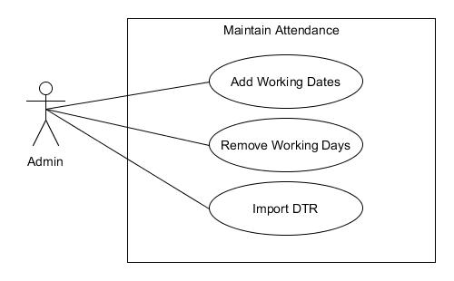

Figure 11: System Use Case of Maintain Attendance

Use Case Description

Use Case name : Add Working Dates

Triggering Actor : Admin

Benefiting Actor : Admin

Purpose : To add working dates.

Pre-condition : The admin wants to add working dates.

Post-condition : The admin successfully added working days.

Steps

|  |  |
| --- | --- |
| Admin | System |
| 1. Clicks working days side navigation button |  |
|  | 2. Loads working dates page. |
| 3. Clicks the add button |  |
|  | 4. Shows the add working dates dialog |
| 5. Inputs required fields and select dates from the calendar. |  |
|  | 5. Refresh page. |

Use Case Description

Use Case name : Remove Working Dates

Triggering Actor : Admin

Benefiting Actor : Admin

Purpose : To remove working dates.

Pre-condition : The admin wants to remove working dates.

Post-condition : The admin successfully removed working days.

Steps

|  |  |
| --- | --- |
| Admin | System |
| 1. Clicks working days side navigation button |  |
|  | 2. Loads working dates page. |
| 3. Clicks the remove button from the table |  |
|  | 4. Displays success message. |

Use Case Description

Use Case name : Import DTR

Triggering Actor : Admin

Benefiting Actor : Admin

Purpose : To import DTR.

Pre-condition : The admin wants to import DTR.

Post-condition : The admin successfully imported DTR.

Steps

|  |  |
| --- | --- |
| Admin | System |
| 1. Clicks DTR side navigation button |  |
|  | 2. Loads DTR page. |
| 3. Clicks the import button |  |
|  | 4. Shows import DTR dialog |
| 5. Fill out all required fields, select excel file from the file browser and clicks import |  |
|  | 6. Refresh page. |

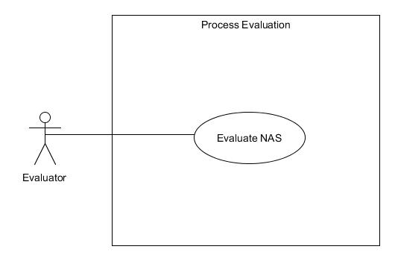

Figure 12: Use Case of Process Evaluation

Use Case Description

Use Case name : Evaluate NAS

Triggering Actor : Evaluator

Benefiting Actor : Evaluator

Purpose : To evaluate NAS.

Pre-condition : The evaluator wants to evaluate NAS.

Post-condition : The admin successfully evaluated NAS.

Steps

|  |  |
| --- | --- |
| Evaluator | System |
|  | 1. Loads evaluator home page |
| 2. Clicks evaluate button in the table |  |
|  | 3. Loads the evaluation page |
| 4. Answer all the evaluation questions and clicks submit button. |  |
|  | 5. Shows confirmation dialog. |
| 6. Clicks submit confirmation button |  |
|  | 7. Loads evaluator home page |

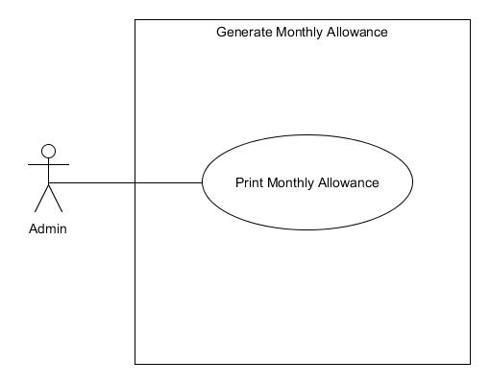

Figure 13: System Use Case of Generate Monthly Allowance

Use Case Description

Use Case name : Print Monthly Allowance

Triggering Actor : Admin

Benefiting Actor : Admin

Purpose : To print monthly allowance.

Pre-condition : The admin wants to print monthly allowance.

Post-condition : The admin successfully printed montly allowance.

Steps

|  |  |
| --- | --- |
| Admin | System |
| 1. Clicks monthly allowance side navigation button |  |
|  | 2. Loads monthly allowance page. |
| 3. Select school year, semester and month and clicks the print button |  |
|  | 4. Shows print dialog |
| 5. Clicks print button in the print dialog |  |
|  | 6. Prints the monthly allowance result |

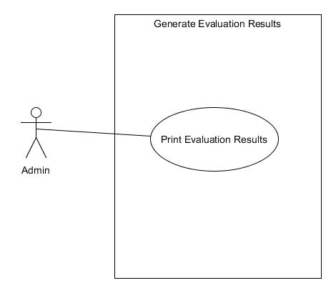

Figure 14: System Use Case of Generate Evaluation Results

Use Case Description

Use Case name : Print Evaluation Results

Triggering Actor : Admin

Benefiting Actor : Admin

Purpose : To print evaluation results.

Pre-condition : The admin wants to print evaluation results.

Post-condition : The admin successfully printed evaluation results.

Steps

|  |  |
| --- | --- |
| Admin | System |
| 1. Clicks evaluation results side navigation button |  |
|  | 2. Loads evaluation results page. |
| 3. Clicks view results to the chosen evaluation in the table |  |
|  | 4. Show NAS evaluation results page |
| 5. Clicks view report button in the table |  |
|  | 6. Loads NAS Evaluation Report page |
| 7. Clicks print button |  |
|  | 8. Shows print dialog |
| 9. Clicks print button in print dialog |  |
|  | 10. Prints the evaluation results |

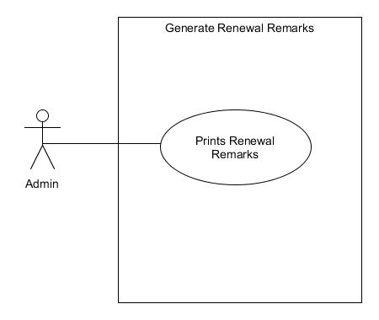

Figure 15: System Use Case of Generate Renewal Remarks

Use Case Description

Use Case name : Print Renewal Remarks

Triggering Actor : Admin

Benefiting Actor : Admin

Purpose : To print renewal remarks.

Pre-condition : The admin wants to print renewal remarks.

Post-condition : The admin successfully printed evaluation results.

Steps

|  |  |
| --- | --- |
| Admin | System |
| 1. Clicks renewal remarks side navigation button |  |
|  | 2. Loads renewal remarks page. |
| 3. Selects Schoolyear , semester and clicks print button. |  |
|  | 4. Shows print dialog |
| 5. Clicks print button in the print dialog |  |
|  | 6. Prints the renewal remarks |

The Class Model

The illustration below is a class diagram which shows the structure of the proposed system by showing the system’s classes, their attributes, operations (or methods) and the relationships among objects.

Figure 16: Class Model of the System

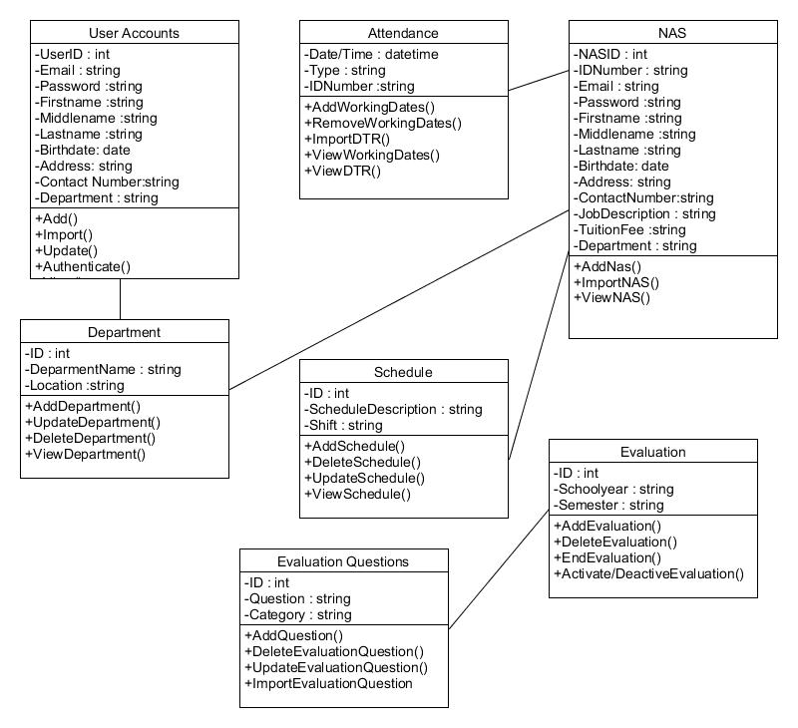

Component Model

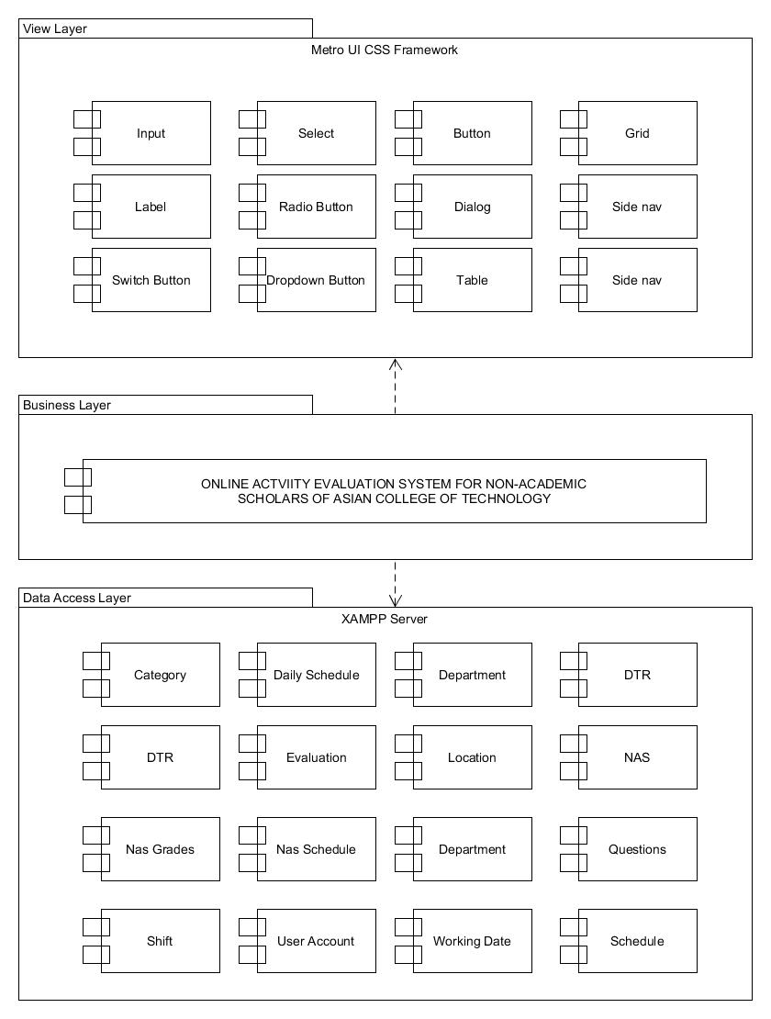The component diagram below models and shows the implementation and is used to represent or illustrate the structure of logical compound systems. It infers and depicts how components in the system are wired together to form larger components of software systems.

Figure 17: The Component Model of Online Evaluation System for Non-Academic Scholars of Asian College of Technology

Deployment Model

The Model below shows the deployment diagram of the system that involves the hardware together with the use of the software components which works a system in the real industry transactions.

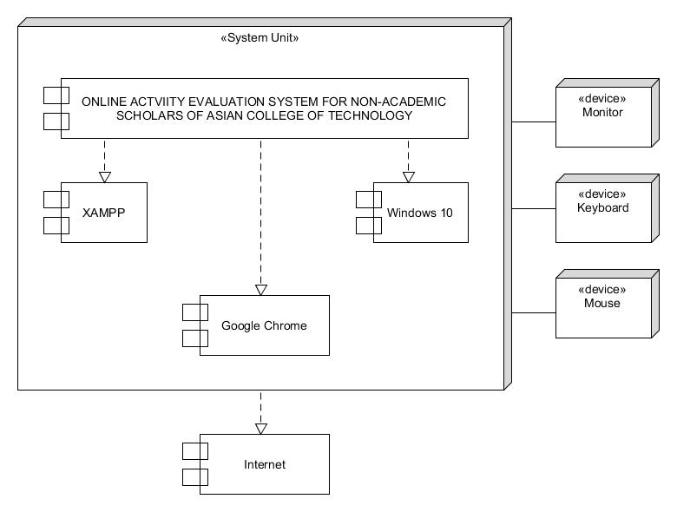

Figure 18: The Deployment Diagram of Online Evaluation System for Non-Academic Scholars of Asian College of Technology

Implementation Strategies

Once the system has been completely developed and prepared to be implemented, the researchers will fully review the system as how to operate the system. When the system is completely developed, implementation is to be done. Upon the implementation, the Admin can now operate the system as well as the evaluator.

If the Asian College of Technology is satisfied and wants to impose the system, the researchers will make the system productive, reliable, secured, and development- ready in a web-based that can be used without any odds.

Chapter 4

DESIGN OF THE PROTOTYPE

The User Interface

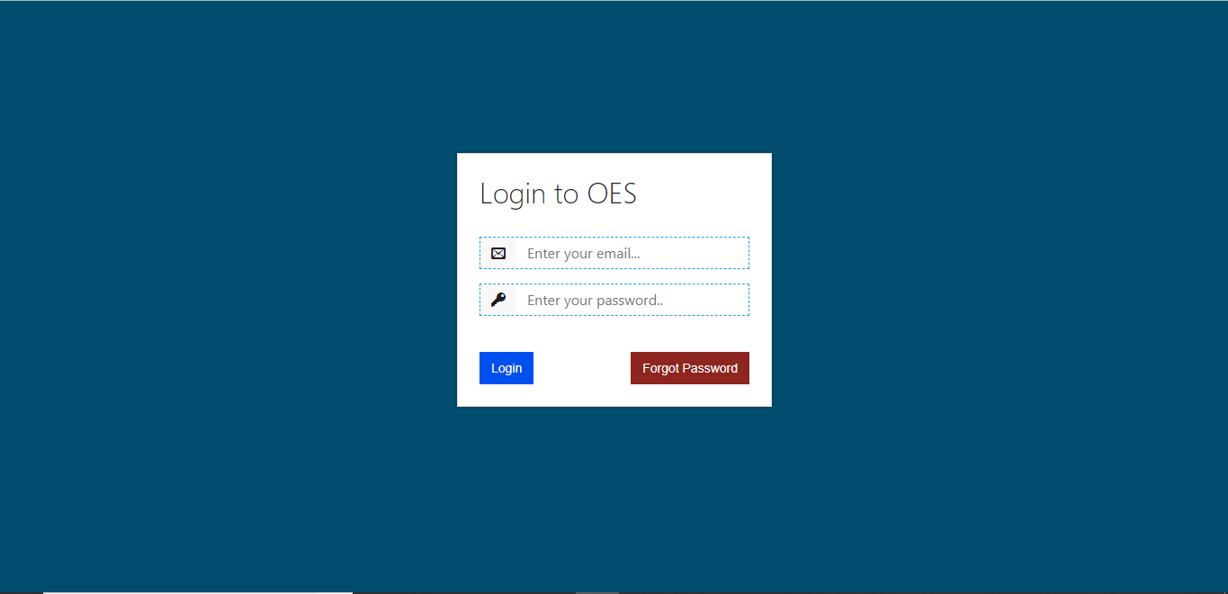

Figure 19: Login Page

Description: This is the admin and evaluator authentication page where they must enter their credentials to gain access of the system.

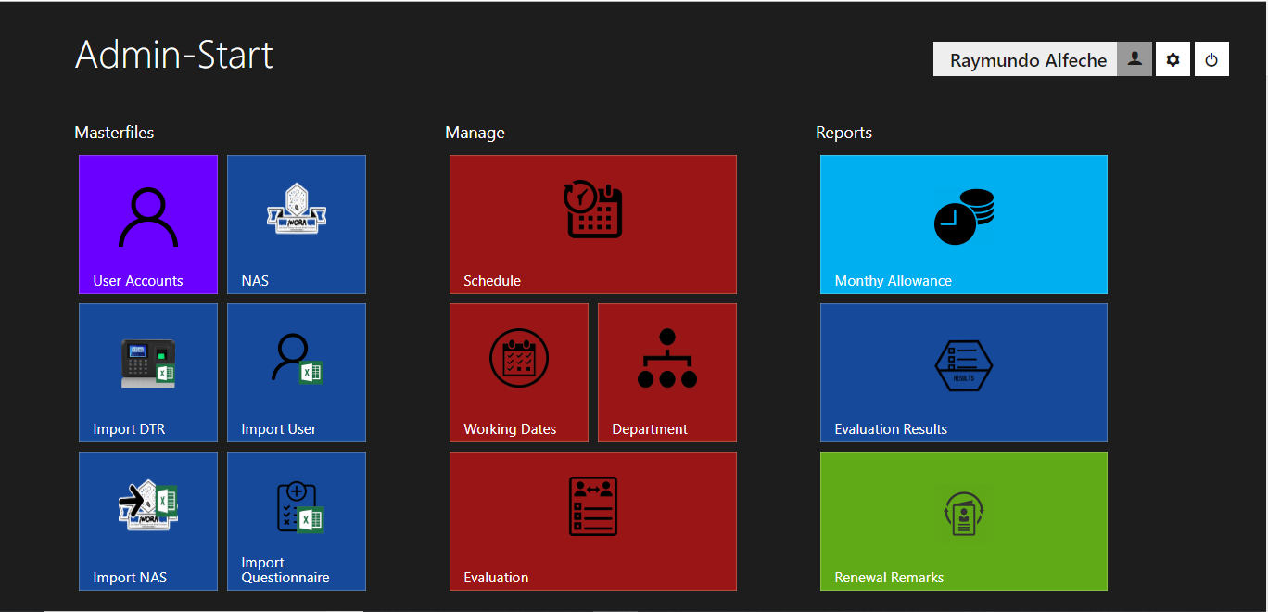

Figure 20: Admin Start Page

Description: This is called Admin-Start where the admin’s landing page after login in. This also serve as the homepage for the admin.

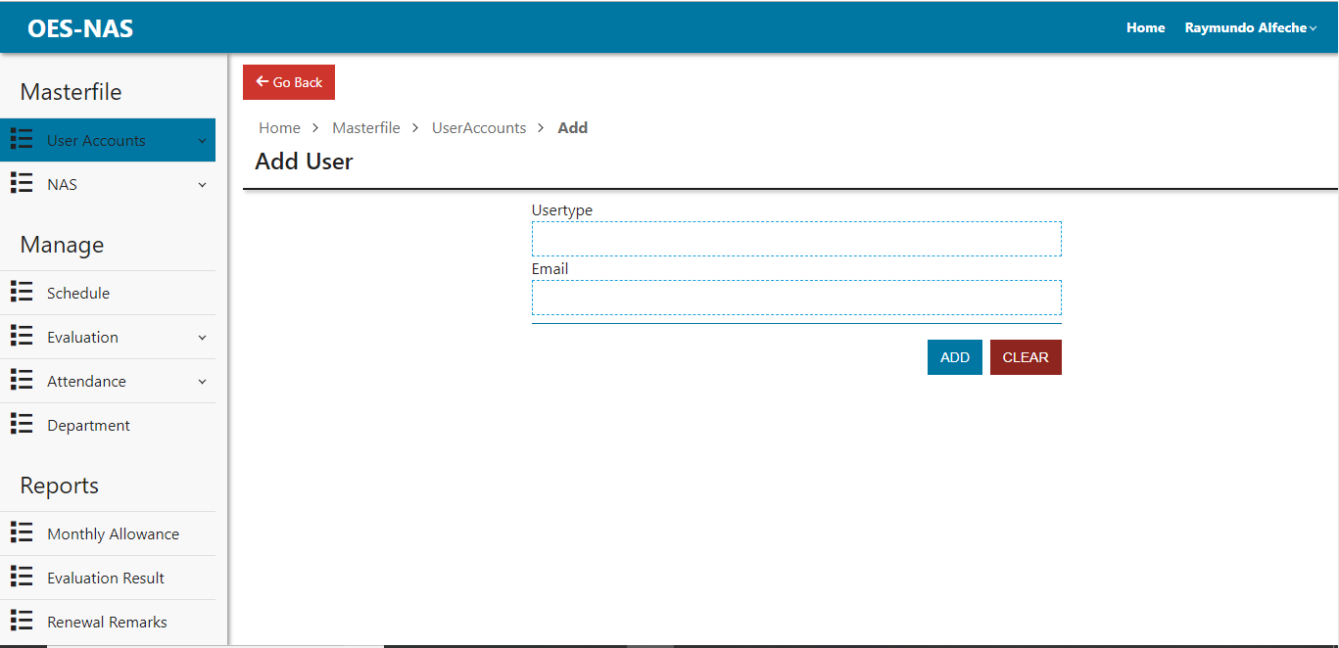

Figure 21: Adding of User page

Description: This page allows the admin to add a user for the system.

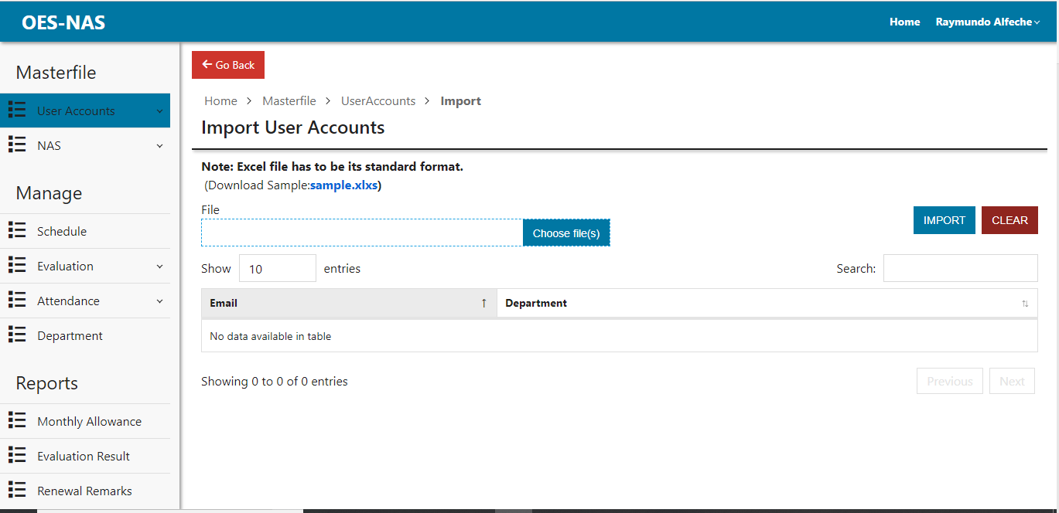

Figure 22: Importing of user page

Description: This page allows the admin to import user accounts from excel file.

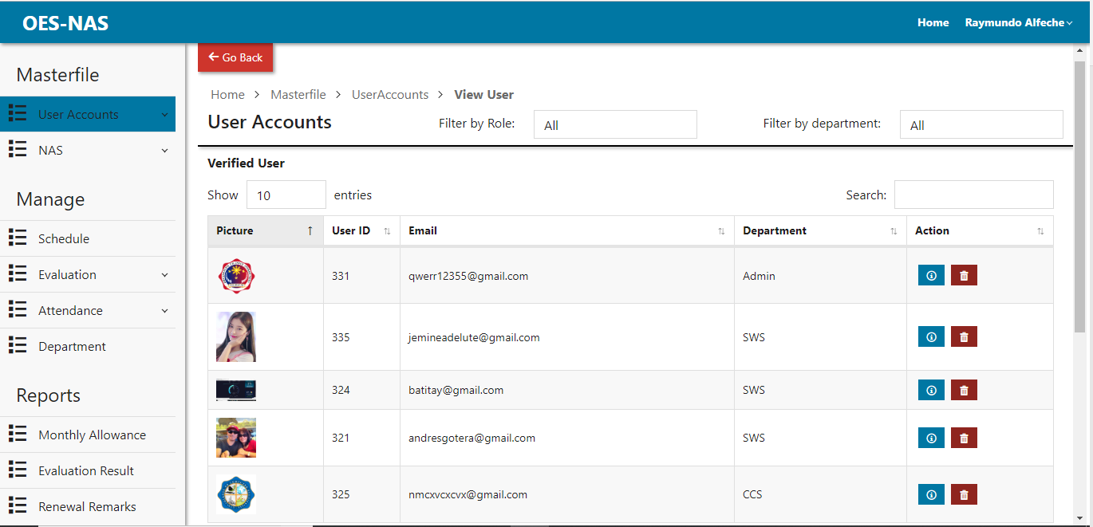

Figure 23: Viewing of user page

Description: This page is where the admin can view Verified and Unverified user.

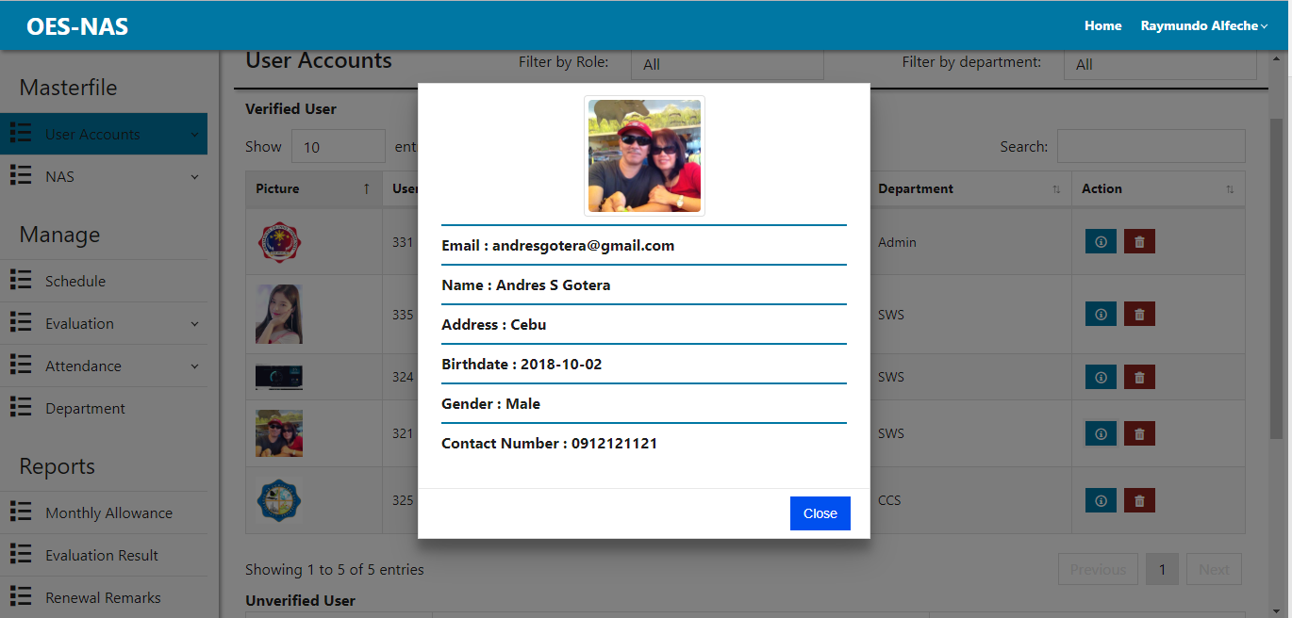

Figure 24: Viewing of user's information dialog

Description: This page allows the admin to view user’s information in.

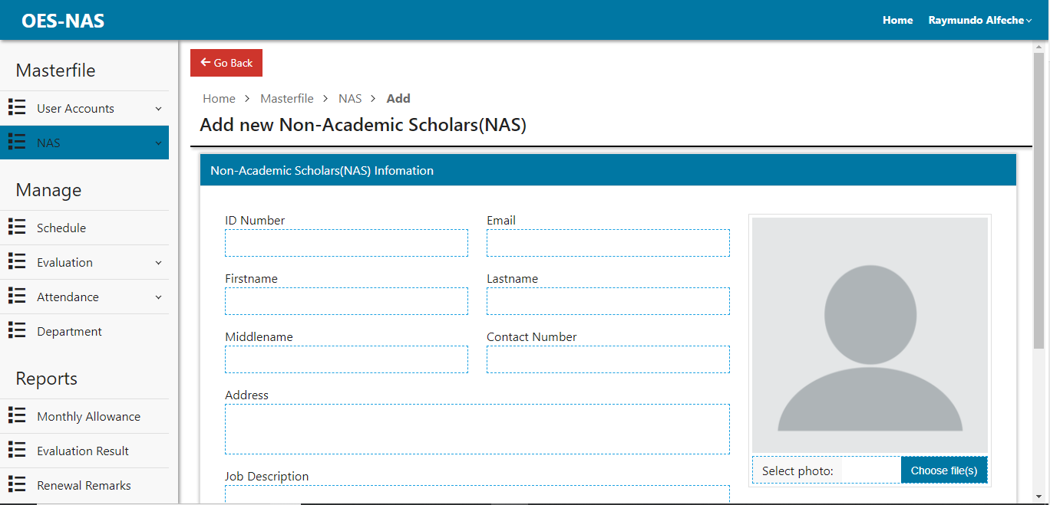

Figure 25: Adding of nas page

Description: This page is where the admin can add new nas.

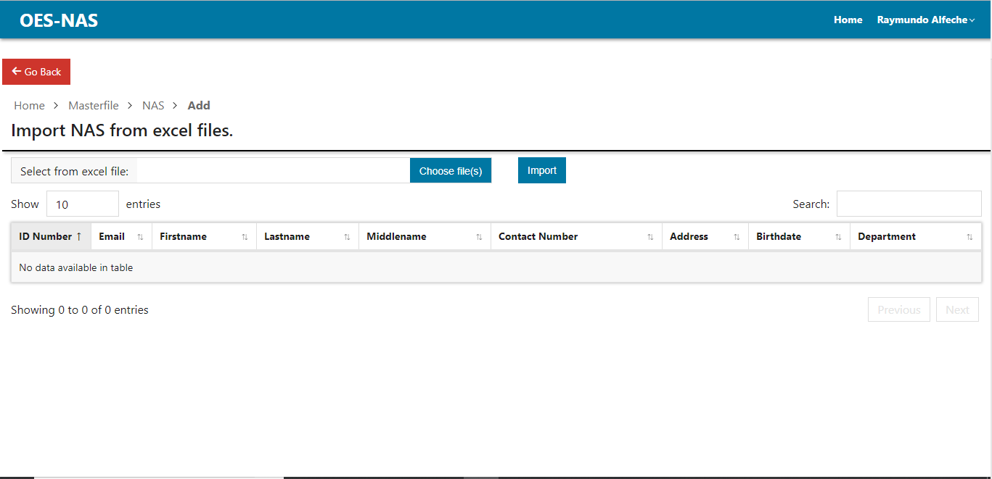

Figure 26: Importing of NAS page

Description: This page is where the admin can import NAS from excel files.

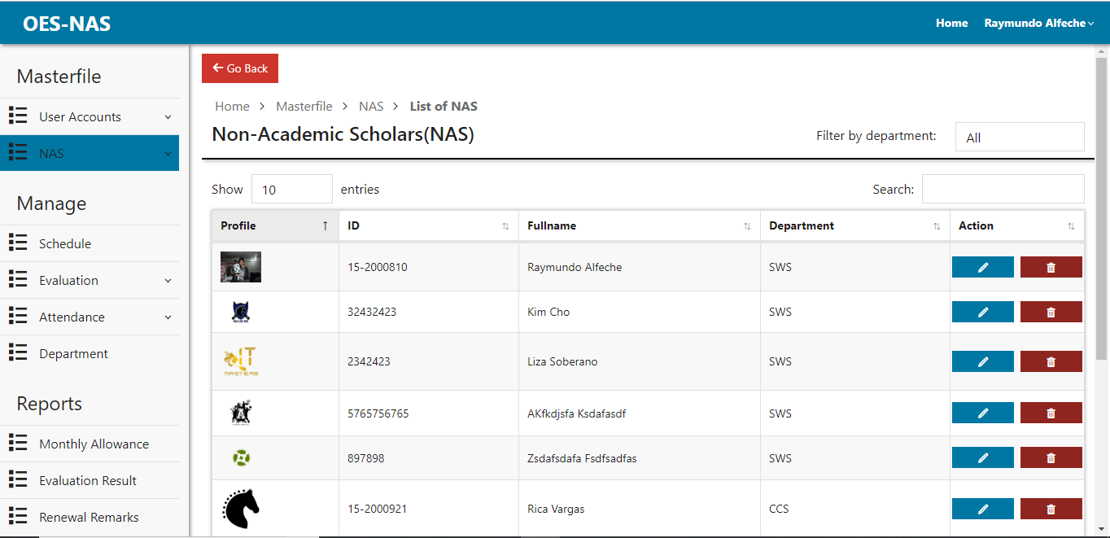

Figure 27: Viewing all NAS page.

Description: This is where the admin can view and manage all NAS.

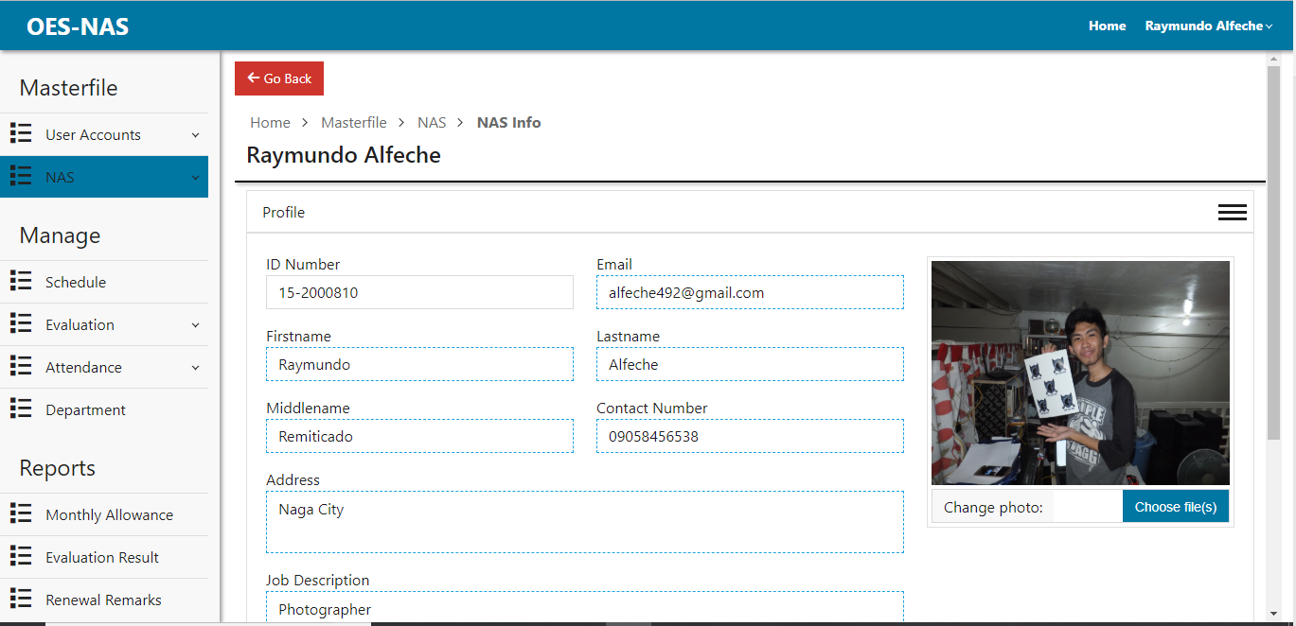

Figure 28: NAS profile page.

Description: This page is where the admin can view and update profile.

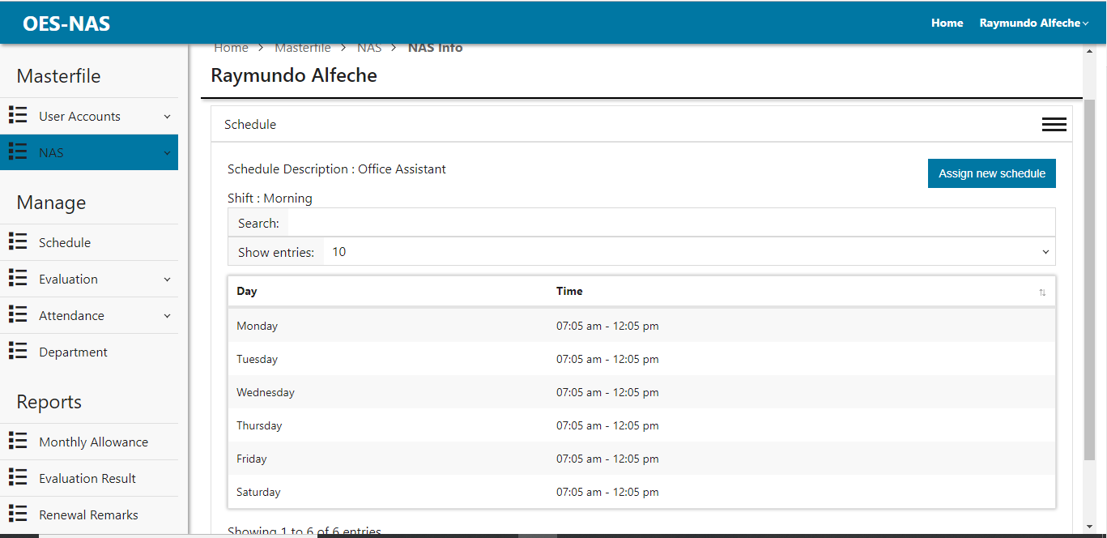

Figure 29: NAS Schedule page

Description: This page is where the admin can view and assign NAS schedule.

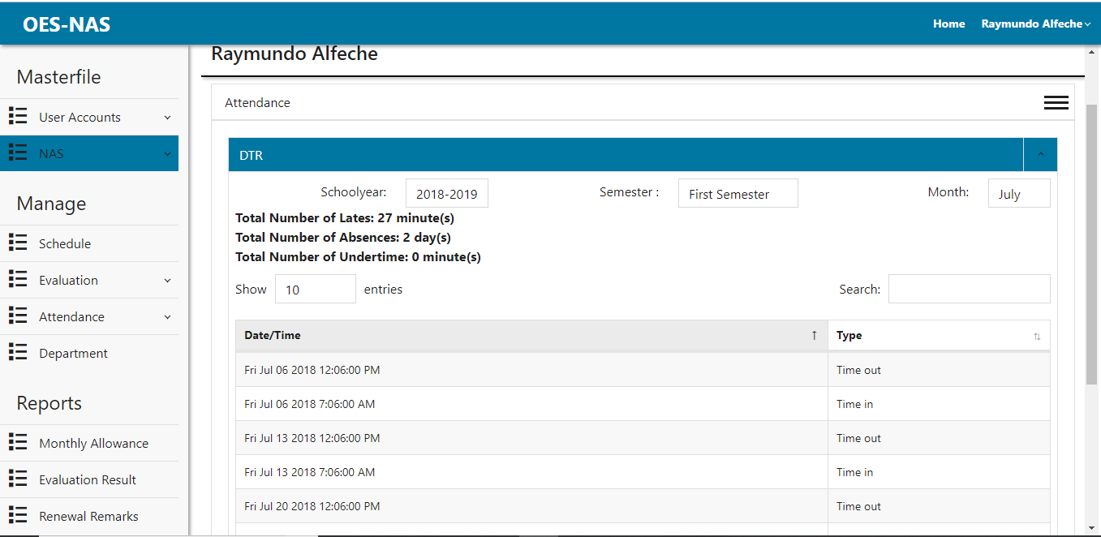

Figure 30: NAS Attendance page

Description: This page is where the admin can view NAS attendance.

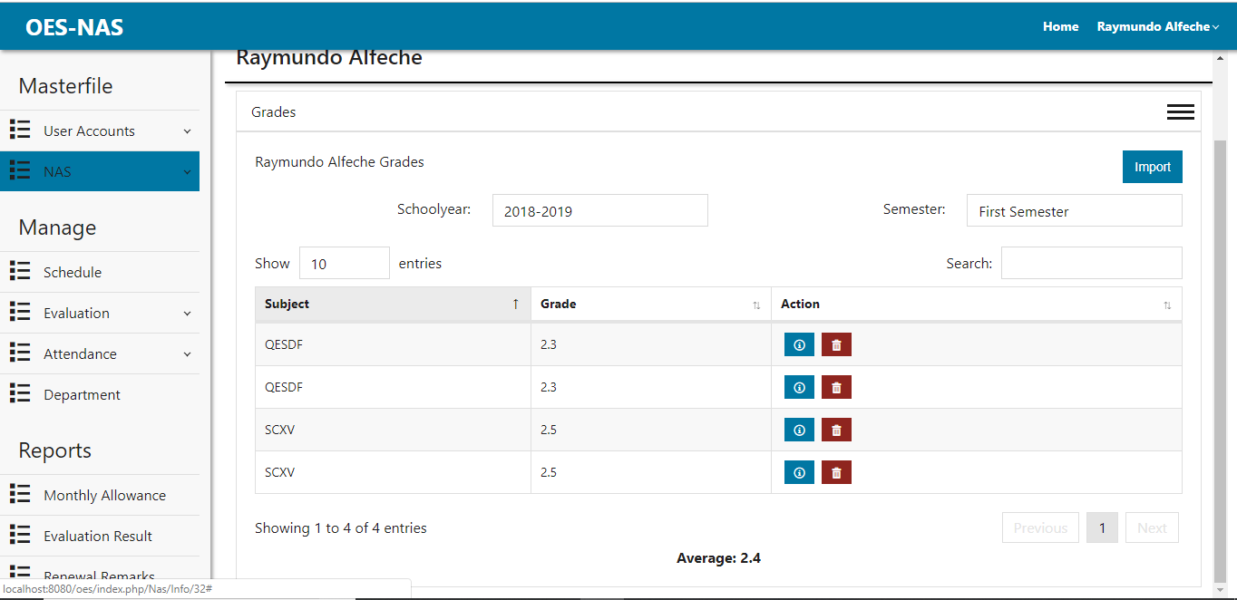

Figure 31: NAS Grade page

Description: This page is where the admin can add new nas.

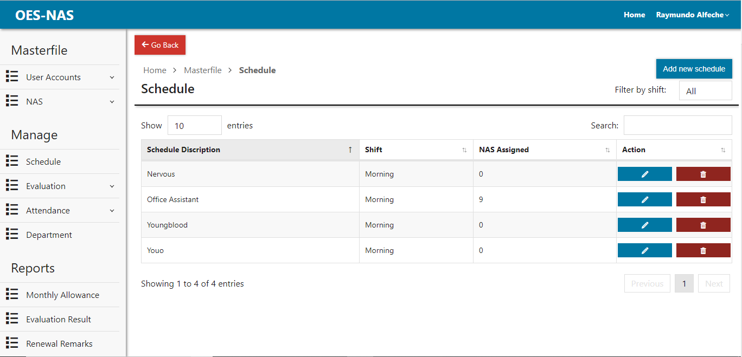

Figure 32: Schedule page.

Description: This page is where the admin can view, delete and add new schedule.

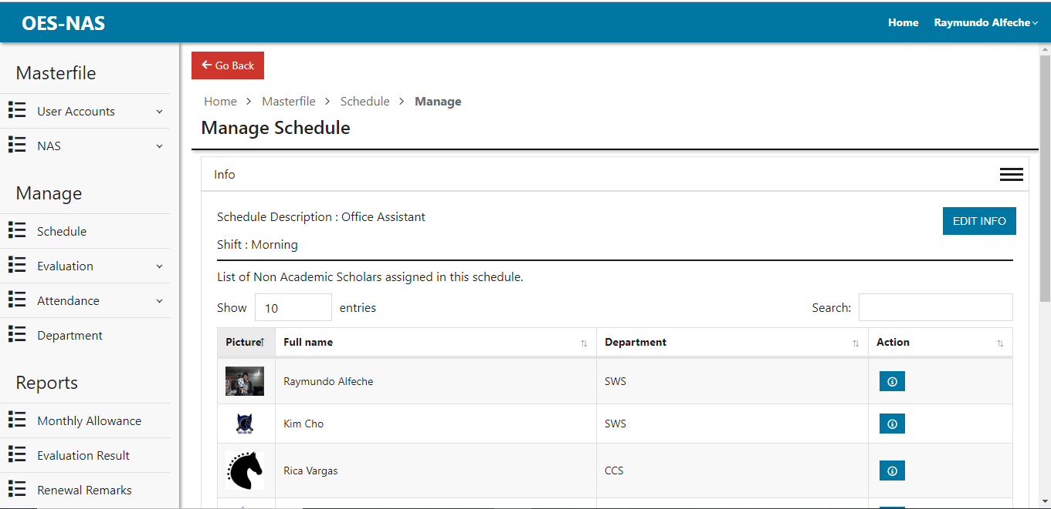

Figure 33: Manage schedule info page

Description: This page is where the admin can edit and view schedule information.

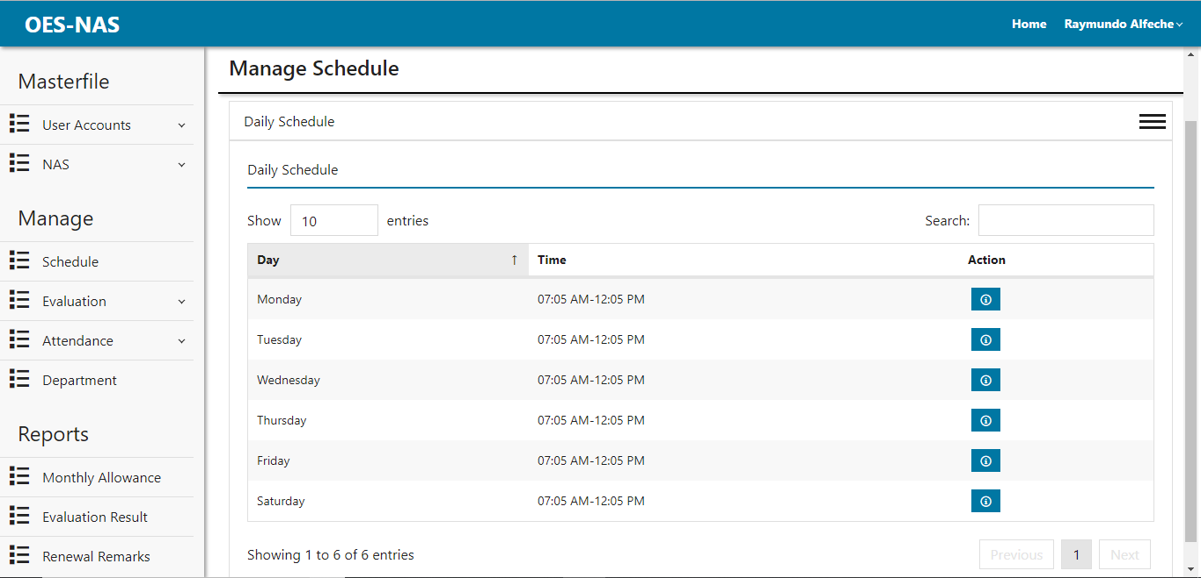

Figure 34: Daily Schedule Page

Description: This page is where the admin can view and edit daily schedule.

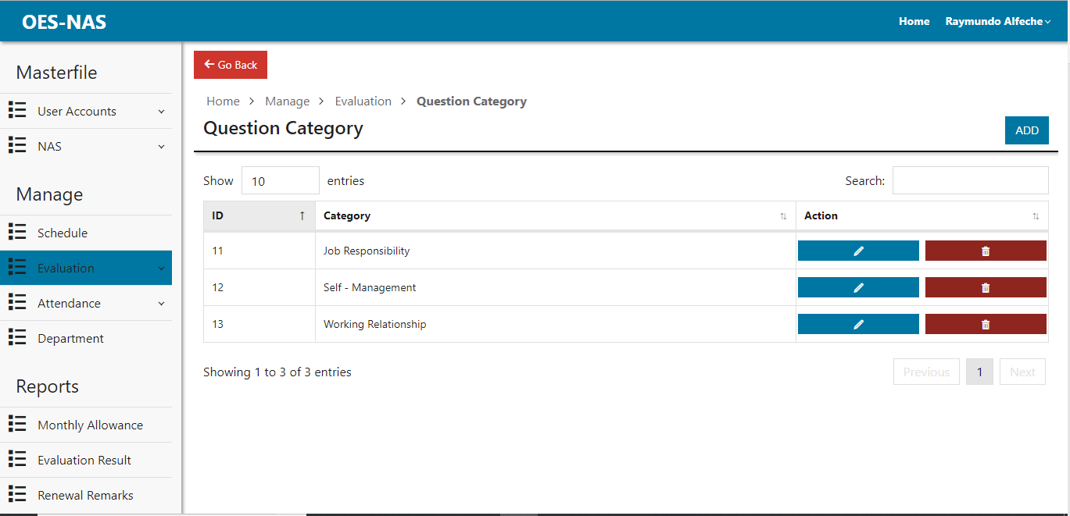

Figure 35: Question Category page.

Description: This page is where the admin can view, add, edit and delete question category that will when adding evaluation question.

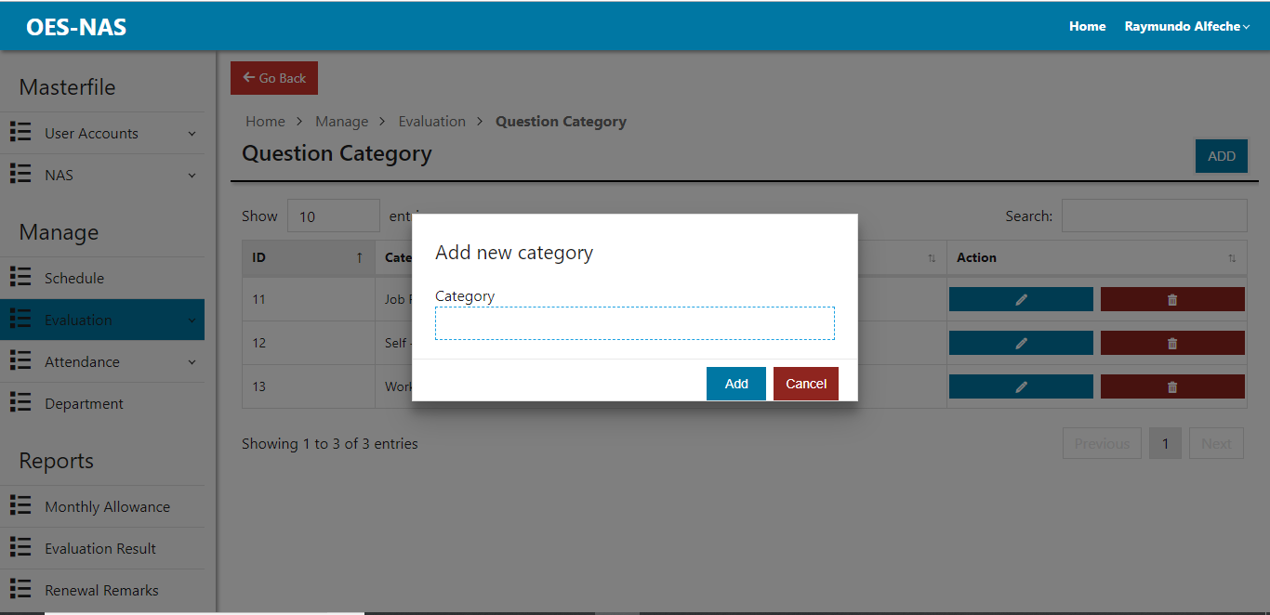

Figure 36: Adding of question category dialog

Description: This dialog is where the admin can add new category for the evaluation questions.

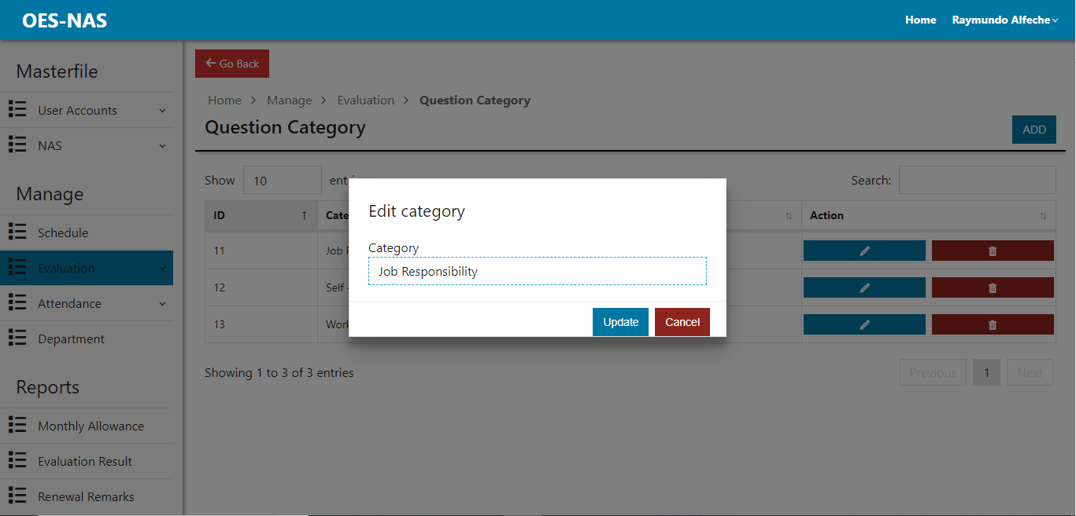

Figure 37: Edit category dialog

Description: This dialog is where the admin can edit category for the evaluation questions.

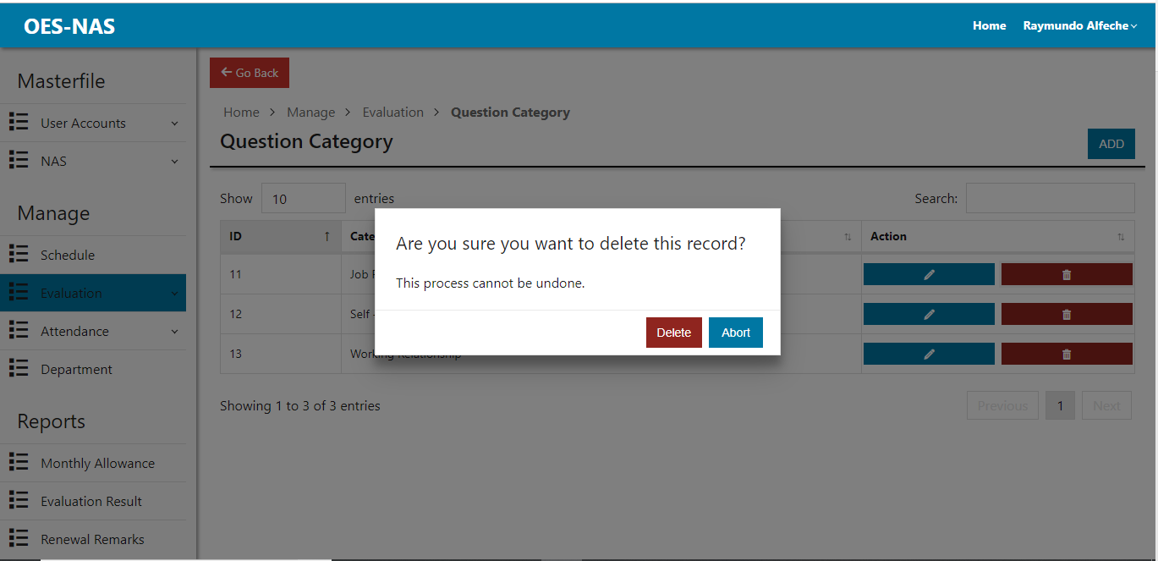

Figure 38: Confirm Category Deletion Dialog

Description: This dialog is where the admin confirms the deletion of the category.

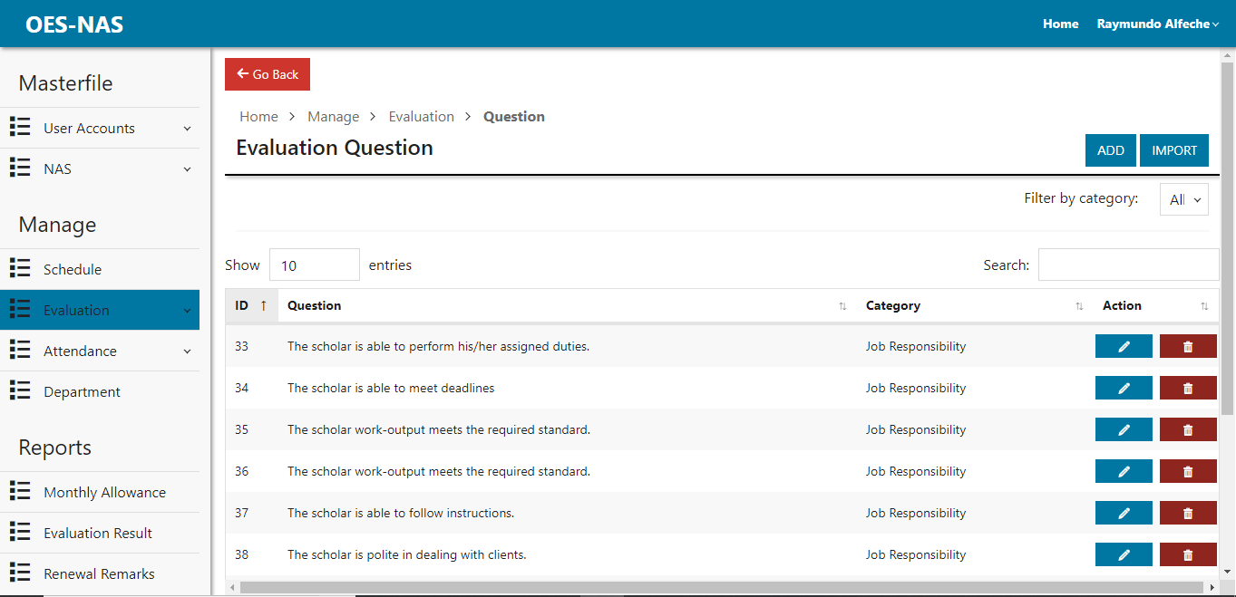

Figure 39: Evaluation Question Page

Description: This page is where the admin can add, view, edit and delete evaluation questions.

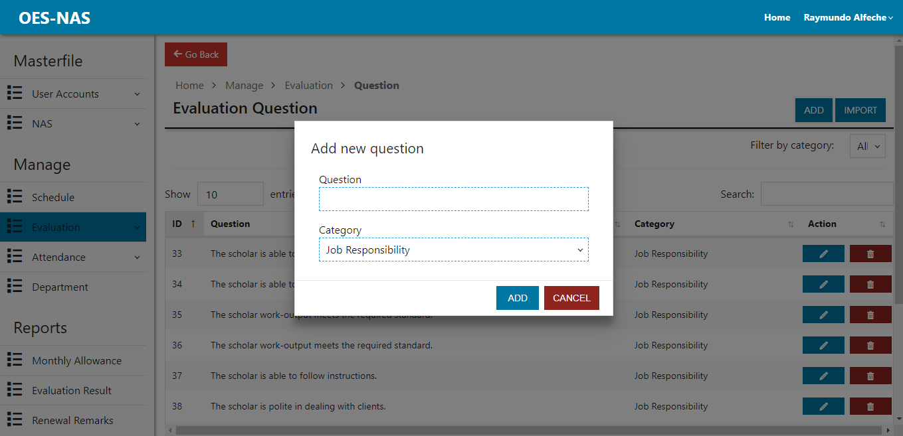

Figure 40: Add Question Dialog

Description: This dialog is where the admin can add new evaluation question.

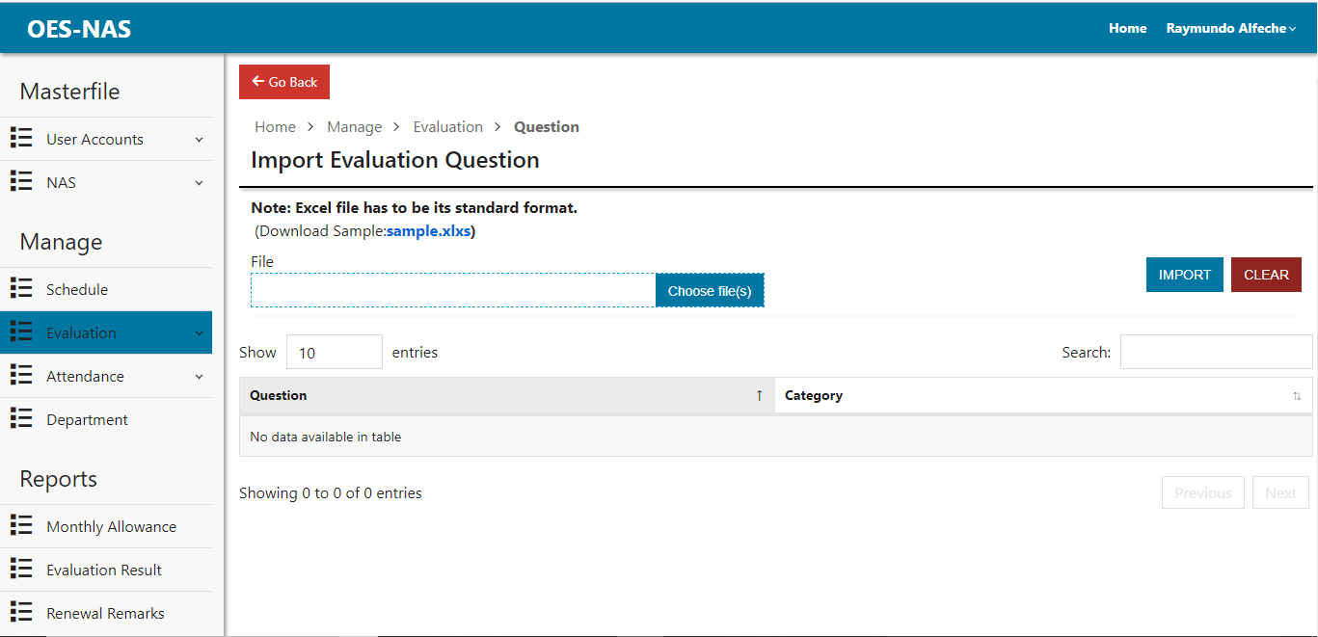

Figure 41: Importing Evaluation Question

Description: This page is where the admin can import evaluation question from excel files.

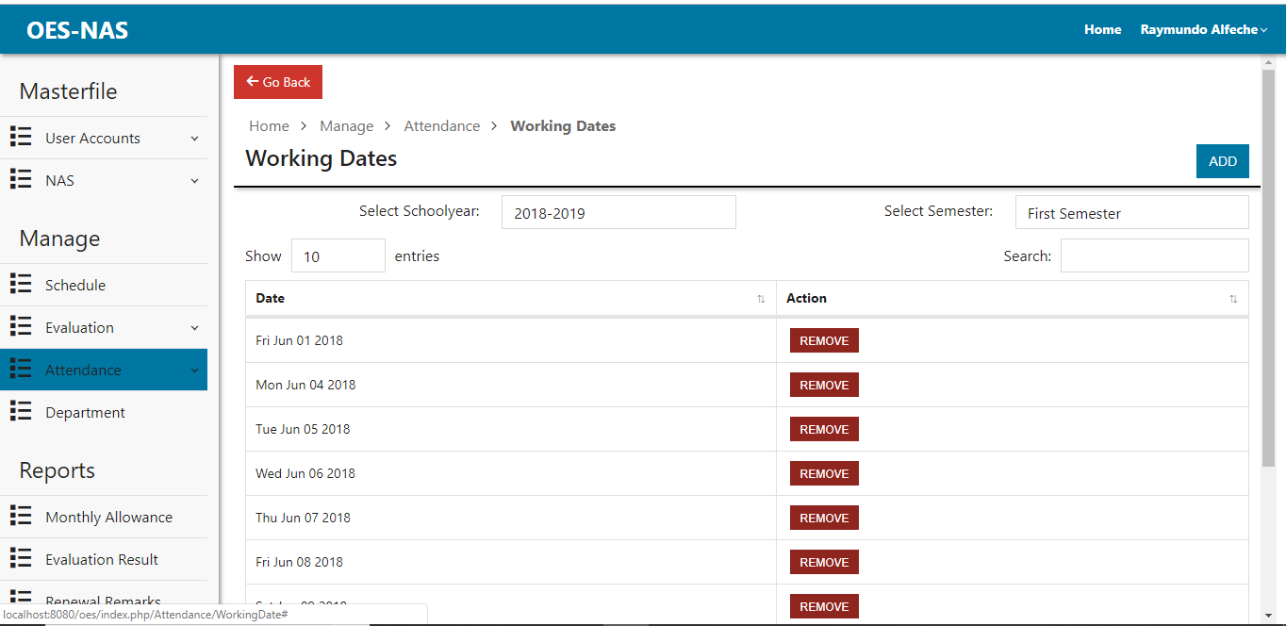

Figure 42: Working Dates Page

Description: This page is where the admin can view, add and remove working dates for the NAS.

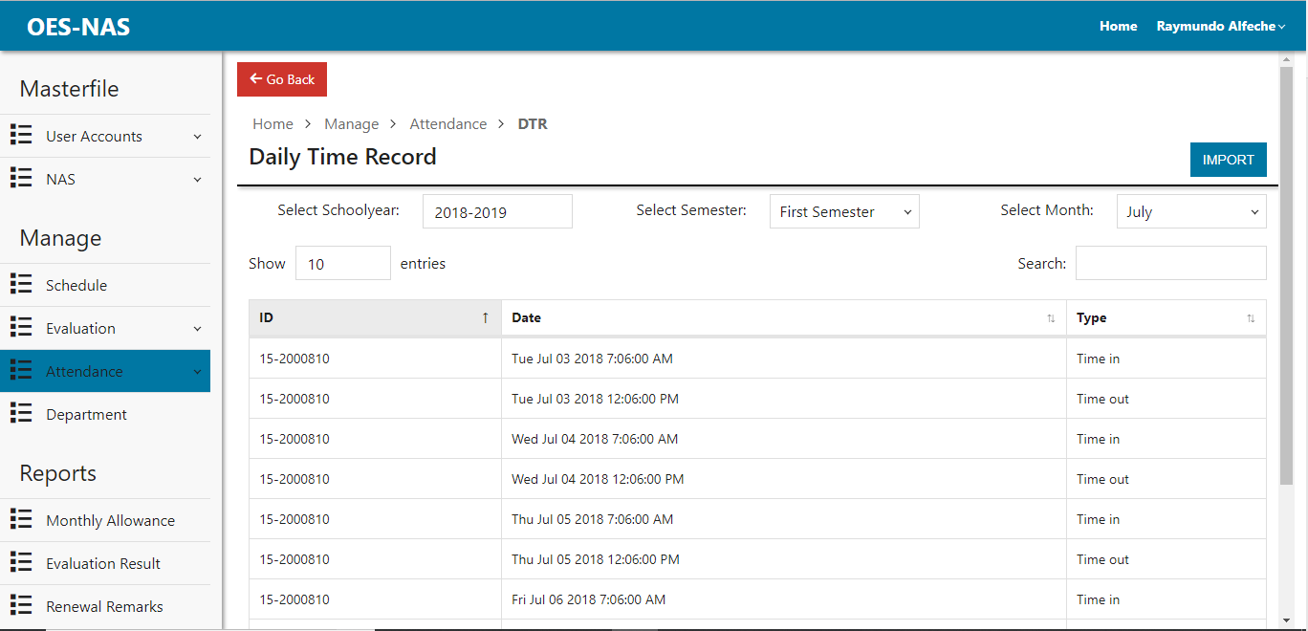

Figure 43: Daily Time Record Page

Description: This page is where the admin can view and import DTR for the attendance.

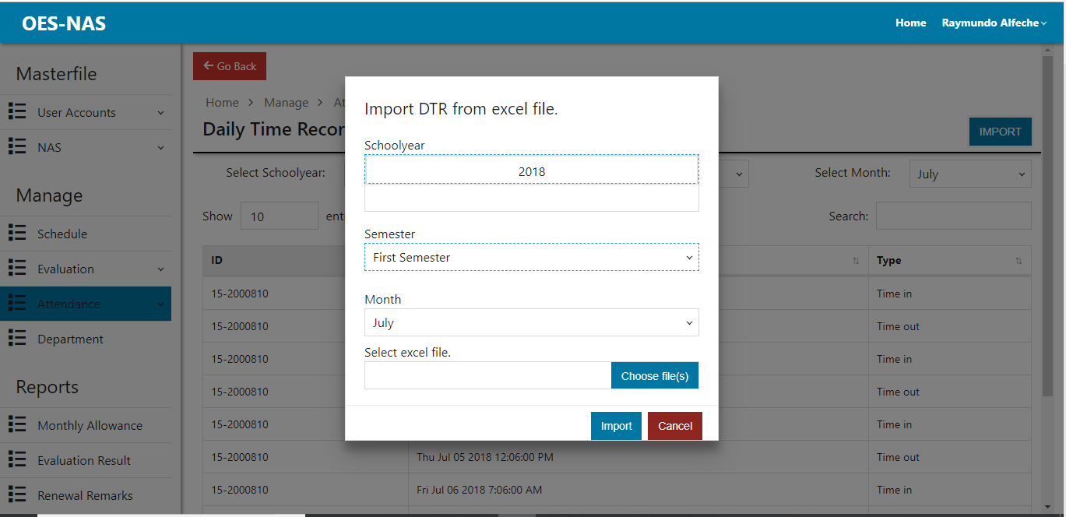

Figure 44: Import DTR Dialog

Description: This dialog is where the Importing of DTR from excel files happens.

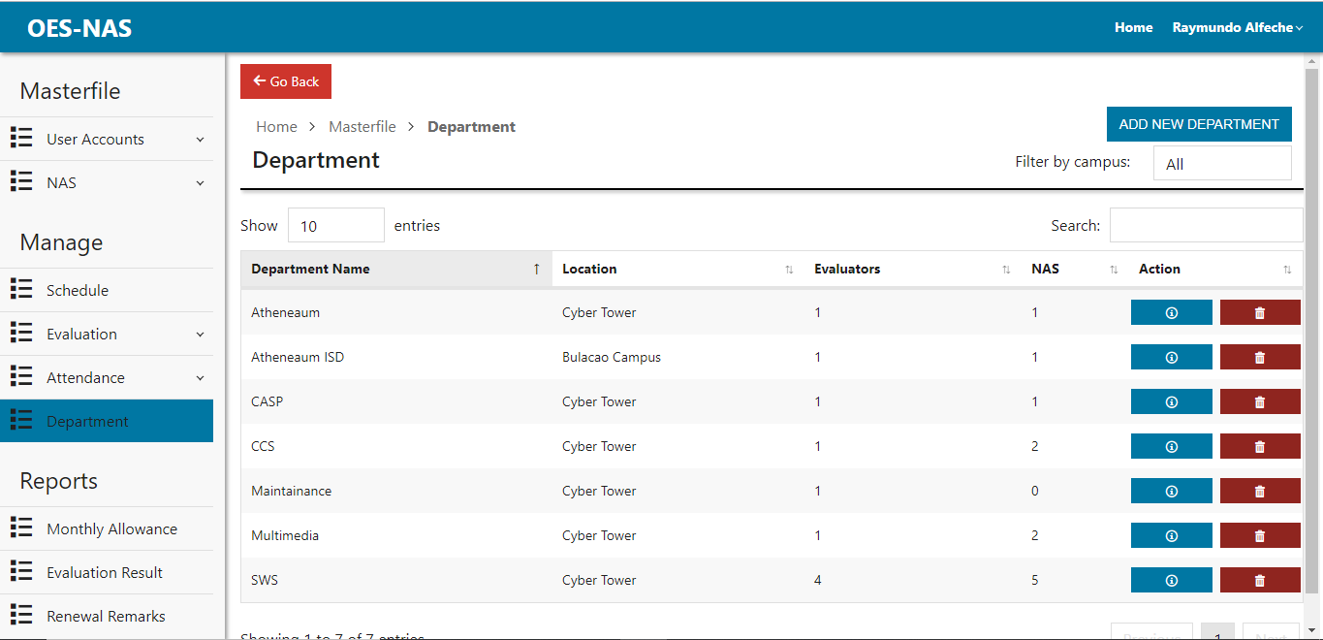

Figure 45: Department Page

Description: This page is where the admin can view, add, edit and delete department.

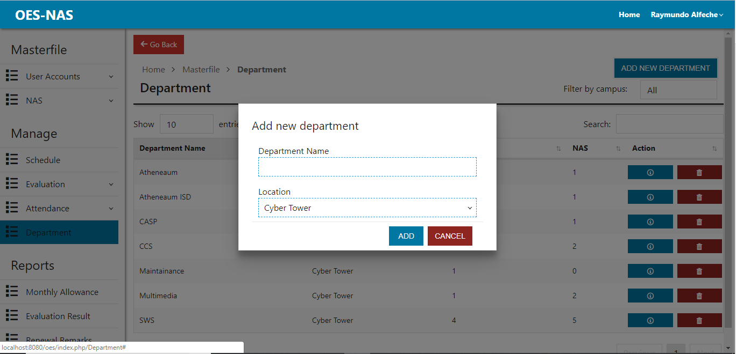

Figure 46: Adding New Department Dialog

Description: This dialog lets admin add new department.

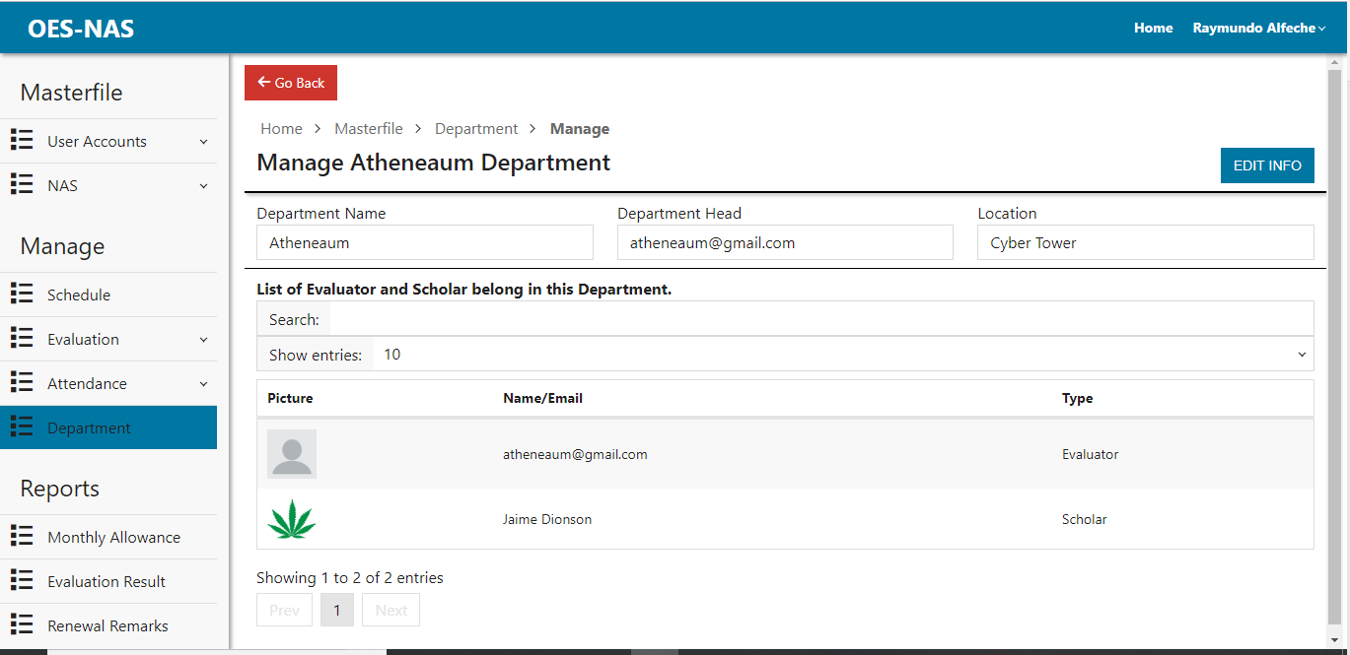

Figure 47: Edit Department Page

Description: This page allows the admin view department information ,evaluator and NAS in the department. The admin can also edit department info.

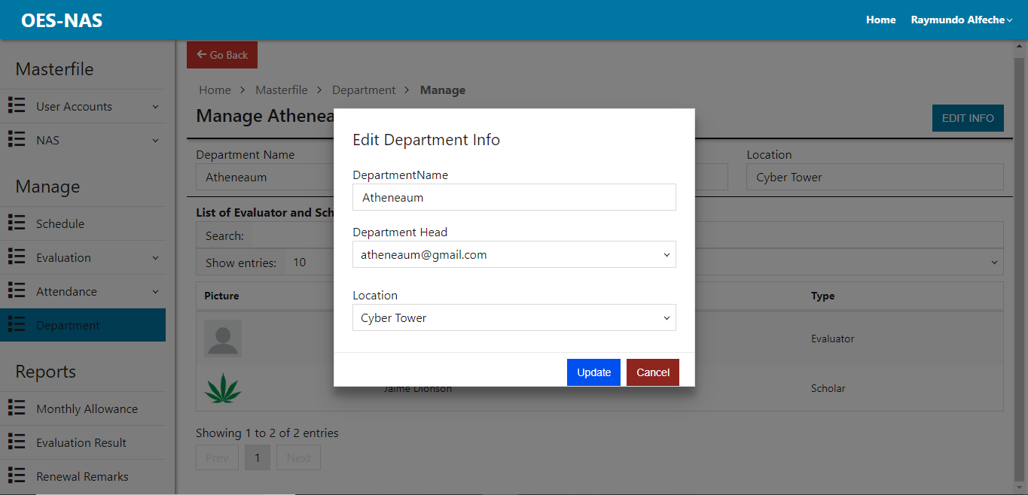

Figure 48: Edit Department Dialog

Description: This dialog is where the admin can edit department info specially choosing the head of the department.

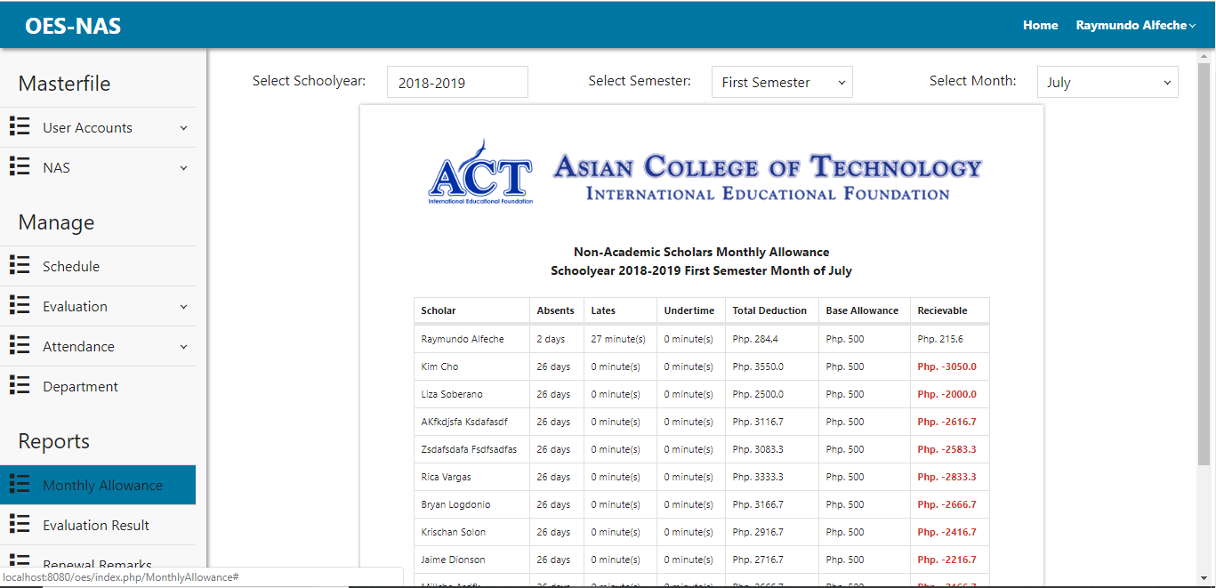

Figure 49: Monthly Allowance Report Page

Description: This page allows the admin to generate monthly allowance report based on the DTR and Working dates.

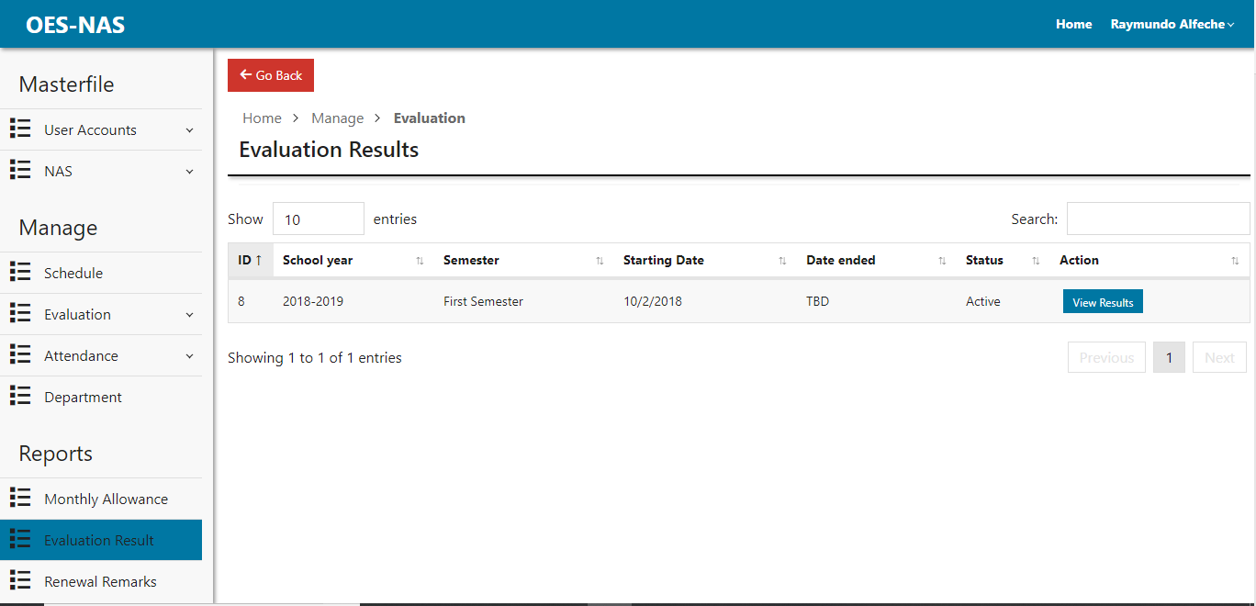

Figure 50: Choosing of Evaluation Results Page

Description: This page allows the admin to choose evaluation results.

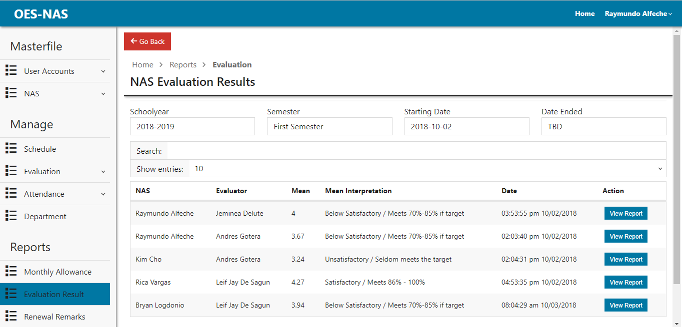

Figure 51: NAS Evaluation Results Page

Description: This page allows the admin to view NAS Evaluation results.

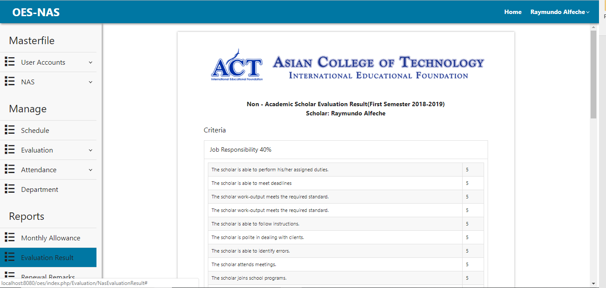

Figure 52: NAS Evaluation Report

Description: This page is a generated report of the NAS Evaluation and can be printed.

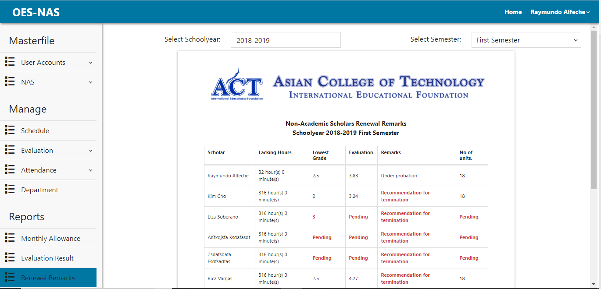

Figure 53: Renewal Remarks Report Page

Description: This page allows the admin to generate renewal report. The admin can print the report or save it as PDF.

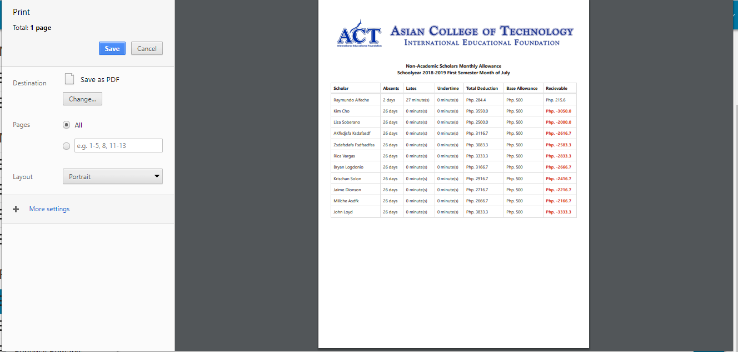

Figure 54: Monthly Allowance Report Print Dialog

Description: This dialog is the admin can Print Monthly allowance report or save it as PDF.

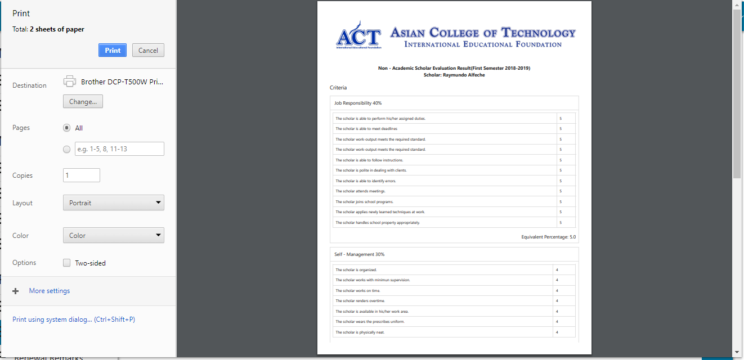

Figure 55: NAS Evaluation Results Print Dialog

Description: This dialog is where the admin can print NAS evaluation result report or save it as PDF.

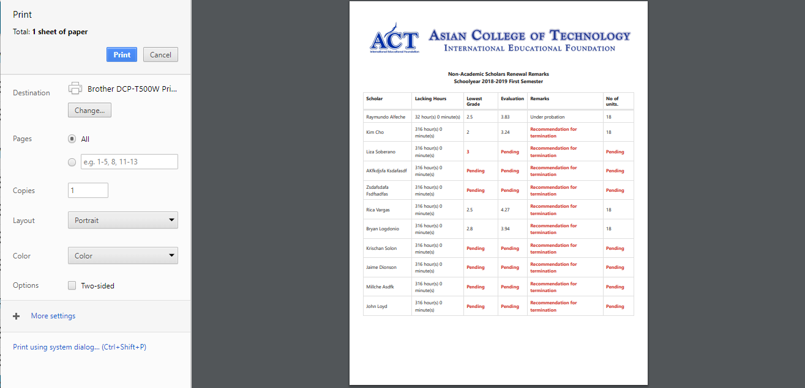

Figure 56: Renewal Remarks Report Print Dialog

Description: This dialog is where the admin can print NAS renewal remark report or save it as PDF.

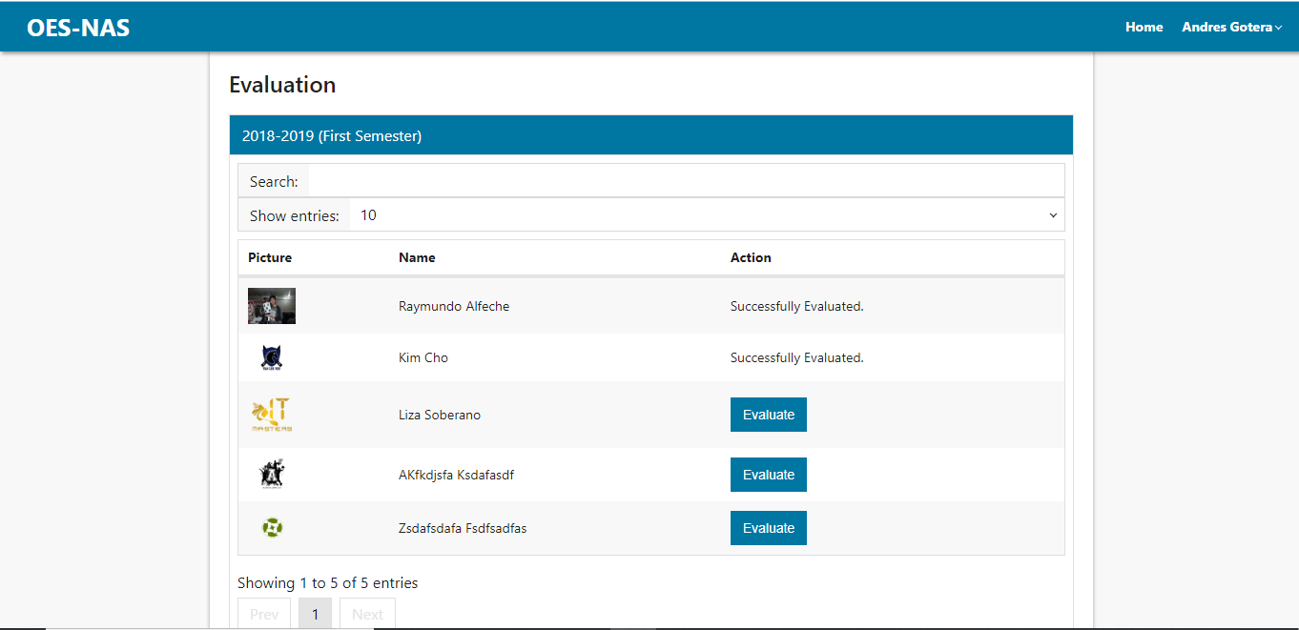

Figure 57: Evaluator Home Page

Description: This is the evaluator’s home page where they can initiate the evaluation of scholars in their department. It shows scholars they have successfully evaluated and not.

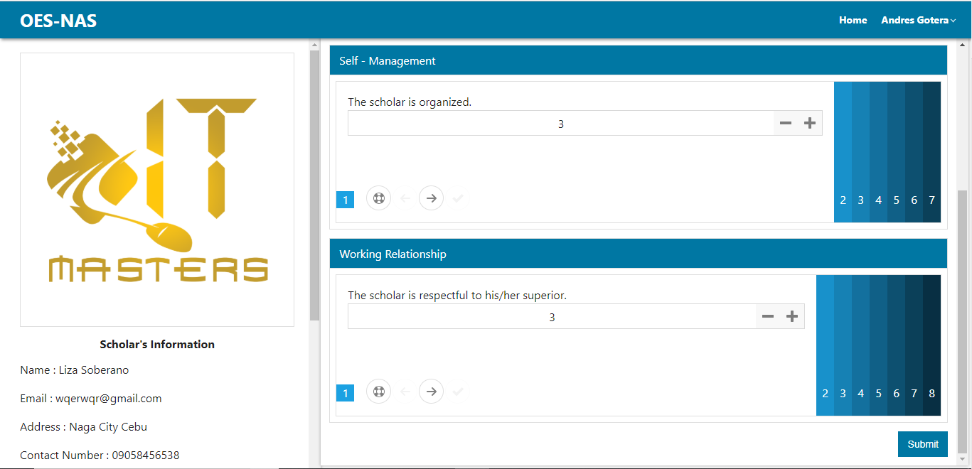

Figure 58: NAS Evaluation Page

Description: This page will be the evaluation page for NAS. In this page the evaluator can evaluate their scholar base on the questions given by the administrator. Questions are also being organized.

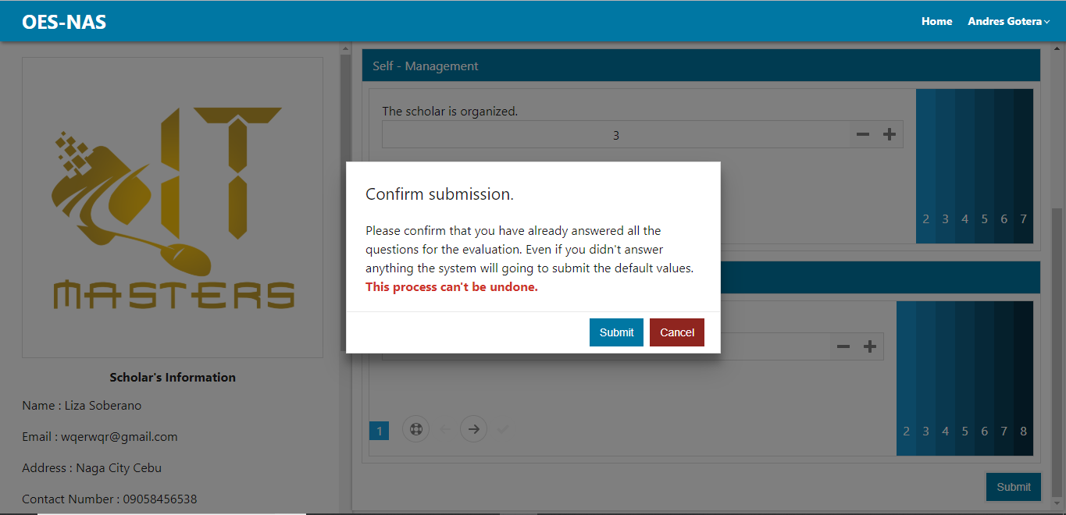

Figure 59: NAS Evaluation Submission Confirmation

Description: This dialog is a confirmation if the evaluator had answered the questions properly.